Aim - Write a program to archive traffic management at flow level by implementing closed loop control
technique ( Leaky buckets)

OBJECTIVES

1.

2.

3.

THEORY

Close loop protocols allows system to enter congested state, detect it, and remove it. It is based on the concept of feedback. Various Metrics can be used to monitor the network for congestion. Some of them are: the average queue length, number of packets that are timed-out, average packet delay, number of packets discarded due to lack of buffer space, etc. A general feedback step would be, say a router, which detects the congestion send special packets to the source (responsible for the congestion) announcing the problem. These extra packets increase the load at that moment of time, but are necessary to bring down the congestion at a later time. Other approaches are also used at times to curtail down the congestion. For example, hosts or routers send out probe packets at regular intervals to explicitly ask about the congestion and source itself regulate its transmission rate, if congestion is detected in the network. This kind of approach is a pro-active one, as source tries to get knowledge about congestion in the network and act accordingly.
The leaky bucket algorithm is a method of temporarily storing a variable number of requests and organizing them into a set-rate output of packets in an asynchronous transfer mode (ATM) network. The algorithm works similarly to the way an actual leaky bucket holds water: The leaky bucket takes data and collects it up to a maximum capacity. Data in the bucket is only released from the bucket at a set rate and size of packet. When the bucket runs out of data, the leaking stops. If incoming data would overfill the bucket, then the packet is considered to be non-conformant and is not added to the bucket. Data is added to the bucket as space becomes available for conforming packets.

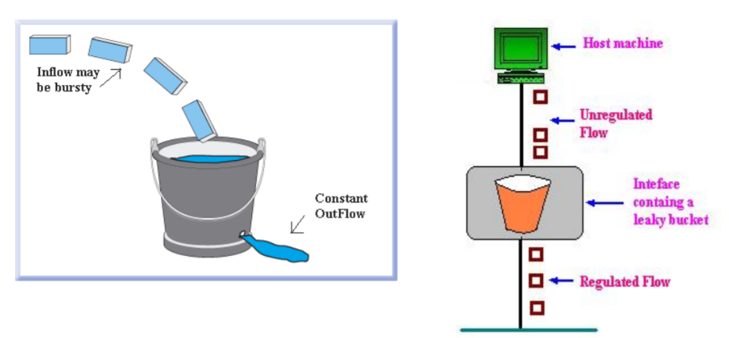
The leaky bucket algorithm can also detect both gradually increasing and dramatic memory error increases by comparing how the average and peak data rates exceed set acceptable background amounts.

METHODOLOGY

Consider a Bucket with a small hole at the bottom, whatever may be the rate of water pouring into the bucket, the rate at which water comes out from that small hole is constant. Once the bucket is full, any additional water entering it spills over the sides and is lost (i.e. it doesn’t appear in the output stream through the hole underneath). The same idea of leaky bucket can be applied to packets. Conceptually each network interface contains a leaky bucket.
And the following steps are performed:

- When the host has to send a packet, the packet is thrown into the bucket.
- The bucket leaks at a constant rate, meaning the network interface transmits packets at a constant rate.
- Bursty traffic is converted to a uniform traffic by the leaky bucket.
- In practice the bucket is a finite queue that outputs at a finite rate.

OUTPUT
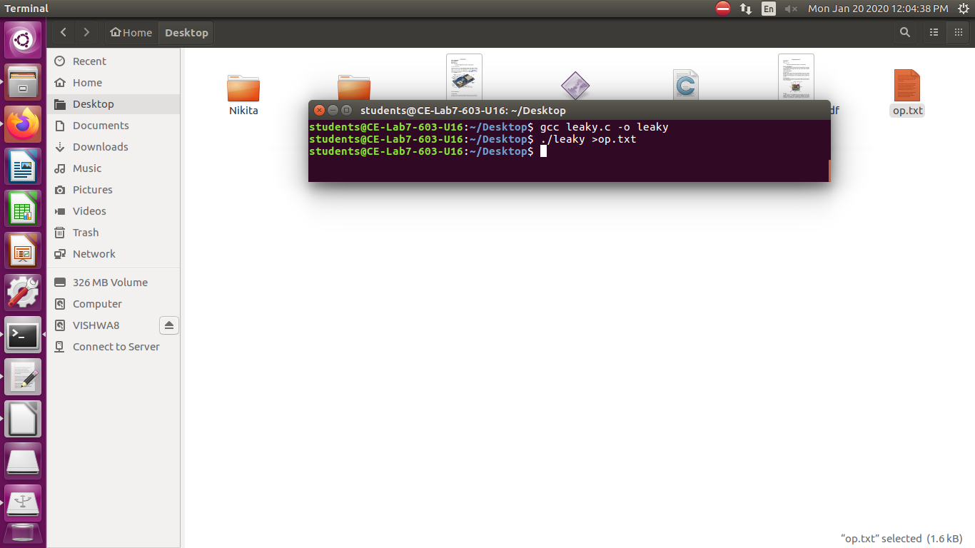

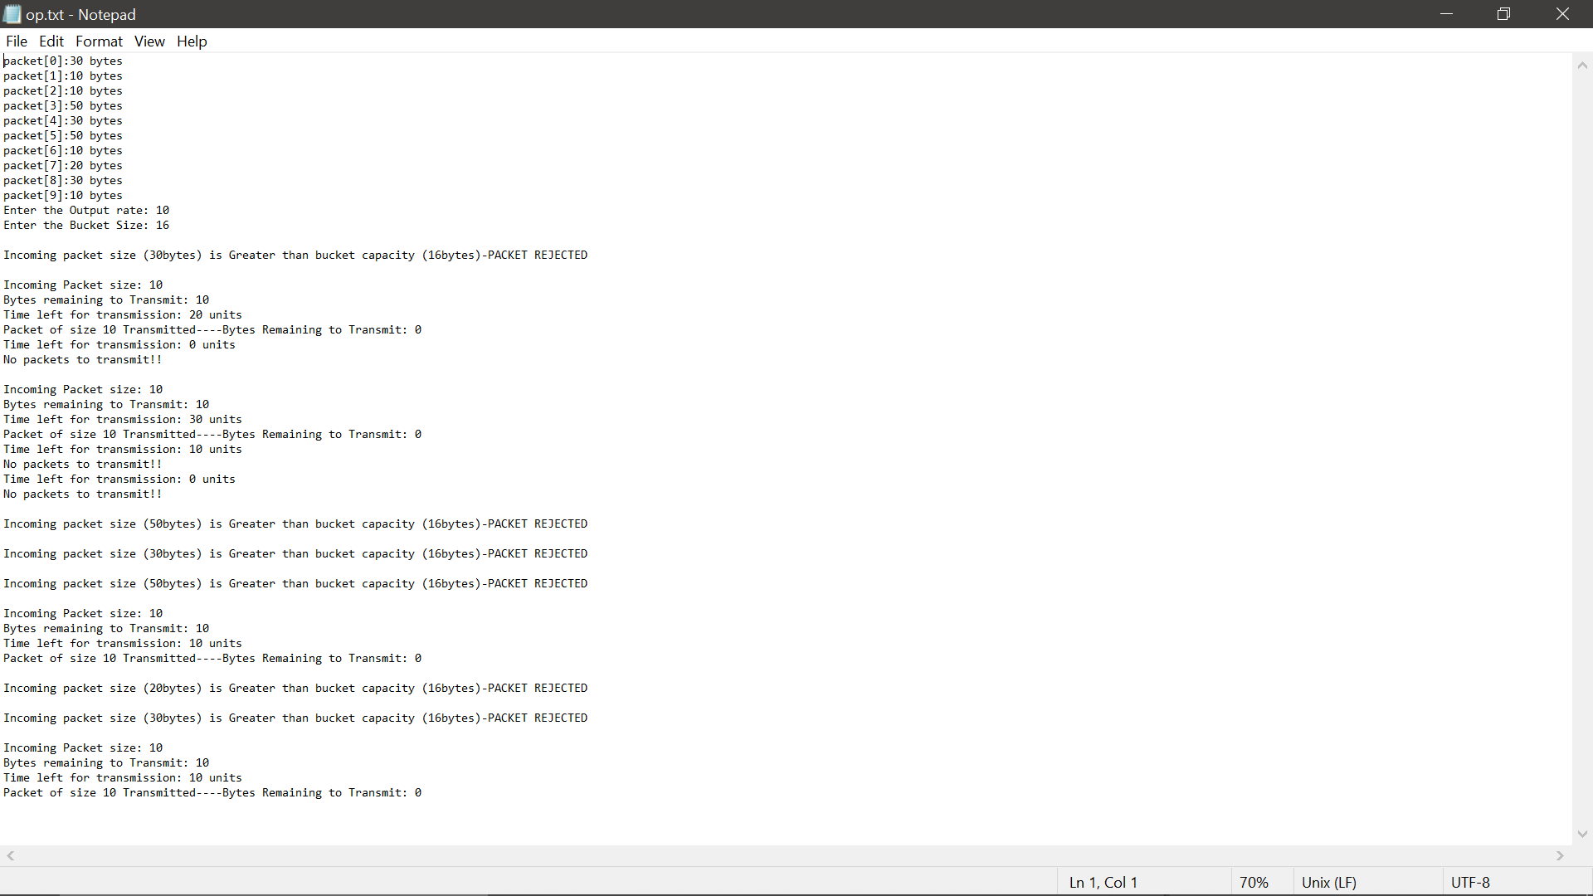

CONCLUSION

