Aim - Write a program to implement dynamic routing strategy in finding optimal path for data transmission.
(Bellman ford algorithm).

Objectives -

- To find the shortest path from a vertex to all other vertices of a weighted graph.
- To guarantee the shortest path in a graph with negative cycle.

Theory -

Methodology -

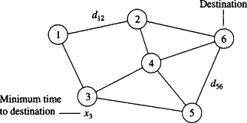
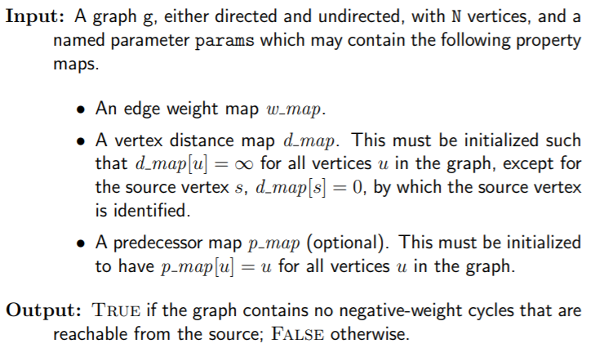

Working-
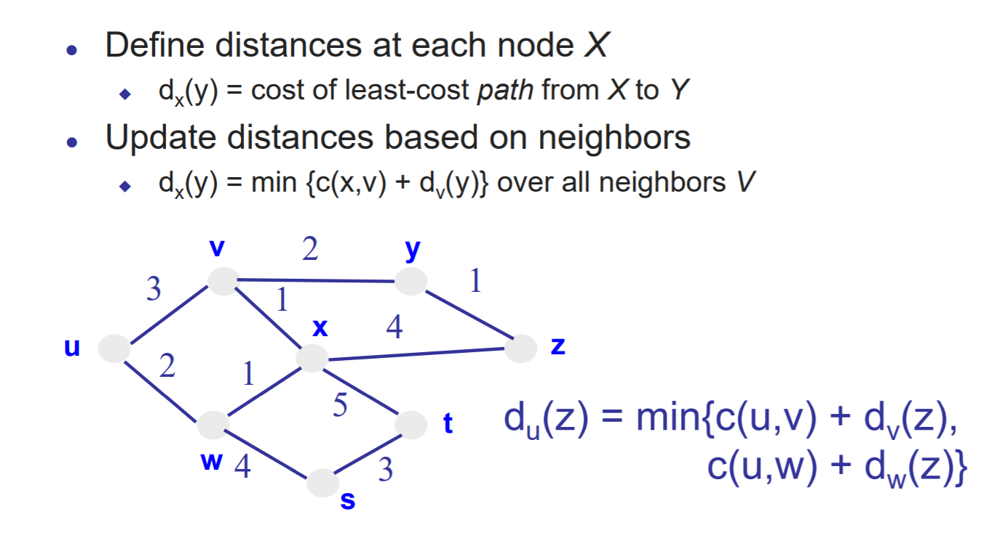
Output -

Conclusion

