# SIT323/SIT737- Cloud Native Application Development

# 9.1P: Adding a database to your application

* Install MongoDB into the Kubernetes cluster, either as a standalone instance or a replica set, depending on your requirements.

Created a replica set

* Configure persistent storage for the MongoDB database by creating a Persistent Volume and Persistent Volume Claim.

* Create a Kubernetes Secret for the MongoDB user credentials and add them to the deployment manifest



* Modify the Kubernetes deployment manifest for your application to include the newly added MongoDB database. Ensure that the configuration includes information such as the database type, credentials, and other necessary parameters.

Username: admin1

Password: (base64-encoded) password123

* Configure the application to connect to the MongoDB database using the MongoDB client driver library and the connection string in the deployment manifest.

For now I’m just connecting to my local host mongodb://localhost:27017

* Test the deployment to ensure that the application can connect to the MongoDB database and perform basic CRUD (Create, Read, Update, Delete) operations.
* Set up database backups and disaster recovery options as necessary.
* Monitor the MongoDB database and application performance to ensure that the database is running smoothly and efficiently.

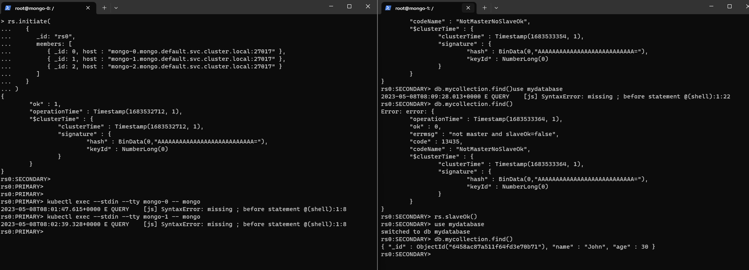I created a record in one instance, and it was automatically added to the whole replica set.