Flood-Resilient Siting of IoT Drone Docks for Smart-City Relief: A Scenario Study of Varanasi and Kanpur
Dr. Swarnalatha P  Professor Grade 1  School of Computer Science and Engineering  Vellore Institute of Technology  Vellore, India  pswarnalatha@vit.ac.in | Ajay Thomas  School of Computer Science and Engineering  Vellore Institute of Technology  Vellore, India  ajaythomas.k2023@vitstudent.ac.in | Dharani I S  School of Computer Science and Engineering  Vellore Institute of Technology  Vellore, India  dharani.is2023@vitstudent.ac.in | Sukant G  School of Computer Science and Engineering  Vellore Institute of Technology  Vellore, India  sukant.g2023@vitstudent.ac.in

Abstract—Relief drones can supply people cut off by urban floods, but they need dry places to launch, swap batteries and reload. In a smart city these places can be permanent, networked drone docks, sited years before any flood. This paper asks where such docks should go so that they keep working as the water rises. We propose an Internet of Things (IoT) architecture in which river and rain gauges, docks and drones report over LoRaWAN and MQTT to a command centre that re-plans missions from docks that are still dry. Docks are sited by a scenario method: an open-source multi-UAV relief planner is run on 30 flood scenarios (two cities, five flood stages, three weather levels), and sites it chooses repeatedly and that stay dry are kept. On held-out flood stages, six robust docks serve 94% of drop points in Varanasi and 90% in Kanpur, against 49% and 45% for docks sited from a single event and 68% and 73% for evenly spread docks. Freely re-sited bases, the upper bound, move by 263 to 287 m on average between consecutive flood stages, which a fixed installation avoids. A city's full telemetry load is 9.61 kbit/s. All results are from simulation on published flood maps; no drone was flown.
Index Terms—smart cities, Internet of Things, drone docks, facility location, flood resilience, UAV relief, MQTT, LoRaWAN.
I. Introduction
Indian cities on large rivers flood almost every monsoon. When water cuts off a ward, the first need is to get small loads of food, water and medicine to people who cannot leave. Small drones can carry such loads over water in minutes, and city governments are already testing them for emergency logistics [1], [2]. A drone, however, is only as useful as the place it flies from. It must take off from dry ground, come back to swap a battery and pick up the next kits, and do so several times within its short endurance. In most studies of relief drones this launch site is assumed to exist or is chosen on the day.
Smart cities offer a different option. Under India's Smart Cities Mission every participating city runs an Integrated Command and Control Centre (ICCC) that already collects data from field sensors, including flood sensors and rain gauges in several cities [3], [4]. A natural extension is a network of drone docks: weather-proof boxes that store a drone, charge or swap its batteries and hold relief kits, connected to the ICCC like any other IoT device. Docks, unlike pop-up launch sites, are infrastructure. They are bought, permitted and wired in advance, so their locations must be decided long before anyone knows how high the next flood will rise.
This creates a siting problem with a twist. A dock placed close to today's flooded wards serves them well, but the same dock may itself be under water when the river rises another metre. A dock placed far from any water is always safe but may be too far for a drone to reach the people who need it. We study this trade-off directly, using an existing open-source relief planner as an evaluator: for any flood map, weather and set of allowed launch sites, it returns the drop points a fleet can serve within battery and payload limits [5].
We address three research questions:
- RQ1. How much relief coverage does a fixed set of docks lose, compared with launch sites re-chosen for every event, as the flood rises and the weather changes?
- RQ2. Can a dock set chosen from a few flood scenarios keep working on flood stages it was not chosen for, and how does it compare with docks sited for one event or spread evenly?
- RQ3. What does an IoT layer that triggers re-planning from sensor readings require in data rate and response time?
Our contributions are: (i) a five-layer IoT architecture that couples gauges, docks and drones to the ICCC and restricts each re-plan to docks that are still dry (Section III); (ii) a scenario-based dock siting method that scores candidate sites by how often a relief planner chooses them and how often they stay dry, with a train and test split over flood stages (Section IV); (iii) an evaluation on flood maps of Varanasi and Kanpur with 180 planner runs, comparing robust, event-sited, evenly spread and freely re-sited bases (Section V); and (iv) a measured telemetry budget and planning latency for the architecture (Section V-F).
II. Related Work
A. IoT for urban flood monitoring
IoT flood monitoring is mature at the sensing level. Zanella et al. [6] describe the layered IoT stack of a smart city, from constrained field devices to cloud services. Low-power wide-area networks suit river gauges: Zakaria et al. [7] report a solar-powered LoRaWAN water-level node with an ultrasonic sensor and measure its packet delivery and delay. Indian ICCCs now integrate such sensors: Chennai's centre plans dozens of flood sensors and rain gauges [3]. These systems detect and warn; none of them dispatches a physical response. We use their sensor stream as the trigger for drone missions.
B. Drones in smart cities and disaster response
Mohamed et al. [1] survey UAV applications in smart cities and the regulation and technology needed to integrate them. Erdelj et al. [2] review UAVs for disaster management, from monitoring to delivery. Rabta et al. [8] model a drone fleet that delivers small relief packages from recharging stations in a disaster area. These works establish the role of drones but treat the launch infrastructure as given.
C. Locating drone bases
Choosing launch sites is a facility location problem. The location set covering model of Toregas et al. [9] and the maximal covering location problem of Church and ReVelle [10] underlie most emergency-facility siting, and Snyder [11] reviews how uncertainty in demand and in facility availability enters such models. Drone networks for cardiac arrest are the best-studied application: Pulver and Wei [12] site medical drone bases with covering models, and Boutilier et al. [13] size a drone network to beat ambulance response times in Toronto. Closest to our setting, Chin et al. [14] locate drone search bases before a disaster in Iwate, Japan, and extend the model to bases that may be damaged. These models need demand points and travel times as inputs and score coverage with straight-line or fixed ranges. Our method instead obtains coverage from a planner that routes around water, splits work into battery-limited sorties and changes its demand points as the flood grows, and it treats flooding of the dock itself as the failure mode.
D. Relief mission planning from flood maps
The evaluator we use, A.D.A.P.T. [5], turns a flood-annotated map and the weather into autopilot missions for one drone or a fleet, with D* Lite routing [15] and battery-limited sorties; its own evaluation concerns perception accuracy, mission verification and simulator flights. We use it unchanged as a black box and add what it does not cover: fixed docks, rising water, and the IoT layer. Table I contrasts the scope of these lines of work.
TABLE I
Scope of related work and of this study
Work | Pre-sited bases | Rising flood | Routed reach | IoT trigger | City case
IoT flood monitoring [6], [7] | – | sensed | – | ✓ | ✓
Drones in smart cities [1], [2] | – | – | – | (✓) | –
Covering models [9], [10], [12], [13] | ✓ | – | – | – | ✓
Damage-aware drone bases [14] | ✓ | (✓) | – | – | ✓
Flood-map relief planner [5] | – | (✓) | ✓ | – | ✓
This study | ✓ | ✓ | ✓ | ✓ | ✓

III. IoT Architecture
Fig. 1 shows the proposed architecture in five layers. Its purpose is to close the loop from a sensor reading to dispatched drone missions without manual map work, while keeping a human approval step.
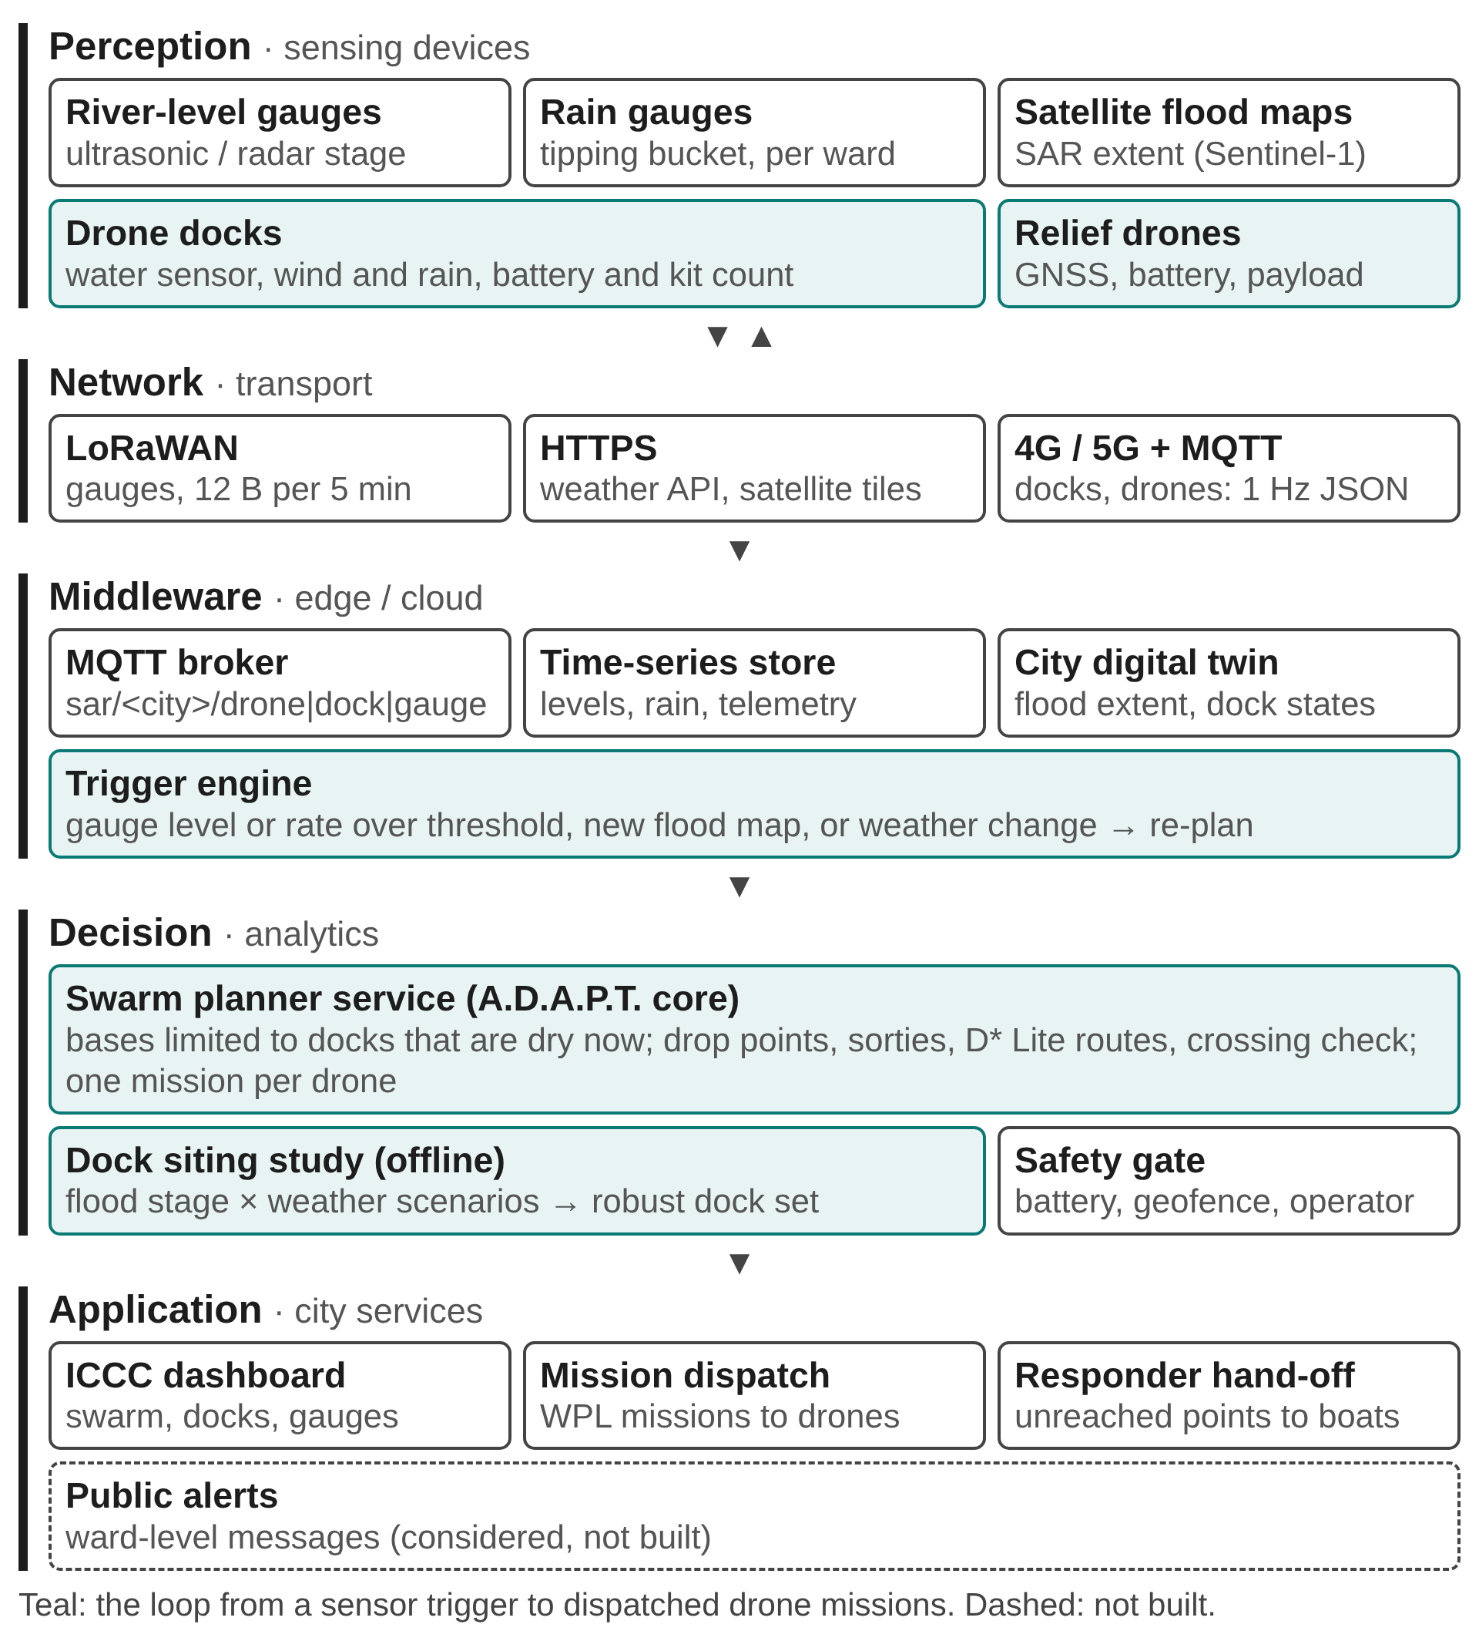
Fig. 1. Proposed IoT architecture for dock-based flood relief. Teal elements form the trigger-to-dispatch path.
Perception. River-stage gauges on ghats and bridges and ward-level rain gauges measure the hazard; satellite radar flood products [19] supply the extent of water when available. Docks carry their own water sensor, an anemometer, a rain sensor and counters for charged batteries and kits, so the ICCC knows at all times which docks can launch. Drones report position, battery, payload and mission progress from the autopilot.
Network. Gauges are battery or solar powered and send packed binary readings of 10 to 12 bytes every five minutes over LoRaWAN, which fits the smallest LoRaWAN payload, allowed at the longest range [17]. Docks and drones need more bandwidth and a down-link for missions, so they use cellular links and publish JSON messages to an MQTT broker [16] under topics of the form sar/<city>/<device type>/<id>/….
Middleware. The broker feeds a time-series store and a city digital twin that holds the current and forecast flood extent and the state of every dock. A rule-based trigger engine starts a re-plan when a gauge crosses a warning level, when its rate of rise exceeds a threshold, when a new flood map arrives, or when the weather changes class.
Decision. The planner service runs the relief planner [5] with one change in how it is called: its candidate launch sites are restricted to docks that the twin reports as dry, clear of the forecast flood and stocked. It returns drop points, sorties and one mission per drone, which pass a safety gate (battery limit, geofence, operator approval). The dock siting study of Section IV runs offline and decides where the docks are in the first place.
Application. The ICCC dashboard shows the swarm, docks, gauges and an event log; missions are sent to the docks; drop points that no dock can reach are handed to boat teams. A prototype of this dashboard, which streams the planner's log and replays the swarm on the city map, was built for this study; the MQTT layer is specified and sized but not deployed.
TABLE II
Message types and data rate for one city
Topic (sar/<city>/…) | Bytes | Rate | N | kbit/s
drone/telemetry | 151 | 1 Hz | 6 | 9.36
drone/event | 81 | 1/120 s | 6 | 0.05
dock/status | 124 | 1/60 s | 6 | 0.13
gauge/level | 78 | 1/300 s | 20 | 0.07
iccc/plan | 209 | 1/1800 s | 1 | 0.00
Total |  |  |  | 9.61

IV. Dock Siting Method
Fig. 2 summarises the study: scenarios are generated, the planner places bases freely in each, dock sets are derived from those plans, and every dock set is evaluated again on all scenarios.
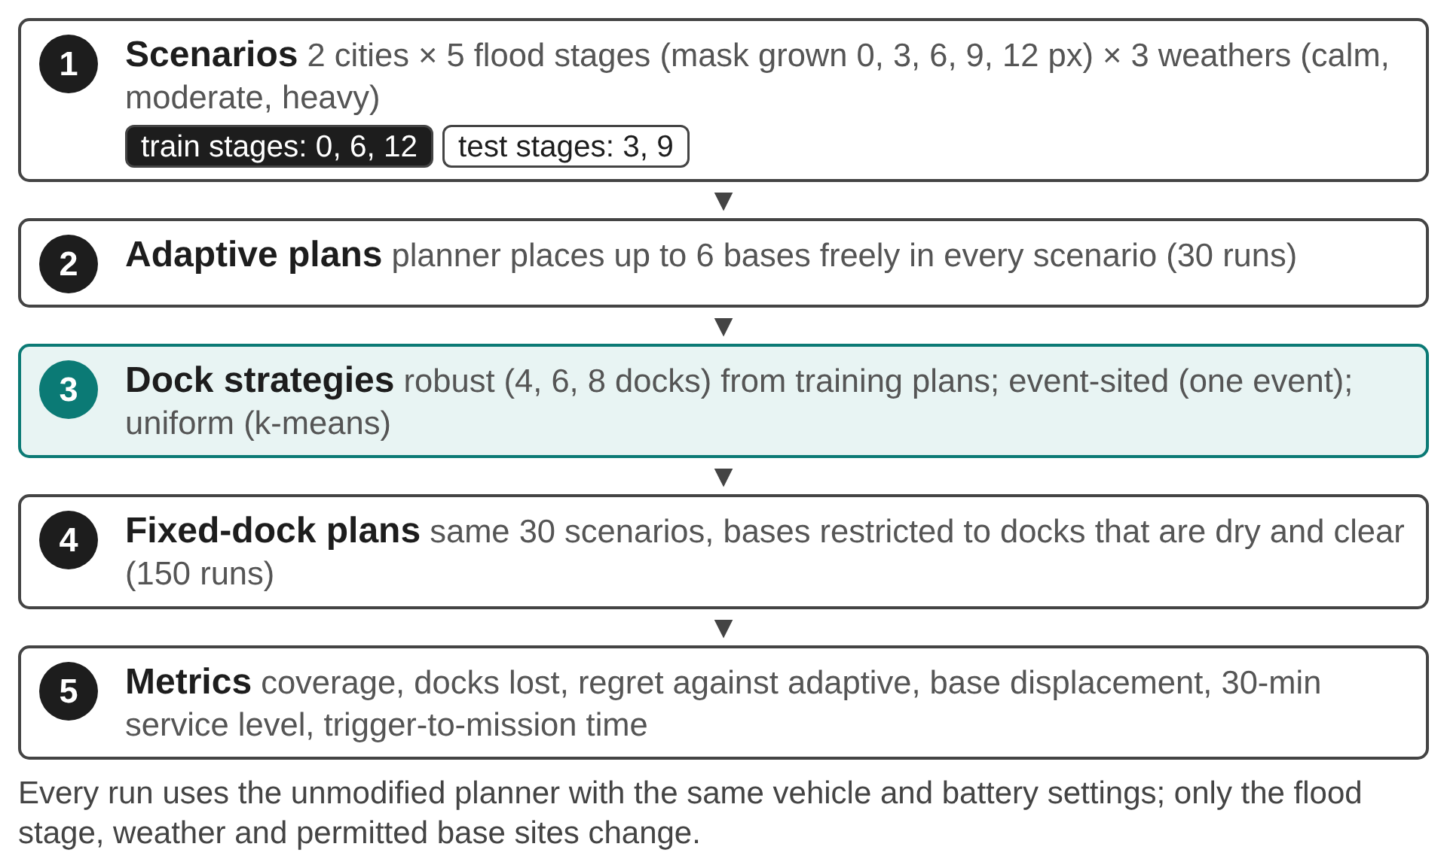
Fig. 2. Study design: scenarios, adaptive plans, dock strategies, fixed-dock plans and metrics.
A. Relief planner as evaluator
For a flood map, the weather and a set of permitted launch sites, the planner [5] segments flooded areas by colour, grows them by a weather-driven forecast over two hours, places drop points on the dry edges of flood zones, chooses up to K launch bases that together reach the most drop points, assigns each drop point to a base, splits each base's work into sorties that respect an 8 kg payload and an 80% battery limit, and routes each leg around current and forecast water. We use its open-source release with default settings (cruise 5 m/s, 7 min loaded endurance, 0.25 kg per kit, nominal scale 2 m per map pixel) and call it unmodified; the only intervention is the list of candidate base sites it may choose from. Its own documentation lists the battery model and the map scale as approximations, so absolute coverage figures here are indicative; all comparisons are made under identical settings.
B. Scenarios
We use the published flood maps of Varanasi and Kanpur from the 2025 Ganga floods, both Smart Cities Mission cities. Flood stage g represents rising water: the detected flood mask is grown by g ∈ {0, 3, 6, 9, 12} map pixels, which raises the flooded share of the map from 10% to 28% in Varanasi and from 15% to 39% in Kanpur. Three weather levels are used: calm (0 mm/h, 0 km/h), moderate (3 mm/h, 12 km/h) and heavy (10 mm/h, 30 km/h), with wind from the west. This gives 15 scenarios per city. Stages 0, 6 and 12 form the training set; stages 3 and 9 are held out for testing.
C. Strategies
Adaptive. The planner chooses up to six bases freely in every scenario. This is an upper bound for coverage, but it assumes that a launch site can be set up wherever the plan says, on the day.
Robust docks. Every base chosen in a training scenario is a candidate site c. Its score combines support and survival:
$s(c) = a(c) · \sum_{b∈B, ‖b−c‖≤45}{n(b)}$ (1)
where B is the set of bases in all training plans, n(b) the drop points base b served, and a(c) the share of training scenarios in which c is dry and clear of the forecast flood under the planner's own test. Sites are taken in order of score, skipping any closer than the planner's 150-pixel minimum base separation, until H docks are chosen; we use H = 4, 6 and 8.
Event-sited docks. The bases the planner chose for one event, stage 0 under moderate weather (5 docks in Varanasi, 5 in Kanpur). This is what a city would install if it sited docks after studying its most recent flood.
Uniform docks. Six sites spread evenly over dry land by k-means clustering of the planner's dry grid points at stage 0, the naive geographic layout.
In every fixed-dock run the planner may choose bases only among the docks of the strategy that are dry and clear in that scenario; flooded docks are counted as lost.
D. Metrics
Coverage is the share of the scenario's drop points that the plan serves. Regret is the relative loss of served drop points against the adaptive plan of the same scenario. Docks lost counts docks that are flooded or within the planner's clearance of the forecast flood. Service level is the share of drop points served within 30 minutes of dispatch, using the routed path at 5 m/s, 40 s to climb to 100 m, 101 s per drop (descent to 10 m, 5 s loiter, climb), 80 s to land and 120 s to swap a battery and reload; vertical speeds follow ArduCopter defaults [18]. Base displacement is the mean distance from each adaptive base to the nearest base of the next flood stage. Planning latency is the wall time of a planner run.
V. Results
All 180 planner runs (30 adaptive, 150 with fixed docks) completed and every one produced a plan with no route crossings: in every scenario at least one dock of every strategy stayed usable. Table III summarises the strategies over all scenarios and over the held-out stages alone (VNS: Varanasi, KNP: Kanpur).
A. Coverage under rising water (RQ1)
Fig. 3 shows coverage against flood stage. Adaptive bases serve 98% of drop points in Varanasi and 96% in Kanpur on average (scenario minimum 92% and 81%), because the planner can move a base next to the water in every scenario. Fixed docks lose coverage as the flood grows, but at very different rates. Robust docks stay closest to the adaptive bound, with a mean regret of 3% in Varanasi and 7% in Kanpur. Event-sited docks do well on the event they were sited for and degrade as the water rises over them (regret 50% and 44%). Uniform docks sit in the middle (regret 31% and 20%): some are lost to the water and the survivors are often far from the drop points.
The number of drop points itself changes with the stage: as separate pockets of water merge, the planner places fewer drop points on the larger merged zones (Kanpur falls from 46 to 13 drop points between stages 0 and 9). Coverage shares therefore compare strategies within a stage, not across stages.
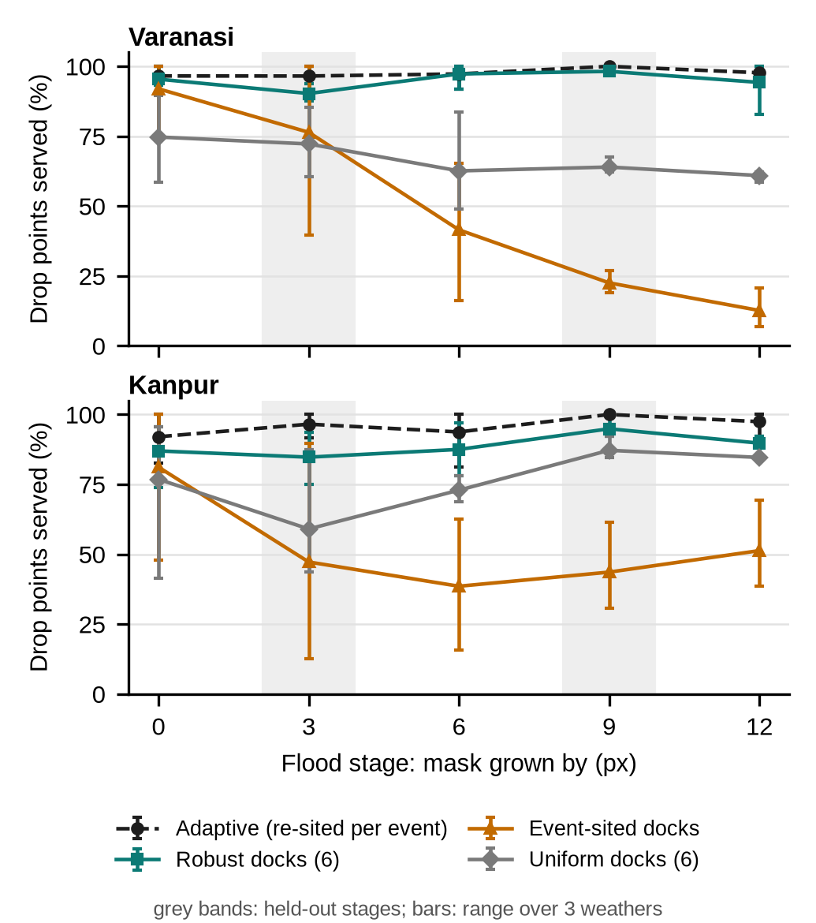
Fig. 3. Share of drop points served as the flood rises. Markers: mean over the three weather levels; bars: range. Grey bands mark held-out stages.
TABLE III
Strategy comparison (mean over scenarios)
Strategy | Docks | Cov. all | Cov. test | Regret | Lost (max) | ≤30 min
VNS adaptive | ≤6 | 98% | 98% | – | – | 68%
VNS robust | 6 | 95% | 94% | 3% | 0.1 (1) | 67%
VNS event-sited | 5 | 49% | 49% | 50% | 2.5 (4) | 40%
VNS uniform | 6 | 67% | 68% | 31% | 1.3 (2) | 52%
KNP adaptive | ≤6 | 96% | 98% | – | – | 77%
KNP robust | 6 | 89% | 90% | 7% | 1.0 (2) | 74%
KNP event-sited | 5 | 52% | 45% | 44% | 2.4 (4) | 44%
KNP uniform | 6 | 76% | 73% | 20% | 1.6 (2) | 70%

B. Dock survival (RQ1)
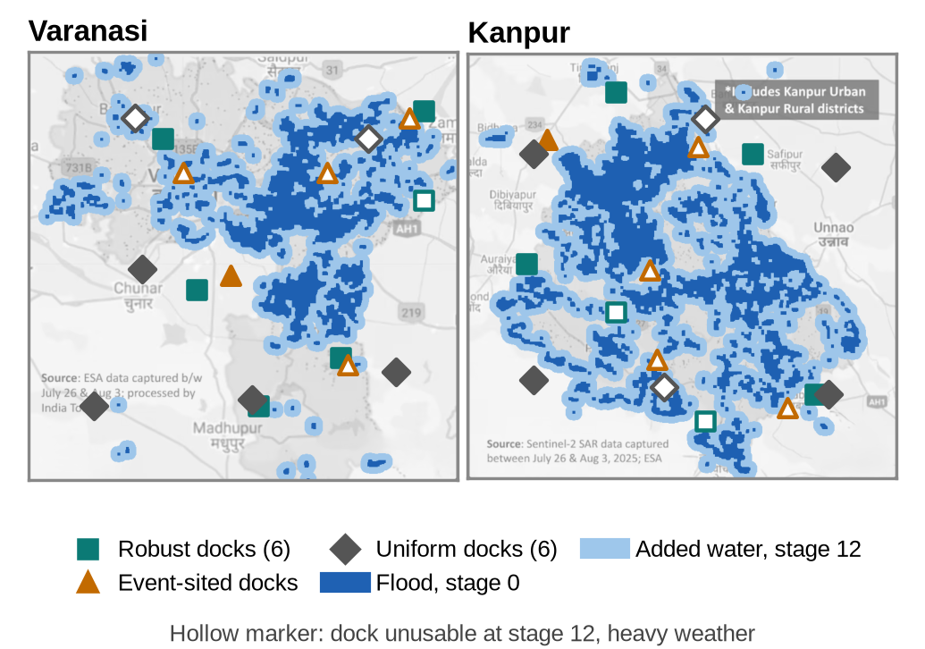
Fig. 4. Dock sites of the three fixed strategies over the stage-0 flood and the water added by stage 12. Hollow markers are docks unusable at stage 12 under heavy weather.
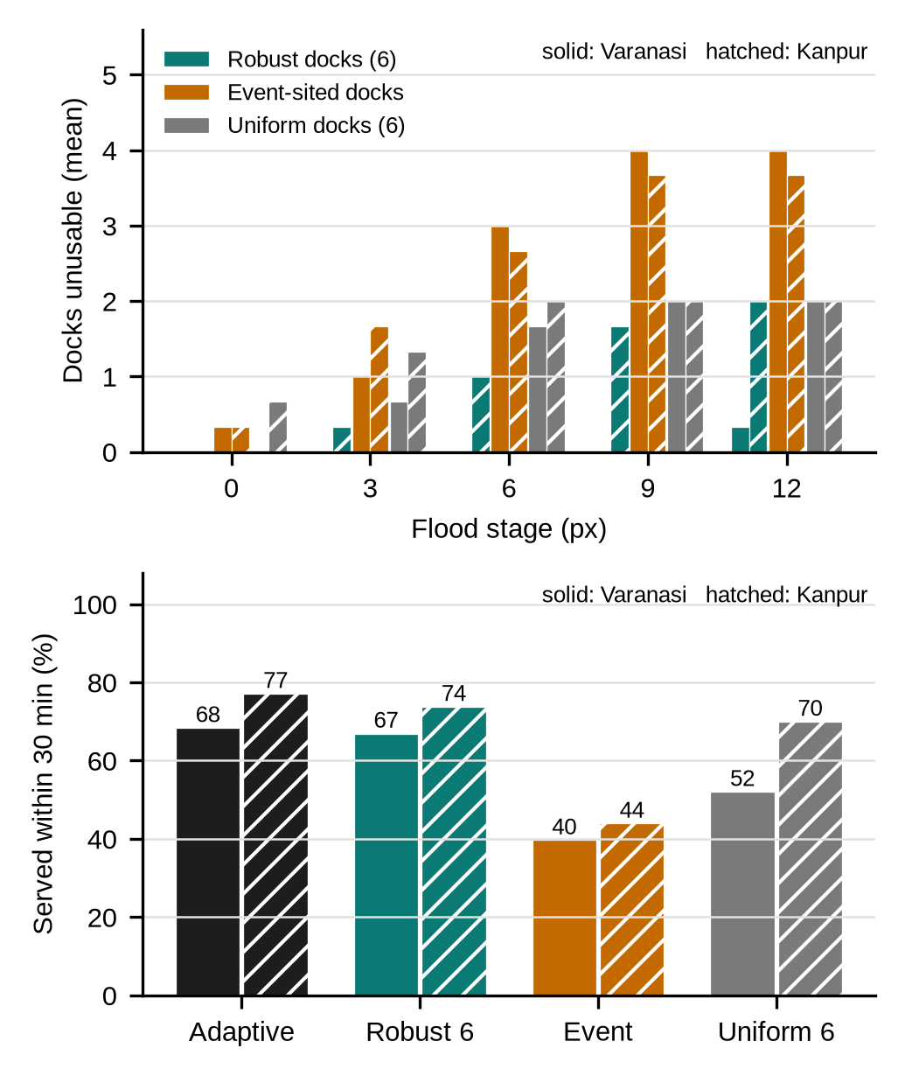
Fig. 5. Top: docks unusable at each flood stage (mean over weathers). Bottom: share of drop points served within 30 minutes of dispatch.
Figs. 4 and 5 (top) explain the coverage gap. Event-sited docks are placed where the planner wanted bases for the stage-0 flood, which is next to the water; as it rises, most of them are flooded or fall inside the clearance of the forecast flood. Robust docks lose fewer because the survival term a(c) in (1) favours sites that stayed dry across the training stages. Uniform docks are placed without regard to the water, so their losses depend on where the clusters happen to fall. On average 2.5 of the 5 event-sited docks are unusable in Varanasi and 2.4 of 5 in Kanpur, against 0.1 and 1.0 of six robust docks and 1.3 and 1.6 of six uniform docks.
C. Generalisation to unseen flood stages (RQ2)
Robust docks were chosen from stages 0, 6 and 12 only. On the held-out stages 3 and 9 they serve 94% of drop points in Varanasi and 90% in Kanpur, compared with 96% and 88% on the training stages. Event-sited docks reach 49% and 45% on the same held-out stages, and uniform docks 68% and 73%.
TABLE IV
Robust dock count (all scenarios)
City | Docks | Coverage | Regret | ≤30 min
Varanasi | 4 | 91% | 6% | 58%
Varanasi | 6 | 95% | 3% | 67%
Varanasi | 8 | 96% | 2% | 68%
Kanpur | 4 | 76% | 20% | 66%
Kanpur | 6 | 89% | 7% | 74%
Kanpur | 8 | 94% | 2% | 79%

Table IV varies the number of robust docks. The selection is nested: the four-dock set is contained in the six-dock set and that in the eight-dock set (Fig. 4 shows six), so a city can install docks in phases, starting with the highest-scoring sites, without moving any later. Returns diminish: going from four to six docks raises coverage by 4 points in Varanasi and 12 in Kanpur, and from six to eight by 0 and 6.
D. Service within 30 minutes
Coverage counts a drop point as served however late the drone arrives. Fig. 5 (bottom) shows the share served within 30 minutes of dispatch. Every vertical manoeuvre costs time: with our timing assumptions a single drop adds 101 s and every reload adds 240 s, so drones far from their drop points or making many sorties fall behind. Adaptive bases reach 68% and 77% within 30 minutes; robust docks 67% and 74%; event-sited 40% and 44%; uniform 52% and 70%.
E. Stability of re-sited bases
The adaptive bound assumes bases can move freely. Between consecutive flood stages under the same weather, an adaptive base lies on average 101 map pixels (about 263 m at the planner's nominal scale) from the nearest base of the next plan in Varanasi and 110 pixels (287 m) in Kanpur; 83% and 70% of bases move by more than 45 pixels. In practice every such move means carrying a launch team, batteries and kits through a flooded city, which is exactly what fixed docks avoid.
F. IoT data rate and planning latency (RQ3)
Table II gives the IoT budget for one city with six drones, six docks and twenty gauges. Drone telemetry at 1 Hz dominates; the whole city needs 9.61 kbit/s, well within one cellular link, and the gauges' packed readings fit LoRaWAN payload limits at all data rates [17]. Planning is the slow step. Run alone on a laptop (16 logical cores), one planner run takes 27 s for Varanasi and 54 s for Kanpur from trigger to exported missions. In the batch, with twelve runs sharing the machine, the median was 79 s for adaptive and 91 s for robust-dock runs. A re-plan per gauge reading every five minutes is therefore feasible on commodity hardware.
VI. Discussion
What a city should do. The results suggest a simple procedure for a city ICCC: run the relief planner on a set of plausible flood stages and weather levels, keep the sites it chooses often and that stay dry, and install docks there in order of score. Docks sited from the most recent flood alone are a poor investment: they are placed exactly where the next, higher flood will reach. Spreading docks evenly is safe but wastes range.
Fixed docks versus mobile launch teams. Robust docks recover most of the coverage of freely re-sited bases while avoiding base moves of hundreds of metres between re-plans. A practical deployment would combine both: fixed docks for the first hours, and mobile teams for drop points that no surviving dock can reach, which the planner lists explicitly.
Role of the IoT layer. The data rates involved are small; the value of the IoT layer is in knowing, at the moment of re-planning, which docks are dry, charged and stocked. Without the dock's own water sensor the planner would have to infer dock availability from a flood map that may be hours old.
VII. Limitations
- Synthetic flood stages. Rising water is modelled by growing the detected flood mask uniformly, not by a hydraulic model with terrain; real floods rise along low ground first.
- Planner approximations. The planner's battery model ignores take-off and descent energy and its maps are not georeferenced, so absolute coverage and distances are optimistic and in map units; the 30-minute service level adds vertical-manoeuvre time but does not change feasibility. Comparisons between strategies share these approximations.
- Two maps, one flood season. The study uses one published map per city; dock sites should be recomputed with more events and with georeferenced inputs.
- Prototype scope. The dashboard was built; the MQTT layer and docks were specified and sized but not deployed, and no drone was flown.
VIII. Conclusion
This paper treated relief-drone launch sites as smart-city infrastructure and asked where IoT drone docks should be installed so that they keep working as a flood rises. Using an open-source relief planner as an evaluator on 30 scenarios for Varanasi and Kanpur, docks chosen for both planner support and survival kept coverage close to freely re-sited bases on flood stages they were not chosen from, while docks sited from a single event lost most of their value as the water rose. A five-layer IoT architecture with LoRaWAN gauges and MQTT-connected docks needs under 10 kbit/s per city and can re-plan within about a minute. Future work will use terrain-based flood scenarios, georeferenced maps, dock costs and a field trial with one dock.
Acknowledgment
The relief planner used as the evaluator in this study is the open-source A.D.A.P.T. system [5] by T. Saha, A. Vatsal, A. Thomas K (one of the present authors) and A. K; a manuscript describing that planner is under review elsewhere. This paper does not describe or evaluate the planner itself. The work was carried out in the Design of Smart Cities course at the School of Computer Science and Engineering, VIT.
References
[1] N. Mohamed, J. Al-Jaroodi, I. Jawhar, A. Idries, and F. Mohammed, "Unmanned aerial vehicles applications in future smart cities," Technological Forecasting and Social Change, vol. 153, Art. no. 119293, 2020.
[2] M. Erdelj, E. Natalizio, K. R. Chowdhury, and I. F. Akyildiz, "Help from the sky: Leveraging UAVs for disaster management," IEEE Pervasive Computing, vol. 16, no. 1, pp. 24–32, 2017.
[3] DT Next, "Over Rs 98 crore allocated for 5-year ICCC operations, integration," Chennai, 2025. [Online]. Available: https://www.dtnext.in/news/tamilnadu/over-rs-98-crore-allocated-for-5-year-iccc-operations-integration
[4] Ministry of Housing and Urban Affairs, Government of India, "Smart Cities Mission." [Online]. Available: https://smartcities.gov.in
[5] T. Saha, A. Vatsal, A. Thomas K, and A. K, "A.D.A.P.T.: Autonomous Drone for Adaptive Path Tracking," open-source software, 2026. [Online]. Available: https://github.com/TSaha4/A.D.A.P.T.-Autonomous-Drone-for-Adaptive-Path-Tracking
[6] A. Zanella, N. Bui, A. Castellani, L. Vangelista, and M. Zorzi, "Internet of Things for smart cities," IEEE Internet of Things Journal, vol. 1, no. 1, pp. 22–32, 2014.
[7] M. I. Zakaria, W. A. Jabbar, and N. Sulaiman, "Development of a smart sensing unit for LoRaWAN-based IoT flood monitoring and warning system in catchment areas," Internet of Things and Cyber-Physical Systems, vol. 3, pp. 249–261, 2023.
[8] G. Rabta, C. Wankmüller, and G. Reiner, "A drone fleet model for last-mile distribution in disaster relief operations," International Journal of Disaster Risk Reduction, vol. 28, pp. 107–112, 2018.
[9] C. Toregas, R. Swain, C. ReVelle, and L. Bergman, "The location of emergency service facilities," Operations Research, vol. 19, no. 6, pp. 1363–1373, 1971.
[10] R. Church and C. ReVelle, "The maximal covering location problem," Papers of the Regional Science Association, vol. 32, no. 1, pp. 101–118, 1974.
[11] L. V. Snyder, "Facility location under uncertainty: A review," IIE Transactions, vol. 38, no. 7, pp. 547–564, 2006.
[12] A. Pulver and R. Wei, "Optimizing the spatial location of medical drones," Applied Geography, vol. 90, pp. 9–16, 2018.
[13] J. J. Boutilier, S. C. Brooks, A. Janmohamed, A. Byers, J. E. Buick, C. Zhan, A. P. Schoellig, S. Cheskes, L. J. Morrison, and T. C. Y. Chan, "Optimizing a drone network to deliver automated external defibrillators," Circulation, vol. 135, no. 25, pp. 2454–2465, 2017.
[14] C. Chin, A. Saravanan, H. Balakrishnan, and A. Andreeva-Mori, "Strategic planning of aerial assets for disaster response: Enabling efficient and equitable access to drone-based search resources," in Proc. 15th USA/Europe Air Traffic Management Research and Development Seminar (ATM2023), 2023.
[15] S. Koenig and M. Likhachev, "D Lite," in Proc. 18th National Conference on Artificial Intelligence (AAAI)*, 2002, pp. 476–483.
[16] OASIS, "MQTT Version 5.0," OASIS Standard, Mar. 2019. [Online]. Available: https://docs.oasis-open.org/mqtt/mqtt/v5.0/mqtt-v5.0.html
[17] LoRa Alliance, "RP002-1.0.4 LoRaWAN Regional Parameters," 2022. [Online]. Available: https://resources.lora-alliance.org
[18] ArduPilot Dev Team, "Complete parameter list: WPNAV_SPEED_UP, WPNAV_SPEED_DN, LAND_SPEED." [Online]. Available: https://ardupilot.org/copter/docs/parameters.html
[19] European Space Agency, "Copernicus Sentinel-1 mission." [Online]. Available: https://sentinels.copernicus.eu

