Design of Smart Cities – Course Project
SMART AERIAL RESPONSE: AN AUTONOMOUS UAV FRAMEWORK FOR RESILIENT FLOOD EMERGENCY MANAGEMENT IN SMART CITIES
Submitted in partial fulfilment of the requirements of the course
Design of Smart Cities
in
B.Tech. Computer Science and Engineering with Specialization in Internet of Things
by
23BCT0222 | DHARANI I S
23BCT0184 | SUKANT G
Under the supervision of
Dr. Swarnalatha P
Professor Grade 1
School of Computer Science and Engineering (SCOPE)

November 2026
DECLARATION
We hereby declare that the project entitled "Smart Aerial Response: An Autonomous UAV Framework for Resilient Flood Emergency Management in Smart Cities" submitted by us, Dharani I S (23BCT0222) and Sukant G (23BCT0184), for the course Design of Smart Cities of the B.Tech. Computer Science and Engineering with Specialization in Internet of Things programme at VIT, is a record of bonafide work carried out by us under the supervision of Dr. Swarnalatha P.
We further declare that the work reported in this project has not been submitted and will not be submitted, either in part or in full, for any other course, degree or diploma in this institute or any other institute or university. Software used from earlier work, in particular the open-source A.D.A.P.T. planner, is acknowledged in the text and the references.
Place : Vellore
Date :
Signature of the Candidates
Dharani I S
Sukant G

CERTIFICATE
This is to certify that the project entitled "Smart Aerial Response: An Autonomous UAV Framework for Resilient Flood Emergency Management in Smart Cities" submitted by Dharani I S (23BCT0222) and Sukant G (23BCT0184), School of Computer Science and Engineering, VIT, for the course Design of Smart Cities, is a record of bonafide work carried out by them under my supervision during the Fall Semester 2026-27, as per the VIT code of academic and research ethics.
The contents of this report have not been submitted and will not be submitted either in part or in full for any other course, degree or diploma in this institute or any other institute or university. The project fulfils the requirements of the course and in my opinion meets the necessary standards for submission.
Place : Vellore
Date :
Signature of the Faculty
Dr. Swarnalatha P
Professor Grade 1
SCOPE, VIT

ACKNOWLEDGEMENTS
We are grateful to the management of Vellore Institute of Technology (VIT) for the opportunity, facilities and learning environment that made this project possible.
We thank Dr. Jaisankar N, Dean of the School of Computer Science and Engineering (SCOPE), for his support and encouragement of project-based learning in the school.
We are especially thankful to our course faculty and guide, Dr. Swarnalatha P, Professor Grade 1, SCOPE, for her guidance throughout the Design of Smart Cities course. Her feedback on how the work connects to smart-city services, and on how to present and test it, shaped both this report and the research paper that came out of it.
We also thank the developers of the open-source A.D.A.P.T. planner, on which the swarm-planning part of this project is built, and the open-source communities behind OpenCV, NumPy, Matplotlib, paho-mqtt and amqtt.
Dharani I S
Sukant G

TABLE OF CONTENTS
Sl. No. | Contents | Page No.
 | List of Figures | vi
 | List of Tables | vii
 | List of Abbreviations | viii
 | Abstract | ix
1. | INTRODUCTION | 1
 | 1.1 Background | 1
 | 1.2 Motivation | 1
 | 1.3 Smart City Context | 1
 | 1.4 Scope of the Project | 2
 | 1.5 Literature Review | 2
 | 1.6 Research Gap | 2
 | 1.7 Objectives | 3
 | 1.8 Problem Statement | 3
 | 1.9 Project Plan | 3
2. | REQUIREMENTS | 4
 | 2.1 Stakeholders and Users | 4
 | 2.2 Functional Requirements | 4
 | 2.3 Non-Functional Requirements | 5
 | 2.4 Feasibility Study | 5
 | 2.4.1 Technical Feasibility | 5
 | 2.4.2 Economic Feasibility | 5
 | 2.4.3 Social Feasibility | 6
 | 2.5 System Specification | 6
 | 2.5.1 Hardware Specification | 6
 | 2.5.2 Software Specification | 6
 | 2.6 Constraints and Assumptions | 7
3. | DESIGN | 8
 | 3.1 System Architecture | 8
 | 3.2 IoT Layered Architecture | 8
 | 3.3 Planning Service Interface | 9
 | 3.4 Data Flow Diagrams | 9
 | 3.5 Use Case Diagram | 11
 | 3.6 Class Diagram | 12
 | 3.7 Sequence Diagram | 12
 | 3.8 Deployment Design | 13
 | 3.9 Data and Message Design | 14
 | 3.10 Dock-Siting Design | 14
4. | IMPLEMENTATION | 15
 | 4.1 Technology Stack and Code Organisation | 15
 | 4.2 Module Description | 15
 | 4.2.1 Planning Service (Reused) | 15
 | 4.2.2 IoT Layer | 15
 | 4.2.3 ICCC Dashboard | 16
 | 4.2.4 Dock-Siting Study | 16
 | 4.3 Project Demonstration | 16
5. | TESTING | 18
 | 5.1 Test Strategy | 18
 | 5.2 Test Environment | 18
 | 5.3 Test Cases and Results | 18
 | 5.4 Scenario Testing | 20
 | 5.5 IoT Loop Testing | 20
 | 5.6 Performance Testing | 20
 | 5.7 Defects Found and Fixed | 21
6. | OUTCOME | 22
 | 6.1 IoT Loop Results | 22
 | 6.2 Dock-Siting Results | 22
 | 6.3 Smart City Impact | 23
 | 6.4 Unique Outcome: Research Paper | 24
 | 6.5 Cost Analysis | 24
 | 6.6 Limitations | 24
7. | CONCLUSION AND FUTURE WORK | 25
 | REFERENCES | 26
 | APPENDIX A – SAMPLE CODE | 28

LIST OF FIGURES
Figure No. | Title | Page No.
1.1 | Project plan for the Fall Semester 2026 | 3
3.1 | Smart-city system architecture of Smart Aerial Response | 8
3.2 | Five-layer IoT architecture; teal elements close the loop from a sensor trigger to dispatched missions | 9
3.3 | Data flow diagram, level 0 (context) | 10
3.4 | Data flow diagram, level 1 | 10
3.5 | Use case diagram | 11
3.6 | Class and module diagram of the implementation | 12
3.7 | Sequence diagram of an automatic re-plan | 12
3.8 | Deployment and network design for one city | 13
4.1 | ICCC dashboard replaying the Varanasi swarm | 17
4.2 | ICCC dashboard replaying the Kanpur swarm | 17
6.1 | Share of drop points served as the flood rises; grey bands mark held-out stages | 23
6.2 | Dock sites of the three fixed strategies; hollow markers are docks unusable at the highest stage | 23

LIST OF TABLES
Table No. | Title | Page No.
2.1 | Stakeholders and their needs | 4
2.2 | Functional requirements | 4
2.3 | Non-functional requirements and how they are checked | 5
2.4 | Hardware used for development and proposed for deployment | 6
2.5 | Software used | 6
3.1 | LoRaWAN gauge uplink (12 bytes, big-endian) | 14
3.2 | MQTT topics | 14
4.1 | Code organisation | 15
5.1 | Summary of automated test results | 18
5.2 | Test cases | 18
5.3 | Automatic re-plans in the IoT loop runs | 20
5.4 | Defects found during development and testing | 21
6.1 | IoT message budget for one city | 22
6.2 | Dock strategies (6 docks unless stated) | 22
6.3 | Indicative hardware cost for one city | 24

LIST OF ABBREVIATIONS
API | Application Programming Interface
CWC | Central Water Commission
D* Lite | Dynamic incremental shortest-path search algorithm
DFD | Data Flow Diagram
FR | Functional Requirement
GNSS | Global Navigation Satellite System
HSV | Hue, Saturation, Value colour space
ICCC | Integrated Command and Control Centre
IoT | Internet of Things
JSON | JavaScript Object Notation
LoRaWAN | Long Range Wide Area Network
MAVLink | Micro Air Vehicle Link protocol
MQTT | Message Queuing Telemetry Transport
NDRF | National Disaster Response Force
NFR | Non-Functional Requirement
QGC WPL | QGroundControl Waypoint List file format
SAR | Synthetic Aperture Radar (also Smart Aerial Response in topic names)
SDS | Software Design Specification
SLA | Service-Level Agreement (here: drops served within 30 minutes)
SRS | Software Requirements Specification
SSE | Server-Sent Events
TSP | Travelling Salesman Problem
UAV | Unmanned Aerial Vehicle
UML | Unified Modeling Language

ABSTRACT
Floods are the most frequent disaster in Indian river cities. During the August 2025 Ganga flood, 84 ghats in Varanasi went under water and more than 6,500 people were displaced [1], and the river crossed its warning mark again in Varanasi and Kanpur in September 2026 [2], [3]. Cut-off households need water, food and medicine within hours, while boats are slow and roads are blocked. Small drones can carry relief kits over the water, but a city needs to know where they should take off, which flooded pockets each one serves, and how to replan when the water keeps rising.
This project, Smart Aerial Response, builds the smart-city layer around an existing open-source multi-drone planner [24]. Its Internet of Things (IoT) layer connects river-level gauges (LoRaWAN), drone docks and drones (MQTT over 4G/5G) to a trigger engine at the city's Integrated Command and Control Centre (ICCC). When the reference gauge is above the Central Water Commission warning mark and the flood stage rises, the engine automatically requests a new plan that may launch only from docks that report dry, and publishes it to the ICCC. A web dashboard runs the planning service live and replays the swarm for the operator. A scenario study then answers a planning question the city faces before any flood: where to install permanent drone docks so that enough of them stay usable as the water rises.
In software-in-the-loop runs on the 2025 Ganga flood maps, the loop re-planned automatically at every rise of the flood stage, dropping flooded docks (Varanasi 6 → 5, Kanpur 6 → 4 dry docks). In 180 planner runs, six docks chosen for flood resilience kept 94% and 90% coverage on flood stages they were not chosen from, against 49% and 45% for docks sited from a single past flood. The message budget of a whole city is 9.61 kbit/s, and the system passed 33 of 33 automated tests. It is a software prototype: no drone was flown and no sensor installed.
Keywords: smart city, Internet of Things, LoRaWAN, MQTT, UAV swarm, flood relief, ICCC, D* Lite, facility location.
CHAPTER 1
INTRODUCTION
1.1 BACKGROUND
India's Smart Cities Mission [4] has given a hundred cities an Integrated Command and Control Centre (ICCC): a room where traffic cameras, utility sensors and emergency calls meet on one dashboard. Floods are where such a centre is tested hardest. Rivers such as the Ganga rise for days, the water spreads street by street, and the people who stay behind in upper floors and on ghats need supplies long before roads reopen. Varanasi already uses a three-dimensional digital twin of the city to predict which homes will be submerged [5], and both Varanasi and Kanpur publish river levels against fixed warning and danger marks [2], [3]. What is missing is the step from knowing where the water is to acting on it at city scale.
Unmanned aerial vehicles (UAVs) are a natural tool for that step [6], [7]. A quadcopter can carry a one-kilogram kit of medicine, water purification tablets and food over a flooded street in minutes. One drone, however, cannot serve a city: its battery limits how far it can fly and its payload limits how many drops it can make per trip. A city needs a swarm, launched from several sites, with routes that avoid the water and each other, re-planned whenever the flood changes.
1.2 MOTIVATION
During the 2025 Ganga flood, 84 ghats in Varanasi were submerged and more than 6,500 people were displaced [1]; in Kanpur, riverside Katri villages were cut off and depended on boats for weeks [3]. Relief teams had to decide, again and again, where to send scarce boats and personnel as the water rose. Three practical questions motivated this project:
- Can a command centre go from a flood map to safe, flyable drone missions for a whole city in about a minute, rather than planning each flight by hand?
- Can the city's existing sensors, river gauges in particular, trigger that planning automatically when the water crosses an official mark?
- If a city installs permanent drone docks, where should they go so that they still work when the next, higher flood arrives?
1.3 SMART CITY CONTEXT
The project is designed as a smart-city service rather than a stand-alone drone tool. It follows the layered IoT model of perception, network, middleware, decision and application [8]. It reuses infrastructure a smart city already has: river and rain gauges, a city network, an ICCC and its data platform. It adds three things: drone docks that report their own state, a trigger engine that turns sensor readings into planning requests, and a swarm planner whose output the ICCC operator approves before dispatch. The two demonstration cities, Varanasi and Kanpur, are both Smart Cities Mission cities on the Ganga with documented flood histories, which makes them realistic test beds.
1.4 SCOPE OF THE PROJECT
- In scope: flood segmentation from satellite flood maps; weather-driven spread forecast; multi-drone base selection, sortie and route planning; mission-file export; a live command-centre dashboard; a software IoT layer with an MQTT broker, LoRaWAN uplink codec, simulated gauges and docks and a trigger engine; a study of where to site permanent docks; automated tests.
- Reused, not re-evaluated: the multi-drone planning algorithms (flood segmentation, spread forecast, base selection, sorties, routing, mission export) come from the open-source A.D.A.P.T. planner [24], developed in an earlier project and described in a separate manuscript that is under review. This report treats the planner as an existing component, does not re-evaluate it, and claims none of its results; the contributions of this project are the IoT layer, the ICCC dashboard, the dock-siting study and the tests.
- Out of scope: flying real drones; hardware sensor installation; public alerting; regulatory approvals (beyond-visual-line-of-sight permission); hydraulic flood modelling.
1.5 LITERATURE REVIEW
UAVs in smart cities and disasters. Mohamed et al. survey UAV applications in smart cities and identify emergency response and delivery as key services [6]. Erdelj et al. review how UAVs support disaster management, from situational awareness to delivering supplies, and highlight the need for coordination among several drones [7].
IoT flood monitoring. Zanella et al. describe the architecture of an urban IoT and its network technologies [8]. Zakaria et al. build a LoRaWAN smart sensing unit for flood monitoring and warning in catchment areas, showing that water-level sensors can report over long distances on very little power [9]. LoRaWAN regional parameters [10] and the MQTT standard [11] define the radio and messaging layers used here.
Drone relief and facility location. Rabta et al. model a drone fleet for last-mile delivery in disaster relief [12]. Where to place service facilities has been studied since the set-covering model of Toregas et al. [13] and the maximal covering location problem of Church and ReVelle [14]; Snyder reviews facility location under uncertainty [15]. For drones, Pulver and Wei optimise medical drone bases [16] and Boutilier et al. site drone bases to deliver defibrillators faster [17].
Path planning. D* Lite [18] is an incremental shortest-path algorithm that is widely used in robotics because it can repair a route quickly when the map changes, which suits a growing flood.
1.6 RESEARCH GAP
Existing work tends to address one layer at a time: IoT papers stop at the warning, drone-routing papers assume the bases are given, and facility-location models assume the demand is fixed. Three gaps follow: (i) no end-to-end loop from a city sensor trigger to dispatched multi-drone missions; (ii) base and dock locations are rarely tested against a flood that keeps rising after they are chosen; (iii) results are seldom demonstrated on real flood maps of Indian cities. This project addresses all three, at prototype level.
1.7 OBJECTIVES
- Integrate an existing open-source multi-drone planner as the city's planning service, callable from the ICCC and restricted to the docks that are usable.
- Build an IoT layer in which river gauges and drone docks report over LoRaWAN and MQTT and a trigger engine re-plans the swarm automatically when the flood stage rises.
- Provide an ICCC-style dashboard that runs the planner live and shows every drone, battery and kit.
- Determine, with a scenario study, where permanent drone docks should be installed so they remain usable as the flood grows.
- Verify the system with automated unit, integration, data and end-to-end tests.
1.8 PROBLEM STATEMENT
Given a city's flood map, its live river-level and weather readings and a set of drone docks, decide automatically and within minutes which docks to launch from, which flooded locations each drone supplies, in which order and by which route, so that every sortie stays within battery and payload limits, no route crosses water or another drone's route, and the plan is renewed whenever the flood stage rises; and choose the dock locations in advance so that enough of them stay dry in future floods.
1.9 PROJECT PLAN
The project ran over the Fall Semester 2026 in eight overlapping work packages, from requirements to the final report, paper and presentation (Figure 1.1).
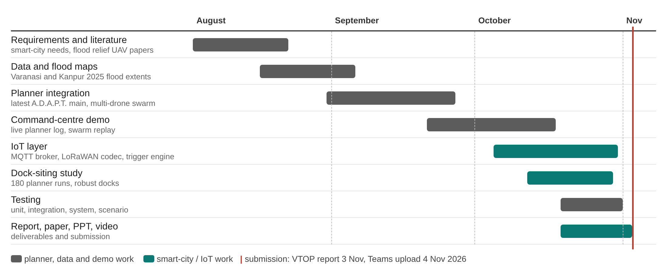
Figure 1.1 Project plan for the Fall Semester 2026
CHAPTER 2
REQUIREMENTS
This chapter is the Software Requirements Specification (SRS) of the system: who uses it, what it must do, how well it must do it, and what it needs to run.
2.1 STAKEHOLDERS AND USERS
Table 2.1 Stakeholders and their needs
Stakeholder | Role | Main need
ICCC operator | Runs the dashboard during a flood | A safe plan in minutes, clear view of every drone, approve before dispatch
District disaster management authority | Owns the response | Know where help can reach and what is left for boats
Smart-city planner | Plans infrastructure | Where to install docks so they survive future floods
Responders (NDRF, boat teams) | Act on the ground | List of points drones cannot reach
Field technicians | Maintain gauges and docks | Low-power devices, simple status messages
Residents in flooded areas | Receive kits | Fast, reliable delivery to where they are

2.2 FUNCTIONAL REQUIREMENTS
Requirements FR1–FR9 are met by the reused planner and were verified, not built, in this project; FR10–FR14 were built in this project.
Table 2.2 Functional requirements
ID | Requirement | Provided by
FR1 | Detect flooded areas in a satellite flood map automatically (no manual clicks needed) | Reused planner
FR2 | Forecast flood spread for the next two hours from rain and wind | Reused planner
FR3 | Fetch live weather or use stored heavy/moderate presets | Reused planner
FR4 | Choose up to K launch bases (docks) that are dry and clear of forecast water | Reused planner (restricted to docks here)
FR5 | Place drop points on flooded pockets and assign each to one base | Reused planner
FR6 | Split each base's work into sorties within payload and 80% battery limits | Reused planner
FR7 | Route every leg around current and forecast water | Reused planner
FR8 | Detect and repair crossings between drones' routes | Reused planner
FR9 | Export one QGC WPL 110 mission file per drone and validate it | Reused planner
FR10 | Decode LoRaWAN gauge uplinks and publish readings on MQTT topics | This project (iot/)
FR11 | Re-plan automatically when the flood stage rises, using only docks reporting dry | This project (TriggerEngine)
FR12 | Show the live plan, drones, batteries and kits on an ICCC dashboard | This project (demo/)
FR13 | List drop points that no drone can reach, for hand-off to responders | This project (dashboard)
FR14 | Evaluate dock-siting strategies over flood-stage and weather scenarios | This project (research/hub_study)

2.3 NON-FUNCTIONAL REQUIREMENTS
Table 2.3 Non-functional requirements and how they are checked
ID | Quality | Target | Verified by
NFR1 | Performance | One city plan in about a minute on a laptop | Measured planner wall time
NFR2 | Safety | No sortie above 80% battery; no route crossings; no straight-line fallbacks over water | Planner checks, system test
NFR3 | Reliability | Re-plan with any subset of docks; flooded docks excluded | IoT tests, IoT loop runs
NFR4 | Scalability | City IoT traffic far below a single 4G link | Data-rate budget
NFR5 | Interoperability | Standard protocols: LoRaWAN, MQTT, MAVLink missions (QGC WPL) | Mission validator, codec tests
NFR6 | Usability | One-click planning, streaming log, clear error if packages are missing | Dashboard demo
NFR7 | Repeatability | Same inputs give the same plan (automatic colour sampling) | Study runs, tests
NFR8 | Portability | Runs on Linux and Windows with Python 3 and a browser | Start scripts

2.4 FEASIBILITY STUDY
2.4.1 Technical Feasibility
All components use mature technology. LoRaWAN water-level sensors and outdoor gateways are sold in India for the IN865 band [19], [20], enterprise drone docks are available from Indian resellers [21], and MQTT brokers run on modest servers. The planner and IoT layer run on an ordinary laptop: a full city plan took 27 s for Varanasi and 54 s for Kanpur on an idle 16-thread machine.
2.4.2 Economic Feasibility
The software stack is open source, so the cost is hardware and operation. Section 6.5 estimates the hardware for one city at roughly one crore rupees for six dock-and-drone sets plus a sensor network. For comparison, the Varanasi digital twin project cost about six crore rupees [5] and ICCC operation contracts run to tens of crores [22]; the drone layer is a small addition that reuses the ICCC.
2.4.3 Social Feasibility
Faster delivery of medicine and water to cut-off households has clear social value, and drones reduce the risk to boat crews in fast water. Concerns about privacy and noise are limited because relief drones fly only during declared emergencies and carry no cameras beyond navigation. Every plan is approved by a human operator, which keeps responsibility with the district authority.
2.5 SYSTEM SPECIFICATION
2.5.1 Hardware Specification
Table 2.4 Hardware used for development and proposed for deployment
Component | Development (used) | Deployment (proposed)
Compute | Laptop, 16 threads, Linux | ICCC server or cloud VM
River gauges | Simulated (iot/smartcity_iot.py) | LoRaWAN ultrasonic level sensor, IN865
Gateway | – | Outdoor 8-channel LoRaWAN gateway
Drone docks | Simulated status messages | Weatherproof drone dock with water sensor, 4G/5G
Drones | Mission files validated in software | Quadcopter with ArduPilot/PX4, 8 kg payload class, servo drop
Network | Localhost MQTT | City fibre / 4G / 5G to the ICCC

2.5.2 Software Specification
Table 2.5 Software used
Software | Version / note | Purpose
Python | 3.14 (project virtual environment) | Planner, IoT layer, study, tests
OpenCV, NumPy, Matplotlib | OpenCV 5.0 | Image processing, numerics, figures
amqtt, paho-mqtt | amqtt 0.12, paho-mqtt 2.1 | MQTT broker and clients
pytest | 9.x | Automated tests
Open-Meteo API | Live weather | Rain and wind for the spread forecast
Web browser | Any modern browser | ICCC dashboard (HTML, canvas, Server-Sent Events)
QGroundControl / Mission Planner | Optional | Open the exported missions

2.6 CONSTRAINTS AND ASSUMPTIONS
- Flood maps are published images of the 2025 floods, not georeferenced rasters; distances use a nominal scale of about 2.6 m per pixel.
- The rise of the flood is modelled by growing the mapped flood outward; the mapping from river level to flood stage is an assumption, not a hydraulic model.
- Battery use follows the planner's endurance model (default settings, not a calibrated vehicle).
- Drone flights require Directorate General of Civil Aviation permission; this prototype stops at validated mission files.
CHAPTER 3
DESIGN
This chapter is the Software Design Specification (SDS): the architecture, the data flows, the UML views and the message formats.
3.1 SYSTEM ARCHITECTURE
Figure 3.1 shows the system from the city's point of view. Sensors and satellite maps feed the ICCC; the planning service produces missions; docks launch drones; the operator watches and approves on the dashboard; points no drone can reach are handed to boat teams.
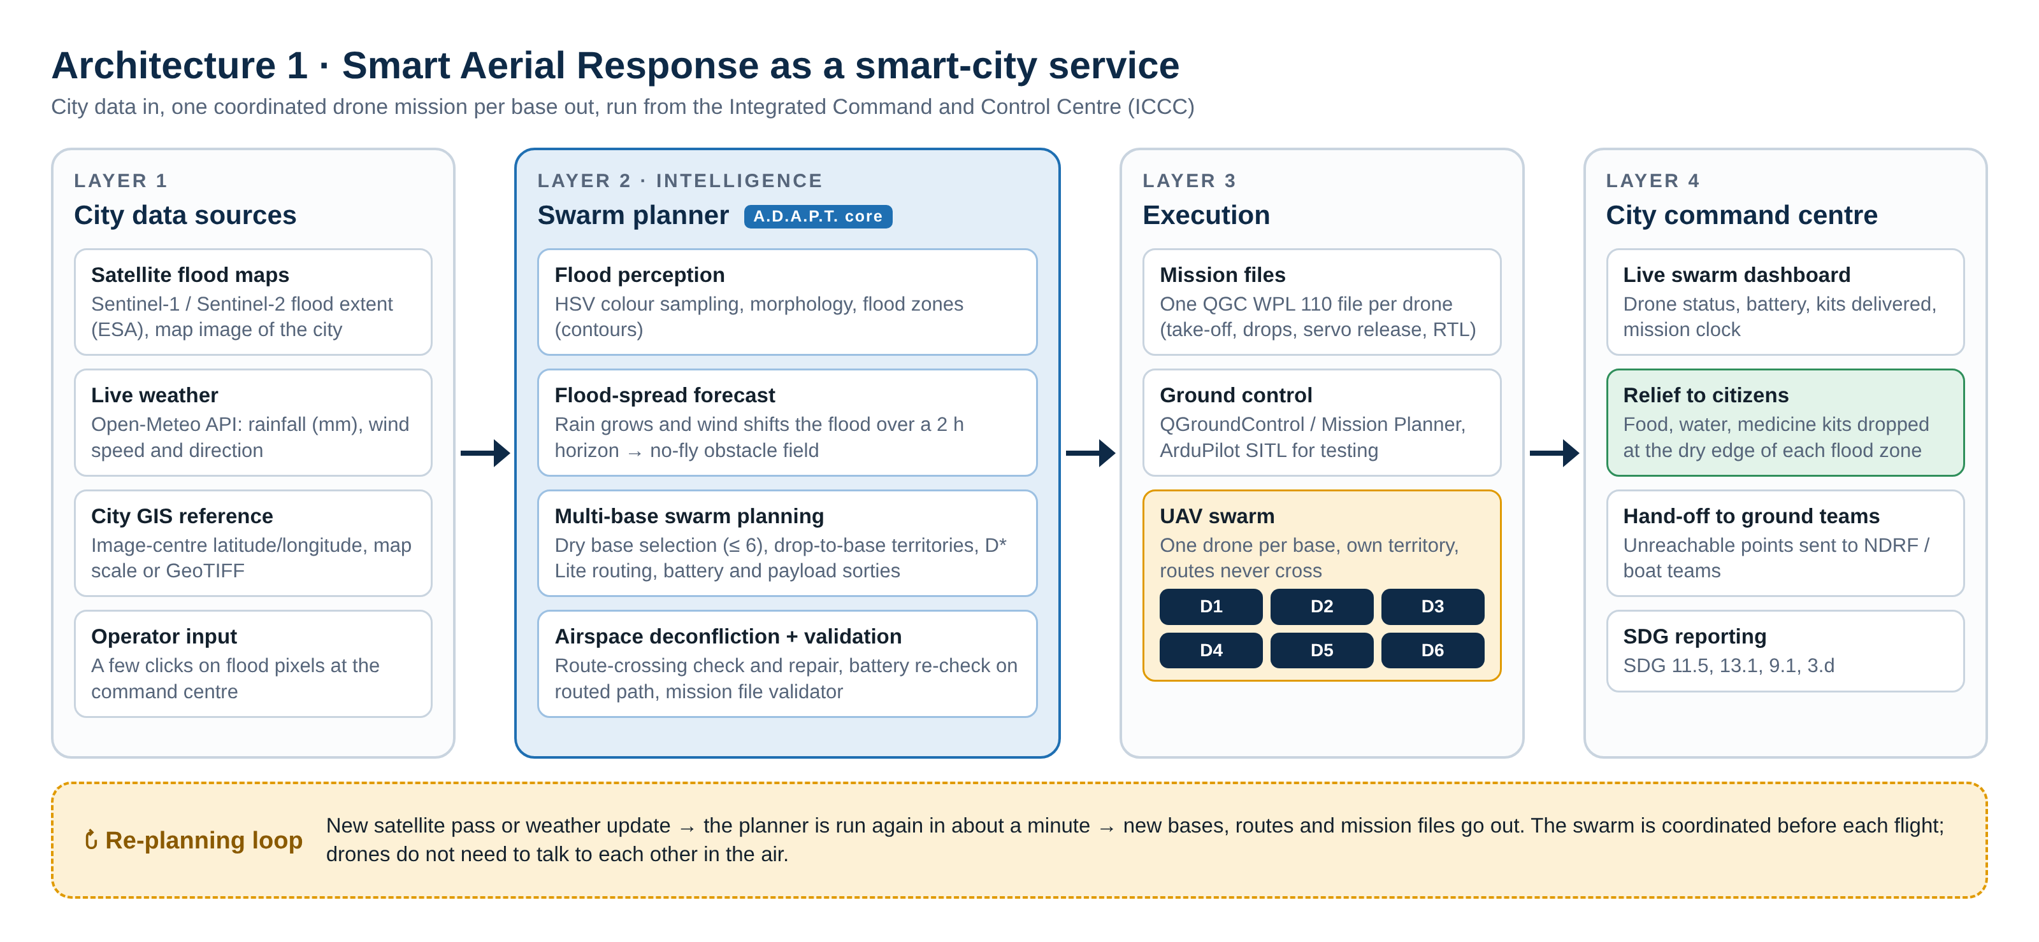
Figure 3.1 Smart-city system architecture of Smart Aerial Response
3.2 IOT LAYERED ARCHITECTURE
The IoT design follows five layers (Figure 3.2). Perception: river and rain gauges, satellite flood maps, drone docks and drones. Network: LoRaWAN for battery-powered gauges, HTTPS for weather and satellite data, 4G/5G with MQTT for docks and drones. Middleware: the MQTT broker, a time-series store, the trigger engine and the city digital twin. Decision: the swarm planner, the offline dock-siting study and a safety gate. Application: the ICCC dashboard, mission dispatch and responder hand-off.
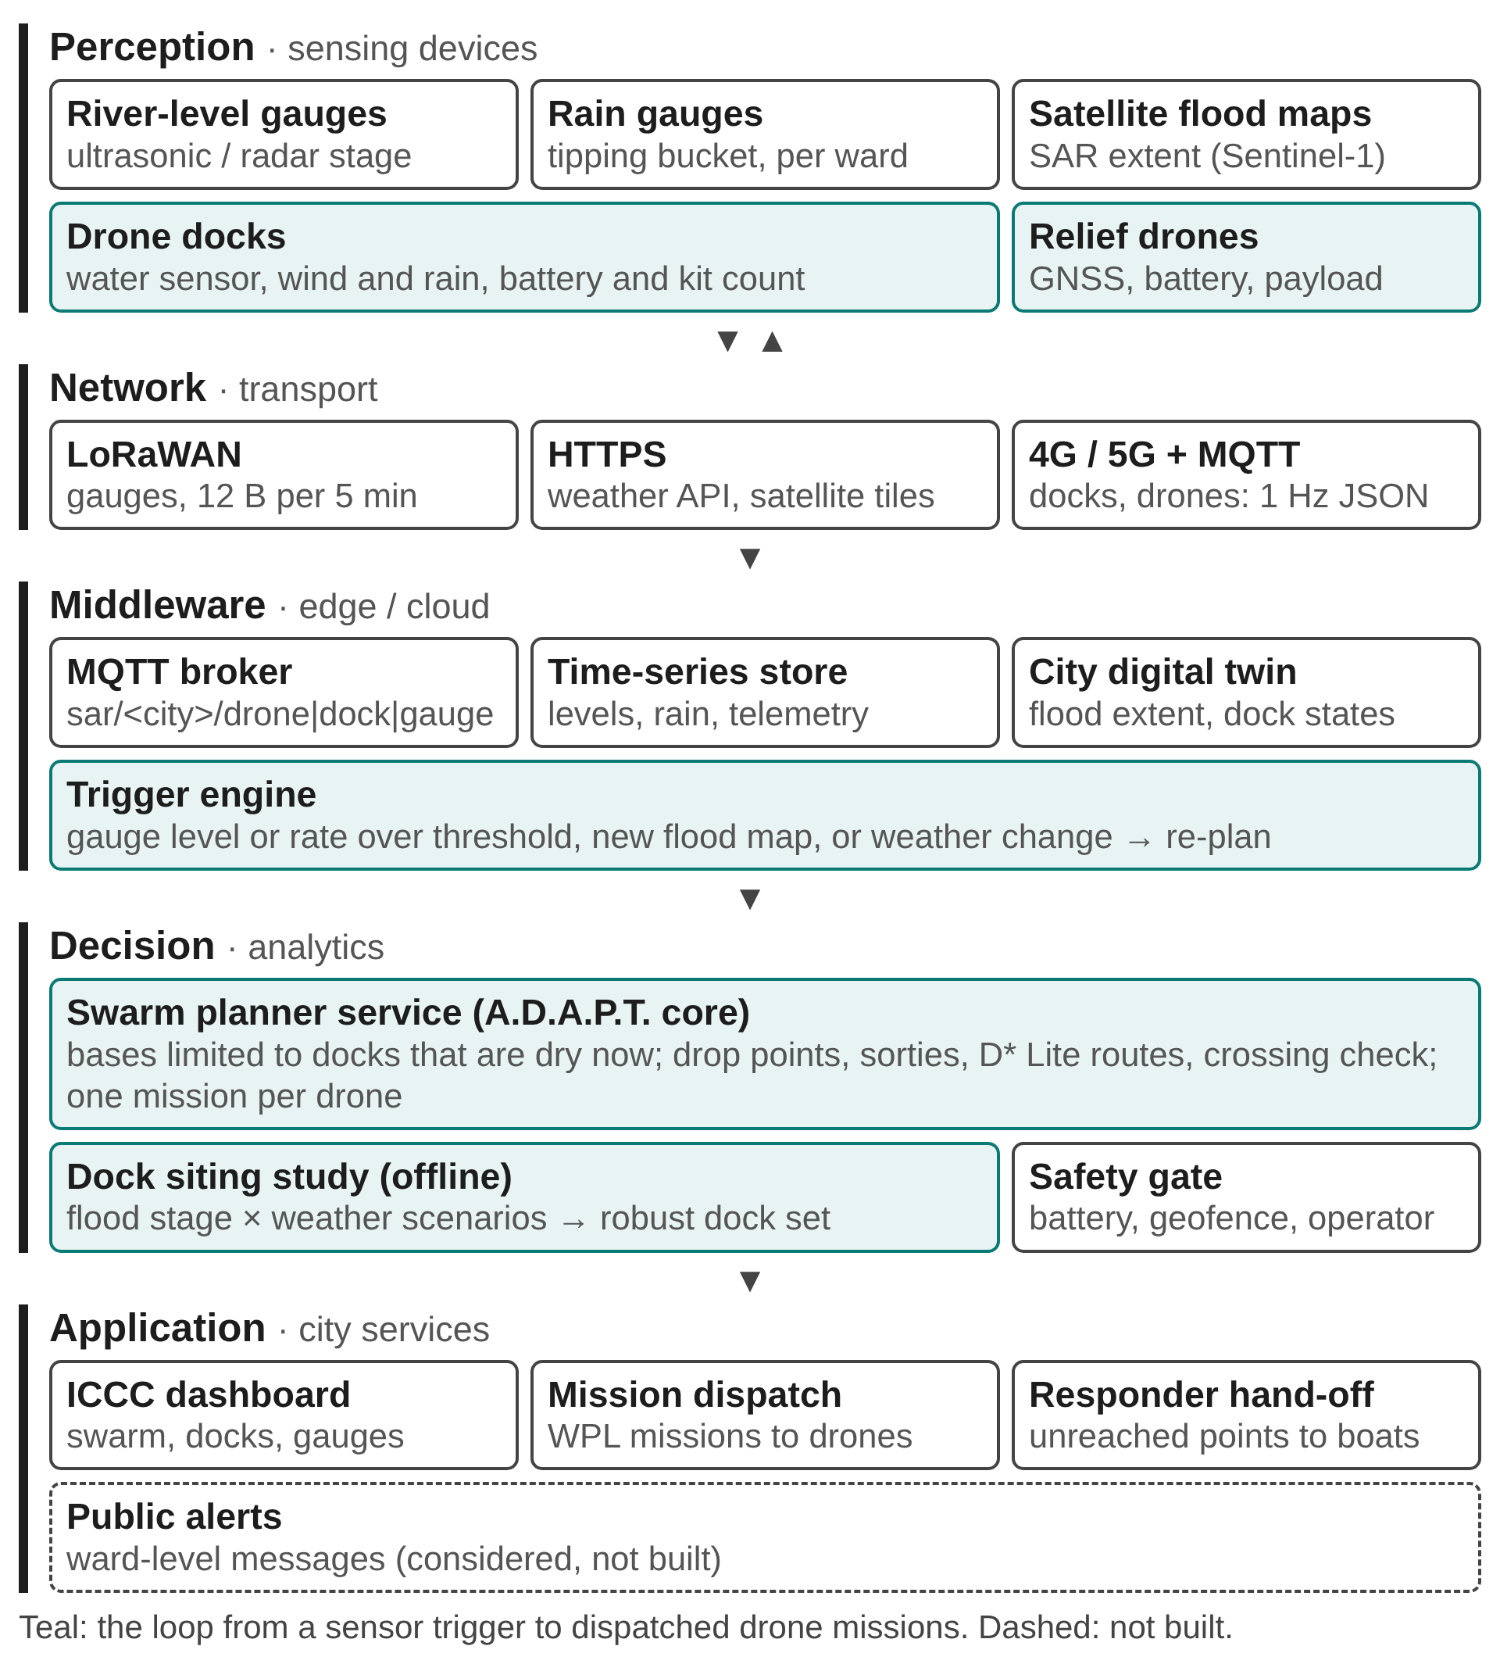
Figure 3.2 Five-layer IoT architecture; teal elements close the loop from a sensor trigger to dispatched missions
3.3 PLANNING SERVICE INTERFACE
The planner is used as a service with a fixed interface. Inputs: a flood map, the weather (live or a preset), the maximum number of drones and, from this project, the list of permitted launch sites (the docks that report dry) and the flood stage. Outputs: a session folder with one validated mission file per drone, the drop points served and not served, and a JSON summary that the trigger engine publishes and the dashboard replays. How the planner computes the plan is described in its own documentation [24] and is not repeated here.
3.4 DATA FLOW DIAGRAMS
The level-0 diagram (Figure 3.3) treats the system as one process and shows its external entities and data flows. The level-1 diagram (Figure 3.5) opens it into six processes and three data stores (Figure 3.4).
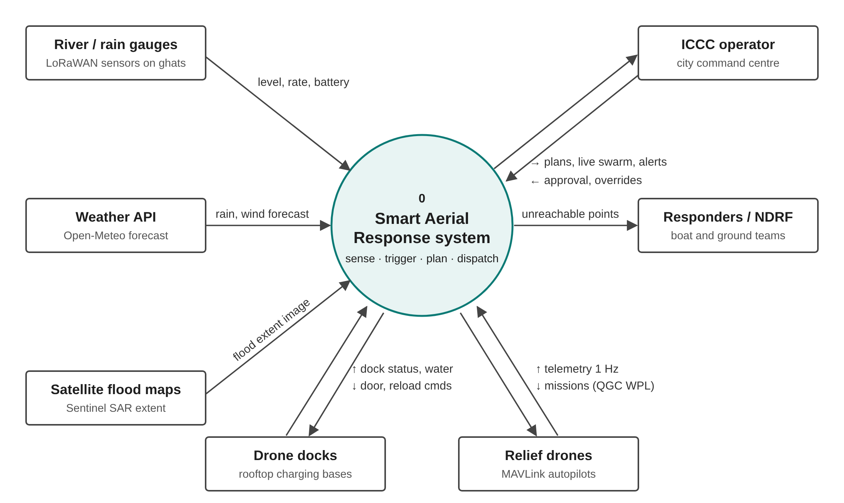
Figure 3.3 Data flow diagram, level 0 (context)
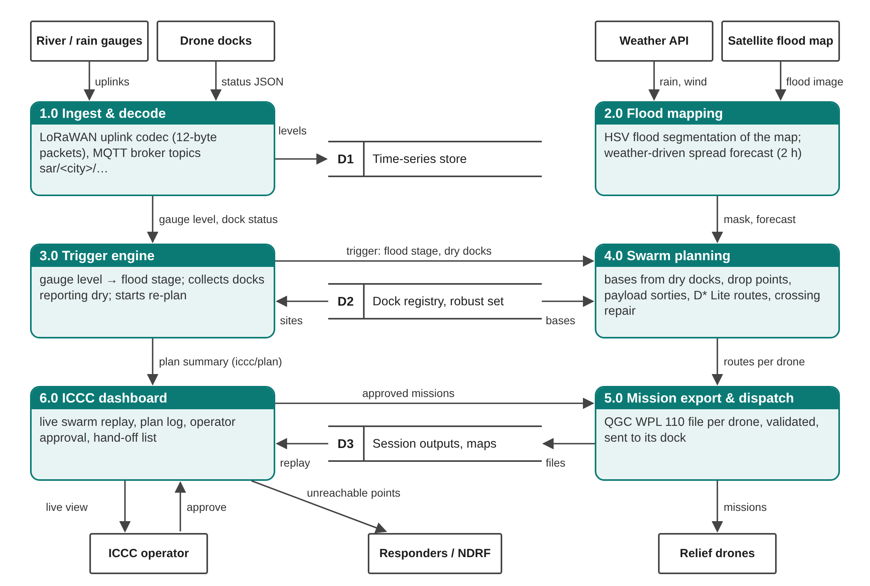
Figure 3.4 Data flow diagram, level 1
3.5 USE CASE DIAGRAM
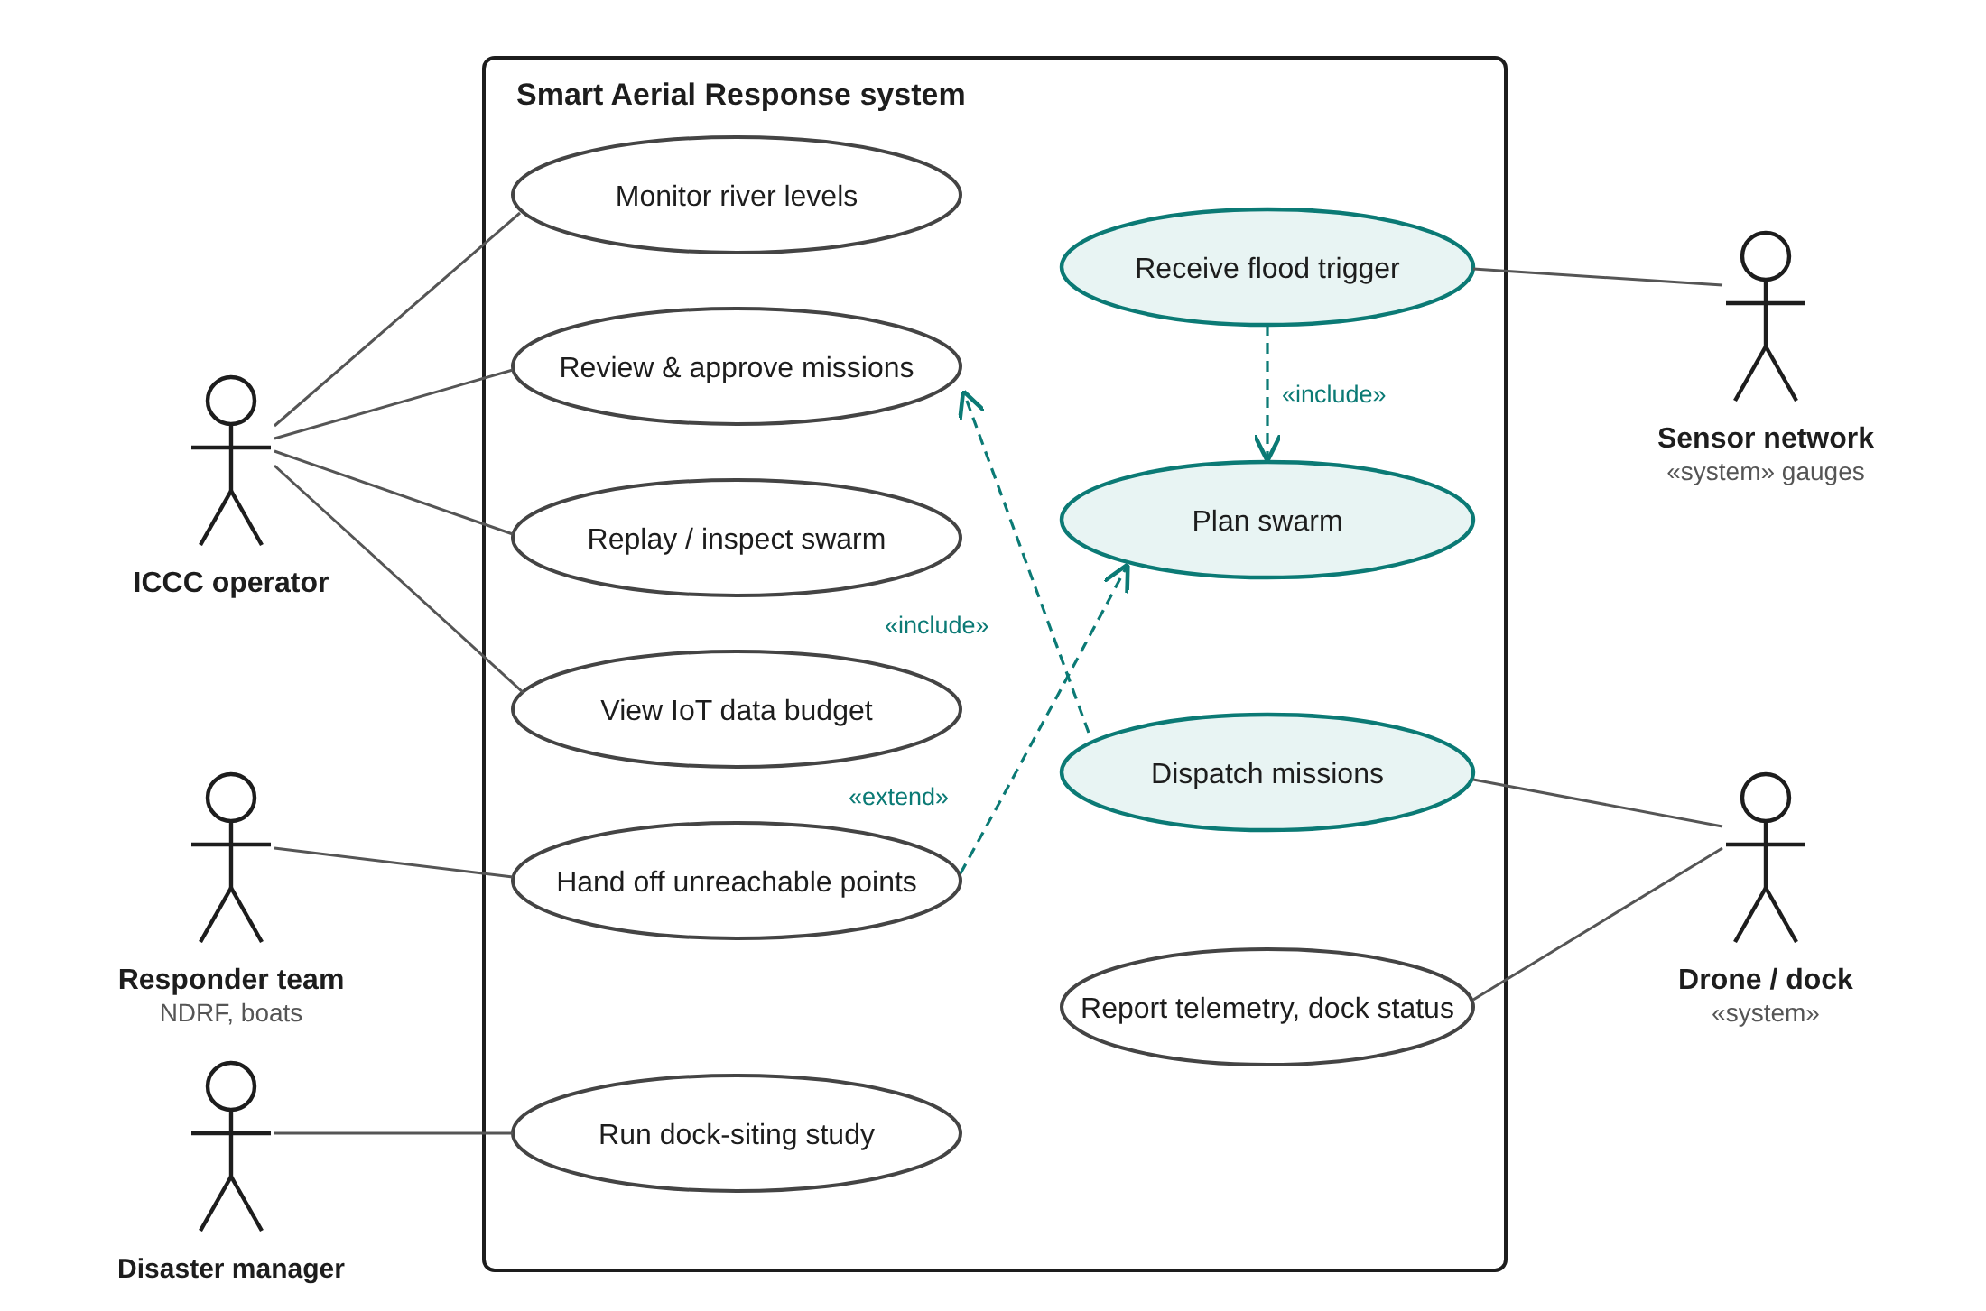
Figure 3.5 Use case diagram
The ICCC operator monitors levels, receives triggers, reviews and approves plans and dispatches missions. The smart-city planner runs the dock-siting study offline. The sensor network and the docks and drones are system actors; responder teams receive the list of points drones cannot reach (Figure 3.5).
3.6 CLASS DIAGRAM
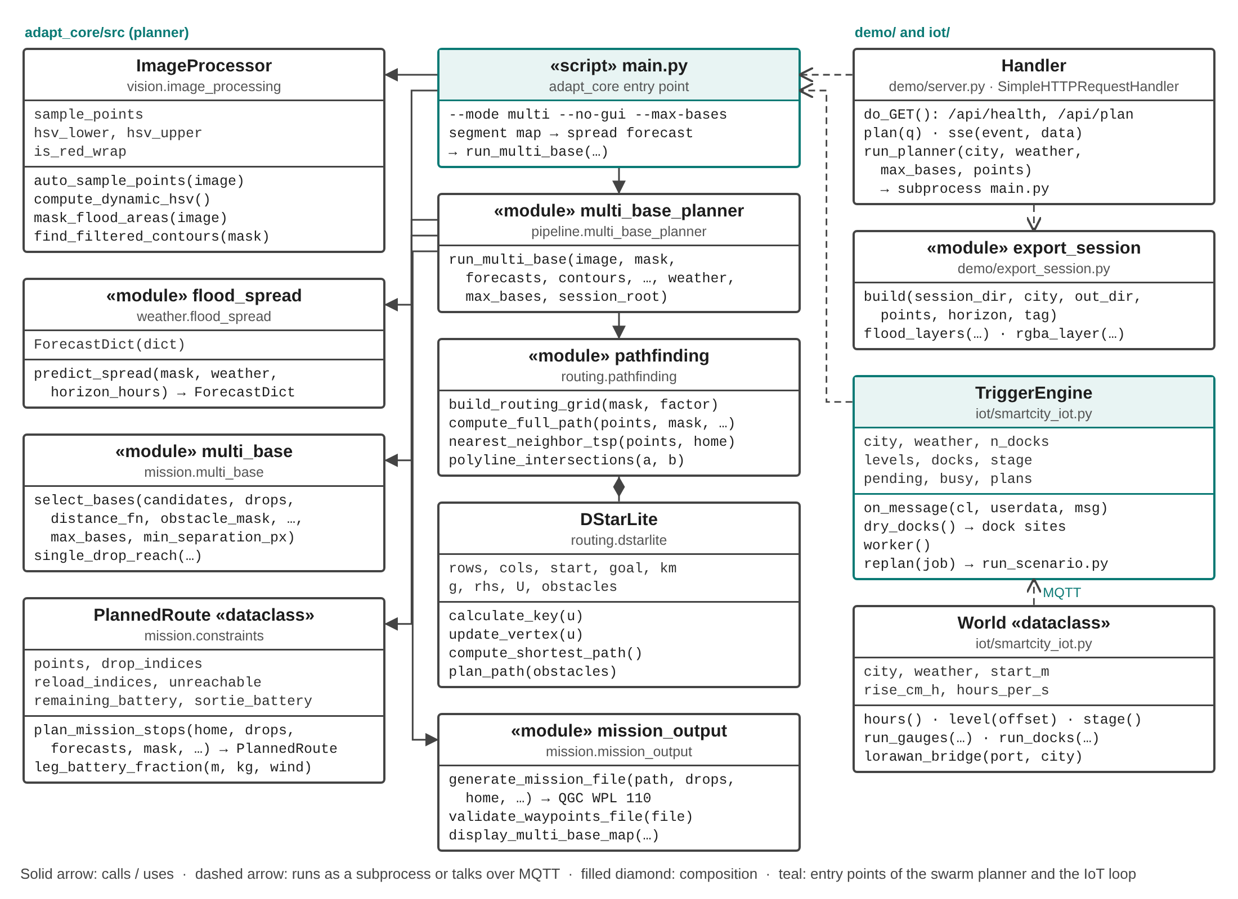
Figure 3.6 Class and module diagram of the implementation
3.7 SEQUENCE DIAGRAM
Figure 3.7 traces one automatic re-plan: a gauge uplink is decoded and published, the trigger engine detects a higher flood stage, collects the docks that report dry, runs the planner restricted to them and publishes the plan to the ICCC, where the operator approves dispatch.
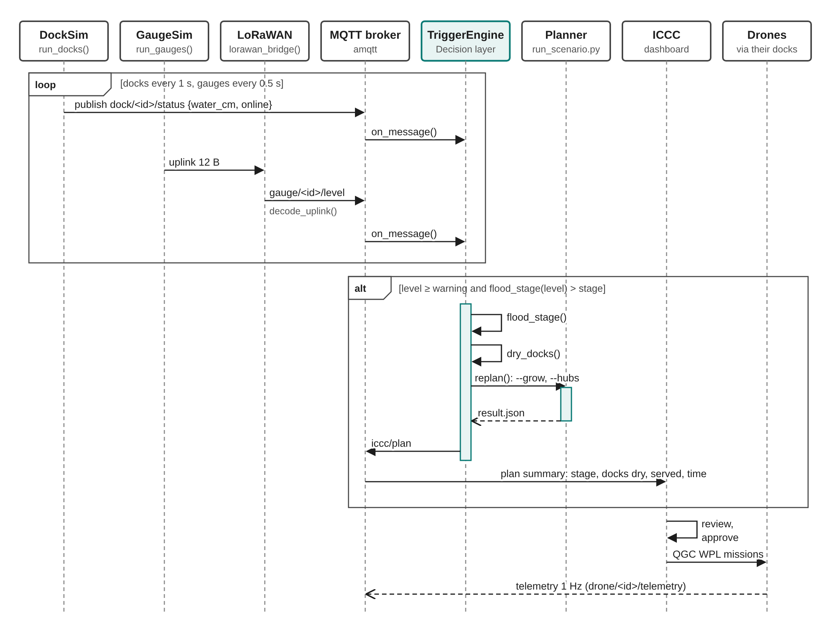
Figure 3.7 Sequence diagram of an automatic re-plan
3.8 DEPLOYMENT DESIGN
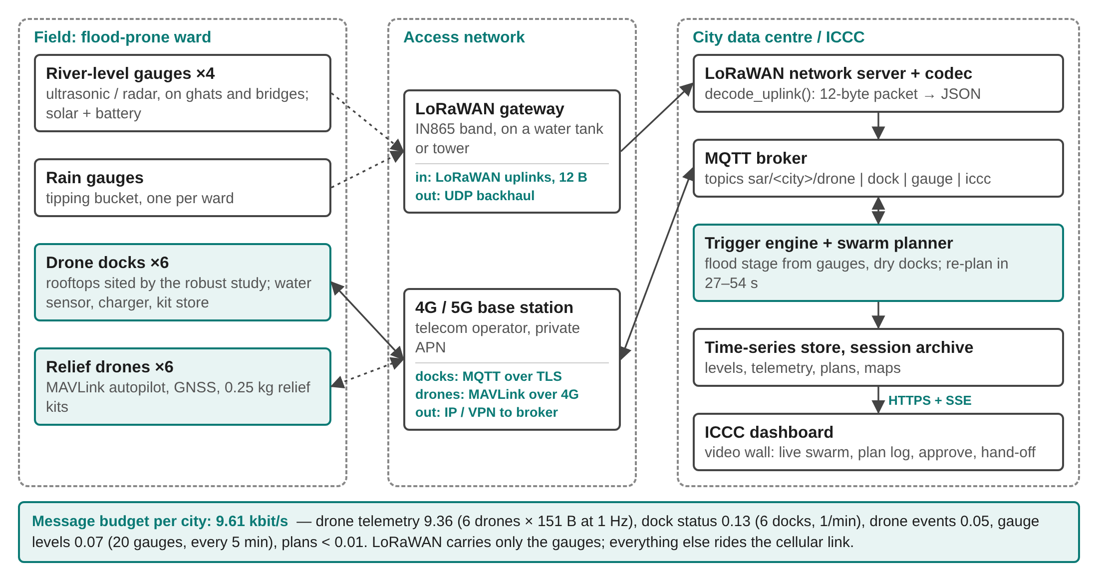
Figure 3.8 Deployment and network design for one city
3.9 DATA AND MESSAGE DESIGN
Gauges send a packed binary uplink to save airtime and battery; everything after the network server is JSON on MQTT topics under sar/<city>/. Table 3.1 gives the uplink layout and Table 3.2 the topics.
Table 3.1 LoRaWAN gauge uplink (12 bytes, big-endian)
Field | Type | Bytes | Example
Device id | uint16 | 2 | 1 (reference gauge)
Time | uint32 (Unix seconds) | 4 | 1793180000
Level | uint16 (cm above MSL) | 2 | 7142 = 71.42 m
Rate of rise | int16 (cm/h) | 2 | 50
Battery | uint16 (mV) | 2 | 3700

Table 3.2 MQTT topics
Topic | Publisher | Rate | Content
sar/<city>/drone/<id>/telemetry | Drone | 1 Hz | position, battery, payload, state
sar/<city>/drone/<id>/event | Drone | 1 / 120 s | drop, reload, landing
sar/<city>/dock/<id>/status | Dock | 1 / 60 s | water at pad, batteries, kits
sar/<city>/gauge/<id>/level | LoRaWAN bridge | 1 / 300 s | level, rate of rise, battery
sar/<city>/iccc/plan | Trigger engine | 1 / 1800 s | trigger, docks used, drops, missions

3.10 DOCK-SITING DESIGN
To choose permanent dock sites, the planner is first allowed to place bases freely in every training scenario (three flood stages × three weather levels). A candidate site c scores s(c) = a(c) × Σ n(b), where the sum runs over training bases b within 45 pixels of c, n(b) is the number of drops base b served, and a(c) is the share of training scenarios in which c is dry and clear of forecast water. Sites are taken in order of score subject to the planner's minimum separation. The resulting "robust" docks are compared with docks sited from a single past flood and with evenly spread docks on held-out flood stages (Chapter 6).
CHAPTER 4
IMPLEMENTATION
4.1 TECHNOLOGY STACK AND CODE ORGANISATION
The swarm planner is the open-source A.D.A.P.T. system [24] (latest main branch, multi-drone mode), used unchanged as a library. The IoT layer, the dashboard, the dock-siting study and the tests were written in this project. Table 4.1 shows how the code is organised.
Table 4.1 Code organisation
Folder | Content | Language
adapt_core/ | Swarm planner (open-source A.D.A.P.T., latest main, multi-drone mode) | Python
iot/ | MQTT broker, LoRaWAN codec, gauge and dock simulators, trigger engine, loop runner | Python
demo/ | ICCC dashboard: HTTP + Server-Sent Events server, exporter, web page | Python, HTML, JavaScript
research/hub_study/ | Dock-siting study: scenario runner, batch, dock selection, analysis | Python
research/paper/ | IEEE research paper build and figures | JavaScript, HTML
tests/ | Automated test suite (unit, integration, data, system) | Python (pytest)

4.2 MODULE DESCRIPTION
4.2.1 Planning Service (Reused)
The open-source planner [24] is called unchanged through its command-line interface or, for runs restricted to docks, through research/hub_study/run_scenario.py, which passes the permitted launch sites and the flood stage. This project added no code to the planner; it only wraps it as a service, checks its outputs (Chapter 5) and consumes its JSON summary.
4.2.2 IoT Layer
iot/smartcity_iot.py implements the five layers in software. An amqtt broker runs in-process. Gauge simulators follow a rising hydrograph and send 12-byte LoRaWAN uplinks to lorawan/<dev>/up. A LoRaWAN bridge (the network-server role) decodes them and republishes JSON on sar/<city>/gauge/<id>/level. Dock simulators publish sar/<city>/dock/<id>/status with water at the pad whenever their site is unusable at the current flood stage. The trigger engine subscribes to both. It waits until every dock has reported and the reference gauge is at or above the Central Water Commission warning mark (Varanasi, Rajghat: 70.262 m warning, 71.262 m danger [2]; Kanpur, Ganga Barrage: 114 m and 115 m [3]). It maps the level to a flood stage and, whenever the stage rises, runs the planner with only the dry docks, then publishes the result on sar/<city>/iccc/plan. If the water rises again while a plan is running, intermediate stages are collapsed and the next plan uses the latest stage.
def on_message(self, cl, userdata, msg):
d = json.loads(msg.payload)
if "/dock/" in msg.topic:
self.docks[d["id"]] = d
return
self.levels[d["id"]] = d
ref = self.levels.get(f"{self.cfg['code']}-RG01")
if not ref or len(self.docks) < self.n_docks or ref["level_m"] < self.cfg["warning"]:
return
stage = flood_stage(ref["level_m"], self.cfg["warning"], self.cfg["danger"])
if self.stage is None or stage > self.stage: # flood got worse: queue a re-plan
...
4.2.3 ICCC Dashboard
demo/server.py is a small HTTP server. /api/plan starts the planner as a subprocess and streams every log line to the browser as Server-Sent Events, then exports the session (routes, timings, flood layers) for replay. The page animates all drones at once on the flood map with battery, payload, sortie and kit counters, and lets the operator change city, weather and the number of drones, or click flood colours. /api/health reports whether the planner's Python packages are installed and how to fix it if not.
4.2.4 Dock-Siting Study
run_scenario.py runs the unmodified planner on one scenario, growing the flood mask by a given number of pixels, fixing the weather and optionally restricting bases to a dock list; run_batch.py runs all 180 scenarios in parallel; select_hubs.py computes the robust, event-sited and uniform dock sets; analyze.py produces the tables and figures.
4.3 PROJECT DEMONSTRATION
The live demonstration covers both cities. Running demo/start_demo.sh creates the environment if needed and opens the dashboard at http://localhost:8765; Plan swarm now runs the real planner and replays the swarm (Figures 4.1 and 4.2). iot/run_iot_demo.py runs the IoT loop in a terminal, printing each trigger, dock count and re-plan.
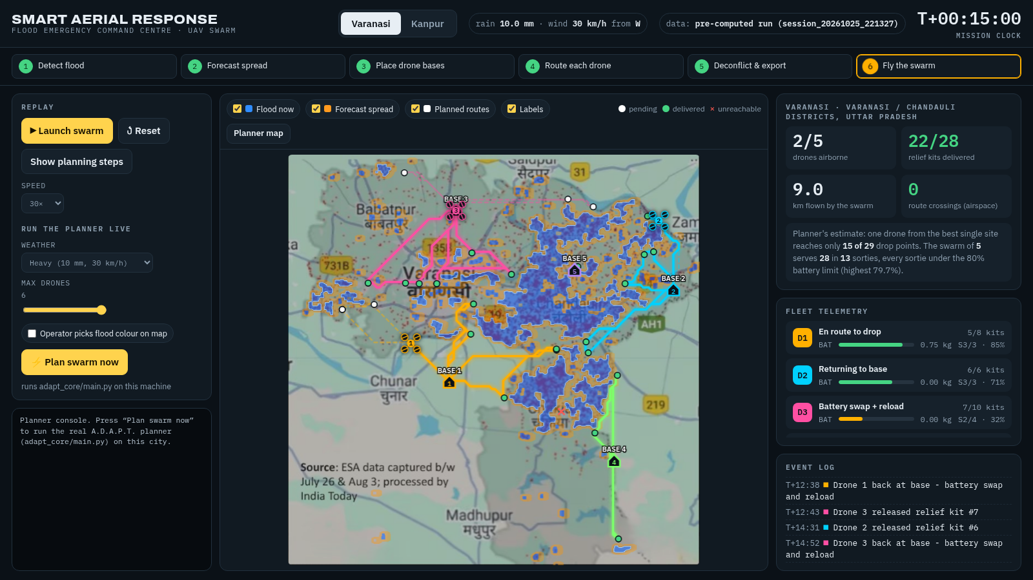
Figure 4.1 ICCC dashboard replaying the Varanasi swarm
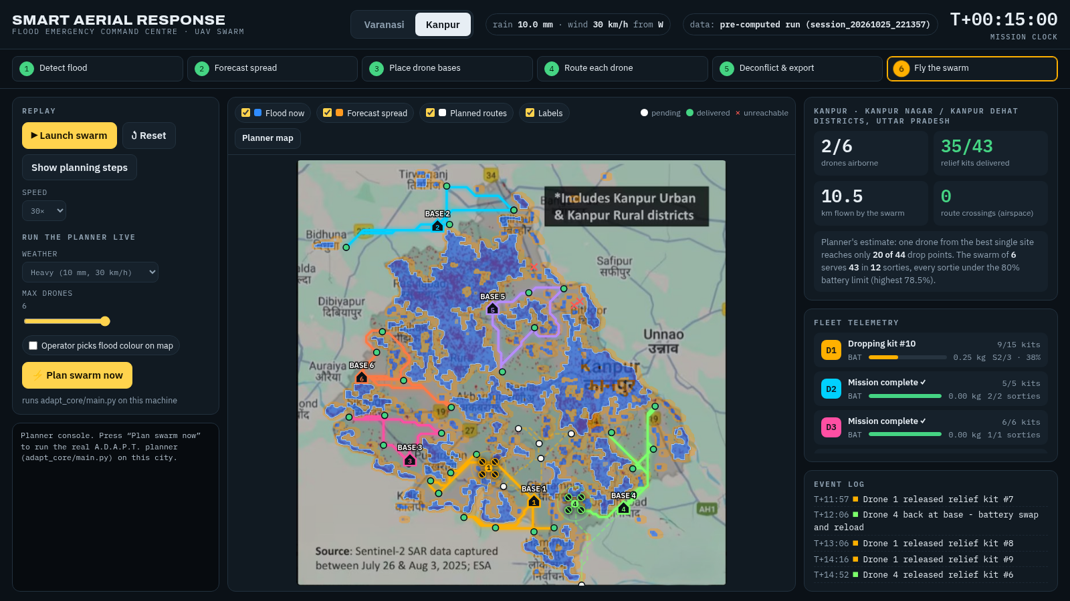
Figure 4.2 ICCC dashboard replaying the Kanpur swarm
CHAPTER 5
TESTING
5.1 TEST STRATEGY
Testing was done at four levels. Acceptance tests check the reused planner's building blocks against known answers before the system relies on them. Integration tests run the IoT layer through a real MQTT broker. Data tests check that the study's outputs are complete and internally consistent. System tests start the dashboard server and run a full plan through its API. In addition, the 180 planner runs of the dock study act as scenario tests, and planning time is measured as a performance test. All automated tests are in tests/ and run with pytest.
5.2 TEST ENVIRONMENT
Linux laptop (16 threads), Python virtual environment of the project, pytest; MQTT broker started on a free local port by each test; the dashboard server started on a free port. Test run: 30 October 2026, 33 tests in 33 s.
5.3 TEST CASES AND RESULTS
Table 5.1 Summary of automated test results
Category | Tests | Passed | Pass rate
Integration (IoT layer) | 9 | 9 | 100%
Acceptance (reused planner) | 12 | 12 | 100%
Study / data checks | 9 | 9 | 100%
System (end to end) | 3 | 3 | 100%
Total | 33 | 33 | 100%

Table 5.2 Test cases
ID | Test | Expected result | Result
TC-I01 | LoRaWAN uplink codec | 12-byte packed payload round-trips exactly | Pass
TC-I02 | River level to flood stage | warning -> 0, danger -> 6, danger + 1 m -> 12 | Pass
TC-I03 | MQTT broker round trip | subscriber receives the published dock status unchanged | Pass
TC-I04 | LoRaWAN-to-MQTT bridge | uplink republished as JSON on sar/varanasi/gauge/VNS-RG02/level | Pass
TC-I05 | Trigger waits for all docks | no re-plan until every dock has reported | Pass
TC-I06 | Trigger ignores normal levels | no re-plan below the warning mark | Pass
TC-I07 | Trigger fires on stage rise only | re-plans at stages 0 and 6, not for small rises within a stage | Pass
TC-I08 | Dry-dock selection | flooded dock excluded; plan records 1 of 2 docks dry | Pass
TC-I09 | City IoT data-rate budget | under 10 kbit/s for 6 drones, 6 docks, 20 gauges | Pass
TC-U01 | Battery use per leg | grows linearly with distance, more with payload and headwind; zero for zero distance | Pass
TC-U02 | Wind unit conversion | 36 km/h = 10 m/s; negative input clamps to 0 | Pass
TC-U03 | Headwind component | full headwind when wind blows from the heading, none from behind | Pass
TC-U04 | Payload sortie split | 5 kits at 0.25 kg with 0.5 kg capacity -> 3 sorties | Pass
TC-U05 | Tour construction | tour starts and ends at the base and visits every drop once | Pass
TC-U06 | Route crossing detector | crossing paths give one point, parallel paths none | Pass
TC-U07 | Pixel to latitude/longitude | centre maps to centre; 100 m north = +0.0009 deg; bad scale rejected | Pass
TC-U08 | Weather input sanitising | missing field becomes 0 and status becomes partial | Pass
TC-U09 | Mission file export | generated QGC WPL 110 file validates; corrupted header is caught | Pass
TC-U10 | D* Lite routing around water | route crosses no flooded pixel and detours around the river | Pass
TC-U11 | Flood segmentation (Varanasi) | 3-40% of the map detected as water | Pass
TC-U12 | Weather-driven flood spread | heavy rain spreads further than calm; forecast never recedes | Pass
TC-S01 | Dock sites shrink as water rises | usable sites at each stage are a subset of the previous stage | Pass
TC-S01 | Dock sites shrink as water rises | usable sites at each stage are a subset of the previous stage | Pass
TC-S01 | Dock sites shrink as water rises | usable sites at each stage are a subset of the previous stage | Pass
TC-S01 | Dock sites shrink as water rises | usable sites at each stage are a subset of the previous stage | Pass
TC-S02 | Robust dock separation | 6 docks, every pair at least the planner's base separation apart | Pass
TC-S02 | Robust dock separation | 6 docks, every pair at least the planner's base separation apart | Pass
TC-S03 | Robust docks on unseen stages | coverage on held-out stages beats event-sited and uniform docks | Pass
TC-S03 | Robust docks on unseen stages | coverage on held-out stages beats event-sited and uniform docks | Pass
TC-S04 | Study completeness | all 180 planner runs present with exit code 0 | Pass
TC-T01 | Server health check | planner_ready is true | Pass
TC-T02 | Live plan via dashboard API | Varanasi heavy run streams to done; drones > 0; 0 route crossings | Pass
TC-T03 | Input validation | unknown city rejected with a fail event | Pass

5.4 SCENARIO TESTING
The dock-siting study ran the planner on 30 scenarios per strategy: two cities, five flood stages (mask grown by 0, 3, 6, 9 and 12 pixels) and three weather levels (calm; moderate: 3 mm/h rain, 12 km/h wind; heavy: 10 mm/h, 30 km/h). All 180 runs completed with a valid plan and no route crossings, including those where flooded docks left the planner with only a few launch sites.
5.5 IOT LOOP TESTING
The full IoT loop was run with the planner for both cities under heavy weather, the river starting 0.3 m below the warning mark and rising 50 cm/h (simulated time compressed). Table 5.3 lists every automatic re-plan.
Table 5.3 Automatic re-plans in the IoT loop runs
City | Plan | Flood stage | Docks dry | Drops served | Bases | Planner | Trigger to plan
Varanasi | 1 | 0 | 6 of 6 | 27 of 29 | 5 | 23 s | 24 s
Varanasi | 2 | 6 | 6 of 6 | 45 of 49 | 4 | 67 s | 75 s
Varanasi | 3 | 12 | 5 of 6 | 24 of 29 | 3 | 42 s | 101 s
Kanpur | 1 | 0 | 6 of 6 | 34 of 46 | 6 | 42 s | 43 s
Kanpur | 2 | 12 | 4 of 6 | 11 of 13 | 3 | 28 s | 38 s

As the river rose, flooded docks dropped out (Varanasi 6 → 5, Kanpur 6 → 4) and the engine re-planned with the remaining ones each time. When the water rose by more than one stage during a plan, the engine skipped the intermediate stage and planned for the latest one, which is why the trigger-to-plan time of a queued plan includes waiting for the previous one.
5.6 PERFORMANCE TESTING
On an idle machine a full Varanasi plan took 27 s and a Kanpur plan 54 s. Across the 180 study runs, executed ten at a time in parallel, the median wall time per run was 79 s for free base placement and 91 s for the robust docks. The IoT layer itself adds well under a second between a gauge uplink and the trigger.
5.7 DEFECTS FOUND AND FIXED
Table 5.4 Defects found during development and testing
Defect | Cause | Fix
Dashboard server failed with 'address already in use' | Another server instance held port 8765 | Server tries ports 8765–8774 and prints the one it uses
'Plan swarm now' failed | System Python lacked OpenCV | Project virtual environment; server runs the planner with it and the page explains how to fix a missing package
Server crashed on a favicon request | Log formatter assumed a string | Log message converted with str()
Trigger engine planned before all docks reported | Engine acted on the first dock message | Engine waits for every dock and for the warning mark

CHAPTER 6
OUTCOME
6.1 IOT LOOP RESULTS
The trigger loop closed automatically in both cities (Table 5.3). Each time the river rose past a new flood stage, the engine collected the docks that still reported dry and published a new plan to the ICCC within one planning time. In Varanasi the number of usable docks fell from 6 to 5 and in Kanpur from 6 to 4 as the water reached them, and every plan was produced from the remaining docks without operator input. When the water rose faster than the planner could run, intermediate stages were skipped so that the ICCC always received a plan for the latest state.
The message budget for a whole city (Table 6.1), computed from the message sizes and rates, is 9.61 kbit/s, dominated by 1 Hz drone telemetry; it fits comfortably on a single 4G link, and LoRaWAN gauges send one 12-byte uplink every five minutes.
Table 6.1 IoT message budget for one city
Topic | Payload (bytes) | Rate | Devices | kbit/s
sar/<city>/drone/<id>/telemetry | 151 | 1 Hz | 6 | 9.36
sar/<city>/drone/<id>/event | 81 | 1 / 120 s | 6 | 0.05
sar/<city>/dock/<id>/status | 124 | 1 / 60 s | 6 | 0.13
sar/<city>/gauge/<id>/level | 78 | 1 / 300 s | 20 | 0.07
sar/<city>/iccc/plan | 209 | 1 / 1800 s | 1 | 0.00
Total |  |  |  | 9.61

6.2 DOCK-SITING RESULTS
Table 6.2 compares the dock strategies on all 30 scenarios and on the held-out flood stages (3 and 9) that were not used to choose the robust docks. Coverage is the share of drop points served; regret is the coverage lost compared with re-siting bases freely for every event.
Table 6.2 Dock strategies (6 docks unless stated)
City / strategy | Coverage (all) | Coverage (held-out) | Regret | Docks lost | ≤ 30 min
Varanasi: Re-sited per event | 98% | 98% | – | – | 68%
Varanasi: Robust docks | 95% | 94% | 3% | 0.1 | 67%
Varanasi: Event-sited docks | 49% | 49% | 50% | 2.5 | 40%
Varanasi: Uniform docks | 67% | 68% | 31% | 1.3 | 52%
Kanpur: Re-sited per event | 96% | 98% | – | – | 77%
Kanpur: Robust docks | 89% | 90% | 7% | 1.0 | 74%
Kanpur: Event-sited docks | 52% | 45% | 44% | 2.4 | 44%
Kanpur: Uniform docks | 76% | 73% | 20% | 1.6 | 70%

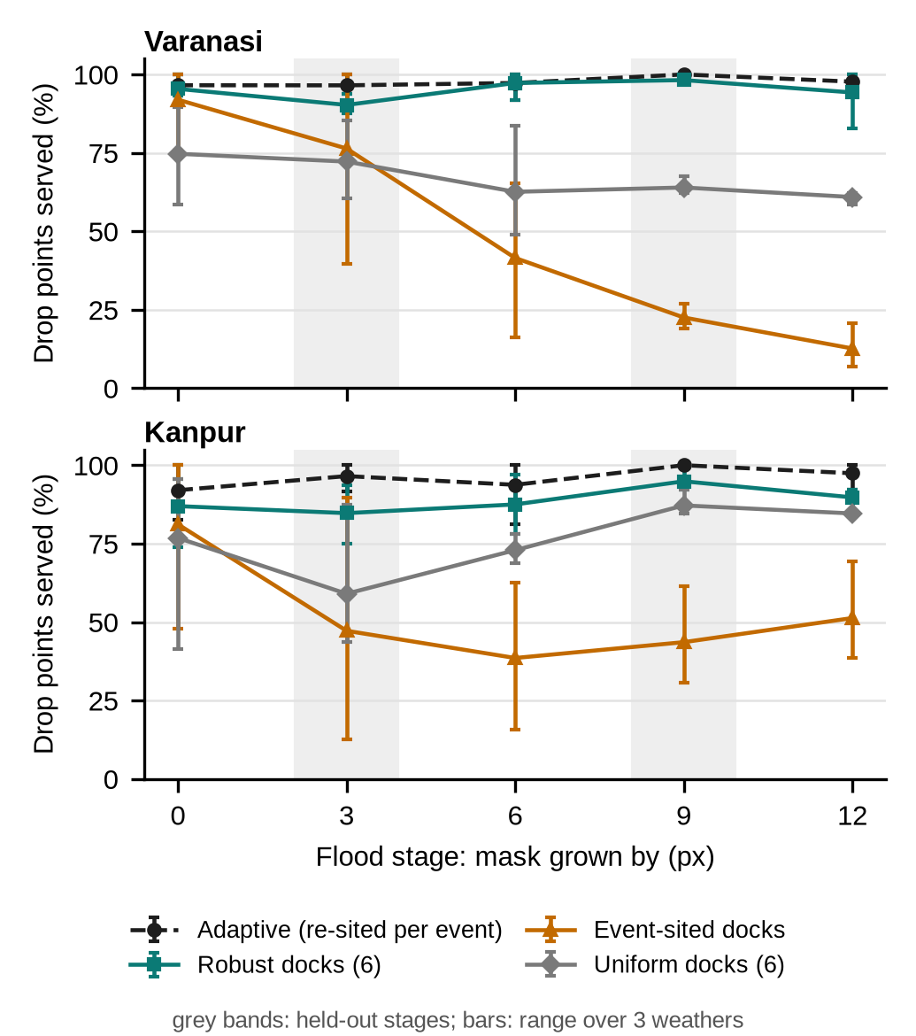
Figure 6.1 Share of drop points served as the flood rises; grey bands mark held-out stages
Docks sited from one past flood fail because the next, higher flood covers them: on average 2.5 of five are unusable in Varanasi. Robust docks lose almost none in Varanasi and keep coverage within a few points of the free re-siting bound, which would require moving every base by hundreds of metres each time the water rises (Figure 6.2).
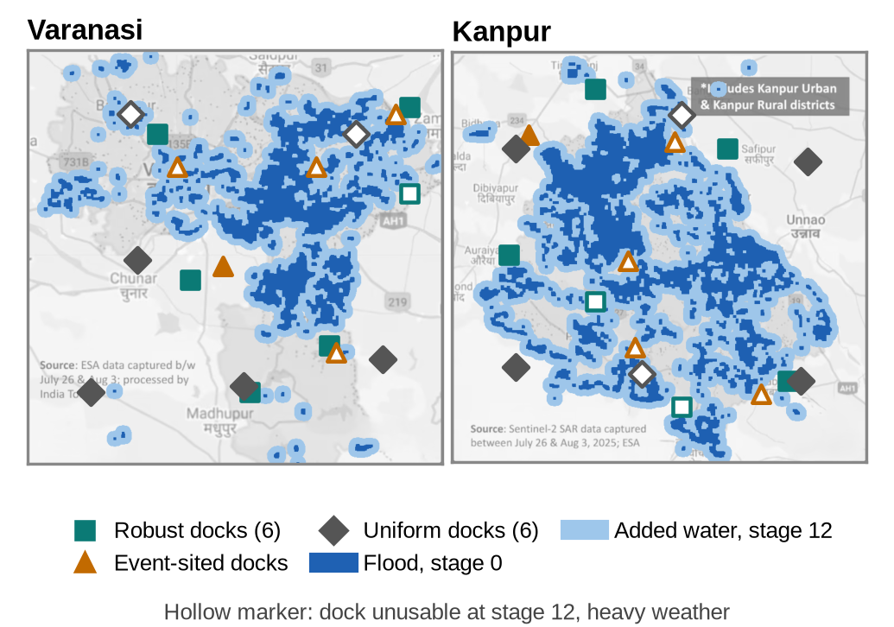
Figure 6.2 Dock sites of the three fixed strategies; hollow markers are docks unusable at the highest stage
6.3 SMART CITY IMPACT
- Automatic response: a new plan is requested as soon as the river crosses the next flood stage, instead of waiting for someone to notice and plan by hand.
- Reuse of city infrastructure: gauges, network and the ICCC dashboard already exist; the system adds docks, a trigger engine and a planner.
- Better infrastructure decisions: the dock study gives planners an evidence-based list of dock sites that survive future floods.
- Safer operations: human approval, battery limits, no crossing routes and a clear list of points left for responders.
6.4 UNIQUE OUTCOME: RESEARCH PAPER
The dock-siting study and the IoT layer are written up as an IEEE-format research paper, "Flood-Resilient Siting of IoT Drone Docks for Smart-City Relief: A Scenario Study of Varanasi and Kanpur", by Dr. Swarnalatha P, Ajay Thomas K, Dharani I S and Sukant G. It asks where a smart city should install drone docks so they keep working as the flood rises, and reports the results of Section 6.2 in full.
6.5 COST ANALYSIS
Table 6.3 gives an indicative hardware cost for one city with six docks and twenty gauges, using list prices from Indian resellers found in October 2026. Prices vary with configuration, software licences and maintenance contracts, so the total is an order of magnitude, not a quotation.
Table 6.3 Indicative hardware cost for one city
Item | Quantity | Unit price (list) | Total
Drone dock with drone (DJI Dock 2 bundle) | 6 | ₹12.3–20.2 lakh [21] | ₹74–121 lakh
LoRaWAN ultrasonic level sensor | 20 | US$79 (≈ ₹6,600) [19] | ≈ ₹1.3 lakh
Outdoor LoRaWAN gateway, IN865 | 2 | ₹65,775 [20] | ≈ ₹1.3 lakh
Server / cloud VM for broker and planner | 1 | existing ICCC | –
Total (hardware) |  |  | ≈ ₹77–124 lakh

The software is open source. The dominant cost is the docks; four robust docks instead of six cut it by a third at a moderate loss of coverage (Varanasi held-out coverage 90% with four docks against 94% with six).
6.6 LIMITATIONS
- All results are from simulation on two published flood maps; no drone was flown and no sensor was installed.
- Rising water is modelled by widening the mapped flood; the level-to-stage mapping is an assumption.
- The planner uses default, uncalibrated battery and speed settings, so results are comparative rather than absolute.
CHAPTER 7
CONCLUSION AND FUTURE WORK
Smart Aerial Response shows that a smart city can close the loop from a river gauge to dispatched drone relief missions. Gauge readings travel over LoRaWAN and MQTT to a trigger engine that re-plans a swarm whenever the flood stage rises, using only the docks that are still dry. The existing open-source planner is wrapped as a city service and fed only with usable docks; the dashboard runs it live for both cities. A study of 180 scenarios shows that docks chosen for flood resilience keep about nine-tenths of the achievable coverage on unseen flood stages, while docks sited from a single past flood lose about half. The system passed 33 of 33 automated tests and runs live for Varanasi and Kanpur.
Future work: georeferenced flood rasters from Sentinel-1 [23] in place of published maps; calibration of the battery model with a real vehicle; a pilot with two docks and a LoRaWAN gauge on one ghat; integration with the city's ICCC platform and digital twin; and a hydraulic model to map river level to flood extent.
REFERENCES
[1] News18, "Ganga crosses danger mark in Varanasi; 84 ghats submerged, over 6,500 displaced amid heavy rain," Aug. 2025. [Online]. Available: https://www.news18.com/india/ganga-crosses-danger-mark-in-varanasi-84-ghats-submerged-over-6500-displaced-amid-heavy-rain-9482124.html
[2] Deccan Chronicle, "UP: Ganga water level crosses warning mark in Varanasi," Sep. 2026. [Online]. Available: https://www.deccanchronicle.com/nation/current-affairs/up-ganga-water-level-crosses-warning-mark-in-varanasi-1984462
[3] The Times of India, "Ganga remains above warning mark for 3rd day," Kanpur, Sep. 2026. [Online]. Available: https://timesofindia.indiatimes.com/city/kanpur/ganga-remains-above-warning-mark-for-3rd-day/articleshow/134154014.cms
[4] Ministry of Housing and Urban Affairs, Government of India, "Smart Cities Mission." [Online]. Available: https://smartcities.gov.in
[5] The Times of India, "Govt uses LiDAR tech to predict flood risks and facilitate relief ops in Kashi," Varanasi, Aug. 2025. [Online]. Available: https://timesofindia.indiatimes.com/city/varanasi/govt-uses-lidar-tech-to-predict-flood-risks-and-facilitate-relief-ops-in-kashi/articleshow/123589626.cms
[6] N. Mohamed, J. Al-Jaroodi, I. Jawhar, A. Idries, and F. Mohammed, "Unmanned aerial vehicles applications in future smart cities," Technological Forecasting and Social Change, vol. 153, Art. no. 119293, 2020.
[7] M. Erdelj, E. Natalizio, K. R. Chowdhury, and I. F. Akyildiz, "Help from the sky: Leveraging UAVs for disaster management," IEEE Pervasive Computing, vol. 16, no. 1, pp. 24–32, 2017.
[8] A. Zanella, N. Bui, A. Castellani, L. Vangelista, and M. Zorzi, "Internet of Things for smart cities," IEEE Internet of Things Journal, vol. 1, no. 1, pp. 22–32, 2014.
[9] M. I. Zakaria, W. A. Jabbar, and N. Sulaiman, "Development of a smart sensing unit for LoRaWAN-based IoT flood monitoring and warning system in catchment areas," Internet of Things and Cyber-Physical Systems, vol. 3, pp. 249–261, 2023.
[10] LoRa Alliance, "RP002-1.0.4 LoRaWAN Regional Parameters," 2022. [Online]. Available: https://resources.lora-alliance.org
[11] OASIS, "MQTT Version 5.0," OASIS Standard, Mar. 2019. [Online]. Available: https://docs.oasis-open.org/mqtt/mqtt/v5.0/mqtt-v5.0.html
[12] G. Rabta, C. Wankmüller, and G. Reiner, "A drone fleet model for last-mile distribution in disaster relief operations," International Journal of Disaster Risk Reduction, vol. 28, pp. 107–112, 2018.
[13] C. Toregas, R. Swain, C. ReVelle, and L. Bergman, "The location of emergency service facilities," Operations Research, vol. 19, no. 6, pp. 1363–1373, 1971.
[14] R. Church and C. ReVelle, "The maximal covering location problem," Papers of the Regional Science Association, vol. 32, no. 1, pp. 101–118, 1974.
[15] L. V. Snyder, "Facility location under uncertainty: A review," IIE Transactions, vol. 38, no. 7, pp. 547–564, 2006.
[16] A. Pulver and R. Wei, "Optimizing the spatial location of medical drones," Applied Geography, vol. 90, pp. 9–16, 2018.
[17] J. J. Boutilier, S. C. Brooks, A. Janmohamed, A. Byers, J. E. Buick, C. Zhan, A. P. Schoellig, S. Cheskes, L. J. Morrison, and T. C. Y. Chan, "Optimizing a drone network to deliver automated external defibrillators," Circulation, vol. 135, no. 25, pp. 2454–2465, 2017.
[18] S. Koenig and M. Likhachev, "D Lite," in Proc. 18th National Conference on Artificial Intelligence (AAAI)*, 2002, pp. 476–483.
[19] Dragino Technology, "LDDS20 LoRaWAN liquid level sensor," product page. [Online]. Available: https://shop.dragino.com (accessed Oct. 2026).
[20] RAKwireless, "WisGate Edge Pro V2 RAK7289V2, IN865, 8-channel," Indian reseller listing, fron.in. [Online]. Available: https://fron.in/products/rakwireless-wisgate-edge-pro-v2-rak7289v2-in865-8-channel-non-lte (accessed Oct. 2026).
[21] MAV Drones, "DJI Dock 2 price in India," reseller listing. [Online]. Available: https://www.mavdrones.com/product/dji-dock-2-buy-now-best-price-in-india/ (accessed Oct. 2026).
[22] DT Next, "Over Rs 98 crore allocated for 5-year ICCC operations, integration," Chennai, 2025. [Online]. Available: https://www.dtnext.in/news/tamilnadu/over-rs-98-crore-allocated-for-5-year-iccc-operations-integration
[23] European Space Agency, "Copernicus Sentinel-1 mission." [Online]. Available: https://sentinels.copernicus.eu
[24] T. Saha, A. Vatsal, A. Thomas K, and A. K, "A.D.A.P.T.: Autonomous Drone for Adaptive Path Tracking," open-source software, 2026. [Online]. Available: https://github.com/TSaha4/A.D.A.P.T.-Autonomous-Drone-for-Adaptive-Path-Tracking
APPENDIX A – SAMPLE CODE
A.1 LoRaWAN uplink codec (iot/smartcity_iot.py)
UPLINK = struct.Struct(">HIHhH") # dev id, unix time, level cm, rate cm/h, battery mV: 12 bytes

def encode_uplink(dev, t, level_m, rate_cm_h, battery_v):
return UPLINK.pack(dev, int(t), round(level_m * 100), round(rate_cm_h), round(battery_v * 1000))

def decode_uplink(payload):
dev, t, level_cm, rate, mv = UPLINK.unpack(payload)
return {"dev": dev, "t": t, "level_m": level_cm / 100, "rate_cm_h": rate, "batt_v": mv / 1000}
A.2 River level to flood stage (iot/smartcity_iot.py)
STAGES = (0, 3, 6, 9, 12)

def flood_stage(level_m, warning, danger):
"""Warning mark = stage 0, danger mark = 6, one metre above danger = 12."""
raw = 6.0 * (level_m - warning) / (danger - warning)
return max(s for s in STAGES if s <= max(0.0, raw))
A.3 Re-plan with the dry docks (iot/smartcity_iot.py, abridged)
docks = self.dry_docks()
hubs.write_text(json.dumps(docks))
cmd = [PLANNER_PY, "run_scenario.py", "--city", self.city, "--grow", str(job["stage"]),
"--rain", str(rain), "--wind", str(wind), "--max-bases", "6", "--hubs", str(hubs), "--out", str(run_dir)]
subprocess.run(cmd, capture_output=True, text=True)
self.c.publish(f"sar/{self.city}/iccc/plan", json.dumps(rec), qos=1)
A.4 Server-Sent Events from the dashboard server (demo/server.py)
def sse(self, event, data):
payload = f"event: {event}\ndata: {json.dumps(data)}\n\n".encode()
self.wfile.write(payload)
self.wfile.flush()
A.5 Example unit test (tests/test_planner_units.py)
def test_u06_crossing_detector():
assert polyline_intersections([(0, 0), (10, 10)], [(0, 10), (10, 0)]) == [(5.0, 5.0)]
assert polyline_intersections([(0, 0), (10, 0)], [(0, 5), (10, 5)]) == []

