**Leave Management System**

**Abstract**

People today frequently employ more advanced data management that performs well in this era of technological advancements. Web pages serve as the public face of the Internet and enable visitors to access content on other websites. Web pages are created using a variety of tools and technological stacks, such as HTML, which specifies the structure, CSS, which decorates the structure, and JavaScript, which enables us to have dynamic web pages or applications. Java Enterprise Edition (JEE) and Spring with Spring Boot are two well-known stacks that have been in use for years. As a result, the management of the data is greatly aided by the most recent technologies, Spring Boot and React. Sprint Boot is regarded as a lightweight framework that makes it easier to get and save data. Extremely competent at handling dependencies is React JS. Our model assists in managing employee(user) data in a database using React JS as the front end and Sprint boot as the backend. The front end and the back end are connected via JavaScript.

**Keywords:** Spring boot, Java, React JS.

**Introduction**

In the existing paperwork related to leave management, leaves are maintained using the attendance register for staff of different departments. The staff needs to submit their leaves manually to their respective authorities in their respective departments. This increases the paperwork & maintaining the records becomes tedious. Maintaining notices in the records also increases the paperwork. The main objective of the proposed system is to decrease the paperwork and help in easier record maintenance by having a particular centralized Database System, where Leaves and Notices are maintained in every department and be. The proposed system automates the existing system. It decreases the paperwork and enables easier record maintenance. It also reduces chances of Data loss. This module intelligently adapts to Manager policy of the management &allows employees and their line managers to manage leaves and replacements for better scheduling of workload. The Task assignment application basically reduces the distracted communication.

Our project, the Leave Management System, implements a web application utilising Spring Boot as the backend and React with a router as the frontend. One of the most widely used libraries for front-end development is React. React renders its components on a single web page. A strong web application is created by bridging the gap between the Spring Framework and React Library with JavaScript. This project uses Apache Derby and JDBC integration as a database, taking user information from a web page on React and passing it over Axios to the backend, which then stores the information in the Derby database. Any other SQL database may be used with this process as well. Therefore, utilising a customizable home page, activities like add, edit, view, and delete may be used to keep employees' data.

**Literature Review**

1. **S Selvi, Manas Rath, N K Sinha, S P Singh, N N J Hemrom, A Bhattacharya, A K Biswal , "HR e-Leave Tour Management System at RDCIS, SAIL International Conference on Information Technology, [June 2014].**

This project is aimed at developing an online leave apply system and Employee task assignment application that is of importance to either an organization or school or an office. The Leave Application System (LMS) is an Intranet based application that can be accessed throughout the organization or a specified group/Dept. The Employee Task Assignment system is also accessible foe both employee and employer in any organization. This system can be used to automate the workflow of leave applications, and their approvals, task assignment, task completion and their tracking. The periodic crediting or debiting of leave is also automated and system dependent. There are features like email notifications, automatic approval of leave, mentor approval, functional head approval, report generators etc. in this system. Leave Application System will reduce paperwork and maintains record in more efficient way. Task assignment application also helps to maintain workflow and deadlines with proper Identification and Attendance of employees.

1. **Sai Ba Oo*, Nang Hlaing Myat Oo, Suparat Chainan, arpha Thongniam, Waralak Chongdarakul , School of Information and Technology, Mae Fah Luang University, "Cloud-based web application with NFC for employee attendance management system, [June 2018]**

Efficient employee attendance management leads any organizations to increase overall corporate performance and accomplish specific goals. Accurate employee attendance records are importantly used to control working discipline and increase worker’s productivity. Manual attendance-time checking makes increasingly the expense of time-consuming and paper work of the companies. Human actions i.e. mistake at work, and fraudulent time keeping are additional hidden expenses which affect the productivity of the organization. Variation of the attendance policies set up in different companies make more complicated in evaluation of employee working hours. Hence, automated time attendance management system is the key operational variables for enhancing the performance, and profitability. The attendance management system captures time-attendance data and serves the management of the employee working hour records. However, some existing time attendance systems have limitations in terms of identification speed, cost of system devices, real-time attendance monitoring, and flexibility of database storage size. In this paper, we introduce a cloud-based employee attendance management system using NFC technology. The proposed application provides several important operations such as captured attendance records using NFC, automatic time calculation, leave and overtime checking, working hours evaluation, real-time updated information access, and generating reports. The proposed system also offers online portal which allows multiple company user accounts, requires no special software to install, and provides more flexible data storage. The evaluation of user satisfaction shows that our proposed system is practically used and satisfied.

1. **S Selvi, Manas Rath, N K Sinha, S P Singh, N N J Hemrom, A Bhattacharya, A K Biswal , "HR e-Leave Tour Management System at RDCIS, SAIL International Conference on Information Technology, [June 2014].**

Every organization is information driven and it's the employee who drives and carries out day to day activities. The P&A department train the people, organizes them, so that employees can effectively perform these activities. This requires viewing people as human assets, not costs to the organization. Looking at people as assets is part of human resource management and human capital management. For managing and automating the HR Process to maximize the productivity of the organization, the organization has to implement HRMS, a Human Resource Management System. HRMS system will help in reducing costs, saving time, integrating and aligning HR efforts with the rest of the organization. Employees will be empowered and engage with more input and control over their work life. Through HRMS one can quickly build the workflows and processes. The powerful flexibility features keep employees current and compliant, even as rules and regulations change. For competent management of business process, computerization is must in today's scenario. RDCIS (Research and Development Centre for Iron & Steel), is a research unit of SAIL in the area of Iron Steel. The organization hierarchy is two tier architecture. Top level is Area and Bottom level is department. Each area has various departments. The P&A (Personnel & Administration) department carries out different activities for managing various Human Resource functions. The different functions carried out by P&A department are Manpower Planning, Succession plans, Redeployment/ Job rotation, Career Planning, Compensation Revision, Employee Profile, Manpower Statistics, Age/ Skill/ Qualification matrix, Employee Turnover, Utilization of perks (LTC, Company Leased Housing etc.), Facilities (Residential phone, Housing loan etc.), Employee Performance/ Appraisal analysis, Training program details, Stagnation Analysis etc. Without a computerize systems, it is very difficult to drive the HR functions. In this regard, a project was taken to implement a Human Resource Management System for forecasting of organizational needs, and for the continual monitoring and adjustment of personnel systems to meet current and future requirements, and the management of change. The project comprises of database design, application design and development of software for storage and retrieval for the maintenance of HR data through user friendly interfaces. The developed software also has mechanisms to avoid tampering of data. The software has been developed with 3-tier approach. The software tools used are Oracle Designer, Oracle Database and JSP. The software has been deployed with Tomcat Apache Server on Windows Operating System.

1. **A.S.SyedNavaz, A.S.SyedFiaz, C.Prabhadevi, V.Sangeetha, S.Gopalakrishnan, “Human Resource Management System”, IOSR Journal of Computer Engineering (IOSR-JCE), Volume 8, Issue 4 (Jan. – Feb. 2013) Page 62-71.**

Every organization, whether or not massive or little, has human resource challenges to beat. Each organization has totally different worker management desires, thus we have a tendency to style exclusive worker management systems that area unit tailored to your social control necessities. This can be designed to help in strategic designing, and can assist you make sure that your organization is provided with the correct level of human resources for your future goals. Also, for those busy government World Health Organization area unit continually on the go, our systems associate with remote access options, which is able to enable you to manage your force anytime, in any respect times. These systems can ultimately enable you to raised manage resources. One in every of the most options in worker management system is time pursuit for workers. Effective time pursuit mechanism saves each time and cash for the organization.

1. **Singh Pratik Udayshankar, Fartyal Hemant Singh, Zubair Khan Abdul Ahad (2019), Employee management System, in IRJET (2019), (Pg-No. 188-192).**

The objective of “Employee Management System” is designing a scheduling system for a work centre. Scheduling is such a tool with which the process of intimating activities and notifications will be easy and even online in the organization where it is installed. But these task of scheduling the different activities if manually done whether they may be personal or official is time consuming and also may lead to confusion if not properly scheduled. Employee Management System is a distributed application, developed to maintain the details of employees working in any organization. It maintains the information about the personal details of their employees. The application is actually a suite of applications developed using PHP. It is simple to understand and can be used by anyone who is not even familiar with simple employee’s system. It is user friendly and just asks the user to follow step by step operations by giving him few options. It is fast and can perform many operations of a company or organization. This software project has been developed using the powerful coding tools of HTML, CSS and PHP at Front End and Microsoft Sql Server at Back End. The software is very user friendly. The project contains modules like Employee and Admin. This version of the software has multi-user approach. For further enhancement or development of the package, user’s feedback will be considered.

**Existing System**

In the existing system, Tomcat server-based Java servlets are used to manage employee data. Servlets employ containers, and because containers include built-in services like security, mail, and messaging, they are bulky and have poor data management performance. This is viewed as a weakness in the current system.

**Disadvantages:**

* Less scalability
* Less security

**Proposed Method**

To overcome the drawback in the existing system, we have used spring framework in our model. Spring Boot is considered as a light-weight framework which results in less complexity in maintaining the data. In our project, we have implemented the spring framework since it uses less weight containers. Therefore we can easily manage data operations of employee. Here using chat facility the employee can make a request for leave. Manager can view that employee leave request then he/she can accept/reject that leave.

**Advantages:**

* More scalability
* Springboot provides high security

**Block Diagram:**

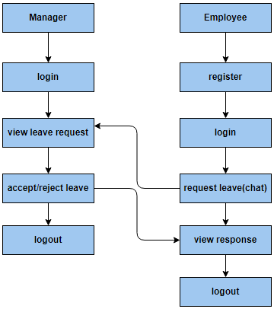

**Fig 1. Block diagram of proposed method**

**Architecture Design**

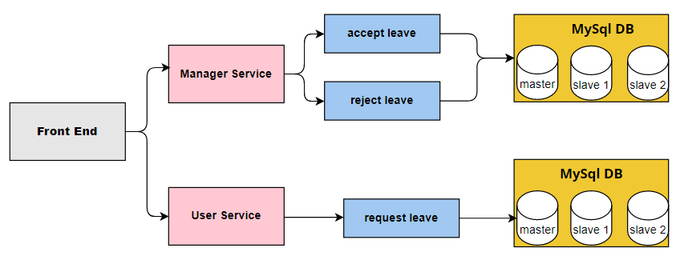

**Fig 2. Architecture diagram**

**Conclusion**

In this project we have successfully created a user friendly web application called Leave Management System that will help employee(user) as well the manager to communicate easily. Here, user will register and login into the application and user can make a request regarding leave to their respective manager with the help of chat facility. Manager can view that leave request and he/she can accept/reject that leave.

**References**

1. S Selvi, Manas Rath, N K Sinha, S P Singh, N N J Hemrom, A Bhattacharya, A K Biswal , "HR e-Leave Tour Management System at RDCIS, SAIL International Conference on Information Technology, [June 2014]
2. Sai Ba Oo*, Nang Hlaing Myat Oo, Suparat Chainan, arpha Thongniam, Waralak Chongdarakul , School of Information and Technology, Mae Fah Luang University, "Cloud-based web application with NFC for employee attendance management system, [June 2018]
3. Singh Pratik Udayshankar, Fartyal Hemant Singh, Zubair Khan Abdul Ahad (2019), Employee management System, in IRJET (2019), (Pg-No. 188-192).
4. A.S.SyedNavaz, A.S.SyedFiaz, C.Prabhadevi, V.Sangeetha, S.Gopalakrishnan, “Human Resource Management System”, IOSR Journal of Computer Engineering (IOSR-JCE), Volume 8, Issue 4 (Jan. – Feb. 2013) Page 62-71.
5. Spring Boot Tutorial – Journal Dev Articles – React (reactjs.org) Articles – React (reactjs.org)
6. Thesis and Dissertation Writing Boot Camps - Graduate Student Services - Kathleen Jones White WritingCenter - IUP
7. Master thesis with ReactJS - Stack Overflow
8. Spring Boot in Action by Craig Wallss
9. Inversion of Control Containers and the Dependency Injection pattern (martinfowler.com)How To Code in React.js eBook | DigitalOcean
10. Pandore Yogesh Bandopant ,"E-Notifier: Transport Information Services in Colleges and Exploring Mobile Notification Journal of Advanced Research in Computer and Communication Engineering Vol.5, Issue 4",[April 2016]