PDF Tools Hub
─────────────────────────────
Organization: Future Invo Solutions
Technologies:
Frontend: HTML, CSS, JavaScript / React
Backend: Java Spring Boot
Frontend: Gayathri
Backend: Ajay

Table of Contents
Purpose 3
Objective 3
Feature Scope 4
Technology Stack 4
Systsem Architecture 4
Workflow 5
Challenges 5
Future Enhancements 5
Conclusion 5

Overview:

Purpose
PDF Tools Hub is a full-stack web application that provides users with a browser-based interface to perform PDF operations. The React JS frontend handles user interactions and file uploads, while the Java Spring Boot backend processes files and returns results. The system covers four core categories: Conversion, Editing, Security, and Optimization.

Objective
To develop a full-stack web application that provides a centralized platform for performing various PDF operations such as conversion, editing, security, and optimization through a user-friendly interface and efficient backend services.
Frontend Objectives
- To design a simple and intuitive user interface for uploading and managing PDF files
- To provide easy navigation between different PDF tools (merge, convert, compress, etc.)
- To enable users to upload files and download processed outputs seamlessly
- To display real-time feedback such as success, error, and loading states

Backend Objectives
- To build RESTful APIs using Java Spring Boot for handling PDF operations
- To implement PDF processing functionalities like merge, split, convert, lock/unlock, and compress
- To ensure efficient file handling using temporary storage and optimized processing
- To maintain clean architecture (Controller → Service → Utility layers)

System Objectives
- To integrate frontend and backend using HTTP REST APIs
- To ensure fast and reliable processing of PDF files
- To maintain scalability and modular design for future enhancements
- To provide a secure environment for file uploads and processing

User Objectives
- To reduce dependency on multiple tools by providing an all-in-one PDF solution
- To allow users to perform tasks quickly without technical knowledge
- To ensure ease of use and accessibility

Feature Scope

Category | Features
PDF Conversion | • PDF → Word  • Word → PDF  • Excel → PDF
PDF Editing | Merge PDF, Split PDF, Rotate PDF
PDF Security | Lock PDF, Unlock PDF
PDF Optimization | Compress PDF

Technology Stack
Frontend:
- React – Used to build the user interface
- Vite – Fast development and build tool
- Tailwind CSS – Styling and responsive design
- Axios / Fetch API – For API communication
Backend:
- Java – Core programming language
- Spring Boot – Used to develop REST APIs
Version Control:
- Git & GitHub – Code management and collaboration
Other Concepts:
- REST APIs, File Upload, Responsive Design

Systsem Architecture
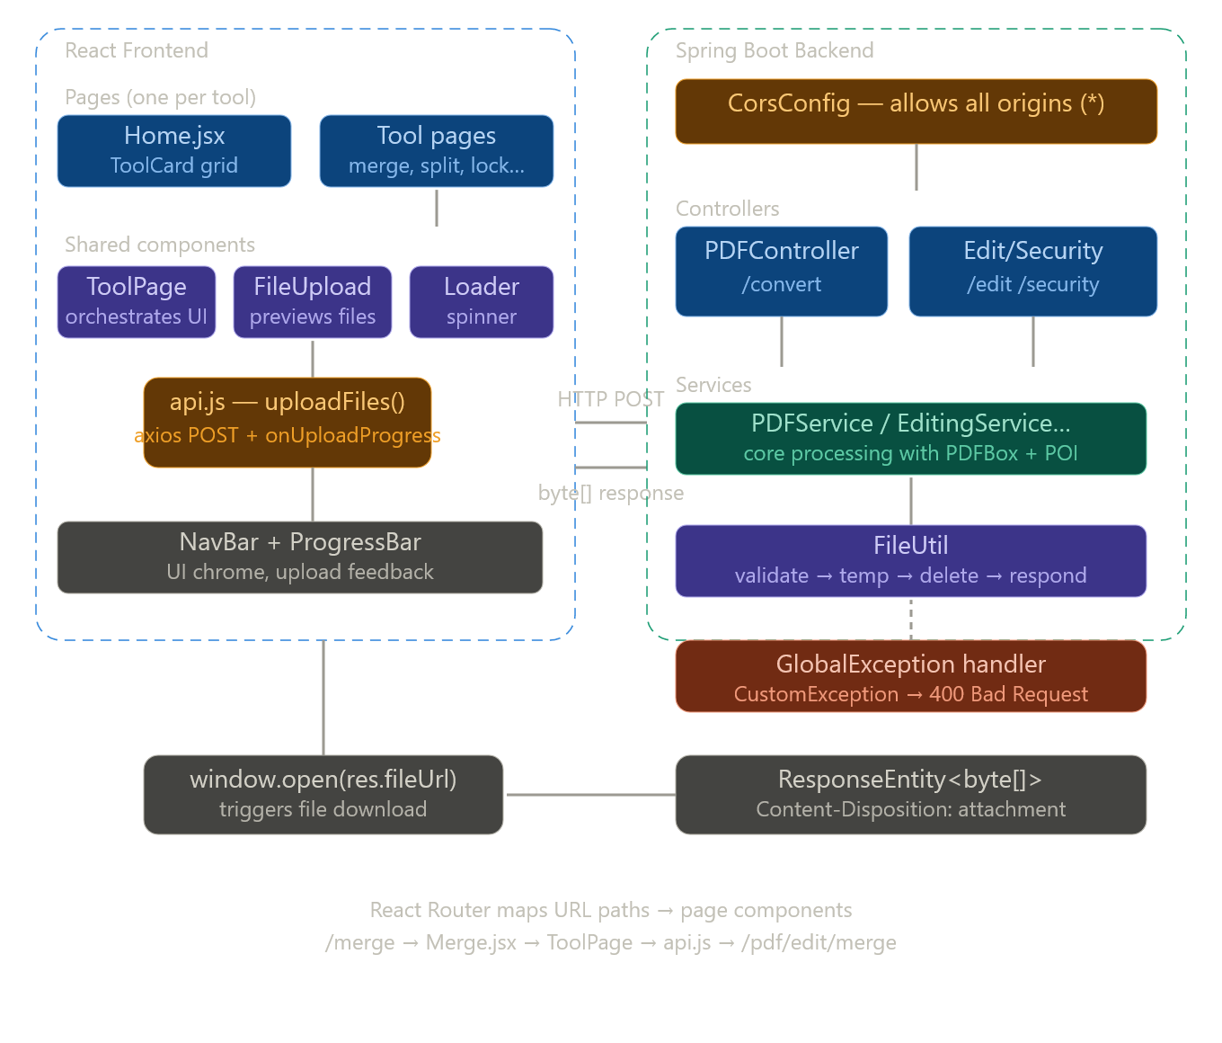

Modules
Backend --
Module 1 — Entry Point & CORS
PdftoolshubApplication bootstraps the Spring context. CorsConfig registers a global CORS rule that permits requests from any origin with allowedOrigins("*"). This means your React/Vue frontend on any domain can call the API without being blocked by the browser's same-origin policy.
Module 2 — PDFService
The PDFService provides conversion functionalities between different file formats such as PDF, Word, and Excel.
📌 Functionality:
- PDF → Word: Extracts text using PDFBox and writes into Word using Apache POI
- Word → PDF: Reads Word content and generates PDF using PDFBox
- Excel → PDF: Converts spreadsheet data into structured PDF format
📌 Key Responsibilities:
- Extract and transform document content
- Generate output files in required formats
- Handle formatting and pagination
2.1 PDFController (Conversion Module)
The PDFController manages all PDF conversion-related operations such as converting PDF to Word, Word to PDF, and Excel to PDF.
📌 Functionality:
It exposes multiple endpoints under /pdf/convert:
- /pdf-to-word
- /word-to-pdf
- /excel-to-pdf
The controller performs initial validation such as checking if the file is empty. It then calls the corresponding methods in the PDFService to process the file.
The result is returned using the FileUtil class, which ensures proper HTTP headers and file download formatting.
📌 Key Responsibilities:
- Handle file upload requests
- Validate input files
- Delegate conversion logic to service layer
- Return processed files in correct format
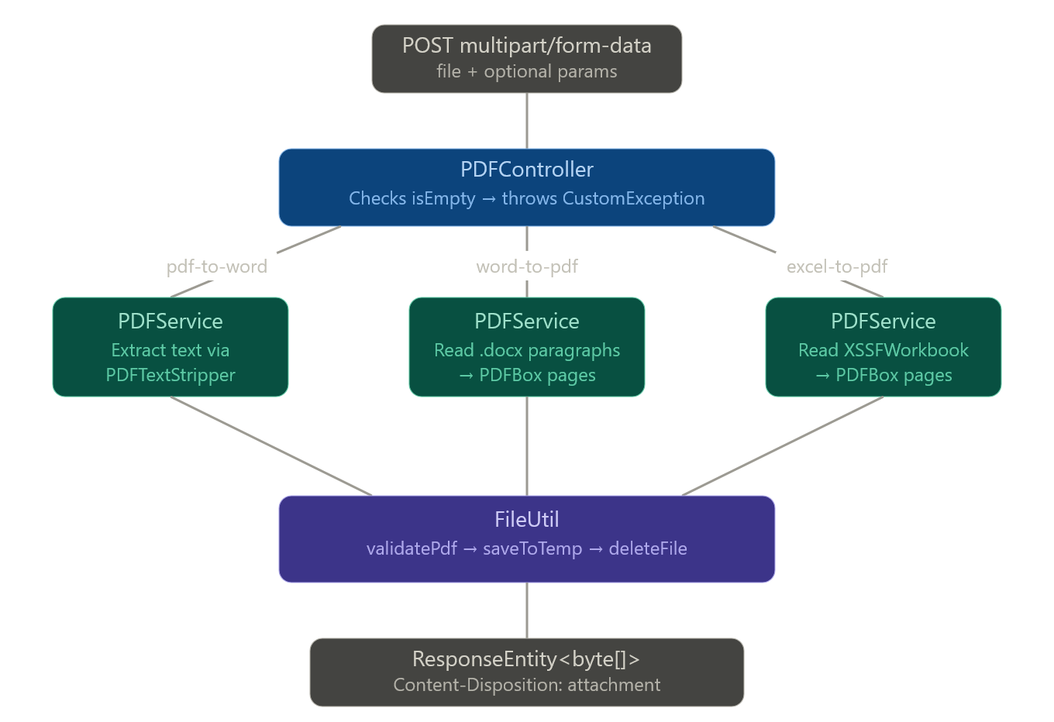
Module 3 — PDFEditingService
The PDFEditingService implements core logic for PDF editing operations such as merging, splitting, and rotating documents.
📌 Functionality:
- Merge: Combines multiple PDFs using PDFMergerUtility
- Split: Extracts specific page ranges using Splitter
- Rotate: Rotates selected pages based on user input
The service uses temporary file storage to handle large files efficiently and ensures cleanup after processing.
📌 Key Responsibilities:
- Perform merge operations
- Handle page-based splitting
- Apply rotation transformations
- Validate inputs and manage errors
3.1 PDFEditingController
The PDFEditingController handles operations related to editing PDF documents, including merging, splitting, and rotating PDFs.
📌 Functionality:
This controller provides endpoints under /pdf/edit:
- /merge for combining multiple PDFs
- /split for extracting specific page ranges
- /rotate for rotating selected pages
It receives input parameters such as file(s), page range, rotation angle, and page numbers. These parameters are passed to the PDFEditingService for processing.
📌 Key Responsibilities:
- Handle multiple file uploads
- Accept page range and rotation parameters
- Call service methods for editing operations
- Return modified PDF files
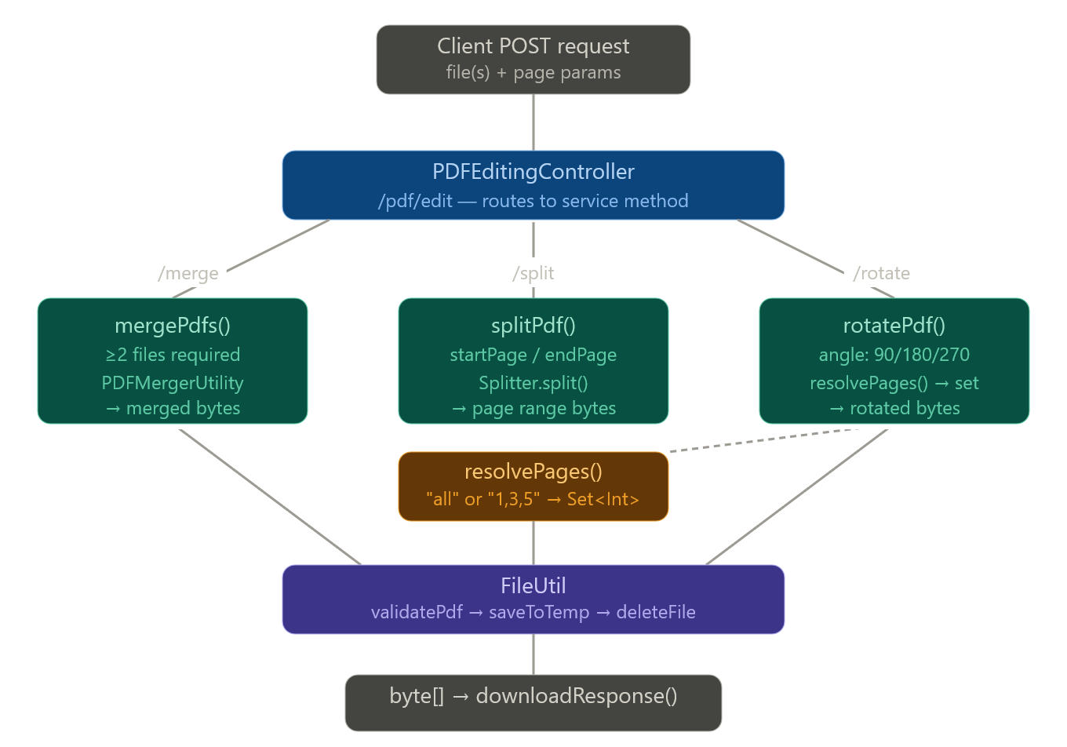

Module 4 — OptimizationService
The OptimizationService contains the business logic for compressing PDF files. It reduces file size primarily by compressing images within the PDF.
📌 Functionality:
The service validates the PDF file and saves it temporarily. It iterates through each page, extracts images, and compresses them using JPEG encoding with reduced quality.
Advanced techniques such as image scaling and RGB conversion are applied to optimize performance and maintain compatibility.
📌 Key Responsibilities:
- Validate PDF input
- Process images within PDF pages
- Apply compression techniques
- Return optimized PDF
4.1 OptimizationController
The OptimizationController is responsible for handling PDF optimization-related API requests. It exposes REST endpoints that allow users to compress PDF files by reducing image quality within the document.
📌 Functionality:
This controller defines a POST endpoint /pdf/optimize/compress which accepts a PDF file and an optional image quality parameter. The request is logged using a logger for traceability and debugging purposes.
The controller delegates the core processing to the OptimizationService, ensuring separation of concerns. After processing, it uses the FileUtil class to generate a properly formatted downloadable response.
📌 Key Responsibilities:
- Accept PDF file input
- Accept compression quality parameter
- Log request details
- Call service layer for processing
- Return compressed PDF as a downloadable response
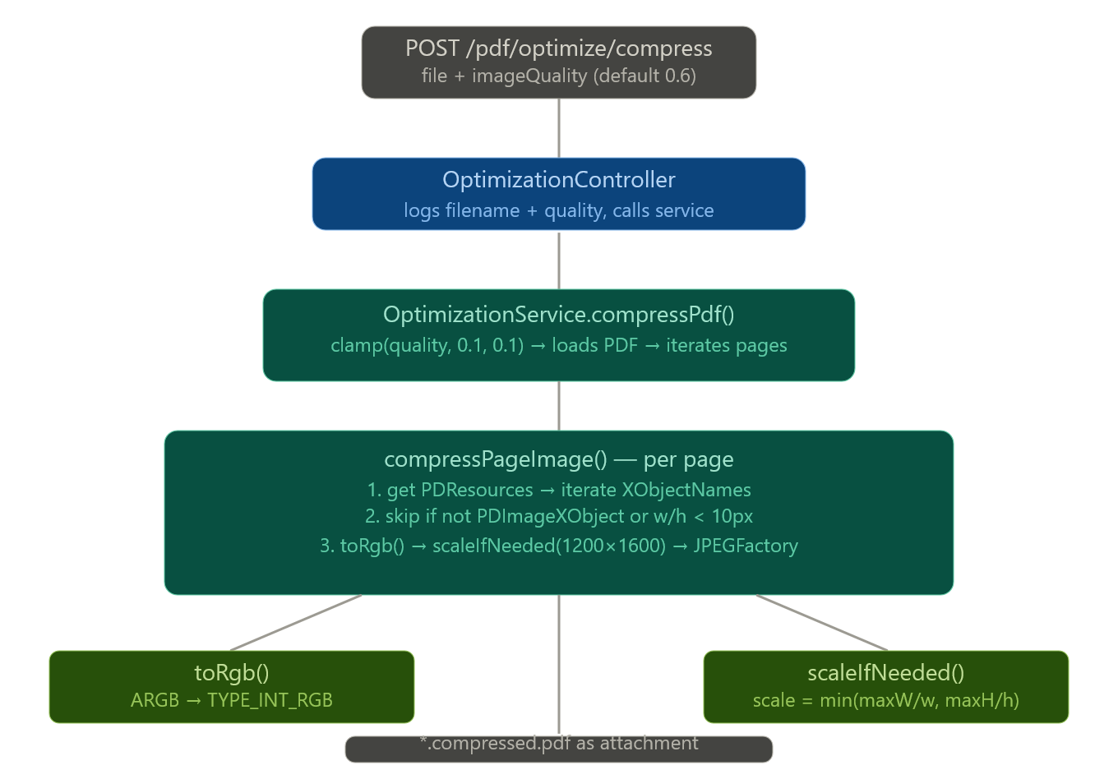

Module 5 --- PDFSecurityService
The PDFSecurityService handles encryption and decryption of PDF files.
📌 Functionality:
- Applies password protection using StandardProtectionPolicy
- Configures permissions such as printing and copying
- Uses AES-256 encryption for strong security
- Removes security when unlocking PDFs
It also handles exceptions like incorrect passwords.
📌 Key Responsibilities:
- Encrypt PDF files
- Decrypt PDF files
- Manage permissions
- Handle password validation
5.1 PDFSecurityController
The PDFSecurityController is responsible for managing PDF security operations such as locking (encrypting) and unlocking (decrypting) PDF files.
📌 Functionality:
It exposes endpoints under /pdf/security:
- /lock for adding password protection
- /unlock for removing password protection
The controller accepts parameters such as user password, owner password, and permissions like printing and copying. It forwards these inputs to the PDFSecurityService.
📌 Key Responsibilities:
- Accept password and permission parameters
- Handle encryption and decryption requests
- Return secured or unsecured PDF files
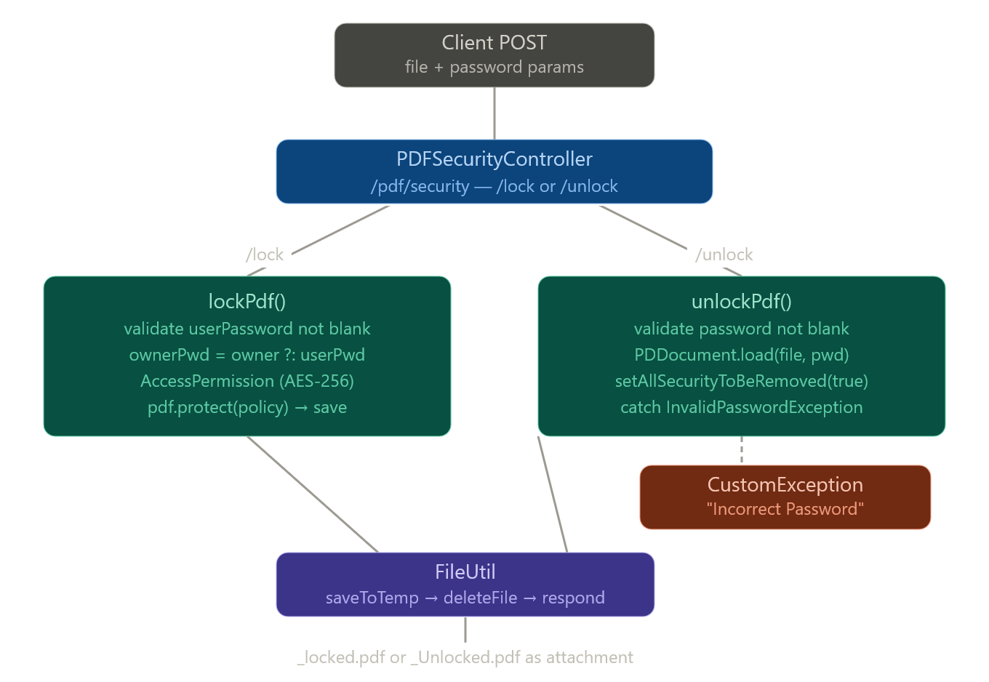
Module 6 --- Exception Handling Module
The Exception Handling module consists of two main components: CustomException and GlobalException. Together, they provide a centralized mechanism for handling errors across the application.
The CustomException class is a user-defined runtime exception used to represent application-specific errors such as invalid file inputs, incorrect parameters, or business rule violations. It allows developers to throw meaningful and controlled exceptions from the service or controller layers.
The GlobalException class is implemented using @RestControllerAdvice and acts as a centralized exception handler for the entire application. It intercepts exceptions thrown during request processing and converts them into structured HTTP responses.
Module 7 --- FileUtil (Utility Class)
The FileUtil class is a core utility component responsible for file handling, validation, and response generation.
📌 Functionality:
- Saves uploaded files to temporary storage
- Deletes temporary files after processing
- Validates PDF files using magic number
- Builds HTTP responses for file download
📌 Key Responsibilities:
- Manage file lifecycle
- Validate file type and content
- Provide reusable helper methods
- Ensure safe file handling
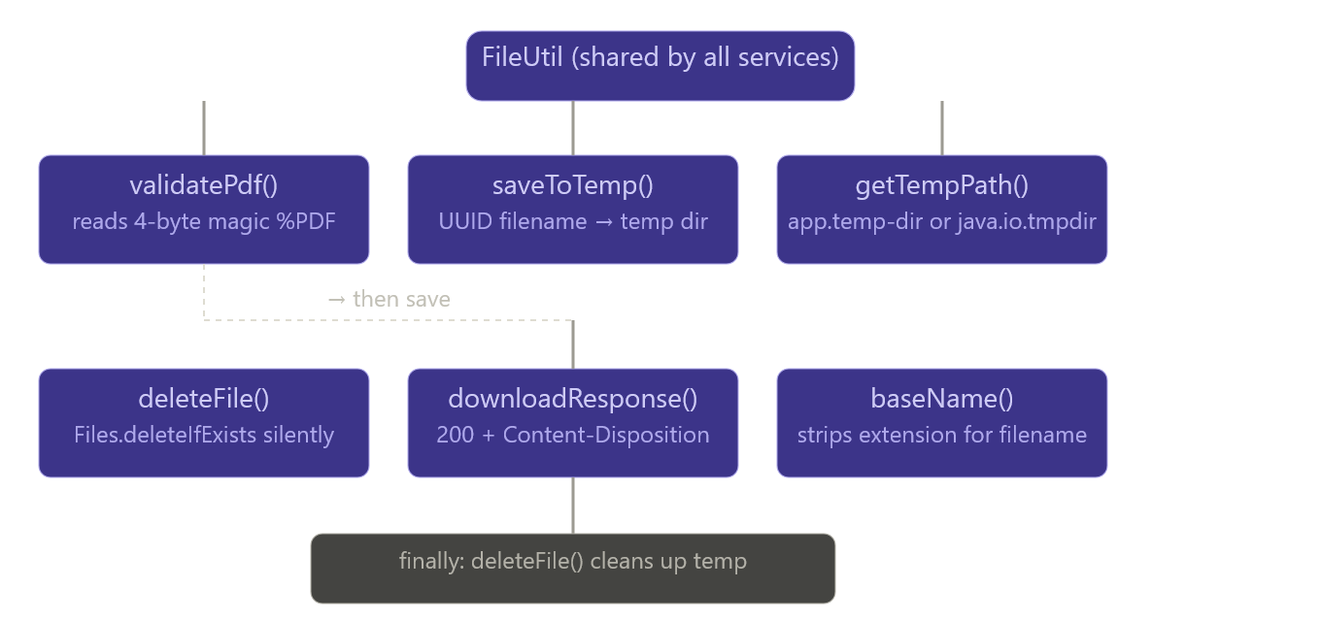

Workflow
- User selects the desired tool
The user chooses a specific PDF operation such as merge, split, compress, or convert from the homepage.
- User uploads file(s)
The user uploads one or multiple PDF files through the drag-and-drop interface or file selector.
- Frontend sends API request
The React application validates the file(s) and sends them to the backend server via REST API using Axios.
- Backend processes the file
The backend built with Spring Boot receives the request, performs the required PDF operation using appropriate libraries, and generates the processed output.
- Backend returns processed file
After successful processing, the server sends the modified file back to the frontend.
- User downloads the result
The frontend provides a download option and displays success feedback to the user.

Challenges
- Handling Large File Sizes
Managing large PDF uploads without performance issues or timeouts was a challenge. Efficient handling and temporary storage strategies were required.
- API Integration Between Frontend and Backend
Ensuring smooth communication between React frontend and backend APIs, including error handling and response management.
- Managing UI States
Handling loading states, success messages, and error feedback to improve user experience.
- Cross-Browser Compatibility
Ensuring the application works consistently across different browsers like Chrome, Edge, etc.
- File Validation & Security
Preventing invalid file uploads and ensuring safe file handling.

Future Enhancements
- User Authentication System
Allow users to create accounts and securely manage their files.
- Cloud Storage Integration
Store files using cloud services like AWS S3 for better scalability and accessibility.
- File History & Dashboard
Maintain a history of previously processed files for easy access and reuse.
- AI-Based PDF Features
Implement features like PDF summarization, keyword extraction, and smart search.
- Batch Processing
Enable users to process multiple files at once for better efficiency.
- Progress Indicators
Show real-time progress bars during file upload and processing.

Conclusion
The PDF Tools Hub project successfully demonstrates the integration of a modern frontend developed using React with a robust backend powered by Spring Boot.
The application provides a seamless and efficient platform for performing various PDF operations with a user-friendly interface. It highlights key concepts such as API integration, file handling, and responsive UI design.
This project not only improves productivity by simplifying PDF tasks but also showcases real-world full-stack development skills, making it a valuable addition to professional experience.

