

SCENARIO-BASED REQUIREMENT ANALYSIS
Software Requirement Specification (SRS) Document

CSA1012
SOFTWARE ENGINEERING

Cold-Chain Logistics Integrity Platform
(Food & Pharma Distribution)

Submitted By
E Ajay Velmail
Register Number
192311385
Department
B.E Computer Science and Engineering

Table of Contents
I. Introduction
II. Problem Description
III. Scope of the System
IV. Stakeholder and Actor Analysis
V. Actors and Use Cases
VI. Use Case Diagram
VII. Functional Requirements
VIII. Non-Functional Requirements
IX. Data Requirements
X. External Interface Requirements
XI. System Features
XII. Assumptions
XIII. Constraints
XIV. Requirement Validation
XV. Conclusion
XVI. References

I. Introduction
Cold-chain logistics is one of the most critical components of modern food and pharmaceutical distribution. It ensures that temperature-sensitive products such as vaccines, insulin, biologics, dairy products, seafood, meat, and fresh produce are transported and stored under controlled environmental conditions. Even a small deviation in temperature or humidity can reduce product effectiveness, shorten shelf life, or render a shipment unsafe for use.
Most existing cold-chain monitoring approaches depend on data loggers and manual inspection, where readings are reviewed only after a shipment reaches its destination. This scenario-based requirement analysis studies that business domain and specifies the requirements for a proposed Cold-Chain Logistics Integrity Platform — a cloud-based system that uses IoT sensors, cloud computing, and AI analytics to provide continuous, real-time visibility and predictive alerts across the cold-chain supply network.
This document follows the structure of a Software Requirement Specification (SRS): it analyses the problem and business domain, identifies stakeholders and actors, derives functional and non-functional requirements, models actor-system interactions through use cases, specifies data and interface requirements, and validates the requirement set for completeness and consistency.

II. Problem Description
The business domain is temperature-controlled logistics for food and pharmaceutical supply chains. Shipments of perishable or temperature-sensitive goods travel through refrigerated trucks, cold-storage warehouses, and shipping containers, where refrigeration failures, door breaches, or route delays can silently push products outside their safe temperature band.
Existing challenges identified in the scenario include:
- No continuous, real-time visibility into shipment temperature, humidity, or location during transit.
- Reactive monitoring — data loggers are reviewed only after delivery, by which time spoilage or non-compliance has already occurred.
- No predictive capability to anticipate refrigeration unit failure before it happens.
- Manual, error-prone compliance reporting for regulators such as the FDA, WHO, and FSSAI.
- Delayed stakeholder notification when abnormal conditions occur, preventing timely corrective action.
- Financial loss, product recalls, and reduced customer trust caused by undetected excursions.
The system objective is to replace this reactive model with a continuously connected platform that senses, analyses, predicts, and reports on cold-chain conditions in real time, enabling proactive intervention before products are compromised.

III. Scope of the System
The proposed platform covers monitoring, prediction, alerting, and compliance reporting across the following operating environments:
- Refrigerated trucks used for perishable goods transportation.
- Cold-storage warehouses and distribution centres.
- Refrigerated shipping containers for domestic and international logistics.
- Pharmaceutical cold chains for vaccines, insulin, biologics, and other temperature-sensitive medicines.
- Food distribution networks handling fresh produce, dairy, meat, and seafood.
The system is in scope for: IoT-based data collection, real-time analytics and anomaly detection, AI-based failure prediction, multi-channel alerting, a web/mobile monitoring dashboard, and automated compliance report generation. Physical manufacture or repair of refrigeration hardware, route planning/routing optimisation, and warehouse inventory billing are outside the scope of the current release and are listed under Future Enhancements.

IV. Stakeholder and Actor Analysis
Stakeholders are the individuals and organisations with an interest in the system's success; actors (below, Section V) are the subset of stakeholders and external systems that directly interact with the platform.

Primary Stakeholders
Logistics Companies / Administrator — Own and configure the platform; manage users, devices, and vehicles; responsible for on-time, quality-preserving delivery.
Logistics Managers — Operate the platform day-to-day — monitor shipments, respond to alerts, assign drivers, and generate compliance reports.
Drivers — Operate refrigerated vehicles; view shipment details, update status, and respond to in-transit alerts.
Warehouse Managers — Oversee cold-storage facilities; monitor storage conditions and manage inventory records.
Pharmaceutical Companies & Food Suppliers — Depend on an unbroken cold chain for product safety and shelf life; consume compliance and audit data.
Regulatory Authorities (FDA, WHO, FSSAI) — Set and audit compliance standards; require accurate, tamper-evident records.
Customers — Final recipients of shipments; expect visibility into delivery status and product condition.

V. Actors and Use Cases
Actors are grouped into primary (human roles that initiate interactions) and secondary/system actors (external systems that the platform depends on or serves).

Primary Actors
Administrator — Manage user accounts & roles; configure IoT devices and gateways; view system-wide audit logs.
Logistics Manager — Monitor the live shipment dashboard; view AI risk predictions; manage alerts & notifications; assign drivers to shipments; generate compliance reports.
Driver — View assigned shipment details; update shipment/delivery status; report equipment issues; receive in-transit alerts.
Warehouse Manager — Monitor cold-storage conditions; manage inventory records; view historical sensor data for a facility.
Customer — Track shipment location; receive delivery notifications; view proof of temperature compliance on delivery.
Regulatory Authority — Access and download compliance reports and audit logs for inspection.

Secondary / System Actors
IoT Sensor Network — Continuously sends temperature, humidity, GPS, door-status, and refrigeration-health readings into the platform.
AI Prediction Engine — Consumes sensor streams to detect anomalies, predict equipment failure, and compute shipment risk scores.
SMS / Email Gateway — External service used by the Alert Service to deliver notifications to stakeholders.

Use Case Descriptions (Representative Set)
ID | Use Case | Primary Actor(s) | Description
UC-01 | Monitor Live Shipment Dashboard | Logistics Manager | Actor views real-time temperature, humidity, GPS, and door-status data for all active shipments on a single dashboard.
UC-02 | View AI Risk Prediction & Score | Logistics Manager | System (via AI Prediction Engine) calculates and displays a risk score and estimated safe-transport time remaining for each shipment.
UC-03 | Manage Alerts & Notifications | Logistics Manager | Actor configures alert thresholds and acknowledges/resolves triggered alerts.
UC-04 | Generate Compliance Report | Logistics Manager, Regulatory Authority | System compiles sensor history and alert logs into a signed PDF report for a given shipment or period.
UC-05 | Update Shipment / Delivery Status | Driver | Actor marks a shipment as picked up, in-transit, delayed, or delivered.
UC-06 | Report Equipment Issue | Driver | Actor logs a refrigeration or vehicle fault directly from the mobile app, creating a maintenance ticket.
UC-07 | Monitor Cold Storage Conditions | Warehouse Manager | Actor views live and historical temperature/humidity trends for a specific storage facility.
UC-08 | Track Shipment Location (GPS) | Customer | Actor views the live location and ETA of an incoming shipment.
UC-09 | Send Real-Time Sensor Data | IoT Sensor Network | Sensors transmit periodic readings through the gateway to the cloud ingestion service.
UC-10 | Predict Equipment Failure / Anomaly | AI Prediction Engine | System analyses streamed data to flag anomalies and forecast refrigeration-unit failure before it occurs.

Extend/include relationships: “Generate Compliance Report” extends “Monitor Live Shipment Dashboard” and is triggered by “Access Compliance Reports for Audit” from the Regulatory Authority. “View AI Risk Prediction” includes the output of “Predict Equipment Failure / Anomaly.” “Monitor Live Shipment Dashboard” includes “Send Real-Time Sensor Data” as its data source.

VI. Use Case Diagram
The diagram below models the system boundary of the Cold-Chain Logistics Integrity Platform, showing primary actors (left/right) and secondary/system actors (bottom), with association lines to their use cases and dotted lines representing extend/include relationships.
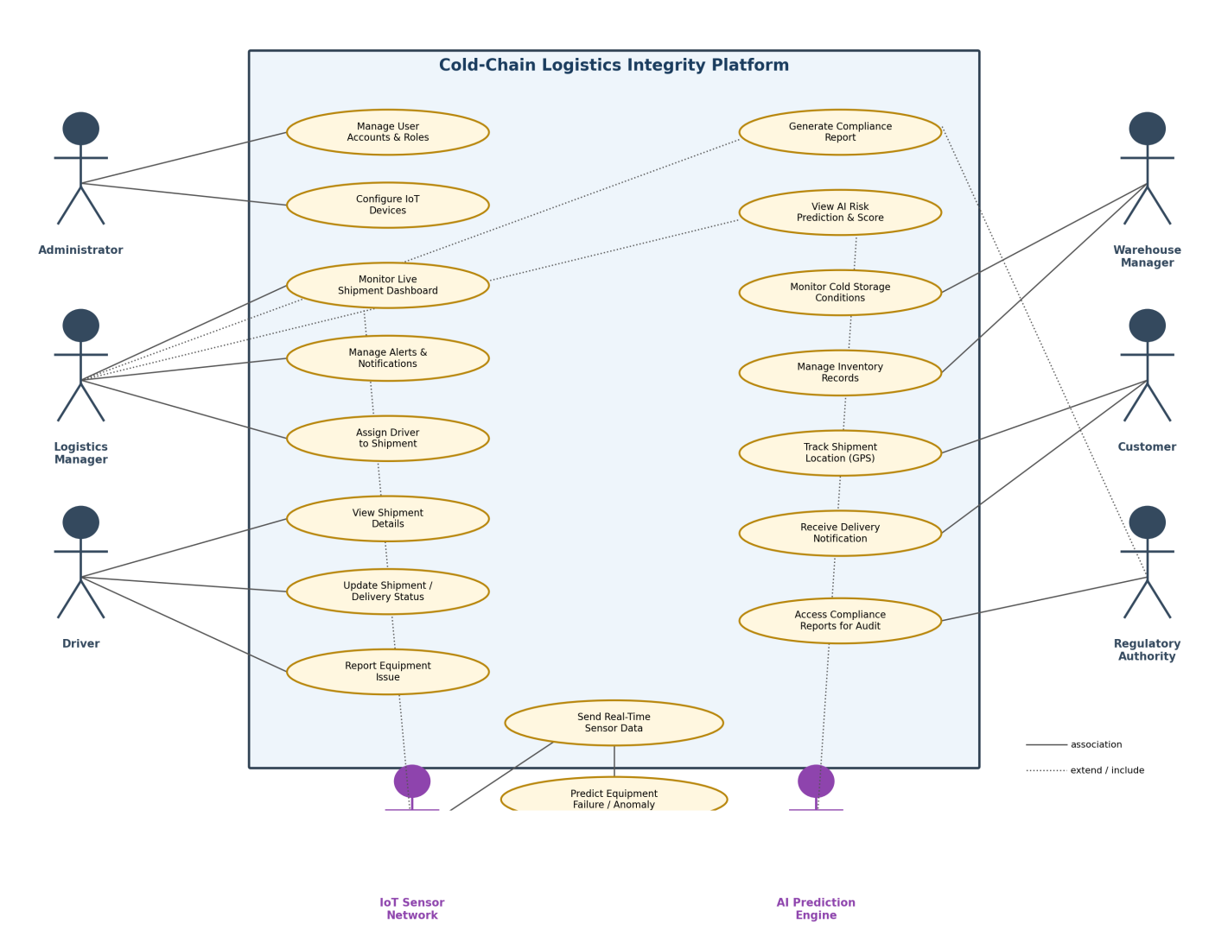

VII. Functional Requirements
ID | Requirement | Description
FR-01 | User Management | The system shall allow registration, secure login, and role-based access for Administrator, Logistics Manager, Driver, Warehouse Manager, and Customer roles.
FR-02 | Shipment Monitoring | The system shall continuously ingest temperature, humidity, GPS location, and door-status data from IoT sensors in near real time.
FR-03 | Alert Management | The system shall detect threshold breaches and abnormal conditions and dispatch alerts via SMS, email, and mobile push notification.
FR-04 | Dashboard | The system shall present a live dashboard with maps, charts, shipment status, and historical sensor data.
FR-05 | AI Prediction | The system shall predict potential refrigeration failures, compute a shipment risk score, and estimate remaining safe-transport time.
FR-06 | Compliance Reporting | The system shall auto-generate exportable PDF compliance reports and maintain tamper-evident audit logs.
FR-07 | Driver Status Updates | The system shall allow drivers to update shipment status and log equipment issues from a mobile app.
FR-08 | Customer Tracking | The system shall allow customers to view live shipment location and receive delivery notifications.
FR-09 | Warehouse Monitoring | The system shall allow warehouse managers to monitor storage-unit conditions and manage inventory records.

VIII. Non-Functional Requirements
ID | Requirement | Description
NFR-01 | Performance | Sensor data shall be processed and reflected on the dashboard within 2 seconds of receipt.
NFR-02 | Scalability | The platform shall support 100,000+ simultaneously connected IoT devices.
NFR-03 | Availability | The system shall maintain 99.9% uptime for monitoring and alerting services.
NFR-04 | Reliability | A fault-tolerant, redundant architecture shall ensure continuous operation during partial failures.
NFR-05 | Security | Data shall be protected with AES encryption at rest, TLS in transit, and Multi-Factor Authentication for user access.
NFR-06 | Maintainability | A modular microservices architecture shall allow independent updates to individual services.
NFR-07 | Usability | The dashboard and mobile app shall provide intuitive navigation requiring minimal training for logistics staff.
NFR-08 | Interoperability | The platform shall expose REST/MQTT interfaces so third-party logistics and ERP/WMS systems can integrate.

IX. Data Requirements
The platform must persist and manage the following core data entities:
Entity | Key Attributes
User | user_id, name, role, email, phone, password_hash, status
Shipment | shipment_id, origin, destination, product_type, assigned_driver, status, start_time, end_time
Device | device_id, type (temp/humidity/GPS/door), vehicle_id/warehouse_id, install_date, health_status
Sensor Reading | reading_id, device_id, timestamp, temperature, humidity, gps_lat, gps_long, door_state
Alert | alert_id, shipment_id, trigger_condition, severity, timestamp, acknowledged_by, resolution_status
Compliance Report | report_id, shipment_id, generated_date, report_file, regulatory_standard, audit_status
Risk Prediction | prediction_id, shipment_id, risk_score, predicted_failure_time, generated_at

Sensor readings and alert/audit records must be retained for a minimum regulatory period (e.g. 3 years for pharmaceutical shipments) and stored in a manner that prevents retroactive modification, to satisfy FDA/FSSAI/WHO audit requirements.

X. External Interface Requirements

User Interfaces
- Web dashboard for Administrators and Logistics Managers (shipment map, charts, alert console, report export).
- Mobile app (Android/iOS) for Drivers (status updates, alerts) and Customers (tracking, notifications).

Hardware Interfaces
- IoT sensor modules (temperature, humidity, GPS, door, refrigeration-unit health) connected via an IoT gateway.
- Gateway connectivity over 4G/5G, Wi-Fi, LoRa, or NB-IoT depending on vehicle/warehouse location.

Software Interfaces
- MQTT-based message broker for sensor ingestion; REST/HTTPS APIs for dashboard and mobile clients.
- Third-party SMS/Email gateway API for alert delivery.
- Integration APIs for external ERP/WMS and logistics partner systems.
- Secure export/submission interface for regulatory authority portals.

Communication Interfaces
- Encrypted communication (TLS 1.2+) between edge devices, gateway, and cloud platform.
- OAuth 2.0-secured APIs for all client and third-party integrations.

XI. System Features
Feature | Priority | Description
Real-Time Shipment Monitoring | High | Continuous ingestion and visualisation of environmental data. Related: FR-02, FR-04, UC-01.
Predictive Maintenance & Risk Scoring | High | AI-driven anomaly detection and failure prediction to enable proactive action. Related: FR-05, UC-02, UC-10.
Automated Alerting | High | Multi-channel notification when readings breach configured thresholds. Related: FR-03, UC-03.
Automated Compliance Reporting | Medium | One-click, audit-ready PDF report generation and tamper-evident logging. Related: FR-06, UC-04.
Role-Based Access Control | Medium | Differentiated dashboards and permissions per actor role. Related: FR-01.
Driver Mobile Workflow | Medium | Status updates and issue reporting from the field. Related: FR-07, UC-05, UC-06.
Customer Shipment Tracking | Low | Customer-facing visibility into shipment location and delivery status. Related: FR-08, UC-08.

XII. Assumptions
- All refrigerated vehicles and storage units can be fitted with compatible IoT sensor hardware.
- A stable cellular or Wi-Fi connection is available along the majority of transport routes.
- Users have access to a smartphone or web browser to use the platform.
- Historical sensor data volumes are within the capacity planned for the cloud storage tier.
- Regulatory reporting formats (FDA, WHO, FSSAI) remain reasonably stable during initial development.

XIII. Constraints
Category | Constraint
Technical | Dependence on continuous network connectivity; GPS signal loss in tunnels, remote areas, or underground storage.
Operational | Requires periodic sensor calibration and battery/hardware maintenance across a distributed device fleet.
Economic | High initial hardware and installation cost; ongoing cloud infrastructure and connectivity costs.
Legal / Regulatory | Must comply with region-specific standards (FDA, WHO, FSSAI, ISO 22000) and data-protection regulations.
Time | Sprint-based delivery must align with the Agile Scrum schedule; delays in IoT hardware procurement can affect pilot timelines.

XIV. Requirement Validation

Completeness Check
Each stakeholder identified in Section IV has at least one corresponding actor, use case, and functional requirement: Administrator → FR-01/UC-Manage Users; Logistics Manager → FR-02–FR-06/UC-01–UC-04; Driver → FR-07/UC-05–UC-06; Warehouse Manager → FR-09/UC-07; Customer → FR-08/UC-08; Regulatory Authority → FR-06/UC-04. No stakeholder from the analysis is left without a mapped requirement.

Consistency and Ambiguity Check
- Terminology is kept consistent (“shipment,” “device,” “actor” used uniformly rather than mixing synonyms).
- Quantified requirements (e.g. NFR-01: “< 2 seconds,” NFR-02: “100,000+ devices”) avoid vague terms such as “fast” or “many.”
- No two requirements in the set directly contradict one another (e.g. real-time alerting (FR-03) and offline GPS constraint (Section XIII) are treated as a constraint, not a conflicting requirement).

Redundancy Check
Overlap between “AI Prediction” (FR-05) and “Send Real-Time Sensor Data” (UC-09) is intentional and modelled explicitly as an include relationship rather than a duplicated requirement, avoiding redundant specification.

Gaps Identified and Suggested Improvements
- Add an explicit data-retention/deletion requirement to fully satisfy data-protection regulations (currently only implied in Section IX).
- Add a non-functional requirement for offline buffering on IoT devices to handle temporary connectivity loss without losing readings.
- Add an explicit use case for “Calibrate/Test Sensor” under the Administrator, referenced in Assumptions but not yet modelled as a use case.
- Define a formal SLA metric for alert-delivery latency (currently only dashboard latency, NFR-01, is quantified).

XV. Conclusion
This scenario-based requirement analysis translates the Cold-Chain Logistics Integrity Platform problem statement into a structured Software Requirement Specification. By identifying actors and their use cases, deriving functional and non-functional requirements, specifying data and interface needs, and validating the requirement set for completeness and consistency, the analysis provides a solid foundation for architecture design and Agile sprint planning. The identified gaps are minor and can be closed in the next requirement-refinement iteration without affecting the overall scope.

XVI. References
- IEEE Xplore Digital Library, IoT in Cold Chain Logistics. Available: https://ieeexplore.ieee.org/
- World Health Organization (WHO), Guidelines on the International Packaging and Shipping of Vaccines and Pharmaceutical Products. Available: https://www.who.int/
- U.S. Food and Drug Administration (FDA), Food Safety Modernization Act (FSMA). Available: https://www.fda.gov/
- Food Safety and Standards Authority of India (FSSAI), Cold Storage and Food Safety Guidelines. Available: https://www.fssai.gov.in/
- OASIS Standard, MQTT Version 5.0 Protocol Specification. Available: https://mqtt.org/
- International Organization for Standardization (ISO), ISO 22000: Food Safety Management Systems. Available: https://www.iso.org/
- IEEE Std 830-1998, Recommended Practice for Software Requirements Specifications.

