TiRex-DHS: Improving the Computational Efficiency of TiRex-2 Through Dynamic Horizon-Aware Sparse Covariate Selection

Research background
Time-series forecasting predicts future values using historical observations. It is used in electricity-demand prediction, weather forecasting, finance, industrial monitoring, and resource planning.
TiRex-2 is a pretrained time-series foundation model. In your experimental setup, it processes the target series and all 100 additional covariate series through its 12 model blocks. The model's weights remain frozen; only the proposed selector is trained.
A covariate is an additional variable that may help predict the target. For example, when forecasting electricity demand, other customers' electricity consumption can be included as covariates.
However, not every covariate necessarily provides useful information. Processing unnecessary series consumes computational resources, and a variable's usefulness may differ between short-term and long-term forecasts.

Problem statement
TiRex-2 processes the input time series supplied to it through its forecasting architecture. When many covariates are provided, some may contribute little additional predictive information while still increasing computational cost.
The research problem is to determine whether a lightweight, dynamic, horizon-aware covariate selection mechanism can reduce the computation required by TiRex-2 while maintaining comparable forecasting accuracy and uncertainty calibration across different prediction horizons.
Specific problems to investigate
- Unnecessary computation: All supplied covariates are processed in the baseline, including variables that may provide little predictive value.
- Changing relevance: The usefulness of a covariate may depend on the current input context and the forecast horizon.
- Accuracy–efficiency trade-off: Removing variables may save computation but could also remove useful predictive information.
- Soft-selection limitation: Down-weighting a covariate does not necessarily save computation if the model still processes that series.
- Generalizability: A selector that removes all covariates on one dataset may not identify useful variables on other datasets.

Research gap
Area | What needs investigation
Covariate relevance | Whether all input series are necessary for accurate forecasts
Horizon awareness | Whether the useful covariates change between 7-, 30-, and 60-day forecasts
Computational efficiency | Whether removing unhelpful series reduces actual runtime, FLOPs, and memory use
Accuracy preservation | Whether sparse selection maintains forecasting performance within an acceptable margin
Selection strategy | Whether hard removal offers practical advantages over soft gating
Statistical reliability | Whether observed accuracy differences are meaningful across test windows
Generalizability | Whether the method works beyond one electricity-demand dataset

Research questions
RQ1 · Primary
Can dynamic, horizon-aware sparse covariate selection reduce TiRex-2's computational cost while maintaining comparable forecasting accuracy?
RQ2 · Selection strategy
How does hard covariate removal compare with soft covariate gating in terms of forecasting accuracy and computational efficiency?

Null and alternative hypotheses
For the primary efficiency question:
- H0₁: Hard selection does not reduce computational cost relative to the baseline.
- H1₁: Hard selection reduces computational cost relative to the baseline.
For the accuracy-preservation question, define an acceptable error margin $δ$in advance:
- H0₂: Hard selection degrades forecasting performance beyond the predefined acceptable margin.
- H1₂: Hard selection remains within the predefined acceptable margin.

What TiRex-2 already does
TiRex-2 has 12 blocks. Every block has two mixers:
- Time mixer. A bidirectional xLSTM. It reads one series at a time and does not look at the other series.
- Variate mixer. Attention across series at the same time position.
After block 12 the network applies a stack norm, an output patch embedding, the tokenizer’s output transform, and the scaler’s inverse transform. The postprocessor turns that tensor into the quantile forecast.
One forward of plain TiRex-2 produces every horizon. Days 7, 30, and 60 are three positions in the same 60-day forecast.
Work per window: 33 series × 12 blocks = 396 series-blocks.
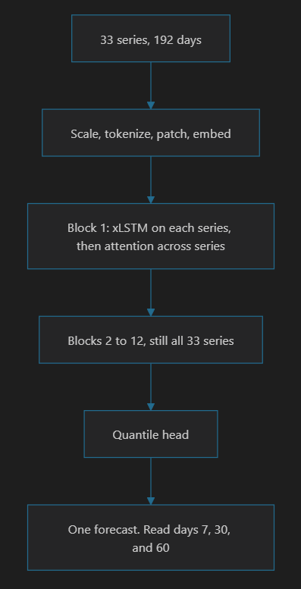
1. Formal selector
The formal selector leaves every series in the tensor. After block 1’s xLSTM it multiplies unselected series by zero. Blocks 2 through 12 still execute all 33 series. At the entrance of each of those blocks the same zero is applied again, because a later xLSTM can otherwise revive a channel that was zeroed.
The gate depends on the horizon, and the hook sits inside the normal TiRex-2 forward. Each horizon needs its own full forward. Days 7, 30, and 60 are three separate passes over all 12 blocks.
Work per window: 33 × 12 × 3 = 1,188 series-blocks.
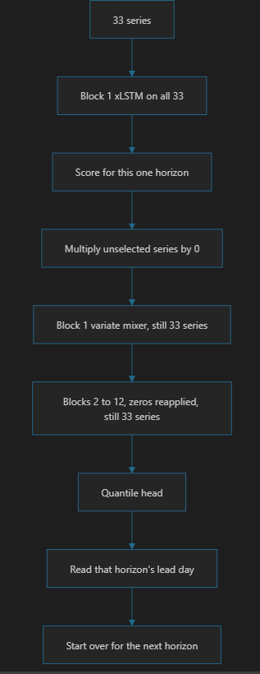

2. Gather selector, the optimized path
The gather selector deletes the unselected series from the tensor before the rest of the network runs. The first xLSTM still sees all 33 series, and that output is cached. Each horizon repeats only the cheaper tail, and that tail contains 4 series.
Work per window: 33 series through 1 time mixer, then 4 series through the remaining 11 blocks, three times.
33 + 4 × 11 × 3 = 165 series-blocks.
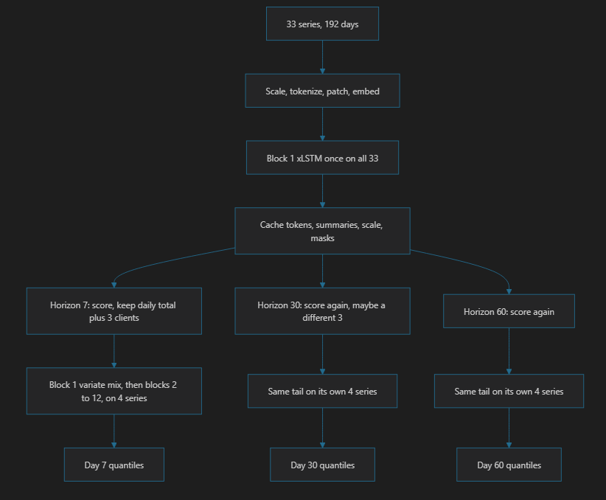

Side-by-Side Comparison
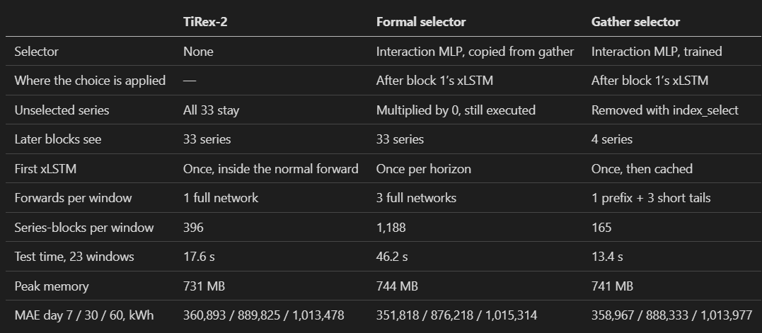

Result Comparison
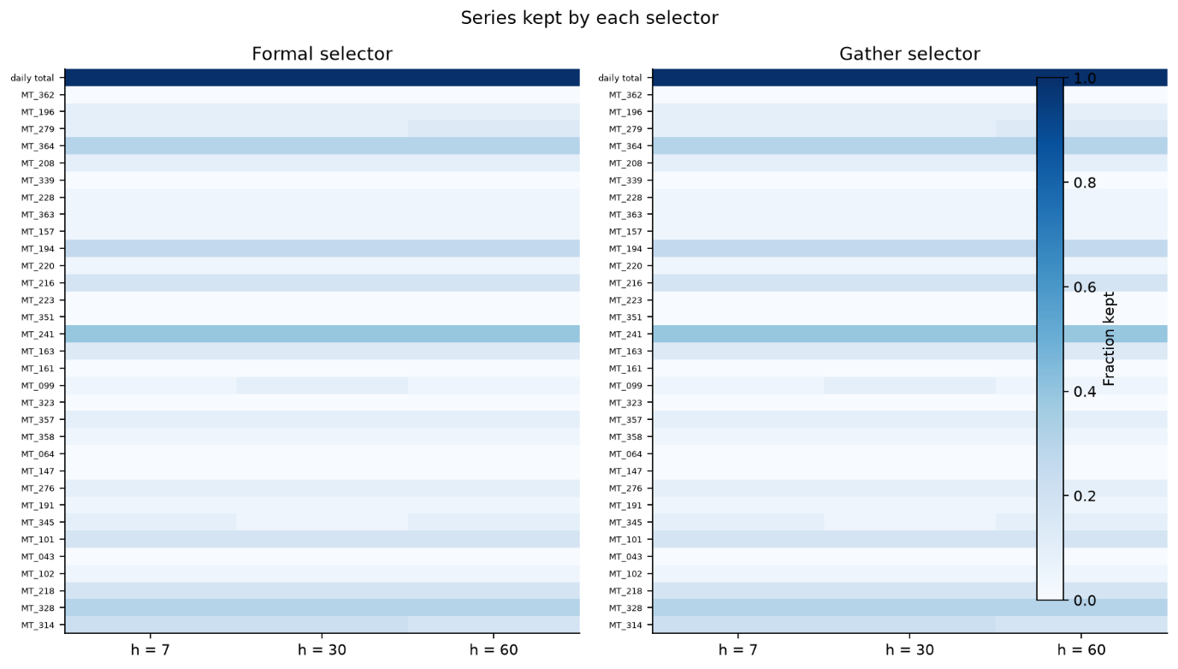
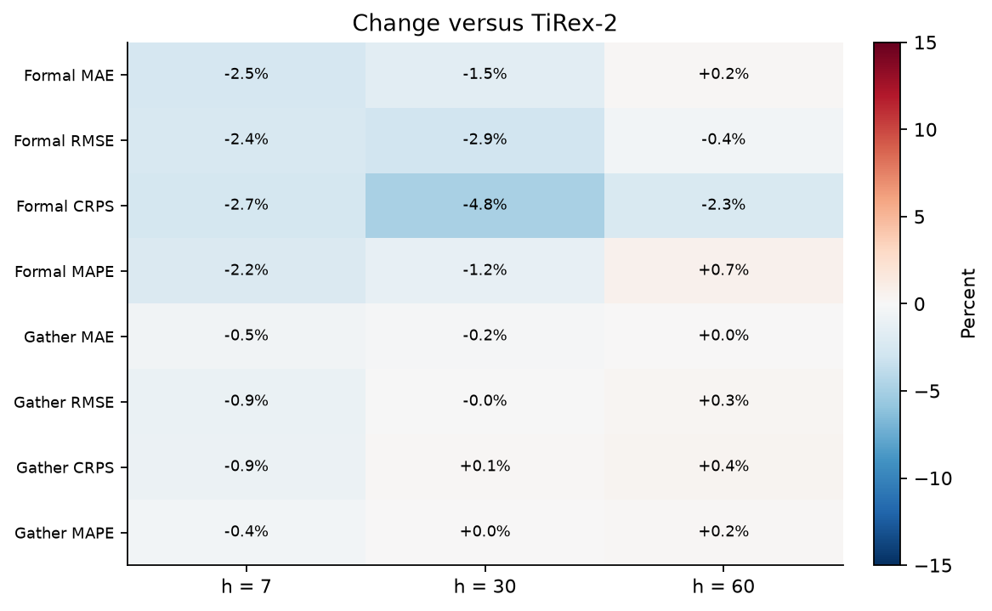

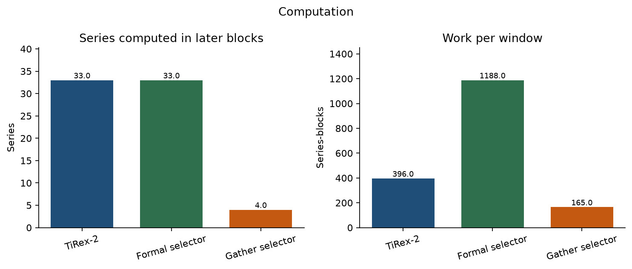
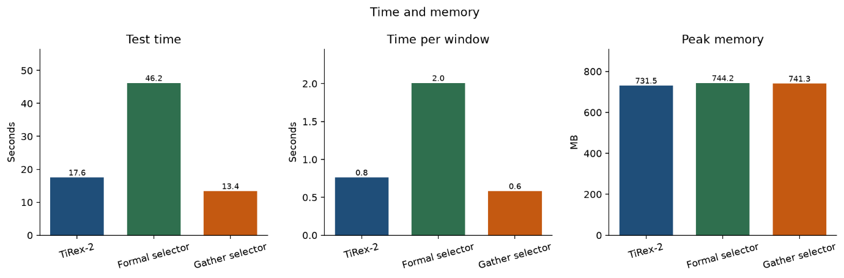
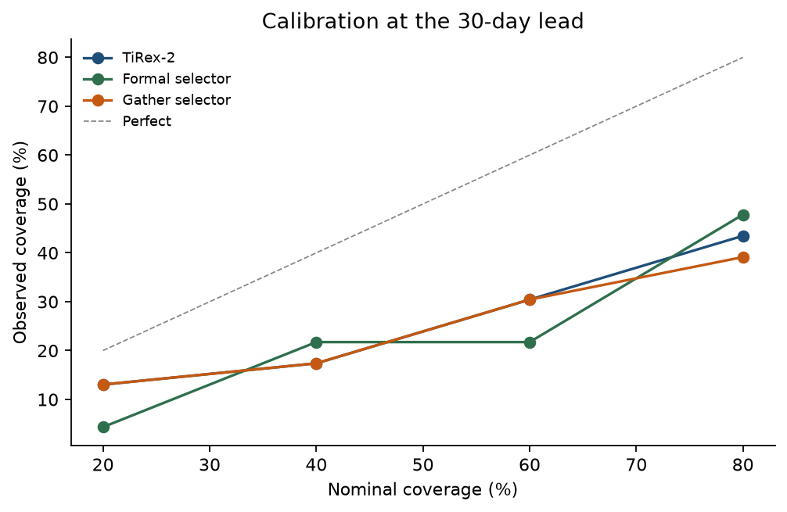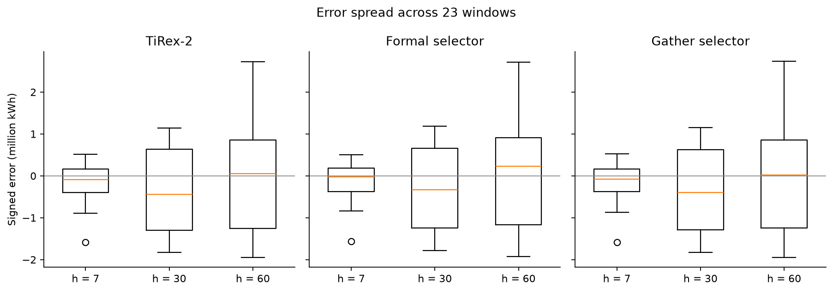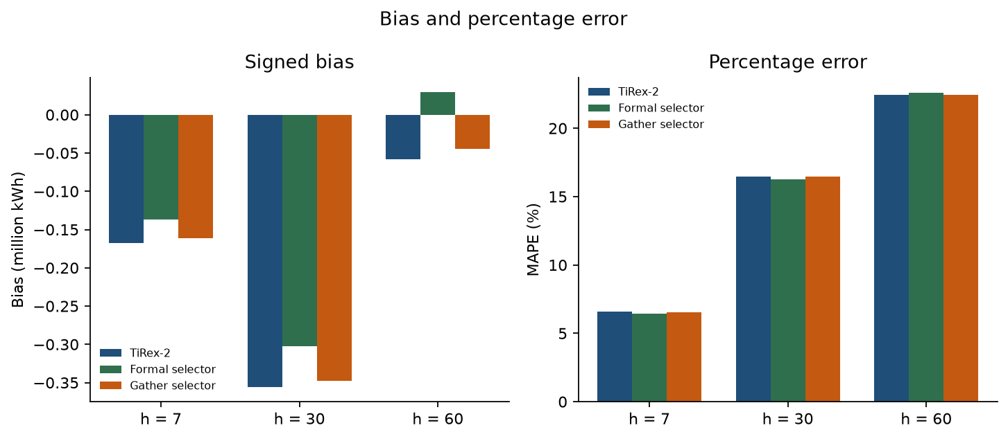
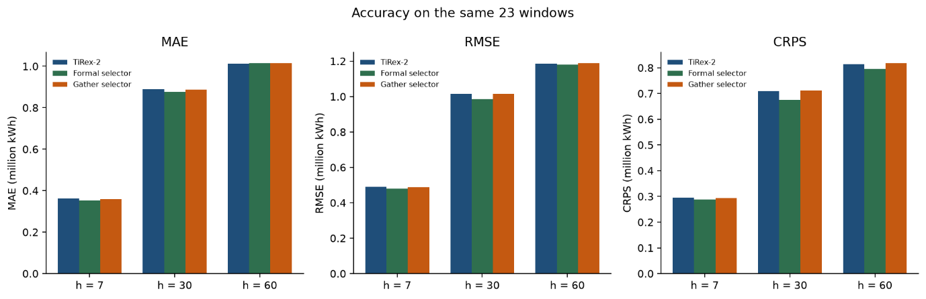
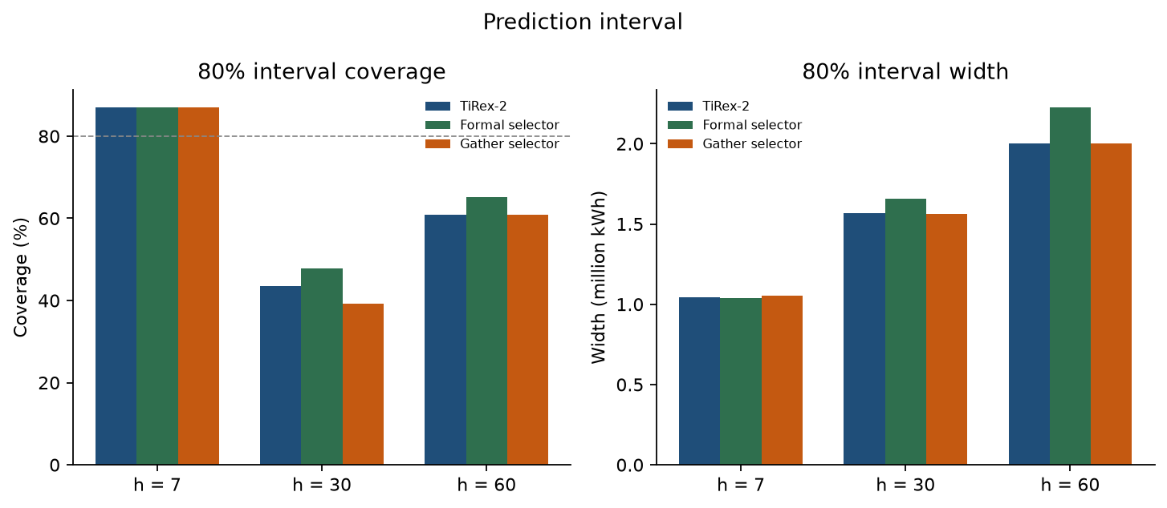

Conclusion:
In conclusion, this research proposes TiRex-DHS, a dynamic, horizon-aware sparse covariate selection mechanism for improving the computational efficiency of TiRex-2. The preliminary results show that hard covariate selection can significantly reduce runtime and computational operations while maintaining comparable forecasting accuracy on the evaluated electricity-demand dataset. However, the current experiment selected no additional covariates, so further experiments are required to determine whether the selector can identify genuinely useful variables. Future work will evaluate the approach across datasets with predictive covariates, different forecasting horizons, and varying numbers of input series to assess its effectiveness and generalizability.

