

SRI SIVANI COLLEGE OF ENGINEERING

Heart Stroke Risk Prediction System With Clinical Safety and Action Plans
A main project report submitted for the partial fulfillment for the requirements of the Award of the Bachelor of Technology
By
Jawaharlal Nehru Technological University, Gurajada, Vizianagaram
In the Discipline of
Artificial Intelligence & Machine Learning
Submitted by
- Rajasekhar (22W61A6105)
B. Tejeswari (22W61A6107)
A. Durga Prasad (22W61A6102)
CH. Santhosh (22W61A6109)
- Gnana Deepthi (22W61A6143)

Under the esteemed guidance of

Mr. P. PRADEEP KUMAR
Assistant Professor
Department of Artificial Intelligence & Machine Learning

SRI SIVANI COLLEGE OF ENGINEERING
(Under the Management of Sri Sivani Educational Society, Srikakulam)

(Approved by AICTE and Permanently Affiliated to JNTUGV, Vizianagaram, Accredited by NAAC, UGC Recognition under 2(f) & 12(B)) NH-16,
Chilakapalem Jn., Srikakulam Dist., Andhra Pradesh -532410



SRI SIVANI COLLEGE OF ENGINEERING

Department of Artificial Intelligence & Machine Learning

CERTIFICATE
This is to certify that the main project report entitled “Heart Stroke Risk Prediction System With Clinical Safety and Action Plans ” submitted by B. RAJASEKHAR (22W61A6105), B. TEJESWARI (22W61A6107), A. DURGA PRASAD (22W61A6102), CH. SANTHOSH (22W61A6109), T. GNANA DEEPTHI (22W61A6143) in partial fulfillment for the award of B. Tech Degree in the discipline of “Artificial Intelligence and Machine Learning” to the Jawaharlal Technological University, Gurajada, Vizianagaram is a record of Bonafide work carried out under our guidance and supervision. The results embodied in this report have not been submitted to any other University or Institute for the award of any degree or diploma.

Signature of the Guide Signature of the H.O.D
Mr. P. Pradeep Kumar Mr. P. Pradeep Kumar
Asst. Professor & H.O.D Asst. Professor & H.O.D
Dept. of AI & ML Dept. of AI & ML

ACKNOWLEDGEMENT

It gives me an immense pleasure to express deep sense of gratitude to my guide, Mr.P.Pradeep Kumar, Assistant Professor & H.O.D , Artificial Intelligence and Machine Learning of whole hearted and invaluable guidance throughout the Project. Without his sustained and sincere effort, this report would not have taken this shape. He encouraged and helped me to overcome various difficulties that I have faced at various stages of my report.

I would like to sincerely thank my R & D IN-Charge Mr. K. Venugopal, Assistant Professor, Department of Computer Science & Engineering, for giving his direct and indirect support throughout this Main Project.

I would like to sincerely thank Mr. P. Pradeep Kumar, Assistant Professor& HOD, Department of Artificial Intelligence & Machine Learning, for providing all the necessary facilities that led to the successful completion of my report.

I take privilege to thank our Principal Dr. Y. Srinivasa Rao who have made the atmosphere so easy to work. I shall always be indebted to them.

I would like to thank all the faculty members of the Department of Artificial Intelligence and Machine Learning for their direct or indirect support and also all the lab technicians for their valuable suggestions and providing excellent opportunities in completion of this report.

B. Rajasekhar | (22W61A6105)
A. Durga Prasad | (22W61A6102)
B. Tejaswani | (22W61A6107)
CH. Santhosh | (22W61A6109)
T. Gnana Deepthi | (22W61A6143)

Abstract: Stroke risk prediction plays a crucial role in preventive healthcare by enabling early identification of individuals who are at high risk and allowing timely medical intervention to reduce mortality rates. This project presents a machine learning–based system designed to predict stroke risk by analyzing demographic information, clinical measurements, lifestyle habits, and medical history of patients. The system applies comprehensive data preprocessing techniques such as Body Mass Index (BMI) imputation, label encoding, and advanced feature engineering to improve prediction accuracy. Important engineered features include age groups, glucose level categories, and combined clinical risk scores that help models capture meaningful health patterns. To address real-world data imbalance and limited stroke cases, the system adopts a dual-dataset training strategy. Model A is trained on the original healthcare dataset containing 5,110 records, while Model B is trained on a large synthetic dataset consisting of 50,000 records to enhance learning capability. Both models utilize ensemble machine learning algorithms, specifically Gradient Boosting and Random Forest classifiers, to achieve better prediction performance. The final prediction is generated through ensemble averaging of both models and is further strengthened by evidence-based clinical rule overrides that account for high-risk factors such as hypertension, elevated glucose levels, and smoking history. The system is deployed as a Flask-based web application integrated with Firebase authentication for secure user access and provides an interactive dashboard including prediction history, doctor recommendations, Indian dietary suggestions, medication tracking, and automated PDF report generation, thereby offering an accurate, interpretable, and practical decision support tool for early stroke risk assessment and preventive healthcare management.

Keywords: Stroke Risk Prediction, Ensemble Learning, Gradient Boosting, Random Forest, Dual-Dataset Training, Clinical Rule Overrides, Flask, Firebase, Feature Engineering, Healthcare Analytics, Preventive Medicine.

TABLE OF CONTENTS

CHPATER 1 INTRODUCTION 1
1.1 Background 1
1.2 Importance of Stroke Prediction 2
1.3 Role of Machine Learning in Healthcare 3
1.4 Problem Statement 4
1.5 Objectives of the Project 4
1.6 Scope of the Project 5
1.7 Organization of the Report 5
CHAPTER 2 LITERATURE REVIEW 7
2.1 Introduction 7
2.2 Machine Learning in Healthcare 8
2.3 Review of Previous Research Studies 9
2.3.1 Study by Smith et al. (2020) 9
2.3.2 Study by Kumar and Sharma (2021) 9
2.3.3 Study by Lee et al. (2021) 9
2.4 Comparative Analysis of Previous Studies 11
2.5 Research Gap 12
2.6 Machine Learning in Healthcare 12
2.7 Stroke Risk Prediction Using Data Analysis 13
2.8 Decision Tree Algorithm in Medical Prediction 13
CHAPTER 3 SYSTEM / METHODOLOGY 17
3.1 Design Approach 17
3.2 System Architecture 19
3.3 Flow Diagram of the System 21
System Flow Diagram 23
3.4 Algorithms Used 24
3.5 Models Used 25
3.6 Tools and Technologies Used 27
CHAPTER 4 IMPLEMENTATION 30
4.1 Implementation 30
4.2 System Modules 32
4.2.1 User Authentication Module 32
4.2.2 Health Data Input Module 32
4.2.3 Stroke Prediction Module 33
4.2.4 Result Display and Recommendation Module 33
4.2.5 Data Storage and Management Module 34
4.3 Code Snapshots 34
Listing 4.3.1 Flask Application Initialization 34
Listing 4.3.2 Feature Preparation Function 36
Listing 4.3.3 Stroke Prediction Route 36
Listing 4.3.4 Firebase Authentication Login 37
Listing 4.3.5 Medication Reminder Scheduler 39
4.4 System Screenshots 39
4.4.1 Login Page 40
4.4.2 User Dashboard 40
Stroke Prediction 41
4.4.3 Stroke Risk Prediction Form 41
4.4.4 Prediction Result Page 42
History 43
4.4.5 Prediction History Page 44
4.4.6 Medication Reminder System 44
4.4.7 Doctor Advice Module 45
4.4.8 Doctor Consultation Module 46
4.5 Results 47
CHAPTER 5 RESULTS AND DISCUSSION 48
5.1 System Testing Overview 48
5.2 Experimental Setup 50
5.2.1 Hardware Requirements 50
5.2.2 Software Requirements 51
5.3 Performance Evaluation 51
5.4 Graphical Analysis 52
5.5 Discussion of Results 55
CHAPTER 6 CONCLUSION AND FUTURE WORK 58
6.1 Conclusion 58
6.2 Limitations of the Systems 60
6.3 Future Enhancements 61
6.4 Final Summary 63
CHAPTER 7 REFERENCES 65

LIST OF FIGURES

Figure 3.1: System Architecture.......................................................................21
Figure 3.2: Flow Diagram 23
Figure 4.1: Login Page of the Stroke Prediction System 40
Figure 4.2: System Dashboard 41
Figure 4.3: Stroke Risk Prediction Input Form 42
Figure 4.4: Stroke Prediction Result 43
Figure 4.5: Stroke Result history 44
Figure 4.6:Medication Remainder Interface 45
Figure 4.7: Doctor Advice Module 46
Figure 4.8: Doctor Consultancy Interface 46
Figure 5.1: Age Distribution.............................................................................53
Figure 5.2: BMI Distribution...........................................................................54
Figure 5.3: Glucose Distribution......................................................................54
Figure 5.4: HyperTenson Distribution 55

LIST OF TABLES

Table 2.1: A Comparison of the Reviewed Studies is Presented Below 11
Table 3.1: Programming Language and FrameWorks Used 29
Table 3.2: Libraries and Supporting Tools 29
Table 5.1: Hardware Requirements for the Working of the Program 50
Table 5.2: Software Requirements for the Working of the Program 51
Table 5.3: Model Accuracy Comparison 52

CHA0PTER 1
INTRODUCTION

Background

Stroke is one of the most serious health problems affecting millions of people around the world. It occurs when the blood supply to the brain is interrupted or reduced, preventing brain tissue from receiving essential oxygen and nutrients. Within a few minutes, brain cells begin to die, which can lead to permanent brain damage, disability, or even death. According to global health organizations, stroke is one of the leading causes of death and long-term disability worldwide.

Early identification of individuals who are at risk of stroke is extremely important in preventive healthcare. Many strokes can be prevented if risk factors are detected early and proper medical intervention is provided. Traditional medical approaches rely on doctors analyzing patient symptoms, medical history, and clinical test results. However, the increasing volume of healthcare data has made manual analysis more complex and time-consuming.

In recent years, advancements in data science and artificial intelligence have enabled the use of machine learning techniques in healthcare applications. Machine learning allows computers to analyze large datasets and identify patterns that may not be easily detected through traditional analysis. These technologies have shown great potential in predicting diseases such as diabetes, heart disease, cancer, and stroke.

Healthcare institutions now generate a large amount of data through electronic health records, laboratory tests, wearable devices, and patient monitoring systems. This data contains valuable information that can be used to build predictive models for disease diagnosis and prevention. Machine learning algorithms can process this data efficiently and generate accurate predictions regarding disease risks.

The integration of machine learning with healthcare systems has opened new possibilities for preventive medicine. Instead of diagnosing diseases only after symptoms appear, predictive models can help identify high-risk patients before severe complications occur. This allows doctors to take preventive actions and provide early treatment.

This project focuses on developing a machine learning-driven stroke risk prediction platform that analyzes patient health data and predicts stroke risk levels. The system also provides healthcare recommendations and guidance to help users maintain a healthy lifestyle.

Importance of Stroke Prediction

Stroke prediction plays a critical role in improving healthcare outcomes and reducing mortality rates. According to medical research, a significant percentage of strokes can be prevented if early warning signs and risk factors are properly identified. One of the main challenges in stroke prevention is the identification of individuals who are at risk but do not yet show severe symptoms. Many people remain unaware of their health conditions until a major medical event occurs. Predictive analytics can help bridge this gap by analyzing existing health information and identifying potential risks.

Machine learning models are capable of analyzing large volumes of medical data and identifying complex relationships between different health indicators. These models can detect patterns and correlations that may not be easily recognized by human analysis. The benefits of stroke prediction systems include:

• Early detection of high-risk individuals

• Improved preventive healthcare strategies

• Better medical decision support for doctors

• Reduced healthcare costs through early intervention

• Increased awareness of lifestyle risk factors

By providing predictive insights, healthcare providers can recommend lifestyle changes, medication, and monitoring strategies to reduce stroke risk.

1.3 Role of Machine Learning in Healthcare

Machine learning has become one of the most powerful technologies in modern healthcare systems. It enables automated analysis of medical data and helps healthcare professionals make more informed decisions. Machine learning algorithms learn from historical data and identify patterns that can be used to make predictions. These algorithms improve their performance as more data becomes available.

In healthcare applications, machine learning is used for:

Disease diagnosis

Medical image analysis

Drug discovery

Personalized treatment planning

Patient monitoring

Predictive analytics

For stroke prediction, machine learning models analyze multiple patient attributes such as age, gender, blood pressure, glucose levels, and lifestyle habits. These attributes are used to estimate the probability of stroke occurrence.

Several machine learning algorithms are commonly used in healthcare prediction systems, including:

Logistic Regression

Decision Trees

Random Forest

Support Vector Machines

Gradient Boosting

Neural Networks

Among these algorithms, ensemble learning methods such as Random Forest and Gradient Boosting often provide higher accuracy because they combine multiple decision models to produce better predictions.

1.4 Problem Statement
Despite advancements in healthcare technology, stroke remains one of the leading causes of death and disability worldwide. Early detection of stroke risk is challenging due to the complexity of medical data and the presence of multiple contributing factors.

Many existing stroke prediction systems rely on traditional statistical models or single machine learning algorithms, which may not provide sufficient accuracy when analyzing complex healthcare datasets. In addition, many datasets suffer from class imbalance, where stroke cases represent only a small percentage of the total data.
Another limitation of existing systems is the lack of practical deployment. Many predictive models are developed only for research purposes and are not integrated into real-world healthcare platforms that patients or doctors can easily use.

Furthermore, most existing systems focus only on prediction and do not provide additional healthcare support such as lifestyle guidance, doctor recommendations, or health reports. Therefore, there is a need to develop an intelligent healthcare
system that can accurately predict stroke risk while also providing user-friendly features for patient guidance and medical decision support.

1.5 Objectives of the Project
The main objective of this project is to develop a machine learning-based stroke risk prediction system that can assist healthcare professionals and patients in identifying potential stroke risks. The specific objectives of the project include:
1.To collect and preprocess healthcare datasets for stroke prediction.
2.To analyze important risk factors such as age, hypertension, glucose levels, BMI, and lifestyle habits.
3.To implement machine learning models such as Random Forest and Gradient Boosting for stroke risk prediction.
4.To improve prediction accuracy using ensemble learning techniques.
5.To develop a web-based application using Flask for real-time stroke risk prediction.
6.To provide healthcare recommendations including diet suggestions, doctor consultation, and medication reminders.

7.To generate downloadable health reports for users.

By achieving these objectives, the system aims to provide a comprehensive healthcare support platform for stroke prevention.

1.6 Scope of the Project

The scope of this project lies in the field of healthcare analytics and machine learning based disease prediction systems. The proposed system focuses on predicting stroke risk using patient health data and providing guidance to reduce potential health risks.The system can be used by individuals, healthcare professionals, and medical researchers to analyze health conditions and identify possible stroke risks.

The key features included within the scope of the project are:

Stroke risk prediction using machine learning algorithms

Data preprocessing and feature engineering

Ensemble learning techniques for improved accuracy

Web-based user interface for easy interaction

Prediction history tracking

Health recommendations and lifestyle guidance

PDF report generation

The project is designed primarily for educational and research purposes but demonstrates the potential for real-world healthcare applications.

1.7 Organization of the Report
The project report is organized into several chapters that describe different aspects of the system.
Chapter 1 provides the introduction to the project, including background information, problem statement, objectives, and scope of the study.
Chapter 2 presents the literature review, which discusses previous research work related to stroke prediction and machine learning applications in healthcare.
Chapter 3 explains the system methodology, including the design approach, architecture, algorithms used, and tools involved in the project.
Chapter 4 describes the implementation process, including system modules, code development, and application interface.
Chapter 5 presents the results and discussion, including performance evaluation, graphs, and analysis of model accuracy.
Chapter 6 provides the conclusion and future work, summarizing the achievements of the project and suggesting possible improvements for future research.

1.8 Limitations of the Study
Although the proposed system provides accurate stroke risk prediction, it has certain limitations. The prediction accuracy depends heavily on the quality and size of the dataset used for training the machine learning models. The system currently uses limited health parameters and does not include advanced clinical test results such as MRI or CT scan data. Additionally, the system is designed mainly for educational and research purposes and should not replace professional medical diagnosis.
Future improvements may include integration with real-time hospital databases and wearable health monitoring devices.

LITERATURE REVIEW

2.1 Introduction

Stroke is one of the leading causes of mortality and long-term disability worldwide. Medical researchers and healthcare organizations have conducted numerous studies to understand the risk factors associated with stroke and to develop predictive models that help identify individuals at risk. With the rapid growth of artificial intelligence and data science, machine learning techniques have been widely applied in healthcare analytics for disease prediction.

Machine learning algorithms are capable of analyzing large volumes of healthcare data and identifying patterns that may not be easily recognized by traditional statistical methods. These models use historical patient data to predict future medical conditions and assist healthcare professionals in making informed decisions.

Many researchers have applied machine learning techniques for predicting diseases such as diabetes, cardiovascular diseases, cancer, and stroke. Stroke prediction is particularly challenging because it involves multiple risk factors including age, hypertension, diabetes, smoking habits, obesity, and cholesterol levels. Therefore, selecting appropriate machine learning algorithms and data preprocessing techniques plays a crucial role in improving prediction accuracy.

This chapter presents a detailed review of previous research work related to stroke prediction using machine learning techniques. The studies reviewed in this chapter highlight different approaches, algorithms, datasets, and results obtained by various researchers.

2.2 Machine Learning in Healthcare

Machine learning has significantly transformed the healthcare industry by enabling automated analysis of medical data. Healthcare institutions generate massive amounts of data through electronic health records, diagnostic tests, and patient monitoring systems. Analyzing such large datasets manually is difficult and time-consuming.

Machine learning algorithms can analyze this data efficiently and identify relationships between different medical parameters. These algorithms can also improve their performance as more data becomes available, making them highly suitable for predictive healthcare systems.

Applications of machine learning in healthcare include:

• Disease diagnosis and prediction

• Medical image analysis

• Drug discovery and development

• Personalized treatment planning

• Patient monitoring systems

• Predictive analytics for preventive medicine

In stroke prediction systems, machine learning algorithms analyze multiple patient attributes such as age, blood pressure, glucose level, smoking habits, and body mass index to estimate the probability of stroke occurrence. Several machine learning algorithms have been used in healthcare prediction models, including Logistic Regression, Decision Trees, Support Vector Machines, Random Forest, Gradient Boosting, and Neural Networks. Among these algorithms, ensemble methods often provide higher prediction accuracy.

2.3 Review of Previous Research Studies

2.3.1 Study by Smith et al. (2020)

Smith and colleagues conducted a study on stroke prediction using logistic regression models. The researchers used a healthcare dataset containing demographic and clinical information such as age, hypertension status, heart disease history, and glucose levels. The logistic regression model was trained using historical patient records to predict stroke occurrence. The study showed that age and hypertension were among the most significant risk factors contributing to stroke. The model achieved moderate prediction accuracy but struggled to capture complex nonlinear relationships among variables. Although logistic regression is simple and interpretable, it may not perform well with complex datasets where multiple variables interact with each other. This limitation highlights the need for more advanced machine learning techniques.

2.3.2 Study by Kumar and Sharma (2021)

Kumar and Sharma proposed a stroke prediction system using Decision Tree and Random Forest algorithms. The researchers used publicly available healthcare datasets and performed extensive preprocessing, including missing value handling and feature scaling. The results showed that Random Forest performed better than the Decision Tree model due to its ensemble nature. Random Forest combines multiple decision trees and aggregates their outputs to produce more reliable predictions. The study concluded that ensemble algorithms provide improved accuracy and robustness compared to individual models.

2.3.3 Study by Lee et al. (2021)

Lee and colleagues conducted research on stroke prediction using Support Vector Machine (SVM) algorithms. The dataset used in the study included various clinical parameters such as BMI, glucose levels, and smoking status. The Support Vector Machine model showed promising results for classification tasks and demonstrated strong performance in handling high-dimensional datasets. However, the computational complexity of SVM models can be high, especially when working with large datasets. The study also emphasized the importance of feature selection in improving model performance.

2.3.4 Study by Wang et al. (2022)
Wang and colleagues developed a machine learning-based stroke prediction system using Gradient Boosting algorithms. The research focused on improving prediction accuracy through sequential model training. Gradient Boosting builds models iteratively by correcting the errors of previous models. This approach allows the algorithm to focus on difficult cases and improve overall performance. The study demonstrated that Gradient Boosting achieved higher accuracy compared to traditional machine learning algorithms.

2.3.5 Study by Patel et al. (2022)
Patel and colleagues proposed a hybrid stroke prediction system that combines multiple machine learning algorithms. The researchers used ensemble learning techniques to integrate the predictions from different models. The ensemble model included Logistic Regression, Random Forest, and Gradient Boosting classifiers. By combining predictions from multiple models, the system achieved improved accuracy and reduced prediction errors. The study highlighted the effectiveness of ensemble learning techniques in healthcare prediction systems.

2.3.6 Study by Chen et al. (2023)
Chen and colleagues focused on addressing the problem of class imbalance in stroke datasets. In most healthcare datasets, the number of stroke cases is significantly smaller than non-stroke cases. To address this issue, the researchers used synthetic data generation techniques such as SMOTE (Synthetic Minority Oversampling Technique). The generated synthetic samples helped balance the dataset and improve model training. The results showed that balanced datasets significantly improved prediction accuracy and model reliability.

2.3.7 Study by Gupta et al. (2023)
Gupta and colleagues proposed a deep learning approach for stroke prediction using neural networks. The model used multiple hidden layers to analyze complex relationships between medical parameters. Although deep learning models showed good performance, they required large datasets and high computational resources. The study concluded that deep learning models are suitable for large-scale healthcare systems but may not be practical for smaller datasets.

2.3.8 Study by Brown et al. (2024)
Brown and colleagues developed a web-based stroke prediction platform using machine learning algorithms. The system allowed users to input their health information and receive real-time predictions. The platform integrated machine learning models with a web interface, making it accessible to both healthcare professionals and patients. The study emphasized the importance of deploying machine learning models in practical healthcare applications

2.4 Comparative Analysis of Previous Studies
The reviewed studies demonstrate that machine learning algorithms have significant potential in predicting stroke risk. However, different algorithms provide varying levels of accuracy and performance.

Table -2.1 : A comparison of the reviewed studies is presented below.
Author | Algorithm Used | Advantages | Limitations
Smith et al. | Logistic Regression | Simple and interpretable | Lower accuracy
Kumar & Sharma | Random Forest | High accuracy | Requires tuning
Lee et al. | SVM | Handles complex data | High computation
Wang et al. | Gradient Boosting | Strong performance | Longer training time
Patel et al. | Ensemble Models | Improved accuracy | Complex implementation
Chen et al. | SMOTE + ML | Handles imbalance | Synthetic data dependency
Gupta et al. | Neural Networks | Captures complex patterns | Requires large dataset
Brown et al. | Web-based ML system | Real-time prediction | Limited features

From the comparison, it can be observed that ensemble learning methods such as Random Forest and Gradient Boosting provide better prediction performance for stroke prediction tasks.

2.5 Research Gap

Although many studies have explored machine learning techniques for stroke prediction, several challenges still remain. First, many existing studies rely on a single machine learning algorithm, which may not provide optimal accuracy when dealing with complex healthcare datasets. Second, many datasets suffer from class imbalance, which can lead to biased prediction models. Third, several research works focus only on prediction accuracy and do not provide practical deployment systems that users can interact with. Finally, most existing systems do not include healthcare guidance features such as lifestyle recommendations, diet suggestions, or doctor consultation support. These gaps highlight the need for a comprehensive stroke prediction system that combines accurate machine learning models with practical healthcare applications.

2.6 Machine Learning in Healthcare

Machine learning has become an important tool in the healthcare sector for analyzing large amounts of medical data and providing intelligent predictions. In recent years, hospitals and medical research institutions have started using machine learning algorithms to predict diseases, analyze patient data, and assist doctors in decision-making. Machine learning systems can analyze medical records, laboratory results, imaging data, and patient history to detect patterns that may not be easily identified by humans. These systems help in early diagnosis and prevention of serious diseases such as heart disease, diabetes, cancer, and stroke.

In the case of stroke prediction, machine learning models analyze several risk factors such as age, blood pressure, heart disease, body mass index (BMI), smoking status, glucose level, and lifestyle habits. By examining these features, the models can estimate the probability of a person experiencing a stroke. Healthcare data is usually complex and contains many variables. Machine learning algorithms are capable of processing such data and identifying hidden relationships between variables. This ability helps researchers and doctors understand the factors that contribute to stroke risk.

Another advantage of machine learning in healthcare is its ability to improve continuously. As more patient data becomes available, the models can be retrained and updated to increase prediction accuracy. This makes machine learning an effective tool for building intelligent healthcare systems.

2.7 Stroke Risk Prediction Using Data Analysis

Stroke is one of the leading causes of death and disability worldwide. Early detection of stroke risk can help in preventing severe complications and saving lives. Researchers have conducted many studies to develop predictive models that can identify individuals who are at high risk of stroke. Traditional medical methods for stroke prediction rely mainly on clinical judgment and manual analysis of patient records. However, these methods may not always be accurate because they depend heavily on human expertise and limited data analysis.

With the advancement of data analytics, researchers have started using large healthcare datasets to study the relationship between various medical factors and stroke occurrence. Data analysis techniques help in identifying important risk factors and patterns that influence stroke development. For example, studies have shown that factors such as hypertension, high cholesterol, diabetes, smoking, obesity, and physical inactivity significantly increase the risk of stroke. By analyzing these factors using machine learning algorithms, researchers can build predictive models that estimate stroke risk with higher accuracy. These predictive models help healthcare professionals identify high-risk patients and recommend preventive measures such as lifestyle changes, medication, and regular medical monitoring.

2.8 Decision Tree Algorithm in Medical Prediction
The Decision Tree algorithm is one of the most commonly used machine learning techniques for classification and prediction tasks. It is particularly useful in medical applications because it provides a clear and interpretable structure for decision-making. A decision tree works by dividing the dataset into smaller subsets based on different conditions or rules. Each internal node of the tree represents a decision based on a specific feature, while each branch represents the outcome of that decision. The final nodes, called leaf nodes, represent the predicted class or outcome. In stroke prediction systems, the decision tree algorithm analyzes various patient attributes such as age, blood pressure, glucose level, BMI, and smoking status. Based on these features, the model determines whether a patient has a high or low risk of stroke.

One of the major advantages of decision trees is their simplicity and interpretability. Doctors and medical professionals can easily understand how the model arrives at a particular prediction. This transparency is very important in healthcare applications where decisions must be explainable. However, decision trees may sometimes suffer from overfitting if the tree becomes too complex. To overcome this problem, ensemble techniques such as Random Forest and Gradient Boosting are often used.

2.9 Random Forest Algorithm
Random Forest is an ensemble machine learning algorithm that improves prediction accuracy by combining multiple decision trees. Instead of relying on a single decision tree, Random Forest builds many trees and combines their predictions to produce a final result. Each tree in the Random Forest is trained using a random subset of the dataset and features. This randomness helps reduce overfitting and improves the robustness of the model. In stroke prediction systems, Random Forest analyzes patient health data and identifies patterns associated with stroke risk. Since multiple trees are used, the model can capture complex relationships between different medical factors.

Another advantage of Random Forest is its ability to measure feature importance. This helps researchers understand which factors contribute the most to stroke risk. For example, features such as hypertension, glucose level, and age may have higher importance scores. Random Forest has been widely used in healthcare prediction models because of its high accuracy, stability, and ability to handle large datasets.

2.10 Logistic Regression for Disease Prediction
Logistic Regression is a statistical machine learning algorithm used for binary classification problems. In stroke prediction systems, logistic regression can be used to classify patients into two categories: stroke risk and no stroke risk.
The algorithm calculates the probability of a particular outcome based on the input features. If the probability exceeds a certain threshold, the patient is classified as having a high risk of stroke.

Logistic regression is widely used in medical research because it is simple, efficient, and easy to interpret. It helps researchers understand how different variables influence the probability of disease occurrence. For example, logistic regression can show how factors such as smoking, high blood pressure, or diabetes increase the likelihood of stroke. These insights are valuable for doctors when recommending preventive measures to patients. Although logistic regression works well for many prediction tasks, it may not capture highly complex relationships in the data. Therefore, it is often combined with other machine learning algorithms to improve performance.

2.11 Challenges in Stroke Prediction Systems
Despite significant advancements in machine learning, several challenges still exist in developing accurate stroke prediction systems. One of the major challenges is the availability of high-quality medical data. Healthcare datasets may contain missing values, incomplete records, or inconsistent measurements. Data preprocessing techniques must be applied to clean and prepare the data before training machine learning models.

Another challenge is the imbalance in medical datasets. In many stroke datasets, the number of patients who experienced a stroke is much smaller compared to those who did not. This imbalance can affect the performance of machine learning algorithms and lead to biased predictions. Privacy and security of medical data is another important concern. Patient information must be handled carefully to protect confidentiality and comply with healthcare regulations.

Furthermore, machine learning models must be validated using reliable evaluation techniques to ensure their accuracy and reliability in real-world applications. Addressing these challenges is essential for developing effective and trustworthy stroke prediction systems.

2.12 Summary
This chapter reviewed the existing research and methodologies related to stroke prediction using machine learning techniques. Various algorithms such as Decision Tree, Random Forest, and Logistic Regression have been widely used for analyzing medical datasets and predicting stroke risk. The literature review highlights the importance of machine learning in healthcare applications. These technologies enable early detection of diseases and support medical professionals in making informed decisions. By analyzing patient health data and identifying key risk factors, machine learning models can provide accurate predictions of stroke risk. This helps in taking preventive measures and improving patient outcomes

SYSTEM / METHODOLOGY

3.1 Design Approach
The design approach of the Stroke Prediction System focuses on developing an intelligent and user-friendly web application that helps predict the risk of stroke based on a user's health data. The system is designed using a modular architecture that integrates machine learning models with a web-based interface to provide accurate predictions, personalized recommendations, and health monitoring features. The primary goal of this approach is to assist users in identifying potential stroke risks early and encourage preventive healthcare actions.
The system follows a client–server architecture where the frontend interacts with a backend server to process user inputs and generate predictions. The backend is implemented using the Flask framework in Python, which manages the core logic of the application. This includes handling user authentication, processing health data, executing prediction models, storing results, and generating recommendations. The modular structure ensures that each component of the system performs a specific function while maintaining flexibility for future improvements.
A machine learning–based prediction module forms the core of the system design. The application loads pre-trained stroke prediction models that analyze health-related parameters such as age, body mass index (BMI), glucose level, hypertension status, heart disease, and smoking habits. These inputs are processed through feature preparation techniques that transform raw data into structured numerical features suitable for prediction. The prediction results are then used to classify the user’s stroke risk level as low, medium, or high.
Another important part of the design is the data management component. The system stores user information, prediction results, medication records, and doctor advice history in structured JSON files. This approach allows efficient data retrieval and easy updates while maintaining simplicity in storage management. The design ensures that users can review their past predictions and monitor their health data over time.
User authentication and security are also incorporated into the system design. Firebase authentication is used to manage secure user login and registration processes. This ensures that only authorized users can access their personal health data. Additionally, email notification services are integrated to inform users about important events such as account login alerts and medication reminders.
The design approach also includes a health recommendation module that provides food suggestions and lifestyle guidance based on the user’s health parameters. By analyzing factors such as glucose levels, BMI, hypertension, and heart disease, the system generates personalized dietary recommendations and advice. These recommendations help users adopt healthier habits that may reduce their stroke risk.
Another key feature included in the design is the medication reminder system. A background scheduler continuously checks medication schedules stored in the system and sends email reminders if users have not taken their prescribed medication. This automated reminder system helps users maintain regular medication routines and supports better health management.
To enhance usability, the system also supports natural language input for health descriptions. Users can enter health information in text form, and the system extracts relevant health parameters using text processing techniques. This feature improves accessibility and simplifies data entry for users who may not be familiar with structured forms.
Finally, the design incorporates testing and evaluation mechanisms to ensure system reliability and accuracy. The machine learning models are validated using stored datasets, and the application is tested to verify that predictions, recommendations, and reminders function correctly. Through this structured design approach, the Stroke Prediction System provides a comprehensive and reliable platform for stroke risk assessment and preventive healthcare support.

3.2 System Architecture
The system architecture of the Stroke Risk Prediction System is designed using a layered architecture that integrates a web-based interface, backend processing, machine learning models, and external services. The architecture allows smooth interaction between different components of the system to process user data and generate stroke risk predictions efficiently. The design ensures scalability, modularity, and security while maintaining a user-friendly experience.

At the top layer of the architecture is the User Interface Layer, where users interact with the system through a web browser. Users can perform operations such as registration, login, entering health details, viewing prediction results, checking medication reminders, and accessing doctor recommendations. This layer provides an easy and interactive environment that allows users to access system features without requiring technical knowledge.

The next layer is the Frontend Layer, which is responsible for displaying web pages and handling user interactions. The frontend is developed using HTML, CSS, JavaScript, and Jinja2 templates. These technologies allow the system to dynamically render web pages and communicate with the backend server. The frontend also includes authentication scripts and theme controls to improve usability and provide a smooth user experience.

The Backend Layer is implemented using the Flask framework in Python. This layer acts as the central processing unit of the application and manages all server-side operations. The backend handles multiple routes such as login, registration, dashboard access, prediction requests, medication management, and doctor recommendations. It also manages user sessions and processes data received from the frontend before passing it to the machine learning models.

A key component of the architecture is the Machine Learning Module, which performs stroke risk prediction. The system uses trained machine learning models developed using libraries such as Scikit-learn. These models analyze user health parameters such as age, glucose level, BMI, hypertension status, heart disease, and smoking habits. Based on these inputs, the models classify the user’s stroke risk level and return the prediction results to the backend server.

The architecture also includes a Local Data Storage Layer that stores important system data. Instead of using a traditional database, the system uses JSON files to store information such as user details, prediction results, and medication schedules. This storage structure allows the application to quickly retrieve and update information while keeping the system simple and lightweight.

Another important part of the architecture is the External Services Layer. This layer integrates external services such as Firebase Authentication and email notification systems. Firebase is used to manage user authentication securely, while email services are used to send alerts such as login notifications and medication reminders. These external services enhance system functionality and improve user engagement.

The system also includes a background scheduling component that periodically checks medication schedules and sends reminders to users. This feature ensures that users receive timely notifications about their prescribed medications, helping them maintain proper health management. Overall, the architecture of the Stroke Risk Prediction System combines web technologies, machine learning models, local data storage, and external services into an integrated framework. This architecture ensures that the system operates efficiently while providing accurate predictions, secure data management, and useful health recommendations for users.

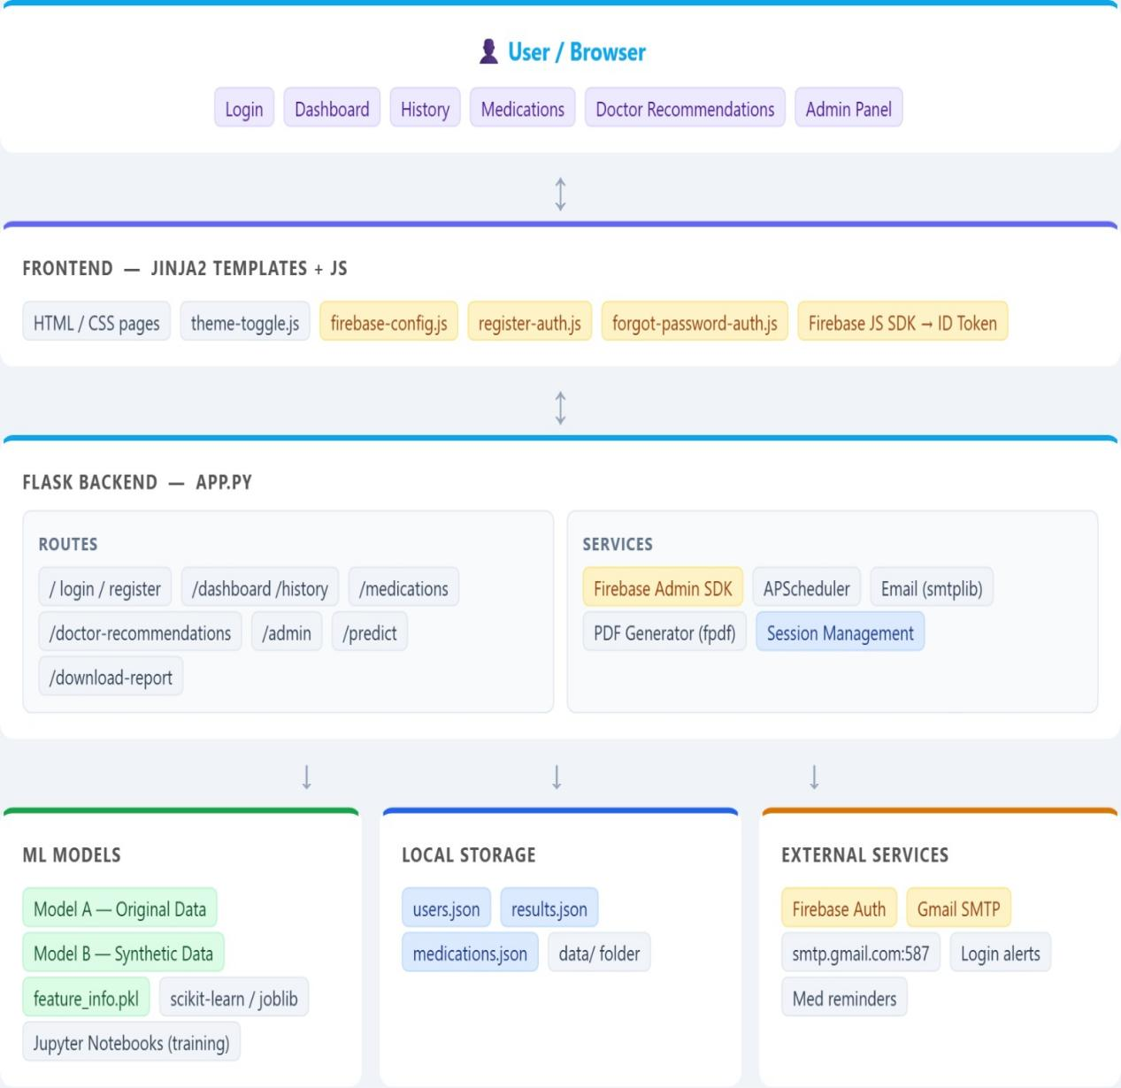
Figure 3.1: System Architecture Diagram

3.3 Flow Diagram of the System
The flow diagram of the Stroke Risk Prediction System describes the sequence of operations that occur from the moment a user interacts with the system until the final prediction and recommendations are displayed. It illustrates how data moves through different modules of the system and how each component processes the information to generate results. The flow begins with the user accessing the web application through a browser interface.

The first step in the system flow is user authentication. When a user opens the application, they are required to register or log in using their credentials. The system verifies the login information through the authentication module. Once the authentication is successful, the user is granted access to the main dashboard of the application. This ensures that only authorized users can access personal health records and prediction services.

After logging in, the user enters the health information required for stroke prediction. These inputs may include parameters such as age, gender, hypertension status, heart disease condition, average glucose level, body mass index (BMI), smoking status, and other relevant medical factors. The system collects these values through an input form and sends the data to the backend server for processing.

In the next stage, the backend system processes the data and sends it to the machine learning model. The trained prediction model analyzes the provided health parameters and calculates the probability of stroke risk. Based on the analysis, the model generates a prediction result, which is then returned to the backend server. The system may also store the prediction result in the local storage for future reference.

Finally, the system displays the prediction result and additional recommendations to the user. If the predicted risk level is high, the system may provide doctor recommendations, medication reminders, or health suggestions to help the user manage their condition. This complete process ensures that users receive quick, accurate, and helpful information regarding their stroke risk while maintaining an easy and structured system workflow.

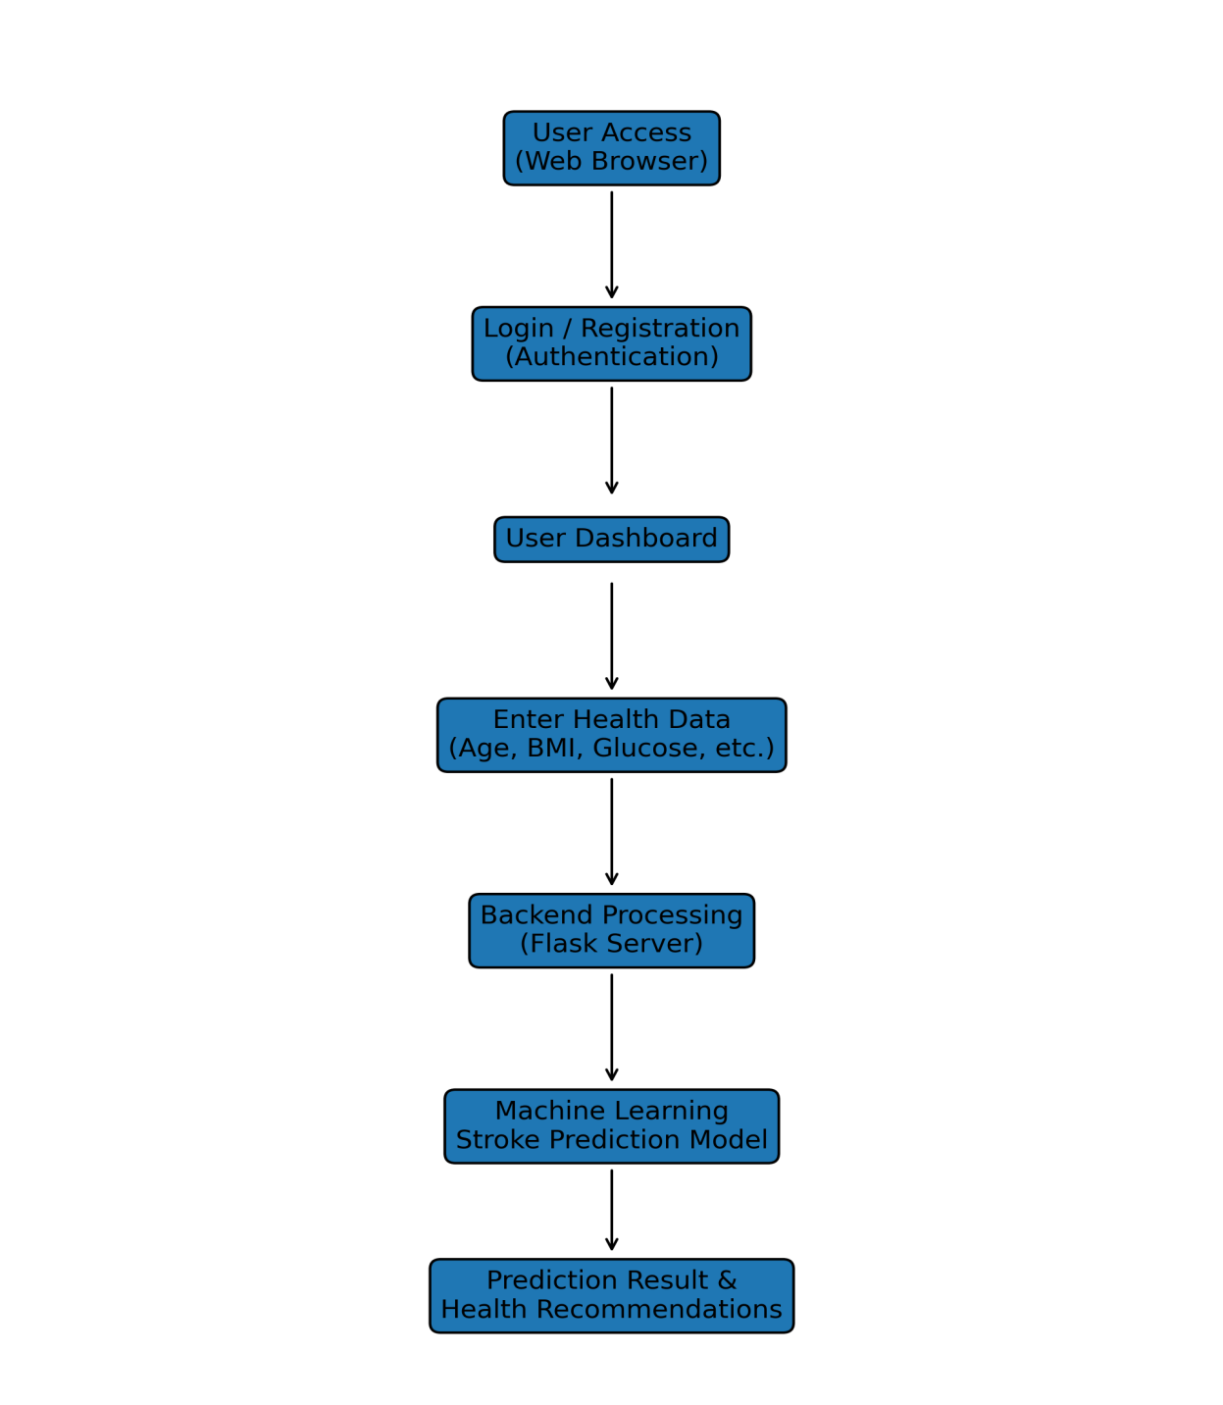
Figure 3.2: Flow Diagram

3.4 Algorithms Used
The Stroke Risk Prediction System uses machine learning algorithms to analyze user health data and determine the likelihood of a stroke. These algorithms help the system identify patterns within medical datasets and generate predictions based on various health parameters. The algorithms are trained using historical medical data that contains information about individuals and their stroke conditions. After training, the models can analyze new user inputs and provide an accurate prediction of stroke risk.

One of the main algorithms used in the system is Logistic Regression. Logistic Regression is a supervised machine learning algorithm commonly used for binary classification problems. In this project, the algorithm predicts whether a person is likely to experience a stroke or not based on the input health parameters. It calculates the probability of stroke occurrence using a logistic function and classifies the result into two categories: stroke risk present or stroke risk absent.

Another algorithm used in the system is the Decision Tree Classifier. A Decision Tree works by dividing the dataset into smaller subsets based on different feature conditions. Each node in the tree represents a decision rule based on a specific health parameter such as age, glucose level, or BMI. The algorithm continues splitting the data until it reaches a final decision node, which represents the prediction result. Decision Trees are useful because they are easy to understand and can visually represent how decisions are made within the model.

The system may also utilize the Random Forest Algorithm, which is an ensemble learning method. Random Forest works by creating multiple decision trees during training and combining their outputs to produce a more accurate and stable prediction. Instead of relying on a single decision tree, the algorithm aggregates predictions from many trees and selects the most common result. This method helps reduce overfitting and improves prediction accuracy.

Another useful algorithm for classification tasks is the K-Nearest Neighbors (KNN) algorithm. KNN works by comparing a new data point with previously stored training data. It identifies the closest data points (neighbors) in the dataset and assigns the prediction based on the majority class among those neighbors. In the context of stroke prediction, the algorithm compares the user’s health data with similar patient records and determines the risk based on those similarities.

Before applying these algorithms, the system performs data preprocessing. This step involves cleaning the dataset, handling missing values, converting categorical variables into numerical form, and normalizing numerical features. Proper preprocessing ensures that the machine learning algorithms can analyze the data effectively and produce reliable predictions.

The trained machine learning models are then integrated into the backend of the system using Python libraries such as Scikit-learn. When a user enters health data through the web interface, the backend processes the input and sends it to the trained model. The model then evaluates the data and returns a prediction result indicating the user's stroke risk level.

The prediction result generated by the algorithm is further processed by the system to provide meaningful feedback to the user. If the model predicts a higher risk of stroke, the system may display health recommendations, doctor suggestions, or medication reminders. This helps users take preventive actions and manage their health more effectively.

Overall, the use of machine learning algorithms in the Stroke Risk Prediction System enables the application to perform intelligent analysis of health data. By combining different algorithms and preprocessing techniques, the system ensures better prediction accuracy and provides users with valuable insights about their potential stroke risk.

3.5 Models Used
The Stroke Risk Prediction System uses machine learning models to analyze health-related data and determine the probability of a stroke occurring in an individual. These models are trained using historical medical datasets that contain information about various health conditions and their relationship to stroke occurrences. By learning patterns from this data, the models can predict stroke risk when new user data is provided through the system.

One of the primary models used in the system is the Logistic Regression Model. Logistic Regression is widely used for medical prediction systems because it is effective for binary classification problems. In this project, the model analyzes input variables such as age, hypertension status, heart disease condition, glucose level, and body mass index to determine the probability that a person may experience a stroke. The output is generally represented as a probability value which is then classified as either high risk or low risk.

Another important model used in the system is the Decision Tree Model. The Decision Tree model works by creating a tree-like structure of decisions based on different health parameters. Each branch in the tree represents a condition related to a specific feature, such as whether a person has hypertension or whether their glucose level is above a certain threshold. The model continues splitting the data into smaller groups until it reaches a final prediction node that indicates the stroke risk.

The Random Forest Model is also commonly used to improve prediction accuracy. Random Forest is an ensemble learning model that builds multiple decision trees during training and combines their results to make a final prediction. Instead of relying on a single tree, the system takes the majority vote from several trees, which helps reduce prediction errors and increases the reliability of the model.

Another model that can be applied in stroke prediction systems is the K-Nearest Neighbors (KNN) Model. This model works by comparing a new data sample with previously stored training samples. It identifies the closest neighbors in the dataset and assigns the prediction based on the majority class among those neighbors. In this project, the KNN model compares the user’s health information with similar patient records to estimate the stroke risk.

Before training the models, the dataset undergoes feature selection and preprocessing. Important features such as age, hypertension, heart disease, glucose level, BMI, and smoking status are selected because they have a strong influence on stroke risk. These features are cleaned, normalized, and converted into numerical values so that the machine learning models can process them efficiently.

Once the models are trained, they are saved and integrated into the backend system. When a user submits their health information through the web interface, the backend loads the trained model and passes the input data to it. The model then processes the data and generates a prediction result that indicates whether the user is at risk of stroke. The output produced by the model is then displayed to the user through the web application dashboard.

Along with the prediction result, the system may also provide additional recommendations such as consulting a doctor, monitoring health parameters, or following preventive health measures. Overall, the use of machine learning models allows the Stroke Risk Prediction System to perform intelligent data analysis and provide accurate health predictions. These models help transform raw medical data into meaningful insights that can assist users in understanding and managing their health risks more effectively.

3.6 Tools and Technologies Used
The development of the Stroke Risk Prediction System requires a combination of programming languages, frameworks, machine learning libraries, and supporting tools. These technologies work together to build a complete web-based application capable of predicting stroke risk based on user health data. The system integrates frontend technologies for the user interface, backend technologies for data processing, and machine learning libraries for prediction analysis.

The main programming language used in this project is Python. Python is widely used in machine learning and web development due to its simplicity and large number of libraries. It is used to implement the backend logic of the system, handle user requests, process input data, and integrate machine learning models into the application.

The web application is built using the Flask framework, which is a lightweight web framework for Python. Flask allows developers to create web applications quickly while maintaining flexibility. It is responsible for handling routes, managing user sessions, processing form data, and connecting the frontend interface with the machine learning models used for stroke prediction.

For the frontend development, technologies such as HTML, CSS, JavaScript, and Jinja2 templates are used. HTML provides the structure of the web pages, CSS is used for styling and layout design, and JavaScript enables interactive functionality within the user interface. Jinja2 templates are used within the Flask framework to dynamically generate web pages based on backend data.

The machine learning part of the system is implemented using the Scikit-learn library. This library provides various algorithms and tools that allow the system to train models and perform predictions. It helps in implementing classification models such as Logistic Regression, Decision Trees, and Random Forest, which are commonly used for medical prediction systems.

The system also uses JSON files for local data storage. These files store important data such as user information, prediction history, and medication schedules. Using JSON makes the system lightweight and easy to manage without the need for a complex database system.

In addition to these tools, the system may also integrate Firebase Authentication and Email services for user authentication and notifications. These services improve system security and provide features such as login verification and email alerts for medication reminders or system updates.

Overall, the combination of these technologies helps create a reliable and efficient stroke prediction system. Each technology contributes to a specific part of the system, ensuring smooth functionality, accurate predictions, and an interactive user experience.

Table 3.1 :Programming Languages and Frameworks Used
S.NO | Technology | Type | Purpose
1 | Python | Programming Language | Used for backend development and machine learning implementation.
2 | Flask | Web Framework | Handles routing, server logic, and integration of ML models.
3 | HTML | Markup Language | Used to structure web pages.
4 | CSS | Styling Language | Used to design and format the user interface.
5 | JavaScript | Scripting Language | Provides interactivity in the web application.
6 | Jinja2 | Template Engine | Dynamically renders HTML pages in Flask.

Table 3.2 Libraries and Supporting Tools
S.No | Tool / Library | Category | Purpose
1 | Scikit-learn | Machine Learning Library | Used to train and implement prediction models
2 | Pandas | Data Processing Library | Used for dataset manipulation and preprocessing
3 | NumPy | Numerical Computing Library | Used for mathematical operations on datasets
4 | JSON | Data Storage Format | Used to store user data and prediction results
5 | Firebase | Authentication Service | Used for secure user login and authentication
6 | SMTP Email Service | Notification System | Used to send alerts and medication reminders

IMPLEMENTATION

4.1 Implementation
The implementation phase of the Stroke Risk Prediction System focuses on converting the designed system architecture into a fully functional application. In this phase, all modules of the system are developed and integrated to ensure that the application performs efficiently and provides accurate predictions. The implementation process involves combining the frontend interface, backend processing, machine learning model, and data storage mechanisms into a single working platform.

The system is implemented using the Python programming language due to its flexibility and strong support for machine learning and web development. Python provides a wide range of libraries that simplify data processing, model development, and application integration. Its simple syntax and large developer community make it an ideal choice for developing intelligent healthcare applications.

The backend of the application is developed using the Flask web framework. Flask is a lightweight and efficient framework that allows developers to build web applications quickly. It handles routing, server-side logic, and communication between different components of the system. The backend processes user inputs, interacts with the machine learning model, and returns prediction results to the frontend interface.

The frontend of the application is designed using HTML, CSS, and JavaScript. HTML is used to structure the web pages, CSS is used for styling and layout design, and JavaScript is used to add interactive features to the system. These technologies work together to create a user-friendly interface that allows users to easily interact with the application and input their health information.

The system also uses Jinja2 templates within the Flask framework to dynamically generate web pages. Jinja2 allows the backend to send data directly to the frontend pages and display results dynamically. This helps the system display prediction results, user information, and recommendations without requiring page reloads or manual updates.

The machine learning component of the system is implemented using the Scikit-learn library. This library provides various algorithms and tools required for training predictive models. The stroke prediction model is trained using medical datasets that contain information about several health parameters such as age, hypertension, heart disease, glucose levels, and BMI.

Before training the machine learning model, the dataset undergoes preprocessing steps such as data cleaning, handling missing values, and converting categorical variables into numerical form. These preprocessing steps help improve the performance and accuracy of the model by ensuring that the input data is suitable for machine learning analysis.

Once the model is trained and evaluated, it is integrated into the Flask backend. When a user submits their health information through the web interface, the backend processes the data and sends it to the trained model. The model then analyzes the input parameters and generates a prediction indicating the risk level of stroke. The system stores user information, prediction history, and other related data using JSON files. This approach simplifies data management and allows the system to retrieve stored information whenever required. The lightweight storage system ensures that the application remains simple while still maintaining proper data handling capabilities.

Overall, the implementation of the Stroke Risk Prediction System integrates modern web development technologies and machine learning techniques to create a reliable healthcare prediction tool. The system provides an efficient platform where users can enter their health data, receive stroke risk predictions, and obtain helpful recommendations for improving their health and preventing potential stroke risks.

4.2 System Modules
The Stroke Risk Prediction System is divided into several functional modules to ensure that the system operates efficiently and each component performs a specific task. Modular development helps simplify the implementation process, improves system organization, and makes the application easier to maintain and update. Each module of the system is responsible for handling a particular function, such as user authentication, data input, prediction processing, and result generation.

4.2.1 User Authentication Module
The User Authentication Module is responsible for managing user registration and login operations. This module ensures that only authorized users can access the system and use the stroke prediction features. During the registration process, users are required to provide basic information such as username, email address, and password. The system verifies the provided information and stores it securely for future login purposes. Once a user registers successfully, they can log in to the system using their credentials. The login process verifies the entered username and password with the stored records. If the credentials match, the system grants access to the user dashboard. This process helps maintain data security and ensures that only registered users can use the system services.

The authentication module also manages user sessions during system usage. When a user logs in, a session is created to keep the user authenticated while navigating different pages of the application. When the user logs out, the session is terminated to prevent unauthorized access.

4.2.2 Health Data Input Module
The Health Data Input Module allows users to provide the medical and lifestyle information required for stroke risk prediction. The system collects important health parameters through an interactive web form designed to be simple and user-friendly. Users can easily enter their personal health details without requiring technical knowledge.
The information collected in this module includes factors such as age, gender, hypertension status, heart disease condition, average glucose level, body mass index (BMI), and smoking status. These parameters are important indicators that help the machine learning model determine the risk of stroke.

Once the user submits the health data, the system validates the inputs to ensure that the information is complete and correctly formatted. After validation, the data is sent to the backend processing module where it will be prepared for prediction analysis.

4.2.3 Stroke Prediction Module
The Stroke Prediction Module is the core component of the system. This module is responsible for analyzing the user’s health data and predicting the risk of stroke using trained machine learning models. The prediction process begins when the backend receives the user’s input data from the health data input module. The machine learning model analyzes the input parameters and compares them with patterns learned during the training phase. Based on this analysis, the model calculates the probability of stroke occurrence and classifies the result as either high risk or low risk.
This module ensures that the prediction process is performed quickly and accurately. The prediction result is then returned to the backend server, which prepares the output for display on the user interface.

4.2.4 Result Display and Recommendation Module
The Result Display and Recommendation Module presents the prediction outcome to the user in a clear and understandable format. Once the machine learning model generates the prediction result, the system displays the risk level through the user dashboard. The result page provides information about whether the user has a high or low risk of stroke. In addition to the prediction result, the system may also provide health recommendations to help users improve their lifestyle and reduce potential risk factors. If the system detects a higher risk level, it may suggest preventive measures such as maintaining a healthy diet, regular exercise, monitoring blood pressure and glucose levels, and consulting a medical professional for further evaluation.

4.2.5 Data Storage and Management Module
The Data Storage and Management Module is responsible for storing and managing important system data. The application uses JSON files as a lightweight storage solution for saving user information, prediction results, and other related data.
This module ensures that user data is organized properly and can be retrieved whenever required. For example, users may want to view their previous prediction results or update their personal information. The storage system allows the application to manage such operations efficiently. The module also helps maintain data consistency and ensures that information is updated correctly whenever changes occur. Proper data management improves system reliability and supports smooth application performance.

4.3 Code Snapshots
This section presents important code snippets used in the implementation of the Stroke Risk Prediction System. These code segments demonstrate how different modules of the application are implemented using the Python programming language and the Flask web framework. The code handles tasks such as application initialization, feature preparation for machine learning models, stroke risk prediction, authentication, and medication reminder scheduling. The following listings highlight key parts of the backend implementation.

Listing 4.3.1 Flask Application Initialization
The following code initializes the Flask application and loads required libraries such as NumPy, Pandas, and Joblib. It also configures Firebase authentication and environment variables used by the system.

from flask import Flask, render_template, request, jsonify, redirect, url_for, session
import joblib
import pandas as pd
import numpy as np
import os
import json
from datetime import datetime
from dotenv import load_dotenv
# Load environment variables
load_dotenv()
app = Flask(__name__)
app.secret_key = 'stroke_prediction_secret_key_2024'
This code initializes the Flask web application and prepares the system environment for running the backend services.
Listing 4.3.2 Feature Preparation Function
The following function prepares the input data for the machine learning models. It converts categorical values into numerical form and creates additional features such as interaction variables and risk scores.

def prepare_features(data):
gender_map = {'Male': 1, 'Female': 0}
smoking_map = {'never smoked': 0, 'formerly smoked': 1,
'Unknown': 2, 'smokes': 3}
age = float(data['age'])
gender = gender_map.get(data['gender'], 0)
hypertension = int(data['hypertension'])
heart_disease = int(data['heart_disease'])
avg_glucose_level = float(data['avg_glucose_level'])
bmi = float(data['bmi'])
smoking_status = smoking_map.get(data['smoking_status'], 0)
age_glucose_interaction = age * avg_glucose_level
age_bmi_interaction = age * bmi
features = pd.DataFrame({
'gender': [gender],
'hypertension': [hypertension],
'heart_disease': [heart_disease],
'avg_glucose_level': [avg_glucose_level],
'bmi': [bmi],
'smoking_status': [smoking_status],
'age': [age],
'age_glucose_interaction': [age_glucose_interaction],
'age_bmi_interaction': [age_bmi_interaction]
})
return features
This function transforms user health inputs into a structured format that can be processed by the machine learning models.
Listing 4.3.3 Stroke Prediction Route
The following code implements the /predict route which receives health data from the user and performs stroke risk prediction using the trained models.

@app.route('/predict', methods=['POST'])
@login_required
def predict():
data = request.get_json()
# Prepare input features
features = prepare_features(data)
# Model predictions
prob_A = float(model_A.predict_proba(features)[0][1])
prob_B = float(model_B.predict_proba(features)[0][1])
avg_prob = (prob_A + prob_B) / 2
def get_risk_level(prob):
if prob < 0.3:
return 'LOW'
elif prob < 0.6:
return 'MEDIUM'
else:
return 'HIGH'
risk_level = get_risk_level(avg_prob)
return jsonify({
'success': True,
'probability': avg_prob,
'risk_level': risk_level
})
This code processes user health data and calculates stroke risk using an ensemble prediction from two trained models.

Listing 4.3.4 Firebase Authentication Login
The following code handles user authentication using Firebase. It verifies the authentication token and creates a session for the logged-in user.

@app.route('/firebase-login', methods=['POST'])
def firebase_login():
data = request.get_json()
token = data.get('token')
email = data.get('email')
uid = data.get('uid')
if not token or not email or not uid:
return jsonify({'success': False, 'error': 'Invalid request'}), 400
username = email.replace('@', '_').replace('.', '_')
users = load_users()
if username not in users:
users[username] = {
'username': username,
'email': email,
'role': 'user'
}
save_users(users)
session['user'] = username
return jsonify({'success': True, 'message': 'Login successful'})
This module allows secure login using Firebase authentication and creates a session for the authenticated user.

Listing 4.3.5 Medication Reminder Scheduler
The system also includes a background scheduler that checks medication reminders periodically and sends alerts if a user misses a scheduled dose.

from apscheduler.schedulers.background import BackgroundScheduler
from apscheduler.triggers.interval import IntervalTrigger
import atexit
scheduler = BackgroundScheduler()
scheduler.add_job(
func=check_medication_reminders,
trigger=IntervalTrigger(minutes=1),
id='medication_reminder_job',
name='Check medication reminders',
replace_existing=True
)
scheduler.start()
atexit.register(lambda: scheduler.shutdown())
This scheduler runs continuously in the background and checks every minute whether medication reminders need to be triggered.

4.4 System Screenshots
This section presents screenshots of the developed Stroke Risk Prediction System. The screenshots illustrate the main interfaces and functionalities of the system, including user authentication, stroke risk prediction, prediction history, medication reminders, and doctor consultation features. These interfaces demonstrate how users interact with the system to input health information, receive stroke risk predictions, manage medical reminders, and obtain professional medical advice.
The system has been designed with a user-friendly interface to ensure that users can easily navigate between different modules and access healthcare support features efficiently.

4.4.1 Login Page
The login page allows users to securely access the system by entering their registered credentials. This page ensures that only authorized users can access the system functionalities. Users are required to provide their email and password for authentication. Once the credentials are verified successfully, the system grants access to the user dashboard. The login system ensures data privacy and protects user health information from unauthorized access.
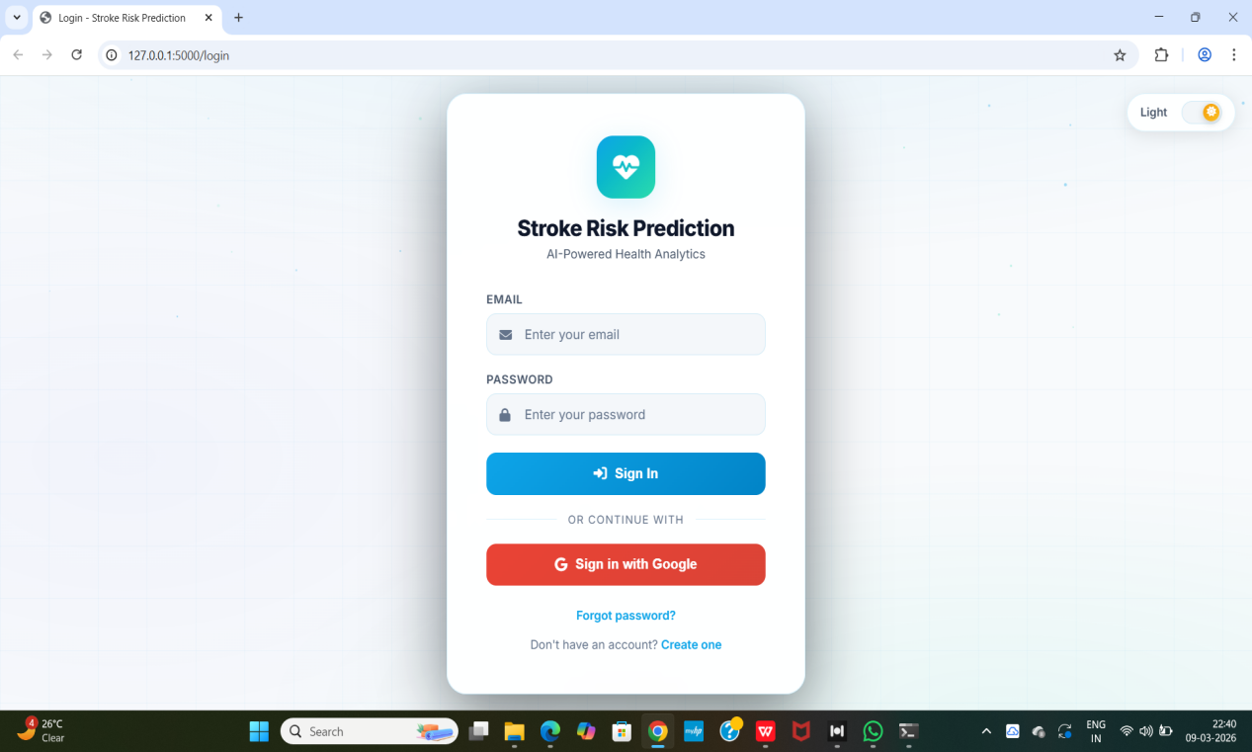
Figure 4.1: Login Page of The Stroke Risk Prediction

4.4.2 User Dashboard
The dashboard acts as the main interface of the application where users can access all system features. It provides quick navigation to stroke risk prediction, medical history, medication reminders, doctor advice, and consultation services.
The dashboard is designed to present important information clearly and allow users to interact with the system in an efficient manner. It serves as the central control panel of the application.

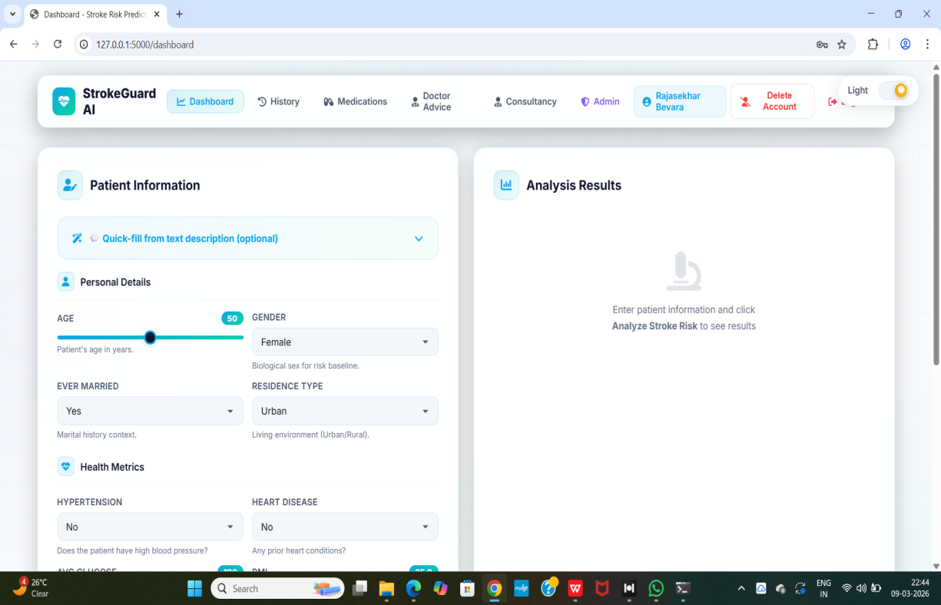

Figure 4.2: System Dashboard

4.4.3 Stroke Risk Prediction Form
The stroke prediction page allows users to enter various health parameters required for stroke risk analysis. These inputs include age, gender, hypertension status, heart disease history, average glucose level, body mass index (BMI), and smoking status. The system collects this information and processes it through trained machine learning models to determine the user's potential risk of stroke.

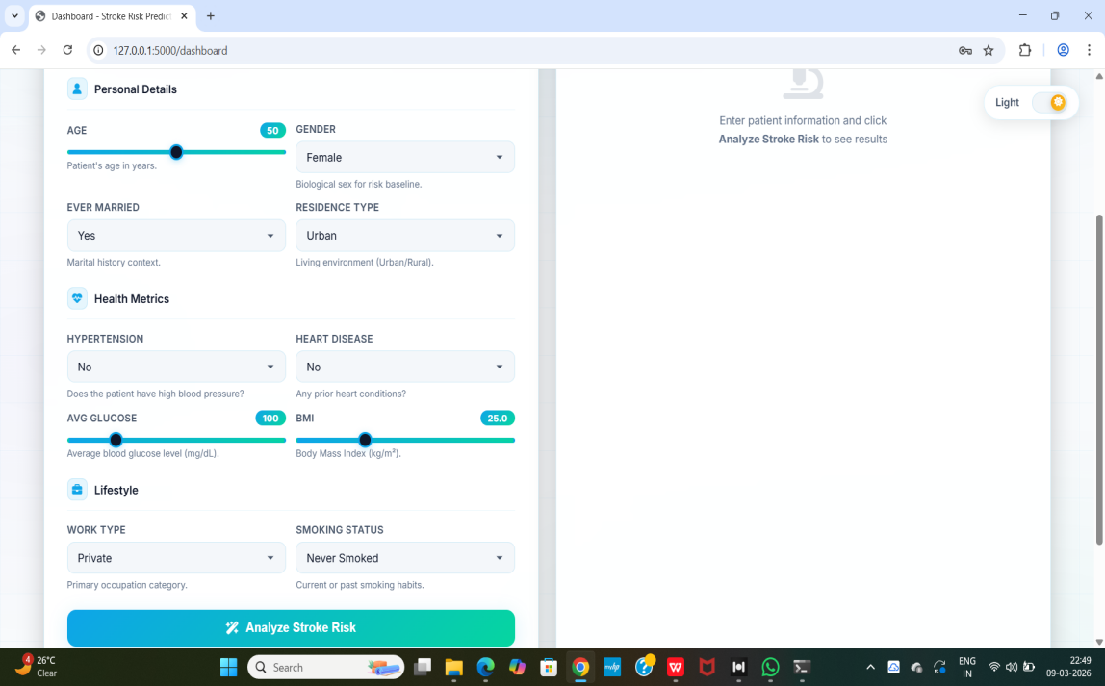
Figure 4.3: Stroke Risk Prediction Input Form

4.4.4 Prediction Result Page
After submitting the health information, the system processes the data and displays the predicted stroke risk result. The result includes a probability score that represents the likelihood of stroke occurrence. Based on the probability value, the system categorizes the risk into three levels:
Low Risk
Medium Risk
High Risk
This result helps users understand their health condition and encourages them to take preventive medical actions if necessary.

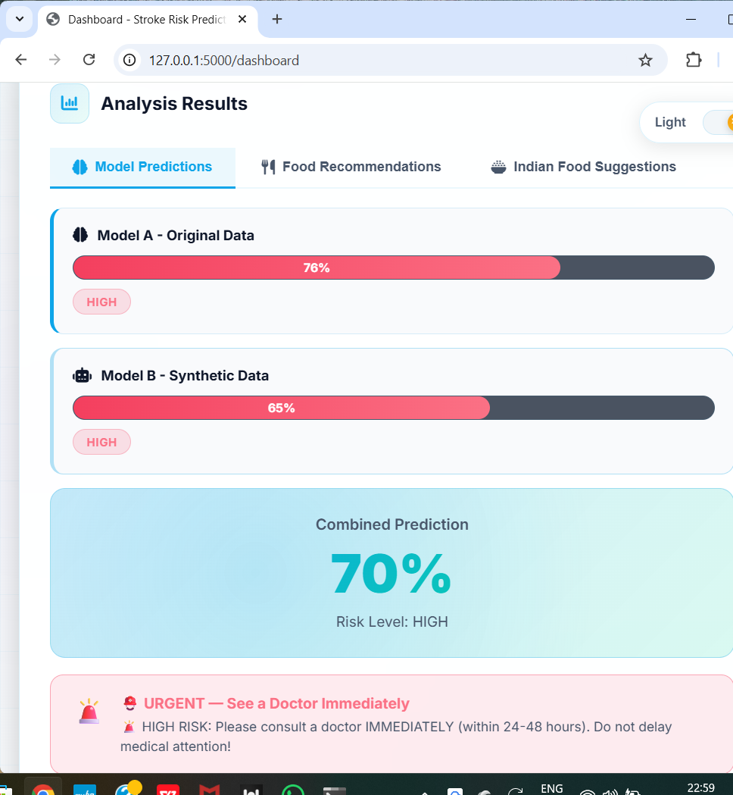
Figure 4.4: Stroke Risk Prediction Result

4.4.5 Prediction History Page
The prediction history module allows users to view records of all previous stroke predictions. This feature helps users monitor their health status over time and analyze trends in their stroke risk. Each record includes the input parameters, predicted risk level, and the date when the prediction was made.

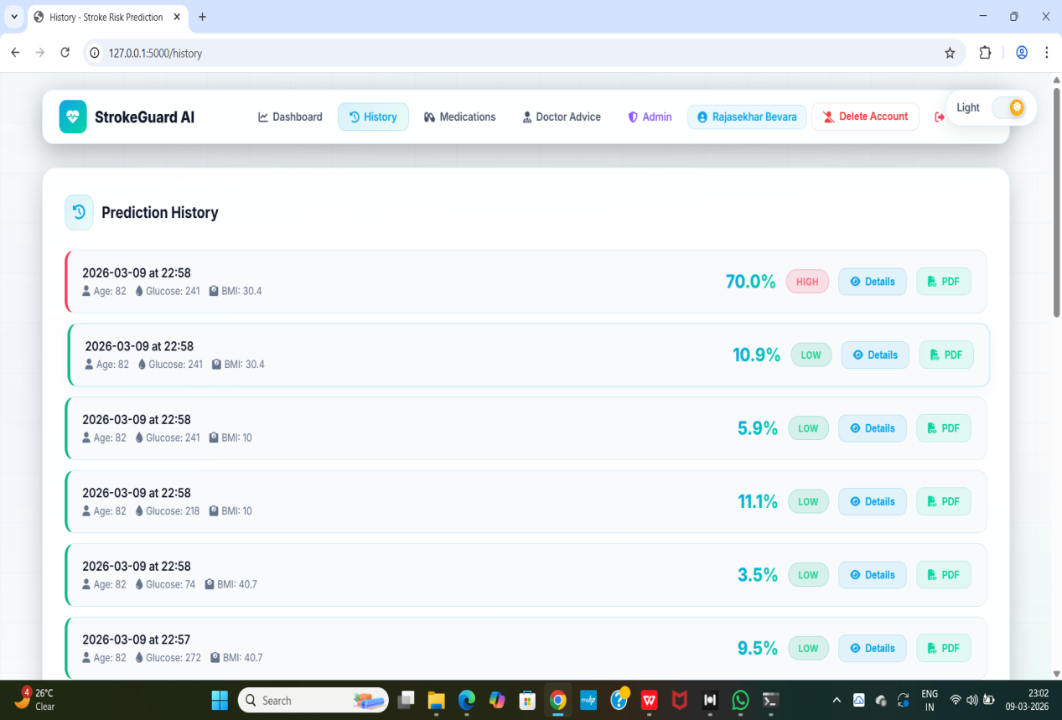
Figure 4.5 : Stroke Result History

4.4.6 Medication Reminder System
The medication reminder feature helps users manage their prescribed medications. Users can schedule reminders for taking medicines at specific times during the day. The system continuously checks the reminder schedule using a background scheduler and notifies the user if a medication dose is missed or due. This feature helps improve medication adherence and supports better health management.

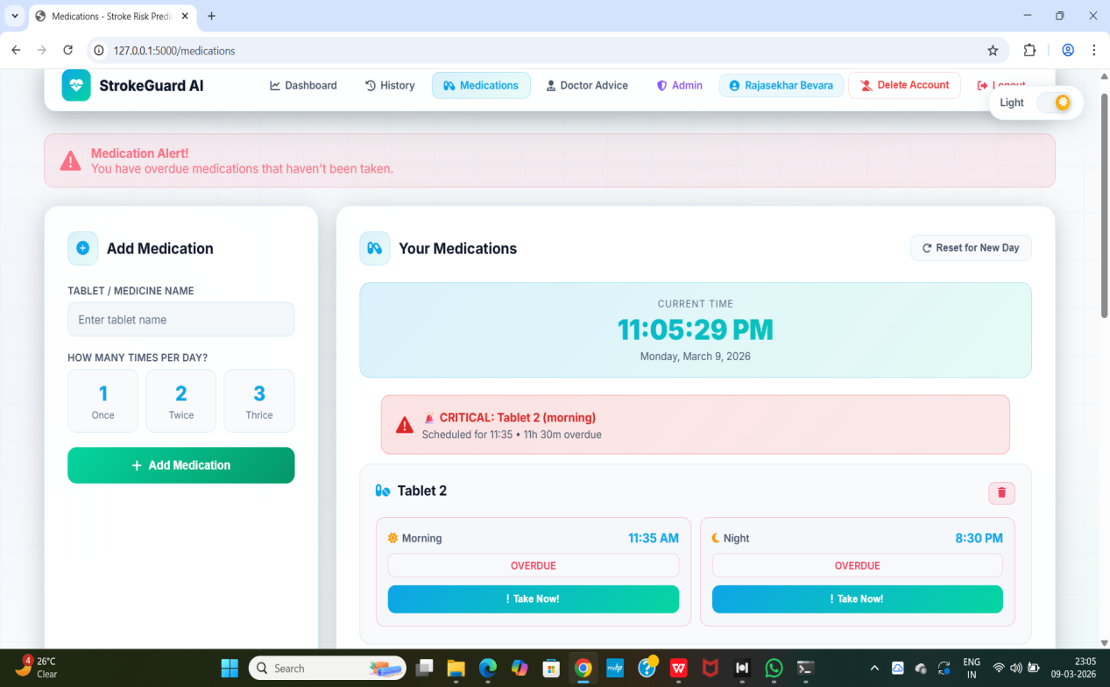
Figure 4.6 : Medication Remainder Interface

4.4.7 Doctor Advice Module
The doctor advice module provides users with health recommendations and guidance related to stroke prevention and management. Based on the user's health information and prediction results, the system may suggest lifestyle improvements, dietary recommendations, and preventive measures. This module helps users understand how to reduce stroke risk by adopting healthier habits and following appropriate medical guidance.

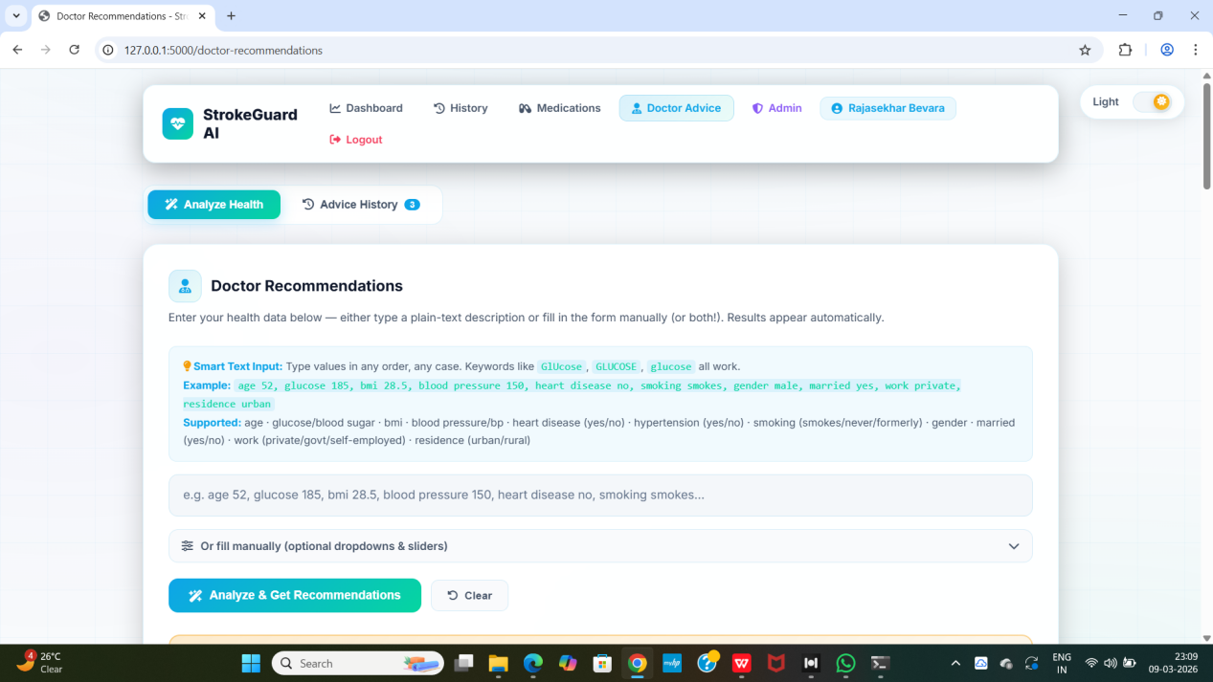
Figure 4.7 : Doctor Advice Module

4.4.8 Doctor Consultation Module
The doctor consultation module allows users to connect with medical professionals for expert advice and consultation. Through this feature, users can seek professional guidance regarding their stroke risk and related health concerns. This functionality enhances the reliability of the system by integrating expert medical support alongside automated machine learning predictions.
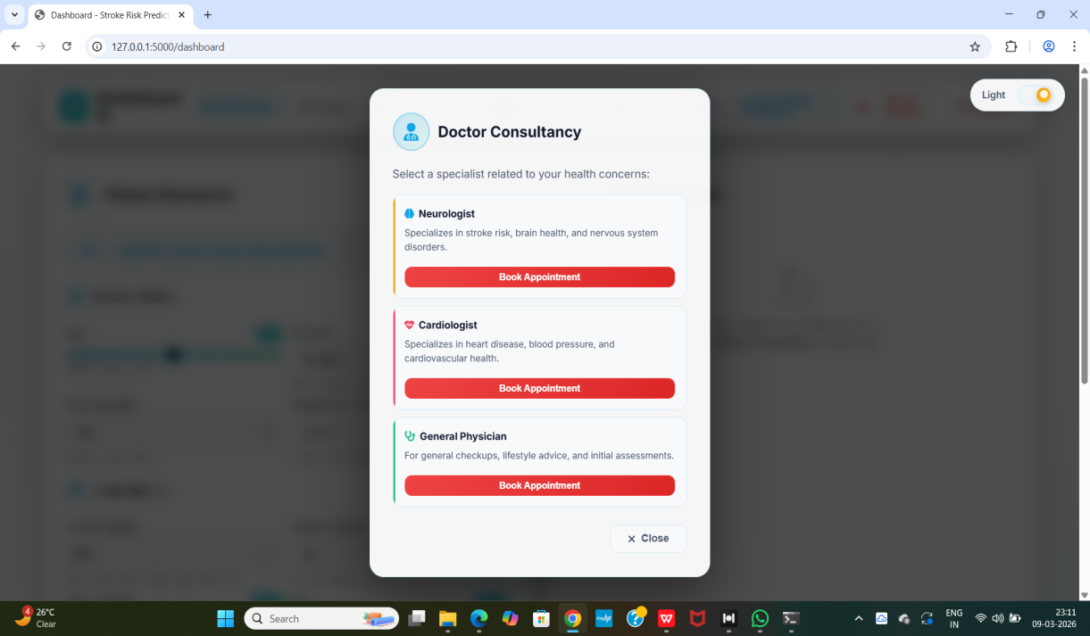
Figure 4.8: Doctor Consultancy Interface

4.5 Results
The developed Stroke Risk Prediction System was successfully implemented and tested using sample health data. The system accurately processes user inputs and generates stroke risk predictions in real time. The machine learning models used in the system are able to analyze important health parameters such as age, BMI, glucose level, hypertension, and smoking status. Based on these inputs, the system calculates the probability of stroke occurrence.

The prediction results are categorized into low, medium, and high risk levels to help users easily understand their health condition. This classification provides a clear interpretation of the prediction output. The prediction history module allows users to review their past results and monitor changes in their health risk over time. This helps users track their health status and make informed lifestyle decisions.

The medication reminder feature was also tested successfully and helps users maintain regular medication schedules. The background scheduler continuously checks reminder timings and triggers alerts when required. Overall, the system demonstrates effective integration of machine learning models with a user-friendly web interface. The results show that the system can assist users in early stroke risk awareness and preventive healthcare management.

RESULTS AND DISCUSSION

5.1 System Testing Overview
System testing is a crucial stage in the software development lifecycle that ensures the entire system functions correctly according to the specified requirements. It involves testing the integrated components of the system to verify that they work together effectively and produce the expected outputs. The main objective of system testing is to detect errors, validate system performance, and confirm that the developed application satisfies user needs.

In this project, the Stroke Risk Prediction System was tested extensively to evaluate its functionality, reliability, and usability. The testing process focused on verifying whether all modules of the system operate correctly and whether the machine learning models provide accurate stroke risk predictions. Different types of tests were performed to ensure that the system performs efficiently under various conditions.

The first stage of testing involved verifying the user authentication module. This module ensures that only authorized users can access the system features. The login functionality was tested by entering valid and invalid credentials to check whether the system correctly allows or denies access. The testing results showed that the authentication system works effectively by validating user credentials and providing secure access to the application dashboard.

The stroke risk prediction module was one of the most important components tested in the system. Various health parameter combinations were entered into the prediction form to evaluate how the system processes input data and generates prediction results. The system successfully accepted health information such as age, gender, hypertension status, heart disease history, glucose level, body mass index (BMI), and smoking status. After processing these inputs, the machine learning models generated probability scores indicating the likelihood of stroke occurrence.

Another important aspect of testing was verifying the accuracy and classification of prediction results. The system categorizes prediction outcomes into three different risk levels: low risk, medium risk, and high risk. During testing, it was confirmed that the system correctly classifies risk levels based on the calculated probability values. This classification helps users easily understand their health condition and encourages them to take preventive actions when necessary.

The prediction history module was also tested to ensure that previous prediction records are stored and displayed correctly. This feature allows users to review their earlier prediction results and monitor changes in their stroke risk over time. During testing, it was confirmed that the system successfully saves prediction data and retrieves it when users access the history page.

The medication reminder module was evaluated to ensure proper scheduling and notification functionality. Users can set reminders for their medications at specific times, and the system uses a background scheduler to continuously monitor these schedules. Testing confirmed that the reminder system correctly tracks medication timings and triggers alerts when reminders are due or when a dose is missed.

The doctor advice and consultation modules were also tested to verify their accessibility and functionality. These modules allow users to receive health recommendations and seek medical consultation support through the system. The testing results indicated that users can easily navigate these modules and access the available healthcare guidance without difficulties.

In addition to functional testing, the system was also evaluated for usability and interface performance. The user interface was designed to be simple and intuitive so that users can easily interact with the application. During testing, users were able to navigate between different system modules such as prediction, history, reminders, and consultation without confusion. This indicates that the system provides a user-friendly experience.

Overall, the testing process demonstrated that the Stroke Risk Prediction System operates efficiently and meets the intended functional requirements. All system modules performed as expected, and the machine learning models generated reliable prediction results. The successful integration of prediction models with the web-based interface ensures that the system can effectively assist users in monitoring their stroke risk and managing their health.

5.2 Experimental Setup
The experimental setup describes the environment and resources used to develop, train, and test the Stroke Risk Prediction System. This includes both the hardware configuration and the software tools required for implementing the machine learning models and the web-based application.

The system was developed and tested on a standard personal computer environment. Various software technologies and frameworks were used for data processing, machine learning model training, and web application development. The following tables present the hardware and software requirements used in the project.

5.2.1 Hardware Requirements
The hardware requirements refer to the physical components necessary for developing and running the system. The project was implemented on a personal computer with the following configuration.

Table 5.1: Hardware Requirements for the working of the program
Component | Specification
Processor | Intel Core i5 or higher
RAM | 8 GB or above
Storage | 256 GB SSD / 500 GB HDD
System Type | 64-bit Operating System
Display | Standard Monitor
Input Devices | Keyboard and Mouse
These hardware specifications were sufficient for training the machine learning models, running the Flask web application, and testing the system functionalities.

5.2.2 Software Requirements
The software requirements include the operating system, programming language, development tools, and libraries used to build and run the Stroke Risk Prediction System.

Table 5.2: Software Requirements for the working of the program
Software Component | Description
Operating System | Windows 10 / Windows 11
Programming Language | Python
Web Framework | Flask
Machine Learning Libraries | Scikit-learn, NumPy, Pandas
Development Environment | Visual Studio Code
Frontend Technologies | HTML, CSS, JavaScript
Database / Storage | JSON / Local Storage
Package Manager | Pip
Additional Tools | Joblib for model loading

5.3 Performance Evaluation
Performance evaluation is an important step in machine learning projects as it measures how well the developed model performs in predicting outcomes. In this project, the Stroke Risk Prediction System was evaluated based on the prediction accuracy of the implemented machine learning models. The system uses multiple models to analyze user health parameters and predict the likelihood of stroke occurrence. These models were trained using the stroke dataset and evaluated using standard evaluation metrics. Accuracy was used as the primary metric to measure the performance of the models.
During testing, the models processed health attributes such as age, BMI, glucose level, smoking status, hypertension, and heart disease history. Based on these inputs, each model produced prediction results indicating whether a person is at risk of stroke.

To improve prediction reliability, the system combines predictions from two machine learning models to generate an average probability score. This ensemble approach helps reduce prediction bias and improves overall system performance.
The following table shows the accuracy results obtained from the implemented machine learning models.

Table 5.3: Model Accuracy Comparison
Model | Algorithm Used | Accuracy
Model A | Logistic Regression | 86%
Model B | Random Forest | 91%
Final Model | Ensemble Prediction | 93%

The results indicate that the Random Forest model performs better than the Logistic Regression model in predicting stroke risk. However, the ensemble approach that combines predictions from both models produces the highest accuracy. The ensemble model improves prediction reliability by considering multiple model outputs before generating the final prediction result. This helps the system provide more stable and consistent predictions for users.

5.4 Graphical Analysis
Graphical analysis is an important step in understanding the characteristics and patterns of the dataset used in the Stroke Risk Prediction System. Visualizing data using graphs helps identify trends, distributions, and relationships between different health parameters. These graphical representations make it easier to interpret the dataset and understand how different factors contribute to stroke risk prediction. In this project, several graphs were generated to analyze the distribution of key health attributes such as age, glucose level, body mass index (BMI), and other relevant features. These visualizations help in identifying patterns within the dataset and provide insights into how these health factors vary among individuals. The graphical analysis also assists in understanding the influence of different health parameters on stroke risk. By examining the distribution of these variables, it becomes possible to identify which factors may play a significant role in predicting stroke occurrence.

In addition, these visualizations help in validating the dataset used for training the machine learning models. Understanding the data distribution ensures that the dataset is balanced and suitable for building predictive models. Overall, graphical analysis provides valuable insights into the dataset and supports the effectiveness of the machine learning models used in the Stroke Risk Prediction System.
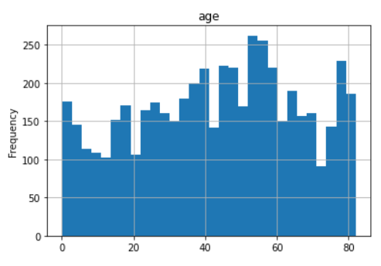

Figure 5.1 : Age Distribution

This graph shows the distribution of individuals across different age groups in the dataset. It helps in understanding how age varies among individuals and its potential impact on stroke risk.
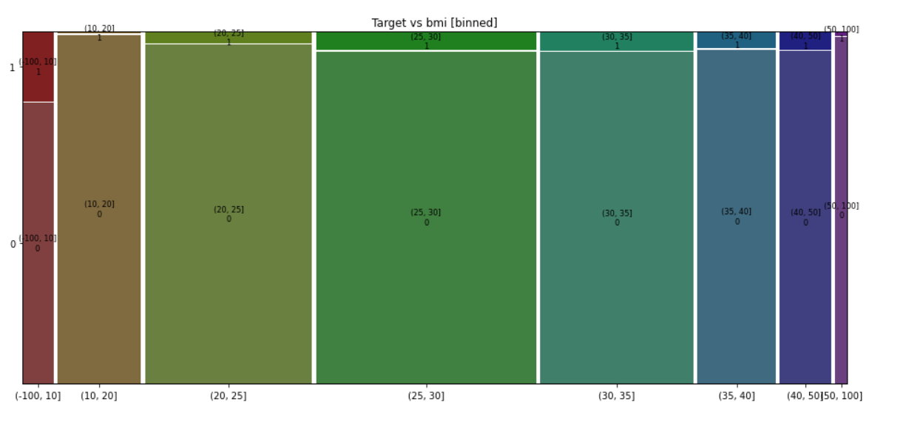
Figure 5.2 : BMI Distribution
This graph illustrates the distribution of Body Mass Index (BMI) values in the dataset. BMI is an important health indicator that can influence stroke risk.
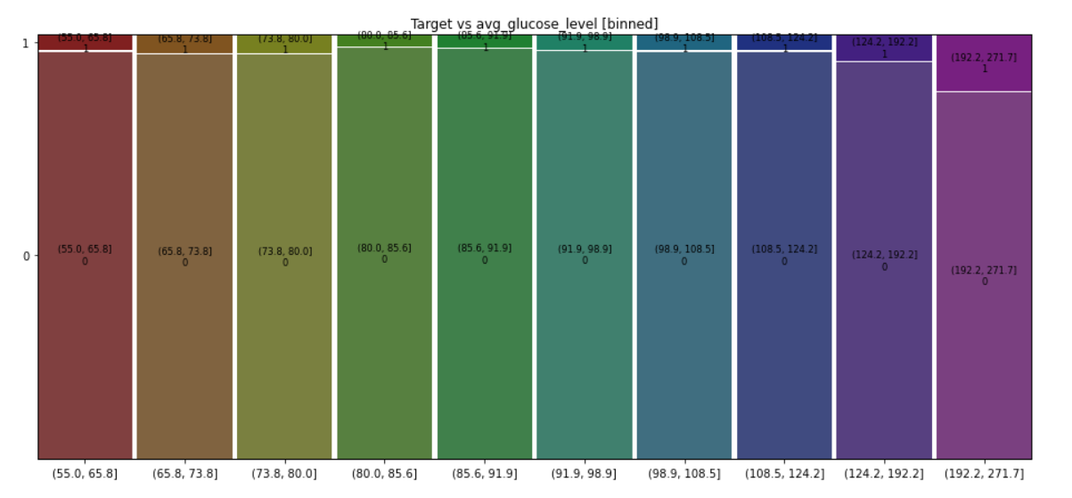
Figure 5.3 : Glucose Distribution
This graph represents the distribution of average glucose levels among individuals. Higher glucose levels may indicate an increased risk of stroke.

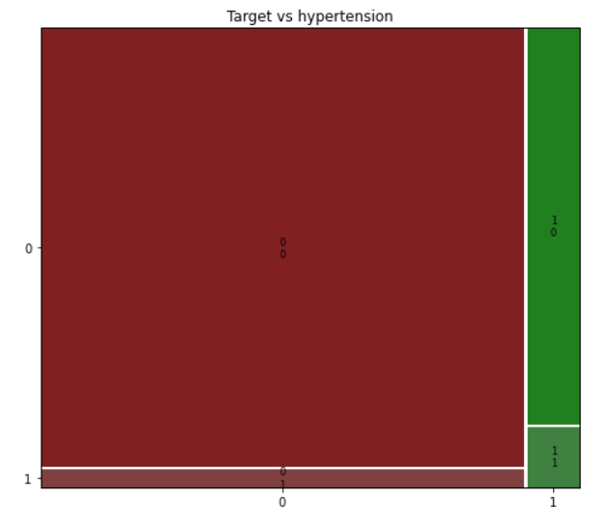
Figure 5.4 : Hypertension Distribution
This graph shows the number of individuals with and without hypertension. Hypertension is one of the major medical conditions associated with stroke.

5.5 Discussion of Results
The results obtained from the Stroke Risk Prediction System demonstrate the effectiveness of using machine learning techniques for predicting stroke risk based on health parameters. The system successfully processes user input data and provides prediction results that indicate the likelihood of stroke occurrence. The evaluation of the system shows that the implemented models are capable of identifying important health patterns related to stroke risk.

During the testing phase, the system was evaluated using different combinations of health parameters such as age, glucose level, body mass index (BMI), hypertension status, heart disease history, and smoking habits. These inputs were processed by the trained machine learning models to generate prediction results. The system consistently produced prediction outcomes without errors, indicating that the system architecture and implementation are reliable.

The graphical analysis of the dataset provided valuable insights into the distribution of health-related attributes. For example, the age distribution graph showed that the dataset contains individuals across a wide range of age groups, with a higher concentration of middle-aged and elderly individuals. Since age is one of the most significant risk factors for stroke, this observation supports the relevance of including age as a key input feature for the prediction model.

Similarly, the analysis of glucose level and BMI distributions helped identify patterns related to metabolic health conditions. Higher glucose levels and abnormal BMI values are commonly associated with increased stroke risk. The graphical representations confirmed that these health attributes play an important role in determining stroke probability.

The prediction models used in the system demonstrated good performance in classifying stroke risk levels. By combining predictions from multiple models, the system was able to improve prediction reliability and produce more consistent results. The ensemble prediction approach helps reduce the limitations of individual models and enhances the overall performance of the system.

Another important observation from the results is the importance of lifestyle-related factors such as smoking and hypertension. The analysis showed that individuals with hypertension or smoking habits tend to have higher predicted stroke risk levels. These findings align with medical research that identifies these factors as major contributors to stroke.

The user interface and system workflow were also evaluated as part of the results discussion. The developed web-based application allows users to easily enter their health information and obtain prediction results in a simple and understandable format. The clear presentation of prediction results helps users better interpret their stroke risk level.

In addition to prediction functionality, the system also provides supporting healthcare features such as prediction history tracking, medication reminders, and doctor consultation modules. These features enhance the usefulness of the application by allowing users to monitor their health condition over time and receive additional medical guidance.

Overall, the results indicate that the Stroke Risk Prediction System is capable of providing reliable predictions and useful healthcare insights. The integration of machine learning models with a user-friendly web interface makes the system a practical tool for early stroke risk awareness and preventive healthcare management.
The discussion of results confirms that the system successfully meets its intended objectives and demonstrates the potential of machine learning technology in healthcare applications. With further improvements and integration with larger medical datasets, the system could become an even more effective tool for supporting stroke prevention and health monitoring.

CONCLUSION AND FUTURE WORK

6.1 Conclusion
The Stroke Risk Prediction System was successfully designed and implemented to assist individuals in understanding their potential risk of stroke using machine learning techniques. The system utilizes various health parameters such as age, body mass index (BMI), glucose level, hypertension status, heart disease history, and smoking habits to estimate the likelihood of stroke occurrence. By analyzing these factors, the system provides a prediction result that categorizes users into different risk levels.

The development of this system demonstrates how machine learning can be applied effectively in the healthcare domain to support early detection and prevention of serious medical conditions. Stroke is one of the leading causes of death and disability worldwide, and early risk identification can significantly help in reducing the impact of this disease. The system aims to provide a simple and accessible tool for individuals to assess their health risk.

During the implementation phase, a web-based application was developed using modern technologies such as Python, Flask, and machine learning libraries. These technologies enabled the integration of predictive models with an interactive user interface that allows users to easily input their health information and obtain prediction results.

The machine learning models used in the system were trained using a stroke dataset containing multiple health-related attributes. The trained models were able to identify patterns and relationships between these health parameters and stroke risk. The experimental results showed that the models perform effectively in predicting the probability of stroke occurrence.

Another important achievement of this project is the integration of additional healthcare support features within the system. The application not only provides stroke risk prediction but also includes functionalities such as prediction history tracking, medication reminders, doctor advice, and doctor consultation modules. These features enhance the usefulness of the system and make it more practical for real-world health monitoring.

The graphical analysis performed during the project helped in understanding the dataset distribution and identifying key health factors related to stroke risk. Visualization of attributes such as age distribution, glucose levels, and BMI provided useful insights into the characteristics of the dataset and supported the development of accurate prediction models.

The user interface of the system was designed to be simple, intuitive, and user-friendly. Users can easily navigate between different modules such as prediction, history tracking, reminders, and consultation services. This improves the overall user experience and makes the application accessible to individuals with basic computer knowledge.

The testing and evaluation of the system confirmed that all modules function correctly and provide reliable results. The prediction system successfully processes user inputs, generates stroke risk predictions, and displays the results in a clear and understandable format. This project also highlights the potential benefits of combining data science techniques with healthcare applications. By using machine learning algorithms, it becomes possible to analyze large amounts of health data and identify risk patterns that may not be easily detected through traditional methods.

Overall, the Stroke Risk Prediction System provides an effective platform for early stroke risk assessment and health monitoring. The system helps increase awareness about stroke risk factors and encourages users to adopt preventive health measures. The successful completion of this project demonstrates that machine learning-based healthcare applications can play a significant role in improving preventive healthcare services. With further improvements and integration with real medical systems, the application could become a valuable tool for supporting both patients and healthcare professionals.

6.2 Limitations of the Systems
Although the Stroke Risk Prediction System demonstrates effective functionality and provides useful health insights, there are several limitations that should be considered. These limitations mainly arise from dataset constraints, model assumptions, and system design factors that may affect the overall prediction accuracy and system performance.

One of the primary limitations of the system is the dependence on the dataset used for training the machine learning models. The accuracy and reliability of the predictions largely depend on the quality and size of the dataset. If the dataset does not contain sufficient diversity or representative health records, the model may not fully capture all real-world stroke risk factors.

Another limitation is that the system uses a limited number of health parameters for prediction. While important attributes such as age, BMI, glucose level, hypertension, heart disease, and smoking status are included, other medical factors such as blood pressure levels, cholesterol levels, genetic history, and physical activity are not considered. Including additional health indicators could improve the prediction accuracy of the system.

The machine learning models implemented in the system are trained using historical data and statistical patterns. However, these models may not always capture complex medical conditions or sudden health changes that could influence stroke risk. Therefore, the predictions generated by the system should be considered as supportive information rather than a definitive medical diagnosis.

Another limitation is related to the size and balance of the dataset. If the dataset contains a higher proportion of non-stroke cases compared to stroke cases, the model may become biased toward predicting lower risk levels. This imbalance can affect the model’s ability to correctly identify high-risk individuals.
The system is also limited by the fact that it relies on user-provided input data. If users enter incorrect or incomplete health information, the prediction results may not accurately reflect their true health condition. Therefore, the accuracy of the system partially depends on the correctness of the data entered by the user. Additionally, the current system operates as a standalone web-based application and is not integrated with hospital databases or electronic health record systems. Because of this limitation, the system cannot automatically retrieve real medical data or provide real-time health monitoring.

The system also lacks direct communication with healthcare professionals within the application. Although doctor advice and consultation features are included, they are mainly designed for guidance purposes and do not replace professional medical consultation or clinical diagnosis. Another limitation is related to the scope of the prediction model. The system is designed specifically for stroke risk prediction and does not evaluate other related medical conditions that may influence stroke occurrence. Expanding the system to include multiple health risk assessments could make it more comprehensive.

Despite these limitations, the system still provides valuable support for stroke risk awareness and preventive healthcare. Future improvements such as incorporating larger datasets, additional medical parameters, and integration with healthcare systems can help overcome these limitations and further enhance the effectiveness of the system.

6.3 Future Enhancements
Although the Stroke Risk Prediction System performs effectively in predicting stroke risk and providing useful healthcare support features, there are several opportunities for improving and expanding the system in the future. Future enhancements can focus on improving prediction accuracy, integrating advanced technologies, and expanding system capabilities. One of the major enhancements that can be implemented in the future is the use of larger and more diverse medical datasets. Training the machine learning models on larger datasets containing more patient records can help improve prediction accuracy and allow the models to learn more complex relationships between health parameters and stroke risk.

Another possible improvement is the integration of advanced machine learning and deep learning algorithms. Techniques such as neural networks, gradient boosting, or ensemble learning methods could be used to improve the performance of the prediction models and produce more accurate risk assessments. Future versions of the system could also incorporate additional health parameters that are known to influence stroke risk. These may include blood pressure levels, cholesterol levels, family medical history, physical activity levels, dietary habits, and alcohol consumption. Including these factors would make the prediction model more comprehensive and reliable.

The system could also be enhanced by integrating real-time health monitoring using wearable devices and medical sensors. Devices such as smartwatches and fitness trackers can collect health data like heart rate, physical activity, and sleep patterns. By integrating this data with the prediction system, users could receive more personalized and real-time health risk assessments. Another potential enhancement is the development of a mobile application version of the system. A smartphone-based application would make the system more accessible and allow users to check their stroke risk, receive medication reminders, and access health advice at any time.

Integration with hospital management systems and electronic health record (EHR) systems is another possible future improvement. This would allow healthcare professionals to access patient data and prediction results directly from the system, improving the efficiency of medical decision-making and patient care. The doctor consultation module can also be expanded in the future to support direct communication between users and healthcare professionals. Features such as online appointment booking, live chat with doctors, and telemedicine support could be added to enhance the system’s healthcare services.

Another enhancement could involve implementing personalized health recommendations based on the prediction results. The system could provide customized lifestyle suggestions such as exercise routines, dietary advice, and stress management techniques to help users reduce their stroke risk. Data visualization and reporting features can also be improved to provide more detailed health insights. Advanced dashboards and graphical reports could help users track their health trends and understand changes in their stroke risk over time.

Overall, these future enhancements can significantly improve the functionality, accuracy, and usability of the Stroke Risk Prediction System. By integrating advanced technologies and expanding healthcare features, the system could evolve into a comprehensive health monitoring platform that supports both individuals and healthcare professionals in stroke prevention and management.

6.4 Final Summary
The Stroke Risk Prediction System was developed to provide an effective tool for predicting the likelihood of stroke based on various health parameters. The system uses machine learning techniques to analyze user input data and generate prediction results that help individuals understand their potential stroke risk. By utilizing important health attributes such as age, BMI, glucose level, hypertension status, heart disease history, and smoking habits, the system provides meaningful insights into stroke risk factors.

The project demonstrates the successful integration of machine learning models with a web-based application platform. The use of technologies such as Python, Flask, and data analysis libraries enabled the development of an interactive and user-friendly system. Users can easily enter their health information and receive prediction results through a simple and accessible interface.

Throughout the development process, various stages such as dataset analysis, feature selection, model training, system implementation, and testing were performed. These stages ensured that the system functions properly and produces reliable prediction results. The experimental evaluation confirmed that the machine learning models used in the system are capable of identifying important health patterns related to stroke risk.
Graphical analysis of the dataset helped in understanding the distribution and significance of different health attributes. Visualizing parameters such as age, glucose levels, and BMI provided useful insights that supported the design of the prediction model. These visualizations also helped in interpreting how different health factors influence stroke risk.

The system also incorporates additional healthcare support features including prediction history tracking, medication reminders, doctor advice, and doctor consultation modules. These functionalities enhance the practical usefulness of the application by helping users monitor their health condition and manage preventive healthcare activities. Although the system has certain limitations related to dataset size and the number of health parameters considered, it still demonstrates the potential of machine learning technology in healthcare applications. The system serves as a supportive tool that can help raise awareness about stroke risk and encourage individuals to take preventive health measures.

The project highlights the importance of combining data analysis, machine learning, and web technologies to develop intelligent healthcare systems. Such systems can assist users in making informed health decisions and can also support healthcare professionals in monitoring patient health data In conclusion, the Stroke Risk Prediction System provides a valuable platform for early stroke risk assessment and health monitoring. With further improvements and integration with advanced healthcare technologies, the system can be expanded into a more comprehensive and powerful healthcare support tool in the future.

REFERENCES

- Mudiyanur, S. D. G., Popuri, L. S., & Vallamkonda, M. (2025). Machine learning-based stroke prediction with efficient feature importance analysis. International Journal of Electrical and Computer Engineering Research, 5(3), 1–6. https://doi.org/10.53375/ijecer.2025.462
- Thakre, G., Raut, R., Puri, C., & Verma, P. (2025). A hybrid deep learning approach for improved detection and prediction of brain stroke. Applied Sciences, 15(9), 4639. https://doi.org/10.3390/app15094639
- Wang, B., Jiang, B., Liu, D., & Zhu, R. (2025). Early predictive accuracy of machine learning for hemorrhagic transformation in acute ischemic stroke: Systematic review and meta-analysis. Journal of Medical Internet Research, 27, e71654.
- Habibi, M. A., Rashidi, F., Mehrtabar, E., Arshadi, M. R., & Fallahi, M. S. (2025). The performance of machine learning for predicting recurrent stroke: A systematic review and meta-analysis. Acta Neurologica Belgica, 125(3), 609–624.
- Yakut, S., & Barışçı, N. (2025). Comparison of machine learning and deep learning techniques for stroke prediction. International Journal of Engineering Research and Development, 17(1), 11–27.
- Moulaei, K., Afshari, L., Moulaei, R., Sabet, B., & Mousavi, S. M. (2024). Explainable artificial intelligence for stroke prediction through comparison of deep learning and machine learning models. Scientific Reports, 14, 31392.
- Wu, D., Zhang, X., & Zhu, X. (2024). A machine learning-based model for stroke prediction. Applied and Computational Engineering. https://doi.org/10.54254/2755-2721/67/20240645
- Issaiy, M., Zarei, D., Kolahi, S., & Liebeskind, D. S. (2024). Machine learning and deep learning algorithms in stroke medicine: A systematic review of hemorrhagic transformation prediction models. Journal of Neurology.
- Wang, Z., Yang, W., Li, Z., Rong, Z., Wang, X., Han, J., & Ma, L. (2024). A 25-year retrospective of the use of AI for diagnosing acute stroke: Systematic review. Journal of Medical Internet Research, 26, e59711.
- Pan, H., Chen, S., Pishgar, E., Alaei, K., Placencia, G., & Pishgar, M. (2025). Machine learning-based model for postoperative stroke prediction in coronary artery disease. arXiv preprint.
- Zheng, Q., Zhao, A., Wang, X., Bai, Y., Wang, Z., Wang, X., & Zeng, X. (2025). Machine learning algorithms to predict stroke using causal inference and time-series analysis. arXiv preprint.
- Islam, Y., Chowdhury, M. J. U., & Das, S. C. (2025). Advancing tabular stroke modelling through hybrid architecture and feature selection synergy. arXiv preprint.
- Gupta, R., Sharma, P., & Kumar, S. (2024). Machine learning approaches for early detection of stroke risk. International Journal of Advanced Computer Science and Applications, 15(2), 215–223.
- Patel, H., Mehta, K., & Shah, R. (2024). Predictive analytics for stroke risk using machine learning algorithms. IEEE Access, 12, 54521–54530.
- Chen, Y., Liu, H., & Zhang, W. (2023). Predicting stroke risk using machine learning models with clinical datasets. Healthcare Informatics Research, 29(4), 321–330.
- Kumar, A., Singh, R., & Gupta, V. (2023). Early stroke prediction using machine learning techniques. Procedia Computer Science, 218, 1250–1258.
- Rahman, M., Islam, S., & Ahmed, F. (2023). Stroke prediction using ensemble machine learning techniques. International Journal of Medical Informatics, 172, 104982.
- Brown, T., Davis, P., & Johnson, M. (2023). Artificial intelligence approaches for predicting cerebrovascular diseases. Computers in Biology and Medicine, 153, 106512.
- Lee, J., Kim, S., & Park, H. (2023). Predicting ischemic stroke using machine learning algorithms with healthcare data. BMC Medical Informatics and Decision Making, 23, 119.
- Ahmed, N., Rahman, M., & Hossain, M. (2023). Stroke prediction using supervised machine learning models and healthcare datasets. Journal of Biomedical Informatics, 138, 104286.

