Bezawada . Purna Ajay

JLL/T intern.

1.1

create database assignment;

use assignment;

CREATE TABLE Employee ( Emp_ID INT NOT NULL, Manager_ID INT,First_Name VARCHAR(50) NOT NULL,Last_Name VARCHAR(50) NOT NULL,Emp_Title VARCHAR(50) NOT NULL,Salary VARCHAR(50) NOT NULL,Joining_Date VARCHAR(50) NOT NULL, DEP VARCHAR(50) NOT NULL );

INSERT INTO Employee VALUES(1,null,'Monika','Arora','Manager','100000','02/20/14 9:00','HR');

INSERT INTO Employee VALUES(2,1,'Niharika','Verma','Executive','80000','06/11/14 9:00','Admin');

INSERT INTO Employee VALUES(3,1,'Vishal','Singhal','Manager','300000','02/20/14 9:00','HR');

INSERT INTO Employee VALUES(4,null,'Amitabh','Singh','Manager','500000','02/20/14 9:00','Admin');

INSERT INTO Employee VALUES(5,4,'Vivek','Bhati','Asst. Manager','500000','06/11/14 9:00','Admin');

INSERT INTO Employee VALUES(6,5,'Vipul','Diwan','Executive','200000','06/11/14 9:00','Account');

INSERT INTO Employee VALUES(7,4,'Satish','Kumar','Lead','75000','01/20/14 9:00','Account');

INSERT INTO Employee VALUES(8,4,'Geetika','Chauhan','Lead','90000','04/11/14 9:00','Admin');

select * from Employee;

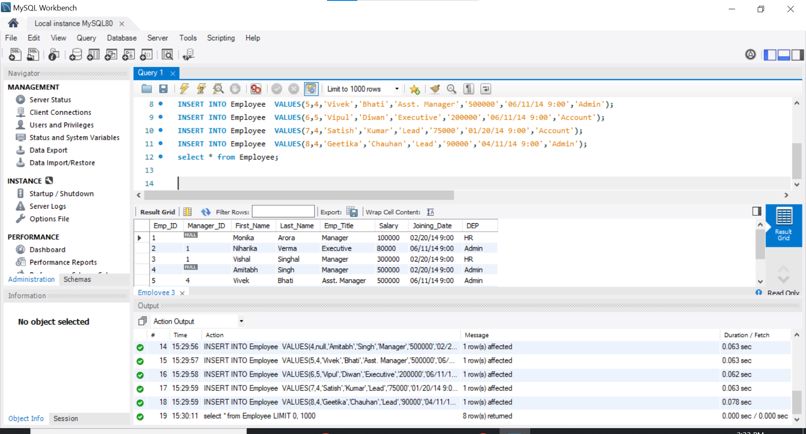

1.2) SELECT CONCAT(First_Name,' ',Last_Name) as EmpName,Salary FROM Employee WHERE Salary BETWEEN 50000 AND 100000

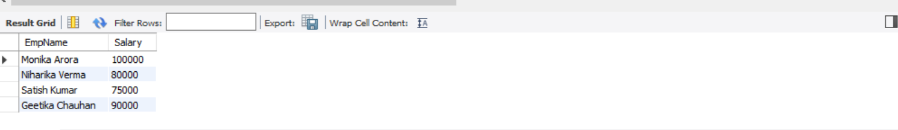

1.3)

SELECT CONCAT(emp.First_Name,' ',emp.Last_Name) AS EmployeeName, CONCAT(mgr.First_Name,' ',mgr.Last_Name) AS ManagerName

FROM Employee emp JOIN Employee mgr ON

emp.Manager_ID=mgr.Emp_ID;

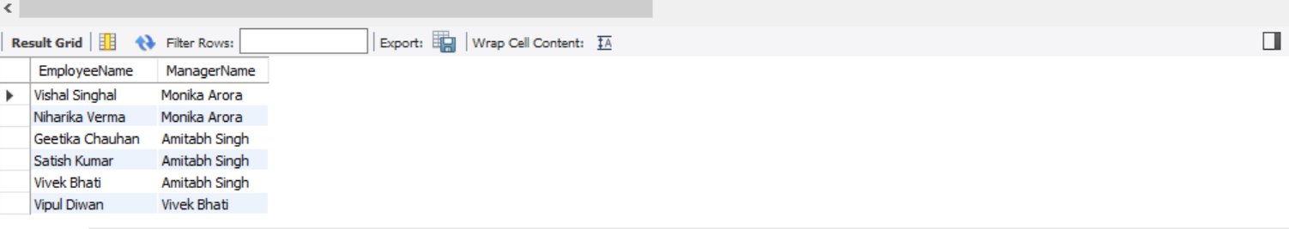

1.4)

SELECT DEP,COUNT(*) AS Count FROM Employee GROUP BY DEP ORDER BY Count DESC;

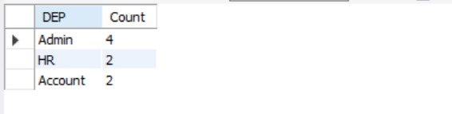

1.5) SELECT * FROM( SELECT CONCAT(First_Name,' ',Last_Name) AS EmpName,Salary, DENSE_RANK() OVER (ORDER BY Salary DESC)r FROM Employee) e WHERE e.r=5;



1.6)

select * from (select Salary,dense_rank() over(order by Salary DESC)r from Employee

)e where e.r = 5;

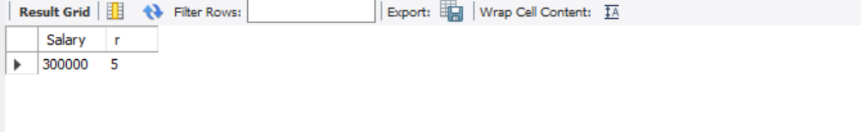

1.7)

SELECT * FROM( SELECT *, ROW_Number() OVER (PARTITION BY EMP_ID ORDER BY Emp_ID) r FROM Employee) e WHERE e.r <> 1 ;

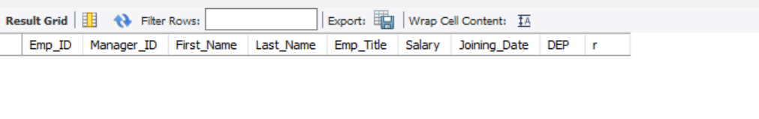

1.8)

select CONCAT(First_Name,' ',Last_Name) as EmpName from Employee where Manager_ID is NUll or Manager_ID = 0;



CREATE TABLE Customer

(

CustID INT PRIMARY KEY,

CustName VARCHAR(50),

City VARCHAR(50),

Grade INT,

SalesMan_ID INT

)

INSERT INTO Customer VALUES (3001,'Nick Rimando','New York',100,5001);

INSERT INTO Customer VALUES(3002,'Brad Davis','New York',200,5001);

INSERT INTO Customer VALUES(3003,'Graham Zusi','California',200,5002);

INSERT INTO Customer VALUES(3004,'Julian Green','London',300,5002);

INSERT INTO Customer VALUES(3005,'Fabian John','Paris',300,5006);

INSERT INTO Customer VALUES(3006,'Geoff Rock','Berlin',100,5003);

INSERT INTO Customer VALUE(3007,'Rozy Altidor','Moscow',200,5007);

INSERT INTO Customer VALUES(3008,'Brad Gujan','London',300,5005);

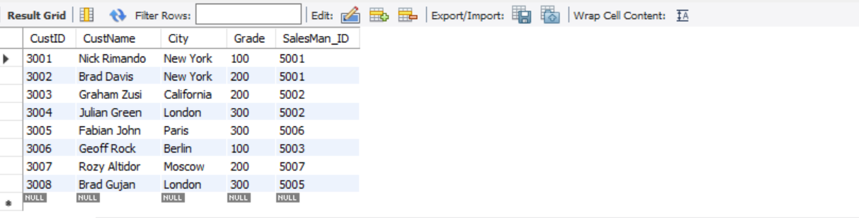

CREATE TABLE Orders

(

OrderNo INT,

OrderDate DATE,

Order_Amt varchar(20),

Cust_ID INT REFERENCES Customer(CustID),

SalesMan_Id INT,

Commision Varchar(3)

);

INSERT INTO Orders VALUES (1,'2005/12/22',160,3001,5002,'13%');

INSERT INTO Orders VALUES(9,'2005/08/10',190,3001,5005,'11%');

INSERT INTO Orders VALUES(2,'2005/07/13',500,3002,5001,'15%');

INSERT INTO Orders VALUES(4,'2005/07/15',420,3002,null,'0');

INSERT INTO Orders VALUES(7,'2005/12/22',1000,3003,null,'0');

INSERT INTO Orders VALUES(5,'2006/10/02',820,3004,5001,'15%');

INSERT INTO Orders VALUES(8,'2006/11/03',2000,3004,5001,'15%');

INSERT INTO Orders VALUES(10,'2006/10/09',1500,3005,5006,'14%');

INSERT INTO Orders VALUES(12,'2006/10/20',1800,3005,5003,'12%');

select * from Orders;

2.1)

SELECT c.CustID,c.CustName,Count(o.Cust_ID) NoOfOrders

FROM Customer c JOIN Orders o ON

c.CustID=o.Cust_ID

GROUP BY CustID,CustName

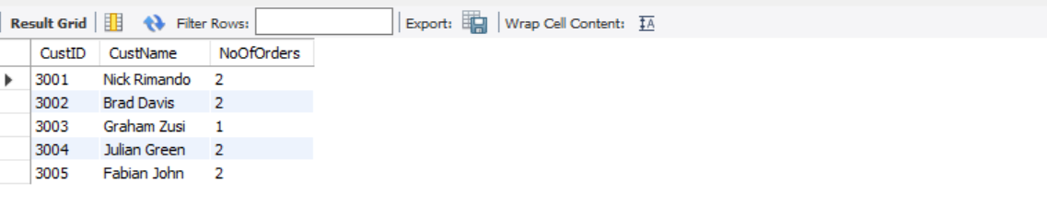

2.2) SELECT o.OrderNo,o.OrderDate,o.Order_Amt,o.Cust_ID

FROM Orders o

WHERE o.Cust_ID NOT IN (SELECT c.CustID FROM Customer as c);



2.3)

select c.CustName from Customer as c inner join Orders as o on c.CustID = o.Cust_ID where month(o.OrderDate) = 7 or month(o.OrderDate) = 8;



2.4)

SELECT c.CustID,c.CustName,o.Order_Amt

FROM Customer c LEFT OUTER JOIN Orders o ON

o.Cust_ID=c.CustID

WHERE O.Order_Amt<(SELECT AVG(Order_Amt) FROM Orders)

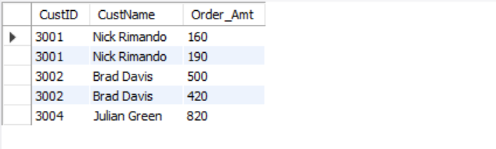

3.1)

SELECT MIN(Order_Amt) MinimumAmt,MAX(Order_Amt) MaximumAmt,AVG(Order_Amt) AverageAmt From Orders;

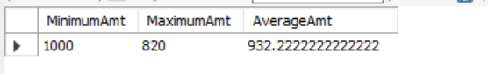

3.2)

SELECT c.City,COUNT(o.OrderNo) as No_Of_Order,SUM(o.Order_Amt) as Order_Value FROM Customer c JOIN Orders o ON c.CustID=o.Cust_ID GROUP BY City ORDER BY Order_Value

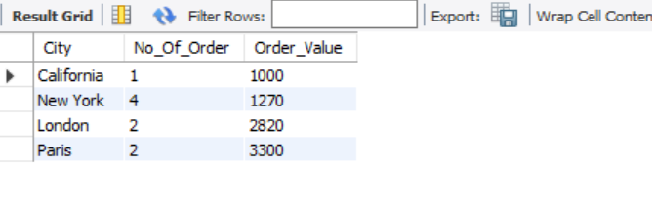

3.3) SELECT Top(2) c.CustID,SUM(o.Order_Amt) as Total

FROM Customer c JOIN Orders o ON

c.CustID=o.Cust_ID

GROUP BY CustID

ORDER BY Total DESC

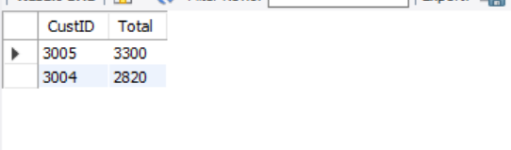

3.4)

SELECT c.City,COUNT(*) OrderNo,SUM(o.Order_Amt) MaxOrderAmount FROM Customer c JOIN Orders o ON c.CustID=o.Cust_ID Group by City Order BY MaxOrderAmount DESC limit 1;

