Training session 3

Bezawada Purna Ajay

JLL/T Interns

1. Write a program which will find all such numbers which are divisible by 7 but are not a multiple of 5,  
between 2000 and 3200 (both included).  
The numbers obtained should be printed in a comma-separated sequence on a single line.

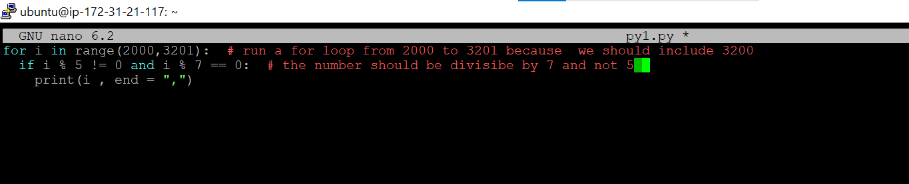

2) Write a program that accepts a comma separated sequence of words as input and prints the words in a comma-separated sequence after sorting them alphabetically.  
Suppose the following input is supplied to the program:  
without,hello,bag,world  
Then, the output should be:  
bag,hello,without,world

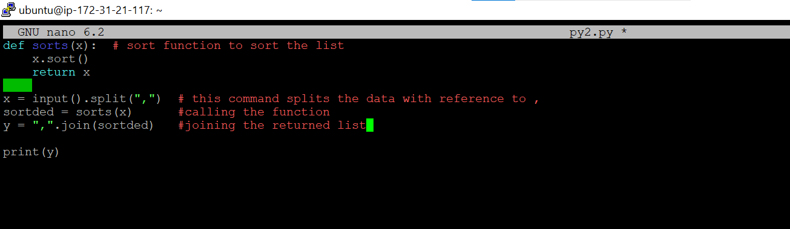

3) You are required to write a program to sort the (name, age, height) tuples by ascending order where name is string, age and height are numbers. The tuples are input by console. The sort criteria is:  
1: Sort based on name;  
2: Then sort based on age;  
3: Then sort by score.  
The priority is that name > age > score.  
If the following tuples are given as input to the program:  
Tom,19,80  
John,20,90  
Jony,17,91  
Jony,17,93  
Json,21,85  
Then, the output of the program should be:  
[('John', '20', '90'), ('Jony', '17', '91'), ('Jony', '17', '93'), ('Json', '21', '85'), ('Tom', '19', '80')]

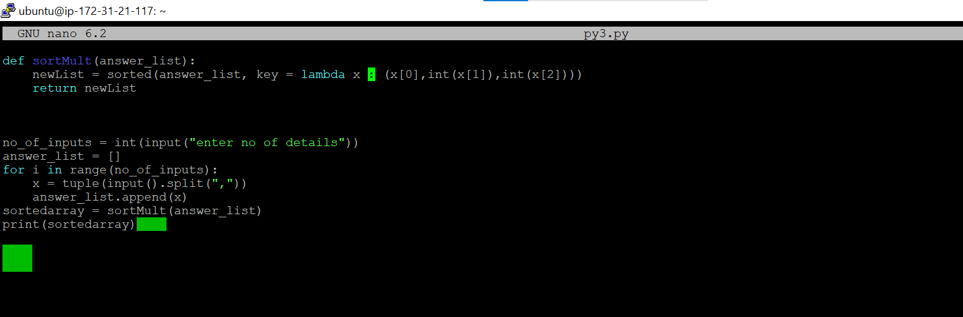

4) Write a program that accepts a sentence and calculate the number of letters and digits.  
Suppose the following input is supplied to the program:  
hello world! 123  
Then, the output should be:  
LETTERS 10  
DIGITS 3

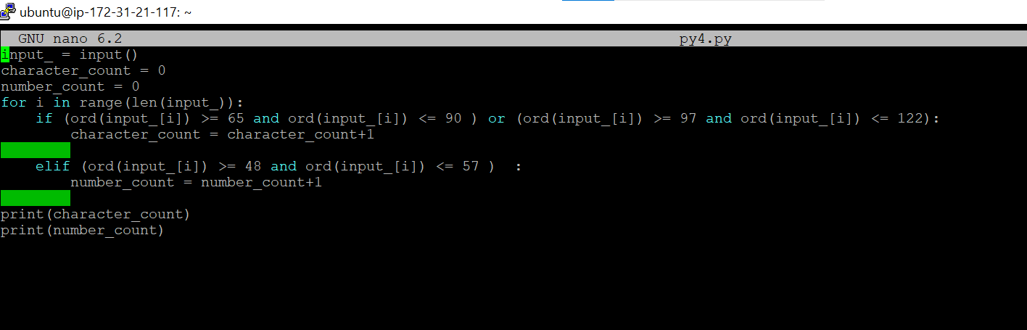

5) Write a computer program that will:  
Ask for the number of students taking part in the trip.  
Ask for the number of teachers taking part in the trip.  
Calculate the total number of participants (by adding the number of students and the number of teachers).  
One large coach can carry 15 people and one small coach can carry 5 people. The cost of hiring one large coach is Rs 2000 and the cost of hiring one small coach is Rs 1000.  
Find out and output the number of large coaches that will be required.  
Find out and output the number of small coaches that will be required.  
Calculate and output the total cost of hiring these coaches for a day.

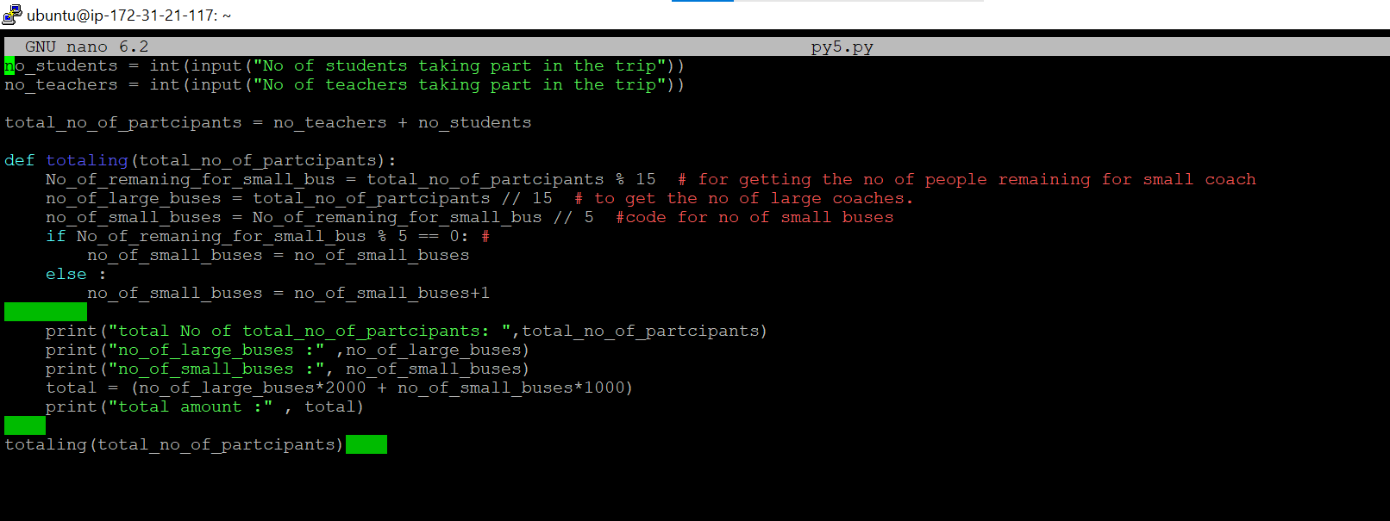

6)

Write function to implement below scanario.

 Kevin and Stuart want to play the '**The Minion Game**'.

**Game Rules**

Both players are given the same string, .  
Both players have to make substrings using the letters of the string .  
Stuart has to make words starting with consonants.  
Kevin has to make words starting with vowels.  
The game ends when both players have made all possible substrings.

**Scoring**  
A player gets +1 point for each occurrence of the substring in the string .

Output should give score of each player

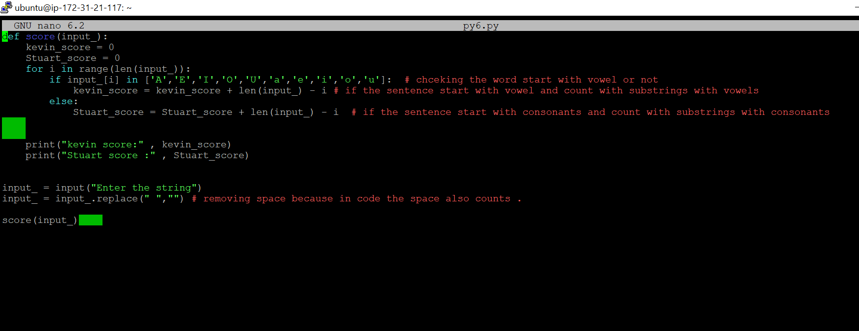

6) Write a program to build a simple Student Management System using Python which can perform the following operations:

1.    Accept

2.    Display

3.    Search

4.    Delete

5.    Update

1.    **Accept**– This method takes details from the user like name, roll number, and marks for two different subjects.

2.    **Display**– This method displays the details of every student.

3.    **Search**– This method searches for a particular student from the list of students. This method will ask the user for the roll number and then search according to the roll number

4.    **Delete**– This method deletes the record of a particular student with a matching roll number.

5.    **Update**– This method updates the roll number of the student. This method will ask for the old roll number and the new roll number. It will replace the old roll number with a new roll number.

Data after each operation should be available on a file which acts as a database for all methods.

