ASSIGNMENT

1) Write a small program where you need to implement a Try and Catch Block .

Code:

using System;

public class Program
{
public static void Main()
{
string str = null;

try
{
Console.WriteLine(str[0]);
}

catch(NullReferenceException e)
{
Console.WriteLine(e.Message);
}

}
}

Output:
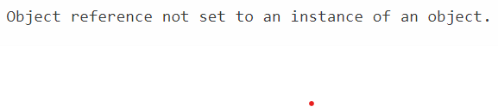

2) When should we write multiple catch blocks for a Single Try block?

=> We write multiple catch blocks for a Single Try block when we want to handle different type of exceptions in different ways. Each catch block can be used to catch a specific type of exception, allowing you to handle each type of exception differently.

Example:

class Program
{
static void Main(string[] args)
{
int[] arr = { 1, 2, 0, 3 };

try

{
Console.WriteLine(arr[8]);
int a = 2;
int b = 0;
int c = a / b;

Console.WriteLine(c);

}

catch (IndexOutOfRangeException e)
{
Console.WriteLine(e.Message);
}
catch (DivideByZeroException e)
{
Console.WriteLine(e.Message);

}
Console.ReadKey();
}
}

3) How to define a delegate and call any method or event using it?

Code:

class DelegateClass
{
public delegate void addnum(int a, int b);
public delegate void subnum(int a, int b);
public delegate void str(string s);

public void sum(int a,int b)
{
Console.WriteLine("The sum is :{0} ", a + b);

}

public void subtract(int a ,int b)
{
Console.WriteLine("The difference between no is : {0} ", a - b);

}
public void String(string s)
{
Console.WriteLine("My name is {0}", s);
}

static void Main(string[] args)
{
DelegateClass obj = new DelegateClass();
addnum d1 = new addnum(obj.sum);
subnum d2 = new subnum(obj.subtract);
d1(50,50);
d2(100, 20);

str d3 = new str(obj.String);
d3("Ajay Bohra");

Console.ReadKey();

}
}

Output:
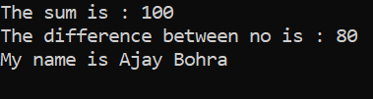

4) Try to use Func, Action and Predicate any program.

class Program
{
static void Main(string[] args)
{
Func<int, float, double, double> obj1 = new Func<int, float, double, double>(AddNumber);
double sum = obj1.Invoke(400,32.23f,238.2322);

Console.WriteLine(sum);

Action<int, int> obj2 = new Action<int,int>(SubNumber);
obj2.Invoke(100,80);

Predicate<string> obj3 = new Predicate<string>(CheckLength);
bool str = obj3.Invoke("Ajay Bohra");
Console.WriteLine(str);
Console.ReadKey();
}
public static double AddNumber(int no1, float no2, double no3)
{
return no1 + no2 + no3;
}

public static void SubNumber(int x, int y)
{
Console.WriteLine("The difference is : {0} ",x-y);
}
public static bool CheckLength(string name)
{
if (name.Length > 3)
return true;
return false;
}
}

Output:

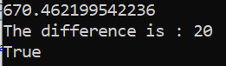

5) What will be the output of below code snipped :

static void Main()
{
Func <string,string> output=delegate(string name)
{
return "Hello" + name;
};
Console.Write(output("James"));
}

static void Main()
{
Action <int> output = i=>Console.Write(i);
output(10);
}

Output: Hello James
10

6) Write a program to implement Async await with proper justification.

class Program
{
static void Main(string[] args)
{
Console.WriteLine("Main method start.");
Add();
Console.WriteLine("Main method end. ");
Console.ReadKey();
}

public async static void Add()
{
int x;
int y;

Console.WriteLine("Enter the value of x: ");
x =int.Parse( Console.ReadLine());
Console.WriteLine("Enter the value of x: ");
y = int.Parse(Console.ReadLine());

Console.WriteLine("Adding Number");
await Task.Delay(1000);
Console.WriteLine("The sum is : {0} ",x+y);
}
}

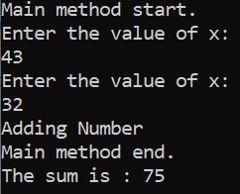
Output:

