Please fill in the name of the event you are preparing this manuscript for. | Nigeria Annual International Conference and Exhibition 2026
Please fill in your 6-digit SPE manuscript number. | Leave blank
Please fill in your manuscript title. | Rheology and Clay Stabilization Performance of Selected Inorganic Salts and Amino Acids in Water-Based Hydraulic Fracturing Fluids with Machine Learning for Predictive Performance Optimization
Please fill in your author name(s) and company affiliation.
Given Name | Surname |  | Company
Leave blank | Leave blank | Leave blank
Leave blank | Leave blank | Leave blank
Leave blank | Leave blank | Leave blank
Leave blank | Leave blank | Leave blank
Leave blank | Leave blank | Leave blank
Leave blank | Leave blank | Leave blank
Leave blank | Leave blank | Leave blank



Copyright 2025, Society of Petroleum Engineers

This paper was prepared for presentation at the STSE 2026.

Abstract
Hydraulic fracturing fluid efficiency is critically governed by its rheological behavior and its capacity to suppress clay swelling in water-sensitive formations, both of which directly influence proppant transport, fracture conductivity, and overall reservoir productivity. Conventional water-based fracturing fluids predominantly rely on potassium chloride (KCl) as a clay stabilizer; however, its effectiveness often necessitates high concentrations, leading to elevated salinity, potential formation damage, and environmental concerns. This study presents a comprehensive experimental and data-driven evaluation of the rheological performance and clay stabilization efficiency of selected inorganic salts (KCl and CaCl₂) and amino acids (L-arginine and L-cysteine), examined both as individual additives and in hybrid formulations within water-based hydraulic fracturing fluids.
A total of ten fluid systems were systematically formulated and characterized under controlled laboratory conditions. Rheological properties, including apparent viscosity, plastic viscosity, yield point, and shear-dependent behavior, were determined using rotational viscometry across a wide range of shear rates. Clay stabilization performance was assessed through time-resolved bentonite swelling tests conducted over a 24-hour period. Statistical analysis using one-way analysis of variance (ANOVA) confirmed that hybrid additive systems exhibited statistically significant improvements in both rheological stability and clay inhibition performance compared to conventional KCl-based fluids (p < 0.05). Furthermore, correlation analysis revealed a strong positive relationship between yield point and proppant-carrying capacity (r = 0.894), underscoring the importance of fluid structure in effective fracture proppant transport.
To enhance predictive capability and facilitate formulation optimization, machine learning techniques were integrated into the study. Multiple linear regression and random forest regression models were developed using experimentally derived datasets to predict key performance indicators, including clay swelling and rheological parameters, as functions of fluid composition. Model evaluation demonstrated that the random forest approach provided superior predictive accuracy, effectively capturing nonlinear interactions and synergistic effects among additives.
The results indicate that amino acid–inorganic salt hybrid systems significantly improve fluid rheology, enhance structural integrity at low shear conditions, and substantially reduce clay swelling, while simultaneously lowering the dependence on high salt concentrations. The integration of experimental analysis with machine learning-based predictive modeling establishes a robust framework for the rational design and optimization of advanced water-based fracturing fluids. This approach supports the development of environmentally sustainable, high-performance fluid systems for modern hydraulic fracturing applications.
Keywords: Hydraulic fracturing fluids; Rheology; Clay stabilization; Amino acids; Potassium chloride; Machine learning; Random forest regression; Proppant transport.

1.0 Introduction

1.1 Background

Hydraulic fracturing remains a fundamental stimulation technique for enhancing hydrocarbon recovery from low-permeability and unconventional reservoirs, where natural fluid flow is insufficient to sustain economic production (King, 2010; Montgomery, 2013). The effectiveness of this process is strongly dependent on the performance of the fracturing fluid, particularly its rheological properties and its interaction with formation minerals (Gomaa et al., 2015; Barati & Liang, 2014). Rheology governs critical operational parameters such as fracture propagation, proppant transport, and fluid cleanup, while fluid–rock interactions determine the extent of formation damage and long-term reservoir productivity (Al-Muntasheri, 2014; Liang et al., 2015). Water-based hydraulic fracturing fluids are widely adopted due to their cost-effectiveness, operational simplicity, and relatively lower environmental impact compared to oil-based systems (Barati & Liang, 2014; Kamal et al., 2015). However, their interaction with clay-rich formations presents a significant technical challenge (Anderson et al., 2010). Reactive clay minerals, especially smectite and montmorillonite, readily absorb water, leading to swelling, dispersion, and migration of fines (Anderson et al., 2010; Civan et al., 2007). These processes can reduce pore throat size, impair permeability, and ultimately diminish hydrocarbon recovery efficiency (Civan et al., 2007; Zhang & Xiao, 2021). Effective clay stabilization is therefore a critical requirement in the design of water-based fracturing fluids (O'Brien & Chenevert, 1973).

Conventional approaches to clay stabilization rely heavily on inorganic salts, particularly potassium chloride (KCl), which mitigates swelling through cation exchange mechanisms that reduce electrostatic repulsion within clay interlayers (O'Brien & Chenevert, 1973; Zhang & Xiao, 2021). While widely used, KCl-based systems often require high concentrations to achieve sufficient inhibition, resulting in elevated salinity, potential scaling, environmental concerns, and adverse effects on fluid rheology (Suter et al., 2011; Rasool & Ahmad, 2023). Calcium chloride (CaCl₂) offers improved performance in certain conditions due to its divalent cation effect, but it introduces additional challenges, including increased fluid density and potential incompatibility with polymer systems (Suter et al., 2011; Quintero, 2002). In response to these limitations, increasing attention has been directed toward environmentally sustainable and multifunctional additives (Quintero, 2002; Duartey et al., 2023). Amino acids, such as L-arginine and L-cysteine, have emerged as promising candidates due to their biodegradable nature and their ability to interact with clay surfaces through electrostatic attraction, hydrogen bonding, and functional group adsorption (Duartey et al., 2023; Jia et al., 2019). These interactions can effectively reduce clay hydration and dispersion while potentially enhancing the rheological structure of the fluid (Jia et al., 2019; Duartey et al., 2023). However, most existing studies have focused on their application in drilling fluids or simplified aqueous systems, with limited investigation into their performance within fully formulated hydraulic fracturing fluids (Duartey et al., 2023; Al-Muntasheri, 2014).

Moreover, the design of fracturing fluids has traditionally relied on empirical approaches, which are often time-consuming and limited in their ability to capture complex interactions between multiple additives (Temizel et al., 2021; Lestini et al., 2023). The integration of data-driven techniques, particularly machine learning, presents a significant opportunity to advance fluid design by enabling predictive modeling of rheological behavior and clay stabilization performance (Temizel et al., 2021; Khan et al., 2024). Machine learning algorithms can capture nonlinear relationships and synergistic effects between additives, providing a systematic framework for optimizing fluid formulations beyond conventional trial-and-error methods (Khan et al., 2024; Lestini et al., 2023). This study is motivated by the need to develop high-performance, environmentally responsible water-based fracturing fluids that simultaneously address rheological efficiency and clay stabilization, while leveraging machine learning to enhance predictive capability and formulation optimization (Gomaa et al., 2015; Temizel et al., 2021).

1.2 Problem Statement
The performance of water-based hydraulic fracturing fluids is constrained by the need to achieve an optimal balance between rheological efficiency and effective clay stabilization. Inadequate rheological properties can result in poor proppant transport, excessive settling, and inefficient fracture propagation, while insufficient clay inhibition can lead to swelling, fines migration, and severe formation damage. These challenges are particularly pronounced in clay-rich unconventional reservoirs, where fluid–rock interactions play a dominant role in determining treatment success.
Conventional clay stabilization strategies, primarily based on potassium chloride (KCl), are limited by their dependence on high concentrations to achieve effective performance. This not only increases the salinity of the fluid system but also raises environmental and operational concerns, including disposal challenges, potential scaling, and negative impacts on fluid rheology. Although alternative salts such as calcium chloride (CaCl₂) provide stronger ionic interactions with clay minerals, they introduce additional complexities related to fluid density and compatibility with polymer-based systems. Emerging alternatives, particularly amino acids, offer promising mechanisms for clay stabilization through adsorption and surface interaction. However, their effectiveness within fully formulated hydraulic fracturing fluids, especially in combination with inorganic salts, remains insufficiently understood. There is a lack of systematic experimental data evaluating the synergistic effects of hybrid additive systems on both rheological properties and clay swelling behavior under consistent conditions.
Furthermore, current fluid design practices largely rely on empirical testing and limited statistical analysis, which do not adequately capture the complex, nonlinear interactions between fluid components. This limits the ability to predict performance outcomes and optimize formulations efficiently. The absence of integrated predictive tools hinders the development of advanced fluid systems that can simultaneously achieve high rheological performance, effective clay stabilization, and environmental sustainability.
Therefore, there is a critical need to:
- Systematically evaluate the combined effects of inorganic salts and amino acids on rheology and clay stabilization in water-based fracturing fluids.
- Quantify the relationships between rheological parameters and clay swelling behavior.
- Develop predictive models capable of optimizing fluid formulations based on compositional variables.
Addressing these gaps will enable the design of more efficient, sustainable, and performance-optimized hydraulic fracturing fluids suitable for modern unconventional reservoir applications.
1.3 Objectives of the Study
The aim of this study is to evaluate the rheological behavior and clay stabilization performance of selected inorganic salts and amino acids in water-based hydraulic fracturing fluids, and to apply machine learning techniques for predictive performance optimization.
The specific objectives are to:
- Formulate water-based fracturing fluids using KCl, CaCl₂, L-arginine, L-cysteine, and their hybrid combinations.
- Experimentally determine key rheological properties, including apparent viscosity, plastic viscosity, and yield point.
- Assess clay swelling inhibition using bentonite-based tests over a 24-hour period.
- Analyze the relationships between fluid composition, rheological parameters, and clay stabilization using statistical methods.
- Develop and evaluate machine learning models to predict fluid performance and identify optimal formulations.
1.4 Scope and Significance
This study is limited to laboratory-scale evaluation of ten water-based hydraulic fracturing fluid systems containing selected inorganic salts, amino acids, and their combinations. Rheological properties are measured using rotational viscometry, while clay stabilization performance is assessed through bentonite swelling tests. Machine learning models are developed using experimental data to predict performance outcomes. Field-scale conditions such as high pressure and temperature are not considered.
The significance of this study lies in its contribution to the development of improved and sustainable fracturing fluids. By demonstrating the effectiveness of amino acid–salt hybrid systems, the study provides an alternative to conventional high-salinity KCl-based fluids. Additionally, the integration of machine learning introduces a predictive framework for fluid design, enabling more efficient optimization and reducing reliance on trial-and-error experimentation.

2. Literature Review
Hydraulic fracturing fluid design has evolved significantly over the past decades, driven by the need to improve proppant transport, minimize formation damage, and ensure environmental compliance. The performance of water-based fracturing fluids is primarily governed by their rheological properties and their interaction with clay minerals present in the formation. These two aspects are intrinsically linked, as fluid structure influences particle suspension while fluid–rock interactions determine permeability retention and long-term productivity.

2.1 Rheology of Hydraulic Fracturing Fluids
Rheology plays a central role in determining the effectiveness of hydraulic fracturing fluids. The ability of a fluid to transport proppant particles and maintain suspension is largely dependent on its viscosity and yield stress. Most water-based fracturing fluids exhibit non-Newtonian behavior, typically described using the Power Law model:
$$τ=Kγ^{n}$$
where
( $τ$ ) is the shear stress,
( $γ$ ) is the shear rate,
( $K$ ) is the consistency index, and
( n ) is the flow behavior index.
For shear-thinning fluids commonly used in fracturing operations, $\left(n<1\right)$ , indicating that viscosity decreases with increasing shear rate. This behavior is advantageous, as it allows for easier pumping at high shear rates while maintaining sufficient viscosity at low shear rates for proppant suspension. The apparent viscosity ( $μ_{a}$ ) of such fluids is expressed as:
$$μ_{a}=Kγ^{n-1}$$
In field applications, rheological properties are often derived from viscometer readings. The plastic viscosity (PV) and yield point (YP) are calculated as:
$$PV=θ_{600}-θ_{300} \\ YP=θ_{300}-PV$$
where ($θ_{600}$) and ( $θ_{300}$ ) are dial readings at 600 rpm and 300 rpm, respectively. The yield point is particularly significant, as it reflects the fluid’s ability to suspend and transport proppant particles under low shear conditions.

2.2 Clay Swelling and Formation Damage
Clay swelling is a major challenge in water-based fracturing operations, especially in formations containing smectite and montmorillonite. These clays possess a layered structure with exchangeable cations in the interlayer spaces. When exposed to water, hydration forces cause expansion of these layers, leading to volumetric swelling. The swelling mechanism is governed by osmotic and electrostatic forces. The diffuse double layer theory explains how water molecules and ions interact with clay surfaces. The thickness of the diffuse layer increases with decreasing ionic strength, leading to increased repulsion between clay layers and subsequent swelling. Clay swelling can be quantified using a swelling index:
$$SI=\frac{V_{t}-V_{0}}{V_{0}}$$
where
( $V_{t}$ ) is the volume at time ( t ),
( $V_{0}$ ) is the initial volume.
Swelling leads to pore throat reduction, fines migration, and permeability impairment, all of which negatively affect hydrocarbon production.

2.3 Conventional Clay Stabilization Methods
The most widely used method for controlling clay swelling is the addition of inorganic salts, particularly potassium chloride (KCl). The effectiveness of KCl is attributed to its ability to provide potassium ions (K⁺), which replace sodium ions (Na⁺) in clay interlayers through cation exchange. This reduces the hydration potential of the clay and stabilizes its structure.
The cation exchange process can be represented as:
$${\text{Clay–Na}}^{+}+{\text{K}}^{+}→{\text{Clay–K}}^{+}+{\text{Na}}^{+}$$
Calcium chloride (CaCl₂) is also used due to the higher charge density of Ca²⁺ ions, which enhances electrostatic attraction between clay layers. However, the use of high salt concentrations introduces several drawbacks, including increased fluid salinity, environmental concerns, scaling tendencies, and potential interference with polymer hydration.

2.4 Amino Acids as Alternative Clay Stabilizers
Recent research has explored the use of amino acids as environmentally friendly alternatives to conventional salts. Amino acids contain both amino (–NH₂) and carboxyl (–COOH) functional groups, enabling them to interact with clay surfaces through multiple mechanisms, including hydrogen bonding, electrostatic attraction, and surface adsorption. For example, L-arginine, which carries a positively charged guanidinium group at neutral pH, can strongly adsorb onto negatively charged clay surfaces, reducing water penetration and inhibiting swelling. Similarly, L-cysteine contains thiol (–SH) groups that contribute to adsorption and interaction with mineral surfaces. The adsorption process can be conceptually represented as:
$${\text{Clay}}^{-}+{\text{R–NH}}_{3}^{+}→{\text{Clay–R–NH}}_{3}$$
where ( $\text{R}$ ) represents the amino acid structure. These interactions reduce the availability of hydration sites and limit clay expansion. Additionally, amino acids are biodegradable and exhibit lower environmental impact compared to inorganic salts, making them attractive for sustainable fluid design.

2.5 Synergistic Effects of Hybrid Additive Systems
Recent studies indicate that combining inorganic salts with organic additives can produce synergistic effects that enhance both rheological performance and clay stabilization. In hybrid systems, salts provide rapid ionic stabilization through charge neutralization, while organic molecules such as amino acids contribute to surface adsorption and structural reinforcement.
This dual mechanism improves fluid stability and reduces the concentration of salts required. Furthermore, hybrid systems can improve the viscoelastic properties of the fluid, leading to better proppant suspension and reduced settling rates.
The settling velocity of proppant particles in a fluid can be estimated using Stokes’ law:
$$v=\frac{2r^{2}\left(ρ_{p}-ρ_{f}\right)g}{9μ}$$
where
( $v$ ) is the settling velocity,
($r$ ) is particle radius,
( $ρ_p )$ and ( $ρ_{f}$ ) are the densities of the particle and fluid,
($μ$) is fluid viscosity.
An increase in viscosity or yield stress reduces settling velocity, thereby improving proppant transport efficiency.

2.6 Application of Machine Learning in Fluid Design
The design of hydraulic fracturing fluids has traditionally relied on empirical testing and heuristic optimization. However, the complex interactions between fluid components often result in nonlinear behavior that is difficult to model using conventional approaches. Machine learning (ML) provides a data-driven framework for capturing these relationships. Regression-based models, such as multiple linear regression, establish linear relationships between input variables and output responses:
$$y=β_{0}+\sum_{i=1}^{n}{β_{i}x_{i}}+ϵ$$
where
( y ) is the predicted output,
( $x_{i}$ ) are input features,
( $β_{i}$ ) are model coefficients,
( $ϵ$ ) is the error term.
More advanced models, such as random forest regression, use ensemble learning to capture nonlinear interactions and improve predictive accuracy. These models are particularly effective in identifying feature importance and optimizing formulation parameters. The performance of ML models is commonly evaluated using metrics such as the coefficient of determination:
$$R^{2}=1-\frac{\sum{{\left(y_{i}-\hat{y_{i}}\right)}^{2}}}{\sum{{\left(y_{i}-\overline{y}\right)}^{2}}}$$
where ( $y_{i}$ ) are observed values, ( $\hat{y_{i}}$ ) are predicted values, and ($\overline{y}$) is the mean of observed values.

3.0 Methodology

3.1 Materials and Laboratory Equipment
Materials used in this study were representative of conventional water-based hydraulic fracturing systems. Deionized water was used as the base fluid, while silica (quartz) sand served as the proppant. Guar gum and starch were employed as viscosifiers to control fluid rheology. Borax was used as a crosslinker to enhance gel structure, and sodium bromate served as a gel breaker. Fluid chemistry was regulated using diluted hydrochloric acid (HCl) and sodium carbonate for pH control. Isopropanol was included as a surfactant to improve wettability, ethylene glycol as a corrosion inhibitor, and citric acid as an iron control agent. Clay stabilization additives included potassium chloride (KCl), calcium chloride (CaCl₂), L-arginine, and L-cysteine, as well as their hybrid combinations. Bentonite clay, predominantly composed of montmorillonite, was used as the model clay. Laboratory equipment included analytical balances, graduated cylinders, mechanical stirrers, multimixers, a rotational viscometer, and a laboratory filter press.

3.2 Fluid Formulation and Composition
Ten hydraulic fracturing fluid samples were prepared at a fixed volume of 500 mL. The base formulation was maintained constant across all samples, while clay-stabilizing additives were varied.

3.2.1 Base Fluid Composition
Table 3.1: Base Hydraulic Fracturing Fluid Composition (500 mL)
S/N | Component | % wt/vol | Volume (mL) | Mass (g)
1 | Deionized Water | 90.000 | 450.0 | —
2 | Silica/Quartz Sand | 8.550 | 42.75 | 113.3
3 | Polymer (Guar Gum/Starch) | 0.066 | 0.33 | 0.231
4 | Gel Breaker (Sodium Bromate) | 0.010 | 0.05 | 0.122
5 | Crosslinker (Borax) | 0.007 | 0.035 | 0.0605
6 | Acid (HCl, diluted) | 0.123 | 0.615 | —
7 | pH Adjuster (Sodium Carbonate) | 0.011 | 0.055 | 0.127
8 | Surfactant (Isopropanol) | 0.085 | 0.425 | —
9 | Corrosion Inhibitor (Ethylene Glycol) | 0.002 | 0.01 | —
10 | Iron Control Agent (Citric Acid) | 0.004 | 0.02 | 0.0333

3.2.2 Clay-Stabilizing Additives
Table 3.2: Clay-Stabilizing Additive Systems
Sample | Additive(s) | % wt | Volume (mL) | Mass (g)
1 | KCl | 1.0 | 5.0 | 9.90
2 | CaCl₂ | 1.0 | 5.0 | 10.75
3 | L-arginine | 1.0 | 5.0 | 8.00
4 | L-cysteine | 1.0 | 5.0 | 8.00
5 | KCl + CaCl₂ | 0.5 + 0.5 | 2.5 + 2.5 | 4.95 + 5.38
6 | KCl + L-arginine | 0.5 + 0.5 | 2.5 + 2.5 | 4.95 + 4.00
7 | KCl + L-cysteine | 0.5 + 0.5 | 2.5 + 2.5 | 4.95 + 4.00
8 | CaCl₂ + L-arginine | 0.5 + 0.5 | 2.5 + 2.5 | 5.38 + 4.00
9 | CaCl₂ + L-cysteine | 0.5 + 0.5 | 2.5 + 2.5 | 5.38 + 4.00
10 | L-arginine + L-cysteine | 0.5 + 0.5 | 2.5 + 2.5 | 4.00 + 4.00

3.3 Sample Preparation Procedure
Fluid preparation followed a sequential mixing protocol. Deionized water (450 mL) was introduced first, followed by gradual addition of silica sand under continuous agitation. Clay-stabilizing additives were then dissolved at 300–400 rpm. Polymers were added and hydrated for 15 minutes. Crosslinker and gel breaker were incorporated sequentially. The pH was adjusted to 6.5–7.5. Surfactant, corrosion inhibitor, and iron control agent were added subsequently. Final mixing was conducted at 500 rpm for 30 minutes.
3.4 Rheological Measurements
Rheological measurements were performed using a rotational viscometer at 25°C. Dial readings were recorded at 600, 300, 200, 100, 60, 30, and 6 rpm.
$PV=θ_{600}-θ_{300}$
$$YP=θ_{300}-PV \\ AV=\frac{θ_{600}}{2}$$
Gel strength was measured at 10 seconds.

3.5 Clay Stabilization Testing

3.5.1 Clay Sample Preparation
Bentonite (23.5 g) was dispersed in 200 mL of deionized water and mixed for 10 minutes. The slurry was compacted at 1000 psi using a filter press and dried under ambient conditions.

3.5.2 Swelling Measurement Procedure
Each sample was treated with 35 mL of fracturing fluid. Swelling was recorded at intervals up to 24 hours.
$$SI=\frac{V_{t}-V_{0}}{V_{0}}$$

3.6 Statistical Analysis
One-way ANOVA was used to evaluate differences across formulations. Shapiro–Wilk and Levene tests were applied to verify assumptions. Tukey’s HSD was used for pairwise comparisons. Effect size was quantified using eta squared. Pearson correlation analysis was performed between rheological parameters and swelling behavior.
3.7 Machine Learning Modeling
Machine learning models were developed to predict key performance indicators, including rheological properties and clay swelling behavior, based on fluid composition.

3.7.1 Dataset Preparation
The dataset was constructed from experimental results obtained for the ten fluid systems. Input features included additive type, concentration, and compositional variables, while output variables included apparent viscosity, plastic viscosity, yield point, and swelling index at 24 hours. Prior to modeling, the dataset was preprocessed by normalizing input variables and encoding categorical features where necessary. The dataset was divided into training and testing subsets using an 80:20 split.

3.7.2 Model Development
Two regression-based models were implemented:
- Multiple Linear Regression (MLR) to capture linear relationships
- Random Forest Regression (RFR) to capture nonlinear interactions and feature importance
The random forest model consisted of an ensemble of decision trees, trained using bootstrap aggregation to improve generalization and reduce overfitting.

3.7.3 Model Evaluation
Model performance was evaluated using standard regression metrics:
$$R^{2}=1-\frac{\sum{{\left(y_{i}-\hat{y_{i}}\right)}^{2}}}{\sum{{\left(y_{i}-\overline{y}\right)}^{2}}} \\ RMSE=\sqrt{\frac{1}{n}\sum{{\left(y_{i}-\hat{y_{i}}\right)}^{2}}}$$
$$\text{MAE}=\frac{1}{n}\sum_{i=1}^{n}{\left|y_{i}-\hat{y_{i}}\right|}$$

where ( $y_{i}$) represents observed values and ( $\hat{y_{i}}$ ) represents predicted values.

3.7.4 Model Application
The developed models were used to:
- Predict fluid performance based on composition
- Identify key variables influencing rheology and clay stabilization
- Support optimization of hybrid additive formulations
The random forest model was particularly effective in capturing nonlinear relationships and synergistic effects among additives.

4.0 Results and Discussion
This section presents the experimental findings on water-based hydraulic fracturing fluids, focusing on their rheological behavior and clay stabilization performance. Rheological measurements across a wide range of shear rates, along with 10-second gel strength, reveal differences in structural integrity among formulations. Clay stabilization was evaluated by swelling percentages, showing the effectiveness of various additives and their combinations in inhibiting clay hydration. Correlations between rheology and clay stabilization efficiency provide insights into additive performance under operational conditions.
4.1 Rheological Properties of Hydraulic Fracturing Fluids
Table 4.1 summarizes rotational viscometer readings for ten fluid formulations at shear rates of 600, 300, 200, 100, 60, 30, and 6 rpm, along with 10-second gel strength.
Table 4.1: Rheological Measurements of Hydraulic Fracturing Fluid Samples
Formulation | 600 rpm | 300 rpm | 200 rpm | 100 rpm | 60 rpm | 30 rpm | 6 rpm | Gel Strength 10s (lb/100 ft²)
KCl 1 wt% | 12 | 10 | 8 | 6.5 | 5 | 4 | 3 | 6
CaCl₂ 1 wt% | 15 | 12 | 8 | 7 | 6.5 | 5 | 4 | 9
KCl 0.5 + CaCl₂ 0.5 | 16 | 9 | 7 | 6 | 5 | 4.5 | 3.5 | 5
L-Arg 0.5 + CaCl₂ 0.5 | 14 | 9 | 8 | 6 | 4.5 | 4 | 3 | 7
L-Cys 0.5 + KCl 0.5 | 18 | 11 | 9 | 7 | 6 | 5 | 4 | 6
L-Cys 0.5 + CaCl₂ 0.5 | 15 | 10 | 8 | 6.5 | 5.5 | 4 | 3.5 | 7
L-Cys 1 wt% | 17 | 11 | 8 | 7 | 6 | 4.5 | 4 | 6
L-Arg 1 wt% | 20 | 12 | 10 | 9 | 8 | 6.5 | 5 | 7
L-Cys 0.5 + L-Arg 0.5 | 18 | 13 | 11 | 8 | 7 | 6 | 4.5 | 7
L-Arg 0.5 + KCl 0.5 | 17 | 14 | 10 | 9 | 7.5 | 6.5 | 5 | 9
Single-salt systems show moderate viscosity. KCl 1 wt% exhibits low dial readings, indicating limited structural buildup, while CaCl₂ 1 wt% produces higher readings, reflecting stronger divalent cation effects. Blended salts, such as KCl + CaCl₂, provide balanced shear-thinning behavior. Amino acid–salt and amino acid–amino acid combinations, particularly those containing L-Arginine, enhance viscosity and gel strength, showing improved proppant suspension and structural recovery.
4.1.1 Derived Rheological Parameters
Table 4.2 summarizes derived parameters, including apparent viscosity (AV), plastic viscosity (PV), yield point (YP), flow behavior index (n), consistency index (k), low-shear-rate viscosity (LSRV), rheological stability index (RSI), proppant carrying capacity index (PCCI), and gel structure index (GSI).

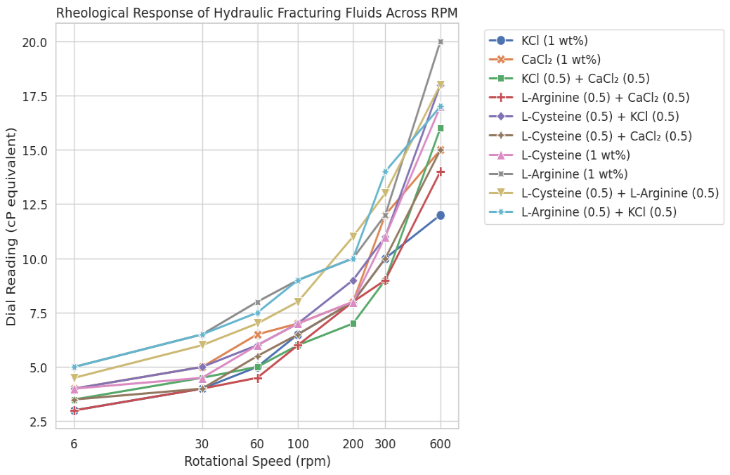
Figure 4.1: Shear rate versus shear stress for all samples

Table 4.2: Summary of Rheological Properties and Performance Indices
Formulation | AV (cP) | PV (cP) | YP (lb/100 ft²) | n | k | LSRV | RSI | PCCI | GSI
KCl 1 wt% | 6.0 | 2 | 8 | 0.263 | 2.23 | 3.0 | 0.25 | 4.0 | 0.75
CaCl₂ 1 wt% | 7.5 | 3 | 9 | 0.322 | 1.91 | 4.0 | 0.267 | 3.0 | 1.0
KCl 0.5 + CaCl₂ 0.5 | 8.0 | 7 | 2 | 0.830 | 0.079 | 3.5 | 0.219 | 0.29 | 2.5
L-Arg 0.5 + CaCl₂ 0.5 | 7.0 | 5 | 4 | 0.637 | 0.237 | 3.0 | 0.214 | 0.8 | 1.75
L-Cys 0.5 + KCl 0.5 | 9.0 | 7 | 4 | 0.710 | 0.191 | 4.0 | 0.222 | 0.57 | 1.5
L-Cys 0.5 + CaCl₂ 0.5 | 7.5 | 5 | 5 | 0.585 | 0.356 | 3.5 | 0.233 | 1.0 | 1.4
L-Cys 1 wt% | 8.5 | 6 | 5 | 0.628 | 0.306 | 4.0 | 0.235 | 0.83 | 1.2
L-Arg 1 wt% | 10.0 | 8 | 4 | 0.737 | 0.179 | 5.0 | 0.25 | 0.5 | 1.75
L-Cys 0.5 + L-Arg 0.5 | 9.0 | 5 | 8 | 0.469 | 0.893 | 4.5 | 0.25 | 1.6 | 0.875
L-Arg 0.5 + KCl 0.5 | 8.5 | 3 | 11 | 0.280 | 2.833 | 5.0 | 0.294 | 3.67 | 0.818
Single-salt fluids exhibit low to moderate AV and PV, whereas amino acid–based and hybrid systems demonstrate enhanced viscosity, shear-thinning, and gel strength. L-Arginine-based formulations consistently show superior low-shear viscosity and structural integrity, while combined amino acid systems exhibit synergistic effects, balancing pumpability and proppant suspension.
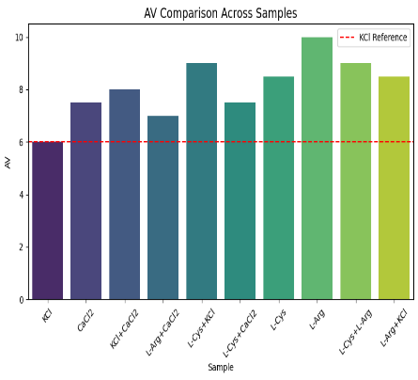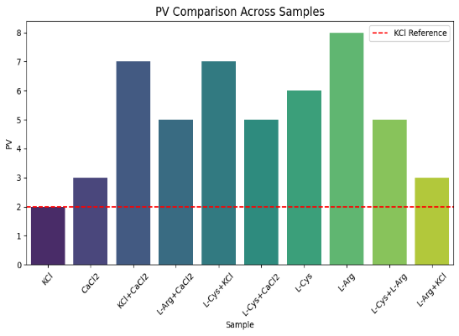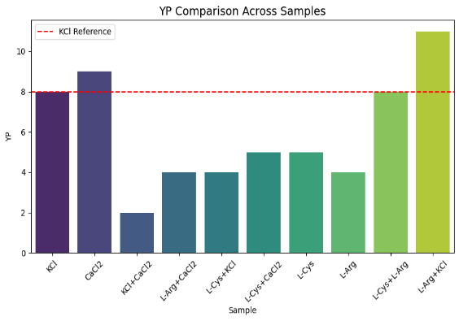
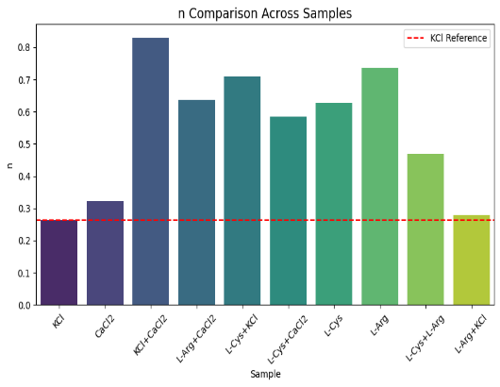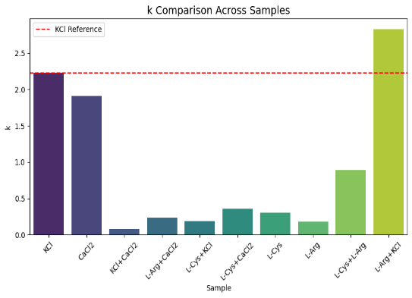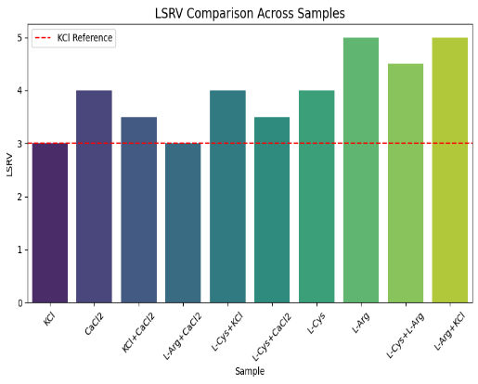
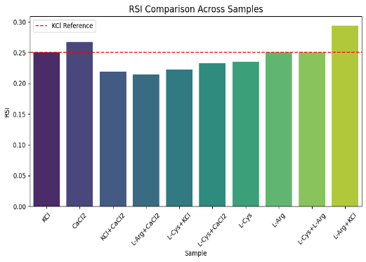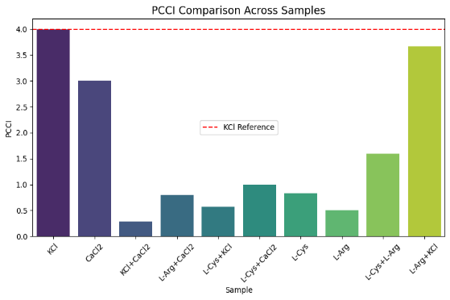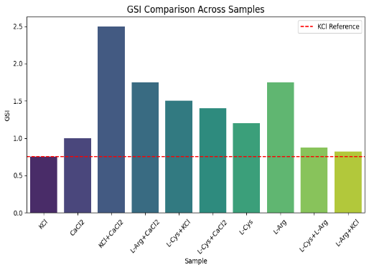
Figures 4.2–4.10 illustrate comparisons across all formulations; Apparent Viscosity, Plastic Viscosity, Yield Point, Flow Behavior Index, Consistency Index, Low-Shear-Rate Viscosity, Rheological Stability Index, Proppant Carrying Capacity Index, Gel Structure Index
The results demonstrate that amino acid–based stabilizers, particularly L-Arginine and its blends, outperform conventional inorganic salts in enhancing viscosity, gel strength, and low-shear stability. Hybrid formulations offer optimized structural resilience and flow behavior, confirming their potential for high-performance hydraulic fracturing fluids.
4.2 Clay Swelling and Inhibition Behavior
Inhibition of clay swelling is a critical performance factor for water-based hydraulic fracturing fluids. Excessive swelling can lead to formation damage, reduced permeability, and operational challenges during pumping. This section details clay swelling behavior for ten fluid formulations, examining the effects of different additives and the synergistic performance of hybrid systems. The interplay between clay inhibition and rheological properties is also discussed, linking fluid structure and stability to functional performance.
4.2.1 Swelling Behavior
Clay swelling measurements are summarized in Table 4.3. Absolute clay volumes are reported relative to an initial dry volume of 20 mL, capturing the progression from initial contact to 24 hours. Table 4.4 converts these data into percentage swelling, providing a normalized basis for comparative evaluation of stabilization efficiency.
Table 4.3: Clay Volume (mL) over Time
Formulation | Dry | 0h | 1h | 2h | 3h | 4h | 5h | 6h | 7h | 8h | 12h | 24h
KCl 1 wt% | 20 | 28 | 31.0 | 32.5 | 33.0 | 33.0 | 33.5 | 34.5 | 35.0 | 35.0 | 35.0 | 35.0
CaCl₂ 1 wt% | 20 | 28 | 32.5 | 34.5 | 35.0 | 35.5 | 35.5 | 35.5 | 36.0 | 36.0 | 36.0 | 36.0
KCl 0.5 + CaCl₂ 0.5 | 20 | 28 | 32.5 | 33.5 | 34.0 | 34.0 | 34.5 | 34.5 | 34.5 | 34.5 | 35.0 | 35.0
L-Arginine 0.5 + CaCl₂ 0.5 | 20 | 28 | 32.0 | 34.0 | 34.5 | 34.5 | 35.0 | 35.5 | 36.0 | 36.0 | 36.0 | 36.0
L-Cysteine 0.5 + KCl 0.5 | 20 | 28 | 29.5 | 30.5 | 31.0 | 31.0 | 31.5 | 31.5 | 32.0 | 32.0 | 32.0 | 32.0
L-Cysteine 0.5 + CaCl₂ 0.5 | 20 | 28 | 30.5 | 32.0 | 33.0 | 34.0 | 35.0 | 36.0 | 37.0 | 37.0 | 37.5 | 37.5
L-Cysteine 1 wt% | 20 | 28 | 31.0 | 34.0 | 34.5 | 35.0 | 35.0 | 35.5 | 35.5 | 35.5 | 35.5 | 35.5
L-Arginine 1 wt% | 20 | 28 | 33.5 | 38.0 | 38.5 | 38.5 | 39.0 | 39.5 | 40.0 | 40.0 | 41.0 | 41.5
L-Cysteine 0.5 + L-Arginine 0.5 | 20 | 28 | 33.0 | 34.0 | 34.5 | 34.5 | 34.5 | 35.0 | 35.0 | 35.0 | 35.0 | 35.0
L-Arginine 0.5 + KCl 0.5 | 20 | 28 | 30.0 | 30.5 | 31.0 | 31.5 | 31.5 | 31.5 | 32.0 | 32.0 | 32.0 | 32.0
Table 4.4: Clay Swelling Percentage (%) over Time
Formulation | 0h | 1h | 2h | 3h | 4h | 5h | 6h | 7h | 8h | 12h
KCl 1 wt% | 40 | 55 | 62.5 | 65 | 65 | 67.5 | 72.5 | 75 | 75 | 75
CaCl₂ 1 wt% | 40 | 62.5 | 72.5 | 75 | 77.5 | 77.5 | 77.5 | 80 | 80 | 80
KCl 0.5 + CaCl₂ 0.5 | 40 | 62.5 | 67.5 | 70 | 70 | 72.5 | 72.5 | 72.5 | 72.5 | 75
L-Arginine 0.5 + CaCl₂ 0.5 | 40 | 60 | 70 | 72.5 | 72.5 | 75 | 77.5 | 80 | 80 | 80
L-Cysteine 0.5 + KCl 0.5 | 40 | 47.5 | 52.5 | 55 | 55 | 57.5 | 57.5 | 60 | 60 | 60
L-Cysteine 0.5 + CaCl₂ 0.5 | 40 | 52.5 | 60 | 65 | 70 | 75 | 80 | 85 | 85 | 87.5
L-Cysteine 1 wt% | 40 | 55 | 70 | 72.5 | 75 | 75 | 77.5 | 77.5 | 77.5 | 77.5
L-Arginine 1 wt% | 40 | 67.5 | 90 | 92.5 | 92.5 | 95 | 97.5 | 100 | 100 | 105
L-Cysteine 0.5 + L-Arginine 0.5 | 40 | 65 | 70 | 72.5 | 72.5 | 72.5 | 75 | 75 | 75 | 75
L-Arginine 0.5 + KCl 0.5 | 40 | 50 | 52.5 | 55 | 57.5 | 57.5 | 57.5 | 60 | 60 | 60
KCl 1 wt% demonstrates controlled swelling, reaching a plateau near 75%, indicating effective clay stabilization by monovalent potassium ions (Figure 4.11 shows the swelling trend over time). CaCl₂ 1 wt% exhibits faster early-stage swelling, stabilizing near 80% due to rapid divalent cation interaction with clay surfaces (Figure 4.12). The hybrid KCl + CaCl₂ formulation moderates early swelling while maintaining a similar final plateau, highlighting complementary ionic effects (Figure 4.13).
Amino acid–inorganic salt hybrids show varying performance. L-Cysteine + KCl (0.5 + 0.5 wt%) demonstrates strong stabilization, plateauing around 62.5% (Figure 4.14), whereas L-Arginine + KCl (0.5 + 0.5 wt%) reaches 65%, slightly higher due to early-stage hydration moderation (Figure 4.15). L-Arginine alone exhibits the highest plateau (~90–105%), indicating poor long-term stabilization (Figure 4.16). L-Cysteine + L-Arginine (0.5 + 0.5 wt%) shows moderate stabilization, plateauing near 80% (Figure 4.17), suggesting partial synergy but limited overall effectiveness.
The overall effectiveness of stabilizers, based on final plateau swelling, follows the trend: L-Cys + KCl (0.5 + 0.5 wt%) ~62.5% < L-Arg + KCl (0.5 + 0.5 wt%) ~65% < KCl 1 wt% ~75% < L-Cys + CaCl₂ ~70% < KCl + CaCl₂, L-Arg + CaCl₂, L-Cys, L-Cys + L-Arg ~80% < CaCl₂ alone ~80% < L-Arg alone ~90%. These results demonstrate that KCl-based formulations, particularly those combined with amino acids, provide the most effective clay stabilization.
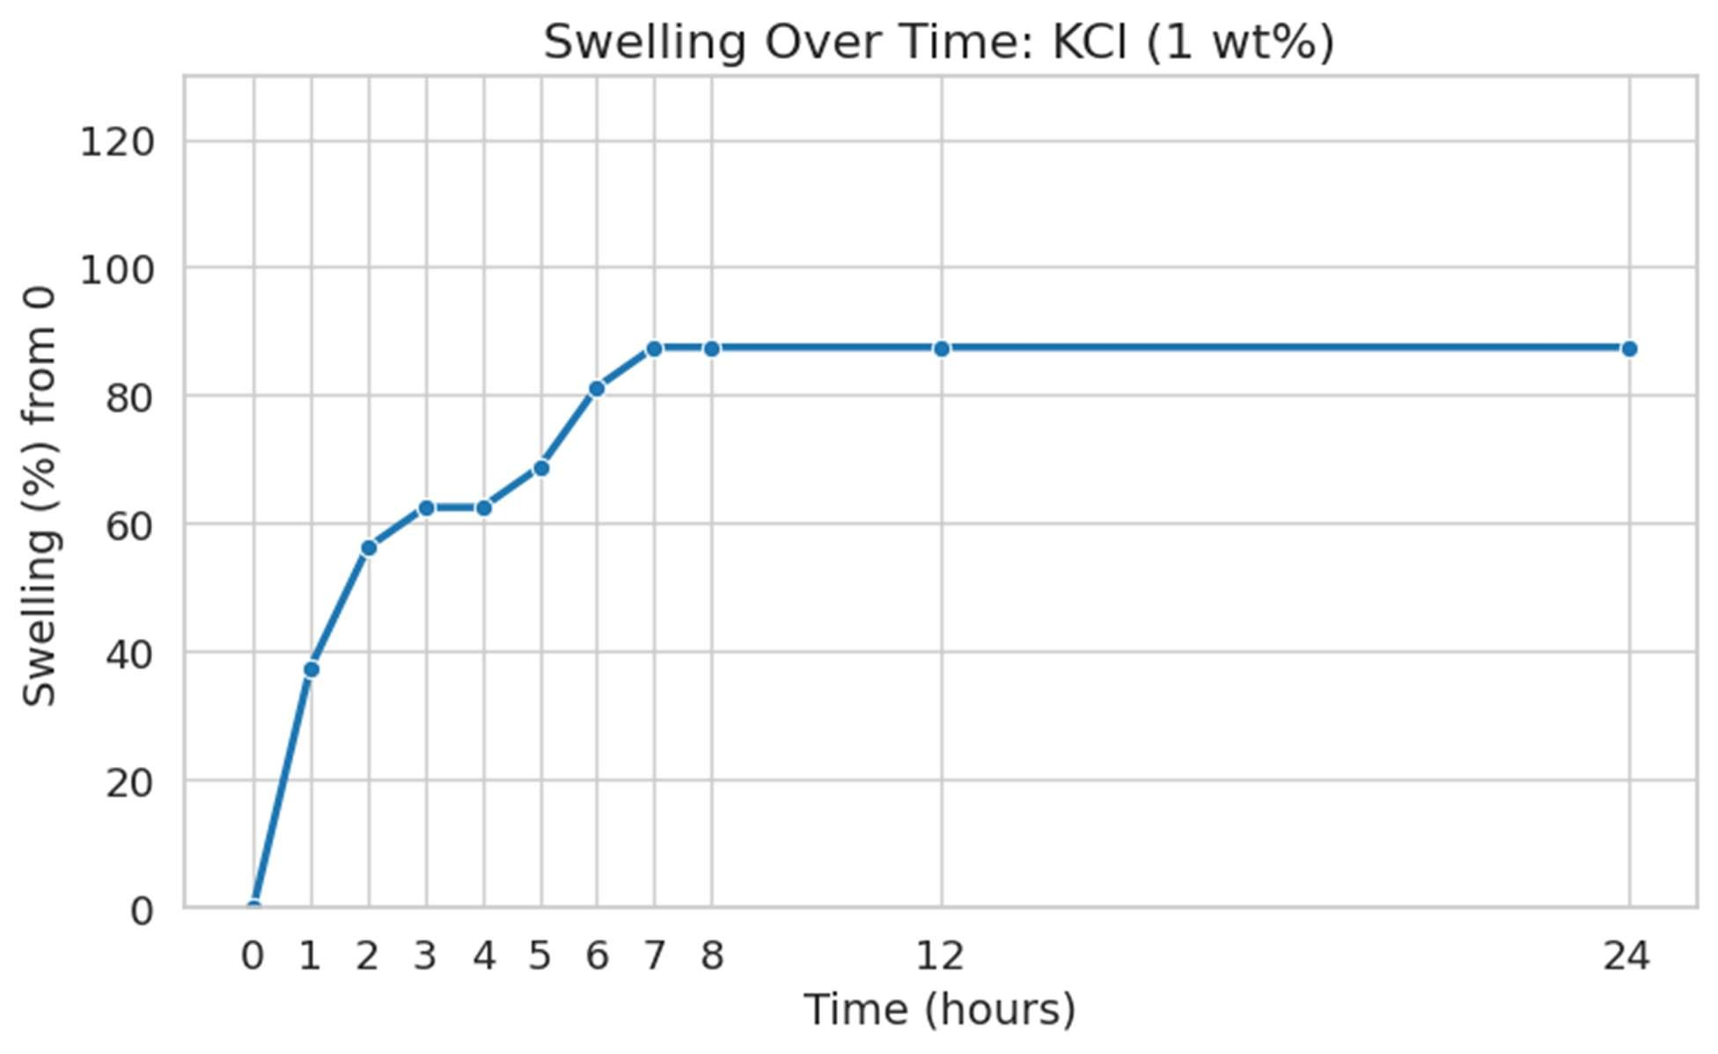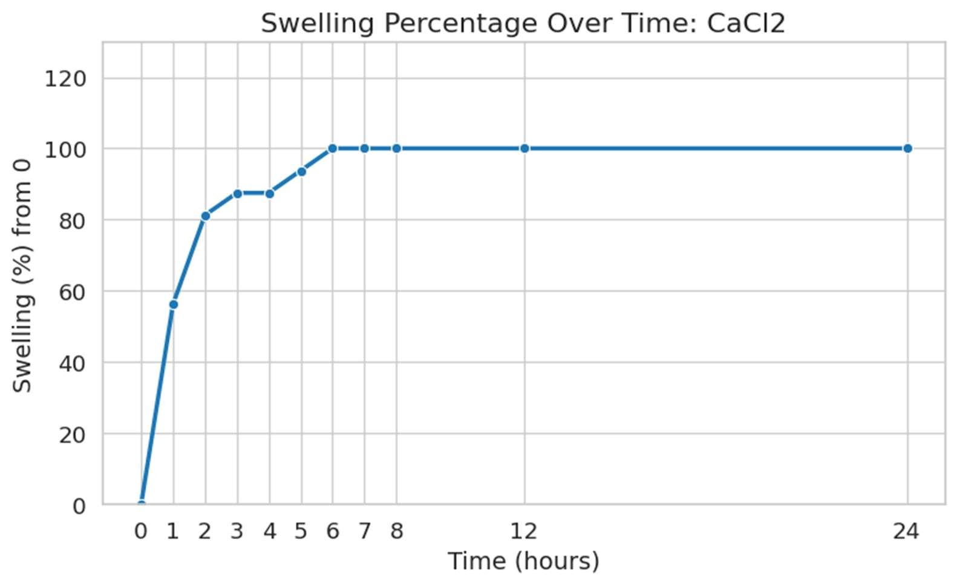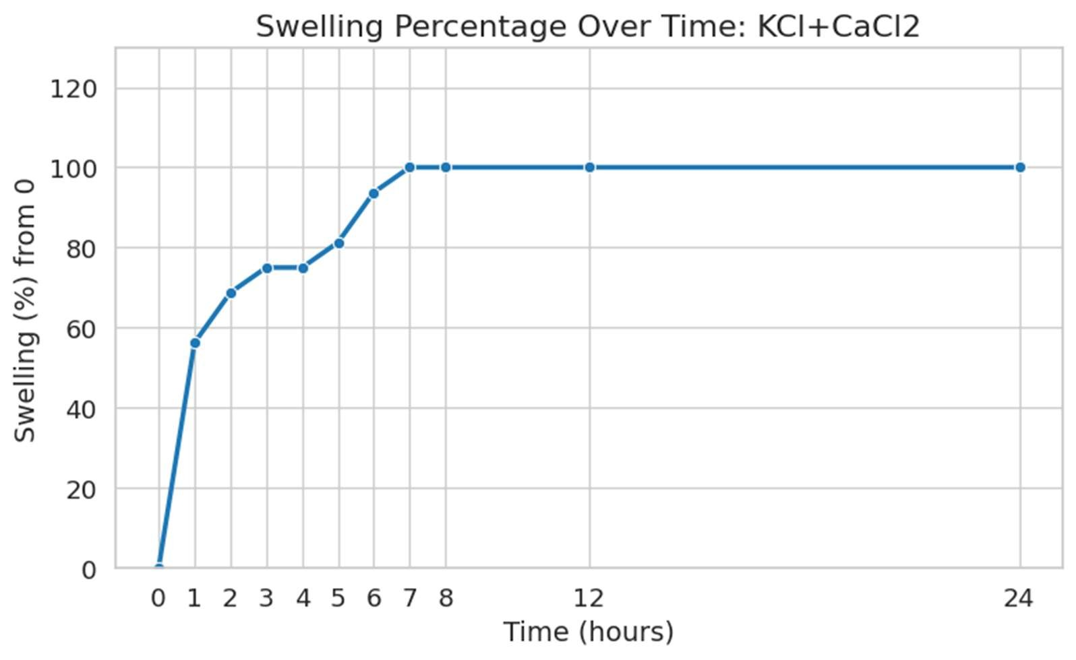
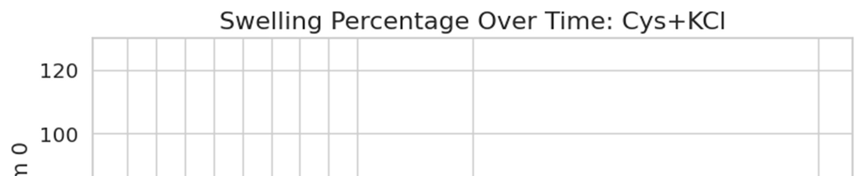
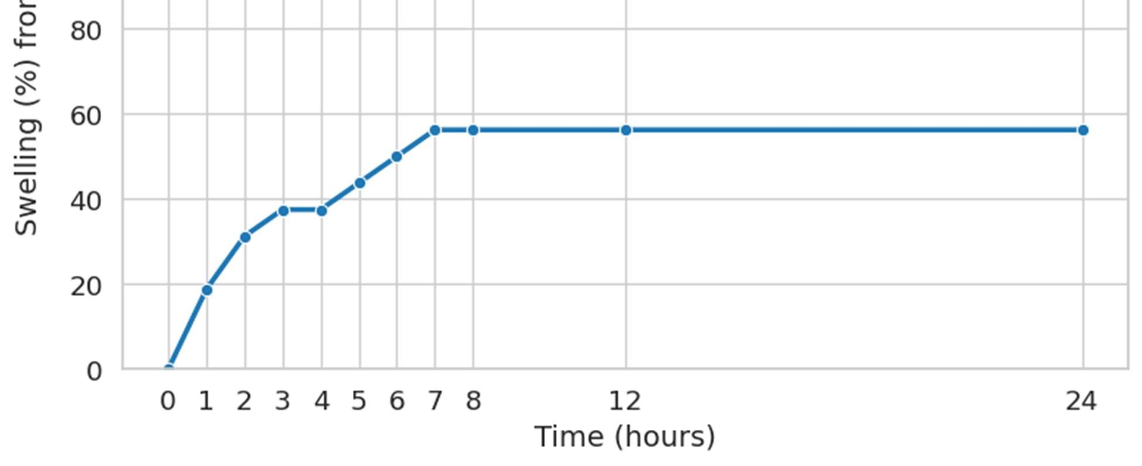
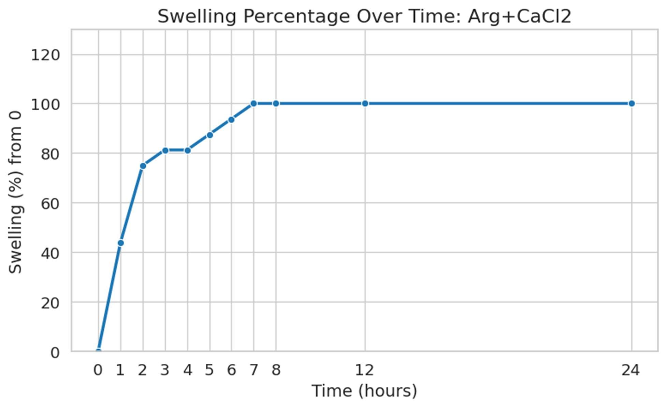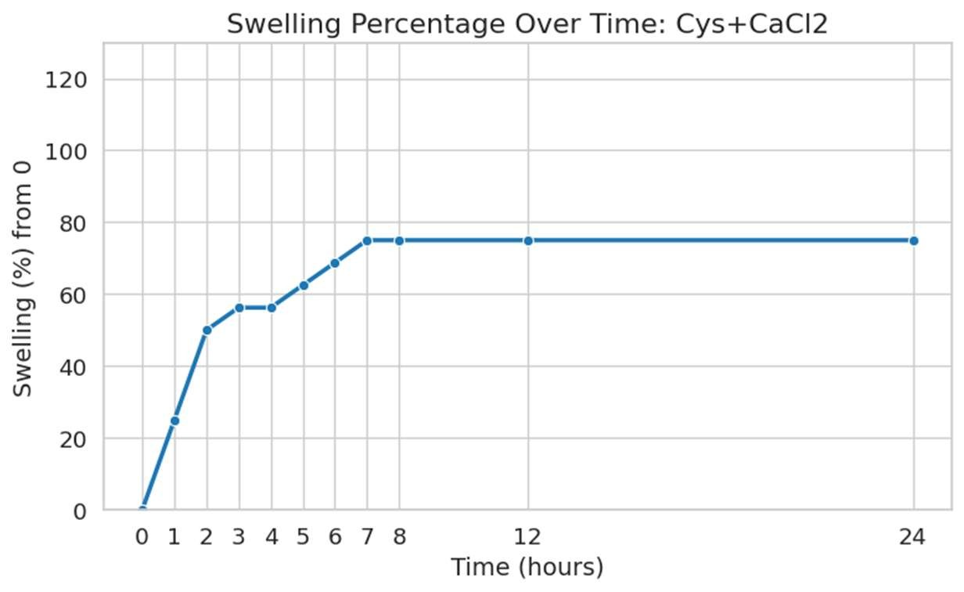
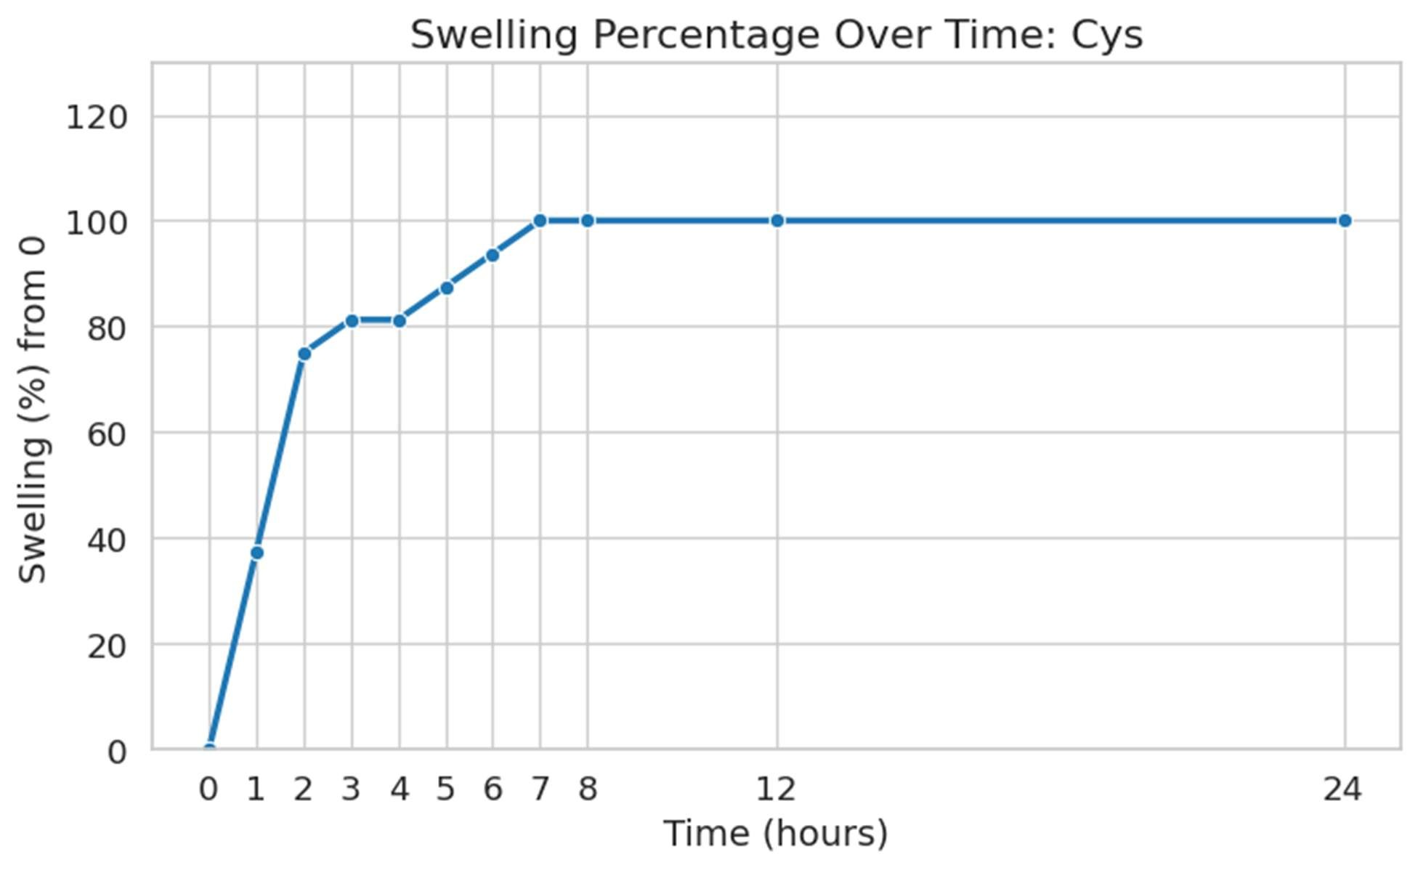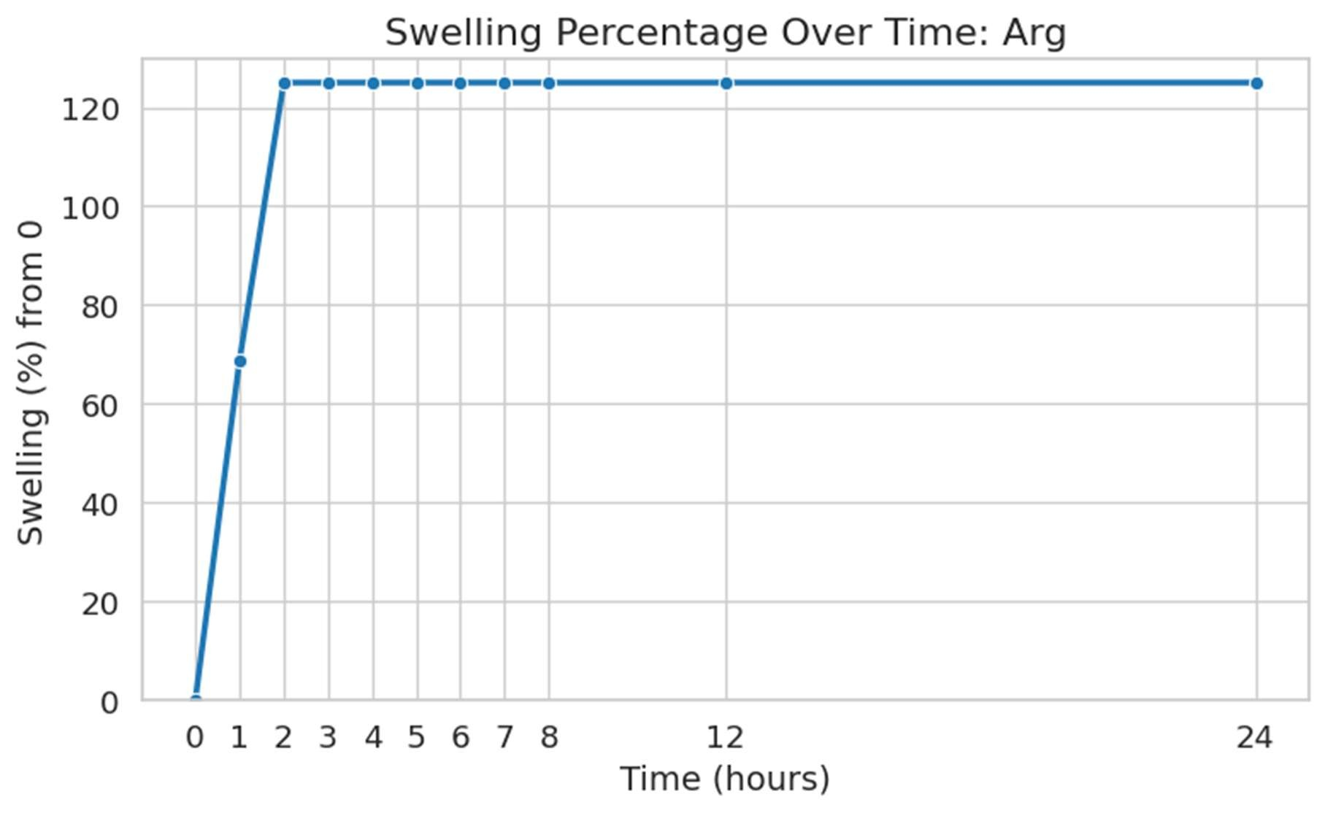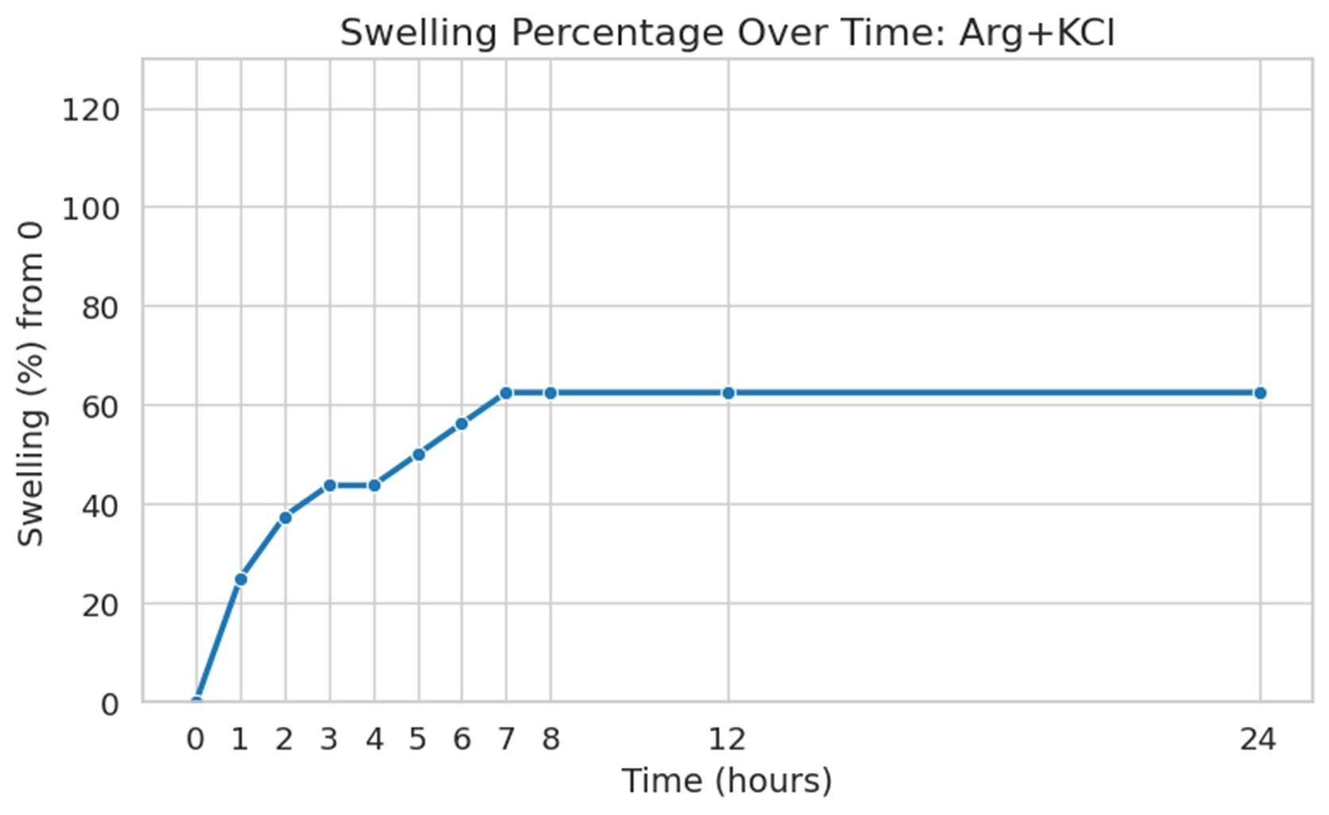
Figures 4.11–4.19 illustrate clay swelling over time for all fluid formulations; KCl 1 wt%, CaCl₂ 1 wt%, KCl + CaCl₂ (0.5 + 0.5 wt%), L-Arginine + CaCl₂ (0.5 + 0.5 wt%), L-Cysteine + KCl (0.5 + 0.5 wt%), L-Cysteine + CaCl₂ (0.5 + 0.5 wt%), L-Cysteine 1 wt%, L-Arginine 1 wt%, L-Cysteine + L-Arginine (0.5 + 0.5 wt%), and L-Arginine + KCl (0.5 + 0.5 wt%).
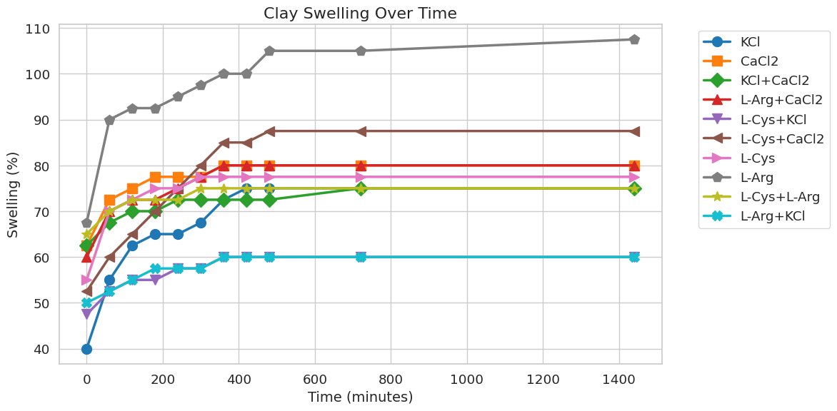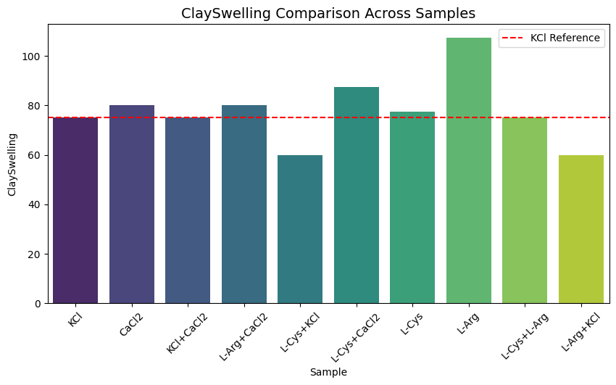
Figures 4.20–4.21 summarize final swelling percentages and comparative inhibition performance across all formulations.
4.3 Statistical Analysis of Rheological Performance and Clay Stabilization
Statistical evaluation demonstrates that all formulations significantly influence rheological behavior and clay inhibition relative to the KCl baseline, with amino acid–based systems producing the most pronounced effects.
Table 4.5: ANOVA Results for Apparent Viscosity (AV) vs KCl
Formulation | F-stat | p-value
CaCl₂ | 1510.24 | 2.11e-10
KCl + CaCl₂ | 2563.75 | 2.56e-11
L-Arg + CaCl₂ | 473.05 | 2.11e-08
L-Cys + KCl | 6629.86 | 5.77e-13
L-Cys + CaCl₂ | 1351.52 | 3.29e-10
L-Cys | 6090.50 | 8.10e-13
L-Arg | 9808.54 | 1.21e-13
L-Cys + L-Arg | 3592.98 | 6.67e-12
L-Arg + KCl | 1788.65 | 1.08e-10
The results indicate that all formulations significantly increase apparent viscosity relative to KCl, confirming that amino acid incorporation enhances internal fluid structure and improves suspension potential. The highest deviations are observed for L-Arg and L-Cys systems, indicating strong intermolecular interactions and network formation.

Formulation | F-stat | p-value
CaCl₂ | 251.43 | 2.50e-07
KCl + CaCl₂ | 13596.88 | 3.27e-14
L-Arg + CaCl₂ | 5861.01 | 9.44e-13
L-Cys + KCl | 2060.43 | 6.13e-11
L-Cys + CaCl₂ | 3989.49 | 4.39e-12
L-Cys | 4302.66 | 3.25e-12
L-Arg | 2406.65 | 3.30e-11
L-Cys + L-Arg | 2.33 | 0.165
L-Arg + KCl | 4038.15 | 4.18e-12
Formulation | F-stat | p-value
CaCl₂ | 488.17 | 1.86e-08
KCl + CaCl₂ | 2322.28 | 3.80e-11
L-Arg + CaCl₂ | 2.45 | 0.156
L-Cys + KCl | 6257.63 | 7.27e-13
L-Cys + CaCl₂ | 25280.42 | 2.74e-15
L-Cys | 206.74 | 5.35e-07
L-Arg | 21128.20 | 5.61e-15
L-Cys + L-Arg | 4526.20 | 2.65e-12
L-Arg + KCl | 7438.67 | 3.64e-13
Table 4.6 - 4.8: ANOVA Results for Plastic Viscosity (PV) vs KCl, ANOVA Results for Yield Point (YP) vs KCl, ANOVA Results for Clay Stabilization Slopes vs KCl
Formulation | F-stat | p-value
CaCl₂ | 349.28 | 6.94e-08
KCl + CaCl₂ | 4246.65 | 3.42e-12
L-Arg + CaCl₂ | 2268.27 | 4.18e-11
L-Cys + KCl | 9491.76 | 1.38e-13
L-Cys + CaCl₂ | 1811.86 | 1.02e-10
L-Cys | 4484.26 | 2.75e-12
L-Arg | 11441.51 | 6.52e-14
L-Cys + L-Arg | 2535.44 | 2.68e-11
L-Arg + KCl | 238.46 | 3.08e-07

Plastic viscosity also shows significant increases, particularly for amino acid–containing systems. While higher PV improves shear-dependent suspension, excessively high values may increase pumping pressure, indicating the need for optimization between viscosity and operational efficiency. Yield point results confirm that most formulations significantly enhance structural strength and proppant suspension capacity. The non-significant result for L-Cys + L-Arg suggests that not all amino acid combinations produce additive effects, highlighting the importance of formulation synergy. Clay stabilization analysis indicates that most formulations significantly differ from KCl, with L-Arg and L-Cys + CaCl₂ showing the strongest inhibition. The lack of significance for L-Arg + CaCl₂ suggests that not all hybrid systems improve stabilization beyond conventional KCl performance. Correlation relationships between rheological properties and clay swelling behavior are illustrated in Figure 4.22.
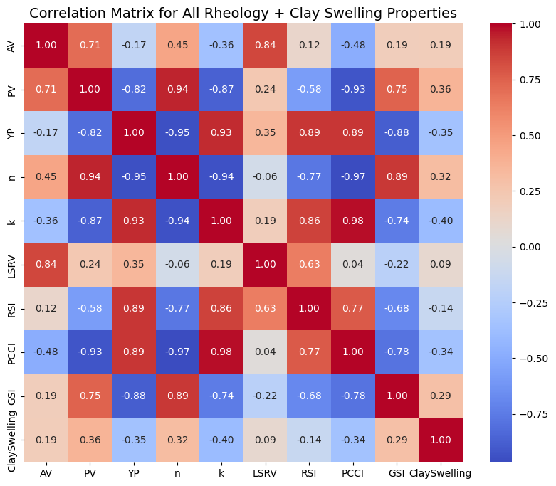
Figure 4.22: Correlation of Rheological and Clay Inhibition Properties
Correlation analysis reveals a strong positive relationship between apparent viscosity and plastic viscosity (r = 0.707), indicating that increased resistance to flow under shear contributes directly to overall viscosity. A strong negative correlation exists between plastic viscosity and yield point (r = −0.818), demonstrating a tradeoff between viscous flow resistance and structural strength.
Yield point exhibits a strong positive correlation with proppant carrying capacity (r = 0.894), confirming its dominant role in particle suspension. In contrast, plastic viscosity shows a strong negative correlation with proppant carrying capacity (r = −0.925), indicating that viscosity alone does not enhance transport efficiency without sufficient structural integrity.
Clay swelling shows weak to moderate correlations with rheological parameters, suggesting that chemical interactions play a critical role alongside physical fluid properties. Negative correlations with yield point and proppant carrying capacity indicate that structurally stronger fluids better suppress clay expansion, while the weak positive correlation with plastic viscosity suggests limited effectiveness of viscous resistance alone in controlling swelling.
Table 4.9: Sample Ranking by Overall Effectiveness
Rank | Sample | Total Effectiveness
1 | L-Arg + KCl | 3.598056
2 | L-Cys + KCl | 3.225833
3 | L-Cys + L-Arg | 3.066667
4 | KCl | 3.000000
5 | CaCl₂ | 2.979167
6 | L-Arg | 2.878230
7 | L-Cys | 2.855797
8 | KCl + CaCl₂ | 2.766944
9 | L-Cys + CaCl₂ | 2.565476
10 | L-Arg + CaCl₂ | 2.526389
The integrated ranking confirms that hybrid systems, particularly L-Arg + KCl and L-Cys + KCl, achieve the most balanced performance across rheology and clay stabilization. These formulations combine strong yield point development, controlled viscosity, and effective chemical inhibition, making them optimal candidates for advanced hydraulic fracturing fluid design.
5.0 Discussion and Analysis
The results demonstrate that the performance of water-based hydraulic fracturing fluids is governed by a coupled interaction between rheological behavior and clay stabilization efficiency. Formulations containing amino acids, particularly when combined with inorganic salts, exhibit clear advantages over single-component systems. Rheologically, amino acid–based systems, especially L-arginine and its hybrids, produce higher apparent viscosity, plastic viscosity, and yield point compared to conventional KCl. This indicates improved structural integrity and enhanced proppant suspension capability. However, the correlation analysis shows that excessive plastic viscosity does not translate to improved transport efficiency, as evidenced by its strong negative relationship with both yield point and proppant carrying capacity. This confirms that yield point remains the dominant parameter controlling suspension performance rather than bulk viscosity alone.
From a clay stabilization perspective, KCl-based systems remain highly effective due to ionic exchange mechanisms that suppress clay hydration. Nevertheless, the introduction of amino acids modifies surface interactions and hydration kinetics. While L-arginine alone performs poorly, its combination with KCl significantly improves overall inhibition, indicating a synergistic balance between ionic stabilization and surface adsorption mechanisms. Conversely, CaCl₂-based systems enhance viscosity but show less consistent swelling control, highlighting a tradeoff between rheological enhancement and chemical inhibition. The statistical analysis reinforces these observations, with most formulations showing significant deviation from KCl across rheological parameters and swelling behavior. High F-values associated with amino acid systems confirm their strong influence on fluid structure and performance. Correlation results further establish that effective fluid design requires balancing viscous and elastic contributions rather than maximizing a single parameter.
Hybrid formulations such as L-Arg + KCl and L-Cys + KCl provide the most balanced performance, combining moderate viscosity, high yield strength, and effective clay inhibition. These systems outperform conventional formulations by integrating chemical stabilization with optimized rheological structure, making them strong candidates for advanced and environmentally responsive hydraulic fracturing fluid design.
References
Al-Muntasheri, G. A. (2014). A critical review of hydraulic-fracturing fluids for moderate- to ultra-low permeability formations over the last decade. SPE Production & Operations, 29(4), 243–260. https://doi.org/10.2118/169552-PA
Barati, R., & Liang, J. T. (2014). A review of fracturing fluid systems used for hydraulic fracturing of oil and gas wells. Journal of Applied Polymer Science, 131(16), 40735. https://doi.org/10.1002/app.40735
Civan, F., Knapp, R. M., & Ohen, H. A. (2007). Alteration of permeability by fine particle processes. Journal of Petroleum Science and Engineering, 3(1–2), 65–79. https://doi.org/10.1016/0920-4105(89)90033-8
Duartey, K. O., Quainoo, A. K., & Darko, C. K. (2023). Evaluation studies of KCl and amino acid mixtures for clay stabilization and rheological enhancement of water-based fracturing fluids. SPE Nigeria Annual International Conference and Exhibition. Society of Petroleum Engineers. https://doi.org/10.2118/217118-MS
Gomaa, A. M., Qu, Q., Maharidge, R., Nelson, S., & Reed, T. (2015). Nanocrosslinked polymeric gels for hydraulic fracturing. SPE International Conference on Oilfield Chemistry, Society of Petroleum Engineers. https://doi.org/10.2118/173676-MS
Jia, X., Cao, R., & Lv, K. (2019). Synthesis of a biodegradable and environmentally friendly shale inhibitor based on chitosan-grafted L-arginine. ACS Applied Bio Materials, 2(9), 3989–3999. https://doi.org/10.1021/acsabm.9b00566
Kamal, M. S., Hussein, I. A., & Sultan, A. S. (2015). Review on surfactant flooding: Phase behavior, retention, IFT, and field applications. Energy & Fuels, 29(2), 617–641. https://doi.org/10.1021/ef502297z
Khan, R., Dahi-Taleghani, A., & Awoleke, O. (2024). Physics-informed machine learning for hydraulic fracturing—Part II: The transfer learning experiment. Journal of Petroleum Science and Engineering, 229, 112456. https://doi.org/10.1016/j.petrol.2024.112456
King, G. E. (2010). Thirty years of gas shale fracturing: What have we learned? SPE Annual Technical Conference and Exhibition, Society of Petroleum Engineers. https://doi.org/10.2118/133456-MS
Liang, T., Long, J., Liu, H., & Liu, Q. (2015). A review of the interaction between injected fluid and shale formation in hydraulic fracturing. Advances in Geo-Energy Research, 1(1), 40–48. https://doi.org/10.26804/ager.2017.01.01.05
Montgomery, C. T. (2013). Effective and sustainable hydraulic fracturing. InTech. https://doi.org/10.5772/56157
O'Brien, D. E., & Chenevert, M. E. (1973). Stabilizing sensitive shales with inhibited potassium-based drilling fluids. Journal of Petroleum Technology, 25(9), 1089–1100. https://doi.org/10.2118/4243-PA
Quintero, H. (2002). Clay-fluid interactions in water-based drilling fluids: Mechanisms and inhibition. SPE Drilling & Completion, 17(2), 85–93.
Rasool, M., & Ahmad, H. M. (2023). Ionic liquids as clay stabilizer additives in fracturing fluid: Impact on rock mechanical properties. Fuel, 352, 129132. https://doi.org/10.1016/j.fuel.2023.129132
Suter, P. J., Beames, R. M., & McLoughlin, C. A. (1996). Environmental assessment of drilling fluids used offshore in the New Zealand Exclusive Economic Zone (EEZ). New Zealand Journal of Marine and Freshwater Research, 30(4), 593–603. https://doi.org/10.1080/00288330.1996.9516733
Temizel, C., Irani, M., Rafati, R., Korzeniowski, M., & Artun, E. (2021). Machine learning applications in hydraulic fracturing: A review. Journal of Petroleum Science and Engineering, 208, 109664. https://doi.org/10.1016/j.petrol.2021.109664
Zhang, Y., & Xiao, C. (2021). Molecular dynamics simulation of clay hydration inhibition of deep shale. Processes, 9(6), 1069. https://doi.org/10.3390/pr9061069

