The Meal DB react js task

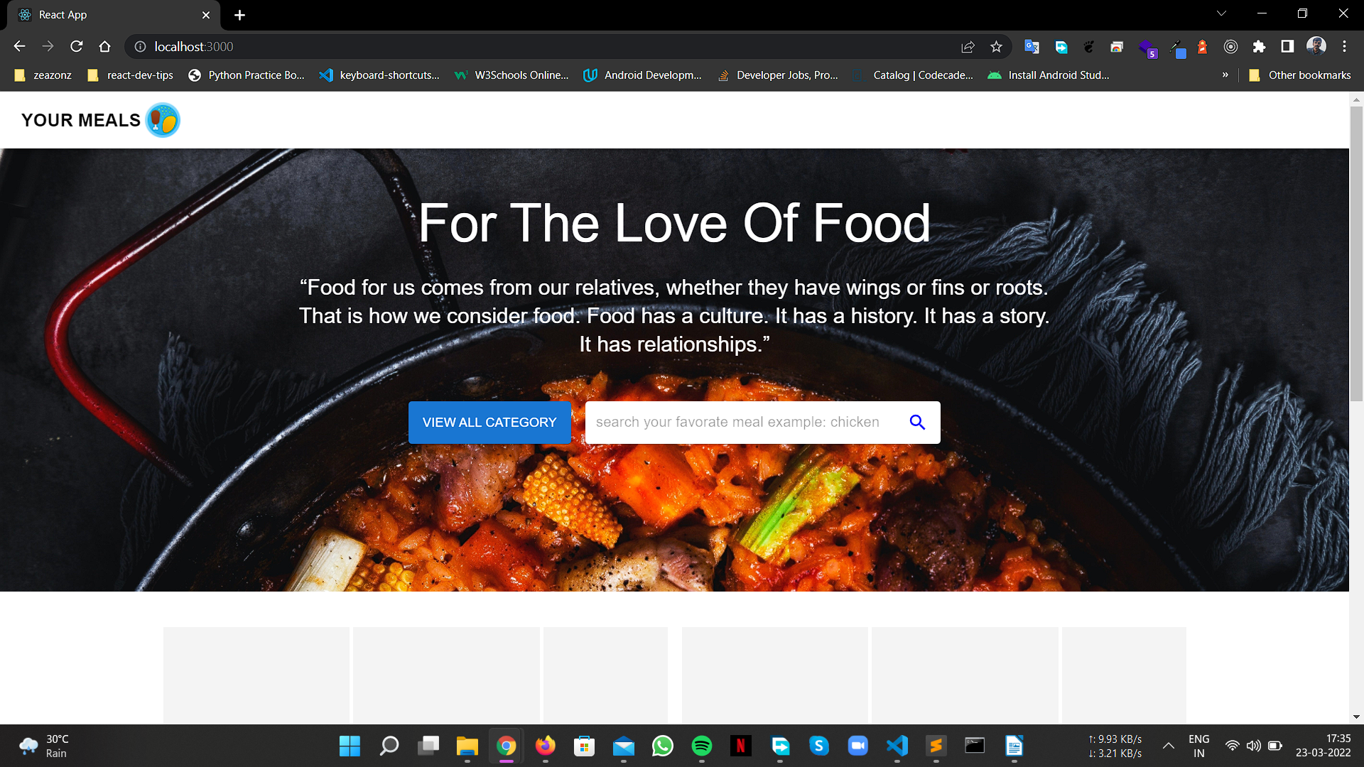
Home page . Here you can see all food category by pressing view all category button

In case you need to search for a specific type of food recipe you can use the search box given here type your desired food and press search icon to find the food
Ex : Fish
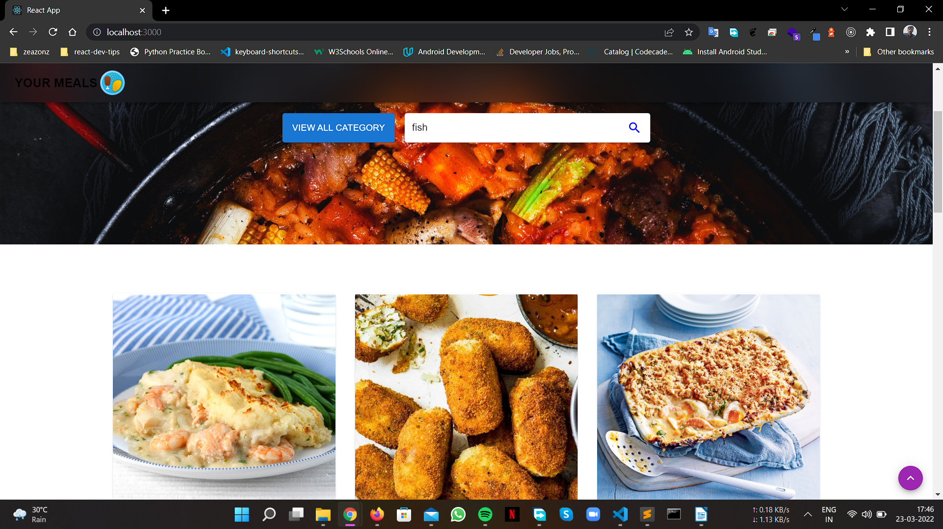

All food items which contains fish will be listed after you searched .
Ex:
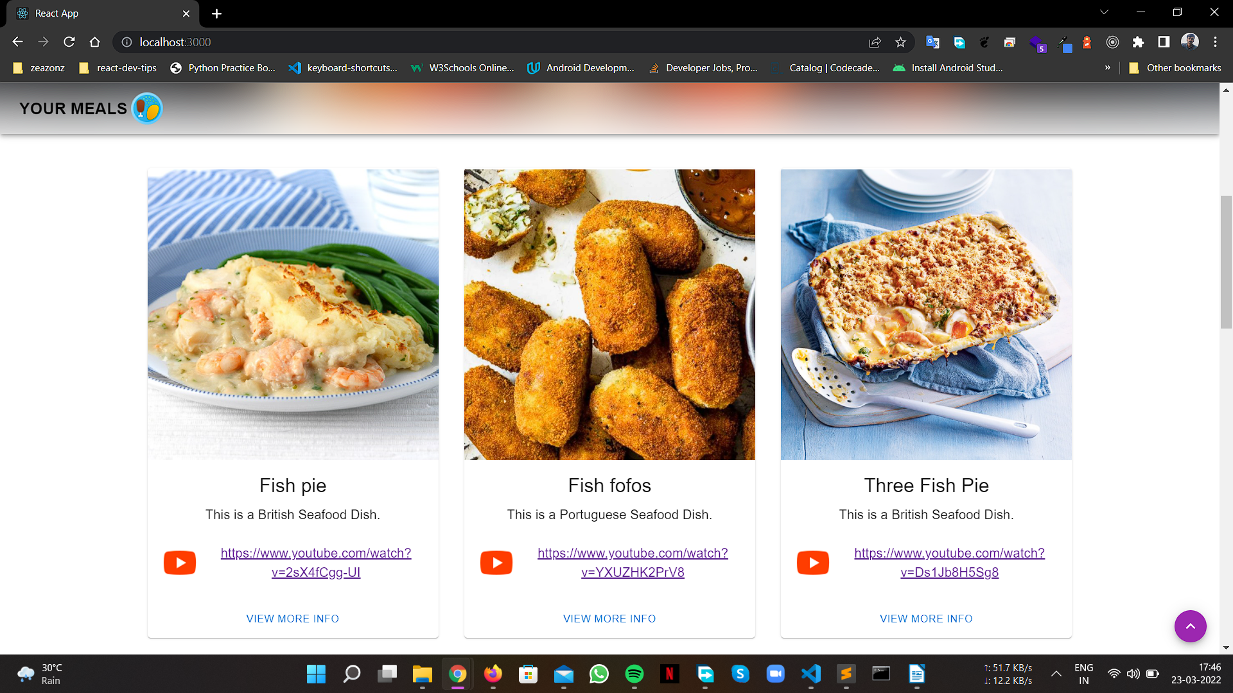
you can use the youtube link for more reference from here . You can see more info about the food if you go tho the view more section. Ex:
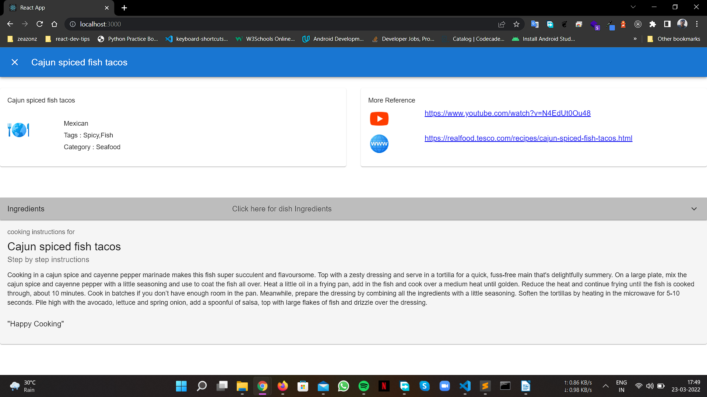

Here you can see all the details about the dish you selected . Like cooking instructions , ingredients and more . You can press the ingredients section to expand to view all ingredients.

Food category :
Here you can see all food category by pressing view all category button
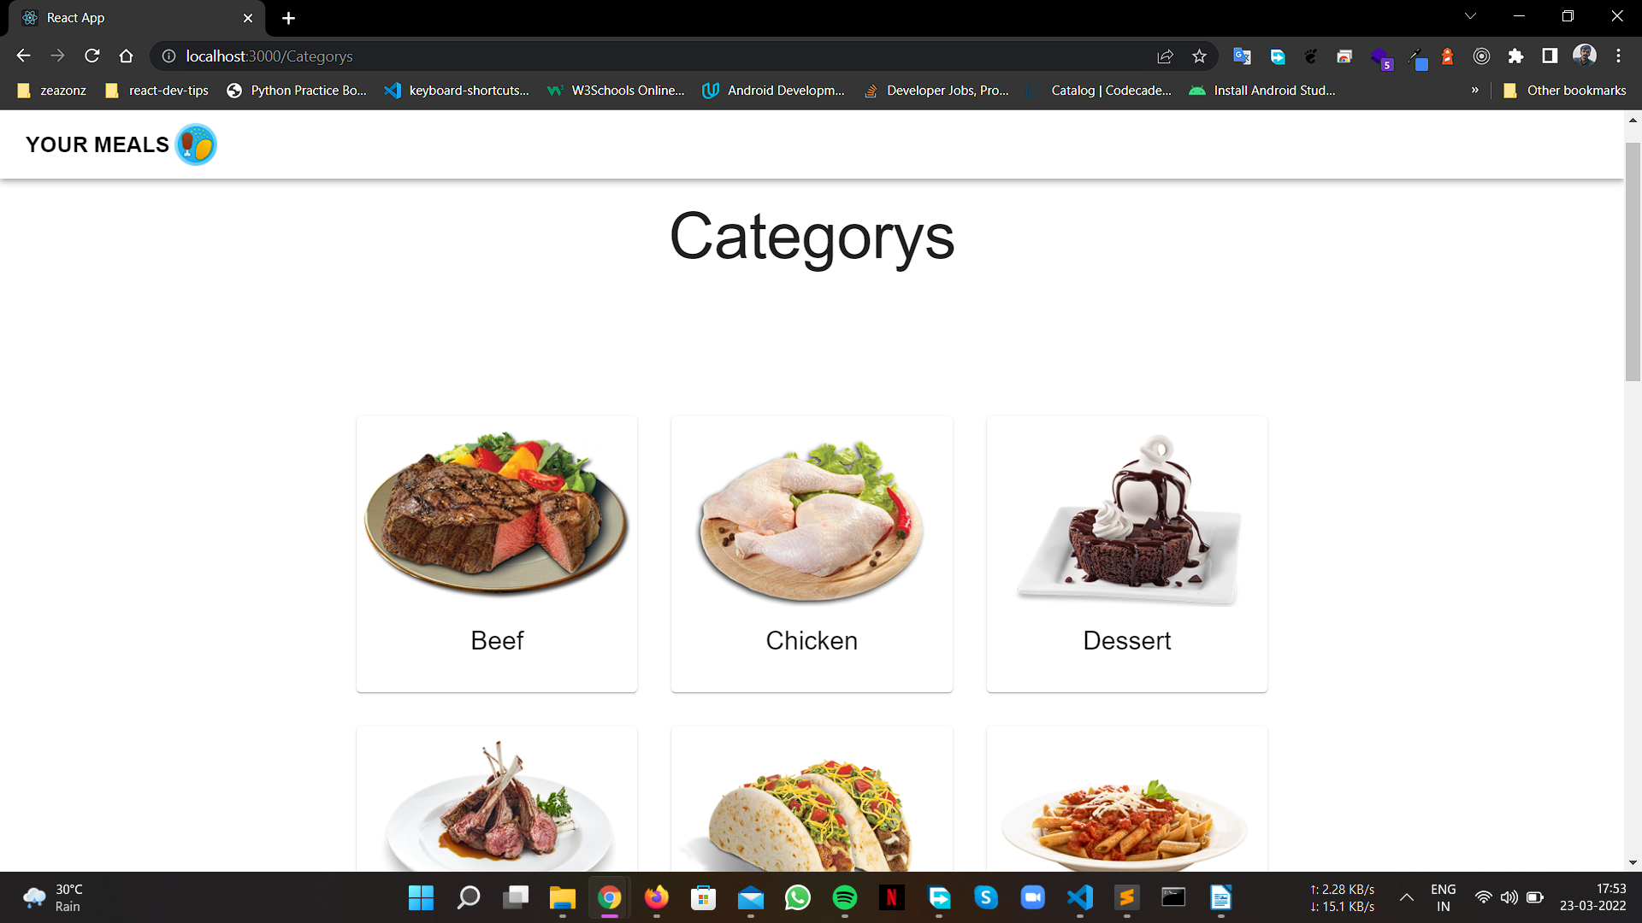

Used meal db apis :
- www.themealdb.com/api/json/v1/1/search.php?s=Arrabiata
- www.themealdb.com/api/json/v1/1/categories.php
- www.themealdb.com/api/json/v1/1/lookup.php?i=52772

Used MUI library for this task

