## Assignment Part-1

**Q1. Why do we call Python as a general purpose and high-level programming language?**

Ans- Because of following reason python is general purpose and high level programming language:

* Simple and easy to learn for beginner
* Platform independent
* Free and open source
* It is Interpreted
* Rich library support
* It is portable

**Q2. Why is Python called a dynamically typed language?**

Ans- In python we don’t have to declare the type of variable while assigning value to a variable. In other languages like C, C++, Java, etc. there is compulsory declaration of variables before assigning values to them. Because of this python is dynamically typed language.

**Q3. List some pros and cons of Python programming language?**

Ans- Following are the pros of Python

1. Improved Productivity
2. Interpreted Language
3. Dynamically typed
4. Free and open source
5. Vast Libraries Support

Following are the cons of Python

1. Slow speed
2. Not memory efficient
3. Weak in mobile computing
4. Database access
5. Run time errors

**Q4. In what all domains can we use Python?**

Ans- In below domains we can use python

1. Machine learning / Artificial intelligence
2. Data analytics and data visualization
3. Web development
4. Game development
5. Mobile app development
6. Embedded systems

**Q5. What are variable and how can we declare them?**

Ans- Variable is a name given to specific memory location. For declaring variable:

1. Give name the variable
2. Assign required value
3. The data type of variable will automatically determined from assigned value.

For example- Declaring integer variable

x=2

print(x)

print(type(x))

**Q6. How can we take an input from the user in Python?**

Ans- In input function takes the input from the user and then evaluates the expression.

Example-

name = input("Enter your Name:")

print("User name = ",name)

**Q7. What is the default datatype of the value that has been taken as an input using input() function?**

Ans- In input function string datatype has been taken as an input.

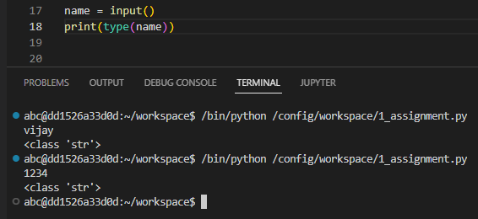

**Q8. What is type casting?**

Ans- The conversion of one data type into other data type is called as type casting.

Example-

float_num = 45.20

float_into_int = int(float_num)

print("float into integer= ", float_into_int)

**Q9. Can we take more than one input from the user using single input() function? If yes, how? If no, why?**

Ans- Yes. We can take more than one input using single input() function.

By using split() method will take more than one input.

x,y,z = input("Enter a three value:").split(",")

print("Total Numer of Employee:",x)

print("Numer of A Grade Employee:",y)

print("Numer of B Grade Employee:",z)

**Q10. What are keywords?**

Ans- keywords are special reserved words that have specific meanings and purposes. It can't be used for anything but those specific purposes.

**Q11. Can we use keywords as a variable? Support your answer with reason.**

Ans- We cannot use a keyword as a variable name. Because python will not allow you to use keyword as variable. It raise the syntax error.

**Q12. What is indentation? What's the use of indentaion in Python?**

Ans- Indentation used to the spaces at the beginning of a code line. Python uses indentation to indicate a block of code.

**Q13. How can we throw some output in Python?**

Ans- In python print() function is used for output.

**Q14. What are operators in Python?**

Ans- Operators are used to perform operations on variables and values.

Following are the operators in python:

1. Arithmetic operators
2. Assignment operators
3. Comparison operators
4. Logical operators

**Q15. What is difference between / and // operators?**

Ans- / and // both are division operator.

But / is used for float division and // is used for integer division.

**Q16. Write a code that gives following as an output.**

```

iNeuroniNeuroniNeuroniNeuron

```

Ans-

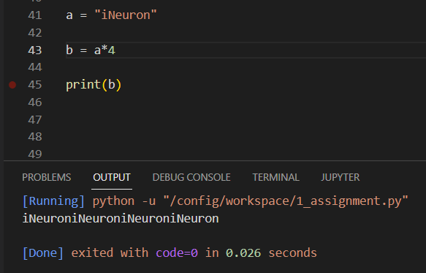

**Q17. Write a code to take a number as an input from the user and check if the number is odd or even.**

Ans-

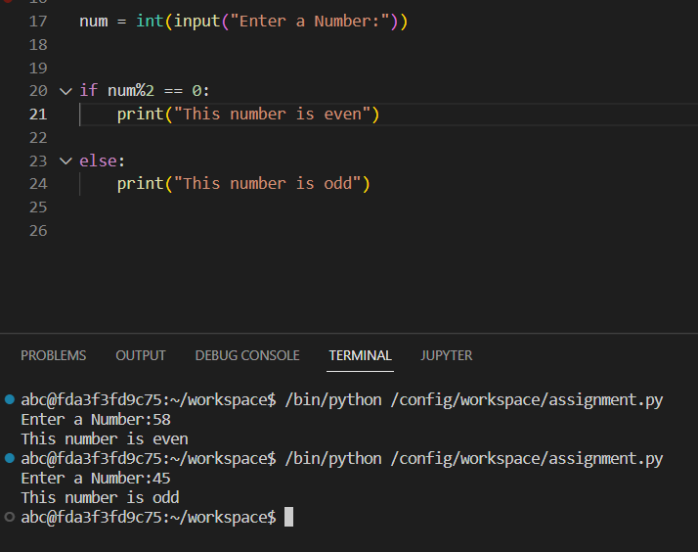

**Q18. What are boolean operator?**

Ans- Boolean is a logical data type that have only the values true or false. Boolean operators are simple words (AND, OR, NOT).

**Q19. What will the output of the following?**

```

1 or 0

Ans- 1

0 and 0

Ans- 0

True and False and True

Ans- False

1 or 0 or 0

Ans- 1

```

**Q20. What are conditional statements in Python?**

Ans- Conditional statements are also called decision-making statements. We use this statements while we want to execute a block of code when the given condition is true or false.

Type of condition statement in Python:

1. If statement
2. If else statement
3. Nested if else statement

**Q21. What is use of 'if', 'elif' and 'else' keywords?**

Ans-

Use of if- It is used for specify the expression or statement. If expression evaluates true value then if statement will be executed.

Use of elif- It is used when we want check more than one expression. It is executed from top to bottom if true condition found then gives output otherwise it goes to next condition.

Use of else- If expression evaluates false then else will be executed.

**Q22. Write a code to take the age of person as an input and if age >= 18 display "I can vote". If age is < 18 display "I can't vote".**

Ans-

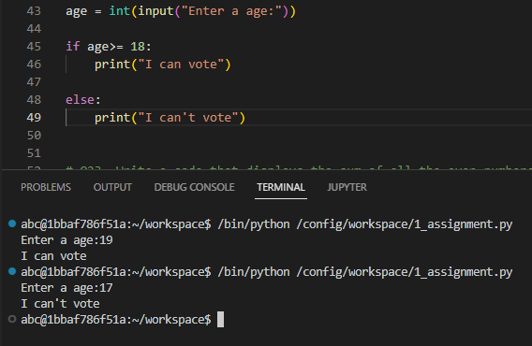

**Q23. Write a code that displays the sum of all the even numbers from the given list.**

```

numbers = [12, 75, 150, 180, 145, 525, 50]

```

Ans-

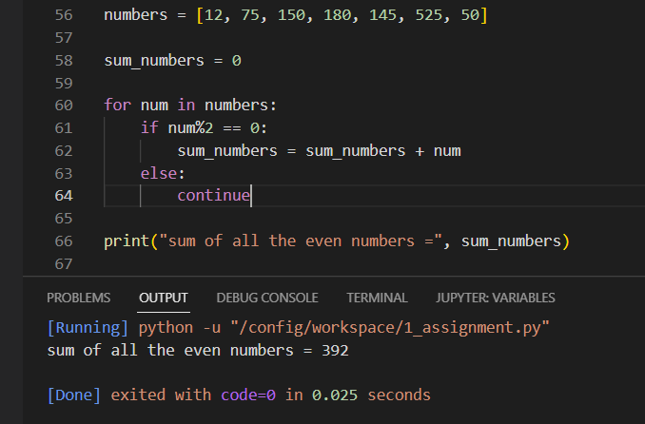

Q24. Write a code to take 3 numbers as an input from the user and display the greatest no as output.

Ans-

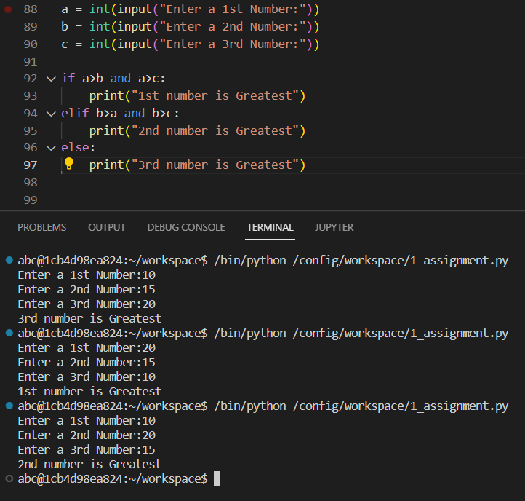

**Q25. Write a program to display only those numbers from a list that satisfy the following conditions**

- The number must be divisible by five

- If the number is greater than 150, then skip it and move to the next number

- If the number is greater than 500, then stop the loop

```

numbers = [12, 75, 150, 180, 145, 525, 50]

```

Ans-

