## Assignment Part-1

**Q1. Why do we call Python as a general purpose and high-level programming language?**

Ans- Because of following reason python is general purpose and high level programming language:

* Simple and easy to learn for beginner
* Platform independent
* Free and open source
* It is Interpreted
* Rich library support
* It is portable

**Q2. Why is Python called a dynamically typed language?**

Ans- In python we don’t have to declare the type of variable while assigning value to a variable. In other languages like C, C++, Java, etc. there is compulsory declaration of variables before assigning values to them. Because of this python is dynamically typed language.

**Q3. List some pros and cons of Python programming language?**

Ans- Following are the pros of Python

1. Improved Productivity
2. Interpreted Language
3. Dynamically typed
4. Free and open source
5. Vast Libraries Support

Following are the cons of Python

1. Slow speed
2. Not memory efficient
3. Weak in mobile computing
4. Database access
5. Run time errors

**Q4. In what all domains can we use Python?**

Ans- In below domains we can use python

1. Machine learning / Artificial intelligence
2. Data analytics and data visualization
3. Web development
4. Game development
5. Mobile app development
6. Embedded systems

**Q5. What are variable and how can we declare them?**

Ans- Variable is a name given to specific memory location. For declaring variable:

1. Give name the variable
2. Assign required value
3. The data type of variable will automatically determined from assigned value.

For example- Declaring integer variable

x=2

print(x)

print(type(x))

**Q6. How can we take an input from the user in Python?**

Ans- In input function takes the input from the user and then evaluates the expression.

Example-

name = input("Enter your Name:")

print("User name = ",name)

**Q7. What is the default datatype of the value that has been taken as an input using input() function?**

Ans- In input function string datatype has been taken as an input.

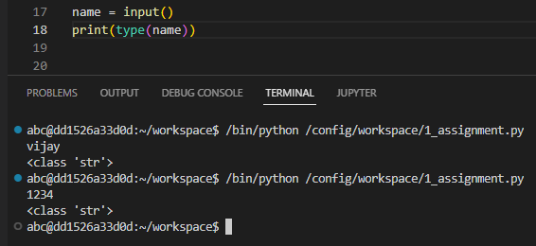

**Q8. What is type casting?**

Ans- The conversion of one data type into other data type is called as type casting.

Example-

float_num = 45.20

float_into_int = int(float_num)

print("float into integer= ", float_into_int)

**Q9. Can we take more than one input from the user using single input() function? If yes, how? If no, why?**

Ans- Yes. We can take more than one input using single input() function.

By using split() method will take more than one input.

x,y,z = input("Enter a three value:").split(",")

print("Total Numer of Employee:",x)

print("Numer of A Grade Employee:",y)

print("Numer of B Grade Employee:",z)

**Q10. What are keywords?**

Ans- keywords are special reserved words that have specific meanings and purposes. It can't be used for anything but those specific purposes.

**Q11. Can we use keywords as a variable? Support your answer with reason.**

Ans- We cannot use a keyword as a variable name. Because python will not allow you to use keyword as variable. It raise the syntax error.

**Q12. What is indentation? What's the use of indentaion in Python?**

Ans- Indentation used to the spaces at the beginning of a code line. Python uses indentation to indicate a block of code.

**Q13. How can we throw some output in Python?**

Ans- In python print() function is used for output.

**Q14. What are operators in Python?**

Ans- Operators are used to perform operations on variables and values.

Following are the operators in python:

1. Arithmetic operators
2. Assignment operators
3. Comparison operators
4. Logical operators

**Q15. What is difference between / and // operators?**

Ans- / and // both are division operator.

But / is used for float division and // is used for integer division.

**Q16. Write a code that gives following as an output.**

```

iNeuroniNeuroniNeuroniNeuron

```

Ans-

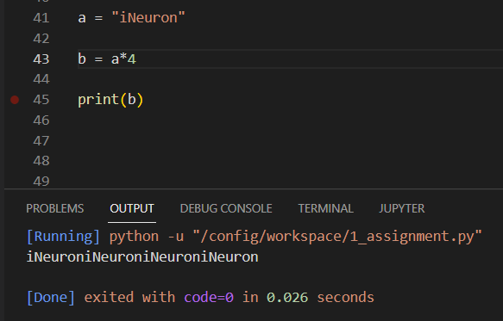

**Q17. Write a code to take a number as an input from the user and check if the number is odd or even.**

Ans-

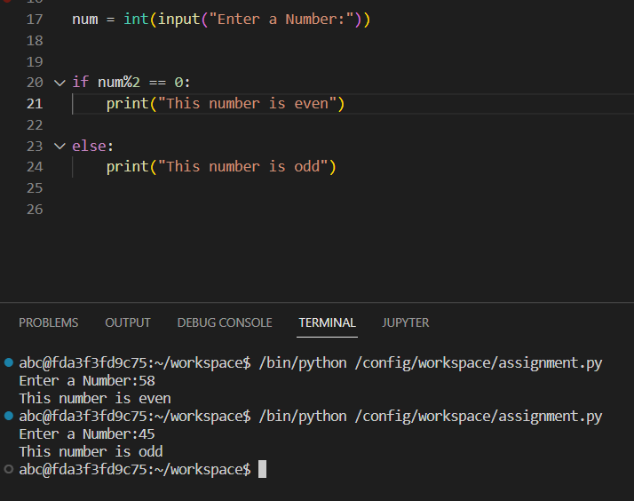

**Q18. What are boolean operator?**

Ans- Boolean is a logical data type that have only the values true or false. Boolean operators are simple words (AND, OR, NOT).

**Q19. What will the output of the following?**

```

1 or 0

Ans- 1

0 and 0

Ans- 0

True and False and True

Ans- False

1 or 0 or 0

Ans- 1

```

**Q20. What are conditional statements in Python?**

Ans- Conditional statements are also called decision-making statements. We use this statements while we want to execute a block of code when the given condition is true or false.

Type of condition statement in Python:

1. If statement
2. If else statement
3. Nested if else statement

**Q21. What is use of 'if', 'elif' and 'else' keywords?**

Ans-

Use of if- It is used for specify the expression or statement. If expression evaluates true value then if statement will be executed.

Use of elif- It is used when we want check more than one expression. It is executed from top to bottom if true condition found then gives output otherwise it goes to next condition.

Use of else- If expression evaluates false then else will be executed.

**Q22. Write a code to take the age of person as an input and if age >= 18 display "I can vote". If age is < 18 display "I can't vote".**

Ans-

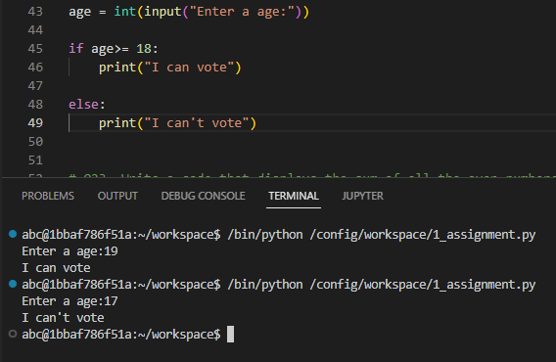

**Q23. Write a code that displays the sum of all the even numbers from the given list.**

```

numbers = [12, 75, 150, 180, 145, 525, 50]

```

Ans-

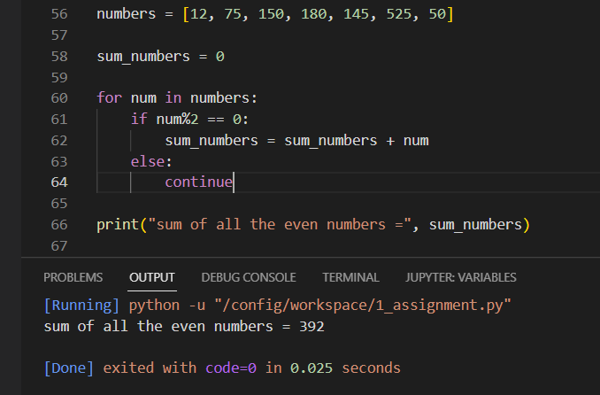

**Q24. Write a code to take 3 numbers as an input from the user and display the greatest no as output.**

Ans-

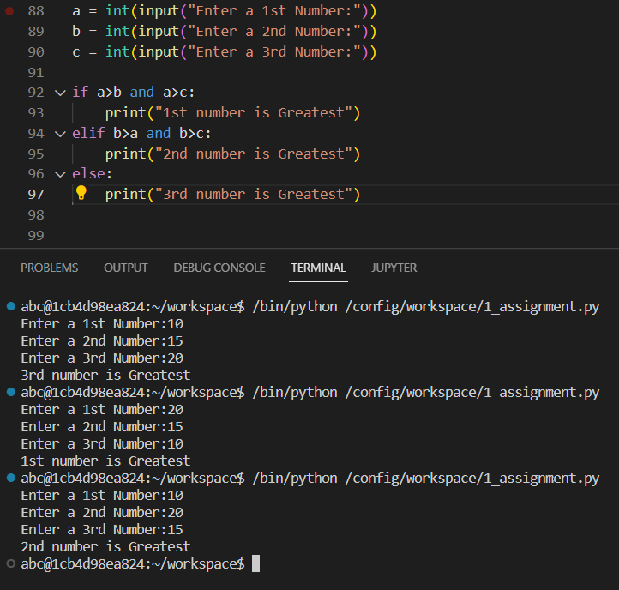

**Q25. Write a program to display only those numbers from a list that satisfy the following conditions**

- The number must be divisible by five

- If the number is greater than 150, then skip it and move to the next number

- If the number is greater than 500, then stop the loop

```

numbers = [12, 75, 150, 180, 145, 525, 50]

```

Ans-

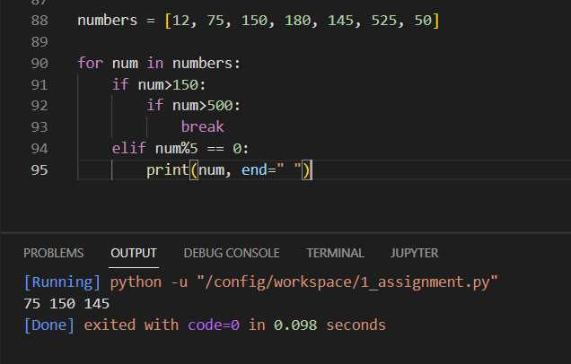

**Q26. What is a string? How can we declare string in Python?**

Ans- String is a sequence of characters. We use single quotes or double quotes to represent a string in Python.

For declaring string we need to assign with variable in single or double quotes. For example-

name = "Ajay Jadhav"

**Q27. How can we access the string using its index?**

Ans- You can access string using its index number inside square brackets.

name = "Ajay Jadhav"

print(name[1])

**Q28. Write a code to get the desired output of the following**

```

string = “Big Data iNeuron”

desired_output = “iNeuron”

```

Ans- print(string[9 : ])

**Q29. Write a code to get the desired output of the following**

```

string = “Big Data iNeuron”

desired_output = “norueNi”

```

Ans- print(string[15 : 8 : -1])

**Q30. Resverse the string given in the above question.**

Ans-

string = "Big Data iNeuron"

string1 = string[15: : -1 ]

print(string1)

**Q31. How can you delete entire string at once?**

Ans- By using del function we can delete string.

**Q32. What is escape sequence?**

Ans- Escape sequence are control character used to move the cursor and print character such as ‘,”,\ and so on.

**Q33. How can you print the below string?**

```

‘iNeuron’s Big Data Course’

```

Ans- print("iNeuron's Big Data Course")

**Q34. What is a list in Python?**

Ans- List is a data structure which is also called collection of items, in which we can store anything like string, float, integer.

**Q35. How can you create a list in Python?**

Ans- To create list in python we use square brackets ([]).

Syntax: list name = [item1, item2,…………itemn]

**Q36. How can we access the elements in a list?**

Ans- To access element in list, use square bracket with index number to obtain element available at that index.

**Q37. Write a code to access the word "iNeuron" from the given list.**

```

lst = [1,2,3,"Hi",[45,54, "iNeuron"], "Big Data"]

```

Ans- print(lst[4][2])

**Q38. Take a list as an input from the user and find the length of the list.**

Ans-

x = input("Enter a value separated by comma:").split(",")

x1 = list(x)

print(len(x1))

**Q39. Add the word "Big" in the 3rd index of the given list.**

```

lst = ["Welcome", "to", "Data", "course"]

```

Ans-

lst = ["Welcome", "to", "Data", "course"]

lst.insert(3, "Big")

print(lst)

**Q40. What is a tuple? How is it different from list?**

Ans- Tuples are used to store multiple items in single variable. Tuple is a data structure which is also called collection of items in which we can store string, float, integer.

Tuple are different from list because it is immutable and they are failed to assign value

**Q41. How can you create a tuple in Python?**

Ans- tuple is created by placing all items inside parentheses () and separated by commas

Syntax: tuple name = (item1, item2,………itemn)

**Q42. Create a tuple and try to add your name in the tuple. Are you able to do it? Support your answer with reason.**

Ans- In tuple I can’t add my name. Because they are immutable and failed to assign the value.

**Q43. Can two tuple be appended. If yes, write a code for it. If not, why?**

Ans- No. tuple can’t appended because they have not inbuilt function of append.

**Q44. Take a tuple as an input and print the count of elements in it.**

Ans-

x = input("Enter a value separated by comma:").split(",")

x1 = tuple(x)

print(len(x1))

**Q45. What are sets in Python?**

Ans- Set is a collection of unique data. The elements of a set cannot be duplicate

**Q46. How can you create a set?**

Ans- In Python, we create sets by placing all elements inside curly braces {}, and separated by comma.

**Q47. Create a set and add "iNeuron" in your set.**

Ans-

set1 = set()

set1.add("ineoron")

print(set1)

**Q48. Try to add multiple values using add() function.**

Ans-

set1 = set()

set1.add("ineoron")

set1.add("Big")

set1.add("Data")

set1.add("Course")

set1.add("Batch")

set1.add(2)

print(set1)

**Q49. How is update() different from add()?**

Ans- By using update() function you can add multiple elements. But using add() function you can add single element only.

**Q50. What is clear() in sets?**

Ans- The clear() method removes all elements in a set

Syntax: set.clear()

**Q51. What is frozen set?**

Ans- Frozen set is an immutable version of python set. You can modify element of set at any time but element of frozen set remain same after creation.

**Q52. How is frozen set different from set?**

Ans- There are no methods like add, update, remove for frozenset like set. Frozenset are unchangeable.

**Q53. What is union() in sets? Explain via code.**

Ans- Union() Method returns a new set which contains all element from the original set. It does not allow repeated element.

A = {2, 3, 5}

B = {1, 3, 5}

print(A | B)

**Q54. What is intersection() in sets? Explain via code.**

Ans- Intersection() method returns a new set with an element that is common from all set.

A = {2, 3, 5}

B = {1, 3, 5}

C = {6, 2, 5}

print(A & B & C)

**Q55. What is dictionary in Python?**

Ans- Dictionaries are used to store data values in key:value pairs.

A dictionary is a collection which is ordered, changeable and do not allow duplicates.

**Q56. How is dictionary different from all other data structures.**

Ans- The dictionary Data Structure in Python is an unordered collection of items. While other Data Structures use only one value as the element, the dictionary is compound data structure. It makes use of two elements i.e. key and a value.

**Q57. How can we delare a dictionary in Python?**

Ans- Dictionary in python is declared by key-value pairs using curly braces({}).

**Q58. What will the output of the following?**

```

var = {}

print(type(var))

```

Ans- dict

It shows dictionary type data structure.

**Q59. How can we add an element in a dictionary?**

Ans- To add element use the dictionary name by square brackets with the key name and assign a value to it.

dict = {}

dict['Name'] = 'Ajay'

dict['Age'] = 25

print(dict)

**Q60. Create a dictionary and access all the values in that dictionary.**

Ans-

dict2 = {'Name': 'Ajay','Age': 25, 'Skills': 'Python','City':'Mumbai'}

for k,v in dict2.items():

print("Key is", k , "And value is",v)

**Q61. Create a nested dictionary and access all the element in the inner dictionary.**

Ans-

dict1 = {'Name': 'Ajay','Age':25,'Other details':{'City': 'Mumbai', 'Nationality':'Indian'}}

for k,v in dict1['Other details'].items():

print("Key is",k,"and value is",v)

**Q62. What is the use of get() function?**

Ans- get() method in Python is used to get the value of any specified key from a dictionary.

**Q63. What is the use of items() function?**

Ans- In Dictionary, items() method is used to return the list of all dictionary keys with values.

**Q64. What is the use of pop() function?**

Ans- The pop() method removes the element by index from the list and returns the removed element.

**Q65. What is the use of popitems() function?**

Ans- popitem() method removes the last inserted key-value pair from the dictionary and returns it as a tuple.

**Q66. What is the use of keys() function?**

Ans- keys() method in Python is used to return all of the keys from the dictionary

**Q67. What is the use of values() function?**

Ans- The values() method returns a view object. The view object contains the values of the dictionary, as a list.

**Q68. What are loops in Python?**

Ans- Loop is a sequence of instructions that is repeated multiple times until a certain condition is reached.

**Q69. How many type of loop are there in Python?**

Ans- There are two types of loop in python.

1 – For loop

2 – While loop

**Q70. What is the difference between for and while loops?**

Ans- When we know the number of iterations must occur in a loop, we use for loop. And if we don’t know how many iterations must occur in a loop, we use while loop.

**Q71. What is the use of continue statement?**

Ans- The continue statement is used to skip the current iteration of the loop and control flow of the program goes to the next iteration.

**Q72. What is the use of break statement?**

Ans- The break statement is used to terminate the loop when a certain condition is met

**Q73. What is the use of pass statement?**

Ans- Suppose we have a loop or a function that is not implemented yet, but we want to implement it in the future. In such cases, we can use the pass statement.

**Q74. What is the use of range() function?**

Ans- The range() function returns a sequence of numbers, starting from 0 by default, and increments by 1 by default, and stops before a specified number.

**Q75. How can you loop over a dictionary?**

Ans- You can loop through a dictionary by using a for loop.

For example:

dict = {'Name': 'Ajay', 'Age': '25', 'Mob': '901120'}

for key in dict:

print(key)

### Coding problems

**Q76. Write a Python program to find the factorial of a given number.**

Ans-

n = int(input("Enter a number:"))

def factorial(n):

if n == 0 or n == 1:

return 1

result = 1

for num in range(1,n+1):

result = result*num

return result

ans = factorial(n)

print("factorial of",n ,"is", ans)

**Q77. Write a Python program to calculate the simple interest. Formula to calculate simple interest is SI = (P*R*T)/100**

Ans-

def simple_interest(p,r,t):

print("The principle is:", p)

print("The rate of interest is:", r)

print("The rate of interest is:", r)

SI = (p*r*t)/100

return SI

ans = simple_interest(10000,7,2)

print("Simple interest is:",ans)

**Q78. Write a Python program to calculate the compound interest. Formula of compound interest is A = P(1+ R/100)^t.**

Ans-

from math import *

def compound_interest(p,r,t):

print("The principle is:", p)

print("The rate of interest is:", r)

print("The rate of interest is:", t)

amount = p*(pow(1+(r/100),t))

CI = amount - p

return CI

ans = compound_interest(12600,10,2)

print("Compound interest is:", ans)

**Q79. Write a Python program to check if a number is prime or not.**

Ans-

n = int(input("Enter a number:"))

if n == 1:

print(n,"is not a prime number")

elif n>1:

for i in range(2,n):

if n%i == 0:

print(n,"is not a prime number")

break

else:

print(n,"is a prime number")

**Q80. Write a Python program to check Armstrong Number.**

Ans-

num = int(input("Enter a number:"))

i = num

n = len(str(num))

result = 0

while (i>0):

digit = i%10

result = result + digit**n

i = i//10

if num == result:

print(num,"is an Armstrong number")

else:

print(num,"is not an Armstrong number")

**Q81. Write a Python program to find the n-th Fibonacci Number.**

Ans-

n = int(input("Enter a number:"))

def fib(n):

a = 0

b = 1

if n == 1:

print(a)

else:

print(a)

print(b)

for i in range(2,n):

c = a + b

a = b

b = c

print(c)

fib(n)

**Q82. Write a Python program to interchange the first and last element in a list.**

Ans-

def swaplist(lst):

n = len(lst)

temp = lst[0]

lst[0] = lst[n-1]

lst[n-1] = temp

return lst

lst = [10,15,16,18,32]

print(lst)

print("Swapped list:", swaplist(lst))

**Q83. Write a Python program to swap two elements in a list.**

Ans-

lst = [12,15,18,20,26]

print(lst)

pos1,pos2 = 1,3

lst[pos1],lst[pos2] = lst[pos2],lst[pos1]

print(lst)

**Q84. Write a Python program to find N largest element from a list.**

Ans-

def Nmaxelement(lst,N):

new_lst = []

for i in range(0,N):

max1 = 0

for j in range(len(lst)):

if lst[j]>max1:

max1 = lst[j]

lst.remove(max1)

new_lst.append(max1)

print(new_lst)

lst = [10,45,20,15,25]

N = 2

Nmaxelement(lst,N)

**Q85. Write a Python program to find cumulative sum of a list.**

Ans-

lst= [10,20,15,30,25]

new_list = []

sum = 0

for i in range(len(lst)):

sum = sum + lst[i]

new_list.append(sum)

print(new_list)

**Q86. Write a Python program to check if a string is palindrome or not.**

Ans-

a = input("Enter a string:")

b = a[-1: :-1]

if a == b:

print("palindrome string")

else:

print("not palindrome string")

**Q87. Write a Python program to remove i'th element from a string.**

Ans-

def remove(string,i):

a = string[ : i]

b = string[i+1 : ]

return a + b

string = "Ajay Jadhav"

i = 5

new_str = remove(string,i)

print(new_str)

**Q88. Write a Python program to check if a substring is present in a given string.**

Ans-

string = input("Enter a string:").lower()

sub_str = input("Enter a sub_str:").lower()

def check(string,sub_str):

if string.find(sub_str) == -1:

print("substring is not present")

else:

print("substring is present")

check(string,sub_str)

**Q89. Write a Python program to find words which are greater than given length k.**

Ans-

def word_k(string,k):

word = string.split(" ")

for x in word:

if len(x)>k:

print(x, end=" ")

k = 3

string = "Big Data iNeuron"

word_k(string,k)

**Q90. Write a Python program to extract unquire dictionary values.**

Ans-

dict1 = {'A' : [1, 3, 5, 4],'B' : [4, 6, 8, 10],'C' : [6, 12, 4 ,8],'D' : [5, 7, 2]}

print("The original dictionary is : " ,dict1)

result = list(sorted({ele for val in dict1.values() for ele in val}))

print("The unique values list is : " , result)

**Q91. Write a Python program to merge two dictionary.**

Ans-

def Merge(dict1, dict2):

return(dict1.update(dict2))

dict1 = {'Name':'Ajay', 'Age':25,}

dict2 = {'City':'Mumbai', 'Nationality':'Indian'}

Merge(dict1, dict2)

print(dict1)

**Q92. Write a Python program to convert a list of tuples into dictionary.**

```

Input : [('Sachin', 10), ('MSD', 7), ('Kohli', 18), ('Rohit', 45)]

Output : {'Sachin': 10, 'MSD': 7, 'Kohli': 18, 'Rohit': 45}

```

Ans-

Input = [('Sachin', 10), ('MSD', 7), ('Kohli', 18), ('Rohit', 45)]

output = dict(Input)

print(output)

**Q93. Write a Python program to create a list of tuples from given list having number and its cube in each tuple.**

```

Input: list = [9, 5, 6]

Output: [(9, 729), (5, 125), (6, 216)]

```

Ans-

list = [9, 5, 6]

output = [(x,x**3) for x in list]

print(output)

**Q94. Write a Python program to get all combinations of 2 tuples.**

```

Input : test_tuple1 = (7, 2), test_tuple2 = (7, 8)

Output : [(7, 7), (7, 8), (2, 7), (2, 8), (7, 7), (7, 2), (8, 7), (8, 2)]

```

Ans-

test_tuple1 = (7, 2)

test_tuple2 = (7, 8)

print("First tuple : ", test_tuple1)

print("Second tuple : ", test_tuple2)

result = [(a,b) for a in test_tuple1 for b in test_tuple2 ]

result = result + [(a,b) for a in test_tuple2 for b in test_tuple1]

print("combinations of 2 tuples is:", result)

**Q95. Write a Python program to sort a list of tuples by second item.**

```

Input : [('for', 24), ('Geeks', 8), ('Geeks', 30)]

Output : [('Geeks', 8), ('for', 24), ('Geeks', 30)]

```

Ans-

tup = [('for', 24), ('Geeks', 8), ('Geeks', 30)]

for i in range(len(tup)):

for j in range(len(tup)-1):

if (tup[j][1] > tup[j+1][1]):

temp = tup[j]

tup[j] = tup[j+1]

tup[j+1] = temp

print(tup)

**Q96. Write a python program to print below pattern.**

```

*

* *

* * *

* * * *

* * * * *

```

Ans-

n = int(input("Enter number of row:"))

for i in range(n):

for j in range(i+1):

print("*",end=" ")

print()

**Q97. Write a python program to print below pattern.**

```

*

**

***

****

*****

```

Ans-

n = int(input("Enter number of row:"))

for i in range(n):

for space in range(5-(i+1)):

print(" ", end=" ")

for j in range(i+1):

print("*",end=" ")

print()

**Q98. Write a python program to print below pattern.**

```

*

* *

* * *

* * * *

* * * * *

```

Ans-

n = int(input("Enter number of row:"))

for i in range(n):

for k in range(n-(i+1)):

print(end=" ")

for j in range(i+1):

print("*", end=" ")

print()

**Q99. Write a python program to print below pattern.**

```

1

1 2

1 2 3

1 2 3 4

1 2 3 4 5

```

Ans-

n = int(input("Enter number of row:"))

for i in range(n):

for j in range(i+1):

print(j+1,end=" ")

print()

**Q100. Write a python program to print below pattern.**

```

A

B B

C C C

D D D D

E E E E E

```

Ans-

n = int(input("Enter number of row:"))

for i in range(65,n+65):

for j in range(65,i+1):

print(chr(i), end=" ")

print()