SOFTWARE REQUIREMENTS SPECIFICATION
CivicTrack
A Community-Driven Civic Issue Reporting Platform
(Streetlights · Garbage Overflow · Water Leakage)
Version 1.0
September 11, 2026
Prepared in accordance with IEEE 830 SRS guidelines

Document Control
Field | Detail
Document Title | Software Requirements Specification – CivicTrack
Version | 1.0
Status | Draft for Review
Prepared For | Municipal Corporation Stakeholders / Project Sponsor
Classification | Internal – Project Planning
Revision History
Version | Date | Description | Author
1.0 | 11-Sep-2026 | Initial draft of the SRS | Product Team

Table of Contents

1. Introduction

1.1 Purpose
This Software Requirements Specification (SRS) document describes the functional and non-functional requirements for CivicTrack, a mobile-first community application that enables citizens to report broken streetlights, garbage overflow, and water leakages directly to the relevant municipal authority, with photographic proof and geolocation. This document is intended to serve as the single point of reference for the design, development, testing, and acceptance of the system by all project stakeholders, including the development team, quality assurance, municipal IT/administrative staff, and project sponsors.

1.2 Document Conventions
Requirements are uniquely identified using the prefix FR- (Functional Requirement) or NFR- (Non-Functional Requirement) followed by a module number and sequence number (e.g., FR-2.3). Priority levels are classified as High (must-have for v1 launch), Medium (should-have), and Low (nice-to-have, may be deferred to a later release). The keywords "shall" and "must" indicate mandatory requirements; "should" indicates a recommended but non-mandatory requirement.

1.3 Intended Audience and Reading Suggestions
- Project Sponsors / Municipal Stakeholders — Sections 1, 2, and 7 (Executive summary, scope, and success metrics).
- Product Managers / Business Analysts — Sections 2, 3, and 6 (Overall description, use cases, data model).
- Developers / Architects — Sections 3, 4, and 5 (Feature requirements, interfaces, non-functional requirements).
- QA / Test Engineers — Sections 3 and 5, used as the basis for test case design and acceptance criteria.
- Municipal IT / Integration Teams — Section 4.3 (Software interfaces) and Section 3.6 (Admin & department routing).

1.4 Project Scope
CivicTrack will allow any citizen to capture a photo of a civic issue, have its location and timestamp auto-tagged, classify it into one of three initial categories (streetlight, garbage overflow, water leakage), and have it automatically routed to the responsible municipal department. Citizens can track the lifecycle of their report from submission to resolution, confirm existing nearby reports to avoid duplication, and view a public transparency map of civic issues in their area. Municipal field staff and administrators will use companion dashboard views to triage, assign, resolve, and report on these issues against defined service-level agreements (SLAs).
In scope for Version 1.0:
- Citizen mobile app (Android and iOS) for report creation and tracking.
- Public web-accessible transparency map.
- Administrator/field-worker web dashboard for triage, assignment, and resolution.
- Automated department routing based on issue category and ward/zone.
- Duplicate detection and citizen upvote/confirmation mechanism.
- Push/SMS notification framework for status updates.
Out of scope for Version 1.0 (candidates for future releases):
- Additional issue categories such as potholes, drainage blockages, illegal dumping, or tree hazards.
- In-app payments, fines, or legal escalation workflows.
- Deep, bespoke integrations with every municipal legacy system (a generic API/webhook/email-SMS gateway is provided instead).
- Predictive analytics / AI-based issue severity scoring (may be considered post-launch).

1.5 References
Ref | Document / Standard
REF-1 | IEEE Std 830-1998 — IEEE Recommended Practice for Software Requirements Specifications
REF-2 | Project Problem Statement — Community Civic Issue Reporting App (internal document)
REF-3 | OGC / GeoJSON specification (RFC 7946) — for map data interchange
REF-4 | WCAG 2.1 — Web Content Accessibility Guidelines

2. Overall Description

2.1 Product Perspective
CivicTrack is a new, standalone product consisting of three primary interfaces sharing a common backend: (1) a citizen-facing mobile application, (2) a public web-based transparency map, and (3) a municipal staff web dashboard. The system integrates with third-party services for mapping, push notifications, SMS gateways, and cloud image storage, and exposes an API/webhook layer to interoperate with existing municipal ticketing or ERP systems where available.

2.2 Product Functions
At a high level, the system shall provide the following major functions:
- Citizen registration, authentication, and profile management.
- Geo-tagged, photo-based issue reporting across three categories.
- Automated routing of reports to the correct municipal department based on category and ward.
- Duplicate detection and community confirmation of existing reports.
- End-to-end status tracking with citizen notifications.
- Public transparency map of open and resolved issues.
- Administrator dashboard for triage, assignment, SLA monitoring, and reporting.
- Audit logging of all status and assignment changes.

2.3 User Classes and Characteristics
User Class | Description | Technical Proficiency
Citizen / Resident | General public reporting issues and tracking resolution; primary mobile app user. | Low–Medium
Field Worker | Municipal staff assigned to physically inspect and resolve reported issues. | Low–Medium
Department Administrator | Departmental staff who triage, assign, and monitor reports for their department. | Medium
Municipal Super Admin | Oversees all departments, configures SLAs/routing rules, and views city-wide analytics. | Medium–High
General Public (Viewer) | Unregistered visitors browsing the public transparency map without submitting reports. | Low

2.4 Operating Environment
- Citizen mobile app: Android 9.0+ and iOS 14+.
- Web dashboard and public map: latest two versions of Chrome, Firefox, Edge, and Safari.
- Backend: cloud-hosted (containerized), horizontally scalable application servers with a managed relational database and object storage for images.
- Network: designed to function on 3G/4G with graceful degradation and offline queuing on unstable connections.

2.5 Design and Implementation Constraints
- The system must support integration with municipal authorities that may only offer email/SMS intake rather than a modern API, requiring a flexible gateway/adapter layer.
- Ward/zone-to-department mapping data must be configurable by administrators without requiring code changes, since municipal boundaries and department structures vary by city.
- Image storage and processing costs must be controlled through client-side compression prior to upload.
- The system must operate within applicable local data-protection and open-records regulations for citizen data and public map data.

2.6 Assumptions and Dependencies
- The municipal authority is willing to designate a receiving department/point of contact for each issue category, or provide an API/dashboard/email-SMS endpoint to receive routed reports.
- Citizens have access to a GPS-enabled smartphone with a working camera.
- A third-party mapping provider (e.g., a maps/tiles API) and SMS/push notification gateway will be available and licensed for the deployment region.
- Ward and department boundary data will be supplied by, or validated with, the municipal authority prior to launch.

2.7 High-Level System Architecture
CivicTrack is built as a set of modular microservices sitting behind a single API Gateway, consumed by three client surfaces (citizen mobile app, public transparency map, and the admin/field-worker web dashboard) as well as optional municipal ticketing integrations. This keeps the reporting, routing, tracking, and analytics concerns independently scalable and deployable.
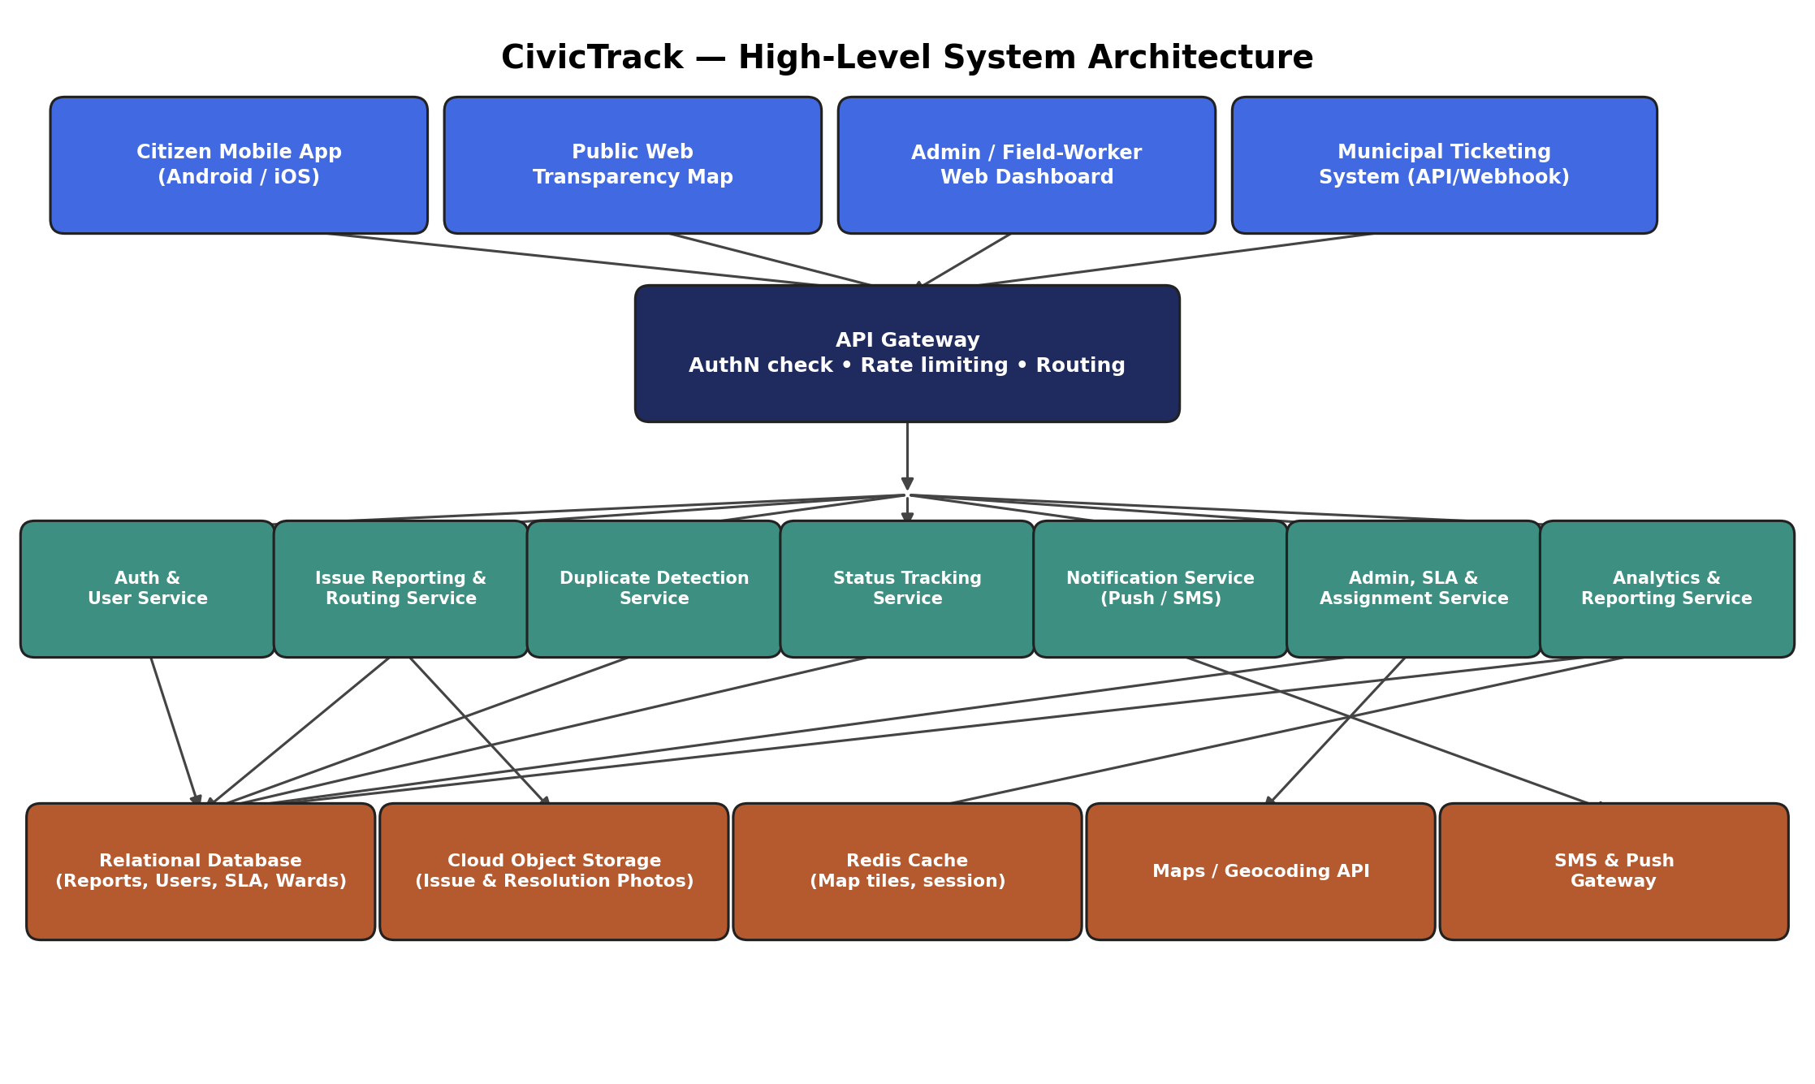
Figure 1: CivicTrack High-Level System Architecture

3. System Features (Functional Requirements)

3.1 User Registration & Authentication
Req ID | Description | Module | Priority
FR-1.1 | The system shall allow a citizen to register using mobile number or email with OTP verification. | Auth | High
FR-1.2 | The system shall allow login via mobile number/OTP, email/password, or supported social login. | Auth | High
FR-1.3 | The system shall allow a citizen to create and edit a basic profile (name, locality, language). | Auth | Medium
FR-1.4 | The system shall support role-based access for Citizen, Field Worker, and Administrator accounts. | Auth | High
FR-1.5 | The system shall allow password/OTP-based account recovery. | Auth | Medium

3.2 Issue Reporting
Req ID | Description | Module | Priority
FR-2.1 | The system shall allow a citizen to capture or upload at least one photo as proof of the issue. | Reporting | High
FR-2.2 | The system shall automatically capture GPS coordinates and timestamp at the time of photo capture. | Reporting | High
FR-2.3 | The system shall allow the user to manually adjust the pinned location if GPS accuracy is low. | Reporting | Medium
FR-2.4 | The system shall require the user to select one issue category: Streetlight, Garbage Overflow, or Water Leakage. | Reporting | High
FR-2.5 | The system shall present category-specific sub-fields (e.g., pole ID for streetlights, leak severity for water). | Reporting | Medium
FR-2.6 | The system shall allow an optional free-text description up to 500 characters. | Reporting | Low
FR-2.7 | The system shall auto-generate a unique, shareable complaint ID upon submission. | Reporting | High
FR-2.8 | The system shall auto-route the report to the correct municipal department based on category and ward/zone mapping. | Reporting | High
FR-2.9 | The system shall allow submission in offline/low-connectivity mode and auto-sync when connectivity is restored. | Reporting | Medium

3.3 Duplicate Detection & Community Confirmation
Req ID | Description | Module | Priority
FR-3.1 | The system shall detect and surface existing open reports within a configurable radius (default 100 m) of a new report's location and category. | Duplicate Handling | High
FR-3.2 | The system shall allow a citizen to upvote/confirm an existing report instead of filing a duplicate. | Duplicate Handling | High
FR-3.3 | The system shall increment a report's priority score when it receives multiple citizen confirmations. | Duplicate Handling | Medium
FR-3.4 | The system shall allow an administrator to manually merge two reports identified as duplicates. | Duplicate Handling | Medium

3.4 Status Tracking & Resolution
Req ID | Description | Module | Priority
FR-4.1 | The system shall track each report through defined statuses: Reported, Acknowledged, In Progress, Resolved, Reopened. | Tracking | High
FR-4.2 | The system shall send push/SMS notifications to the reporting citizen on every status change. | Tracking | High
FR-4.3 | The system shall require the assigned field worker to upload a resolution photo before marking a report Resolved. | Tracking | High
FR-4.4 | The system shall allow the original reporter to reopen a report within 7 days if unsatisfied with the resolution. | Tracking | Medium
FR-4.5 | The system shall allow citizens to rate the resolution quality (1–5 stars) after closure. | Tracking | Low

3.5 Public Map & Transparency
Req ID | Description | Module | Priority
FR-5.1 | The system shall display a public map view of all open and resolved reports, filterable by category, status, and date range. | Map & Transparency | High
FR-5.2 | The system shall visually cluster markers in dense areas and expand on zoom. | Map & Transparency | Medium
FR-5.3 | The system shall display aggregate locality-level statistics (open count, average resolution time) on the map view. | Map & Transparency | Medium
FR-5.4 | The system shall allow filtering the map to a citizen's saved localities/wards. | Map & Transparency | Low

3.6 Administrator Dashboard & Department Routing
Req ID | Description | Module | Priority
FR-6.1 | The system shall provide administrators a dashboard of incoming reports filterable by department, ward, category, priority, and SLA status. | Admin Dashboard | High
FR-6.2 | The system shall allow administrators to assign/reassign reports to specific field workers or teams. | Admin Dashboard | High
FR-6.3 | The system shall enforce configurable SLA timers per category and flag/escalate reports nearing or past SLA breach. | Admin Dashboard | High
FR-6.4 | The system shall generate exportable performance reports (resolution time, backlog, hotspot analysis) by department and time period. | Admin Dashboard | Medium
FR-6.5 | The system shall integrate with municipal ticketing systems or expose report data via a webhook/API/email-SMS gateway. | Admin Dashboard | High
FR-6.6 | The system shall maintain a full audit trail (status changes, assignment history, timestamps, actor) for every report. | Admin Dashboard | Medium

3.7 Notifications
Req ID | Description | Module | Priority
FR-7.1 | The system shall send a confirmation notification immediately upon successful report submission. | Notifications | High
FR-7.2 | The system shall notify citizens who upvoted a report when its status changes. | Notifications | Medium
FR-7.3 | The system shall notify administrators of new high-priority or safety-critical reports in real time. | Notifications | High

4. External Interface Requirements

4.1 User Interfaces
- Mobile app: camera-first reporting flow (open app → camera → auto-tag → categorize → submit) achievable in 3 taps or fewer from launch.
- Public map: interactive web map with filter controls for category, status, and date range; accessible without login.
- Admin dashboard: table and map hybrid view with sortable/filterable queue, SLA countdown indicators, and bulk-assignment controls.

4.2 Hardware Interfaces
- Device camera for photo capture.
- Device GPS/location sensor for coordinate tagging.
- Device push-notification radio (cellular/Wi-Fi) for real-time alerts.

4.3 Software Interfaces
Interface | Purpose
Maps/Geocoding API | Rendering the map view, reverse-geocoding coordinates to addresses, and ward boundary lookups.
Push Notification Service | Delivering real-time status-update alerts to mobile devices.
SMS Gateway | Delivering status notifications to citizens without smartphone push support, and relaying reports to departments lacking API access.
Cloud Object Storage | Storing and serving uploaded and resolution photos securely.
Municipal Ticketing API / Webhook | Optional two-way sync of report status with a municipal authority's existing case-management system.
Identity/OTP Provider | Verifying mobile numbers and emails during registration and login.

4.4 Communication Interfaces
- All client-server communication shall use HTTPS (TLS 1.2+).
- Real-time status updates to the admin dashboard shall use a push-based mechanism (e.g., web-sockets or long-polling) to minimize manual refresh.

5. Non-Functional Requirements
The following quality attributes apply across the system unless otherwise scoped to a specific module.
Category | Requirement | Priority
Performance | The app shall load the map view with up to 500 visible markers within 3 seconds on a 4G connection. | High
Performance | Report submission (excluding image upload time) shall be acknowledged by the server within 2 seconds. | High
Scalability | The backend shall support at least 100,000 registered users and 10,000 concurrent sessions per city deployment without degradation. | High
Availability | The system shall maintain 99.5% uptime for citizen-facing services, excluding scheduled maintenance windows. | High
Security | All data in transit shall be encrypted using TLS 1.2 or higher; data at rest shall be encrypted using AES-256. | High
Security | The system shall implement role-based access control (RBAC) so field workers/admins can only access data relevant to their jurisdiction. | High
Security | Photo metadata (GPS, timestamp) shall be validated server-side to prevent spoofed submissions. | Medium
Privacy | The system shall mask a citizen's personal contact details from field workers and the public map, showing only anonymized report data. | High
Usability | A first-time user shall be able to submit a report in 3 taps or fewer after opening the camera. | High
Usability | The app shall support at least English and one regional language at launch, with an extensible localization framework. | Medium
Reliability | Reports created offline shall not be lost and shall sync automatically once connectivity resumes. | High
Maintainability | The system shall be built on a modular, documented architecture allowing new issue categories to be added via configuration, not code changes. | Medium
Compliance | The system shall comply with applicable local data protection regulations for storage and handling of citizen personal data. | High
Accessibility | The mobile app shall conform to WCAG 2.1 AA guidelines where applicable (contrast, font scaling, screen-reader labels). | Medium
Auditability | Every administrative action (assignment, status override, merge) shall be logged with actor ID and timestamp, retained for a minimum of 3 years. | Medium

6. Data Requirements

6.1 Core Data Entities
The table below summarizes the principal data entities anticipated for the system. This is indicative of the logical data model and will be refined during detailed design.
Entity | Key Attributes | Notes
User | user_id, name, phone/email, role, locality, language_pref | Roles: Citizen, Field Worker, Admin.
Report | report_id, category, sub_type, description, photo_url(s), lat, long, status, priority_score, created_at, sla_due_at | Core entity; one row per reported issue.
Department | dept_id, name, category_mapping, ward_mapping, contact_endpoint | Maps issue category + ward to the responsible authority.
StatusHistory | history_id, report_id, old_status, new_status, actor_id, timestamp | Full audit trail per report.
Confirmation | confirmation_id, report_id, user_id, timestamp | Records duplicate-avoidance upvotes.
Notification | notification_id, user_id, report_id, type, sent_at, channel | Push/SMS/email notification log.
Ward/ Zone | ward_id, name, geo_boundary, dept_mapping | Geo-boundary used for auto-routing.

6.2 Report Status Lifecycle
Each report shall move through the following states, with every transition logged in StatusHistory:
- Reported — Initial state upon citizen submission.
- Acknowledged — Department/field worker has viewed and accepted the report.
- In Progress — Field work has begun on the reported issue.
- Resolved — Field worker has uploaded proof of resolution and closed the report.
- Reopened — Citizen has flagged the resolution as unsatisfactory within the allowed reopen window.
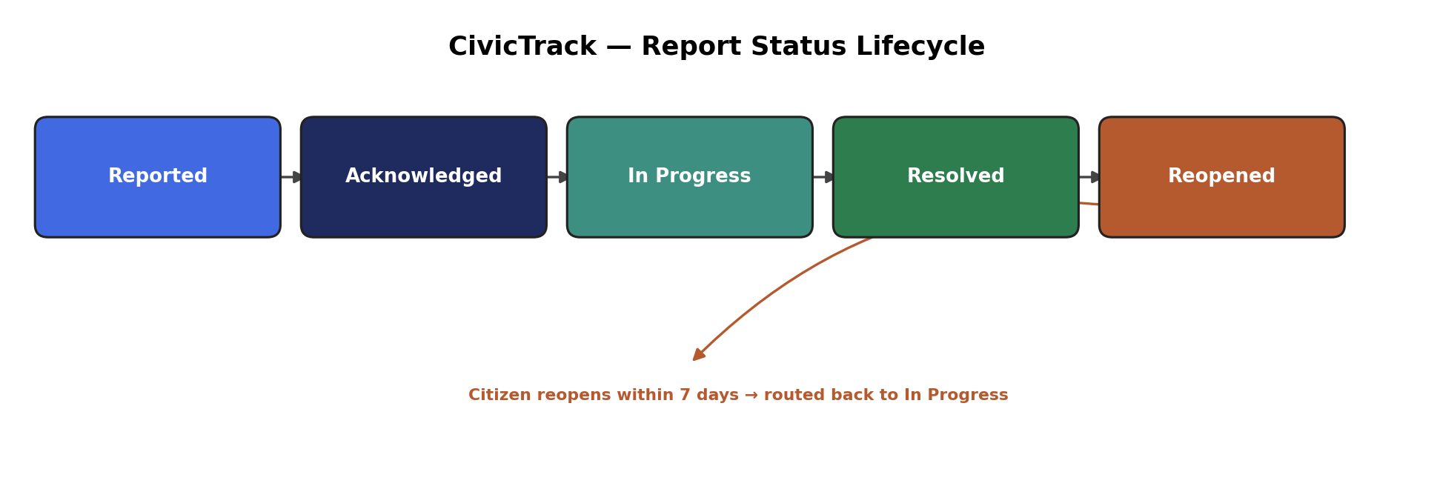
Figure 2: CivicTrack Report Status Lifecycle

6.3 Sample Analytics & Dashboard Visualizations
The following sample visualizations illustrate the type of insight the admin analytics dashboard (FR-6.4) and public transparency map will surface, based on representative sample data.
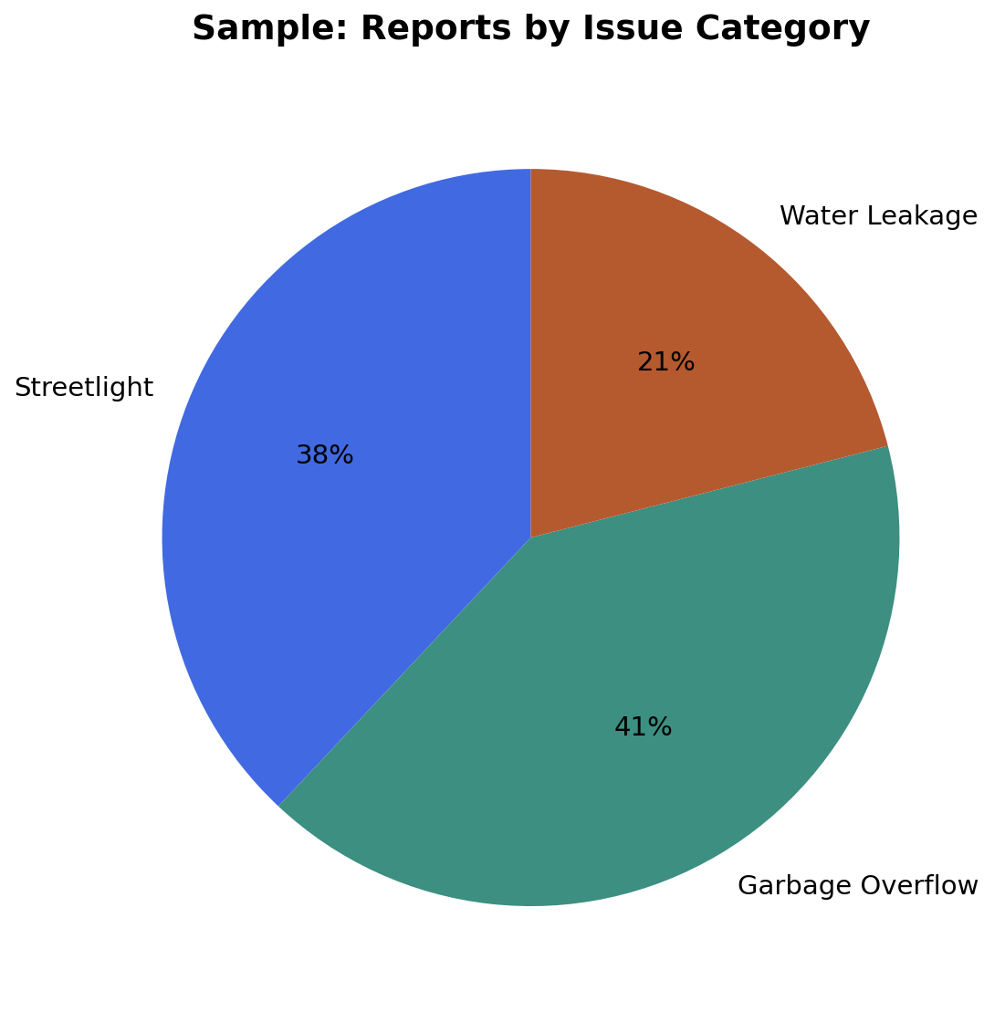
Figure 3: Sample — reports by issue category
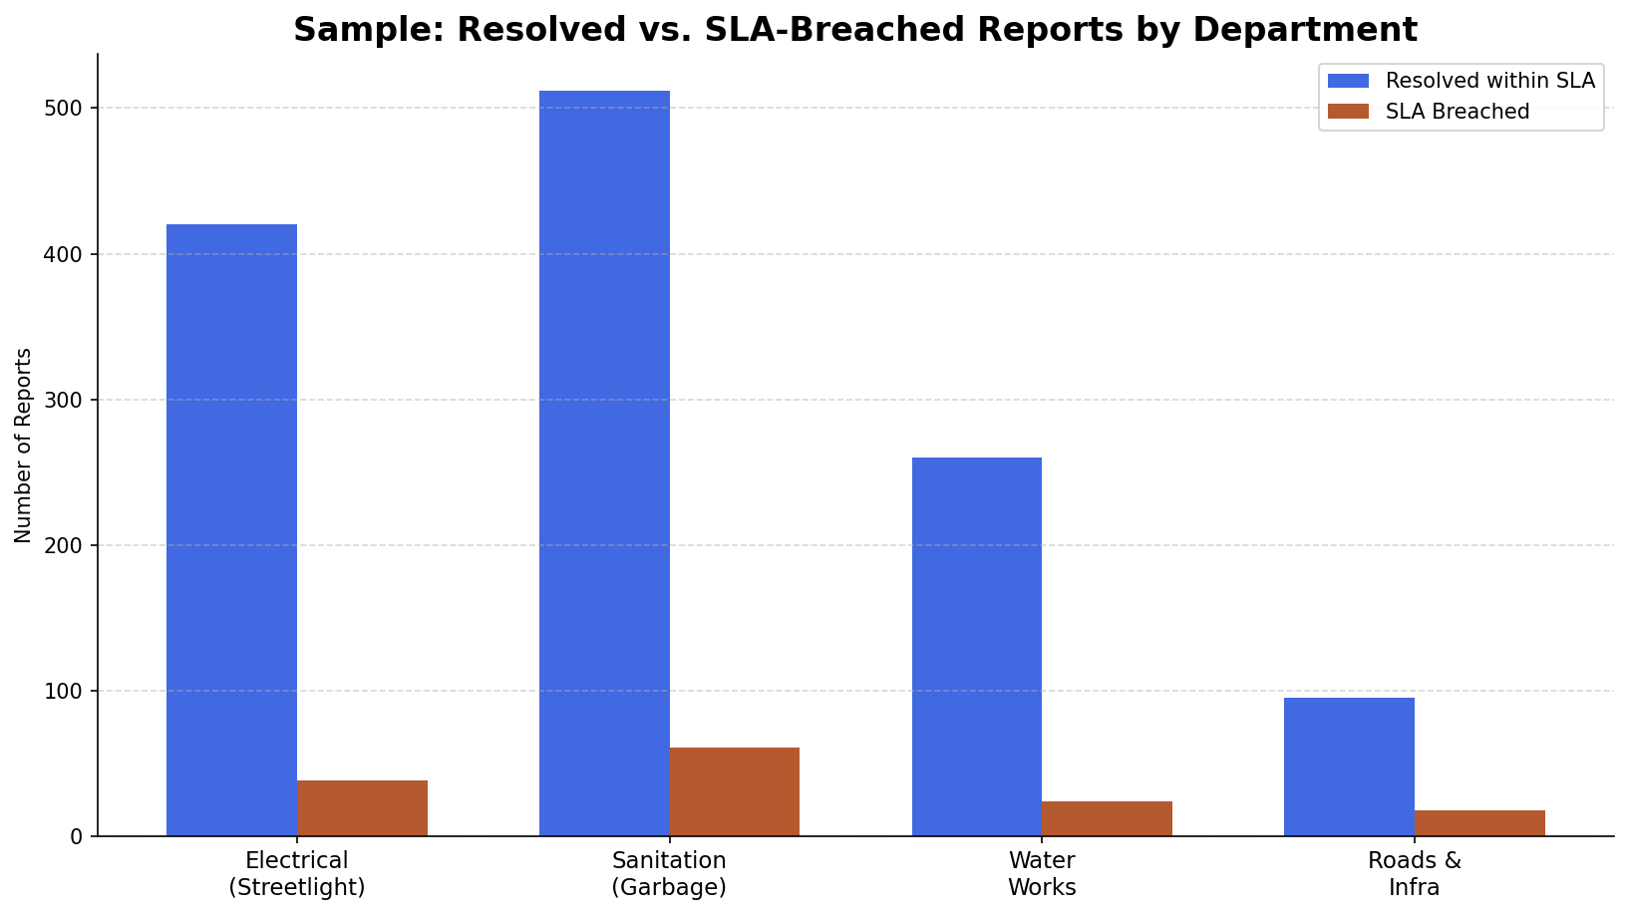
Figure 4: Sample — resolved vs. SLA-breached reports by department
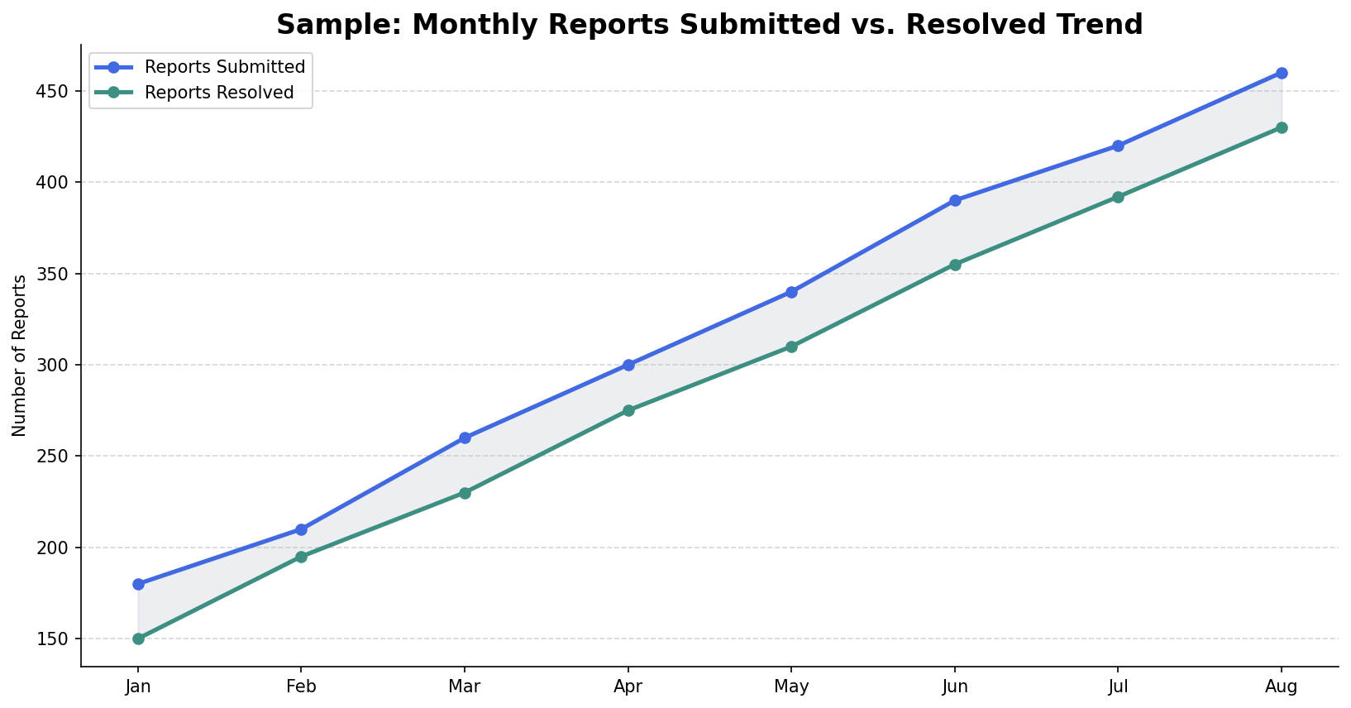
Figure 5: Sample — monthly reports submitted vs. resolved trend

7. Use Case Summary
The following table lists the primary use cases derived from the functional requirements in Section 3. Detailed use-case flows (actors, preconditions, main/alternate flows, postconditions) will be maintained in a separate use-case specification during the design phase.
UC ID | Use Case | Brief Description
UC-01 | Register / Login | A citizen creates an account or logs in via mobile OTP, email, or social login.
UC-02 | Report an Issue | A citizen captures a photo, confirms auto-tagged location, selects a category, and submits a report.
UC-03 | Confirm Existing Report | A citizen sees a nearby existing report and upvotes/confirms it instead of creating a duplicate.
UC-04 | Track Report Status | A citizen views the live status of their submitted reports and receives notifications on updates.
UC-05 | Browse Public Map | Any user browses a map of open/resolved civic issues in a chosen area.
UC-06 | Triage & Assign Report | An administrator reviews incoming reports and assigns them to a field worker or team.
UC-07 | Resolve Assigned Report | A field worker updates status, uploads resolution proof, and closes the report.
UC-08 | Escalate SLA Breach | The system automatically flags and escalates a report that has crossed its SLA threshold.
UC-09 | Reopen Report | A citizen reopens a resolved report within the allowed window if the issue persists.
UC-10 | Generate Performance Report | An administrator generates a department/ward-level performance and hotspot report.

8. Success Metrics / Acceptance Criteria
- Average issue resolution time reduced by a target of 30% within 6 months of launch, measured against pre-launch baseline complaint-handling times.
- At least 90% of new reports auto-routed correctly to the responsible department without manual re-assignment.
- Duplicate report rate reduced to under 15% of total submissions through the confirmation/upvote mechanism.
- At least 70% of resolved reports include citizen-uploaded proof and a corresponding field-worker resolution photo.
- Public map achieves at least 99% data accuracy between actual report status and displayed status, verified via periodic audit.

9. Appendix A: Glossary
Term | Definition
SLA | Service Level Agreement — the target time within which a report of a given category must be acknowledged and resolved.
Ward / Zone | An administrative sub-division of a municipality used to determine departmental jurisdiction.
Geotagging | Automatically attaching GPS coordinates to a piece of content (in this case, a report and its photo).
Duplicate Confirmation | The act of a citizen upvoting an existing open report instead of filing a new one for the same issue.
Field Worker | Municipal staff responsible for physically inspecting and resolving a reported issue.
Hotspot | A geographic cluster of recurring or high-volume reports, used for resource-planning analytics.

Appendix B: Open Items for Stakeholder Review
- Confirm which municipal department(s) will act as the receiving authority/API owner for each issue category.
- Confirm target city/cities for v1 launch to finalize ward-boundary data sourcing.
- Confirm default SLA durations per issue category (draft: Streetlight 7 days, Garbage 48 hours, Water Leakage 24 hours — subject to municipal input).
- Confirm regional language(s) required at launch for localization.

