LAB EXPERIMENTS

COURSE: Cloud computing and big data for business applications. NAME: Ajay Kumar J
COURSE CODE: CSA1519 REG NO: 192372052

1)Create a simple cloud software application and provide it as a service using
any Cloud Service Provider to demonstrate Software as a Service (SaaS).
Ans:
Aim:
- To develop a Hospital Management System using Zoho Creator and deploy it as Software as a Service (SaaS).

Cloud Service Provider:
- Zoho Creator

Procedure
- Created a new application in Zoho Creator.
- Designed Patient Details, Doctor Details, and Appointment Details forms.
- Implemented auto-calculation and lookup fields to link patient and doctor data.
- Tested the application with sample records.
- Published the application and enabled web access.

Output
- A cloud-based Hospital Management System accessible through a web browser, allowing users to manage patient, doctor, and appointment information online.
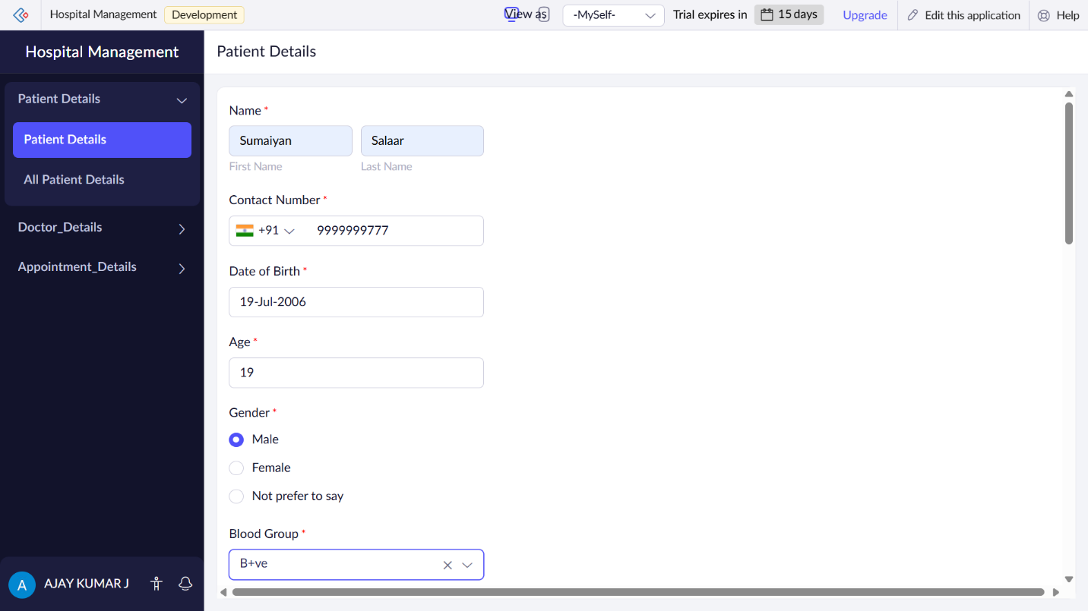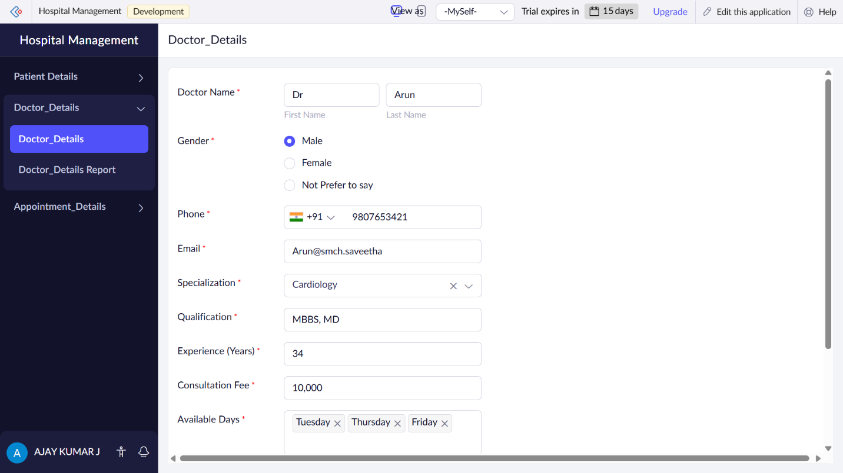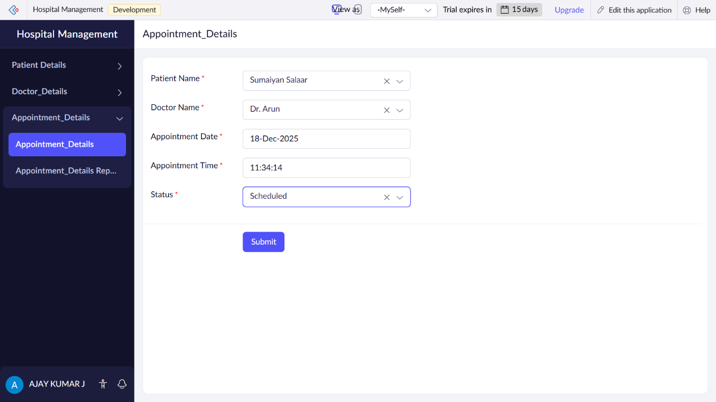

Result
- The Hospital Management System was successfully developed and deployed as a SaaS application, accessible anytime via the internet without local installation.

