LAB EXPERIMENTS

COURSE: Cloud computing and big data for business applications. NAME: Ajay Kumar J
COURSE CODE: CSA1519 REG NO: 192372052

2) Create a simple cloud software application for Flight Reservation System using any Cloud Service Provider to demonstrate SaaS
Aim:
To develop a Flight Reservation System using Zoho Creator and deploy it as Software as a Service (SaaS) for online flight booking and management.

Procedure
• Created a new application in Zoho Creator cloud platform.
• Designed Flight Details, Passenger Details, and Booking Details forms.
• Implemented lookup fields to connect flight and passenger information.
• Added auto-calculation fields to calculate ticket price based on seat count and fare.
• Applied validation rules and workflows for booking confirmation.
• Tested the application using sample flight schedules and passenger records.
• Published the application and enabled web and mobile access.

Output
A cloud-based Flight Reservation System accessible through a web browser, allowing users to search flights, enter passenger details, and book tickets online.
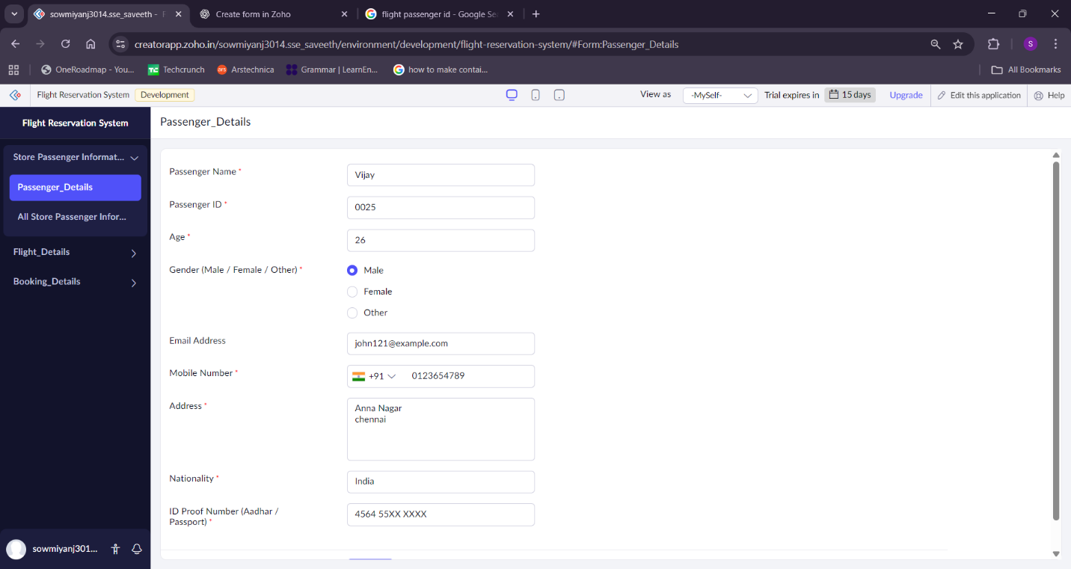
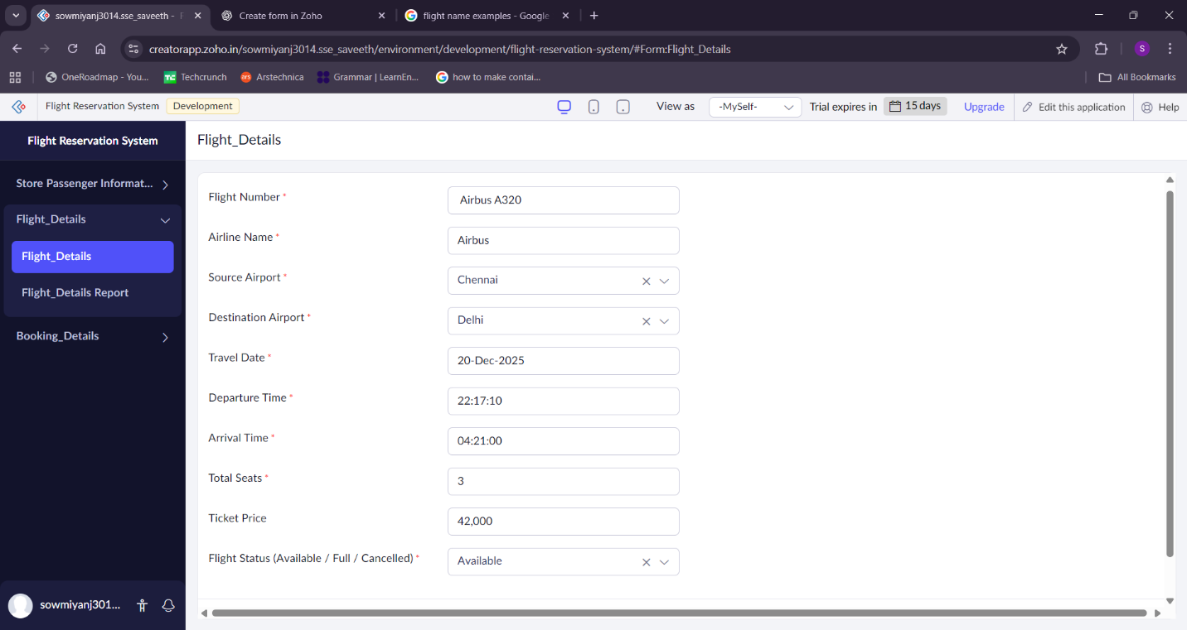
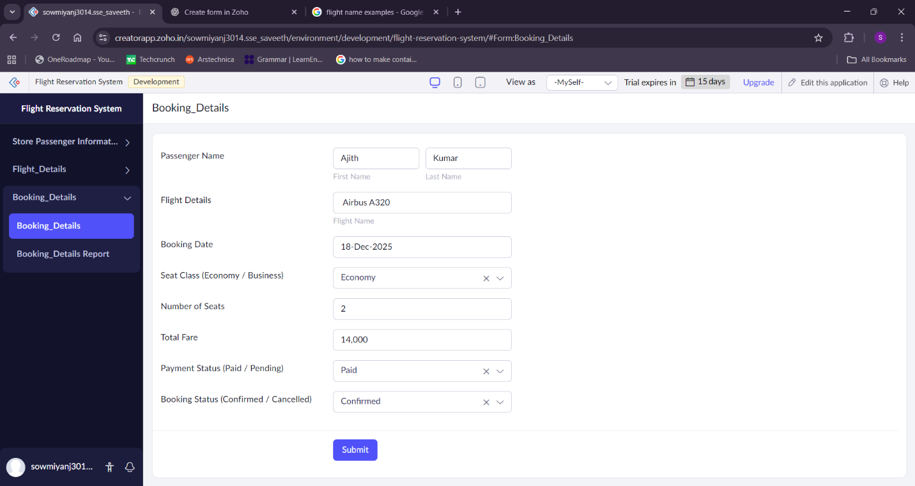

Result
The Flight Reservation System was successfully developed and deployed as a SaaS application, enabling users to access and manage flight bookings anytime, anywhere via the internet without the need for local software installation.

