LAB EXPERIMENTS

COURSE: Cloud computing and big data for business applications. NAME: Ajay Kumar J
COURSE CODE: CSA1519 REG NO: 192372052

3) Create a simple cloud software application for Property Buying and Rental process (In Chennai city) using any Cloud Service Provider to demonstrate SaaS.
Aim
To develop a Property Buying & Rental Management System for Chennai city using Zoho Creator and deploy it as Software as a Service (SaaS).

Procedure
• Created a new cloud application in Zoho Creator.
• Designed Property Details, Owner Details, and Customer Details forms.
• Included location-based fields (Area, Zone, Pin code) specific to Chennai city.
• Implemented lookup fields to link property, owner, and customer information.
• Added auto-calculation fields for rent amount, advance amount, and total cost.
• Configured workflow rules for property availability status (Available / Sold / Rented).
• Tested the application using sample property and customer records.
• Published the application and enabled web-based access.

Output
A cloud-based Property Buying & Rental System accessible through a web browser, allowing users to list properties, manage customer enquiries, and track property sales and rentals online.
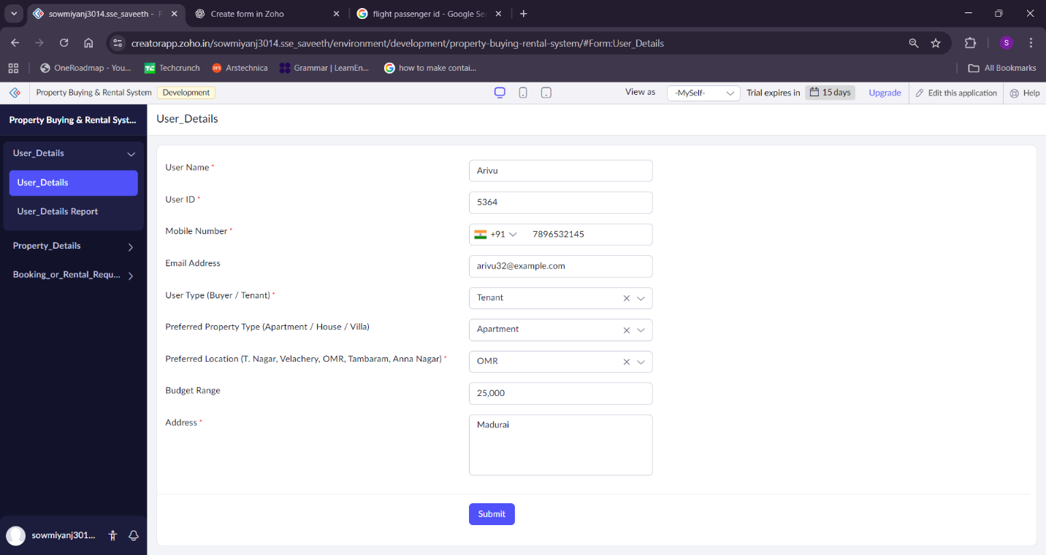
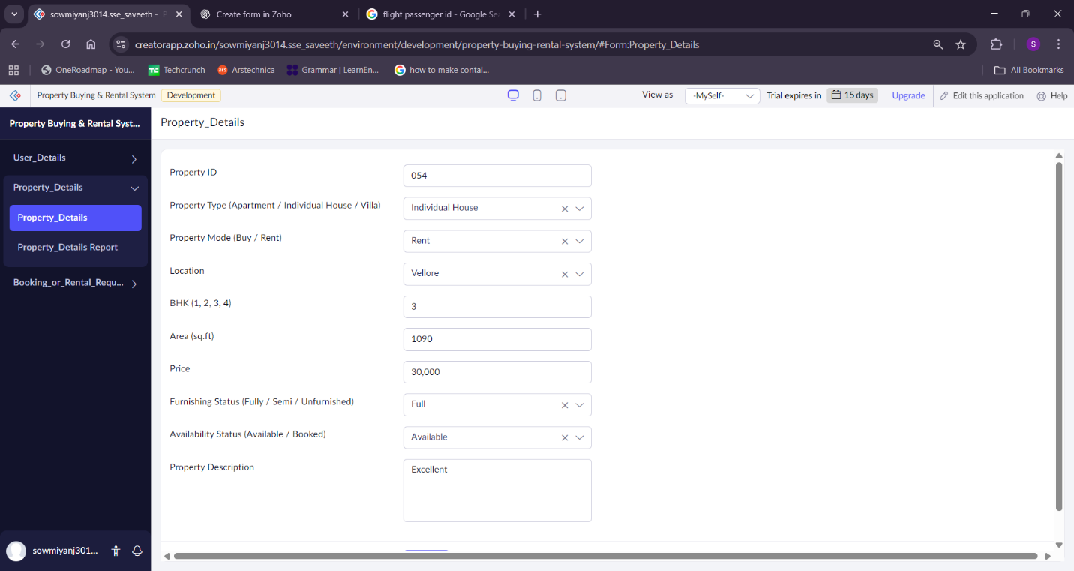
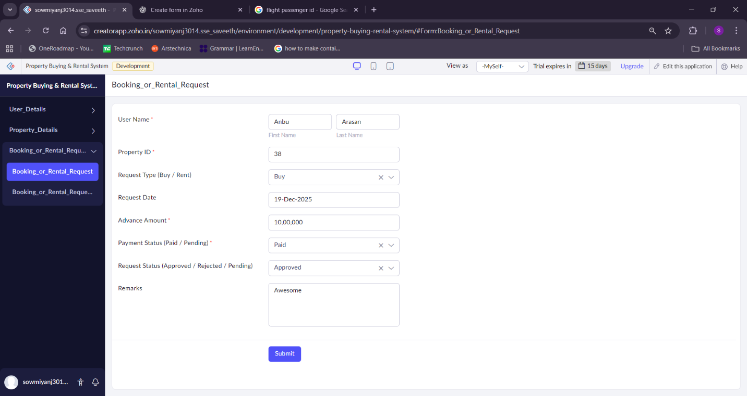

Result
The Property Buying & Rental System was successfully developed and deployed as a SaaS application, providing real-time access to property information across Chennai city without requiring local software installation.

