LAB EXPERIMENTS

COURSE: Cloud computing and big data for business applications. NAME: Ajay Kumar J
COURSE CODE: CSA1519 REG NO: 192372052

4) Create a simple cloud software application for Car Booking Reservation System using any Cloud Service Provider to demonstrate SaaS.
Aim
To develop a Car Booking Reservation System using Zoho Creator and deploy it as Software as a Service (SaaS) for online car booking and management.

Procedure
• Created a new application in Zoho Creator cloud platform.
• Designed Car Details, Customer Details, and Booking Details forms.
• Implemented lookup fields to link car and customer information.
• Added auto-calculation fields to calculate total fare based on distance and duration.
• Applied validation rules to prevent double booking of cars.
• Configured workflow automation to update car availability status after booking.
• Tested the application using sample car and customer records.
• Published the application and enabled web and mobile access.

Output
A cloud-based Car Booking Reservation System accessible through a web browser, allowing users to view available cars, enter booking details, and reserve cars online.
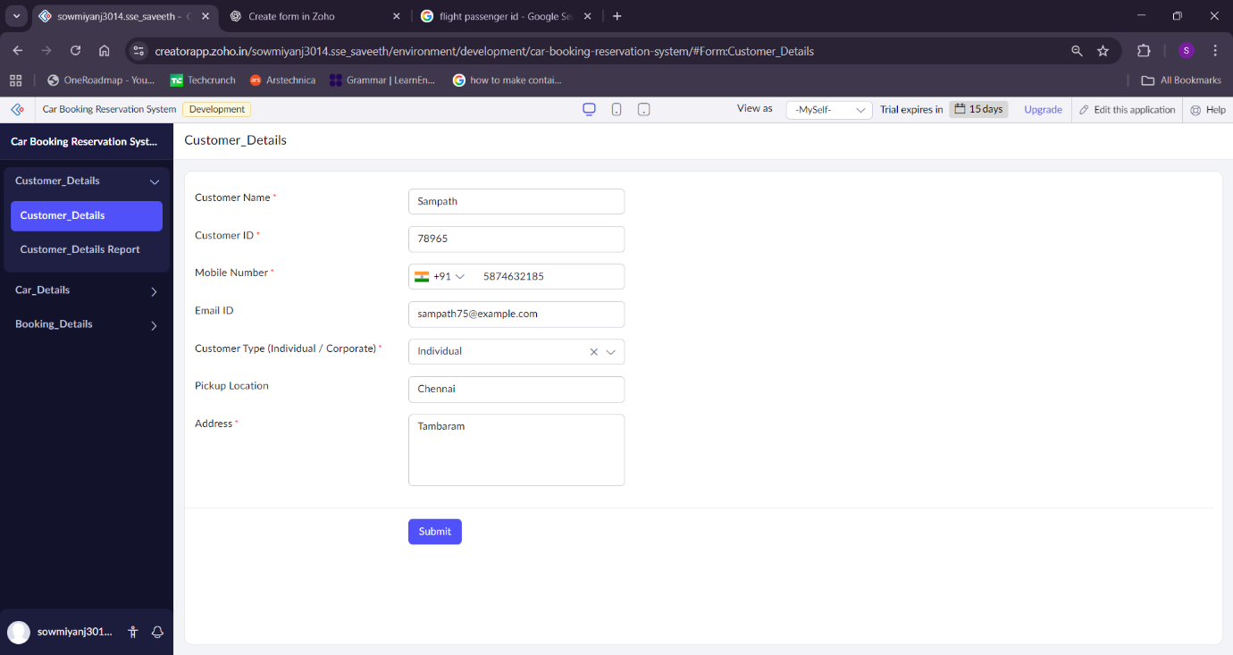
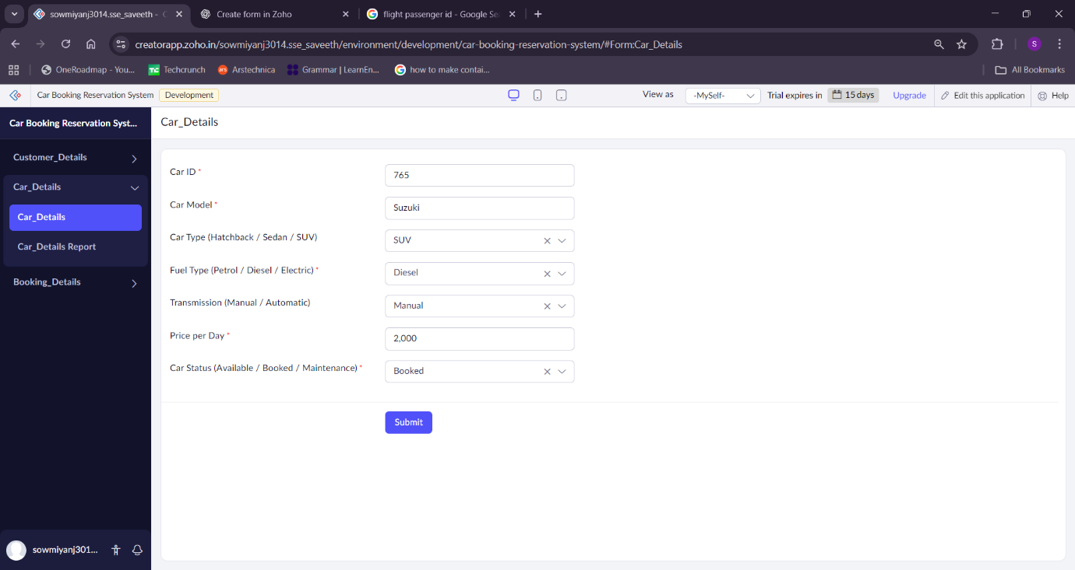
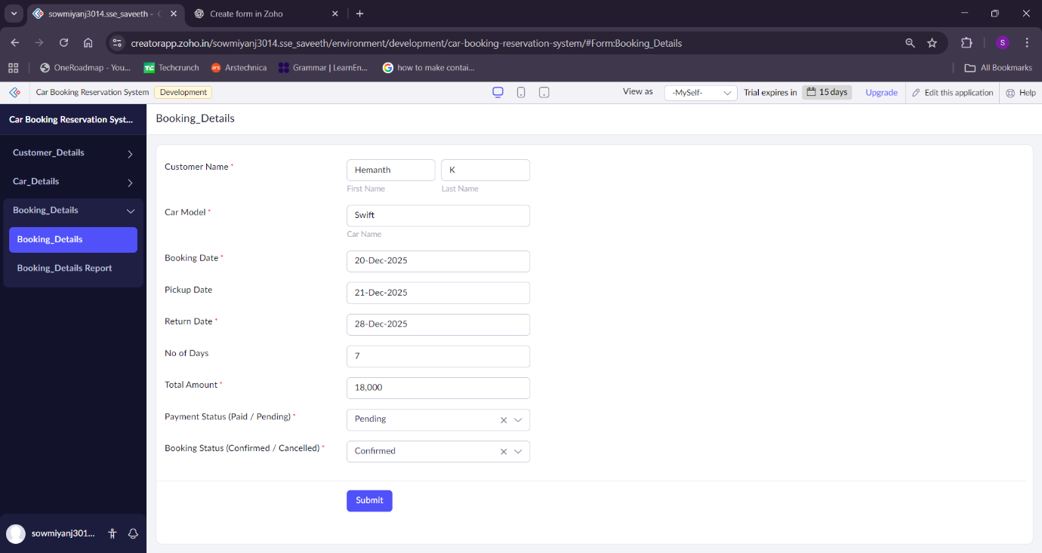

Result
The Car Booking Reservation System was successfully developed and deployed as a SaaS application, enabling users to book and manage car reservations anytime, anywhere via the internet without local software installation.

