LAB EXPERIMENTS

COURSE: Cloud computing and big data for business applications. NAME: Ajay Kumar J
COURSE CODE: CSA1519 REG NO: 192372052

5) Create a simple cloud software application for Library book reservation system for SIMATS library using any Cloud Service Provider to demonstrate SaaS.
Aim
To develop a Library Book Reservation System for SIMATS Library using Zoho Creator and deploy it as Software as a Service (SaaS).

Procedure
• Created a new application in Zoho Creator cloud platform.
• Designed Book Details, Student Details, and Reservation Details forms.
• Implemented lookup fields to link book and student information.
• Added validation rules to restrict multiple reservations of the same book.
• Configured workflow automation to update book availability status after reservation.
• Enabled role-based access for librarian and student users.
• Tested the application using sample book and student records.
• Published the application and enabled web-based access.

Output
A cloud-based Library Book Reservation System accessible through a web browser, allowing students to search books and reserve them online, while librarians can manage book records efficiently.
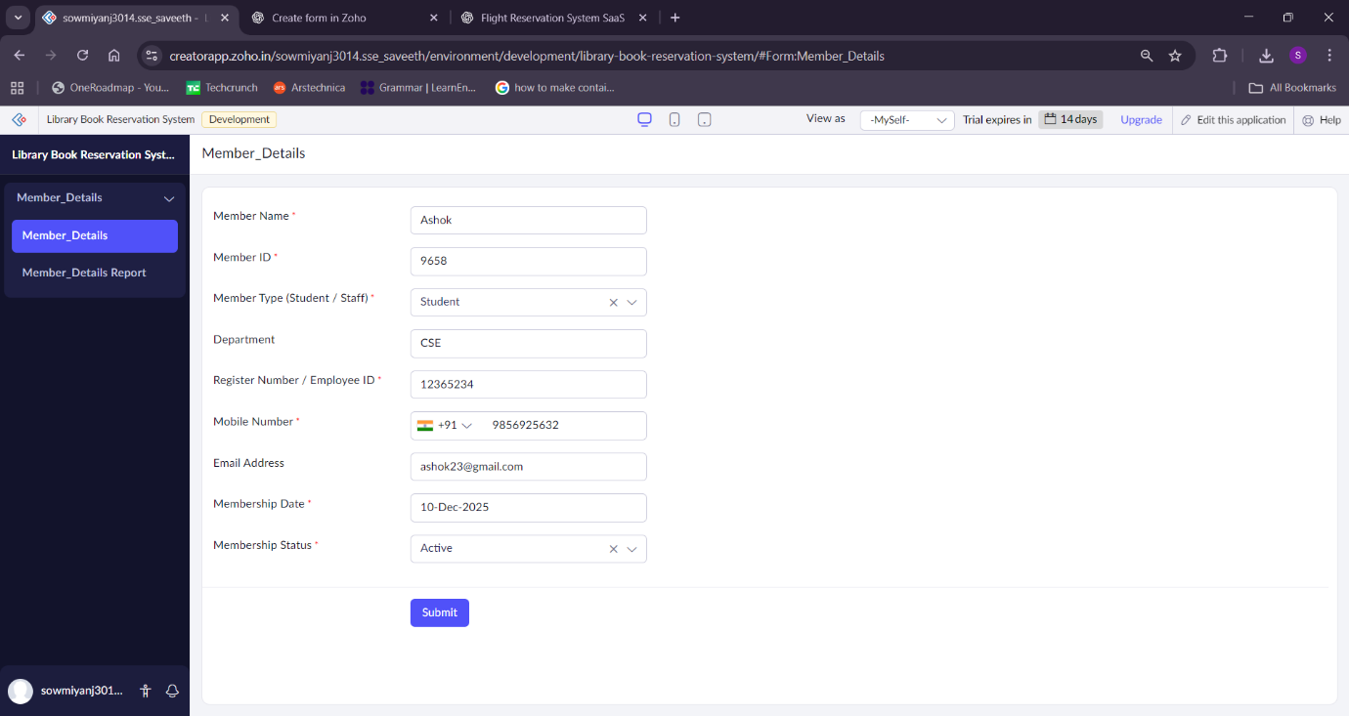
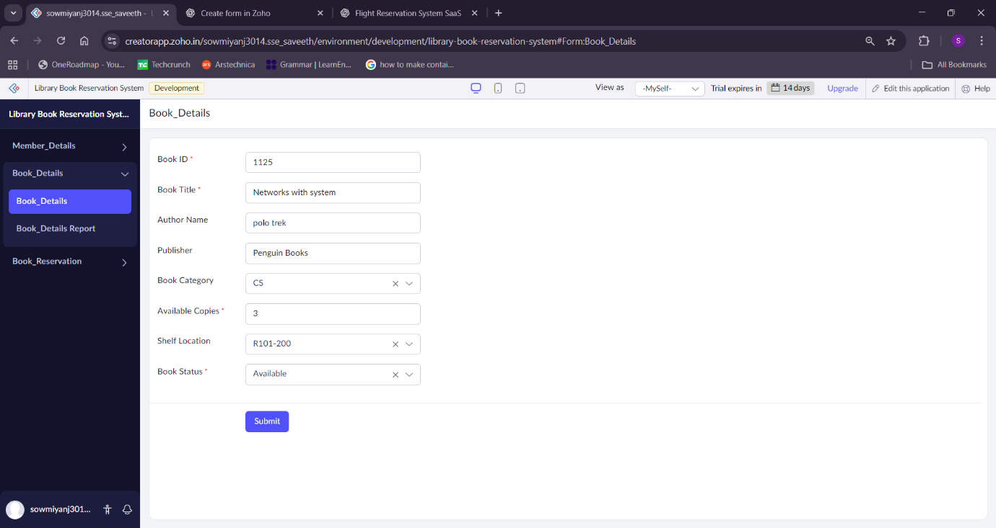
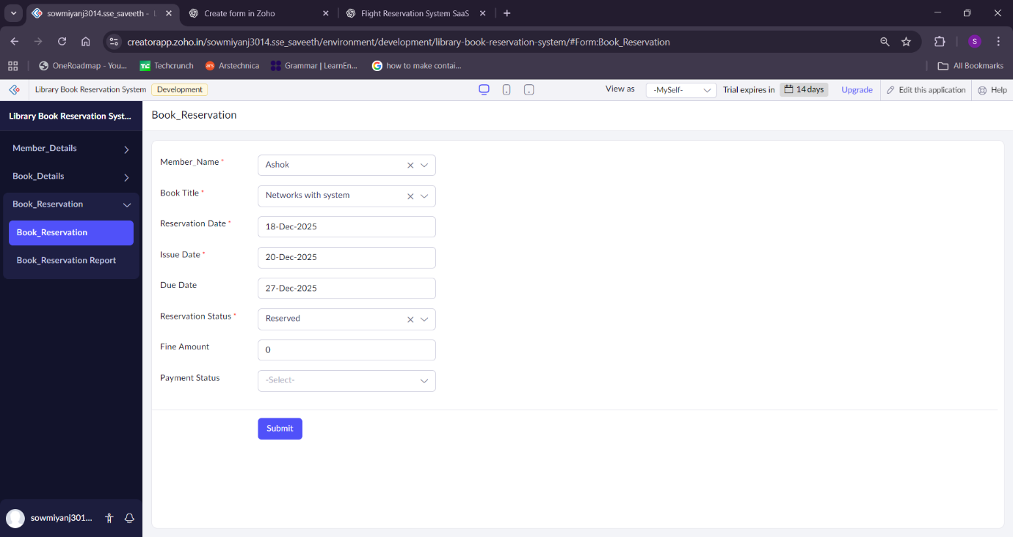

Result
The Library Book Reservation System for SIMATS Library was successfully developed and deployed as a SaaS application, providing centralized, real-time access to library data without the need for local software installation.

