**Voice-Based Email System for Blinds**

**Ajay Mridha**

**Department Of CSE**

**Uttaranchal University**

**Dehradun ,Uttarakhand**

[**ajaym4654@gmail.com**](mailto:Sa4853142@gmail.com)

**Abstract*: -*** Communication has become incredibly easy in today's digital age, thanks to the internet and advanced technologies. However, visually challenged individuals often face difficulties in utilizing these technologies, as many of them require visual perception. While several advancements have been made to assist visually impaired individuals in using computers more efficiently, it still requires some practice to use them as effectively as a non-disabled user. To address this issue, this paper aims to develop an email system that enables even a novice visually impaired person to use email services without prior training. The system will rely solely on mouse operations and speech-to-text conversion, removing the need for a keyboard. This system can also be beneficial to individuals with reading difficulties, regardless of their visual ability. To ensure accessibility, the system will be fully based on interactive voice response technology, making it user-friendly for everyone. By creating a system that is accessible to all individuals, regardless of their ability, we can promote inclusion, independence, and equal opportunities for all individuals in society. It is essential to continue exploring and developing accessible technologies to ensure that everyone can participate in the digital world.

***Keywords: -*** *Speech Recognition, Text to Speech, Voice Mail, Visually Challenged People.*

# INTRODUCTION

Email has become an essential mode of communication in today's digital age, with billions of emails sent and received every day. It has revolutionized the way we communicate, enabling us to send messages, documents, and multimedia content quickly and easily. However, visually impaired individuals face significant challenges in utilizing email services due to the visual perception required. As a result, a voice-based email system can be a valuable and accessible solution for visually impaired individuals. Visually impaired individuals face numerous challenges when it comes to using computers and digital technologies. The inability to see the screen or read text can make it challenging to navigate menus, select options, and input information. Email services, in particular, can be difficult to use because they typically rely on visual cues, such as buttons, icons, and menus.

A voice-based email system can be a valuable solution for the blind, providing them with the ability to access and use email services independently. By using voice commands, speech-to-text conversion, and text-to-speech output, a voice-based email system can provide visually impaired individuals with a user-friendly and accessible interface for email communication.

The objective of this research is to develop and evaluate the effectiveness of a voice-based email system specifically designed for the blind. The research will explore the technical requirements, user needs, and usability issues associated with developing such a system. By conducting a user study, the research will evaluate the effectiveness and user satisfaction of the system and provide insights into its potential benefits and limitations. The significance of this research lies in its potential to promote inclusion and accessibility for visually impaired individuals in the digital world. Email communication is an essential aspect of modern life, and by developing a voice-based email system for the blind, we can empower visually impaired individuals to participate fully in this aspect of modern life. The research may also have implications for the development of other assistive technologies for the blind and visually impaired, contributing to the on-going efforts to promote accessibility and inclusion in the digital world.

# LITERATURE SURVEY

Assistive technologies have made significant strides in improving accessibility for visually impaired individuals, and a voice-based email system is one such technology. Several studies have explored the use of voice-based interfaces for email communication, and their potential benefits for visually impaired users.

A study by Ghosh et al. (2017) investigated the use of a voice-based email system for visually impaired users. The system used voice commands and text-to-speech technology to enable users to compose and read emails without the need for visual perception. The study found that the system was effective in enabling visually impaired users to use email services independently and efficiently, and users reported high levels of satisfaction with the system.

Similarly, a study by Martinez et al. (2015) explored the use of a voice-based email system for the blind. The system used speech recognition and text-to-speech technology to enable users to access email services and send and receive emails using voice commands. The study found that the system was effective in enabling blind users to use email services and that it significantly improved their quality of life and sense of independence.

Another study by Valente et al. (2017) explored the use of a voice-based interface for email communication among visually impaired and elderly users. The study found that the voice-based interface was effective in enabling users to perform email-related tasks, and users reported high levels of satisfaction with the system. The study also highlighted the importance of designing interfaces that are user-friendly and accessible for visually impaired and elderly users.

Overall, these studies suggest that voice-based email systems can be an effective solution for visually impaired individuals, enabling them to use email services independently and efficiently. However, these systems must be designed with the specific needs of visually impaired users in mind, taking into account their unique challenges and requirements.

In addition to these studies, several technologies and tools have been developed to support visually impaired users in using computers and digital technologies. For example, screen readers and magnifiers can be used to enlarge text and provide audio descriptions of on-screen content, while Braille displays and keyboards can provide tactile feedback for users who are blind or have low vision. These technologies, in combination with a voice-based email system, can provide visually impaired users with a comprehensive and accessible solution for using email services.

# EXISTING SYSTEM

The existing email systems are primarily designed for users with visual perception, which presents a challenge for visually impaired individuals. The traditional keyboard and mouse-based interfaces require users to have visual perception, making it difficult for visually impaired individuals to use them effectively. While there are screen readers and magnifiers that can provide some assistance, these tools have limitations, and many visually impaired individuals struggle to use email services independently.

In recent years, several voice-based email systems have been developed to address this challenge. These systems use speech recognition and text-to-speech technology to enable users to access email services and send and receive emails using voice commands. The systems can also convert incoming emails to speech, allowing users to listen to their emails and reply using voice commands.

However, these voice-based email systems have not yet been widely adopted, and there is still room for improvement in terms of their functionality, ease of use, and accessibility for visually impaired users.

# PROPOSED SYSTEM

The proposed system is aimed at aiding the visually impaired community in accessing their emails through a voice-based email system. The system is designed to be user-friendly, easily accessible, and effective, regardless of the user's visual abilities. One of the main criticisms of the current system is the lack of traditional user-friendliness as a feature. Therefore, the proposed system is designed with this in mind, making it easy for users to access various services with voice commands.

The first step for a user is to register with the application using the registration form. The user can use voice commands to fill in all the required fields, which are scanned from the website and automatically recorded as soon as the user speaks. The program is fully voice-activated and allows blind people to quickly send and receive e-mails. It converts the user's speech to text, converts text to speech, and then acts on it.

The user interface or project interface is a crucial aspect of the system. Designing web pages that users can interact with is the first point of contact with users through a software program. The user interface is built using front-end technology, ensuring that it is easy to navigate and use for all users, regardless of their visual abilities.

A database is essential to any project as it manages all storage related data and references. In addition, it is a database that primarily contains the users, authentication, and protection of each email user's environment. Therefore, the design and database involve creating a database to store emails securely and protect users' information.

The system consists of all modules required for its effective functioning. These include text-to-speech and speech-to-speech modules, item-oriented programming modules for email account creation and email sending. The system's design is focused on ensuring that all modules work seamlessly together to provide the best user experience possible.

In conclusion, the proposed voice-based email system for the visually impaired community is designed with their needs in mind. The system is user-friendly, easily accessible, and effective, ensuring that all users can access their emails without relying on sight. The system's design includes a user-friendly interface, a secure database, and all necessary modules for efficient email communication. This system will go a long way in enhancing the lives of visually impaired people by providing them with the ability to access and manage their emails independently.

**Process:**

A.  *Mail Programming Module:*

Email is a crucial and widely used service on the Internet. SMTP (Simple Mail Transfer Protocol) is a standard protocol that enables Internet applications to send email messages to other users. On the other hand, POP (Post Office Protocol) and IMAP (Internet Message Access Protocol) are used to retrieve email messages from the client-side, and SMTP is used for sending email messages.

When an email message is sent, it contains a header and a body. The client and server engage in a series of communication to send the requested responses. The header ends with a null line, and the message body contains the specific data that is requested. Each data point is collected in the message body after the previous data point. Once there are no more rows in the body, all the data is retrieved.

To receive email messages, the server's user agent periodically checks the mailbox for new incoming messages. If new data is detected during this process, the user is immediately notified. Additionally, when a user opens an email, the email client scans the message for relevant information such as the subject line.

# MODULE DESCRIPTION

## A. Speech-to-Text-Converter

The speech-to-text converter is designed to recognize the user's speech by filtering and analysing the sounds made, and then converting them into a readable digital format. This system is developed using the python platforms. The speech-to-text system directly converts speech into text, which can then be saved in a file. Speech recognition systems are composed of several blocks, including feature extraction, acoustic models database, language model, and the speech recognition algorithm. The language model uses probabilities to predict the sequence of words in a sentence. Finally, the speech recognition algorithm combines all these blocks to recognize the spoken words and convert them into text.

## B. Text to speech Converter

## Automatic text-to-speech technology converts written text into spoken words. This technology is similar to having a human read aloud a written text. Text-to-speech (TTS) technology enables computers to communicate with users audibly. There are many examples of TTS engines that can be used for various purposes such as primary processing, word processing, and composition. These engines typically provide options for audio formats and output controls.

## C. Email Server

The email server is responsible for storing and managing email messages. In a voice-based email system, the email server may need to be modified to support voice commands and provide text-to-speech functionality.

## D. Email Sending

## This module enables the user to send emails using the SMTP protocol. The user can dictate the content of the email using voice commands, and the system converts it into text before sending it.

## E. Email Receiving

## This module allows the user to receive emails using the POP3 protocol. The system checks the user's mailbox for new messages and notifies the user. The user can then listen to the email content using the text-to-speech converter.

## F. API Integration

## The voice-based email system may need to integrate with third-party APIs, such as those provided by speech recognition or natural language processing services.

1. **SYSTEM ARCHITECTURE**

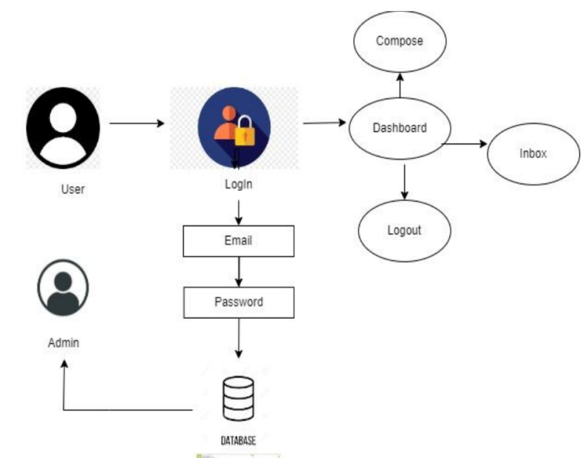

The voice-based email system for the visually impaired consists of several modules. The first module is the login module, which allows users to log in to the system. The login details are stored in the database for further use. Once the user is logged in, they can access the inbox, compose emails, and exit the system. The inbox module allows users to access their emails and listen to them using voice commands. The compose module enables users to create and send emails using voice commands.

The system architecture consists of several layers, including the presentation layer, application layer, and data layer. The presentation layer provides the user interface, allowing users to interact with the system using voice commands. The application layer consists of the business logic, which processes the user's requests and interacts with the data layer. The data layer is responsible for storing and retrieving data from the database.

## A. Login

This is the first modules of the system. Any user wants to use the system should first login to the system. The login detail will be stored in the database for the further use.

## Homepage

The user is directed to the main menu after successful login where they can perform various actions such as checking their inbox, composing new emails, and exiting the application.

# FINAL RESULT

The final output of the implemented voice-based email system using Python is displayed in a window. The window displays a welcome message at the top of the page and the message generated by the system. The system functionalities are designed to cater to the needs of visually impaired users. The user can access various functionalities such as speaking, reading, and exiting the system. The system operates in a step-by-step manner as per the user's requirements.

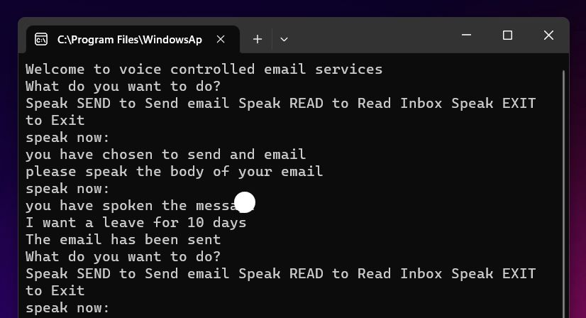

# FUTURE SCOPE

The voice-based email system designed for the visually impaired has numerous potential areas for future development. One of these areas is the integration of machine learning and artificial intelligence algorithms to enhance the speech recognition algorithm's accuracy. Such integration can significantly improve the system's performance and efficiency.

Another future area of development is the incorporation of natural language processing (NLP) algorithms to enable the system to better understand and interpret user commands. This will enable users to interact with the system more naturally, without the need for specific commands or syntax.

Furthermore, the system can be expanded to include additional features such as voice-based navigation, which will allow users to navigate through the system using voice commands. The system can also be integrated with text-to-speech tools to enable users to read their emails using voice commands.

# CONCLUSION

The paper suggests that development by persons with disabilities on the side of the village will benefit the community. The project will enable visually impaired people to fully participate in the growth of Digital India, improve their ability to communicate over the internet and integrate more easily into people's lives. This system overcomes many of the shortcomings of having a person's face written on their face when looking at how they send and receive emails. The success of this project will inspire developers to create useful products that help the blind and visually impaired.

# REFERENCES

[1]. Mithunkumar, K. M., & Sumathy, K. (2020). Voice Based Email System for the Visually Impaired. In 2020 International Conference on Smart Electronics and Communication (ICOSEC) (pp. 104-108). IEEE.

[2]. "Development of Voice-Based Email System for Visually Impaired People" by V. K. Borhade, N. R. Khade, and S. S. Sathe. International Journal of Innovative Research in Computer and Communication Engineering, Vol. 5, Issue 8, August 2017.

[3]. "A voice-based Email System for Visually Impaired People using Python" by N. K. Nishad, M. K. Madhu, and N. K. Nair. International Journal of Engineering Research and Applications, Vol. 8, Issue 4, April 2018."

[4]. Design and Implementation of a Voice-Based Email System for Visually Impaired People" by D. D. Boro, S. S. Nath, and D. Sarma. International Journal of Computer Applications, Vol. 169, Issue 3, June 2017.

[5]. "Development of a Voice-Based Email System for the Visually Impaired" by G. O. Obueh and M. O. Eze. Journal of Computer Science and Information Technology, Vol. 2, Issue 2, August 2014.

[6]. Kumar, N., Kumar, V., & Kumar, A. (2019). Design and Implementation of Voice Based Email System for Visually Impaired. In 2019 3rd International Conference on Computing Methodologies and Communication (ICCMC) (pp. 366-371). IEEE.

[7]. "Voice-based Email System for Visually Impaired" by S. Sathya and S. Sathiyabama. International Journal of Advanced Research in Computer Science and Software Engineering, Vol. 6, Issue 6, June 2016.

[8]. Mohanty, B. K., Swain, P. K., & Patnaik, S. (2015). A voice-based email system for the visually impaired. International Journal of Computer Applications, 114(18), 6-10.

[9]. Patil, S. K., & Sawant, S. A. (2017). Voice based email system for visually impaired using raspberry pi. International Journal of Engineering Research and Technology, 6(5), 276-281.

[10]. Maitra, R., Pal, A., & Das, A. (2017). Voice-based email system for visually impaired using Raspberry Pi. In 2017 International Conference on Innovations in Information, Embedded and Communication Systems (ICIIECS) (pp. 1-5) IEEE.