Cc1

1)

package cc1;

import org.openqa.selenium.By;

import org.openqa.selenium.WebDriver;

import org.openqa.selenium.chrome.ChromeDriver;

import io.github.bonigarcia.wdm.WebDriverManager;

public class cc1 {

public static void main( String[] args ) throws InterruptedException

{

WebDriverManager.*chromedriver*().setup();

WebDriver driver = new ChromeDriver();

driver.manage().window().maximize();

driver.navigate().to("https://www.saucedemo.com/");

driver.manage().window().maximize();

driver.findElement(By.*xpath*("//*[@id=\"user-name\"]")).sendKeys("standard_user");

driver.findElement(By.*xpath*("//*[@id=\"password\"]")).sendKeys("secret_sauce");

driver.findElement(By.*xpath*("//*[@id=\"login-button\"]")).click();

driver.findElement(By.*xpath*("//*[@id=\"add-to-cart-sauce-labs-backpack\"]")).click();

String cartCount = driver.findElement(By.*xpath*("/html/body/div/div/div/div[1]/div[1]/div[3]/a/span")).getText();

if (cartCount.equals("1")) {

System.***out***.println("TESTCASE_01 : ADDED TO CART SUCCESSFULLY");

}

driver.findElement(By.*xpath*("/html/body/div/div/div/div[1]/div[1]/div[3]/a")).click();

String product = "Sauce Labs Backpack";

if(driver.findElement(By.*xpath*("/html/body/div/div/div/div[2]/div/div[1]/div[3]/div[2]/a/div")).getText().equals(product));

{

System.***out***.println("TESTCASE_02 : USER CAN VIEW THE CART");

}

driver.findElement(By.*xpath*("//*[@id=\"checkout\"]")).click();

if(driver.findElement(By.*xpath*("/html/body/div/div/div/div[1]/div[2]/span")).getText().equals("Checkout: Your Information")) {

System.***out***.println("TESTCASE_03 : FORM IS DISPLAYED");

}

driver.findElement(By.*xpath*("//*[@id=\"first-name\"]")).sendKeys("Ajaynavaneeth");

driver.findElement(By.*xpath*("//*[@id=\"last-name\"]")).sendKeys("R");

driver.findElement(By.*xpath*("//*[@id=\"postal-code\"]")).sendKeys("638452");

driver.findElement(By.*xpath*("//*[@id=\"continue\"]")).click();

if(driver.findElement(By.*xpath*("/html/body/div/div/div/div[1]/div[2]/span")).getText().equals("Checkout: Overview")) {

System.***out***.println("TESTCASE_04 : PRODUCT OVERVIEW PAGE IS DISPLAYED");

}

System.***out***.println("TESTCASE_05 : NAME OF THE PRODUCT : " + driver.findElement(By.*xpath*("/html/body/div/div/div/div[2]/div/div[1]/div[3]/div[2]/a/div")).getText());

System.***out***.println("TESTCASE_06 : PRICE OF THE PRODUCT : " + driver.findElement(By.*xpath*("/html/body/div/div/div/div[2]/div/div[1]/div[3]/div[2]/div[2]/div")).getText());

if(driver.getTitle().equals("Swag Labs")) {

System.***out***.println("TESTCASE_04 : TITLE OF THE GIVEN WEBSITE IS SWAG LABS ");

}

if(driver.getCurrentUrl().equals("https://www.saucedemo.com/checkout-step-two.html")) {

System.***out***.println("TESTCASE_07 : URL IS MATCHED WITH THE GIVEN");

}

}

}

}

}

}

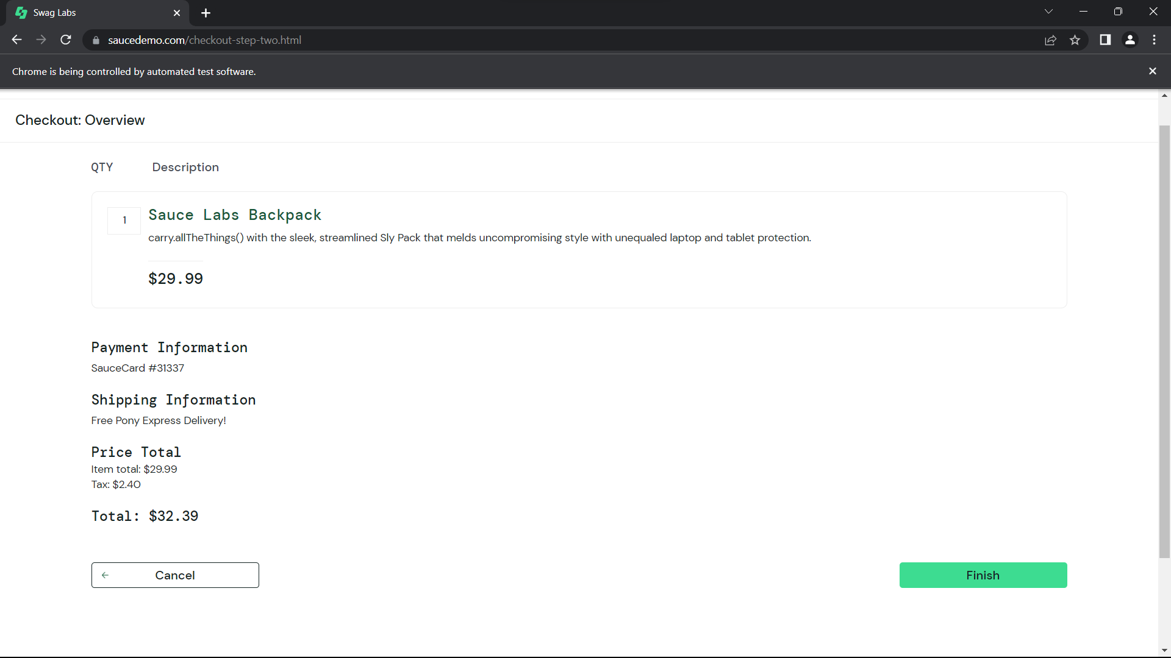

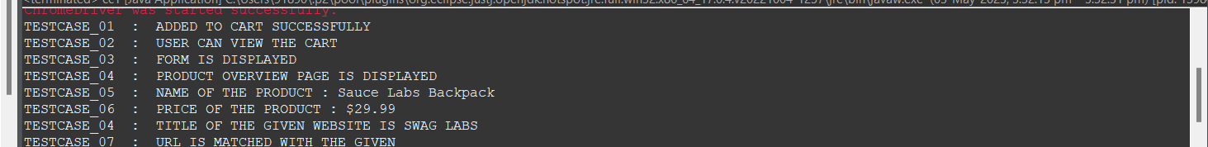

2)

package cc1;

import org.openqa.selenium.By;

import org.openqa.selenium.WebDriver;

import org.openqa.selenium.WebElement;

import org.openqa.selenium.chrome.ChromeDriver;

import org.openqa.selenium.chrome.ChromeOptions;

import io.github.bonigarcia.wdm.WebDriverManager;

public class cc12 {

public static void main(String[] args) throws InterruptedException {

// **TODO** Auto-generated method stub

ChromeOptions co=new ChromeOptions();

co.addArguments ("--remote-allow-origins=*");

WebDriverManager.*chromedriver*().setup ();

WebDriver driver=new ChromeDriver(co);

driver.get ("https://www.saucedemo.com/");

driver.manage().window().maximize() ;

WebElement txtBoxl=driver.findElement(By.*xpath*("//*[@id=\"user-name\"]"));

txtBoxl.sendKeys("standard_user");

WebElement txtBox2=driver.findElement(By.*xpath*("//*[@id=\"password\"]"));

txtBox2.sendKeys("secret_sauce");

driver.findElement(By.*xpath*("//*[@id=\"login-button\"]")).click();

String txt1=driver.findElement(By.*xpath*("//*[@id=\"item_4_title_link\"]/div")).getText();

System.***out***.println(txt1);

driver.findElement(By.*xpath*("//*[@id=\"header_container\"]/div[2]/div/span/select")).click();

driver.findElement(By.*xpath*("//*[@id=\"header_container\"]/div[2]/div/span/select/option[2]")).click();

String txt2=driver.findElement(By.*xpath*("//*[@id=\"item_3_title_link\"]/div")).getText();

System.***out***.println(txt2);

System.***out***.println("filter (A-Z and Z-A");

driver.findElement(By.*xpath*("//*[@id=\"header_container\"]/div[2]/div/span/select")).click();

driver.findElement(By.*xpath*("//*[@id=\"header_container\"]/div[2]/div/span/select/option[3]")).click();

String txt3=driver.findElement(By.*xpath*("//*[@id=\"inventory_container\"]/div/div[1]/div[2]/div[2]/div")).getText();

System.***out***.println(txt3);

driver.findElement(By.*xpath*("//*[@id=\"header_container\"]/div[2]/div/span/select")).click();

driver.findElement(By.*xpath*("//*[@id=\"header_container\"]/div[2]/div/span/select/option[4]")).click();

String txt4=driver.findElement(By.*xpath*("//*[@id=\"inventory_container\"]/div/div[1]/div[2]/div[2]/div")).getText();

System.***out***.println(txt4);

System.***out***.println("filter (low price- high price and high price - low price )");

Thread.*sleep*(5000);





