Day5:

1)

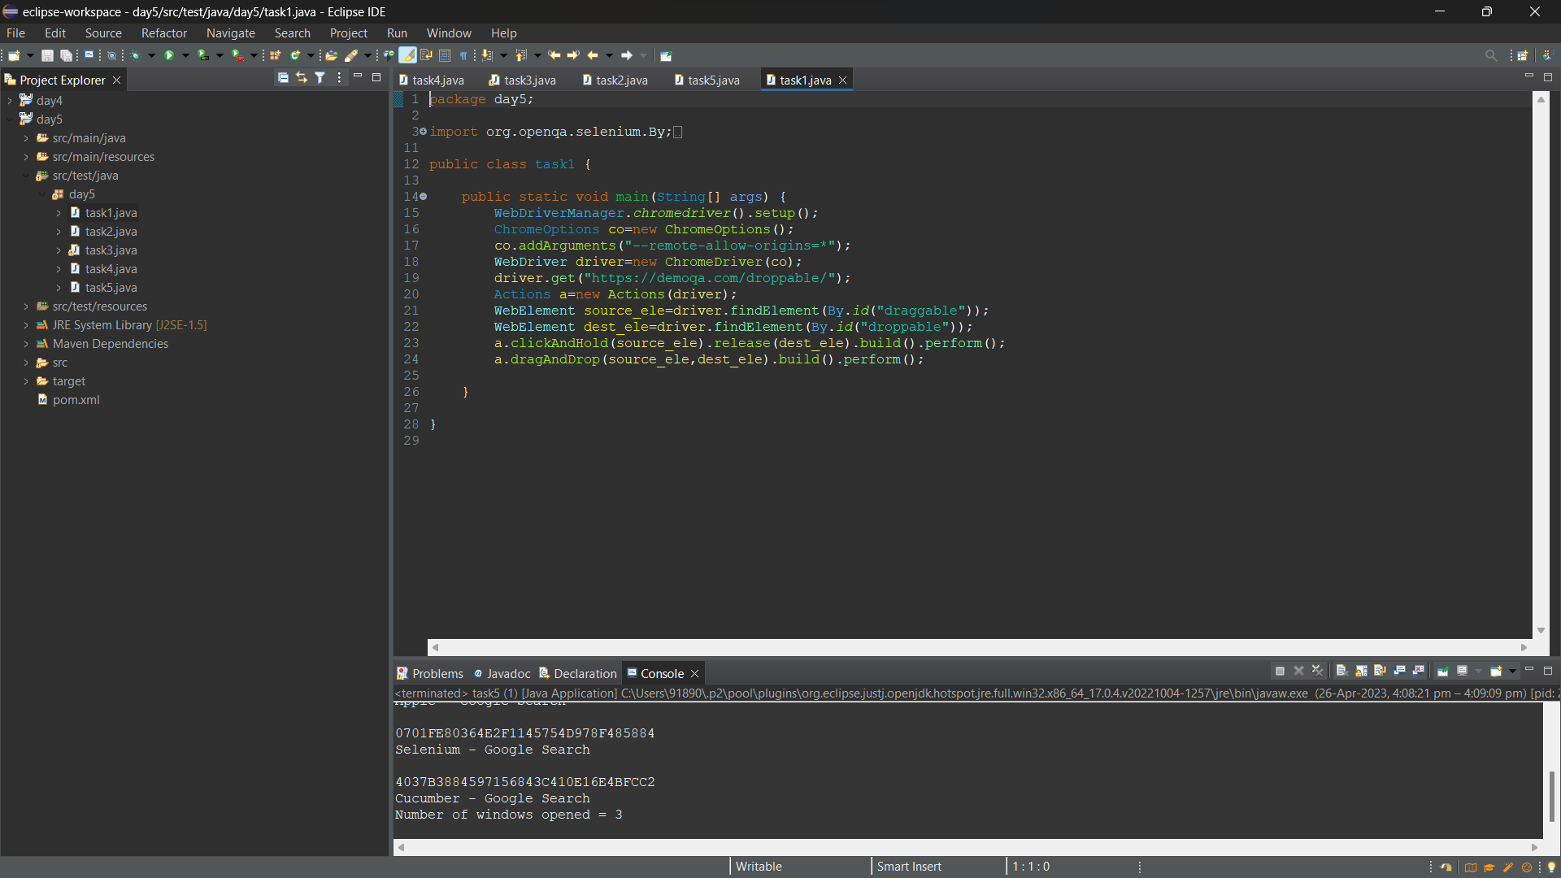

O/P

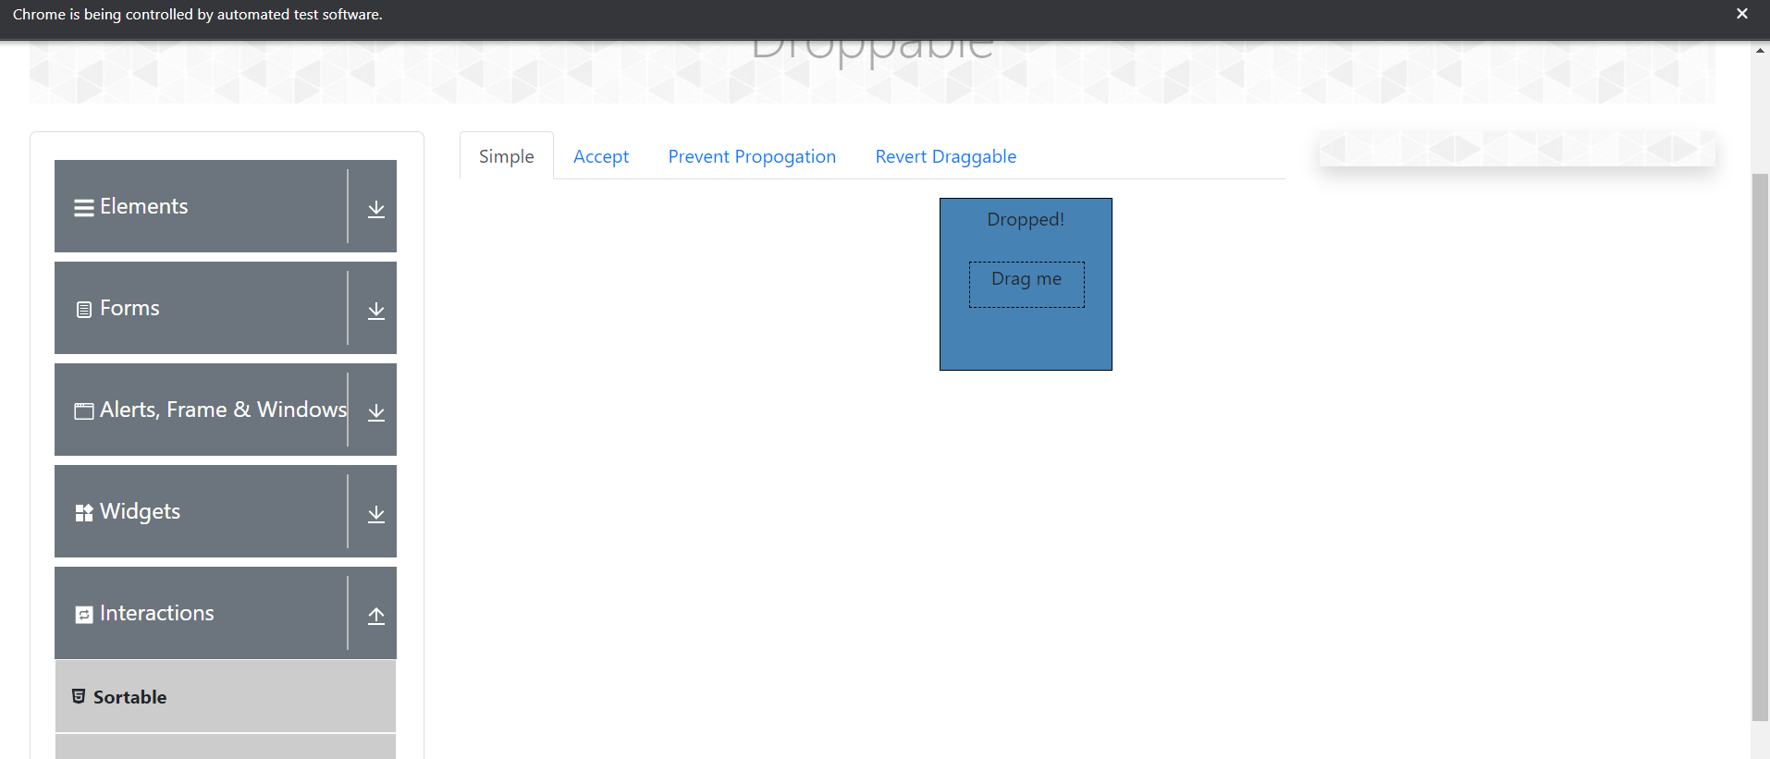

2)

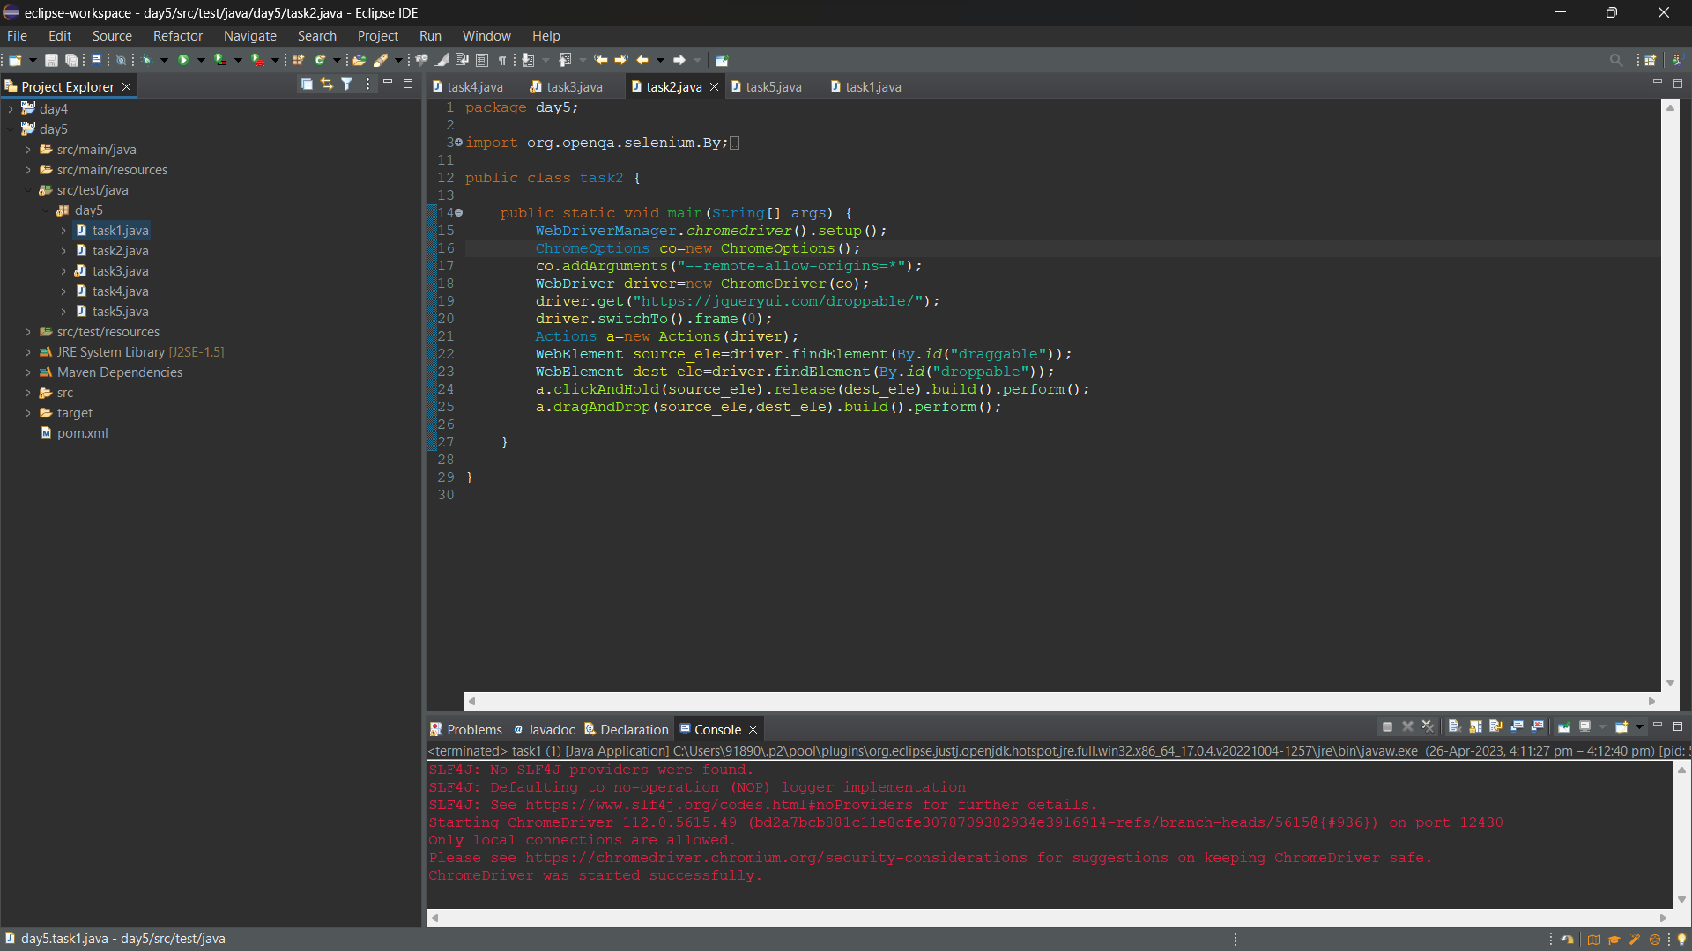

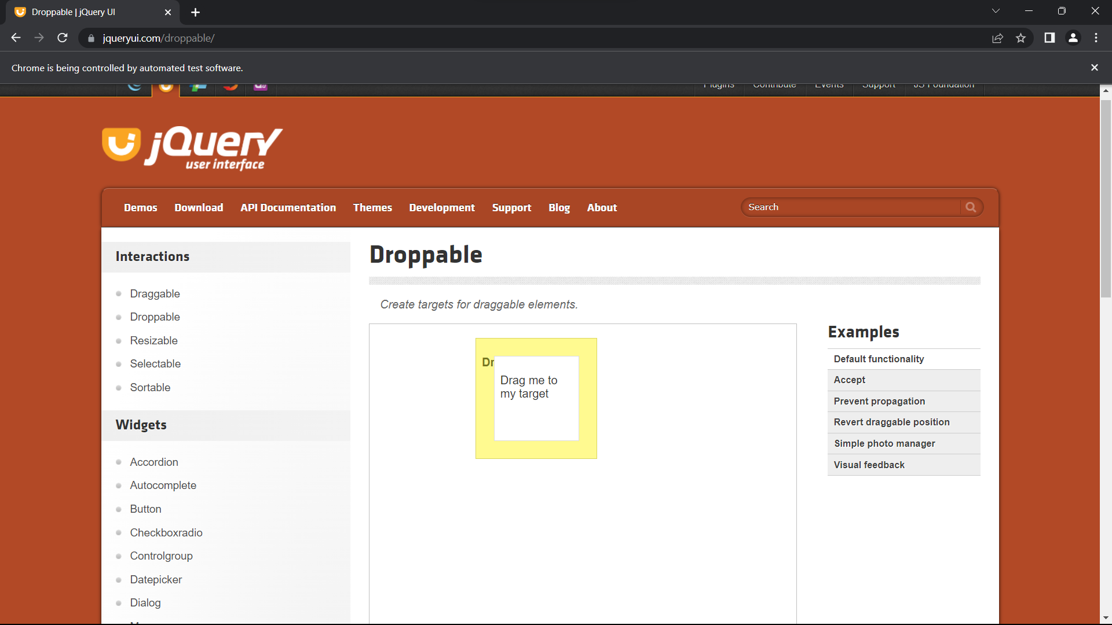

3)

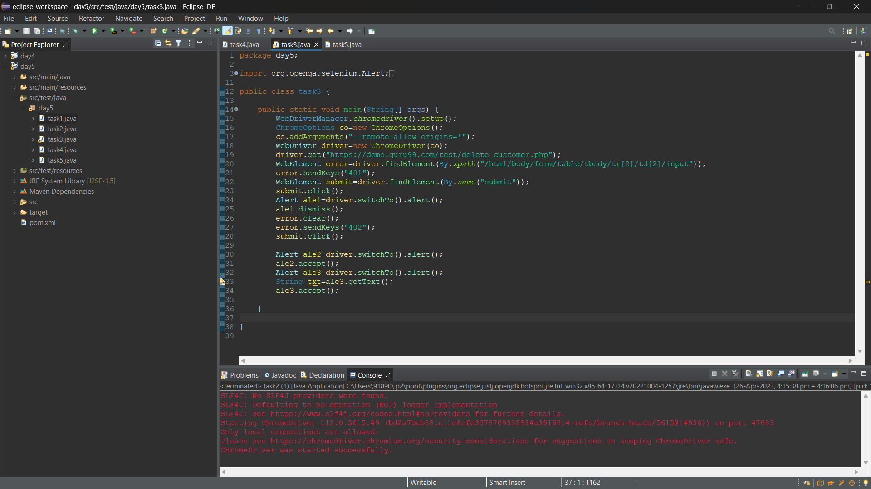

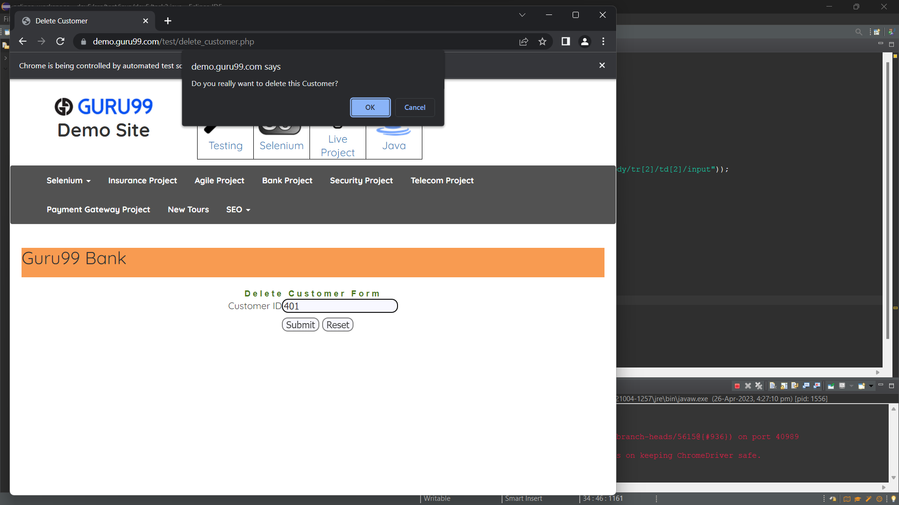

4)

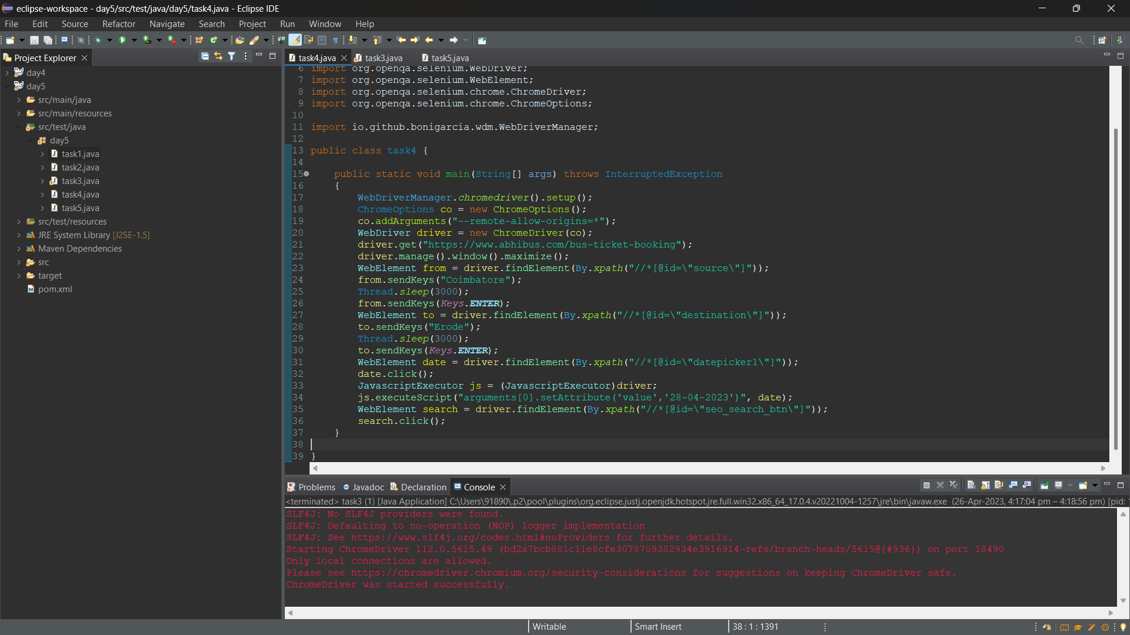

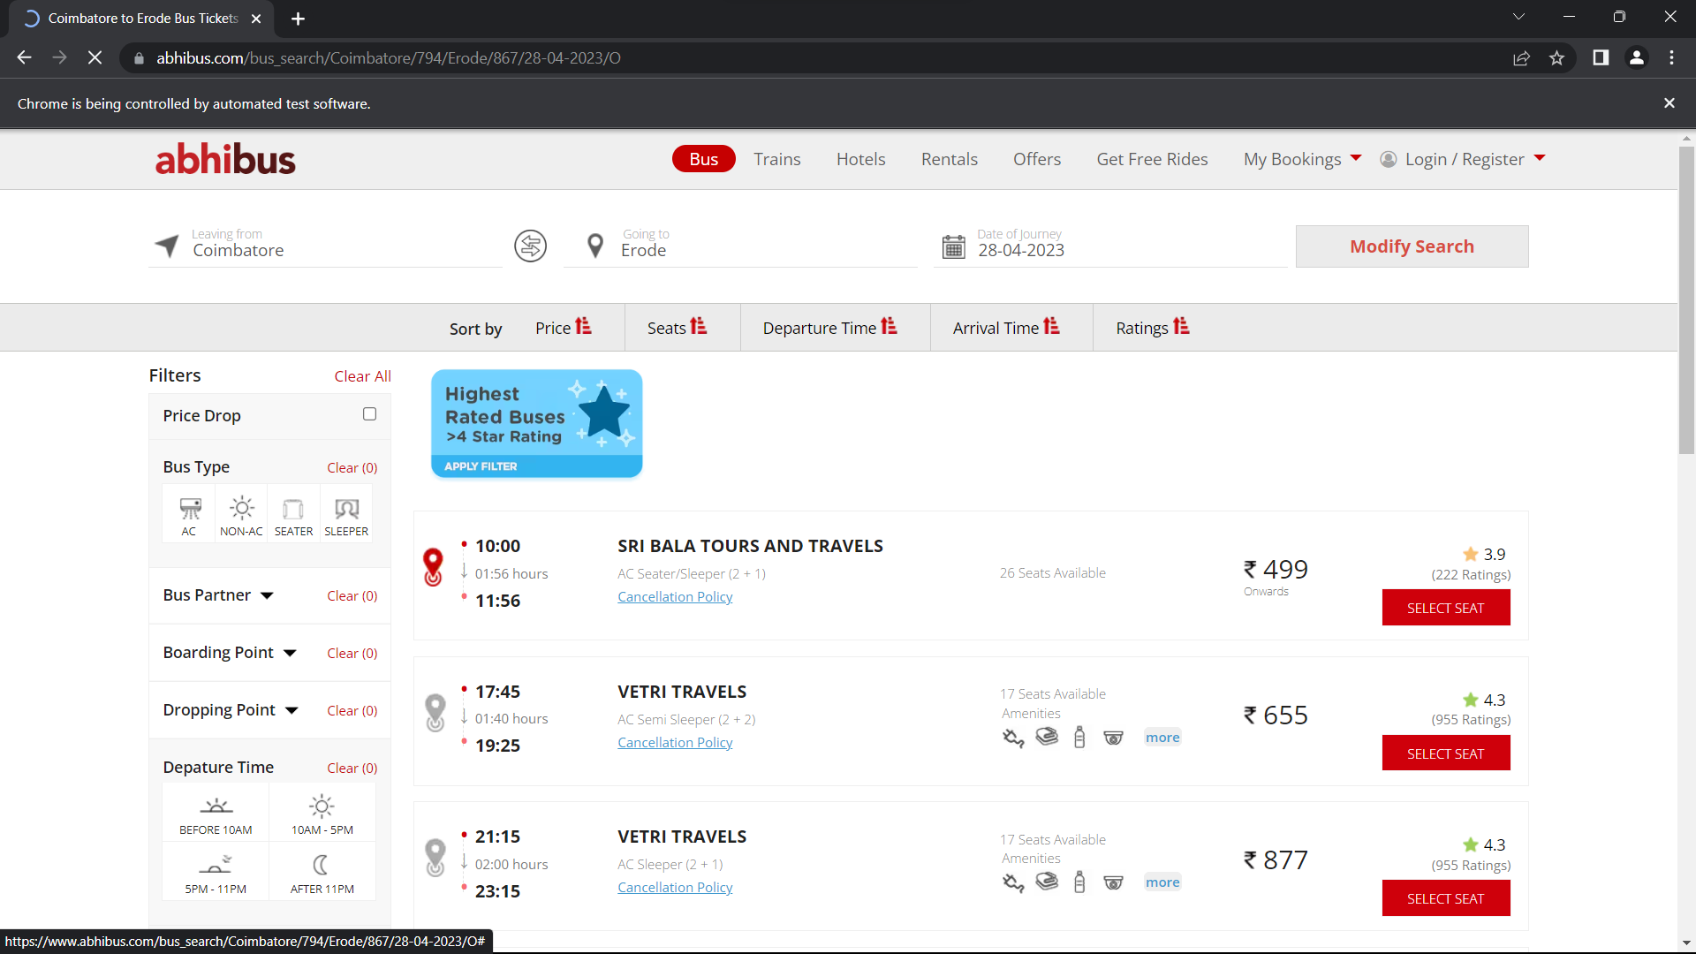

5)

package day5;

import java.util.Set;

import org.openqa.selenium.By;

import org.openqa.selenium.Keys;

import org.openqa.selenium.WebDriver;

import org.openqa.selenium.WebElement;

import org.openqa.selenium.WindowType;

import org.openqa.selenium.chrome.ChromeDriver;

import org.openqa.selenium.chrome.ChromeOptions;

import io.github.bonigarcia.wdm.WebDriverManager;

public class task5 {

public static void main(String[] args) {

WebDriverManager.*chromedriver*().setup();

ChromeOptions co=new ChromeOptions();

co.addArguments("--remote-allow-origins=*");

WebDriver driver=new ChromeDriver(co);

driver.get("https://www.google.com");

driver.manage().window().maximize();

WebElement search = driver.findElement(By.*xpath*("//*[@id=\"APjFqb\"]"));

search.sendKeys("Apple",*Keys*.***ENTER***);

String parent=driver.getWindowHandle();

System.***out***.println(parent);

System.***out***.println(driver.getTitle());

driver.switchTo().newWindow(*WindowType*.***TAB***);

driver.get("https://www.google.com");

driver.manage().window().maximize();

WebElement search2 = driver.findElement(By.*xpath*("//*[@id=\"APjFqb\"]"));

search2.sendKeys("Selenium",*Keys*.***ENTER***);

System.***out***.print("\n"+ driver.getWindowHandle());

System.***out***.println("\n"+ driver.getTitle());

driver.switchTo().newWindow(*WindowType*.***TAB***);

driver.get("https://www.google.com");

driver.manage().window().maximize();

WebElement search3 = driver.findElement(By.*xpath*("//*[@id=\"APjFqb\"]"));

search3.sendKeys("Cucumber",*Keys*.***ENTER***);

System.***out***.print("\n"+ driver.getWindowHandle());

System.***out***.println("\n"+ driver.getTitle());

Set<String>s=driver.getWindowHandles();

System.***out***.println("Number of windows opened = "+ s.size());

}

}

