ASSIGNMENT 1
DSE ZG505 – Preprocessing for AI-Ready Data
Ajay Prakash
2026nd04174@wilp.bits-pilani.ac.in

1. Part 1 - Data Quality & Profiling
I loaded my assigned RAW dataset and used the program to generate the required outputs.
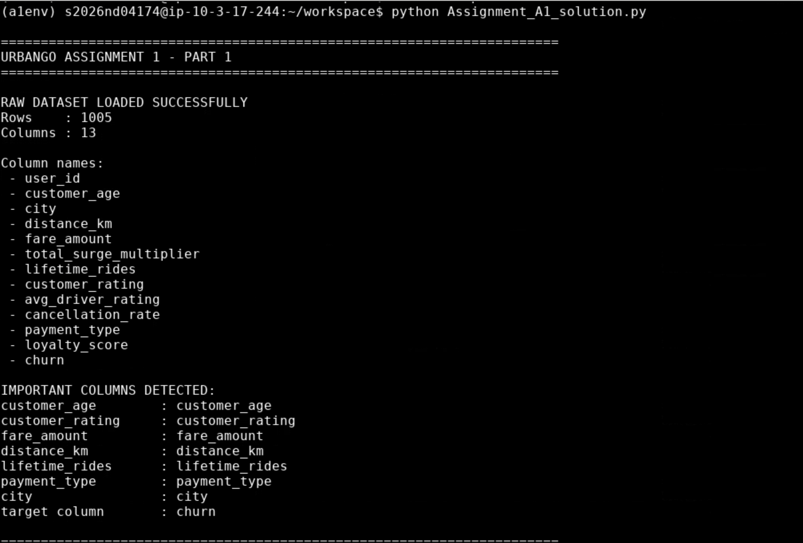
Initial RAW dataset and column details

1.1 Data Quality Metrics
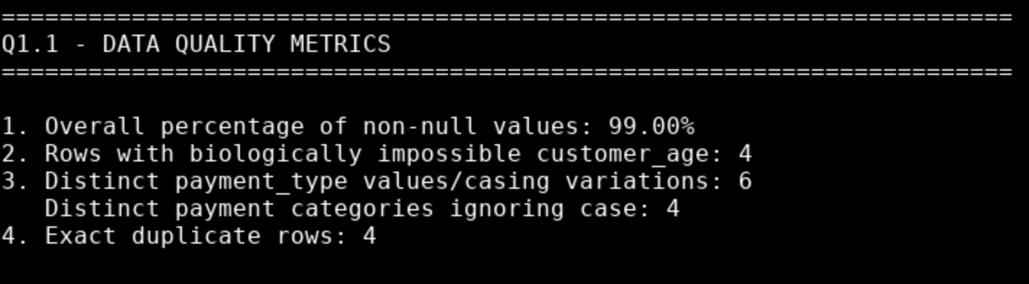
Q1.1 output

1.2 Schema Metadata
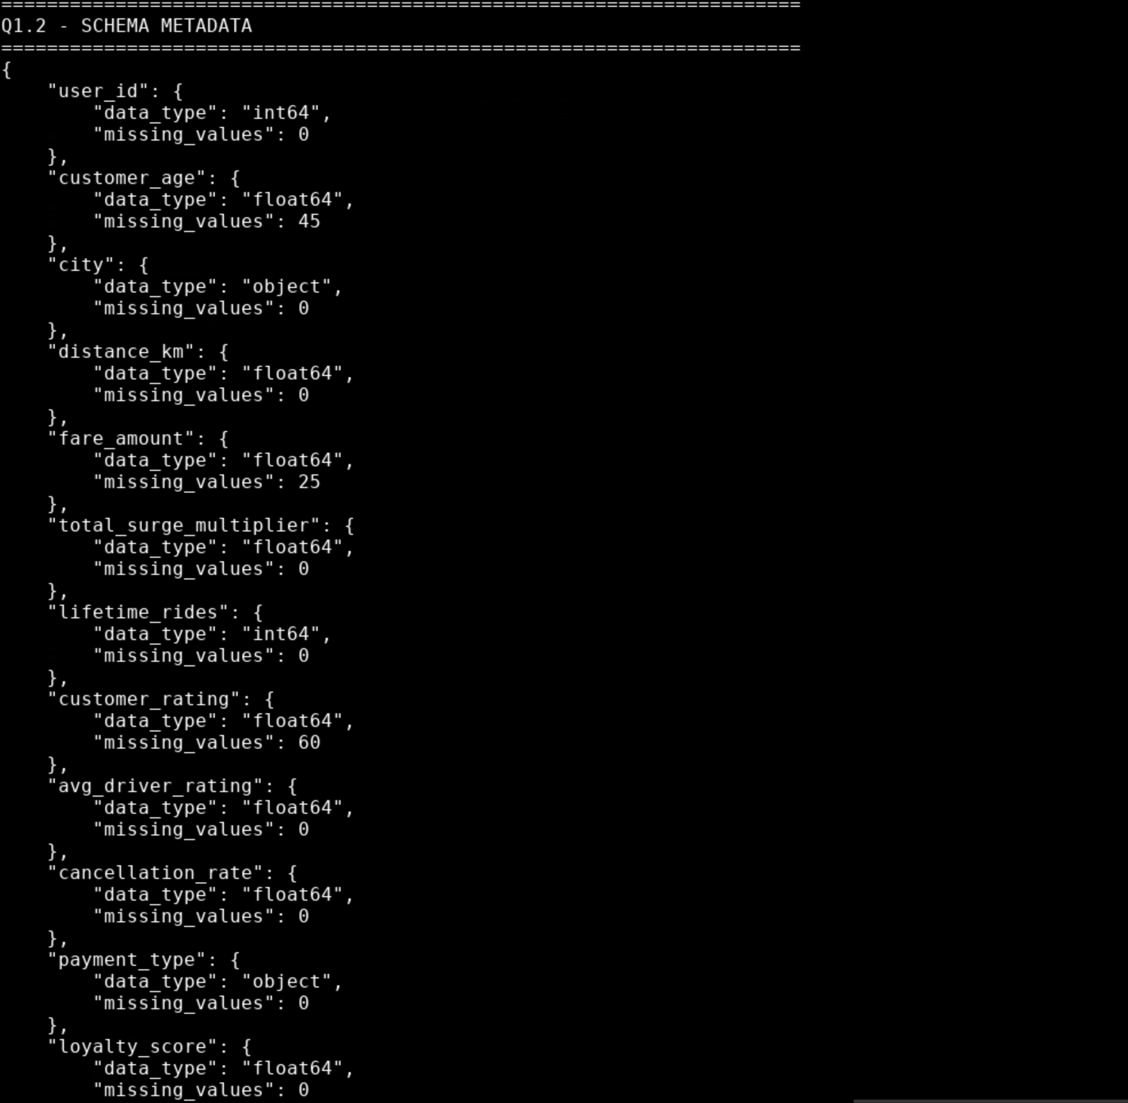

Q1.2 output

1.3 YData Profiling - Technical Observations
The automated YData profiling report was generated as profiling_report.html.
- fare_amount is highly right-skewed, with skewness of 6.0517, indicating that most fares are concentrated at lower/moderate values while a small number of observations have exceptionally high fares. Its kurtosis of 53.2329 indicates a very heavy tail and the presence of extreme fare outliers, which can disproportionately influence distance-based and linear models.
- lifetime_rides is strongly positively skewed, with skewness of 3.0204, while kurtosis of 18.6344 indicates substantial tail heaviness. This suggests that a relatively small number of customers have exceptionally high lifetime ride counts, motivating a nonlinear transformation such as log1p to reduce the influence of extreme values.
- customer_age contains 45 missing values and 4 biologically impossible observations. These issues can distort demographic relationships and therefore require appropriate imputation and invalid-record handling before model training.
- payment_type contains 6 distinct case-sensitive values but only 4 categories when case is ignored, indicating inconsistent categorical representation. The raw dataset also contains 4 exact duplicate rows, highlighting the need for data-quality controls before downstream modelling.

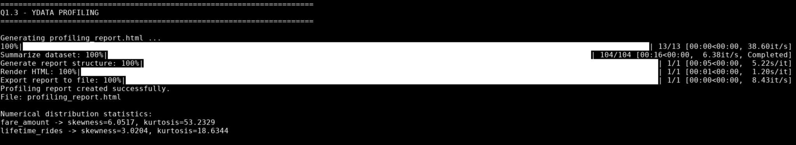
Q1.3 output

1.4 Variance Compression
Variance before mean imputation: 159.859645
Variance after mean imputation: 152.694622
Technical observation: Mean imputation replaces every missing value with the sample mean, whose deviation from the mean is zero; therefore, the imputed observations contribute no squared deviation to the variance, causing variance to decrease from 159.859645 to 152.694622 and potentially compressing genuine demographic differences or distinct customer clusters.

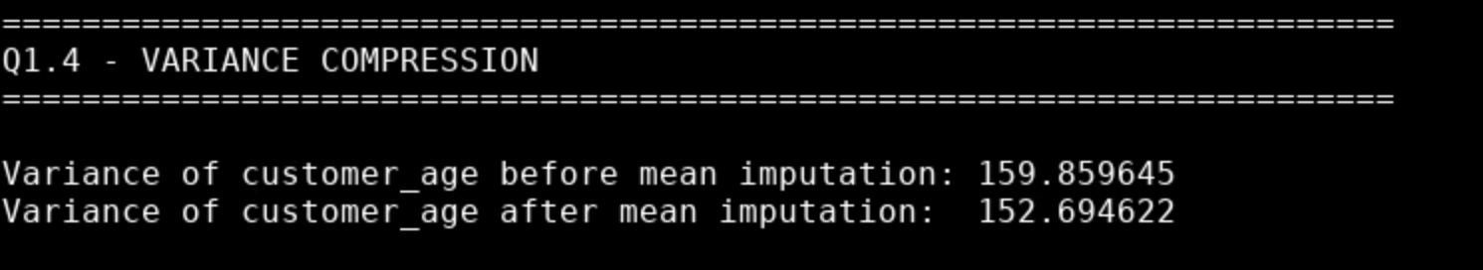
Q1.4 output

2. Part 2 - Preprocessing
I kept the RAW dataset unchanged and applied the required changes to the working DataFrame.
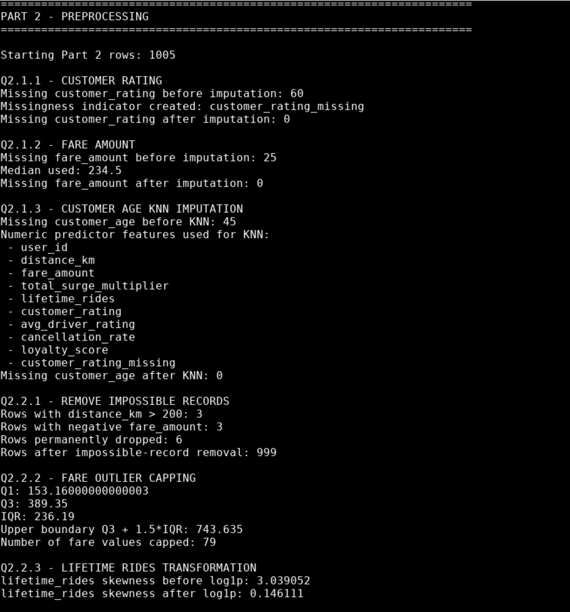
Q2. 1.1 to 2.3 output
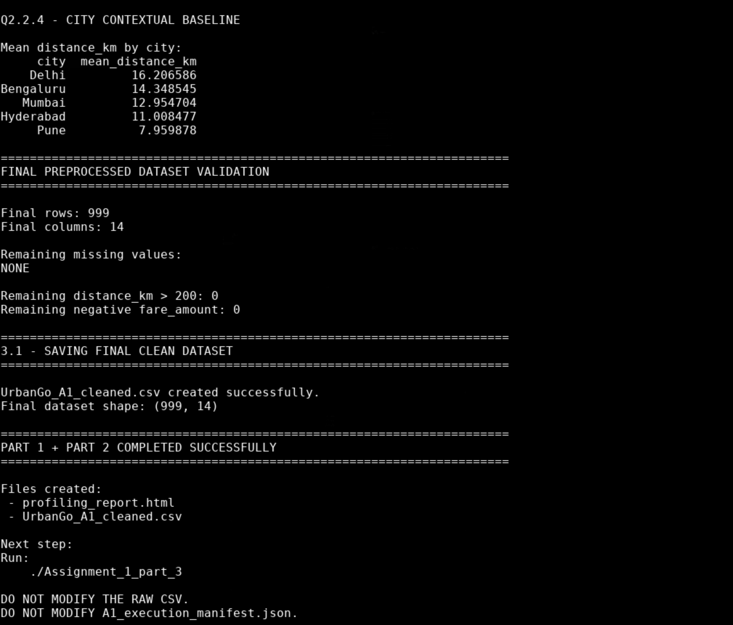
Q2. 2.4 and final validation output
Final dataset: UrbanGo_A1_cleaned.csv - 999 rows × 14 columns. No missing values, distance above 200 km, or negative fares remain.

3. Part 3 — Model Evaluation
I ran the supplied Assignment_1_part_3 program without changes.
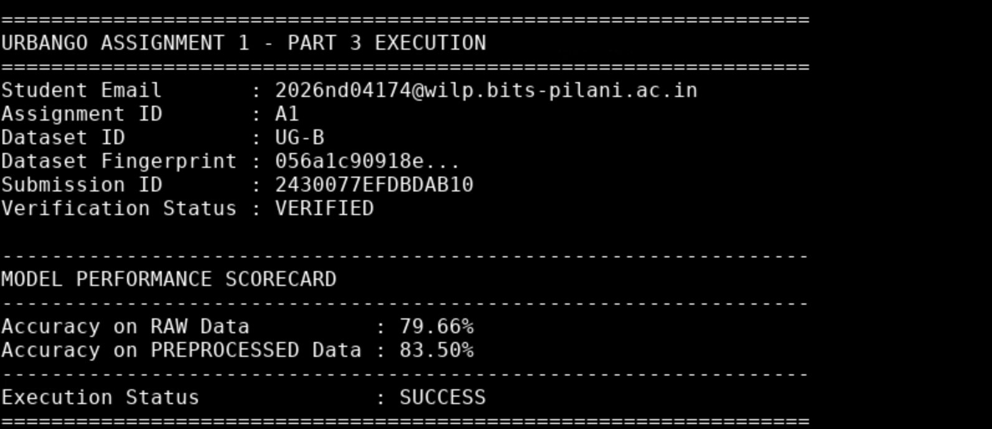
Part 3 - VERIFIED scorecard
RAW accuracy: 79.66%
PREPROCESSED accuracy: 83.50%
Improvement: 3.84 percentage points

3.4 Technical Synthesis & Conclusion
The preprocessing pipeline improved Logistic Regression accuracy from 79.66% to 83.50%, an improvement of 3.84 percentage points, by removing physically impossible records, bounding heavy-tailed fare values, applying log1p to lifetime rides, scaling numerical features before KNN imputation, and avoiding mean-induced variance compression; these steps reduced feature distortion and magnitude dominance, helping prevent gradient oscillation and allowing the optimizer to converge toward a more accurate decision boundary. Further improvement could be explored through consistent categorical encoding, feature selection, interaction features, class-imbalance analysis, and systematic hyperparameter/model tuning, with precision, recall, and F1-score evaluated alongside accuracy.

