**DESCRIPTION:**

**In this assignment I used express generator to make the project and this is the main page of the project**

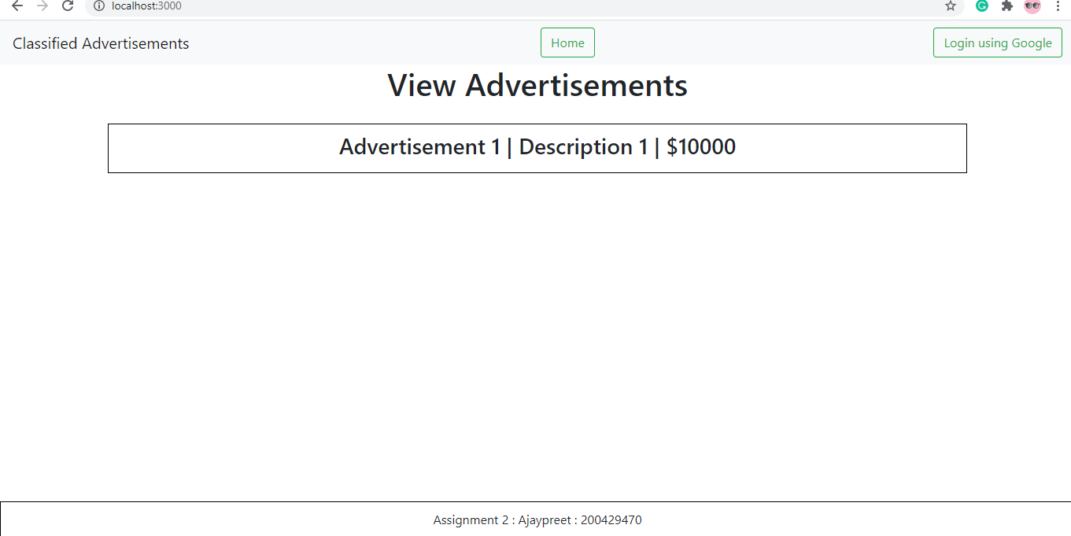

**By using the login google button I will be able to login with the google account on the web used.**

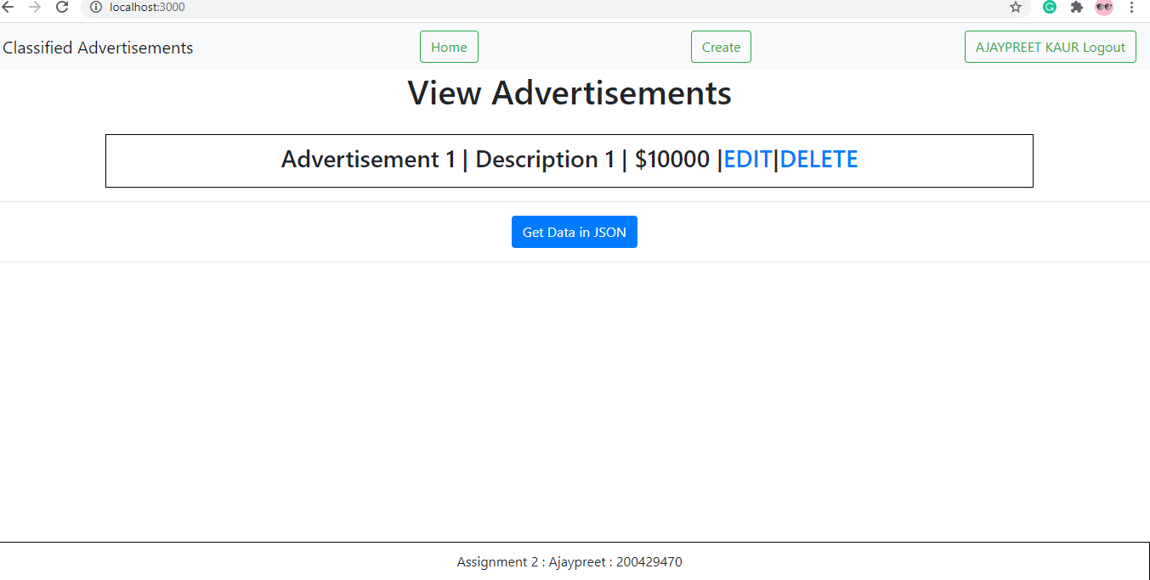

**After login we have a new button showed up called create by using that we can create new adds accordingly.**

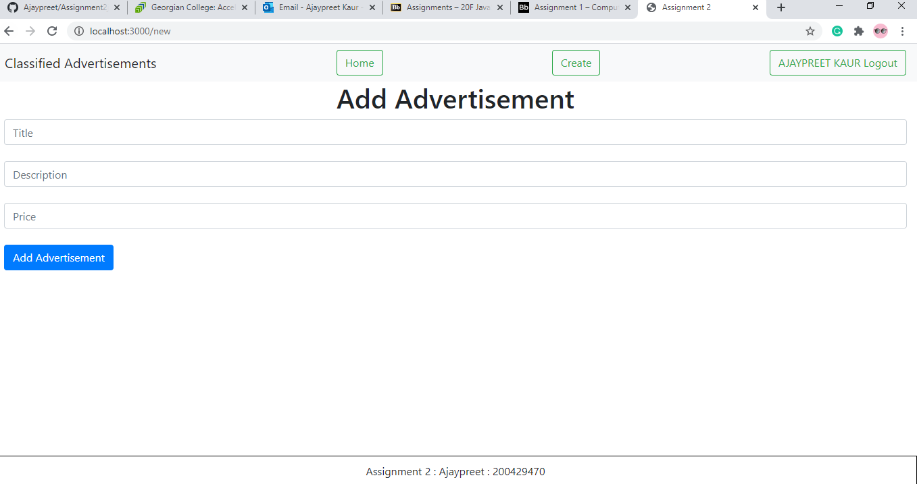

After creating on clicking on the home page we can get all the adds on the home page like a list with all the adds with edit and delete button

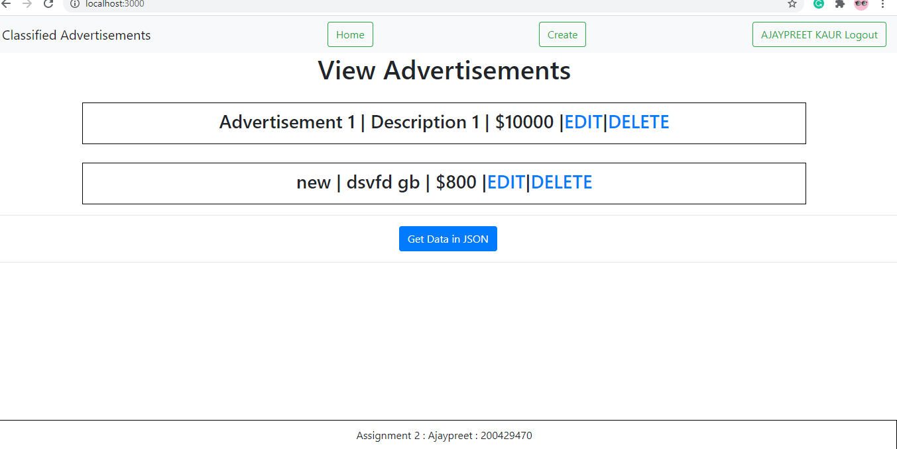

Now if we want to delete the add we can by hitting delete button

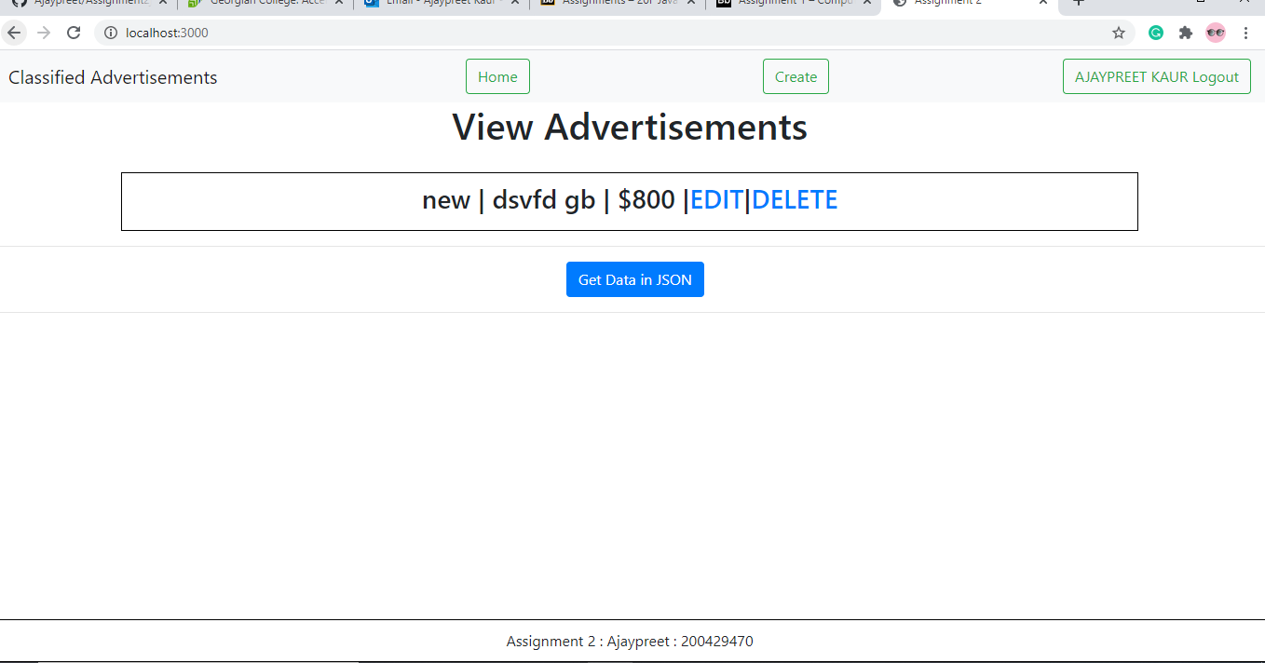

By clicking on the get json data we can get the json

