<https://www.linkedin.com/company/98785/>

use:

**islashires@gmail.com D13tr0llman!**

Extract all this information so that I can recreate these charts.

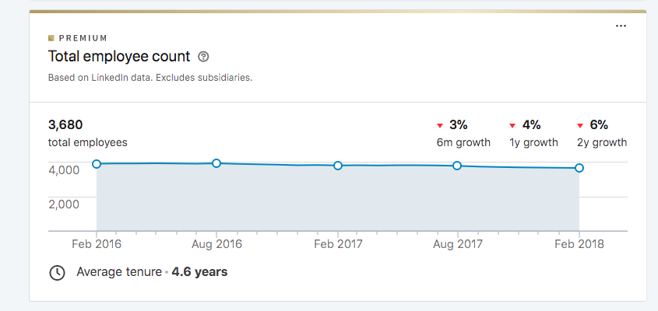

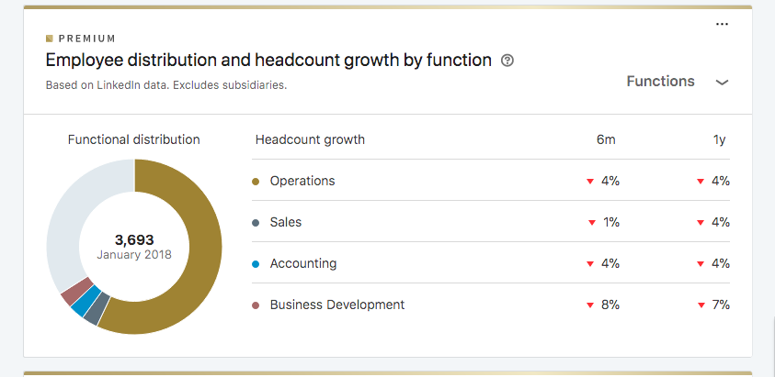

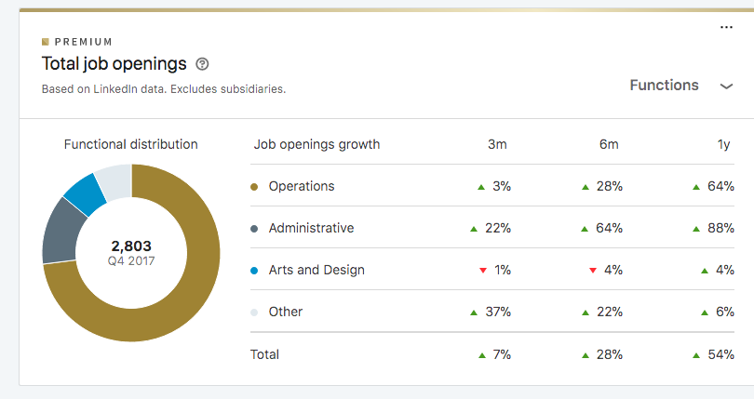

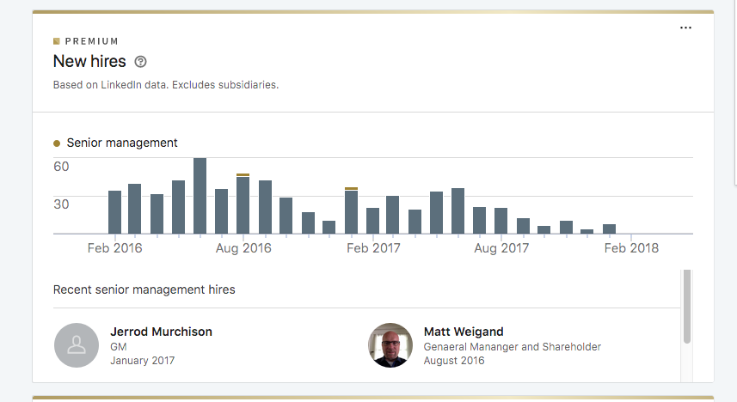

Extract all of this information:

<https://www.linkedin.com/jobs/search?locationId=OTHERS%2Eworldwide&f_C=98785> - get as many as you can.