Property:
1. Property
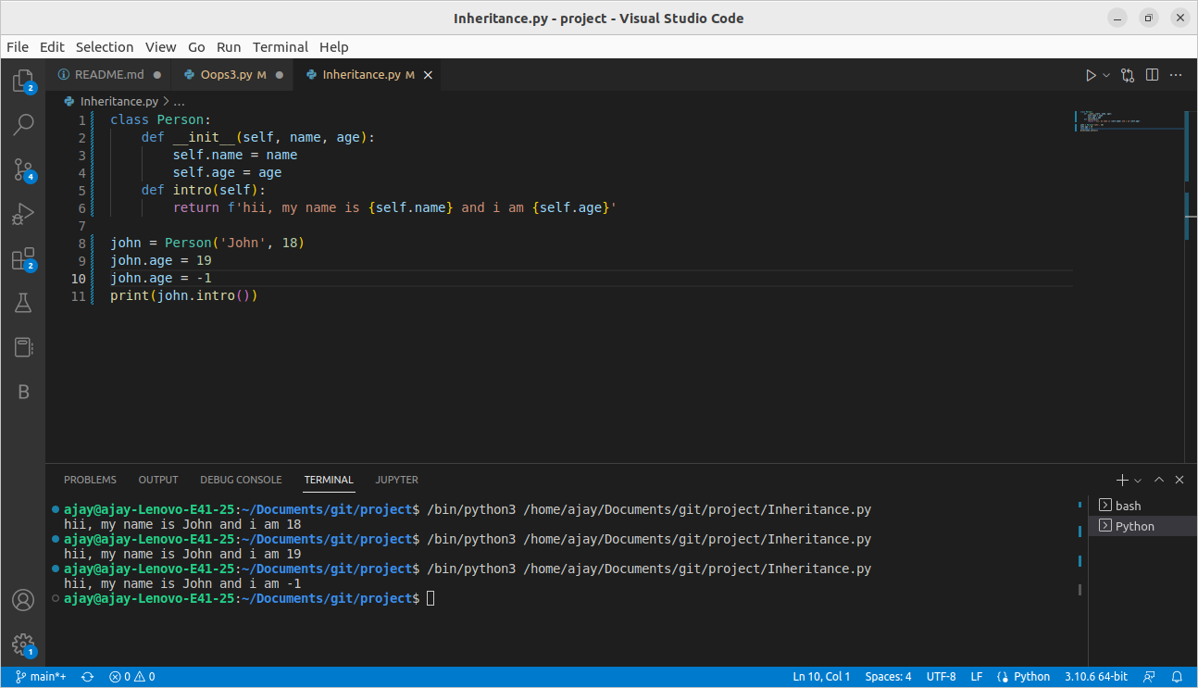
Age cannot be in negative


This is repetitive and difficult to maintain.
To void this we use getter and setter.
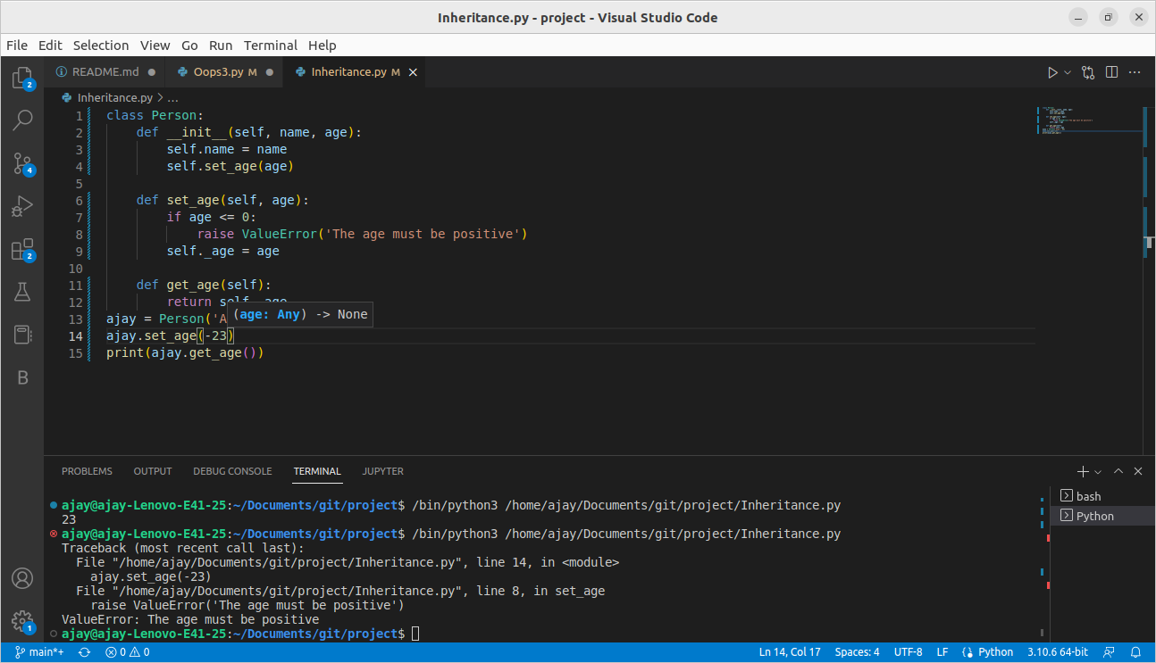
Know we have backward compatibility issue.

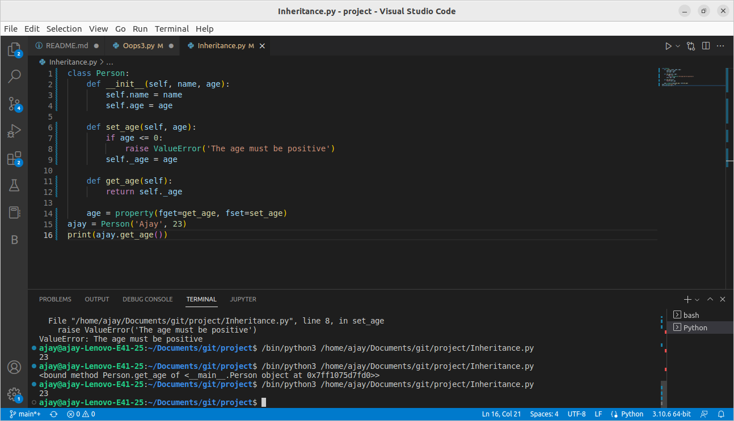
2. @property decorator

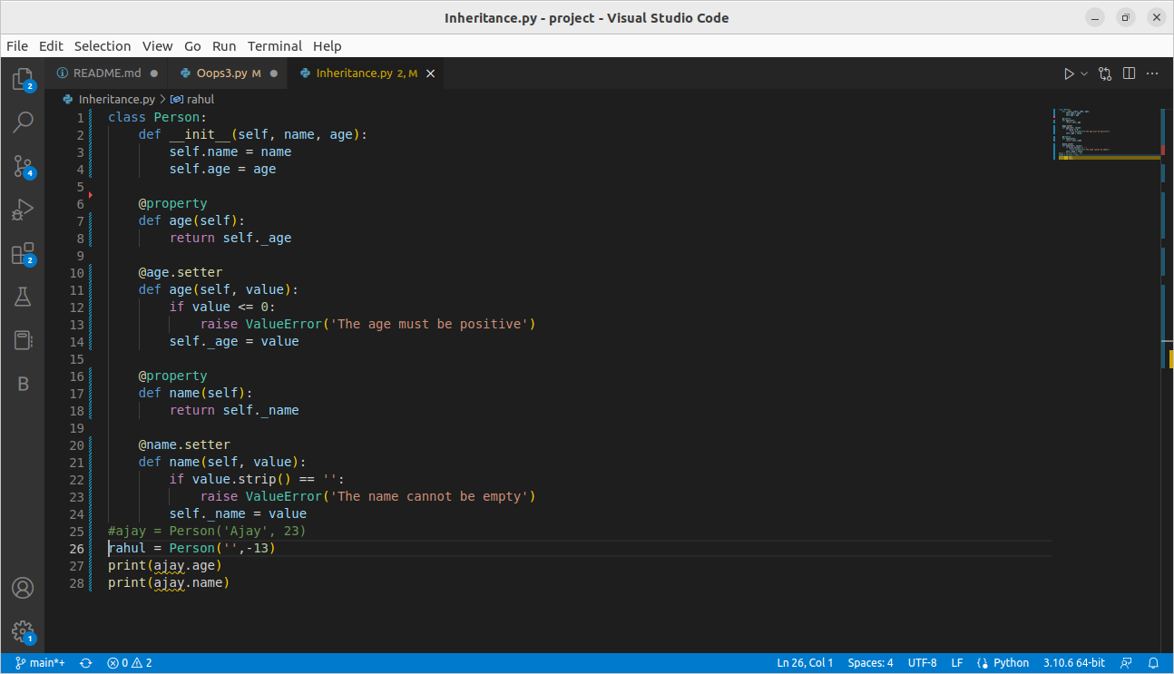
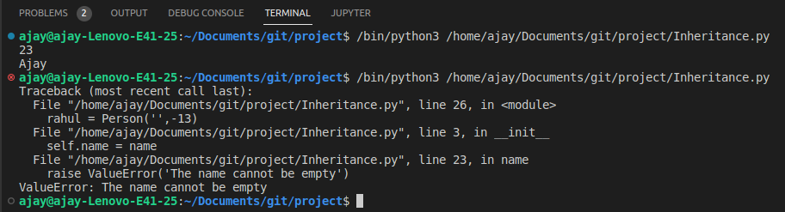
3. Readonly Property
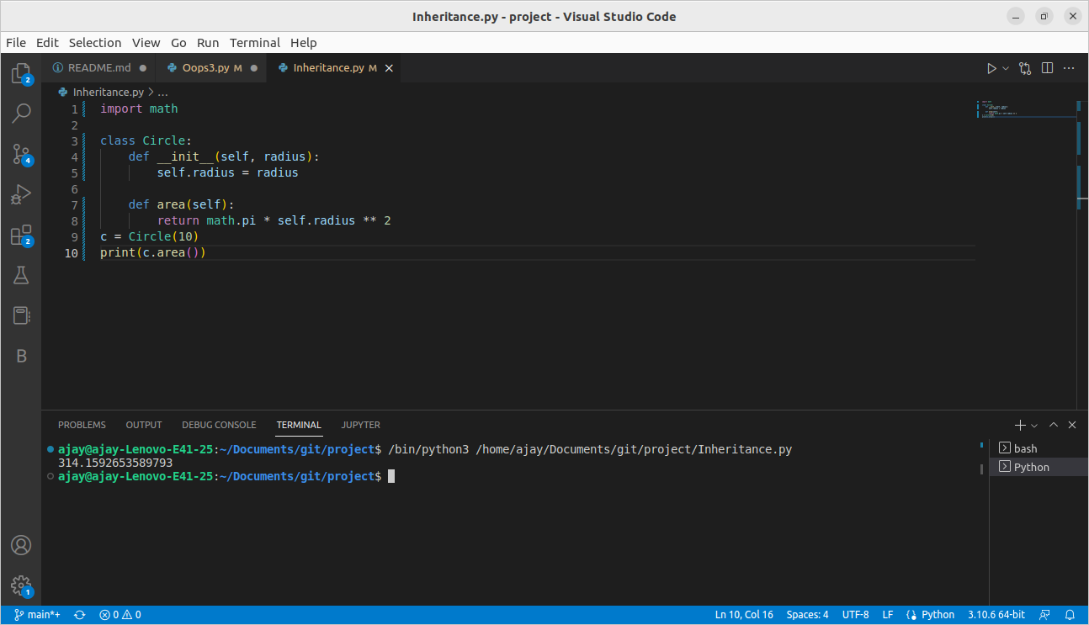
Here area is a method of Circle but it should a property of Circle.
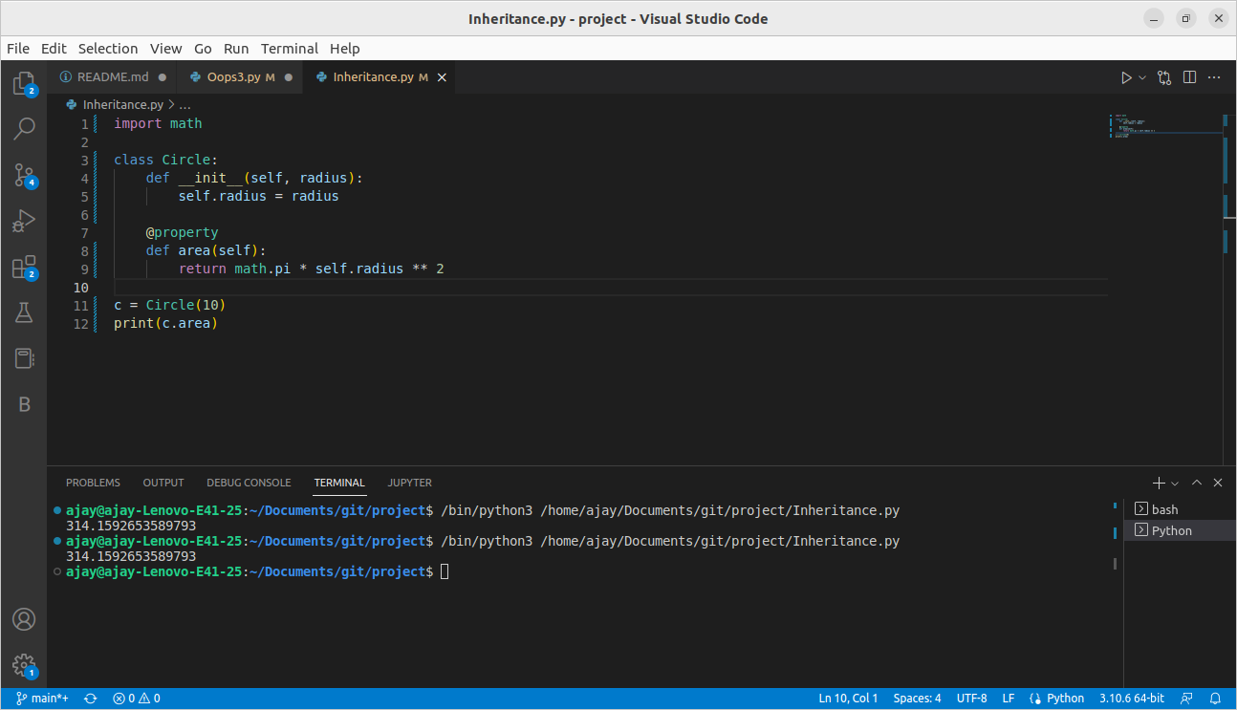
Here is how it works.

4. Delete Property
It will delete a property from an object.
