**Overview of Machine Learning**

**Machine Learning** is a technique to implement artificial intelligence that enables systems to learn from data without being explicitly programmed. The ultimate goal is to create intelligent machines that can improve their performance over time based on the data they encounter.

**Key Concepts**

* **Learning from Data**: Machine learning models learn patterns from data, which allows them to make predictions or decisions based on new inputs.

**Types of Machine Learning**

There are three main types of machine learning:

**1. Supervised Learning**

* **Definition**: In supervised learning, the algorithm learns from labelled data. This means that the input data is paired with the correct output, allowing the model to learn the relationship between the two.

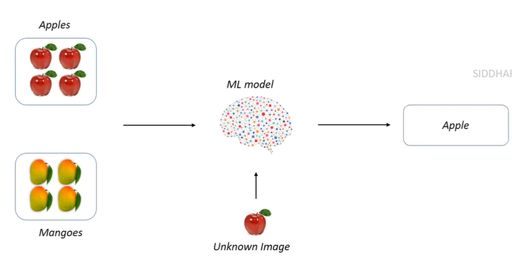

* **Example**: If a model is trained to recognize images of apples and mangoes, it will be provided with labelled images (e.g., "this is an apple" or "this is a mango").
* **Key Point**: The supervision comes from the labels provided during training.

**2. Unsupervised Learning**

* **Definition**: In unsupervised learning, the algorithm learns from unlabelled data. The model tries to find patterns or groupings in the data without any explicit instructions on what to look for.

* **Example**: If the same model is given images of apples and mangoes without labels, it will group similar images together based on patterns it identifies.
* **Key Point**: There is no supervision in terms of labels, allowing the model to discover the inherent structure of the data.

**3. Reinforcement Learning**

* **Definition**: Reinforcement learning involves training an agent to make decisions in an environment to maximize rewards. The agent learns by taking actions and receiving feedback in the form of rewards or penalties.

* **Example**: A computer program designed to play chess acts as the agent in the chessboard environment. It receives positive rewards for winning moves and negative rewards for losing moves.
* **Key Point**: This type of learning is distinct from supervised and unsupervised learning, focusing on the interaction between the agent and the environment.

**Summary Table of Learning Types**

|  |  |  |
| --- | --- | --- |
| **Type** | **Description** | **Example** |
| Supervised Learning | Learns from labelled data | Recognizing apples vs. mangoes with labels |
| Unsupervised Learning | Learns from unlabelled data | Grouping images of apples and mangoes without labels |
| Reinforcement Learning | Learns by interacting with an environment to maximize rewards | Chess-playing program receiving rewards for winning moves |

**Important Points to Remember**

* **Supervised Learning**: Requires labelled data for training.
* **Unsupervised Learning**: Works with unlabelled data, focusing on finding patterns.
* **Reinforcement Learning**: Involves an agent learning through trial and error in an environment.