**Supervised Learning in Machine Learning**

**Overview of Supervised Learning**

**Supervised Learning** is a type of machine learning where the algorithm learns from a labelled dataset. This means that the data provided to the algorithm includes both the input data and the corresponding correct output (label).

The goal is for the algorithm to learn to map the input data to the correct labels so it can make accurate predictions on new, unseen data.

**Key Concepts**

* **Labelled Data**: Data that includes both the input features and the corresponding output labels.
* **Mapping**: The process by which the algorithm learns to associate inputs with the correct outputs.

**Types of Supervised Learning**

There are two main types of supervised learning:

1. **Classification**
   * **Definition**: Predicting a discrete class label (e.g., yes/no, apple/mango).
   * **Example**: Classifying images of fruits as either apples or mangoes 2.
   * **Characteristics**:
     + Outputs are categorical.
     + No intermediate values (e.g., male/female, dog/cat).

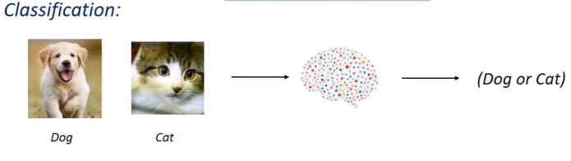

1. **Regression**
   * **Definition**: Predicting a continuous value (e.g., salary, temperature).
   * **Example**: Predicting rainfall based on temperature 3.
   * **Characteristics**:
     + Outputs are numerical.
     + Can take any value within a range (e.g., 0.5 cm, 2.3 cm).

**Important Algorithms**

**Classification Algorithms**

* **Decision Tree Classification**
* **Random Forest Classification**
* **K-Nearest Neighbour Classification**

**Regression Algorithms**

* **Logistic Regression**
* **Polynomial Regression**
* **Support Vector Machine Regression** 4.

**Practical Applications**

* **Classification**: Image recognition, spam detection, medical diagnosis.
* **Regression**: Stock price prediction, weather forecasting, real estate pricing.

**Conclusion**

Understanding the differences between classification and regression, along with their applications and algorithms, is crucial for effectively applying supervised learning techniques in machine learning projects. As you progress, hands-on practice with these algorithms will deepen your understanding and skills