**Deep Learning Basics**

**Introduction to Deep Learning**

* **Deep Learning**: A subfield of machine learning that uses artificial neural networks to learn from data. Unlike traditional machine learning, deep learning can automatically extract features without manual intervention.

**Key Concepts**

1. **Artificial Neural Networks**

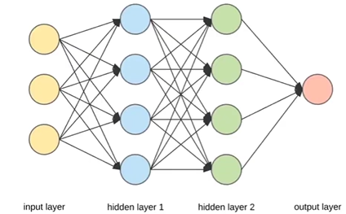

* **Neurons**: Inspired by the human brain, neurons process information and are connected to form a neural network. Each neuron has a mathematical function assigned to it .
* **Network Structure**:
  + **Input Layer**: Receives the data (e.g., image pixels).
  + **Hidden Layers**: Perform computations and feature extraction.
  + **Output Layer**: Produces the final prediction.

**2. Feature Extraction**

* **Manual vs. Automatic**: Traditional machine learning requires manual feature extraction (e.g., defining what features indicate a car), while deep learning automatically determines important features .

**Important Applications**

* **Healthcare**: Deep learning is used for diagnosing diseases from medical images, such as detecting diabetic retinopathy from eye scans.
* **Autonomous Vehicles**: Deep learning powers self-driving cars, enabling them to navigate with minimal human input .
* **Computer Vision**: Applications include facial recognition systems in smartphones .
* **Natural Language Processing**: Used in chatbots and virtual assistants.

**Historical Context**

* **DeepMind and AlphaGo**: In 2016, DeepMind's AlphaGo defeated world champion Lee Sedol in the board game Go, showcasing the power of deep learning and significantly raising interest in the field .

**Summary**

Deep learning represents a significant advancement in machine learning, enabling systems to learn complex patterns from large datasets without explicit feature engineering. Its applications span various fields, from healthcare to autonomous driving, and it continues to evolve rapidly.

**Questions to Consider**

* What are the main differences between traditional machine learning and deep learning?
* How do artificial neural networks mimic the human brain?
* Can you provide examples of deep learning applications in daily life?