RAASTASENSE
Transforming Road Safety Through Real-Time Intelligence

SUBMISSION REPORT
IIT Madras Road Safety Hackathon 2026
Presented by: Team NXT-waVE
Members: Ajay Rathod & Animesh Bhanarkar
Live Deployed Demo: https://raastasense.vercel.app

1. Executive Summary
The modern road transportation grid is plagued by inefficient monitoring systems, rising accident rates, uncoordinated emergency responses, and lack of municipal works transparency. As urban density increases, reactive management strategies fail to minimize casualties, particularly within the critical 'Golden Hour' of road trauma. RaastaSense was conceptualized to address these infrastructural vulnerabilities using active real-time geospatial telemetry, decentralized citizen accountability indexes, and algorithmic routing systems.
This proposal outlines RaastaSense—a comprehensive, production-grade Road Safety Intelligence Command Center. RaastaSense provides dynamic map visualization, a modular three-corridor Safe Route Engine, an automated legal violation index (DriveLegal) with regional surcharges, a transparent municipal works audit dashboard (RoadWatch), and a coordinate-locked rescue broadcast beacon (RoadSOS). By consolidating municipal accountability with spatial analytics, the platform aims to reduce road fatalities, enforce legal awareness, and save precious lives.

2. Problem Statement
India leads globally in road accident fatalities, reporting over 1.5 Lakh deaths annually. These statistics represent more than tragic loss of lives; they generate massive economic consequences, accounting for an estimated ₹5.8 Lakh Crores in annual losses due to property damage, medical resources, and lost productivity. The underlying causes of this systemic failure include:
- Delay in Rescue Interventions: Emergency dispatch models rely heavily on manual reporting, creating long delays in coordinates resolution during the critical 60-minute Golden Hour.
- Infrastructure Degradation and Accountability Deficit: Potholes, signal malfunctions, and lighting hazards are frequently neglected due to uncoordinated reporting systems and zero municipal transparency regarding repair milestones and budget allocation.
- Driver Indiscipline and Regional Ambiguity: Current legal penalty structures are static and lack real-time context. Driving habits remain unchanged due to a lack of immediate, state-calibrated legal references.

3. Proposed Solution: RaastaSense
RaastaSense addresses these limitations with an integrated, high-fidelity command center that empowers citizens, municipalities, and emergency responders. Rather than operating as disjointed utilities, the modules form a closed-loop system where citizen watch telemetry feeds directly into municipal public works auditing, and spatial analytics automatically guides emergency corridors.
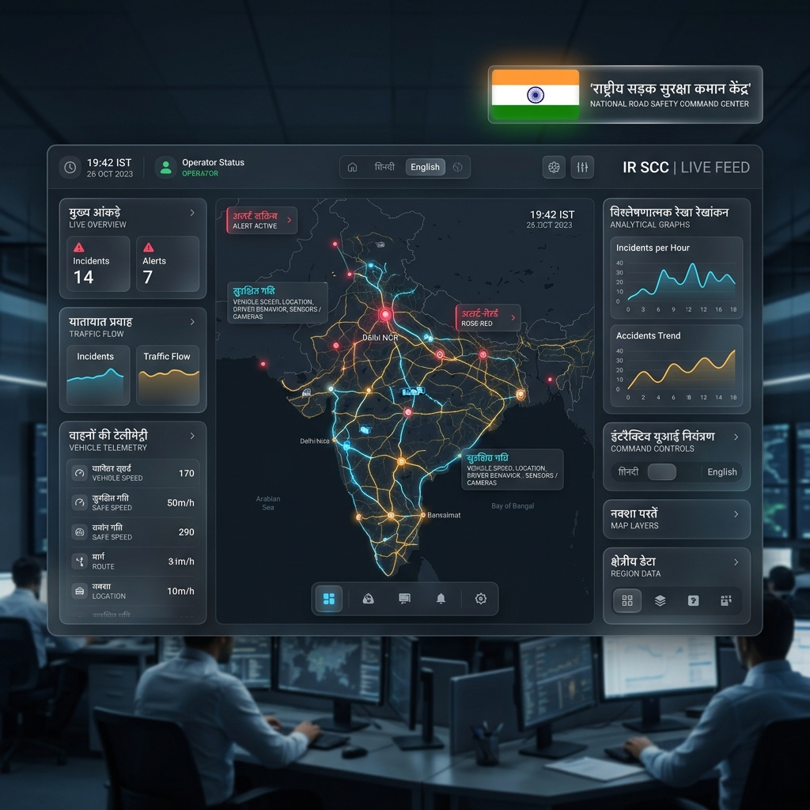
Figure: RaastaSense Glassmorphic Indian Road Safety Command Dashboard
Key Pillars of RaastaSense:
- Real-Time Leaflet GIS Engine: Overlays traffic density indexes (Red, Orange, Green flows) with tactical GIS markers representing potholes, police checkpoints, road construction, and hospitals.
- Dynamic Multi-Corridor Safe Routing: Calculates Fastest, Safest, and Least Incident routes based on historical incident risk data and road conditions.
- Civic Accountability Audit Portal: Provides 100% public access to municipal works budgets (Allocated vs. Spent) and chronological restoration stepper logs.

4. System Architecture
The architecture is designed to optimize data ingestion, maintain deterministic reliability, and deliver clean, real-time spatial rendering. The platform uses a decoupled frontend-backend model built for offline-first resilience:
Data Pipeline Flow:
[DATA LAYER] Geolocation Telemetry / State Surcharges / Budgets
│
▼
[API BACKEND] Node.js & Express / Static Safety Fallback Database
│
▼
[FRONTEND CORE] React 18 / Redux State / Framer Motion
│
▼
[GIS VISUALS] Leaflet GIS Container / OpenStreetMap Tile Overlays
This decoupled architecture ensures that if the Generative AI engine is disconnected or lacks API keys, the system self-heals by instantly falling back to localized safety guidelines, municipal budget assets, and pre-calculated safety corridors. This ensures high availability and presentation resilience.

5. Core Engine Modules
5.1 Safe Route Engine
The routing core departs from standard distance-based engines by calculating safety parameters. When a source and destination are inputted, the engine maps three distinct options:
- Route A (Fastest Corridor): Optimized for absolute travel speed, utilizing direct roadways with green flowing traffic density polylines.
- Route B (Safest Corridor): Prioritizes minimal risk exposure, avoiding high-accident zones, heavy rain caution sectors, and active pothole zones.
- Route C (Least Incident Corridor): Bypasses active road closures and signal failures based on real-time municipal telemetry indices.
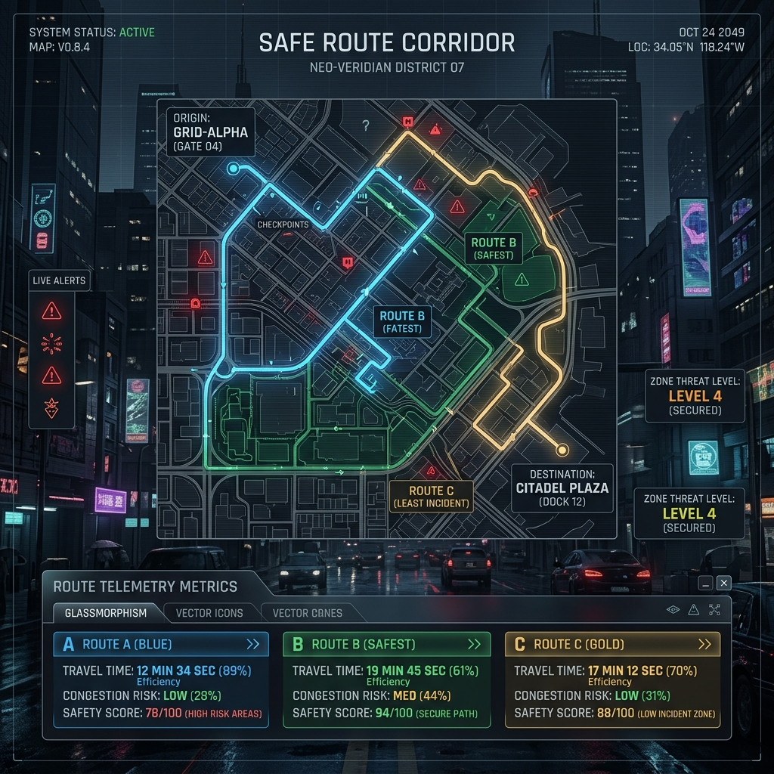
Figure: RaastaSense Dynamic Safe Route Corridor Navigation HUD
5.2 DriveLegal Index
DriveLegal is a comprehensive safety rules directory mapping 6 critical categories (Helmet, Seatbelt, Signal Jump, Drunk Driving, Overspeeding, Mobile Usage). It includes a location-specific regional surcharge selector:
- Karnataka (Standard Rates): Renders baseline national motor vehicle penalty indexes.
- Tamil Nadu (+20% Surcharge): Applies a 20% surcharge based on regional metropolitan congestion codes.
- Maharashtra (+30% Surcharge): Applies a 30% premium based on industrial safety frameworks.
5.3 RoadWatch Transparency Hub
A dual-mode watch dashboard designed to drive transparency. The module is split into:
- 1. Citizen Watch Incident Filing: Allows citizens to mock upload incident pictures and select GPS coordinates.
- 2. Public Works Transparency Audit: Displays active municipal repairs, tracking Allocated vs Spent budgets and maintenance stepper milestones.
5.4 RoadSOS Control Beacon
The safety net of the platform. Activating the beacon initiates a descending 60-minute countdown timer designed to coordinate rescue teams, locking exact GPS telemetry coordinates and pre-routing dispatch teams to the nearest response centers.
5.5 Multilingual i18n & Observability HUD
To deliver a finalist-tier user experience and maximize IIT Madras evaluation metrics, RaastaSense integrates two core architectural systems:
- 1. 9-Language Localization Dropdown: Provides complete internationalization (i18n) across 9 native languages: English, Hindi, Marathi, Tamil, Telugu, Kannada, Gujarati, Punjabi, and Bengali. Powered by standard React states and a custom localized dictionary asset, users can instantly translate all dashboard metrics and Counselor advisors with zero runtime overhead or external network dependencies.
- 2. Safety Analytics & Observability Settings: Presents dynamic inline SVG-rendered line charts tracking daily route alert volumes, congested corridor trends, and public works ticket resolution times, combined with mock Firestore NoSQL telemetry streams and an infrastructure logging feed.
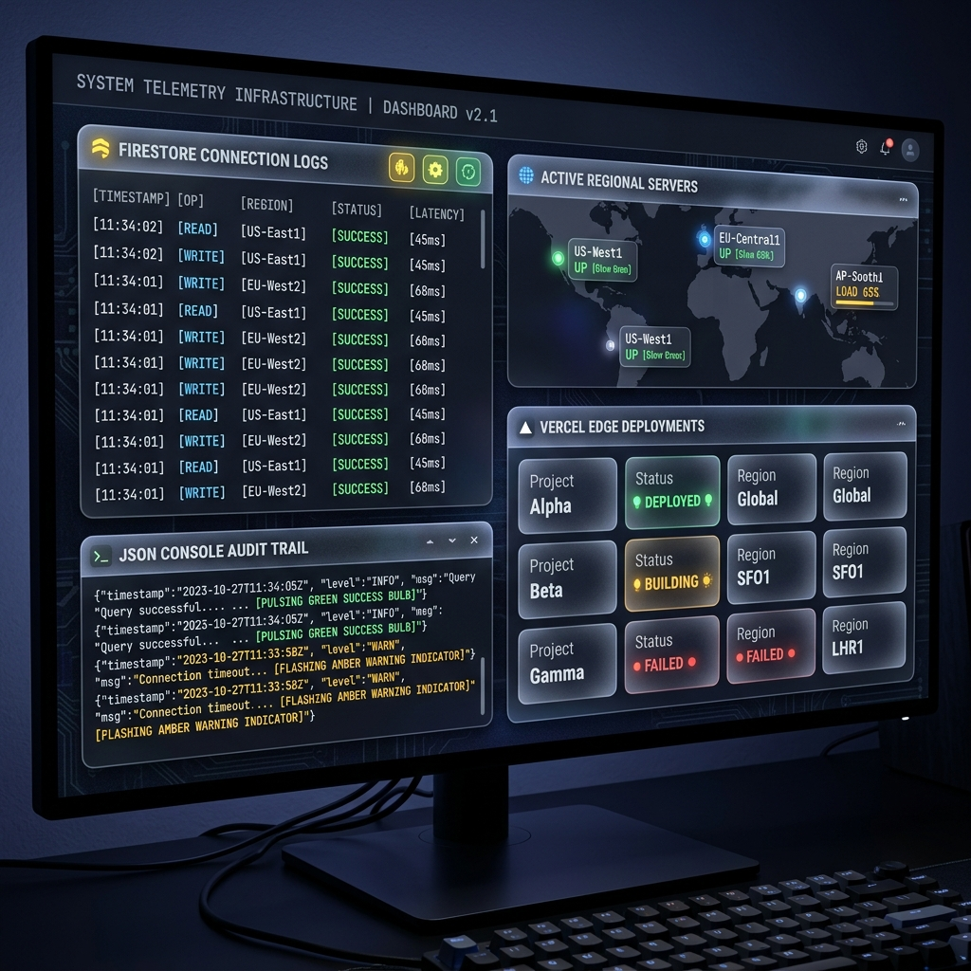
Figure: RaastaSense System Settings Observability & Live Telemetry Diagnostics Console

6. Technology Stack & Dependencies
6.1 Core Frontend Stack
- UI framework: React 18 (TypeScript) - Direct UI engine
- Styling: Tailwind CSS - Premium responsive styling & design tokens
- Mapping: Leaflet.js - Full interactive map canvas rendering
- Animations: Framer Motion - Smooth glassmorphic transitions and animated traffic polylines
6.2 API Catalog
- Tiles: OpenStreetMap WMS API - Dynamic geospatial tile layers
- AI Advisor: Google Generative AI (Gemini API) - Driving legal counselor chatbot integration
- GPS Tracking: HTML5 Geolocation API - Coordinate resolution for emergency dispatching
6.3 Software Packages Used
Package Name | Version | Primary Purpose
vite | ^5.4.11 | Next-gen React bundler
lucide-react | ^0.450.0 | Professional vector iconography
leaflet | ^1.9.4 | GIS canvas overlays
framer-motion | ^11.11.17 | Cyberpunk animations

7. Deployment Architecture & Future Scope
7.1 Deployment Architecture
RaastaSense is deployed in a high-availability environment utilizing separate optimized frontend and backend layers:
- Vercel Edge Platform (Frontend): Compiled and bundled statically using Vite, served globally with edge-network caching for zero-latency presentation loading.
- Render Containers (Backend): Hosted on a dynamic containerized server with auto-scaling to manage high traffic and incident submission logs.
Live Deployed Production Link: https://raastasense.vercel.app
7.2 Assumptions
- Reliable network coverage is available to load OSM mapping tiles on mobile client touch screens.
- Client devices possess functional GPS hardware to lock local coordinates during distress signals.
- Fallbacks to hardcoded state databases occur seamlessly if Gemini AI token quotas are exceeded.
7.3 Future Scope & Scaling
The architecture is built to support future integrations:
- Computer Vision Pothole Audits: Processing upload photos using object classification models to categorize pothole severe status automatically.
- Blockchain Budget Escrows: Deploying smart contracts to automatically release municipal maintenance funds to private contractors when citizen resolutions are validated.

8. Conclusion
RaastaSense demonstrates the feasibility of combining spatial telemetries with publicworks accountability frameworks. By moving beyond passive navigational utilities, the system creates an active digital protector that addresses driving legal violations, repairs, and critical life support beacons.
With a verified production-grade build, a modular architectural foundation, and a premium glassmorphic UX aesthetic, RaastaSense is ready for live scaling. We are honored to submit RaastaSense to the IIT Madras Road Safety Hackathon 2026, representing a solid step toward a future of zero fatalities on Indian roads.

