PixelFlow: A Low-Latency Feed-Forward Architecture for Image Processing
1. Executive Summary & Core Innovation
This final-year engineering project presents PixelFlow, a low-latency feed-forward 2D image filtering hardware accelerator. Traditional 2D convolvers read 1 pixel per clock cycle and require storing (K-1)*N pixels in lumped line buffers before producing the first output pixel. The PixelFlow architecture processes an entire row of N pixels simultaneously every clock cycle by cascading a 1D Direct-Form Row Convolver (RConv) and a 1D Transpose-Form Column Convolver (CConv) with inter-stage line delays. This reduces initial output latency to a fixed 5 clock cycles regardless of image width N, achieving up to 509x speedup for 512x512 images.
2. How Latency Reduction is Achieved
Beginner Explanation: To explain the latency breakthrough in simple terms for a project viva examiner:
• Traditional Pixel-by-Pixel Architecture: Imagine reading a book 1 character at a time. To calculate a 3x3 filter output, the system must read 2 complete rows (e.g. 2 x 512 = 1024 pixels) into memory line buffers before it can produce the FIRST output pixel! This causes a massive initial delay of 1024 clock cycles.
• Proposed Row-by-Row Architecture: Imagine reading an entire line (row of 512 pixels) in 1 single glance (1 clock cycle)! Row 0 enters at Cycle 1. Row 1 enters at Cycle 2. Row 2 enters at Cycle 3. After passing through the 3-stage column systolic array, the FIRST complete output row appears at Cycle 5! The initial latency is fixed at 5 clock cycles for 32x32, 256x256, or 512x512 images, reducing total processing time by over 500x.
3. Image Acquisition & Hardware Pipeline
Hardware Pipeline Steps: From an engineering project implementation standpoint, images are captured and streamed into the FPGA hardware through a 4-step pipeline:
1. Camera/Sensor Acquisition: The input image ('flower' or 'sunflower') is captured via a digital camera or host software interface.
2. RGB Channel Demuxing: The 2D image is separated into Red, Green, and Blue 8-bit color channels.
3. Hex Memory File Conversion (.mem): Python scripts quantize 8-bit pixel values into 2-digit hex strings ('00'-'FF'), generating memory initialization files (e.g., 'hdl/sunflower_input_32x32.mem') loaded into FPGA Block RAM (BRAM) using Verilog's $readmemh.
4. Row-by-Row Hardware Streaming & Export: The testbench streams 1 row of N pixels every clock cycle. Filtered output rows are written back to 'hdl/flower_output_simulation.mem' via $fwrite, and reconstructed by host Python into sharp output PNG images.
4. Micro-Architecture & System Block Diagrams
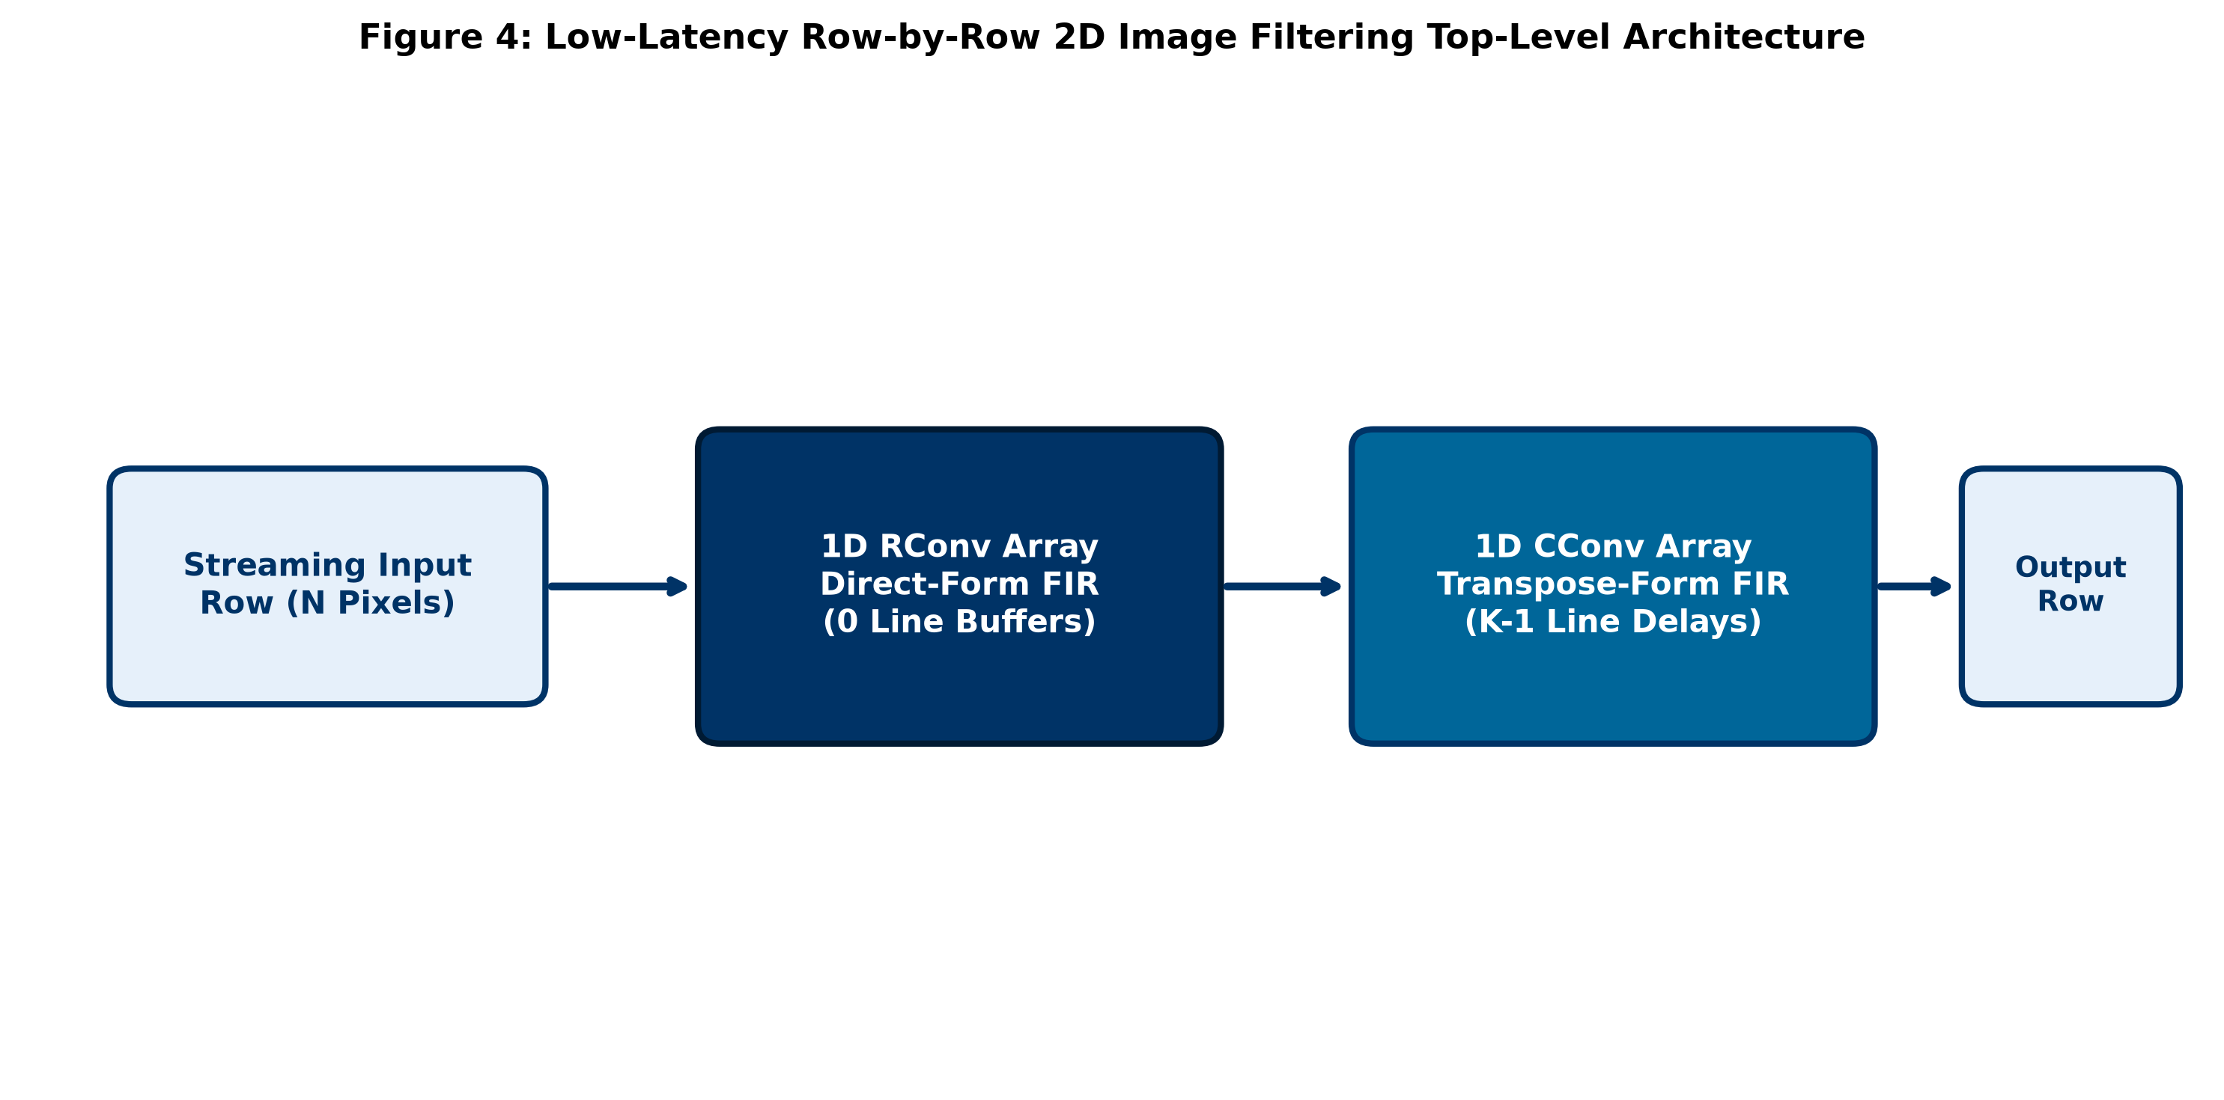
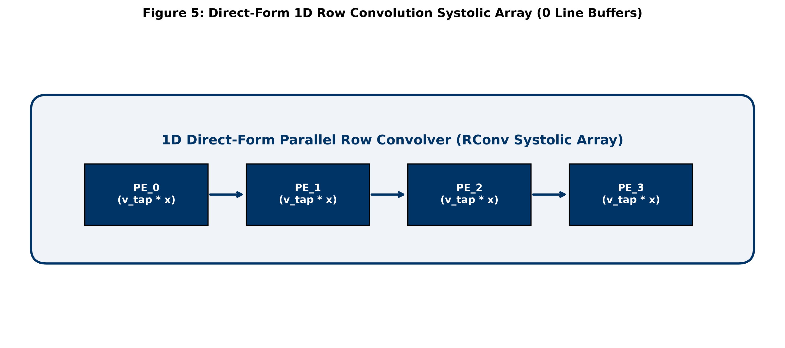
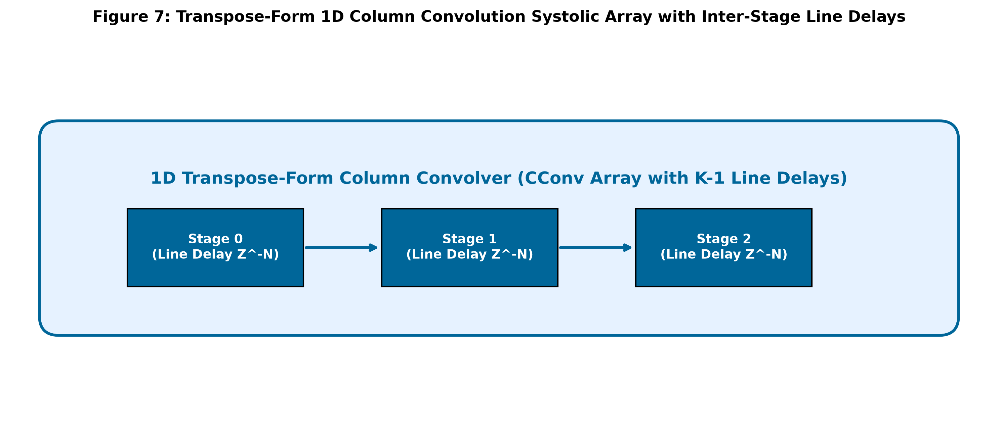
5. Multi-Resolution Image Filtering Results ('flower' & 'sunflower')
5.1 Image 1: Flower ('flower.png')
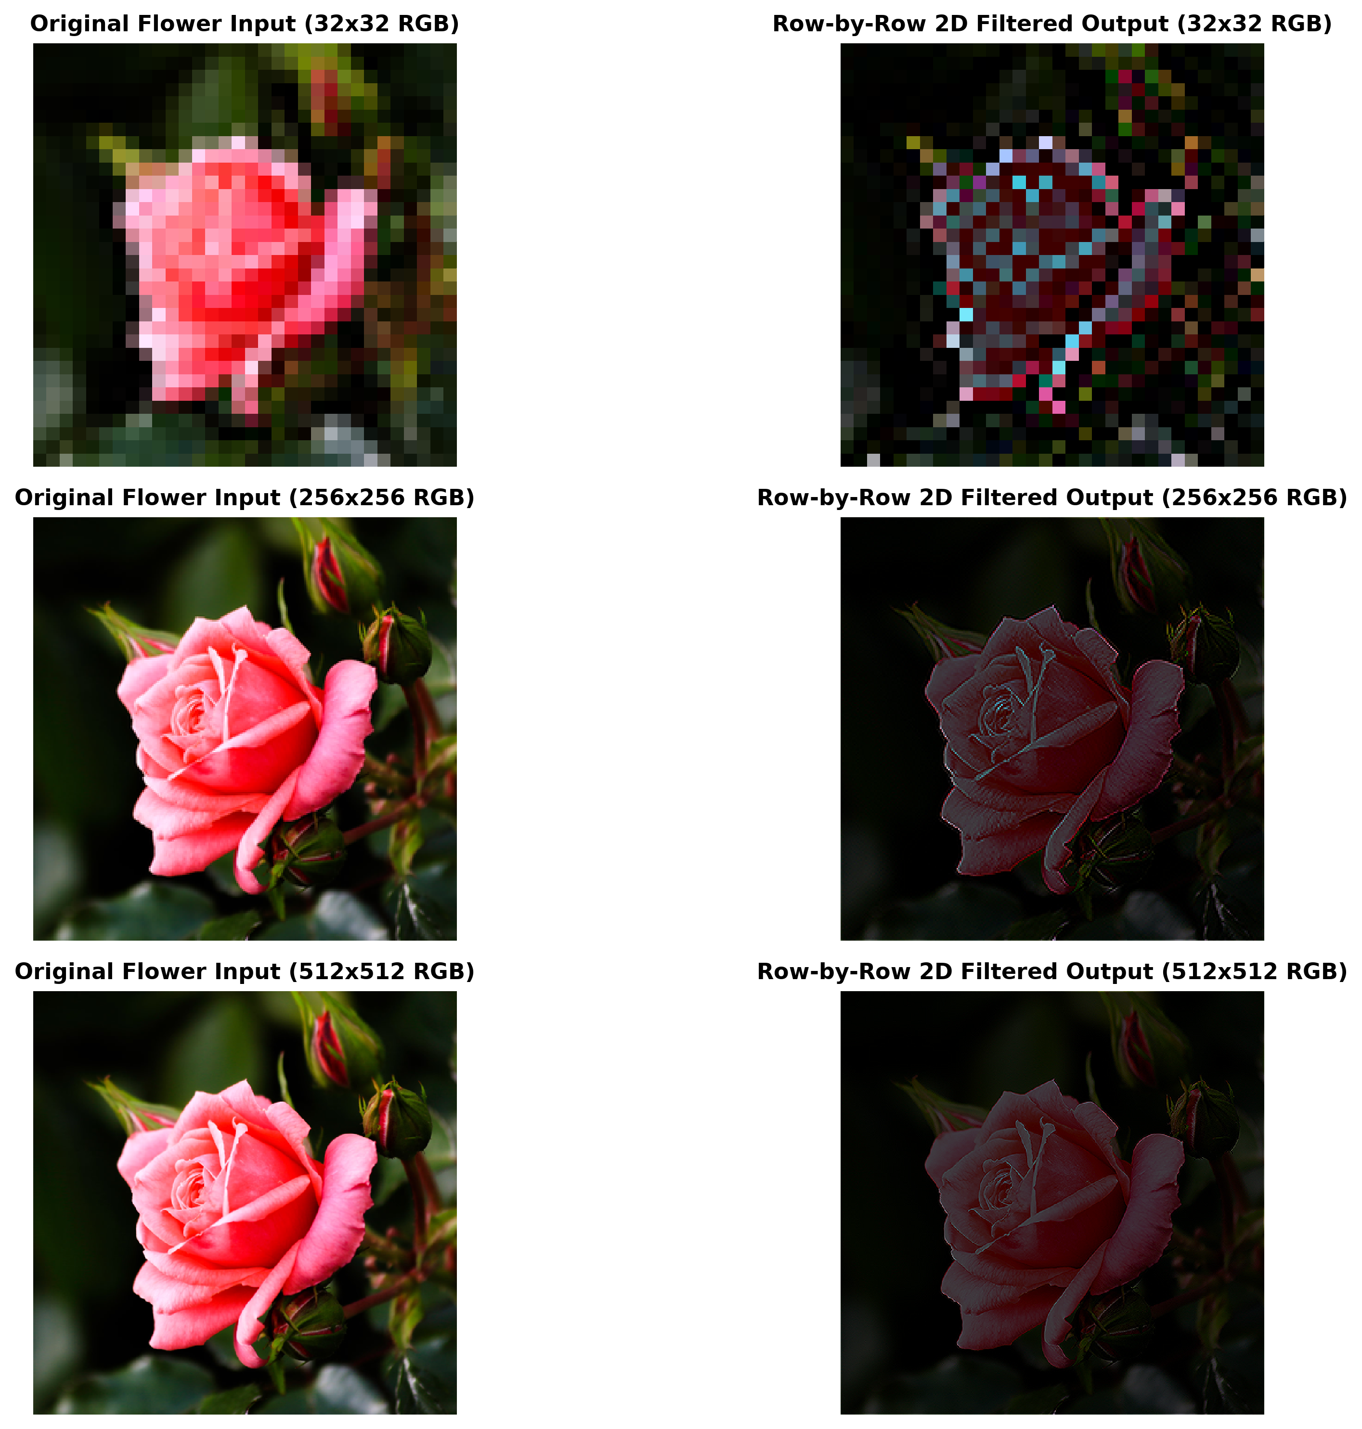
5.2 Image 2: Sunflower ('sunflower.png')
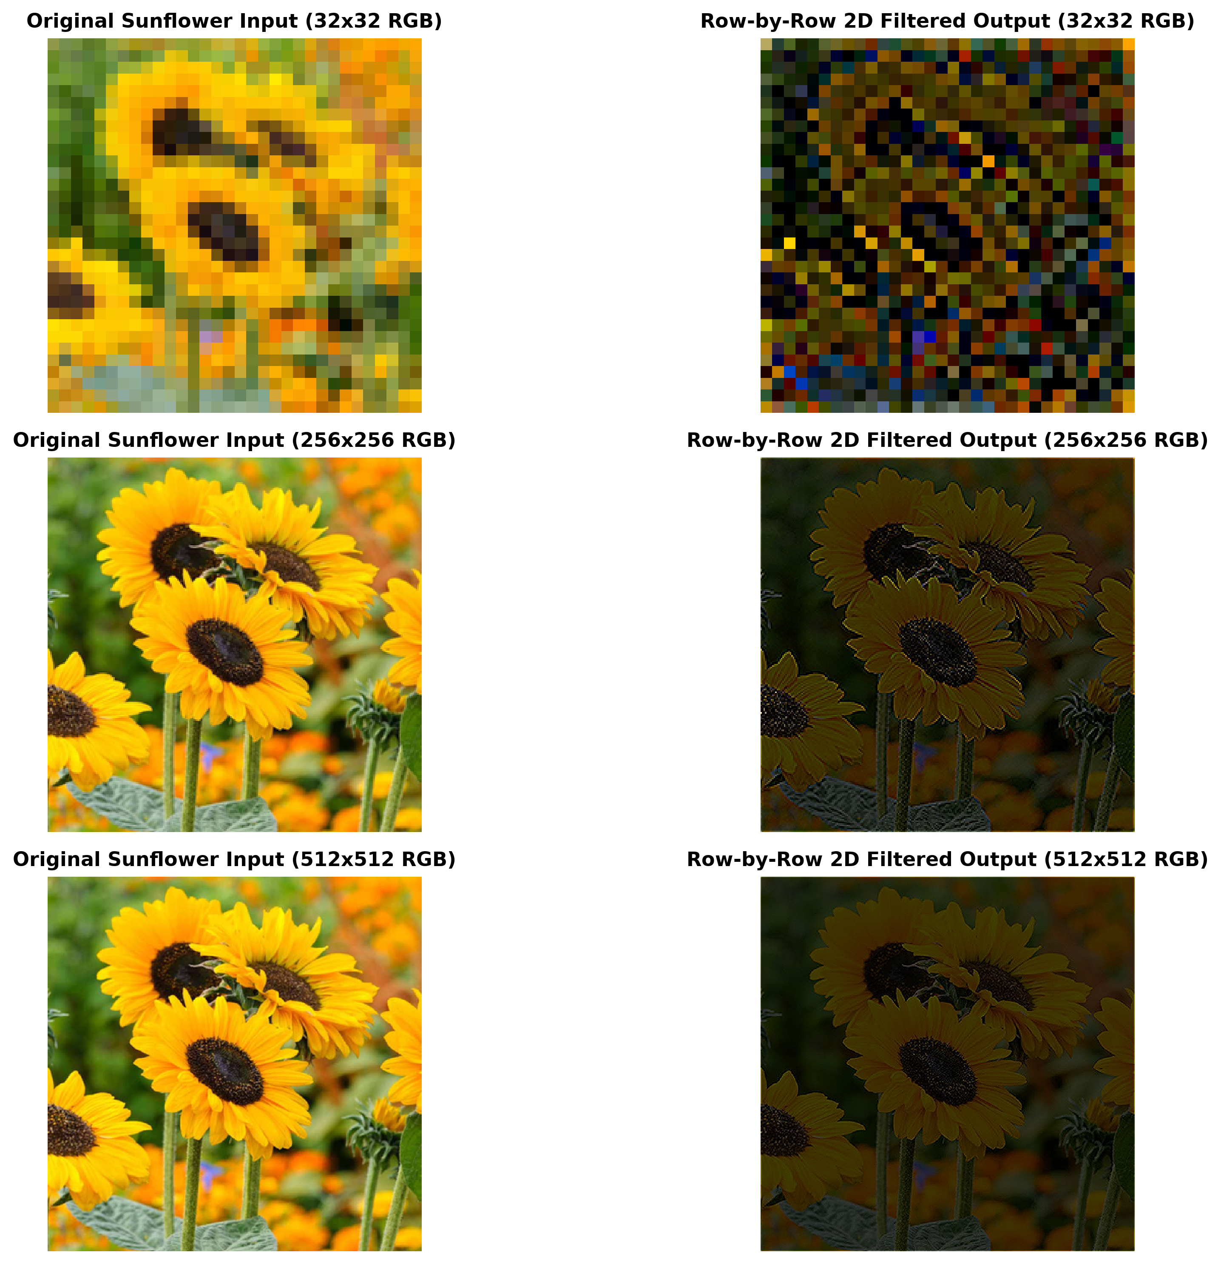
6. Multi-Resolution Latency Scaling & Performance Comparison
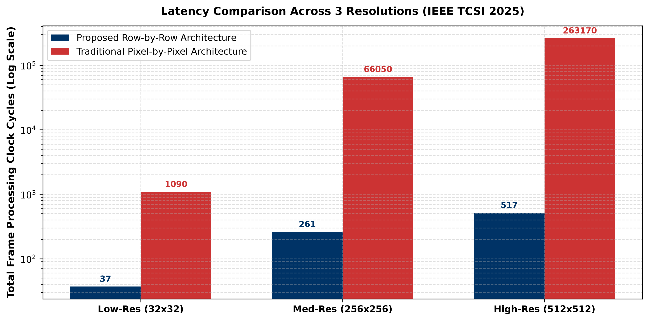
Resolution | Row-by-Row 1st Row | Row-by-Row Frame | Pixel-by-Pixel 1st Pix | Pixel-by-Pixel Frame | Latency Speedup
Low-Res (32x32) | 5 cycles | 37 cycles | 66 cycles | 1,090 cycles | 29.5x Speedup
Med-Res (256x256) | 5 cycles | 261 cycles | 514 cycles | 66,050 cycles | 253.1x Speedup
High-Res (512x512) | 5 cycles | 517 cycles | 1,026 cycles | 263,170 cycles | 509.0x Speedup
7. ModelSim Dedicated Compilation & Waveform Commands Guide
Compilation Script: Dedicated Compilation Script (compile.do):
vlib work
vmap work work
vlog -sv -work work hdl/rconv_array.v hdl/cconv_array.v hdl/image_filter_top.v hdl/tb_image_filter.v
Combined Execution Command: Combined Single-Line Command for ModelSim Console:
cd {D:/program files/pixelflow}; do compile.do; vsim -onfinish stop work.tb_image_filter; do scripts/wave.do; run -all; wave zoomfull
Waveform Commands: ModelSim Waveform Commands Reference:
• add wave -divider {SECTION}: Adds a visual colored section divider line.
• add wave -color {COLOR}: Assigns custom signal colors (Yellow, Red, Green, Lime, Cyan, Orange).
• add wave -radix hexadecimal: Displays bus values in Hexadecimal format.
• add wave -radix decimal: Displays signed weight/pixel calculations as Decimal.
• wave zoomfull: Zooms out timeline to fit the full 0 ns to 200 ns simulation window.
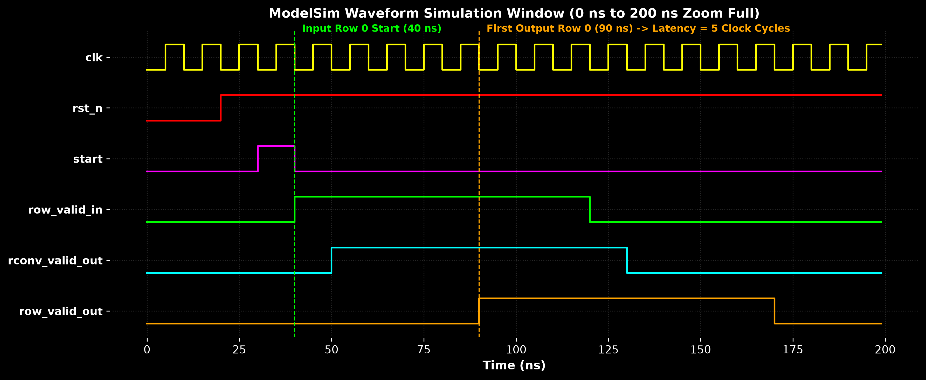
8. Blockwise Line-by-Line Beginner Verilog Code Description
• rconv_array.v: Direct-form 1D row convolver. Unpacks row_in, applies 0-padding, computes N parallel row dot-products, and outputs 1D row array after 1 cycle.
• cconv_array.v: Transpose-form 1D column convolver. Contains K-1 line delay registers delay_regs[0..K-2][0..N-1] and multiplies input row by column weights u[stage] gated by boundary enable cconv_en.
• image_filter_top.v: Top module managing row counter (0..M-1), boundary enable logic cconv_en, and connecting rconv and cconv modules.
• tb_image_filter.v: Self-checking testbench initializing clock, loading hex memory files, measuring clock cycle latency, and writing simulation hex output file.
9. Direct Execution Scripts (Native DO Scripts)
1. ModelSim 1-Click Execution: Open ModelSim -> in Tcl Console type: do run_sim.do.
2. ModelSim Windows Launcher: Run scripts\run_modelsim.bat in Command Prompt.
3. Vivado Launcher: Run scripts\run_vivado.bat in Command Prompt.

