
AI-Enabled Unified Data Architecture Platform on AWS
Intelligent Column Mapping & Automated Data Vault Creation

March 6, 2026
YASH Technologies PVT. LTD.


YASH Technologies, Inc.
USA | United Kingdom | Europe| Middle East | Australia |Asia
11-Feb-2026

Document
Author | Yash technologies
Reviewed By
Approved By | <Name of person/team approved>
Distribution List | <Names of person/team the document to be circulated to>
Intended Users | <End Users of the document>
Document Creation Date | 06-March-2026
Last Reviewed By
Last Approved By | <Author’s Name>
Last Reviewed Date | <DD-Mon-YYYY>

Version | Date | Addition/Modification | Prepared By | Revised By
V1 | 06-March-2026 |  | Shahbaz Ansari, Ankit Shukla

Document Reference Number | Physical File Name
Important Notice
This YASH TECHNOLOGIES document has restricted circulation. No part of this document may be reproduced, stored in a retrieval system, or transmitted in any form or by any means - recording, photocopying, electronic & mechanical without prior written permission of YASH TECHNOLOGIES (India) Private Limited.

Table of Contents:
1. Objective 5
2. Current State Architecture 5
3. Refresh & Orchestration Strategy 6
4. Future State General Architecture 7
5. High-Level Process Flow 7
6. Data Pipeline Source/Target Location Details 8
7. Data Architecture & Processing Layers 9
7.1 Bronze Layer — Raw Vault (Source-Aligned Data) 9
7.2 Silver Layer — Business Vault (Cleansed & Standardized Data) 10
7.2.a High‑Level Flow 10
7.2.b Ingestion Strategy 11
7.2.c Full Load (Historical Data) Pipeline Activities 11
7.2.d Incremental Load Pipeline Activities 11
7.2.e Naming Conventions 12
7.2.f Transformation Pipeline Activities 12
7.2.g Naming Conventions 12
7.3 Gold Layer — Information Mart (Analytics & Consumption) 13
7.3.a Information Mart Publication Pipeline Activities 13
8. AWS Bedrock Integration 14
8.1 AI Integration Overview 14
8.2 AI Use Cases 14
8.3 AI Architecture Flow 14
8.4 Integration Architecture 14
8.5 High-Level Code: AWS Bedrock Integration 15
9. Error Handling & Recovery 17
10. Testing Strategy 17
11. Data Retention & Archival Policy 19
12. Logging and Monitoring 20
12.1. Monitoring Overview 20
12.2 Logging Infrastructure 20
12.2.a AWS Cloudwatch Log: 20
12.2.b AWS Cloudwatch Monitoring Capabilities: 20

Objective
This document describes the design of an AI-enabled unified data architecture platform built on AWS.
The platform leverages artificial intelligence, metadata intelligence, and semantic understanding to automate two critical capabilities:
- Column-to-column mapping across heterogeneous source systems
- Automated Data Vault (Hub, Link, Satellite) creation
The objective is to significantly reduce manual data modeling effort, accelerate source system onboarding, ensure modeling consistency, and improve overall data quality while maintaining strong governance and auditability..
The platform supports:
- End-to-end P2P visibility
- Automated data refresh and orchestration
- Scalable Data Vault architecture
- AI-assisted analytics using AWS Bedrock services
- Self-service business intelligence dashboards
Product Name: ProcureSpendIQ

Current State Architecture
ProcureSpendIQ follows a Lakehouse-first architecture leveraging AWS Data Lake with Delta format storage and a Data Vault modelling approach.
Key Characteristics:
- Centralized data storage
- Historical data preservation
- Scalable compute separation
- Automated orchestration
- Enterprise monitoring

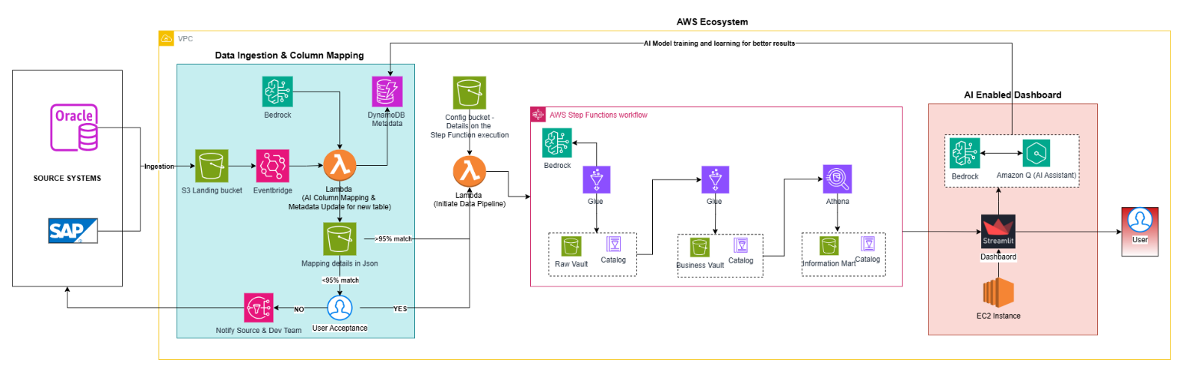

Refresh & Orchestration Strategy
The platform operates on a fully automated refresh framework.
Step | Description
Data Detection | Source changes identified using CDC/watermark logic
Pipeline Execution | AWS pipelines triggered on schedule/Event based
Backend Refresh | Bronze/RAW → Silver → Gold execution
Semantic Model Refresh | Automatic dataset refresh
Dashboard Update | Business dashboards updated
Key Benefits:
• Zero manual intervention
• Reliable scheduling
• Consistent data availability
• Reduced operational overhead

Future State General Architecture
Future enhancements may include:
- Multi-ERP integration
- Real-time event ingestion
- Predictive procurement optimization
- Supplier risk intelligence models
- Autonomous anomaly detection agents

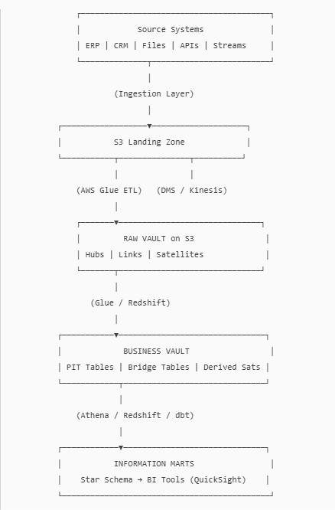

High-Level Process Flow
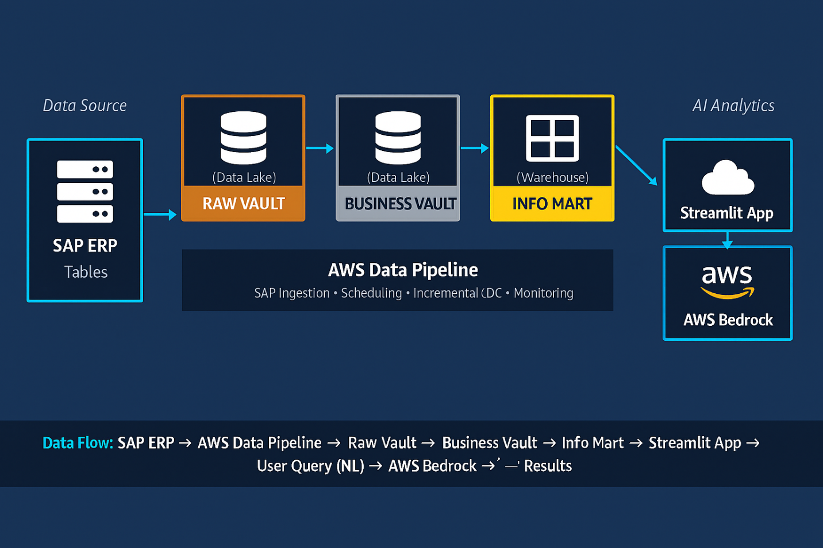

- SAP generates procurement and finance data
- AWS pipelines ingest incremental data
- Raw Vault stores source-aligned history
- Business Vault applies transformations
- Information Mart publishes curated datasets
- Dashboards refresh automatically
- AI services generate insights

Data Pipeline Source/Target Location Details

Environment | Source System | Source Server | Account/Workspace | Lakehouse/Data Lake | S3 Path
DEV | SAP | <SAP-DEV-SID> | <AWS-WS-PROCURESPENDIQ-DEV> | <DL-PROCURESPENDIQ-DEV> | S3/ProcureSpendIQ/DEV/
UAT | SAP | <SAP-UAT-SID> | <AWS-WS-PROCURESPENDIQ-UAT> | <DL-PROCURESPENDIQ-UAT> | S3/ProcureSpendIQ/UAT/
PROD | SAP | <SAP-PROD-SID> | <AWS-WS-PROCURESPENDIQ-PROD> | <DL-PROCURESPENDIQ-PROD> | S3/ProcureSpendIQ/PROD/

Data Architecture & Processing Layers
The ProcureSpendIQ platform follows a layered Data Lake architecture implemented on AWS S3 using Delta Lake/Ice bergs tables storage. The data is progressively refined across three logical layers — Bronze, Silver, and Gold — to ensure scalability, governance, and analytical readiness.

7.1 Bronze Layer — Raw Vault (Source-Aligned Data)
The Bronze layer represents the landing zone for all data ingested from source systems such as SAP SE ERP. This layer preserves the original structure and historical state of source data to ensure traceability and auditability.

Key Activities:
- Ingestion of full and incremental data from source systems
- Addition of technical metadata (ingestion timestamp, source system, load identifiers)
- Schema preservation with minimal transformations
- Historical versioning using Delta Lake capabilities
- Storage of raw data for replay and recovery purposes
Purpose:
- Maintain a reliable system-of-record replica
- Enable data lineage and audit compliance
- Provide a foundation for downstream transformations
No business rules or complex transformations are applied in this layer.
Note: No transformations or business rules are applied during the ingestion stage. The ingested data is prepared exclusively for downstream transformation processing.

7.2 Silver Layer — Business Vault (Cleansed & Standardized Data)
The Silver layer contains cleansed, standardized, and integrated data modelled using Data Vault principles. This layer transforms raw source data into business-aligned structures while maintaining full historical tracking.
Key Activities:
- Data cleansing and standardization
- Data type alignment and format normalization
- Deduplication and key resolution
- Handling late-arriving and changed data
- Currency conversions and business rule application
- Data quality validations and exception handling
Purpose:
- Create a consistent enterprise data foundation
- Enable scalable integration across domains
- Preserve history while supporting analytical transformations
- Provide reusable datasets for multiple use cases
This layer serves as the governed integration layer between raw data and analytics consumption.

7.2.a High‑Level Flow
- Read the RAW_VAULT table
- Apply column standardization (naming/uniformity)
- Apply type correction (cast columns to expected types)
- Apply null handling (default values or rule‑based fills)
- Apply dedupe (primary keys + BUSINESS_VAULT keys)
- Write to BUSINESS_VAULT (Delta), with schema evolution enabled
- Log results

7.2.b Ingestion Strategy
Load Type | Approach | Technology
Initial Full/Historical Load | Full historical extraction | AWS Glue/App Flow Pipelines
Incremental Load | Daily/weekly/monthly extraction of changed records using watermark logic | AWS Glue/App Flow Jobs

7.2.c Full Load (Historical Data) Pipeline Activities
Step | AWS Service | Description
1 | Lambda | Read metadata configuration table (config_ingestion_metadata)
2 | Step Function | Loop through each SAP table in metadata (30+ tables)
3 | Glue/AppFlow | Extract full table from SAP → Write to Raw Vault (Delta Lake)
4 | Glue/AppFlow | Log ingestion metrics (row count, load time, status)

7.2.d Incremental Load Pipeline Activities

Step | AWS Service | Description
1 | Lambda | Read last_update_date from watermark/control table
2 | Step Function | Loop through each active SAP table
3 | Glue/AppFlow | Execute incremental ingestion script (Delta merge logic)
4 | Glue/AppFlow | Update last_update_date in watermark table based on the latest extract

7.2.e Naming Conventions
Component | Naming Convention
Full Load Master Pipeline | pl_<env>_ProcureSpendIQ_full_load_master
Incremental Load Master Pipeline | pl_<env>_ProcureSpendIQ_incremental_master
Incremental Ingestion script | pl_<env>_ProcureSpendIQ_ingest_incremental
Ingestion Logging script | pl_<env>_ProcureSpendIQ_ingest_logger

7.2.f Transformation Pipeline Activities
Step | Activity | Description
1 | Glue: Data Cleansing | Standardize columns, type conversion, null handling, deduplication
2 | Glue: Build Hubs | Create core business entities (Vendor, Material, PO)
3 | Glue: Build Links | Create relationships between entities
4 | Glue: Build Satellites | Capture descriptive attributes with full history
5 | Glue: Build PITs & Bridges | Point-in-Time snapshots and Bridge tables
6 | Glue: Data Quality Checks | Validate data quality, log rejected records

7.2.g Naming Conventions
Component | Naming Convention
Master Transformation Pipeline | pl_<env>_ProcureSpendIQ_transform_master
Hub Glue job | pl_<env>_ProcureSpendIQ_hub_<entity>
Satellite Glue Job | pl_<env>_ProcureSpendIQ_sat_<entity>
Data Quality Glue Job | pl_<env>_ProcureSpendIQ_dq_<domain>

7.3 Gold Layer — Information Mart (Analytics & Consumption)
The Gold layer represents the curated, business-ready data optimized for reporting, dashboards, and advanced analytics. Data in this layer is structured using dimensional modelling and optimized for performance.
Key Activities:
- Creation of dimension tables (Slowly Changing Dimensions)
- Creation of fact tables with business metrics and KPIs
- Aggregations and performance optimizations
- Semantic model preparation for reporting tools
- Data validation prior to publication
- Exposure through SQL endpoints and BI tools

Purpose:
- Deliver trusted, analytics-ready datasets
- Provide a single source of truth for business users
- Support dashboards, self-service BI, and AI analytics
- Optimize query performance and usability

This layer is treated as a read-only consumption layer and is refreshed only after successful completion of upstream processing.

7.3.a Information Mart Publication Pipeline Activities
Step | Activity | Description
1 | Glue: Build Dimensions | Create SCD Type 2 dimension tables (Vendor, Material, etc.)
2 | Glue: Build Facts | Create fact tables with aggregated metrics
3 | Glue: Data Quality Validation | Validate published data
4 | Pipeline: Semantic Model Refresh | Trigger Power BI Semantic Model refresh

AWS Bedrock Integration

AI Integration Overview
ProcureSpendIQ leverages AWS Bedrock Service to provide AI-driven insights, natural language querying, anomaly detection, and intelligent recommendations on procurement data.

AI Use Cases
• Natural Language Insights: Users can ask questions in natural language
• Spend Anomaly Detection: Identify unusual spending patterns
• Vendor Risk Assessment: AI-powered vendor scoring
• Purchase Recommendations: Suggest optimal purchasing strategies
• Contract Compliance: Detect non-compliant transactions
• Forecast Analysis: Predict future spend trends

AI Architecture Flow
Step | Component | Description
1 | User Query | User asks question in Streamlit dashboard
2 | Context Retrieval | Retrieve relevant data from Information Mart layer
3 | AWS Bedrock Processing | Generate insights using Claude
4 | Response Rendering | Display AI-generated insights in dashboard

Integration Architecture
Component Stack:
- Frontend: Streamlit Dashboard
- Data Access: S3/Athena Endpoint
- Data Source: Data Lake Delta Tables (Information mart)
- AI Engine: AWS Bedrock (Claude)
- Query Processing: Natural language to SQL conversion

High-Level Code: AWS Bedrock Integration
import boto3, json
bedrock = boto3.client("bedrock-runtime", region_name="us-east-1")
resp = bedrock.converse(
modelId="anthropic.claude-3-5-sonnet-20241022-v2:0",
messages=[{"role": "user", "content": [{"text": "Hello from Bedrock!"}]}]
)
print(resp["output"]["message"]["content"][0]["text"])

Error Handling & Recovery

Mechanisms:
- Pipelines retry policies
- Checkpointing
- Incremental restart from failure point
- Dead-letter logging tables
- Alert notifications

Testing Strategy

The testing strategy for ProcureSpendIQ ensures that data ingestion, transformation, modeling, and reporting layers function accurately, reliably, and consistently across environments. The approach follows a multi-layered validation framework covering functional, data, integration, performance, and user acceptance testing.
The primary objectives are:
- Validate correctness of data extracted from SAP
- Ensure accuracy of data transformations
- Verify KPI calculations and business logic
- Confirm pipeline reliability and restartability
- Ensure performance meets SLA requirements
Unit Testing
Unit testing validates individual components such as scripts, transformations, and reusable functions.
Scope:
- Record count reconciliation with SAP
- Data transformation logic
- Delta merge logic
- Data cleansing rules (Null handling, Conditional checks, Deduplication, Filters, Data type conversions, etc.)
- Business rule implementation
- KPI calculation logic

Integration Testing
Integration testing validates the end-to-end workflow across multiple components.
Scope:
- SAP → Glue/AppFlow ingestion
- Semantic model refresh
Key Validations:
- Pipelines execute in correct sequence
- Data flows correctly across layers
- Error handling works as expected
- Restart from failure point works correctly

System Testing
System testing validates the complete solution as a unified platform.
Includes:
- End-to-end data processing
- Dashboard refresh validation
- Security validation
- Performance validation
- Monitoring and logging validation

User Acceptance Testing (UAT)
UAT ensures the solution meets business expectations and analytical requirements.
Activities:
- KPI validation with business stakeholders
- Dashboard usability verification
- Data reconciliation with legacy reports
- Business scenario testing
Acceptance Criteria:
- KPI variance within acceptable threshold
- Reports match business expectations

Data Retention & Archival Policy

Data retention policies ensure regulatory compliance, cost optimization, and historical availability. Retention policies vary by data layer and usage requirements.

Retention Policy by Layer
Bronze Layer:
- Full historical retention
- Minimum retention: Few years (based on organizational policy)
- Supports audit
Silver Layer:
- Full historical Data storage
- Retained indefinitely unless policy changes
Gold Layer:
- Current and historical data retained
- Aggregated tables can have shorter retention
Logs and Monitoring Data:
- Default retention: 90 days
- Configurable based on requirements

Logging and Monitoring

Monitoring Overview
ProcureSpendIQ implements comprehensive logging and monitoring across all pipeline activities to ensure operational visibility, troubleshooting capabilities, and performance tracking.

Logging Infrastructure

12.2.a AWS Cloudwatch Log:
- Workspace Name: cloudwatch-log-procurespendiq-<env>
- Retention Period: 90 days (configurable)
- Log Categories: Pipeline execution, Glue jobs runs, data quality checks, errors

12.2.b AWS Cloudwatch Monitoring Capabilities:
- Pipeline run history and metrics
- Glue execution logs
- Error logs
- Semantic model refresh status
- Query performance monitoring

Component | Log Type | Log Location | Details
Data Pipelines | Execution Logs | Cloudwatch Monitoring logs | Pipeline run status, duration, row counts
Glue | Application Logs | Cloaudwatch Workspace Logs | PySpark job logs, transformation metrics
Incremental Load | Watermark Tracking | Delta Lake Table | Maximum date tracking for incremental refresh
Data Quality | Validation Results | Delta Lake (Logging Tables) | DQ check results, rejected records
AWS Bedrock | API Calls | AWS Cloudwatch Monitor | Request/response logs, token u

