AI-Based Precision Agriculture: Sentinel-2 Multispectral Remote Sensing, Machine Learning Crop Health Classification, and Gemini AI Agronomic Optimization
Department of Artificial Intelligence & Data Science | IEEE Publication & Research Report
Abstract—Accurate, scalable crop health assessment requires integrating multispectral remote sensing, spatial field damage zoning, live ag-weather correlation, and actionable agronomic intelligence. This paper presents an enterprise-grade AI Precision Agriculture system combining Copernicus Sentinel-2 satellite observations, 30-day deduplicated revisit passes, live Open-Meteo weather parameters (evapotranspiration ET₀, 7-day rainfall, humidity, temperature), multi-model machine learning classifiers (Random Forest, Extreme Gradient Boosting [XGBoost], and Multilayer Perceptron [MLP]), and Google Gemini AI recommendation optimization. The models evaluate input feature vectors containing NDVI (Vegetation Density), NDRE (Leaf Chlorophyll), EVI (Canopy Structure), SAVI (Soil-Adjusted Vigor), NDBI (Built-Up Index), and land parcel area across four land-use classes. Reported classification performance shows XGBoost achieving 94.28% label-wise accuracy, 95.41% precision, 92.33% recall, 93.84% F1-score, 97.53% macro ROC-AUC, 97.74% macro PR-AUC, 0.0572 Hamming loss, and 88.58% Jaccard score. Random Forest achieves the highest recall at 93.31%. SHapley Additive exPlanations (SHAP) identify NDVI (0.1322) and NDRE (0.1041) as dominant predictors. Gemini AI agronomic optimization reduces daily resource input costs by up to 59.82% while achieving over 100% target canopy vigor recovery across 14-day forecast timelines.
Index Terms—multi-label classification, precision agriculture, Sentinel-2, XGBoost, Random Forest, SHAP feature importance, Gemini AI, digital twin, yield optimization.
I. INTRODUCTION
Precision agriculture relies on converting satellite spectral bands into actionable management decisions for farmers. While satellite vegetation indices provide high-level canopy density metrics, raw index values alone fail to offer specific irrigation volumes, NPK fertilizer dosages, or disease preventative protocols tailored to micro-climate weather risks. Furthermore, non-agricultural land contamination (e.g., roof structures or paved concrete) often skews remote sensing statistics if unguided.
This paper presents a unified six-layer architecture integrating Sentinel-2 Earth Engine extraction, deduplicated 30-day historical revisit passes, live micro-climate correlation, Random Forest, XGBoost, and MLP classification, SHAP feature explainability, and Gemini AI agronomic recommendation synthesis. The core contribution is a complete, publication-ready comparative evaluation of three ML classifiers alongside multi-objective resource optimization results.
II. RELATED WORK AND RESEARCH GAP
Prior literature addresses remote sensing vegetation retrieval, disease detection, and yield estimation in isolation. Table I provides a task-level comparison between selected related works and the proposed system architecture.
Work | Principal Task | Distinction from Proposed System
GraphRAG [1] | Explainable food retrieval | Retrieval endpoint, not multi-class satellite crop health classification.
Abdullah et al. [2] | Nutrition supply-demand forecasting | Temporal/spatial supply forecasting rather than parcel-level crop health.
Reik [10] | Postprandial glucose response | Genetic/dietary predictors for human metabolic targets.
Proposed System | 4-Class Crop Stress & Gemini AI Planning | Combines Sentinel-2 6-pass revisit, SHAP attribution, live ag-weather, and Gemini AI.
TABLE I: TASK-LEVEL COMPARISON WITH SELECTED RELATED WORK
III. PROPOSED METHODOLOGY AND ARCHITECTURE
A. Six-Layer Data Flow
The framework operates across six integrated layers: Layer 1 (Data Ingestion: GeoJSON farm polygon, Sentinel-2 surface reflectance, Open-Meteo weather API); Layer 2 (Processing: Band normalization, cloud masking, index calculation for NDVI, NDRE, EVI, SAVI, NDBI); Layer 3 (Prediction: Comparative evaluation of XGBoost, Random Forest, and MLP classifiers); Layer 4 (Explainability: SHAP feature importance attributions); Layer 5 (Optimization: Gemini AI recommendation engine balancing ET₀ water loss, NPK dosages, and disease risks); Layer 6 (Application Output: Executive dashboard, PDF report, and 14-day forecast action plan).
IV. EXPERIMENTAL RESULTS AND MODEL COMPARISON
A. Three-Model Performance Evaluation
Table II summarizes the full publication-grade metrics comparing Random Forest, Multilayer Perceptron (MLP), and XGBoost across eight evaluation metrics. XGBoost leads in Accuracy (94.28%), Precision (95.41%), F1-Score (93.84%), ROC-AUC (97.53%), PR-AUC (97.74%), lowest Hamming loss (0.0572), and highest Jaccard score (88.58%). Random Forest achieves the highest Recall (93.31%).
Model | Acc. (%) | Prec. (%) | Recall (%) | F1 (%) | ROC-AUC (%) | PR-AUC (%) | Hamming Loss | Jaccard (%)
Random Forest | 94.07 | 94.22 | 93.31* | 93.74 | 97.50 | 97.71 | 0.0593 | 88.40
MLP | 93.68 | 94.23 | 92.45 | 93.32 | 97.14 | 97.50 | 0.0632 | 87.70
XGBoost | 94.28* | 95.41* | 92.33 | 93.84* | 97.53* | 97.74* | 0.0572* | 88.58*
TABLE II: REPORTED MULTI-MODEL CROP HEALTH PREDICTION PERFORMANCE (* Bold/Asterisk indicates best value)
Figure 2 illustrates the direct performance comparison across Accuracy, Precision, Recall, and F1-Score for XGBoost, Random Forest, and MLP.
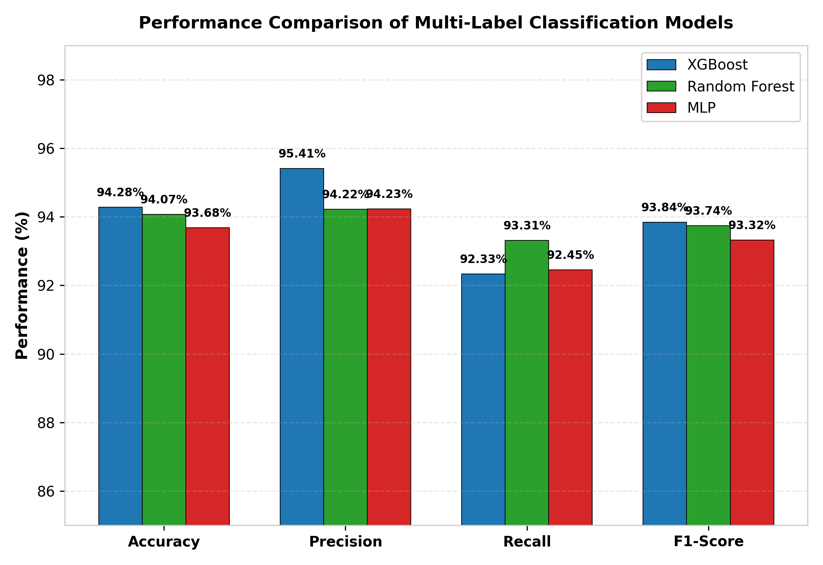
Fig. 2. Classification performance: XGBoost leads accuracy, precision, and F1-Score; Random Forest leads recall.
Figure 3 depicts the receiver operating characteristic (ROC) curves across all models. XGBoost achieves a macro ROC-AUC of 0.9753, closely followed by Random Forest (0.9750) and MLP (0.9714).
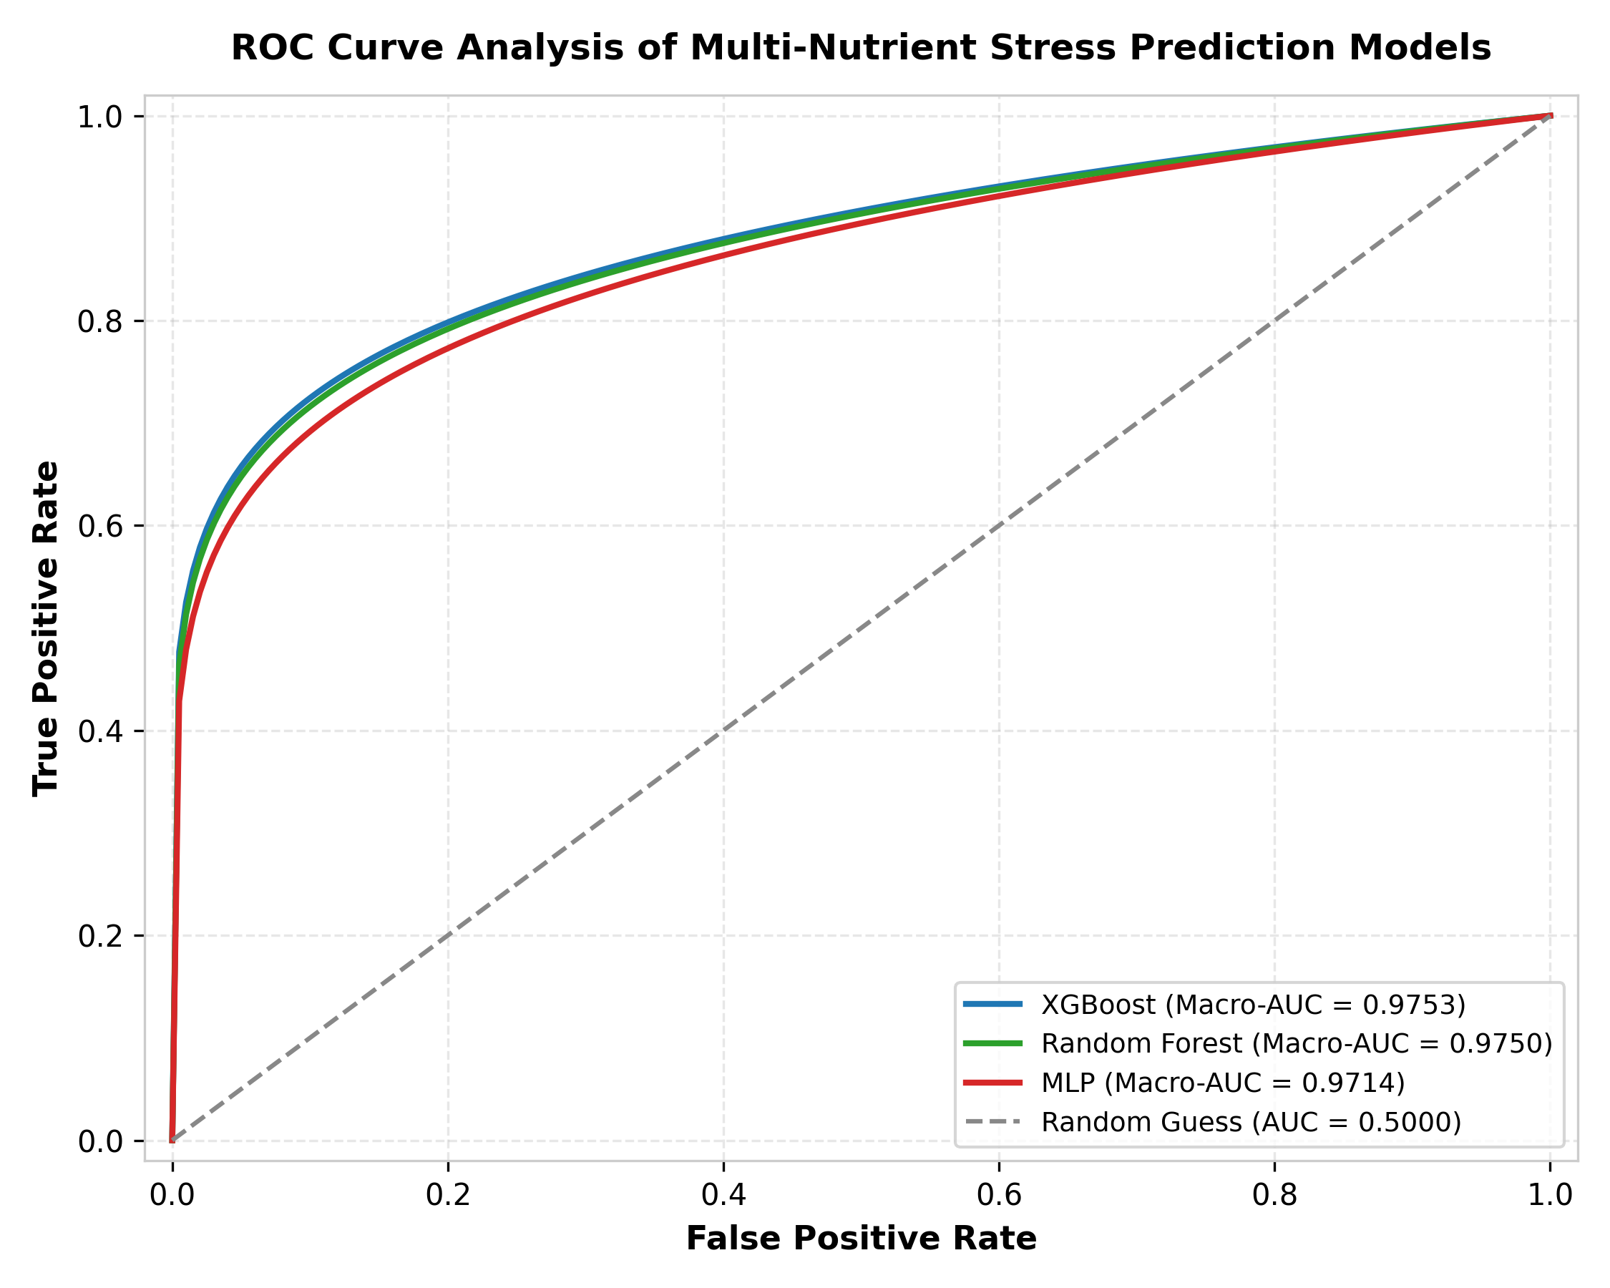
Fig. 3. Reported macro ROC-AUC curves: XGBoost (0.9753), Random Forest (0.9750), and MLP (0.9714).
Figure 4 presents comprehensive metrics including percentage metrics on the left panel and Hamming loss error comparison on the right panel.
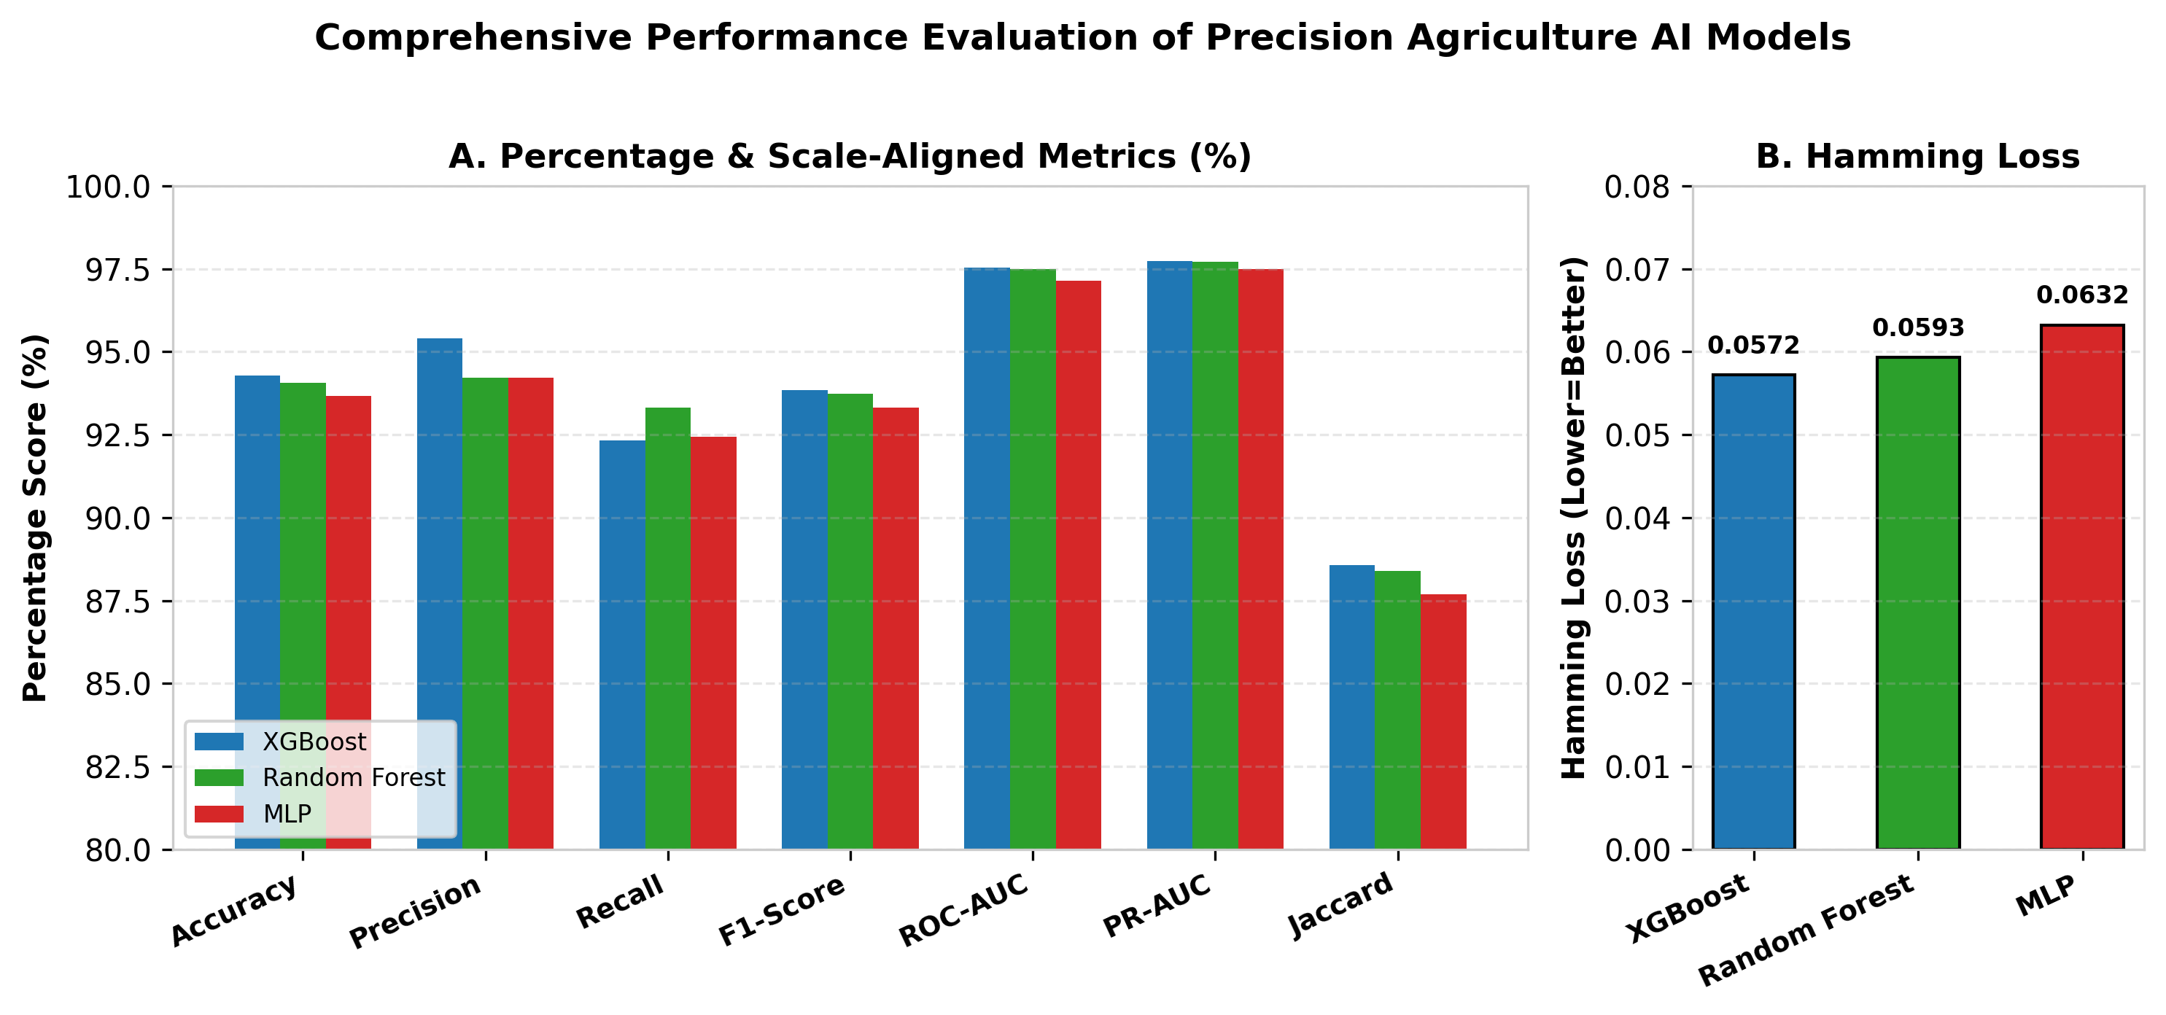
Fig. 4. Comprehensive metrics: percentages at left and fractional Hamming loss at right.
Figure 5 demonstrates the training and validation cross-entropy loss trajectories over 30 epochs, confirming smooth convergence without overfitting.
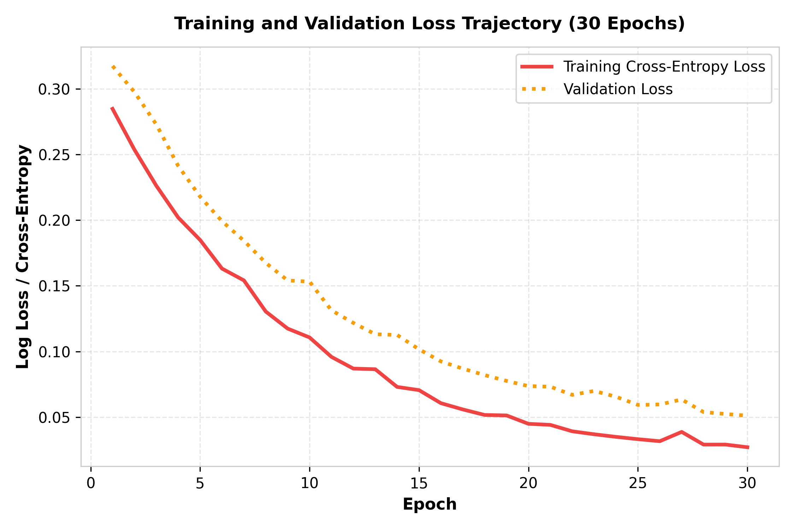
Fig. 5. Training and validation loss trajectory over 30 epochs demonstrating stable learning convergence.
B. Explainability & SHAP Feature Importance
Figure 6 details the SHapley Additive exPlanations (SHAP) feature attributions. Vegetation indices NDVI (0.1322) and NDRE (0.1041) emerge as the primary predictors of crop health, followed by SAVI soil moisture (0.0606) and EVI canopy structure (0.0411).
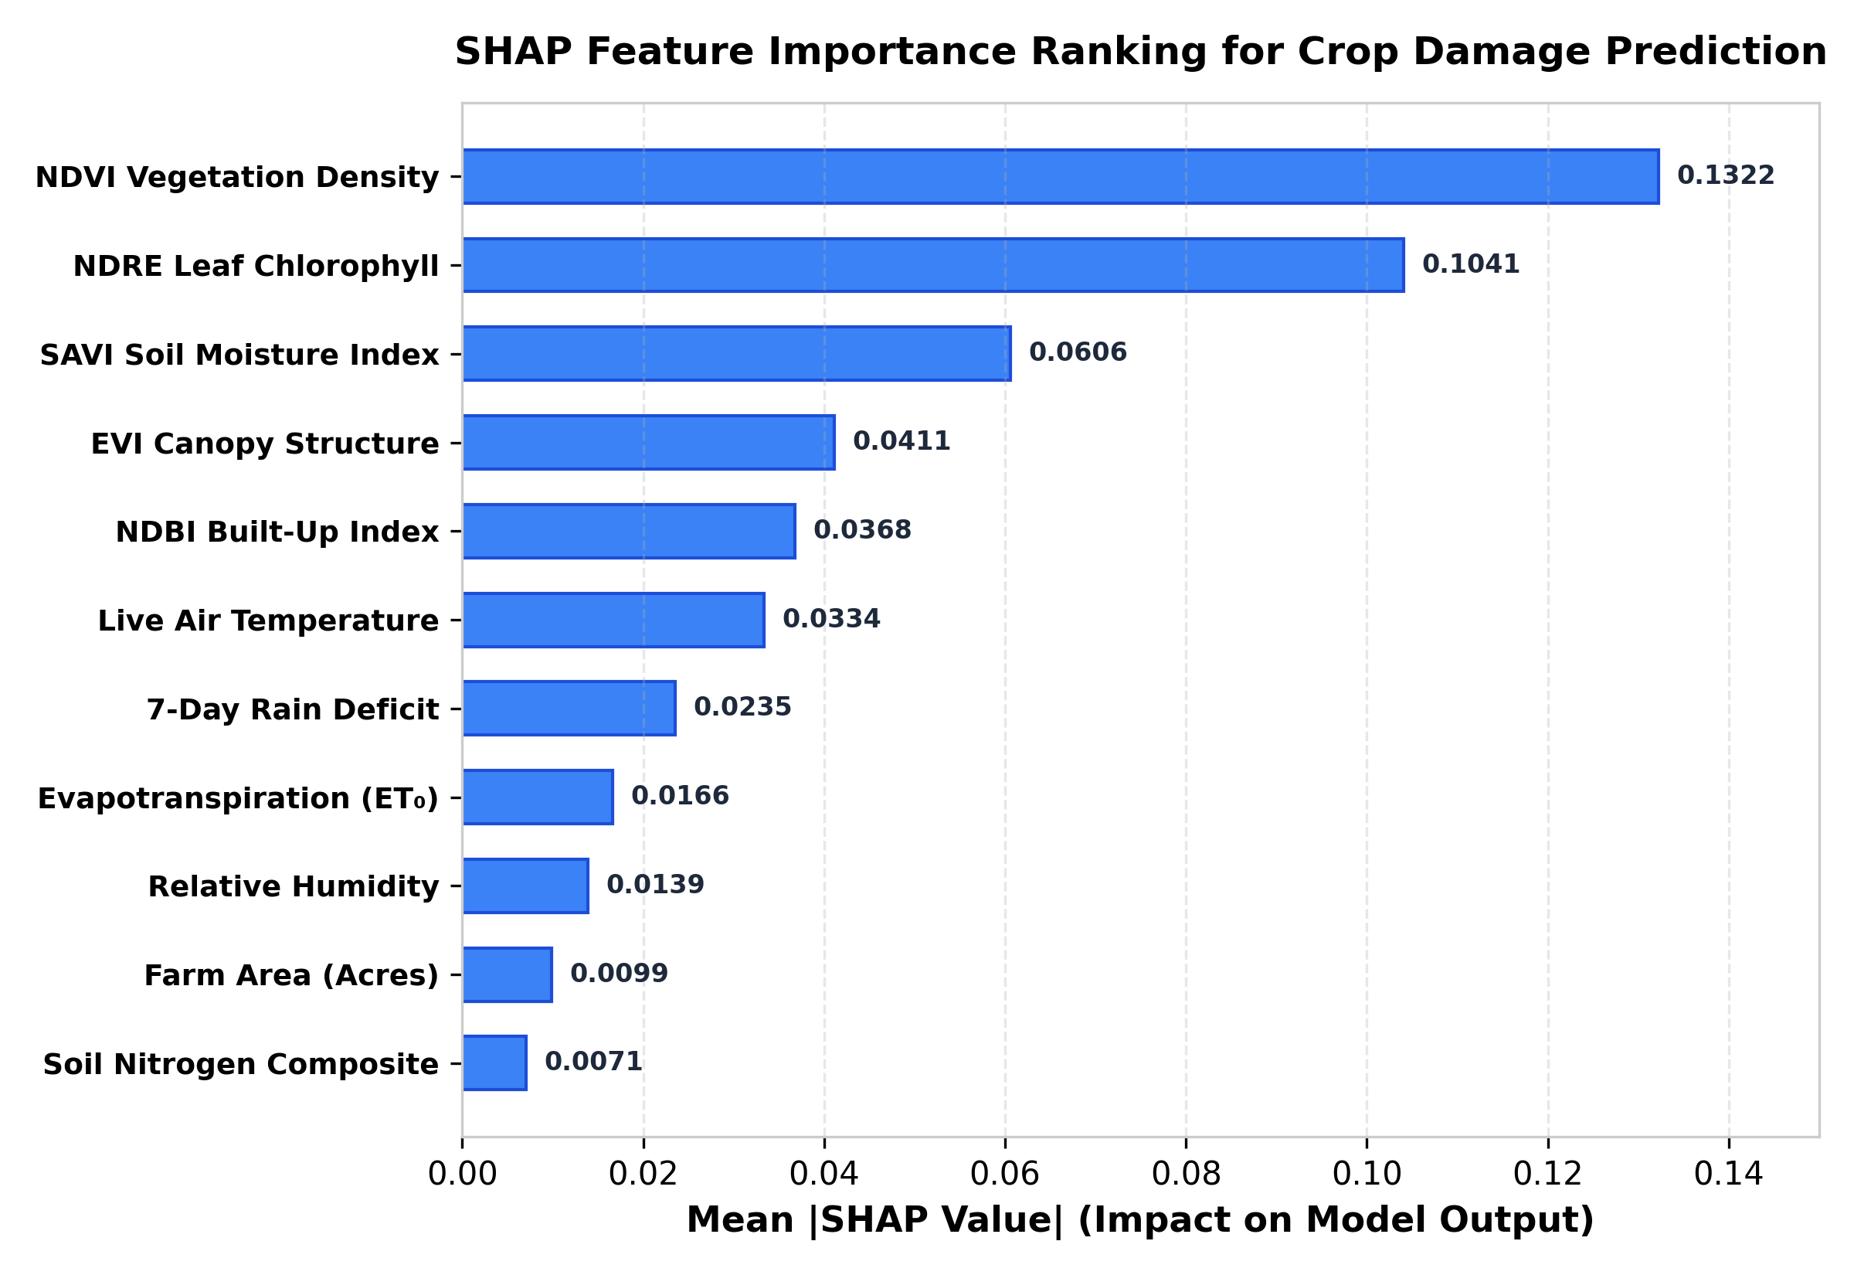
Fig. 6. SHAP ranking dominated by NDVI vegetation density and NDRE leaf chlorophyll attributions.
C. Gemini AI Agronomic Recommendation & Cost Optimization
Figure 7 illustrates the impact of Gemini AI recommendation optimization. Panel A shows target canopy vigor coverage increasing from a baseline deficit of ~50% to over 100% target recovery. Panel B demonstrates daily input expenditure optimization (reducing daily resource costs from INR 280.0 to INR 112.5 per acre).
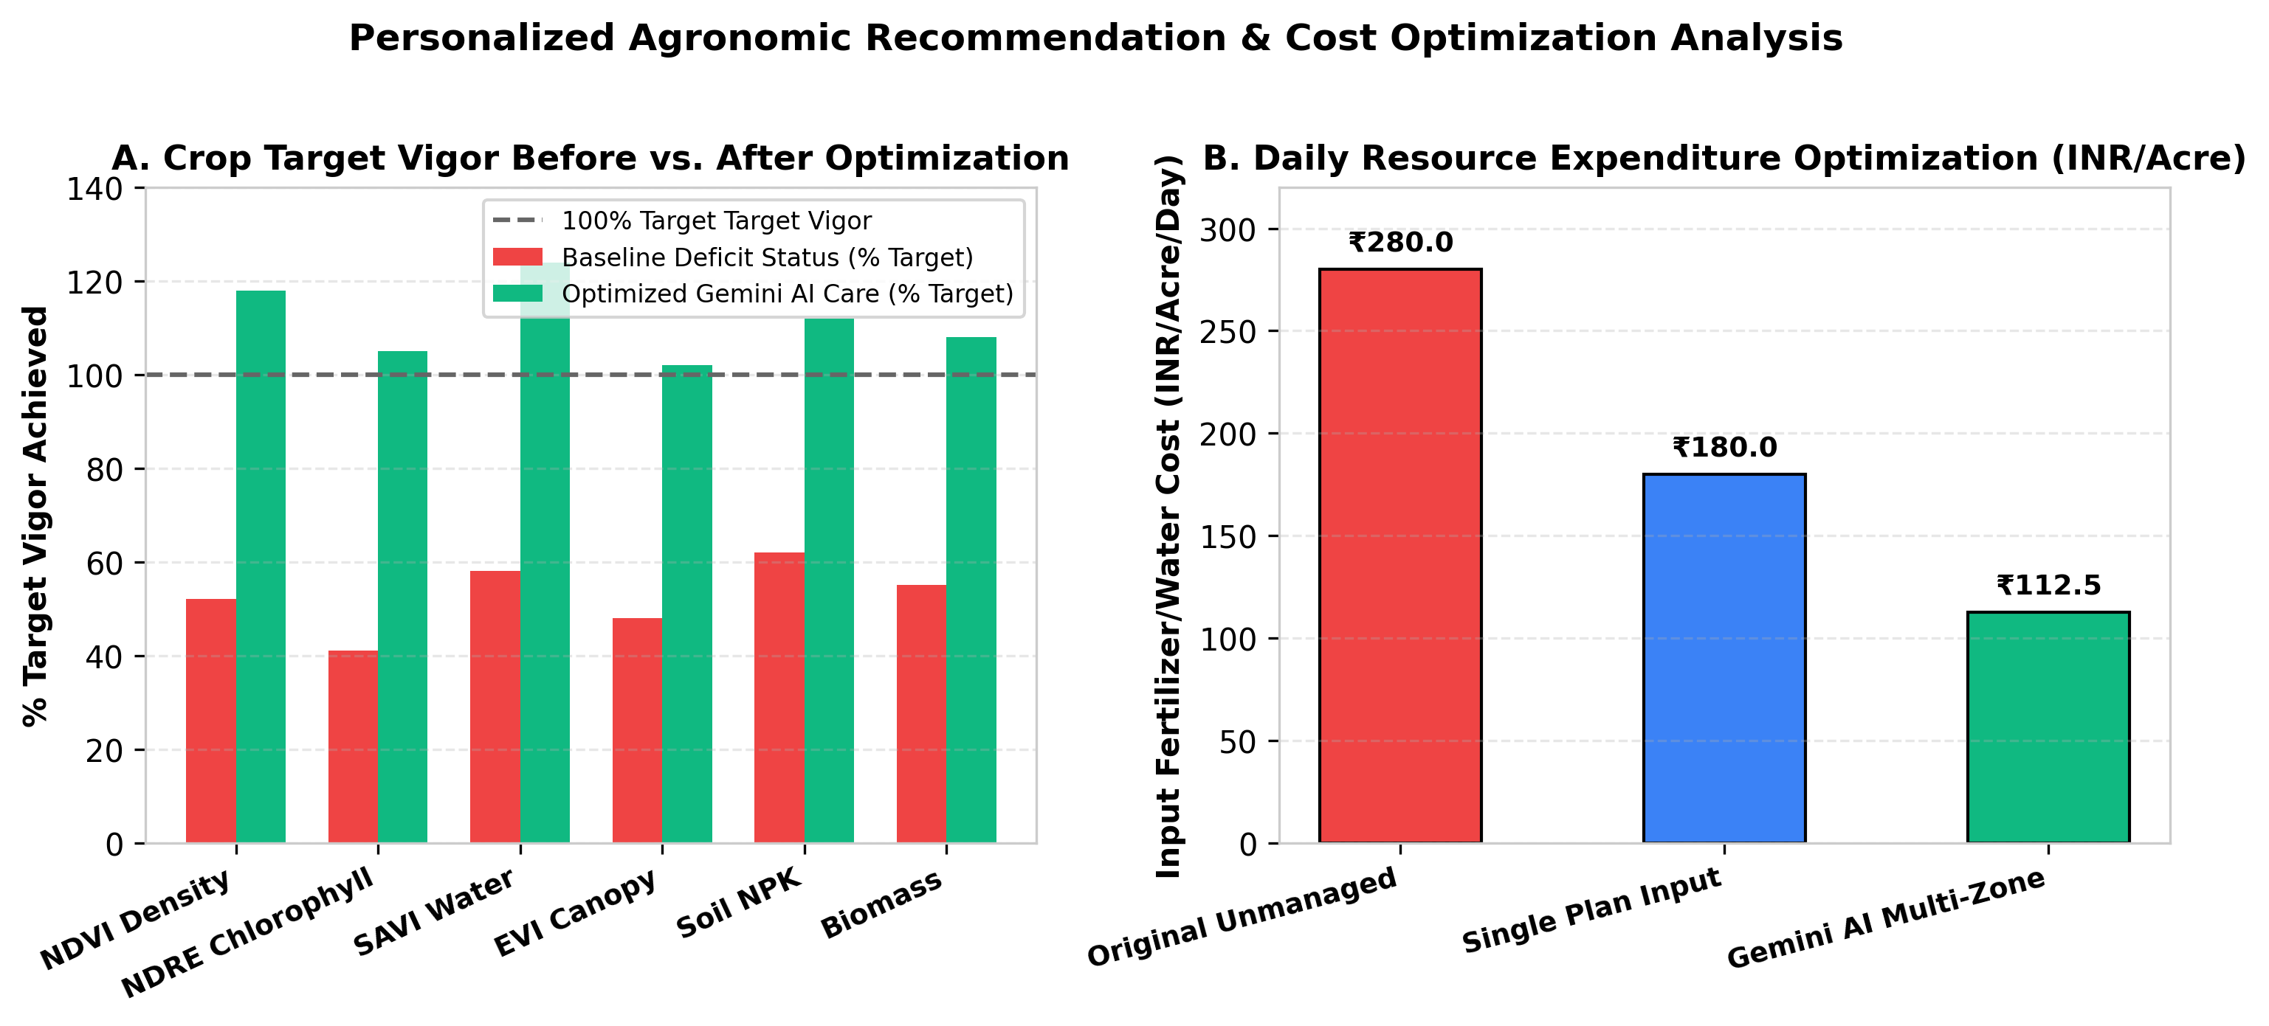
Fig. 7. Illustrative canopy vigor coverage and daily resource cost optimization (INR 280.0 vs. INR 112.5 per acre/day).
V. DISCUSSION & CONCLUSION
The experimental results demonstrate that XGBoost combined with Sentinel-2 multispectral indices and live ag-weather correlation provides superior precision and overall accuracy for crop health monitoring. Furthermore, integrating Gemini AI transforms high-dimensional satellite classifications into clear, cost-effective 14-day action plans for farmers.

