1. Project Title: VentureLens: A Multi-Agent Agentic AI System for Startup Idea Validation
2. Team Members: Ajay Teli (230937), Shruti Negi ([Roll No.]), Diksha Balody ([Roll No.])
3. Problem Definition
- Validating a startup idea normally needs market research, competitor analysis, financial feasibility checks, and risk assessment — usually done manually or by a single AI model working sequentially, which is slow and prone to one-sided bias.
- Student entrepreneurs, early-stage founders, and college incubation cells who want a quick, evidence-backed first opinion on a business idea before committing time or capital.

4. Objectives & Expected Outcomes
- Build a 7-agent CrewAI pipeline that automates idea validation through parallel research; reduce single-agent bias with a dedicated debate/cross-verification step; deliver a clear, scored Go/No-Go recommendation through a simple web interface.
- A working prototype, VentureLens, that takes a plain-text business idea and returns a research-backed score (out of 10) with a Go/No-Go recommendation and justification within a few minutes.

5. Proposed Methodology
- Coordinator (assigns and manages tasks); Market Research, Competitor Analysis, Financial Feasibility, and Risk Assessment agents (parallel research); Comparator/Debate agent (resolves conflicting findings); Investor-Verdict agent (final score and recommendation).
- Serper.dev web search API, used by the Market, Competitor, and Risk agents for live research.
- CrewAI (hierarchical multi-agent process), with a multi-provider LLM fallback chain for reliability, including Gemini flash-lite models and the openai/llama-3.1-8b-instant model accessed via an OpenRouter API key.
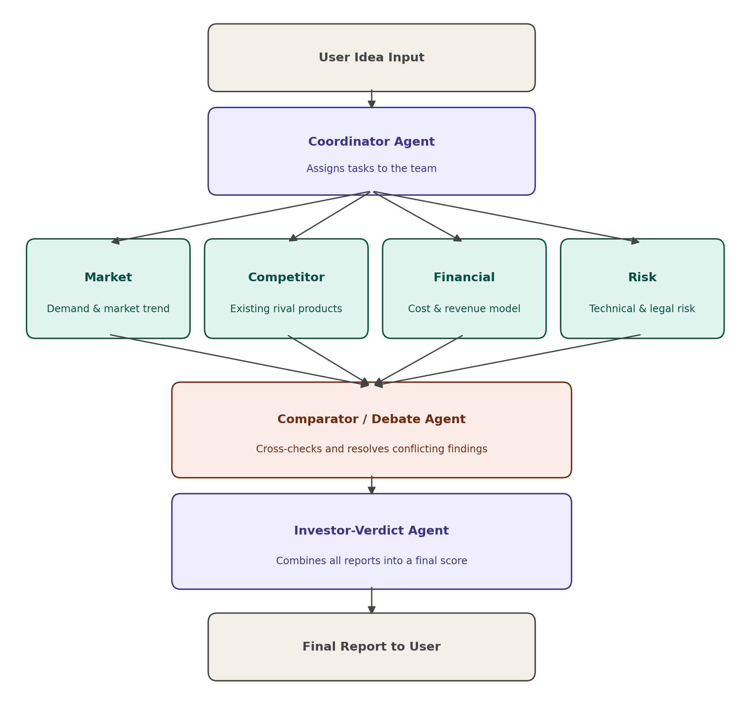

6. Feasibility & Resources
- Live web search results (Google-indexed, via Serper.dev) for market, competitor, and risk research — no proprietary dataset is required.
- Serper.dev search API; Gemini API and OpenRouter API for LLM inference.
- Python 3.10+, CrewAI, LiteLLM, Streamlit.
- A standard laptop with no GPU — all reasoning runs through cloud LLM APIs, so only lightweight local Python dependencies are needed.

7. Team Members & Individual Understanding
Member | Role/Responsibility | Individual Understanding
Ajay Teli (230937) | Team Lead — System Architecture, Agent Design & Development | Understands the full pipeline: how the Coordinator delegates work, how each agent’s role and tools fit together, and how the debate and fallback logic keep verdicts reliable.
Shruti Negi ([Roll No.]) | Research & Prompt Design — Market, Competitor and Risk agents | Understands how each research agent’s prompt and search tool shape its findings, and how those findings are cross-verified by the Comparator agent.
Diksha Balody ([Roll No.]) | Testing, Documentation & UI | Understands how to validate outputs against expected Go/No-Go outcomes and how the Streamlit interface presents the final score and recommendation.

8. Project Timeline
Activity | Week(s) | Deliverable
Problem & Design | Week 1 | Finalised problem statement, 7-agent architecture, and system design document
Development /Coding | Weeks 2–3 | Working agents.py, tasks.py and crew.py implementing all 7 agents and the hierarchical pipeline
Integration & Testing/Debugging | Week 4 | End-to-end pipeline tested on sample ideas with provider fallback verified
Evaluation & Refinement | Week 5 | Outputs verified against benchmark ideas (strong, weak and borderline) and prompts refined
Presentation/Interface UI | Weeks 5–6 | Polished Streamlit interface (VentureLens) showing score, recommendation and justification
Deployment | Week 6 | Locally deployed, demo-ready application
Final Demo | Week 6 | Live demonstration of the complete validation pipeline to evaluators

9. Team Responsibility Matrix
Activity | Ajay Teli | Shruti Negi | Diksha Balody | Member 4
Agent Design | Lead |  | Support
Agent/Tool Development | Lead | Support
Integration & Testing | Support | Lead
Evaluation & Documentation |  | Lead | Support
Presentation/Interface UI | Support |  | Lead
Deployment |  | Support | Lead

