A

Project Report on

Gaming And Chatting Application

Submitted to

Savitribai Phule Pune University

In the partial fulfillment of the requirement of the award of the degree of

Bachelor of Business Administration- Computer Application,

TYBBA – CA, Sem V

Academic Year 2019-20

By

Solaskar Pranalee Mansing

Under the guidance of

Prof. Amit Tale

Through



Alandi (D)- Pune 412105



**Alandi (D) - Pune 412105**

CERTIFICATE

Department of Computer Application

This is to certify that **Ms. Solaskar Pranalee Mansing** Exam Seat No._____________, of TYBBA-CA, Sem VI, has successfully completed project work entitled **Gaming & Chatting Application** in the partial fulfillment of the requirement of the degree of Bachelor Of Business Administrator-Computer Application for the Academic Year 2019-2020

Prof. Amit Tale Prof. Akshada Kulkarni

Project Guide Head of the Department

Internal Examiner External Examiner

*Acknowledgement*

The words are not enough to express my thanks to **Dr. B. B. Waphare**, **Principal, MIT Arts Commerce and Science College Alandi (D)** for providing me with the opportunity to avail the excellent facilities and infrastructure of the institute.

It is my proud privilege to express my profound gratitude to **Prof. Akshada Kulkarni, HOD, Computer Application Department**, for her astute guidance, constant encouragement and sincere support throughout my academic course.

I thank with my honest gratitude to **Prof. Amit Tale** for his inspiration, constructive suggestions and affectionate guidance in my project work completion.

Last but not the least, I express my sincere thanks to all my dear friends and family members for their constant motivation, moral support and invariable direction throughout my life.

.

*DECLARATION*

I, **Solaskar Pranalee Mansing,** hereby declare that this project work entitled **Gaming And Chatting Application** submitted at MIT, Arts Commerce and Science College, Alandi(D), (Affiliated to Savitribai Phule Pune University) is a record of original work done by me under the supervision and guidance of Prof. Amit Tale, Department of Computer Application.

Signature:

1. Name of Student: Solaskar Pranalee Mansing

Exam Seat No.:___________________

Place : Alandi (D), Pune

Date :_____________

*Index*

|  |  |  |
| --- | --- | --- |
| **Sr. No** | **Title** | **Page No** |
| **1** | Introduction   1. Introduction to system 2. Scope of the system 3. Proposed System | **6** |
| **2** | Analysis   1. Fact Finding Technique 2. Feasibility Study 3. Hardware & Software Requirement | **10** |
| **3** | System Design   1. E-R Diagram 2. Context Level Diagram 3. Data Flow Diagram 4. Data Dictionary | **12** |
| **4** | Form Design (with input values) | **17** |
| **5** | Reports | **29** |
| **6** | Advantages & Limitations | **31** |
| **7** | Future Enhancement | **32** |
| **8** | Bibliography | **33** |

*INTRODUCTION*

Project Insight:

The project titled as “Gaming and Chatting application“ is a software application developed using java with NetBeans IDE and oracle database. This software is basically for chatting and gaming purpose. This system allows users to chat and play with friends, relatives, etc.

To start chatting, the user will have to register first in this system and login with the username and password. The user needs to send request to the person with whom the user want to chat. Users are allowed to send private messages to other person if he/she accepts the request.

For gaming,the user needs to register/login into the system. The user will choose the game and then the opponent(s). Then the game begins. The system will display the results, when the game ends.

Objective:

The main purpose of this application is to provide users an application where they can chat and play games either alone or with friend(s).

Otherobjective is to to give the users satisfaction to all the user by fulfilling their requirements and needs.

The system will also keep the records of the users who chat, managing communication between users, players, their scores, etc.

*Scope:*

In this Gaming and Chatting application, the user(s) can play ludo, snake and ladder, tik tack toe,etc and can chat.

The proposed system mainly covers the following

* Login form.
* Create account form.
* Menu
* Choose friend.
* Choose game.
* Rules/ How to play.
* Game
* Result/ score.
* Chat page.

*PROPOSED SYSTEM:*

* Gaming and chatting application system is develop to provide gaming and chatting platform for user.
* The system maintains all rules and regulations for every game as well as for chatting.
* Objective of the system is to maintain all records for every game and chat.
* The system will maintaining all the details of the users (People who chat and play, chat records, scores for each player and each game.

*ANALYSIS*

**Fact Finding Techniques**

The following fact-finding techniques were utilized for gathering the information about the problem definition and requirements: -

**Questionnaires**

Questionnaires were given to rectors as well to find out what are the most important requirements from the system. The questionnaires comprised of mostly MCQs to help condense the data into groups.

**Interviews**

A few one on one interviews were conducted to get information about what difficulties do the rectors face in their day to day tasks.

**Feasibility Study**

**Technical Feasibility**

The firm has to purchase a Pentium machine or higher version the computer must be running window XP or greater having the software necessary to run the system i.e.JAVA and MySql. As the hardware and software needed for designing and implementation of the system is already is technical feasibility.

**Operational Feasibility**

The main users of the system would be the person doing the present clerical job. A description of the method to operate the system would be enough having a graphical user interface the system will be user friendly. Also, they won’t find it difficult to migrate to new system.

**Economic Feasibility**

This is concern with cost include for development and implement of the system and the benefits derived from it. The hardware and software requirement for the system is already available. The only cost involved is that of coding implementation and maintaining the system.

# *System Design*

# *Entity Relationship Diagram:*

# 

# *Context Level Diagram:*

# 

# *Data Flow Diagram*

**

*Data dictionary*

***LOGIN***

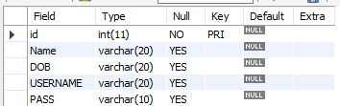

*FRIEND*

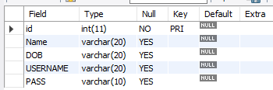

*CHAT*

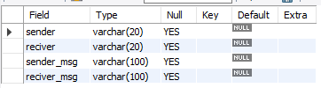

*LUDO SCORE*

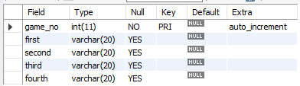

*TIC TAC TOE SCORE*

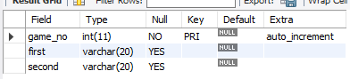

# *Form Design (With input values)*

# *LOGIN FORM:*

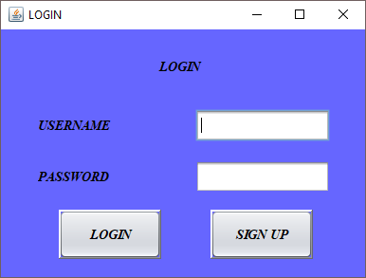

# *LOGIN FORM WITH INPUT VALUES:*

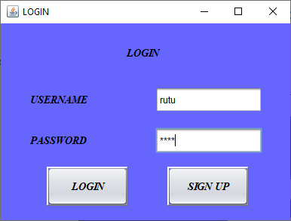

*LOGIN SUCCESSFUL:*

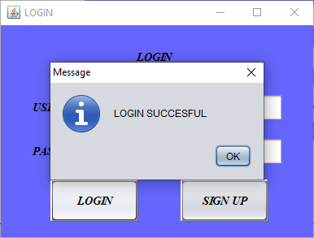

*REGISTRATION FORM:*

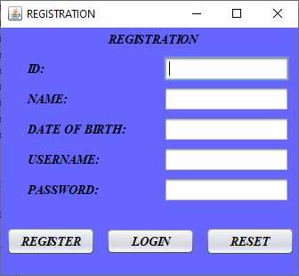

*REGISTRATION FORM(INPUT VALUES):*

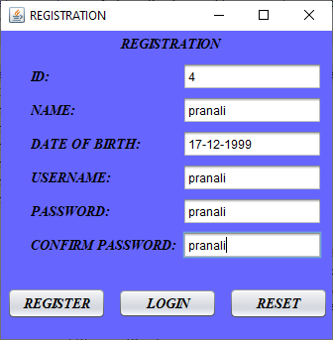

*REGISTRATION FORM(REGISTRATION SUCCESSFULL)*

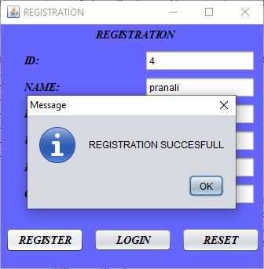

# *MENU FORM:*

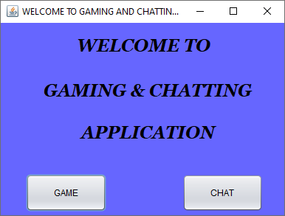

*ON GAM BUTTONS:*

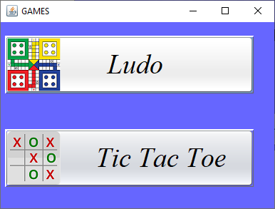

*LUDO MENU*

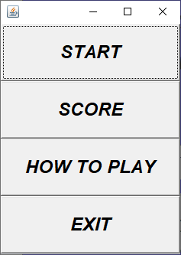

*ON START BUTTON(SELECT COLOUR):*

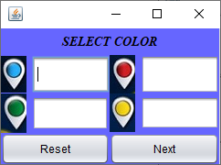 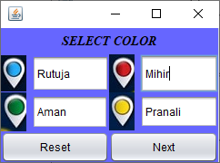

*LUDO:*

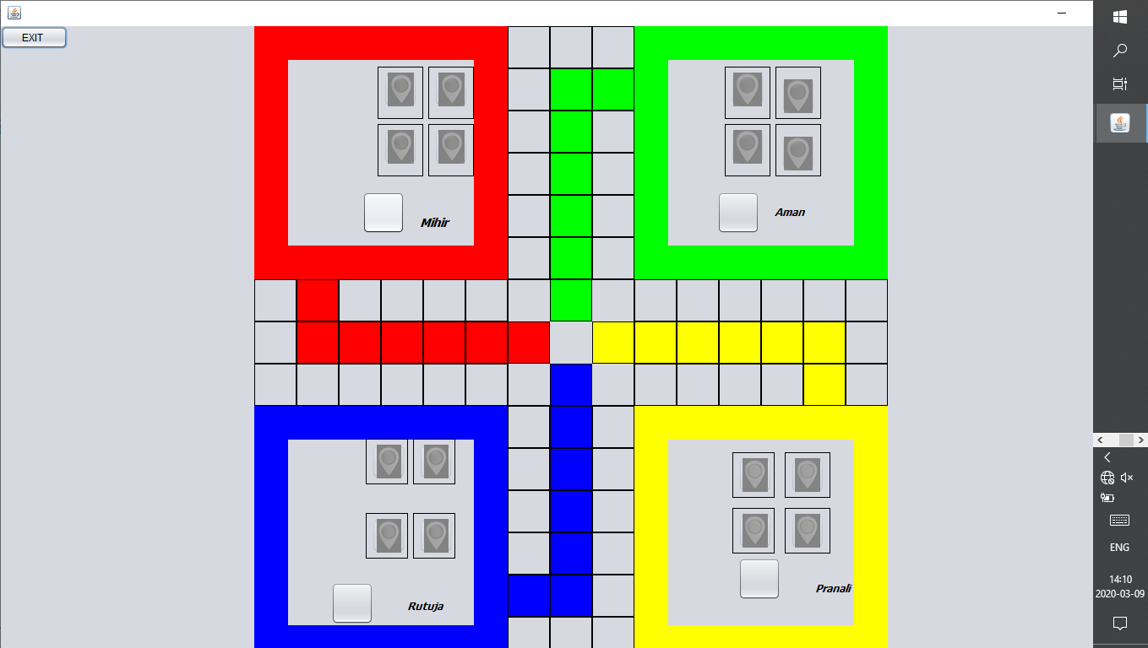

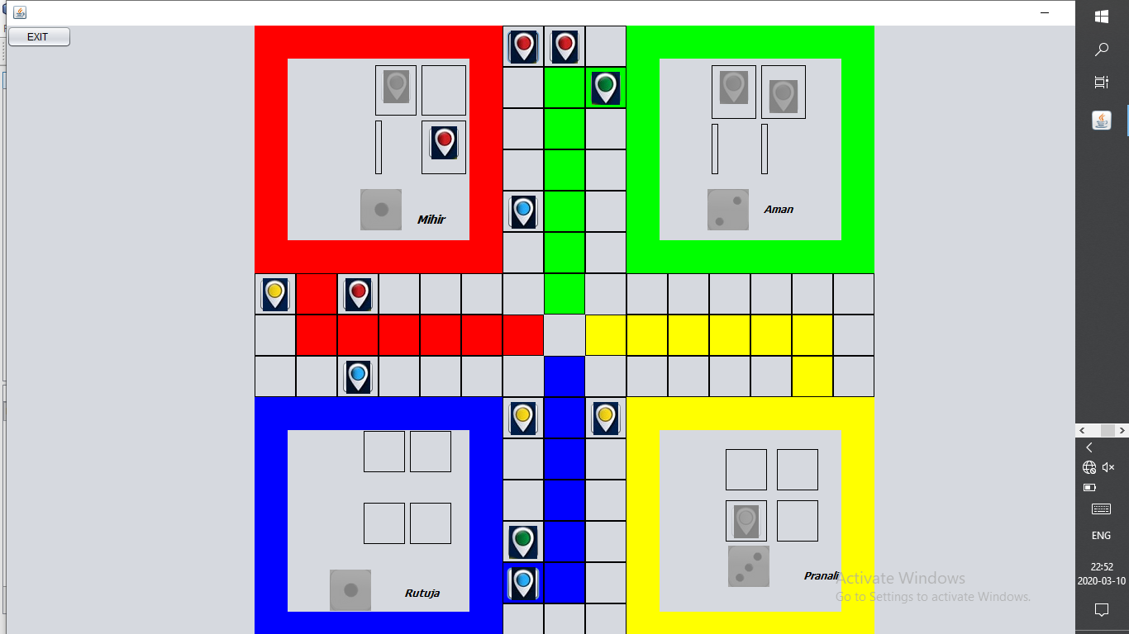

*SCORE BOARD:*

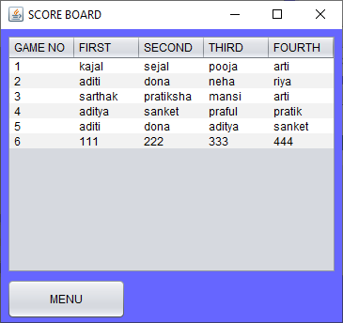

*HOW TO PLAY:*

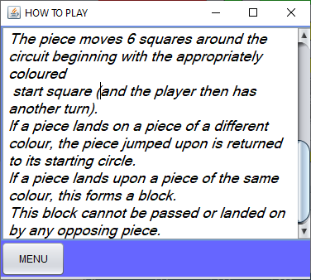

*TIC TAC TOE MENU*

**

*ON START BUTTON*

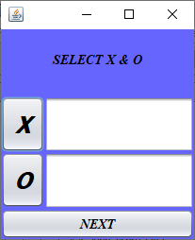 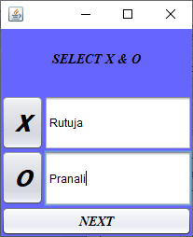

*TIC TAC TOE GAME:*

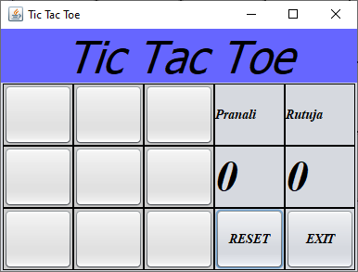

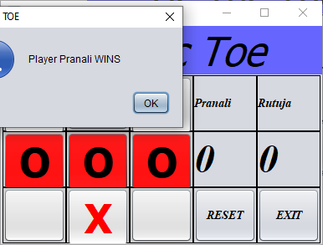

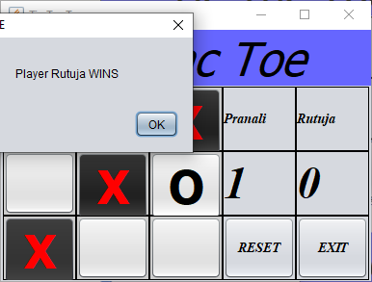

*DRAW MATCH:*

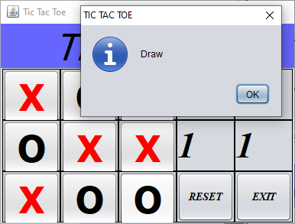

*SCORE BOARD:*

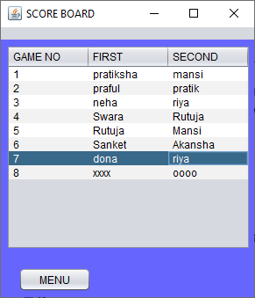

*HOW TO PLAY:*

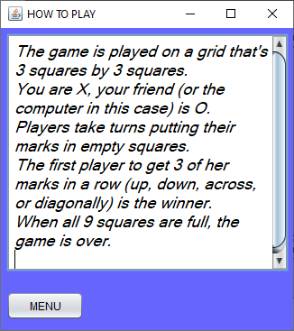

*ON CHAT BUTTON:*

*FRIEND LIST:*

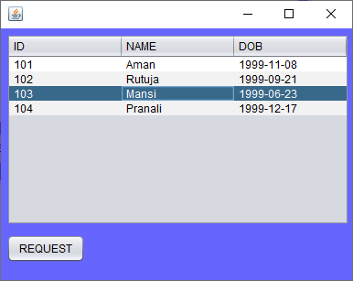

*ON REQUEST BUTTON:*

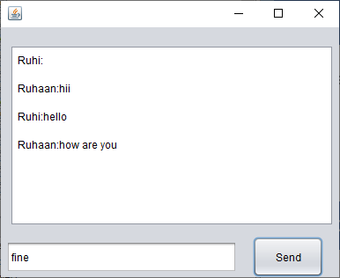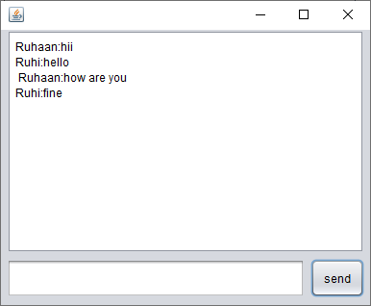

*FUTURE SCOPE:*

With the current proposed system and the provided technology. Future scope of the project involves and update where the front end application be made into an Application.

With the use of internet technologies one would be able to access the database to add/delete/update records from any remote location.

*BIBILOGRAPHY:*

During the development of the above-mentioned project the following reference links, Books were used.

1. The Complete Reference JAVA [7TH EDITION].
2. Java and Advance Java Notes [ Semester 5&6]
3. DBMS Notes [For ERD Purposes]
4. DBMS Notes [For Database Connectivity]
5. Websites:
   1. [https://www.youtube.com/](https://www.youtube.com//)
   2. <https://stackoverflow.com/>
   3. <https://www.google.co.in/?gws_rd=ssl>\