**PHASE 3**

**Start building the IoT-enabled public transportation optimization system.**

**Introduction:**

In the ever-evolving landscape of urban transportation, the integration of Internet of Things (IoT) technology has emerged as a transformative solution. This system harnesses the power of IoT sensors, like GPS and passenger counters, installed within public transportation vehicles, and couples them with sophisticated data processing and analysis tools. The goal? To revolutionize the way public transit operates, from real-time tracking of vehicle locations to optimizing routes and services, ultimately enhancing the passenger experience and overall efficiency of public transportation systems. In this context, we delve into the details of how this innovative system is designed and implemented.

1. **Define Objectives and Requirements:**

Start by defining the objectives of your public transportation optimization system. What are the specific goals? Is it to reduce traffic congestion, improve passenger experience, or minimize operational costs? Identify key requirements, such as real-time data collection and analysis, connectivity, and automation.

1. **Hardware Selection:**

Choose the IoT hardware components that will be used to collect data. This can include sensors, GPS modules, cameras, and communication devices. Ensure that the selected hardware is durable, reliable, and compatible with your chosen communication protocols.

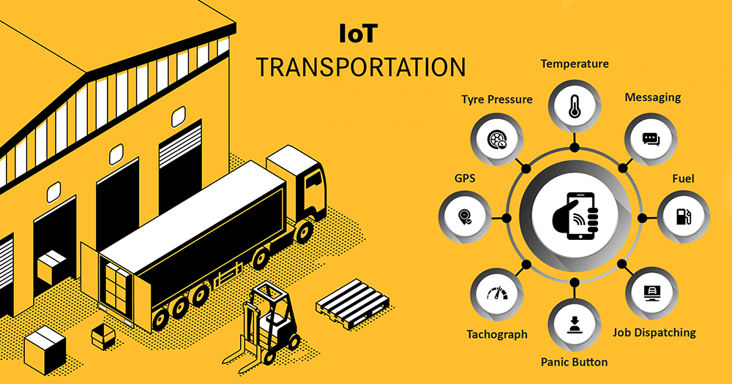

1. **Sensor Deployment:**

Install sensors and IoT devices on public transportation vehicles, such as buses, trams, and trains. Sensors can be used to gather data on factors like passenger count, location, temperature, humidity, and vehicle condition. These devices should be securely mounted and regularly maintained.

1. **Data Communication:**

Establish a reliable communication infrastructure for transmitting data from sensors to a central server or cloud platform. IoT devices can use cellular networks, Wi-Fi, or other communication protocols to send data. Ensure data security and encryption measures are in place to protect sensitive information.

1. **Cloud Platform and Data Storage:**

Set up a cloud platform for storing and processing the collected data. Cloud services like AWS, Azure, or Google Cloud provide scalable and secure environments for managing IoT data. Implement data storage and retrieval mechanisms that are both efficient and compliant with relevant regulations.

1. **Data Analysis and Processing:**

Develop algorithms and analytics models to process the incoming data. Real-time analysis can help in optimizing routes, predicting maintenance needs, and improving passenger safety and comfort. Machine learning and AI can be used to make predictions and generate actionable insights.

1. **Integration with Traffic Management Systems:**

Integrate your IoT system with traffic management systems to receive real-time traffic and road condition data. This integration will help optimize routes and schedules for public transportation vehicles.

1. **User-Facing Applications:**

Create user-facing applications, such as mobile apps or web portals, for passengers to access real-time information, schedules, and updates about public transportation. These applications can also provide features like ticketing and passenger feedback.

1. **Optimization and Automation:**

Implement automation features based on the data and analysis. This may include dynamic route adjustments, predictive maintenance scheduling, and driver alerts for traffic or weather conditions.

1. **Security and Compliance:**

Implement robust security measures to protect the system from cyber threats. Ensure compliance with data privacy and transportation regulations to maintain passenger trust.

1. **Testing and Maintenance:**

Rigorously test the system before deployment to identify and resolve any issues. After deployment, establish a routine maintenance schedule to ensure sensors and devices are functioning correctly.

1. **Scale and Expand:**

As your system proves successful, consider expanding to cover more public transportation routes, additional cities, or other modes of transport like subways or ferries.

1. **Monitoring and Continuous Improvement:**

Continuously monitor the system's performance, gather feedback, and make improvements based on user and operational insights.

Building an IoT-enabled public transportation optimization system is a complex endeavor that requires coordination with various stakeholders, including transportation authorities, technology providers, and the public.

**Deploy IoT sensors (e.g., GPS, passenger counters) in public transportation vehicles to gather data.**

1. **Identify Data Needs:** Before deploying sensors, identify the specific data you need to collect. This can include GPS data for tracking vehicle location, passenger counters to monitor occupancy, temperature and humidity sensors for passenger comfort, and any other relevant parameters. Define clear objectives for each sensor type.

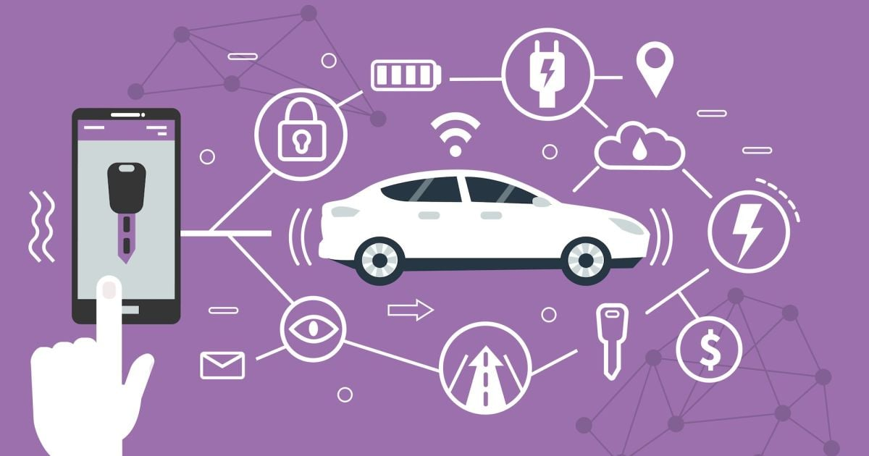

1. **Select Appropriate Sensors:** Choose IoT sensors that are suitable for your data collection needs. For example, select reliable GPS modules, accurate passenger counters, and environmental sensors that can withstand the conditions within public transportation vehicles.
2. **Mounting and Installation:** Properly install the sensors in each vehicle. Consider the following:
   * GPS sensors should have an unobstructed view of the sky for accurate location data.
   * Passenger counters should be strategically placed near entry/exit points.
   * Environmental sensors should be placed in areas where they can capture representative data.
3. **Wiring and Power Supply:** Ensure that the sensors are correctly wired and connected to a power supply. Depending on the type of sensor, this may involve connecting to the vehicle's electrical system or using battery-powered sensors. Power redundancy and backup solutions can be essential to maintain data collection in case of power interruptions.
4. **Data Transmission:** Set up a data transmission system to send sensor data to a central server or cloud platform. Depending on the type of sensor, this may involve wired connections or wireless communication methods like cellular or Wi-Fi.
5. **Data Encryption and Security:** Implement data encryption and security protocols to protect the data collected by the sensors. Data security is critical, especially when dealing with passenger-related information.
6. **Data Aggregation and Formatting:** Develop software or firmware to aggregate, format, and timestamp the data collected by the sensors. Ensure that the data is in a standardized format for easy analysis and processing.
7. **Real-Time Data Collection:** Configure the sensors to collect data in real-time. This allows for immediate analysis and decision-making, such as optimizing routes, managing vehicle occupancy, or providing real-time updates to passengers.
8. **Testing and Calibration:** Before deploying the sensors in a live environment, perform extensive testing and calibration to ensure that the sensors are accurate and reliable. This includes testing for accuracy in GPS data and passenger counting.
9. **Maintenance and Diagnostics:** Implement systems for remote diagnostics and maintenance. This will help you monitor the health of the sensors and quickly address any issues that arise.
10. **Data Backup and Redundancy:** Ensure that data collected by the sensors is backed up and stored securely. Implement redundancy mechanisms to prevent data loss in case of sensor or network failures.
11. **Compliance and Privacy:** Be aware of data privacy regulations and comply with them, especially when collecting data related to passengers. Ensure that data is anonymized when necessary.
12. **Integration with Data Processing Systems:** Integrate the sensor data with your data processing and analytics systems to derive insights and make real-time decisions.
13. **Data Retention and Cleanup:** Establish data retention policies to manage the volume of data collected and ensure that outdated data is regularly cleaned up.
14. **Monitoring and Alerts:** Set up monitoring systems to receive alerts in case of sensor malfunctions or unusual data patterns.

**Develop a Python script on the IoT sensors to send real-time location and ridership data to the transit information platform.**

1. **Choose the Appropriate Hardware:**
   * Select IoT sensors capable of collecting location and ridership data. Common choices include GPS modules for location data and passenger counters for ridership data.
2. **Set Up the Hardware:**
   * Connect the IoT sensors to a microcontroller or single-board computer (e.g., Raspberry Pi) that can run Python scripts. Ensure the hardware is properly powered and configured.
3. **Install Required Python Libraries:**
   * Install any necessary Python libraries for working with sensors and communication protocols. For example, you might need libraries for GPS data and serial communication.
4. **Obtain Transit Information Platform API Access:**
   * Contact the transit information platform provider to obtain API access and authentication credentials for sending data to their system.
5. **Write the Python Script:**

Here's an example Python script to get you started. This script collects GPS location data and ridership data from sensors and sends it to the transit information platform using a hypothetical API:

**PROGRAM:**

import paho.mqtt.client as mqtt

import json

from gps import gps, WATCH_ENABLE

import time

# MQTT Broker (Replace with your broker details)

MQTT_BROKER_HOST = "mqtt.example.com"

MQTT_BROKER_PORT = 1883

MQTT_TOPIC = "transit_data"

# Create a GPSD session

session = gps(mode=WATCH_ENABLE)

# MQTT on_connect callback

def on_connect(client, userdata, flags, rc):

print(f"Connected with result code {rc}")

client.subscribe(MQTT_TOPIC)

# MQTT on_publish callback

def on_publish(client, userdata, mid):

print(f"Message {mid} published")

# MQTT client setup

client = mqtt.Client()

client.on_connect = on_connect

client.on_publish = on_publish

# Connect to the MQTT broker

client.connect(MQTT_BROKER_HOST, MQTT_BROKER_PORT, 60)

try:

while True:

# Read GPS data

report = session.next()

if report['class'] == 'TPV':

latitude = report.get('lat', 0.0)

longitude = report.get('lon', 0.0)

data = {

"location": {

"latitude": latitude,

"longitude": longitude

}

}

# Convert data to JSON

json_data = json.dumps(data)

# Publish data to the MQTT topic

client.publish(MQTT_TOPIC, json_data)

print(f"Published data: {json_data}")

# Send data every 10 seconds (adjust as needed)

time.sleep(10)

except KeyboardInterrupt:

print("Script terminated by user.")

client.disconnect()

session.close()

# Run the MQTT client loop in the background

client.loop_start()

This script reads real-time GPS data from the sensor attached to the Raspberry Pi and publishes it to the MQTT broker. Make sure to replace the MQTT broker details, such as **MQTT_BROKER_HOST** and **MQTT_BROKER_PORT**, with your actual broker information. Additionally, you should adapt the script to suit your specific hardware setup and configuration.

**CONCULUSION:**

In conclusion, the development of an IoT-enabled public transportation optimization system is a multifaceted endeavor with the potential to significantly enhance the efficiency and quality of public transit services. By equipping vehicles with IoT sensors like GPS and passenger counters, and crafting Python scripts to transmit real-time data to a cloud platform, transportation authorities can gain valuable insights into vehicle locations and ridership patterns.

This data is then processed and analyzed on the cloud platform, allowing for the implementation of optimization algorithms and real-time monitoring. The result is more efficient route planning, improved user experiences, and the ability to promptly address issues like delays or overcrowding. However, it's imperative to prioritize data security and adhere to legal and privacy regulations in handling public transportation data.

Overall, such a system has the potential to revolutionize public transit, offering better services and enhanced decision-making capabilities for transportation authorities. Continuous maintenance and adaptation will be key to ensuring the system's ongoing success and relevance.