English oriented to Cybersecurity
Group: I-C
English Project
IoT device name: CruxifAI
Student’s names:
Axel Lopez
Daniel Arce
Edison Sanchez
Teacher’s name
Paul Sanchez Calvo
Date:
28/04/25

CruXifAI by Sacram


Introduction
CruXifAITM is an IoT device which allows you, the user, to become free of sin. CruXifAITM features many SALVATIONTM-oriented functions for users in both times of need and of comfort. CruXifAITM is also designed to help users achieve SALVATIONTM more efficiently and effectively, though a series of built-in features which administer a PENANCETM to the measure of the user’s sins.
Among many of its unique features, CruXifAITM provides access to a counseling service through an AI-powered assistant, aptly named FATHERTM. FATHERTM can listen to the user and reply back, using the CruXifAITM’s speaker. FATHERTM has been approved by the Vatican for sin-forgiveness use cases.
Another of CruXifAITM’s features are seen in the form of its PENANCETM administrators, which are attached to the back side of the device, in close contact with the wearer’s chest. The function of these electrical contacts is to provide PENANCETM, as per the criteria determined by Sacram and the CruXifAI moderation team.

Device overview
- Name of the invention: CruXifAITM
- Motto: “Connected with SALVATIONTM”

Visual diagram
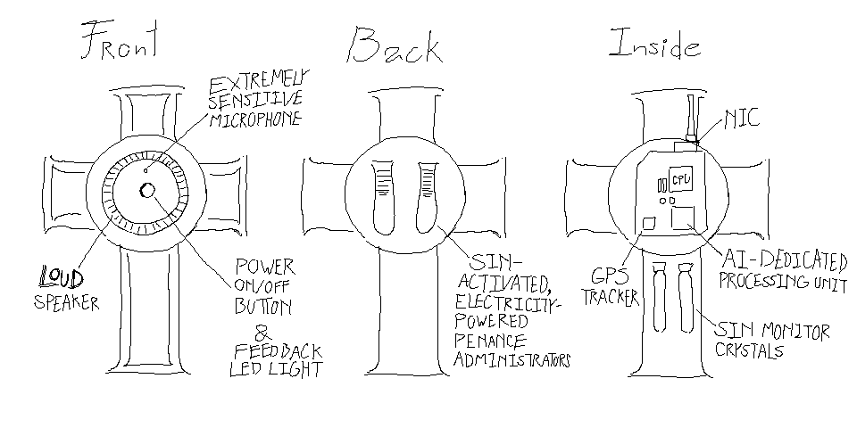
  - Speaker: Plays high-definition audio at an equally high volume. This lets the CruXifAITM comunicate with the user using a synthetized voice, and produce music and ambience.
  - Microphone: Listens to, and overhears the user’s confessions and completely unrelated musings, always ready to respond to—or punish—them accordingly.
  - Power ON/OFF button: Does not really power off the device completely, but rather puts it in a “sleep” mode. This is purely for convenience, of course.
  - LED light: A single source of visual feedback, attached to the Power ON/OFF button. It blinks red when battery is low, and when it’s about to activate the PENANCETM administrators.
  - GPS tracker: Updates the wearer’s location to Sacram’s cloud every twenty seconds. This is used mostly for the user’s convenience, and to consult for nearby churches of all denominations.
  - NIC and Bluetooth interface: Used to back up private data to Sacram’s data centers, and to connect with the mandatory app that comes with the CruXifAITM device.
  - AI-dedicated Processing Unit (AIPU): Helps a bit with the overhead of handling a large language model’s responses.
  - Sin monitor crystals: A propietary technology used to detect the presence of evil spirits and sin. These help the FATHERTM AI determine the weight of the user’s soul, to calculate the right amount of PENANCETM.

Operating instructions

Quick-start Guide
  - Download and install the official FATHERTM app from Google Play or the Apple App Store.
  - Ensure the device has enough battery charge. You can charge the device with the exclusive CruXifAITM charger that comes included with the device
  - To turn on the device, press the Power ON/OFF button located in the front of the crucifix for 2 seconds (see diagrams).
  - Pair the device with your smartphone like with any other Bluetooth device.
  - To activate your CruXifAITM, open the FATHERTM app, and select “Create new account”, if you do not yet have one. Follow through the instructions provided within the sign-up form. Questions will include opinions on controversial subjects, Christian denomination and private information.
  - Select a monthly or a yearly plan. The monthly sucks and the yearly is overpriced.
  - After the form, provide the network details requested so that the CruXifAITM can connect to the internet.
  - Once you’ve completed all of the steps above, your CruXifAITM will be paired with the FATHERTM app. From here, you can monitor the state of the device, as well as browse through some part of the vast amounts of un-deletable data it logs for you on Sacram’s cloud.

How to turn CruXifAITM off
You can NOT turn it back off, once it’s been enabled. CruXifAITM will ALWAYS be with you.

Taking the most out of your CruXifAI
  - CruXifAITM’s main feature is the AI-assistant, FATHERTM. To make use of it, first make sure that you’ve enabled your account, and then simply call upon your NEW_GOD unto the microphone, by saying: “Our father who art in Cloud”.
  - FATHERTM can dynamically answer all of your faith-reated questions, by interfacing with you via natural-language voice commands and queries.
  - FATHERTM is able to:
    - Listen to and overhear the user’s confessions.
    - Provide counseling and advice.
    - Recommend approved reading material.
    - Read recommended maerial out loud.
    - Play approved music and ambience sounds.
    - Suggest the location of nearby churches, according to the users’s denomination.
    - Much, much more.

The intuitive CruXifAITM-FATHERTM ecosystem
- The CruXifAITM device in itself, provides only a button and a microphone as input methods. For greater control, you must resort to the FATHERTM app.
- Once you’ve created a FATHERTM account and settled on a subcription method, the app will let you access more of CruXifAITM’s features and configurations.
- The FATHERTM lets you:
  - Track the current location of the CruXifAITM device.
  - Read (but not delete) logs relating to past conversations you’ve had with FATHERTM.
  - Manage your account and current religious preferences.
  - Purchase official music and reading material at the Sacram Store, so that you can play it back on the CruXifAITM’s speaker.

The PENANCETM system
Not everybody has the time to stop and think about their own sins and hidden skeletons in the closet. At Sacram, we know this better than anybody, and that’s why we decided to implement our PENANCETM system.
The PENANCETM system allows you to offer retribution for your sins in the most efficient way possible. In the back of your CruXifAITM there are two electrical contacts named the PENANCETM administrators. These are activated automatically whenever any of CruXifAITM’s sensors detect the slightest hint of sin or evil presence. This way, you’ll always be free of sin!

Specifications
- Size: varies with model.
- Battery lasts up to 30 hours.

Warranty and Legal information
CruXifAITM is covered by a 1-year warranty from the date of purchase. This warranty covers manufacturing defects in materials and workmanship under normal use conditions.
Sacram will not be responsible, under any circumstances, for:
- Death by electrocution
- Early Rapture
- Prophetic dreams of disaster becoming true
- Schizophrenia
- False tongue-speaking
- Being fooled by the Antichrist

Compliance statements
The CruXifAITM line of products has been approved by the Vatican, and all of the millions of different denominations of churches spread all thoughtout continental America.
CruXifAITM, however, is, by design, not compliant with ISO 666.

Price and contact
- Where is this device available: Get your own CruXifAITM at your nearest Sacram store or authorized electronics retailer today!
- Email and phone number technical support: help@cruxif.ai
- Price of the device: $130*

* Purchase of the CruXifAI device does not include a subscription to the FATHERTM online service. FATHERTM is necessary for the proper operation of CruXifAITM.

