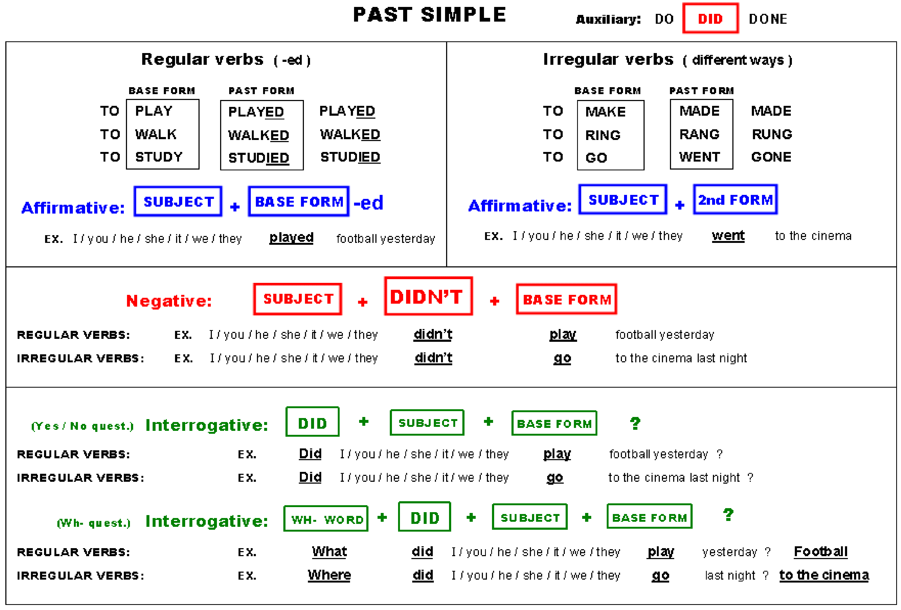

# Past Simple (regular verbs)

 **Write the Past Simple form of the verbs below in the correct column.**

repeat worry finish start phone call miss enjoy visit marry listen cry play hate wash climb live arrive talk look stay ask clean travel open like walk carry stop mix plan decide tidy

|  |  |  |
| --- | --- | --- |
| **pronunciation D** | **pronunciation T** | **Pronunciation ID** |
| Worried  Phoned  Called  Enjoyed  Married  Listened  Cried  Played  Climbed  Lived  Arrived  Stayed  Cleaned  Opened  Carried  Planned  Tidied | Finished  Missed  Washed  Talked  Looked  Asked  Travelled  Liked  Walked  Stopped  Mixed | Repeated  Started  Visited  Hated  Decided |

 **Write sentences in Past Simple:**

1. **Affirmative**
2. **Negative**
3. **Interrogative (Yes / No)**
4. **My sister / tidy / her room / yesterday morning.**
5. **She tidied her room yesterday morning**
6. **She did not (didn’t) tidy her room yesterday**
7. Did she tidy her room yesterday?
8. **We / live / in New York / in 1997.**



1. We lived in New York in 1997
2. We did not live in New York in 1997
3. Did we live in New York in 1997
4. **Tom / travel / to Dublin / last night.**
5. **Tom travelled to Dublin…**
6. **Tom did not travel to Dublin…**
7. **Did Tom travel to Dublin…?**
8. **I / clean / my teeth / twice / yesterday.**
9. I cleaned my teeth…
10. I did not clean my teeth…
11. Did I clean my teeth…?
12. **John / stay / at Mary’s house / last summer.**
13. John stayed at Mary’s house last summer.
14. John did not stay at Mary’s house last summer.
15. Did John stay at Mary’s house last summer?
16. **You / start / school / ten years ago.**
17. You started school…
18. You did not start school…
19. Did you start school…?
20. **The film / end / very late / last weekend.**
21. The film ended very late…
22. The film did not end very late…
23. Did the film end very late…?
24. **Sue and Pat / talk / on the phone / yesterday.**
25. Sue and Pat talked…
26. Sue and Pat did not talk...
27. Did Sue and Pat talk…?

 **Write the verbs in brackets in Past Simple.**

|  |  |
| --- | --- |
| * My sister tidied (tidy) her bedroom yesterday morning. * We phoned (phone) our cousins last week. * The girls played (play) on the computer last night. * I travelled (travel) to Paris three months ago. | * John stayed (stay) at his granny’s house last summer. * The film ended (end) very late yesterday. * My family lived (live) in New York in 1995. * You cleaned (clean) your teeth three times yesterday. |

 **Complete the sentences with the verbs below in Past Simple.**



1. Lucy liked her birthday presents.
2. 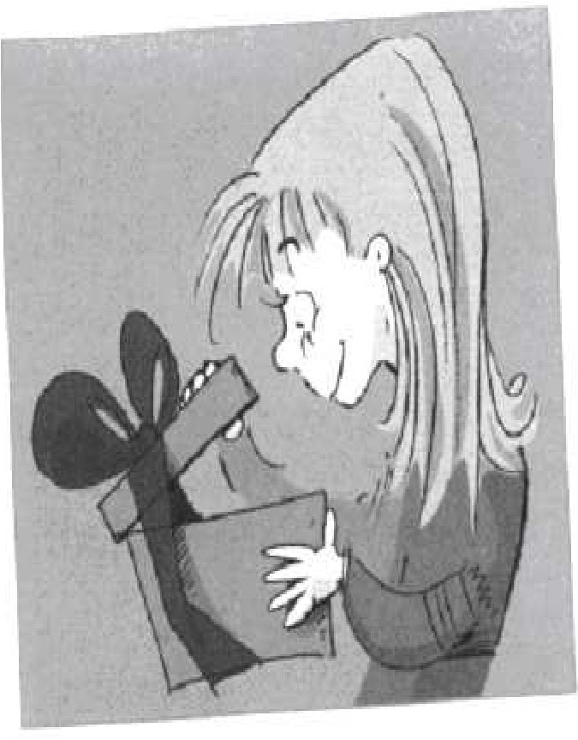Last weekend I walked in the mountains for 2 hours.
3. We enjoyed the party very much.
4. Ken listened to his favourite CD yesterday.
5. My sister studied Maths for an exam.
6. They travelled to the USA in 2003.
7. Dad washed his car last weekend.
8. The film finished at 11:30.

 **Write the sentences in negative.**

1. Lucy did not like her birthday presents.
2. Last weekend I did not walk in the mountains for 2 hours
3. We did not enjoy the party very much
4. Ken did not listen to his favourite CD yesterday
5. My sister did not study Maths for an exam
6. They did not travel to the USA in 2003
7. Dad did not wash his car last weekend
8. The film did not finish at 11:30





**What did you do yesterday? Put a ( ) or a ( ).**

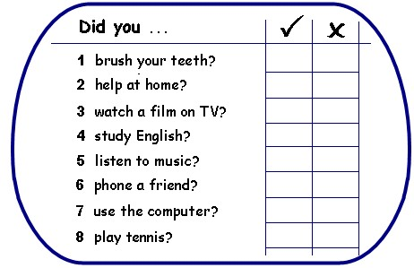

 **Write questions about the previous activities and answer them.**

**1-** Did you brush your teeth yesterday? Yes, I did wash my teeth yesterday

**2- Did you help at home**? Yes, I helped at home

1. Did you watch a film on TV? I did watch a movie, but not on TV
2. Did you study English? No, I did not study English, I used it
3. Did you listen to music? Yes, I listened to music
4. Did you phone a friend? No, I did not phone a friend, but I chatted with one
5. Did you use a computer? Yes, forcefully so.
6. Did you play tennis? You’ll not catch me dead playing tennis

 **Ask your classmate the questions and compare the answers. Use and or but to join the actions.**

1. Yesterday I brushed my teeth and VOID did too
2. Yesterday I helped at home but VOID did not
3. Yesterday I watched a film and VOID did too
4. Yesterday I did not study English but VOID did
5. Yesterday I listened to music but VOID did not
6. Yesterday I chatted with a friend but VOID phoned one
7. Yesterday I used a computer and VOID did too
8. Yesterday I did not play tennis and VOID did not either

# Past Simple (irregular verbs)

 **Complete the table.**

**Then complete the sentences with the Past Simple of the verbs in brackets.**

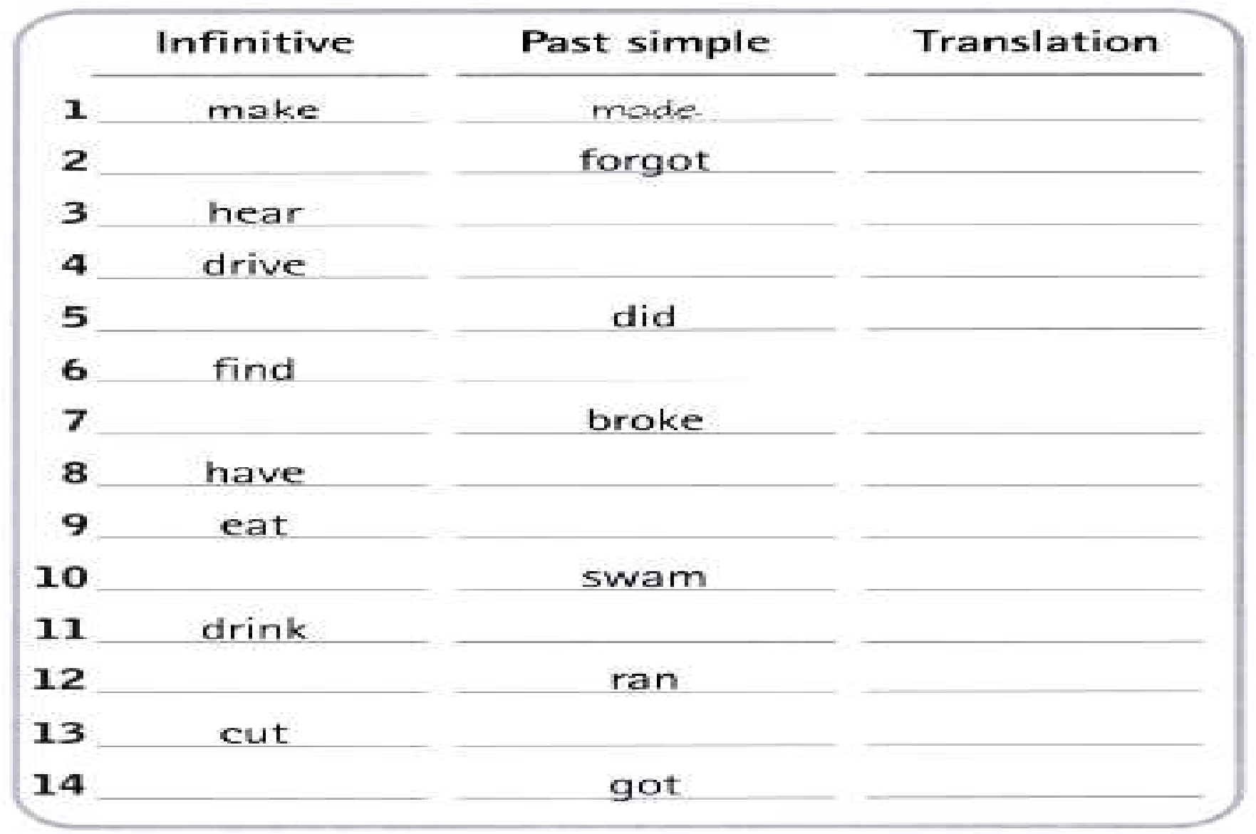

Make made hacer

Forget forgot olvidar

Hear heard escuchar

Drive drove conducer

Do did hacer

Find found encontrar

Break broke romper

Have had tener

Eat ate comer

Swim swam nadar

Drink drank beber

Run ran corer

Cut cut cortar

Get got obtener

She went (go) to school on foot yesterday. **-** My dad gave (give) me a CD for my birthday.

* Paul ate (eat) 2 sandwiches and an apple. **-** Ana had (have) a bath last Sunday.
* I got (get) up very early last night. **-** We swam (swim) in the Mediterranean sea.
* They found (find) 50 euros in the street. **-** Joe wrote (write) a letter to Mary 2 days ago.

 **Complete the sentences. Use the *negative form* of the underlined verbs.**

**Yesterday ...**

* I drank coffee but I didn’t drink tea.
* She found her purse but she didn’t find her keys.
* The children broke the window but they did not find the door.
* He had a shower but he did not have breakfast.
* My father made a cake but he did not make any pastries.
* We spoke English and French but we did not speak German.

 **Match the pictures with the actions and write the Past Simple of the verbs.**

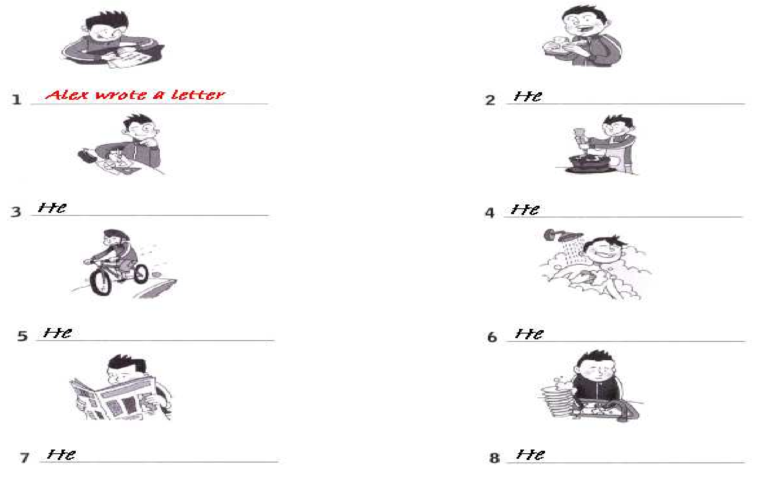

1. Alex wrote a letter
2. He ate a sandwich
3. He did the homework
4. He made a cake
5. He rode a bike
6. He had a shower
7. He read the newspaper
8. He did the washing up

 **Write questions about Alex and answer them.**



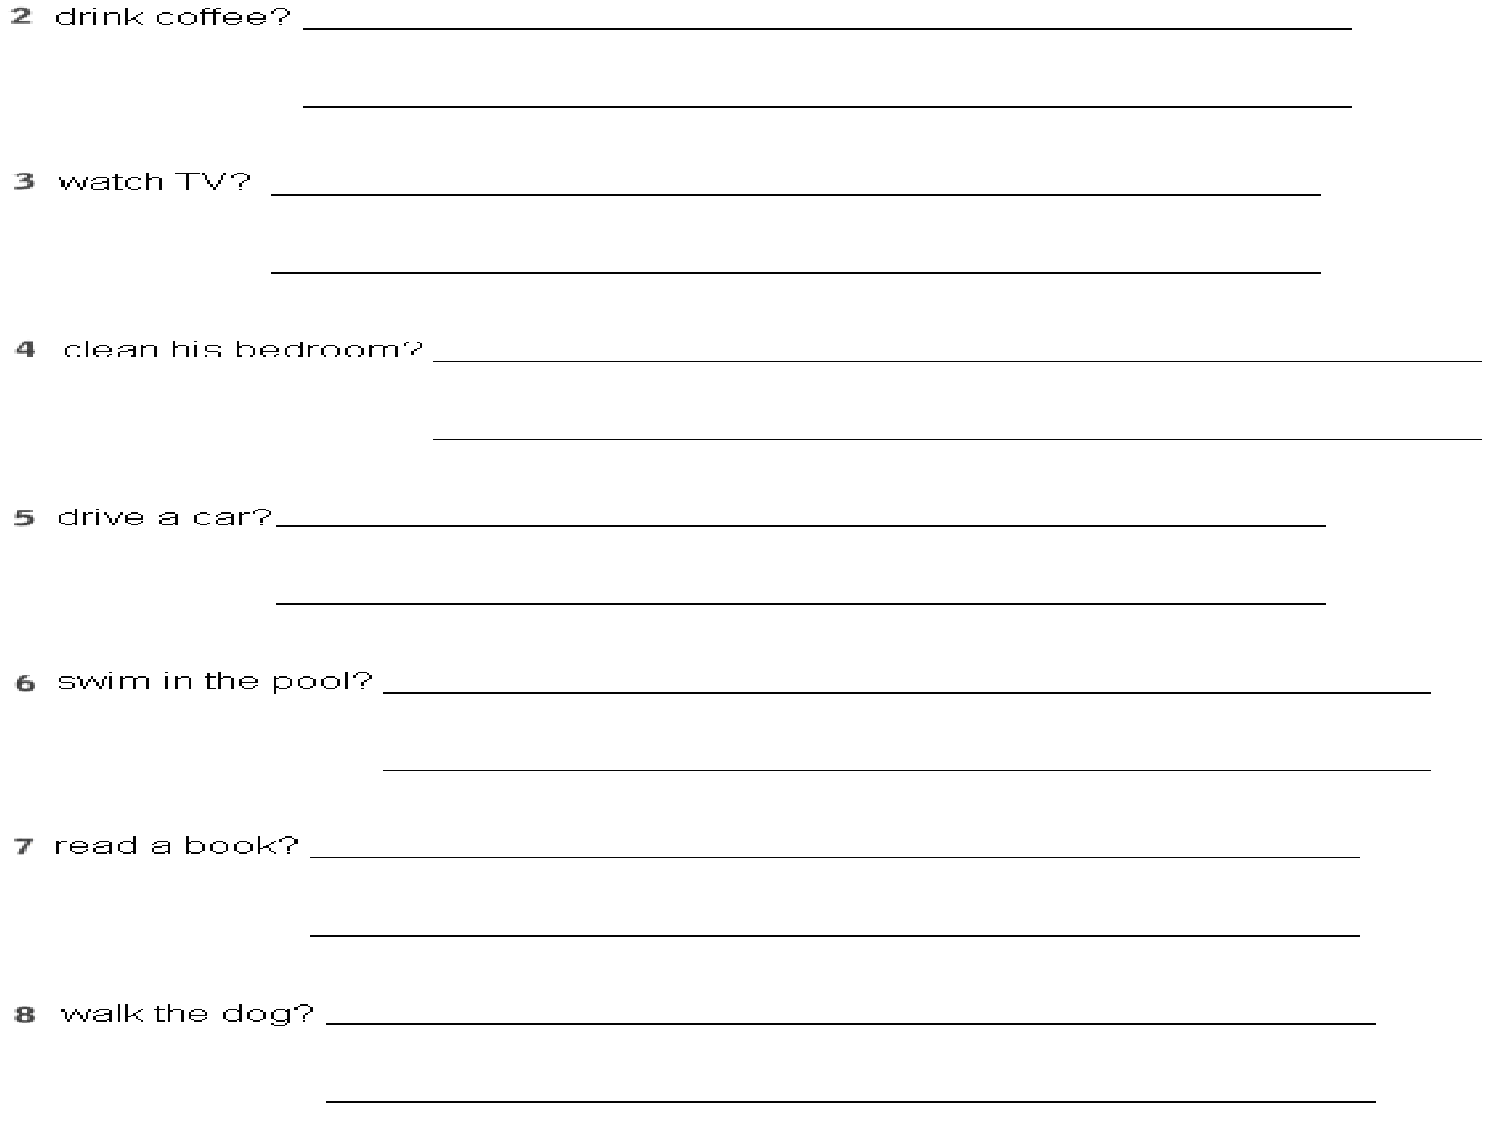

1. Did Alex play computer games? No, he did not. He wrote a letter.
2. Did he drink coffee? No, he did not. He ate a sandwich.
3. Did he watch TV? No, he did not. He read the newspaper
4. Did he clean his bedroom? No, he did not. He did the washing up
5. Did he drive a car? No, he did not. He rode a bike.
6. Did he swim in the pool? No, he did not. He had a shower.
7. Did he read a book? No, he did not. He made a cake.
8. Did he walk the dog? No, he did not. He did the homework

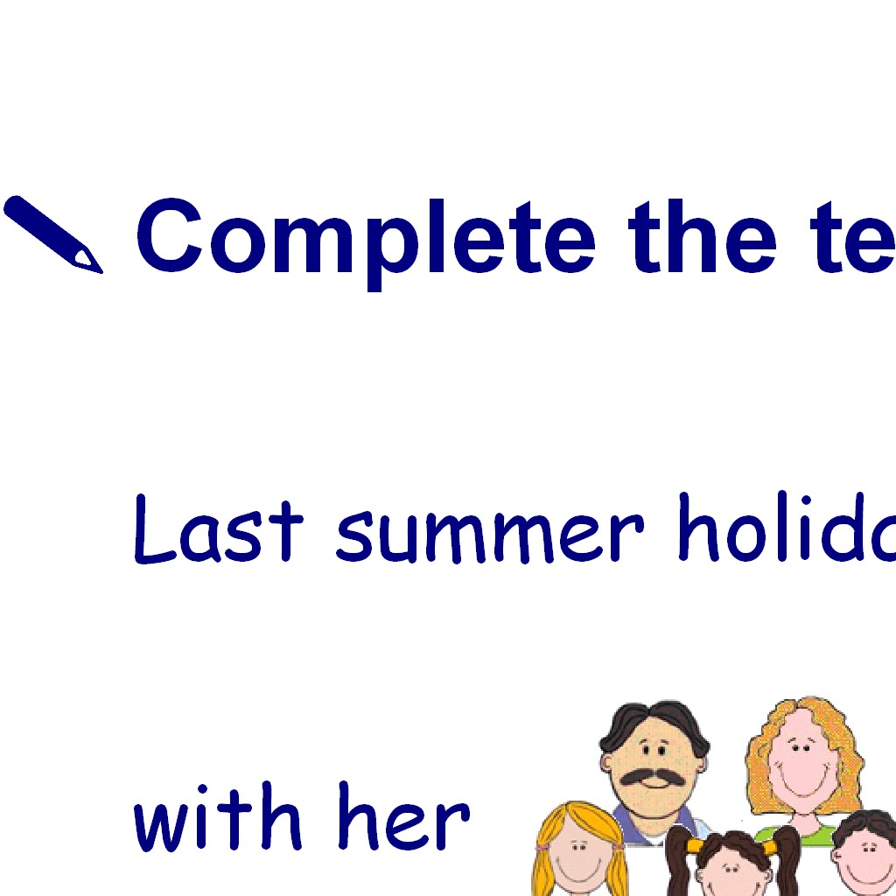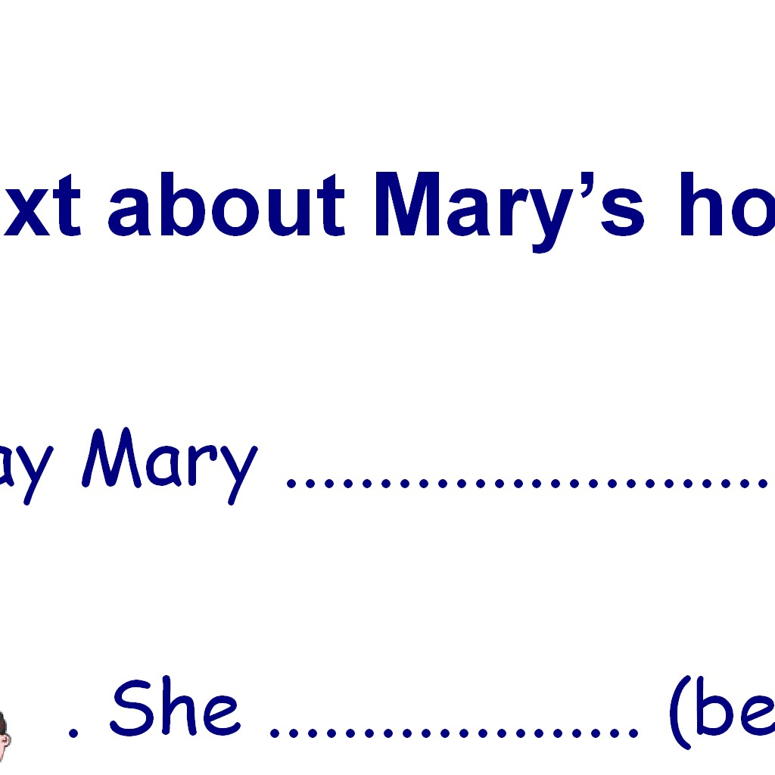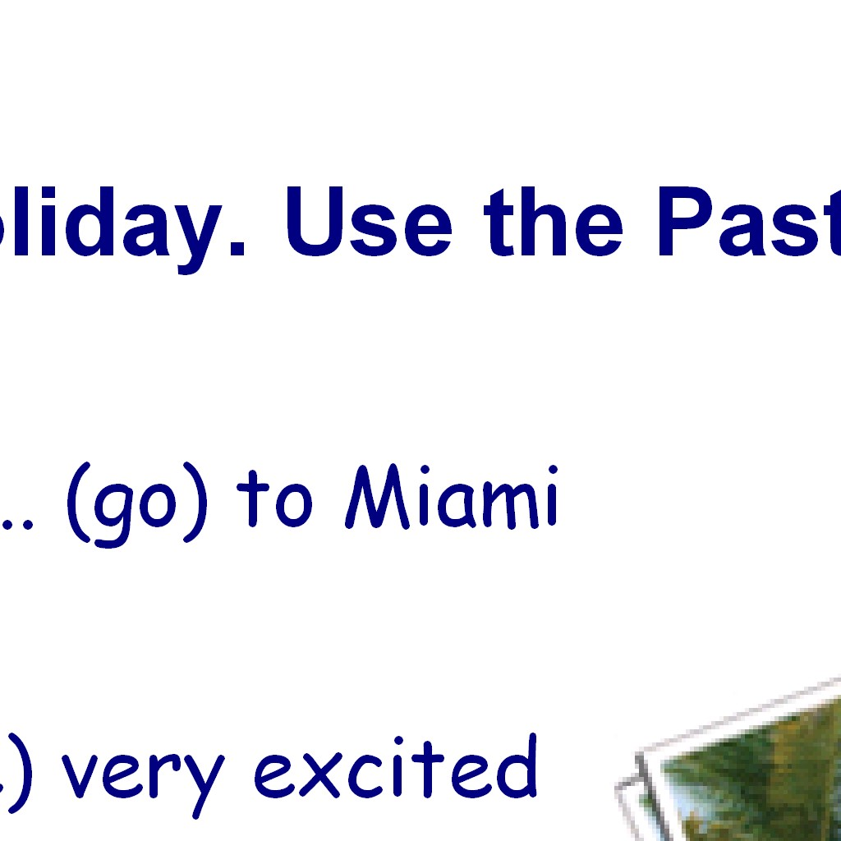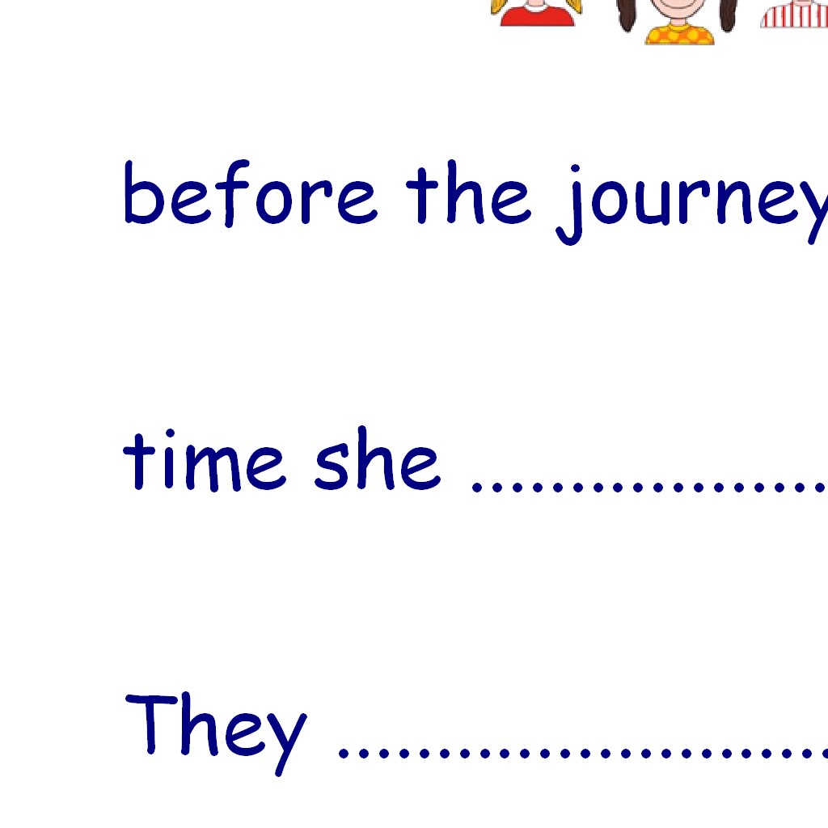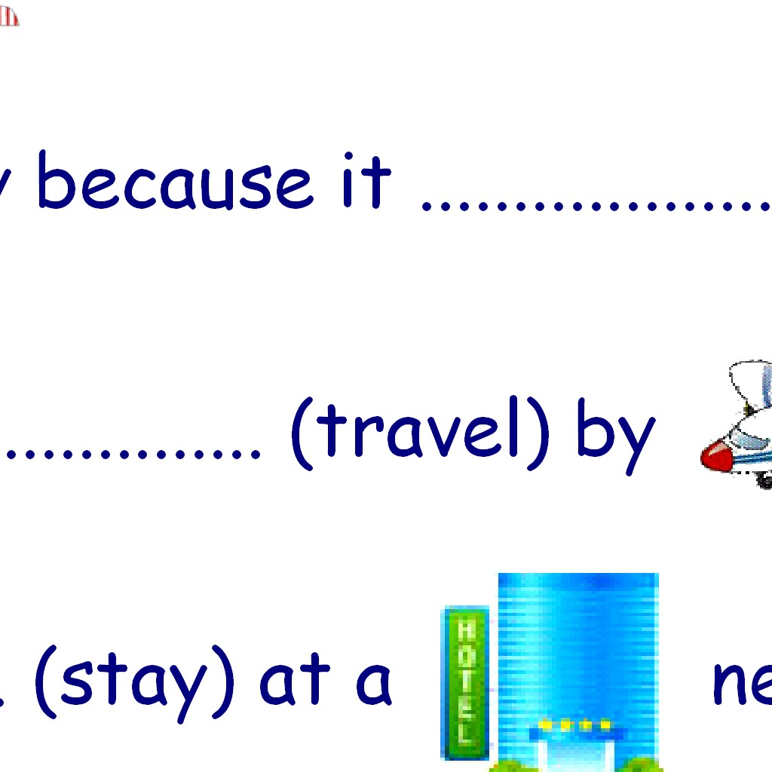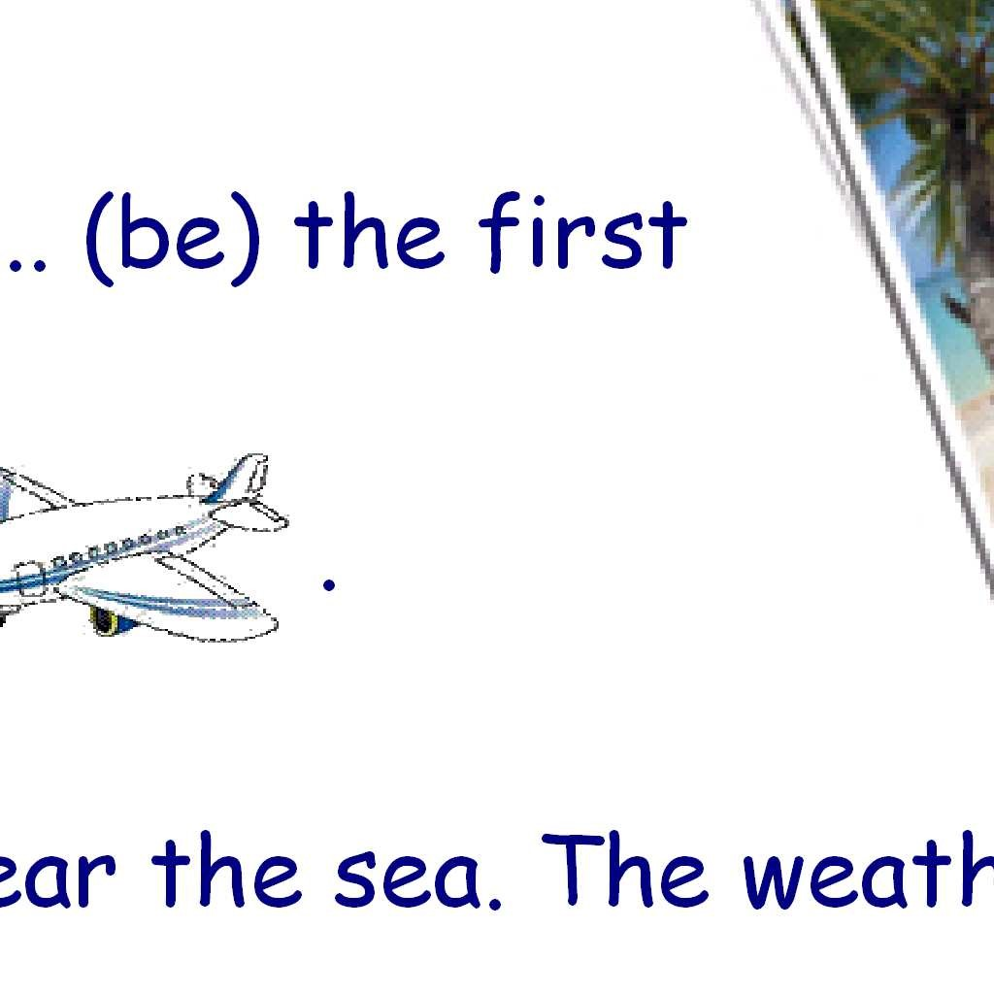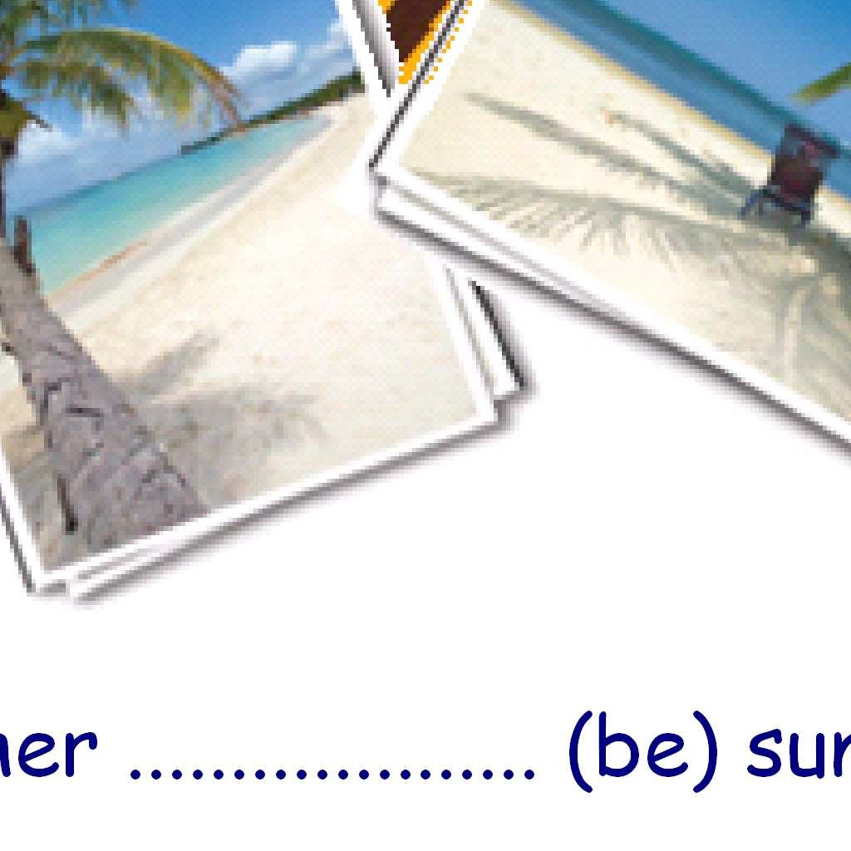

Mary likes and the children love .

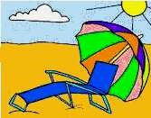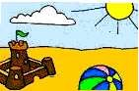

Last summer holiday Mary went to Miami

With her family. She was very excited

Before the journey because it was the first

time she travelled by plane.

They stayed at a hotel near the sea. The weather was sunny and

Very hot. In the morning they usually went to the beach.

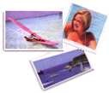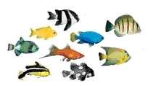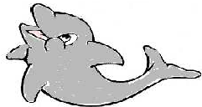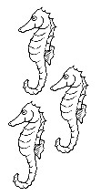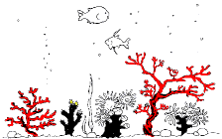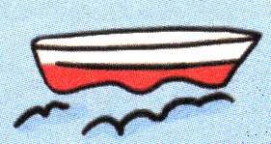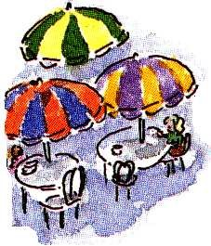So Mary and Mum sunbathed (sunbathe) and the children played (play) with the ball and made (make) sandcastles. Dad swam (swim) in the sea and read (read) the under the umbrella. We usually had (have) lunch in a near the beach. In the afternoon they visited (visit) very interesting places. One day They went (go) out in a . It was (be) amazing! They liked (like) the best. They saw (see) different , some and even a jumped (jump) in front of the boat. They also watched (watch) some people feed the fish. Mary took (take) a lot of .

The family enjoyed (enjoy) a lot.

The last day it rained (rain). The whole family went (go) to a shopping centre.

They bought (buy) some souvenirs. In the afternoon they returned (return)

home. Mary and her family had (have) a great time there !!!!

**WRITE sentences in PAST SIMPLE:**

1. **Affirmative**
2. **Negative**
3. **Interrogative (Yes / No)**
4. **He / phone / a friend / an hour ago.**
5. He phoned a friend…
6. He did not phone a friend
7. Did he phone a friend…?
8. **My father / buy / a jeep / last week.**
9. My father bought…
10. My father did not buy…
11. Did my father buy…?
12. **The girls / wear / skirts / to the party**
13. The girls wore…
14. The girls did not wear…
15. Did the girls wear…?
16. **I / wash / my hair / last night**
17. I washed my hair…
18. I did not wash my hair…
19. Did I wash my hair…?
20. **Jane / send / four e-mails / to Lisa**
21. Jane sent…
22. Jane did not send…
23. Did Jane send…?
24. **The old lady / carry / heavy bags / yesterday morning**
25. The old lady carried…
26. The old lady did not carry…
27. Did the old lady carry…?
28. **The film / end / very late / last weekend**
29. The film ended very late…
30. The film did not end very late…
31. Did the film end very late…
32. **They / go / to bed / at midnight**
33. They went to bed…
34. They did not go to bed…
35. Did they go to bed…?
36. **The children / play / tennis and basketball / at the sports centre.**
37. The children played…
38. The children did not play…
39. Did the children play…
40. **You / do / your homework / last weekend.**
41. You did your homework…
42. You did not do your homework…
43. Did you do your homework...
44. **My friend / study / German / last year.**
45. My friend studied German…
46. My friend did not study German…
47. Did my friend study German…
48. **I / get up / at seven / last Sunday morning**
49. I got up at seven…
50. I did not get up at seven…
51. Did I get up at seven…?
52. **We / visit / our friends / yesterday evening**
53. We visited our friends…
54. We did not visit our friends…
55. Did we visit our friends…?
56. **She / have lunch / in an Italian restaurant**
57. She had lunch…
58. She did not have lunch…
59. Did she have lunch…?
60. **They / watch / TV / in the living room**
61. They watched TV…
62. They did not watch TV…
63. Did they watch TV…?
64. **He / drink / orange juice / for breakfast**
65. He drank orange juice…
66. He did not drink orange juice…
67. Did he drink orange juice…?

**Write *Wh- questions* for the underlined words in the previous sentences.**

**Use these wh- words:**

**WHERE WHAT TIME WHEN WHAT HOW MANY WHO**

1. **– Where were you at the time of the incident?**
2. **– What time did you leave the house?**
3. – When exactly did you make that phone call?
4. **– What color dress was she wearing?**
5. **– How many hours did you drive after finding out about… her?**
6. **– Who was it you saw on the sidewalk before fleeing?**
7. **-** ............................................................................................................................................
8. **-** ............................................................................................................................................
9. **-** ............................................................................................................................................
10. **-** ............................................................................................................................................
11. **-** ............................................................................................................................................
12. **-** ............................................................................................................................................
13. **-** ............................................................................................................................................
14. **-** ............................................................................................................................................
15. **-** ............................................................................................................................................
16. **-** ............................................................................................................................................