

## EDO STATE UNIVERSITY UZAIRUE

SWEP PROGRAM REPORT

## A PRACTICAL REPORT ON STUDENT WORK EXPERIENCE PROGRAM (S.W.E.P)

UNDERTAKEN AT EDO STATE UNIVERSITY ENGINEERING WORKSHOP

KM 7, AUCHI – ABUJA ROAD, IYAMHO- UZAIRUE, EDO STATE, NIGERIA.

**NAME-** AJE-PAUL DAVID OCHOCHE

**MATRICULATION NUMBER-**

ENG/COE/21002660

**DEPARTMENT-**

DEPARTMENT OF COMPUTER ENGINEERING

**FACULTY**-

FACULTY OF ENGINEERING

**LOCATION**-

EDO STATE UNIVERSITY UZAIRUE

**INSTITUTION BASED SUPERVISOR-**

ENGR. F. OAMEN ISAAC

**SUBMITTED IN PARTIAL FUFILMENT OF THE AWARD OF BACHELOR OF ENGINEERING (B.Eng.) IN COMPUTER ENGINEERING**

**FROM-**

29th AUGUST 2022 TO 30th 2021

I

**DECLARATION**

This is to certify that AJE-PAUL DAVID OCHOCHE of Matric number ENG/COE/21002660 compiled this report based on his five (5) weeks student work experience program (S.W.E.P) which was carried out at Edo State University Uzairue, Edo state, Nigeria.

…………………………………... ………………….......................

Name of student Signature and Date

…………………………………………. …………………………………..

Name of Industry Based supervisor Signature and Date

………………………………………… …………………………………

Name of Academic Supervisor Signature and Date

II

**DEDICATION**

It is of great pleasure that I dedicate this Swep report to God Almighty, whose love, mercy, strength has guided me through my life and academic pursuit. And to my parents who have made the resources available to me.

III

**ACKNOWLEDGEMENT**

This report is as a result of the Support and encouragement of several people, among whom is Engr. F. Oamen Isaac who tirelessly put in much effort to see that I acquired the needed experience in the Swep program.

Also, during the program I was fortunate enough to work with the best professional instructors in the university.

Finally, my gratitude goes to my parents Mr and Mrs Paul Aje for their constant support, encouragement and inspiration.

IV

**ABSTRACT**

This report discusses the technical skills gained during the training period and justifying the relevance of the scheme in equipping students with needed technical competence to thrive in the real world.

V

**TABLE OF CONTENT**

Title page……………………………………………………………….I

Declaration………………………………………………………………II

Dedication …………………………………………………………….III

Acknowledgement…………………………………………………….IV

Abstract…………………………………………………………………V

Table of content………………………………………………………...VI

**CHAPTER 1**

1.1 Introduction to SIWES

1.2 Objectives of industrial Training to student

1.3 SIWES Regulatory Agency

1.4 Benefits of Industrial Training (IT) to Student

**CHAPTER 2**

2.1 History of the place of Attachment

2.2 Objective of the Establishment

2.3 Organogram of the Establishment

2.4 Various Department/Units in the Establishment and their Functions

**CHAPTER 3**

3.1 Activities carried out during the period at attachment

3.2 Project Executed

3.3 The experience Acquired

**CHAPTER 4**

4.1 Problems experienced during period of attachment

4.2 Solutions of Problems

VI

**CHAPTER 5**

5.0 Conclusion

5.1 Recommendation

**References**

VII

**CHAPTER ONE**

**1.1 Introduction to SIWES**

The student Industrial Work Experience Scheme (SIWES) was initiated in 1973 by the Industrial Training Fund (ITF). This was to update practical knowledge of students in the Universities, Polytechnics and Colleges of Technology. It was aimed at bridging the gap between the theoretical Knowledge acquired in classes and technical Knowledge in the industries by providing students with the opportunities to apply their educational Knowledge in real work situations.

Over the years, SIWES has contributed immensely to building the common pool of technical and allied skills available to the Nigerian economy which are needed for the nation’s industrial development.

It also gives students the opportunity to blend theoretical Knowledge acquired in the classroom with practical hands-on application of Knowledge required to perform work in the industry. Also, it prepares students for employment and makes the transition from school to the world of work easier after graduation.

I undertook my SWEP training at Edo University, Uzairue Engineering Workshop at Iyamho Edo State, Nigeria. Which lasted from 29th August 2022 to 15th October 2021

**1.2 OBJECTIVE OF THE PROGRAM TO STUDENT**

1. The main objective of the program is to enlighten students on the practical aspects of engineering.

2. Makes the transition from school to the world of work easier and enhance students contact for later job placement

3, It enables the students to put in work all what they have learned in class theoretically.

4. Provides students with an opportunity to apply their knowledge in real work situation thereby bridging the gap between theory and practice.

5. To prepare students for the industrial work situation they are to meet after graduation.

6. It exposes them to various sections such as the carpentry, fitting, welding etc.

7.It also exposes students to work methods and techniques in handling equipment and machinery that may not be available in their institutions.

**CHAPTER TWO**

**2.1 DESCRIPTION OF EDO STATE UNIVERSITY UZAIRUE AS AN ESTABLISHMENT** It is situated in the tranquil and peaceful environment of Iyamho in Edo State, is one of the youngest state universities in Nigeria. Edo State University Uzairue, has become a model for the 21st century university system in the country. Established on the premise of reducing education tourism among young school leavers, EDSU has, no doubt, become a benchmark for the university system in Nigeria; be it public or private. In just two years of its existence, the university has been adjudged the Best State University and Third Best University in Nigeria based on the results of the Open Education Resources Ranking conducted by the National Universities Commission (NUC).

Achieving this feat is not just about the magnificent buildings that adorn the landscape of the university but also the ultramodern facilities available as well the mode of teaching adopted by the university. As strange as this may sound of a public university in Nigeria, all classrooms, workshops and laboratories at EDSU are equipped with projectors, multimedia systems, smart boards and automatic temperature-controlled air-conditioning systems.

The equipment at the engineering workshops are top-notch such that the President of the Council for the Regulation of Engineering in Nigeria (COREN),Engr. Kashim Abdul Ali, during a visit to the university campus, with other members of the body, confessed that he was highly impressed with the facilities at the institution and the body cannot but give its approval to all engineering programmes offered at the university. “Having visited several universities in Nigeria and abroad, I am very impressed with the facilities on ground. The engineering programs have met all the basic requirements and they can be compared with what is obtainable in the civilized world. It gives me the hope that Nigeria can be where it should be shortly”, Ali had said during the visit. Also, the state government has been able to realize that a major problem bedeviling the educational system in Nigeria is the maintenance of facilities and the lack of adherence to best practices which brought about decay in the system and consequently education tourism for what ordinarily should be available in Nigeria.

Thus, in setting up EDSU, the vision of the founding fathers is to reproduce what is obtainable in other climes that makes Nigerians want to travel abroad for tertiary education. During a recent visit to the university campus, EdoState Commissioner for Education,Hon.Emmanuel Agbale, bared his mind on the state administration’s vision for EDSU. According to him, “the facilities are impressive and world-class. Our vision is very clear; we want the university to be one of the best, not only in the Sub-Saharan Africa, but indeed the world over, providing excellent facilities for learning and human capital development. In no distance future, the university will be a reference point for tertiary education in Nigeria.” Skills laboratory.

**2.2 OBJECTIVE OF THE ESTABLISHMENT OF EDO UNIVERSITY IYAMHO.**

**Our Vision and Mission**

**Vision**

The vision of the Edo State University Uzairue is to become a Centre of excellence in quality teaching, research, innovations and community development.

**Mission**

Through its teaching, research, and innovative activities, the University is poised to be a major contributor in the advancement of Knowledge, wisdom and understanding for the benefit of the University in encouraging and promoting scholarship and will relate its activities to social, cultural, and economic needs of the people of Edo State in particular, and Nigeria in general.

|  |
| --- |
| VICE CHANCELLOR |
| DEPUTY VICE CHANCELLOR |
| REGISTRAR |
| BURSAR |
| UNIVERSITY LIBRARIAN |
| PROVOST |
| DEANS |
| HEAD OF DEPARTMENTS |
| LECTURERS |

**2.3 ORGANISATIONAL STRUTURE OF THE ORGANISATION INCLUDING THE ORGANOGRAM OF THE ORGANISATION**

**2.4 VARIOUS SECTIONS IN THE WORKSHOP**

I. FITTING AND MACHINERY SECTION

II. ELECTRICAL SECTION

III. MOTHERCAT SECTION

IV. CARPENTRY SECTION

V. WELDING AND FABRICATION SECTION

**CHAPTER THREE**

**3.1 Activities carried out during the period at attachment.**

**WEEK ONE: Fitting and Machinery Section**

1. Introduction to the basic workshop safety procedures.
2. Identifications and functions of the various machines in the workshop (such as the grinding machine, bench vices, LATHE machine etc.).
3. Learnt about the LATHE machine (moth
4. Learnt how to tack, spark, and fix all connections relating to wielding.
5. Learnt how to weld various metals together

In this section, I was able to that various metallic materials have their highest point before they melt.

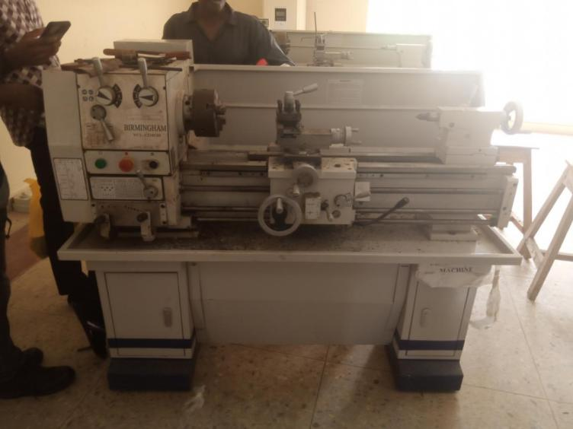

**WEEK TWO: Fitting and machining section**

1. Identification and functions of the machines in the workshop
2. Carried out sawing of metal plate
3. Carrying out filing operation to make metallic objects
4. Learning the working operation of a lathe machine, and its parts.
5. Carrying out operations on the lathe machine such as **facing, plane turning and shoulder turning.**

At the end of this section, I was able to learn that various machines no matter the size and compartment can perform the same function.

**LATHE MACHINE**

**WEEK THREE : Electrical section**

1. Introduction to electrical equipment and Electrical lab.
2. Learning and understanding the working principle of basic electrical components e.g. a transformer, resistor, diode,capacitor,etc
3. Learning Installation of a solar panel system
4. Learnt load calculation for house wiring
5. I was shown a model house wiring and was told how it was wired

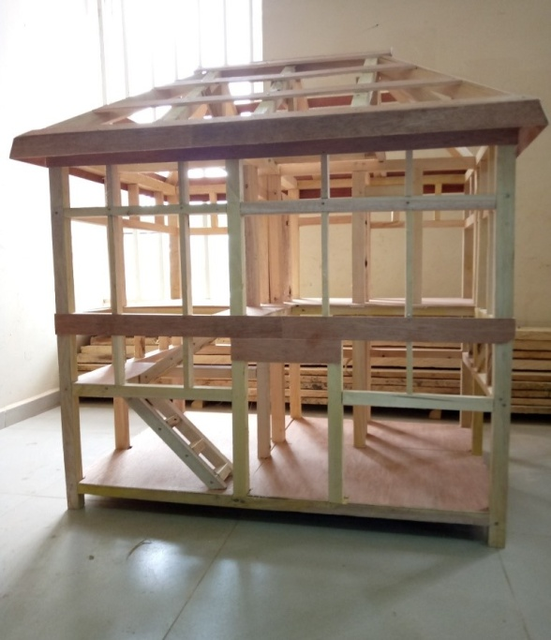

**MODEL OF A WIRED HOUSE**

**WEEK FOUR: Mothercat section**

1. Introduction to the basic tools used in automobile repairs
2. Introduction to the different construction machinery such as paver, grader, escavator, mixer,etc
3. I learnt how to disassemble parts of an engine before repair.
4. I learnt how to assemble the parts of the engine after repairs.

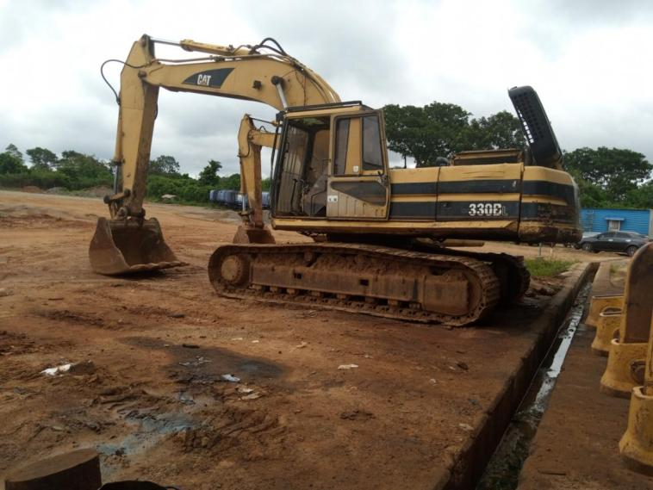

**ESCAVATOR**

**WEEK FIVE: Carpentry and wood work section**

1. Introduction to the basic equipment’s used in the wood work section.
2. Leant how to saw with the hack and jack saw
3. Learnt how to construct a simple bed frame
4. Learnt how to construct a simple wardrobe

**PROJECT EXECUTED**

Various projects were carried out during the SWEP exercise-

1. Shoulder turned shaft
2. V-fitting job
3. Bed frame
4. Wardrobe
5. Square shaped welding

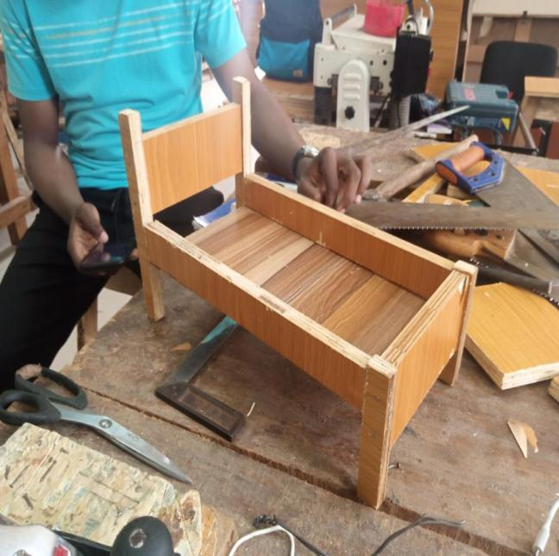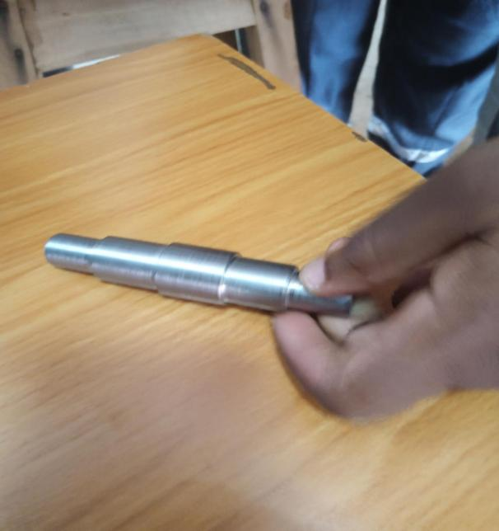

**BED FRAME AND SHAFT**

**CHAPTER FOUR**

**4.1 PROBLEMS ENCOUNTERED DURING THE PERIOD**

During the five (5) weeks period of the SIWES training a lot of activities were carried out in the different sections each having its own experience to be gained and lessons to learn from problems encountered. Some of these problems includes;

1. Late supply of coverall and labcoat for work
2. Lack of sufficient materials that allowed students to be idle.

3. Inability to properly follow instructions, thereby leading to inaccurate measurements which causes delay in finishing time.

4. Inadequate transport which lead to the late coming of students.

5. Inadequate follow up of starting and closing time of the workshop daily.

6. In the fitting and machining section, guidelines of instructors been ignored lead to inaccuracy of outcome, and delay in the completion of work.

**SOLUTIONS TO PROBLEMS**

1. Early provision of coverall to the students

2. Sufficient materials which will eradicate idleness

3. Adequate follow up of starting and closing time of the workshop daily.

4. Adequate transport which lead to the early coming of students.

**CONCLUSION**

My 5 weeks’ industrial attachment with Edo State University, Uzairue has been one of the most interesting, productive, instructive, and educative experience in my life. Through this training program, I was able to pick up new insight and more global understanding about the real industrial

working condition and practice and also improved my functional skills.

These high-end experiences and practical knowledge that I have achieved, were not only acquired through the direct involvement in task but also through other means of training; observation, my interaction with fellow students and instructors and other people related to the field. I was exposed to the engineering environment and was introduced to the problem solving activities in engineering.

**RECOMMENDATION**

The SWEP program for engineering students, 2021 Edo State University Uzairue was able to achieve the major goal which was to impact practical knowledge in the students.

For future purposes, areas of improvements can be worked on, for better results; Such as the area of punctuality.

Another fact that should be worked on is that, each section should have its own instructor who is permanently assigned to that section rather than the occurrences of a single instructor working on supervising two sections. Thus, enhancing smooth flow of assignments. I believe if these recommendations are followed there will be greater efficiency in subsequent SWEP programmmes in the university.

**REFERENCES**

* Students work experience programme logbook
* How to write SWEP report- GEE 199 SWEP report format for electrical engineering 2019
* Fareed SWEP training format 2020