**Case Study**

**Paxos Trust Company: Pax Dollar (USDP)**

**Alex Edwards**

**Overview and Origin**

Paxos Trust Company is a regulated blockchain infrastructure platform with an array of products to help expand and expedite the use of currency. They were founded in 2012 by Charles Cascarilla (CEO) and Richmond Teo (CEO). They created Pax Standard in 2018, which would become known as Pax Dollar(USDP), the first industry-regulated stable coin.

The idea for USDP came about wanting to create a cryptocurrency that more closely followed the standard definition of money. Along with creating a cryptocurrency that met all the characteristics of money, it also needed to be regulated. With regulation comes trust from consumers and businesses.

Paxos has become one of the fastest-growing fintech startups, raising over $500M with a $2.4B evaluation. Some of the early investors in Paxos include Declaration Partners, PayPal, Westcap, and Mithril Capital.

**Business Activities**

Paxos Trust Company offers a wide range of products in the blockchain and cryptocurrency domain, including crypto brokerage, digital asset exchange(itBit), digital assets backed by gold (PAX Gold), and cryptocurrency pegged to the U.S. Dollar (Pax Dollar). The main focus of this case study will be on their most popular and promising product, the Pax Dollar.

**What is it?**

The Pax Dollar (USDP) is one of the first stablecoins. A stablecoin is a cryptocurrency pegged to physical currency, the Pax Dollar being pegged to the U.S Dollar. This token will always have a one-to-one exchange with the U.S. dollar. These stablecoins only exist when an equal amount of U.S. dollars are deposited into an account. When the coins are redeemed, they are removed from the supply. This creates a store of value, limits the volatility that most other cryptocurrencies have. The pegging to the U.S. dollar allows customers to trust that the cryptocurrency they hold in their wallets will be worth that expected value in the future. This means that consumers of this coin are not buying for speculation of growth but rather to use as monetary exchange.

The use of currency merely comes down to trust, which is a fundamental principle missing from most cryptocurrencies. Paxos has gained confidence not just by ensuring the value will not change rapidly but also since it is regulated. The New York State Department of Financial Services regulates the Pax Dollar and every dollar stored FDIC backed banks. The regulation by governing bodies gives consumers the peace of mind that their money will still be there when they need it.

A backed digital currency allows people to safely join the digital economy, allowing them to enact transactions securely and quickly. Consumers can use Pax Dollar without even having a bank account. The only thing they need is an Ethereum Wallet. Crypto in the past has not advanced the very function of money, and this is something Paxos aims to do. This system creates shorter redemption windows and reduces costs for consumers when using digital currency.

One of the utilities of the Pax Dollar(USDP) is to work as a digital exchange to hold earnings from other cryptocurrencies/ currencies so that they do not need to be converted into physical cash. This allows consumers to convert their digital currency quickly and helps reduce transaction delays.

“Pax Dollar represents a significant advancement in digital assets, leveraging the infrastructure, oversight, and stability of the traditional financial system, while operating at the speed of the Internet.” – Charles Cascarilla (CEO)

**Future**

Paxos Trust Company is looking to assist not just in the transactions of digital commodities but international currency exchange as well. They have partnered up with Revolut, a relative startup that also their users through membership to exchange currency digital and physical without any transaction costs.

Paxos hopes to use this as an OTC exchange for physical commodities and assets. They are helping to make all digital currency more liquid in hopes of serving as a primary currency.

**Landscape**

Paxos Trust Company operates in the Blockchain / Cryptocurrency domain of Fintech. One of the most significant innovations in this domain has been pegging crypto to a backed currency. Along with being regulated by a boding government, this is something not seen in most Cryptocurrencies. Through these innovations, Paxos has been able to create more accessibility and trust. Two qualities that were certainly lacking in the domain previously.

Though Paxos has been a first mover in creating stablecoins, they’re not the only one True USD, USD Coin, Huobi USD, GUSD, and Terra USD are some of their closest competitors, with Tether holding the largest market cap.

Binance, one of the world's largest cryptocurrency exchanges in the world offers their stablecoins through Paxos.

Paxos Dollar has a Market Cap of $942.3M, currently the 7th largest in the industry.

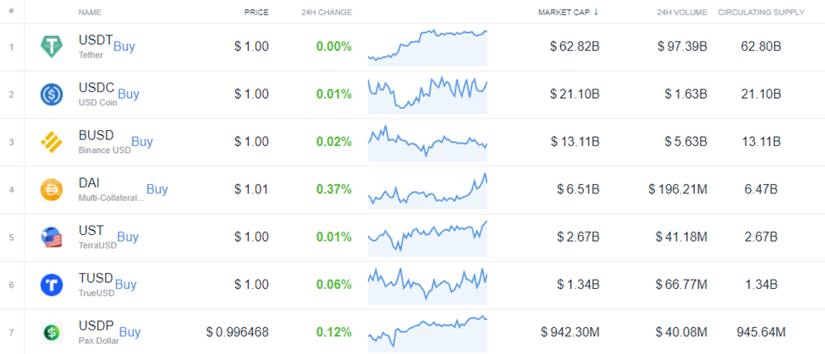

https://coincodex.com/cryptocurrencies/sector/stablecoins/

**Results**

Paxos is in a good position with PayPal using them to convert all crypto assets into USD. This will allow more everyday consumers to buy and sell goods using cryptocurrencies, which will all be exchanged through Paxos. With Paxos being a leader in blockchain and an emphasis on regulation, companies will trust to use them. Mastercard announced earlier this year that their Crypto Card Program would be working with Paxos to create a real-time crypto wallet. Interactive brokers look to introduce cryptocurrency trading through Paxos. Among others using them as a medium of exchange are Venmo and Revolut. These well-known and established companies are willing to use Paxos because they take on all the risks but can be trusted because they are backed and regulated.

**Recommendations**

Paxos has done a great job penetrating the market in offering its services to some of the most prominent digital exchanges in the world. I believe they could take their company further globally by creating other cryptocurrencies pegged to some of the top global currencies(Euro, Franc, and Pound). By creating cryptocurrencies pegged to such economies would only increase the utility of Paxos, further decreasing transaction costs. Paxos already has the blockchain created along with users in these markets via Revolut and PayPal.

The biggest challenge Paxos would face in expanding their new globally pegged digital currencies would be too backed by the respective governing bodies. Regulation is what makes Paxos Dollar so unique and would need to work with foreign countries to show them this is something that they need.

**Sources**

* Bloomberg.com. Accessed October 03, 2021. https://www.bloomberg.com/profile/company/1624511D:US.
* Cascarilla, Charles. "White Paper." Paxos. August 24, 2021. Accessed October 03, 2021. https://insights.paxos.com/hubfs/USDP-whitepaper.pdf.
* "Company." Paxos. August 30, 2021. Accessed October 03, 2021. https://paxos.com/company/.
* "Interactive Brokers Group Introduces Cryptocurrency Trading Through Paxos." Business Wire. September 13, 2021. Accessed October 03, 2021. https://www.businesswire.com/news/home/20210913005584/en/Interactive-Brokers-Group-Introduces-Cryptocurrency-Trading-Through-Paxos.
* "Mastercard Creates Simplified Payments Card Offering for Cryptocurrency Companies." Morningstar. July 20, 2021. Accessed October 03, 2021. https://www.morningstar.com/news/business-wire/20210720005413/mastercard-creates-simplified-payments-card-offering-for-cryptocurrency-companies.
* Mitchell, Eddie, and Author: Eddie MitchellEddie First Rode the Bitcoin Rollercoaster in 2012 and Has Followed the Trail Ever Since. He Has Written across Numerous Tech/crypto Publications over the Years. "Best Stablecoins, Rated and Reviewed for 2021." Bitcoin Market Journal. March 12, 2021. Accessed October 03, 2021. https://www.bitcoinmarketjournal.com/stablecoins/.
* "Paxos Raises $300 Million in Series D Funding at $2.4 Billion Valuation." Paxos. April 29, 2021. Accessed October 03, 2021. https://paxos.com/2021/04/29/paxos-raises-300-million-in-series-d-funding-at-2-4-billion-valuation/.
* Regnard-Weinrabe, Ben, Hannah Pack, Hazem Danny Al Nakib, and Heenal Vasu. "Stablecoins." The Harvard Law School Forum on Corporate Governance. February 10, 2019. Accessed October 03, 2021. https://corpgov.law.harvard.edu/2019/02/10/stablecoins/.
* "Top Stablecoins by Market Cap." CoinCodex. Accessed October 03, 2021. https://coincodex.com/cryptocurrencies/sector/stablecoins/.
* Trentman, Nina. "PayPal Wants More Customers to Pay Using Crypto Assets." Morningstar. May 06, 2021. Accessed October 03, 2021. https://www.morningstar.com/news/dow-jones/2021050621759/paypal-wants-more-customers-to-pay-using-crypto-assets.