AI-DRIVEN MENTOR-MENTEE MANAGEMENT SYSTEM
An Intelligent Platform for Batch Allocation, Academic Mentoring and Risk-Based Student Support
A Machine Learning Mini Project Report
Department of Artificial Intelligence and Data Science Engineering
Annasaheb Dange College of Engineering and Technology, Ashta
(An Empowered Autonomous Institute, Affiliated to Shivaji University, Kolhapur)

1. Abstract
Academic mentoring in most engineering colleges is still handled through paper registers and static spreadsheets, which makes it difficult for mentors to track a student's holistic progress or intervene early when a student begins to struggle. This project proposes an AI-driven Mentor-Mentee Management System that digitizes the complete mentoring lifecycle: batch allocation by the admin, self-service profile and academic data entry by students, and a mentor dashboard enriched with a machine learning layer that scores each student's risk level and recommends corrective action. The system also automates the generation of the four official mentoring reports (Mentoring Report, Academic Progress, Student Progress, and Analysis of Mentees) that are currently filled manually in Excel, directly from the underlying database.

2. Objectives
- To build a unified, role-based platform (Admin, Student, Mentor) that digitizes the entire mentor-mentee workflow.
- To allow admins to allocate batches and assign mentors, and to maintain master records of students and mentors.
- To let students self-register their profile, parental information, academic history, achievements, and raise problems or complaints directly to their mentor.
- To give mentors a consolidated dashboard for batch overview, attendance marking, and meeting management with floating agendas.
- To apply a machine learning model that predicts a student's risk level (weak / average / bright) from attendance, marks, and participation data, and generates an actionable recommendation for the mentor.
- To auto-generate the four standard mentoring reports in Excel format directly from live database records, eliminating manual data entry at the end of every semester.

3. Theory and Background

3.1 The mentoring problem
Formal mentor-mentee programs are mandated by most autonomous engineering institutes as a way of tracking a student's academic, co-curricular, and personal development across a semester. In practice, a mentor manages a batch of 15-20 students and is expected to record meeting minutes, attendance, marks, achievements, and complaints, and later compile this into four separate Excel reports for the department. Because none of these records are linked, a mentor has no single, current view of which students are actually falling behind, and defaulter identification tends to happen reactively rather than by continuous monitoring.

3.2 Role-based access control
The system is built around three roles: Admin, Student, and Mentor, each with a distinct login and a distinct set of permissions. This is implemented using JSON Web Tokens (JWT), where a signed token issued at login carries the user's role and scope, and every protected route on the backend verifies the token and checks the role before returning data. This ensures a student can only ever see their own profile, and a mentor can only see the batch that has been assigned to them by the admin.

4. System Description

4.1 Admin module
The Admin allocates batches and assigns a mentor to each batch. The admin also maintains basic master data for students (name, URN, department, class, division, batch, email) and mentors (name, mentor ID, department, batch, email), which forms the seed data that students and mentors log in against.

4.2 Student module
A student logs in using their URN and is automatically routed into their own batch. From there the student completes their profile (including the default information entered by the admin, profile photo, roll number, contact, and address), enters parental information, enters academic details for both past and current semesters, logs achievements, participations and certifications, and finally can raise a problem or complaint that is routed to their mentor.

4.3 Mentor module
A mentor logs in with a unique mentor ID and is routed into their assigned batch. The mentor gets a batch overview, can open any individual student's page to view full details, add attendance, and view the ML-generated risk level and recommendation for that student. The mentor can also schedule and manage meetings with a floating agenda, saved against every attending student's profile with meeting attendance marked, and generate the four batch-wide Excel reports auto-filled from the database. Problems and complaints raised by a student (submitComplaint()) appear directly on the mentor's dashboard as an open worklist, which the mentor closes out through a matching resolveComplaint() call, as reflected in the Student/Mentor classes of the UML diagram and the Complaint entity of the ER diagram.

5. Machine Learning Approach
Since this is fundamentally a machine learning project, the risk-scoring and recommendation layer is the core deliverable, with the web application acting as the data collection and delivery vehicle around it.

5.1 Problem formulation
Identifying which students need mentoring attention is framed as a supervised multi-class classification problem. The target variable has three classes, matching the categories your department already uses in the Analysis of Mentees report: Weak, Average, and Bright. Given a student's attendance, marks, and participation record, the model predicts which of these three classes the student currently falls into, which is then used to trigger the appropriate mentor recommendation.

5.2 Training data and features
The training data is drawn directly from the records your system already collects across the four mentoring report sheets, so no separate data collection effort is needed once a few semesters of mentoring history have accumulated:
- Attendance features, from the Academic Progress sheet: number of subjects below 75% attendance per month, and the overall attendance percentage for the semester.
- Academic features, from the Academic Progress sheet: subject-wise ISE, MSE, and ESE marks, and the number of subjects failed or borderline in each internal assessment.
- Co-curricular features, from the Student Progress sheet: count of events, NPTEL courses, internships, trainings, workshops, and sports/cultural participation logged for the student.
- Behavioural features, from the Mentoring Report and Complaint records: number of complaints raised, number of meetings attended versus missed, and defaulter flags noted by the mentor.
- Label, from the Analysis of Mentees sheet: the Weak / Average / Bright classification the mentor has already assigned each roll number for that batch, which becomes the ground-truth label for supervised training.
For example, in your own T2 batch mentoring data, 19 students were labelled 4 Bright, 11 Average, and 4 Weak, giving an initial (small) labelled dataset. As more batches and semesters are digitized through the platform, this training set grows automatically, one row per student per semester, which lets the model be retrained periodically rather than being static.

5.3 Algorithms evaluated
Because the feature set is small, tabular, and mixes numeric and categorical fields, tree-based ensemble methods are the primary candidates, benchmarked against a simpler baseline:
- Logistic Regression (baseline): a simple linear multi-class classifier used as a reference point to confirm the ensemble models are actually adding value over a naive linear separation.
- Random Forest Classifier: an ensemble of decision trees trained on bootstrapped samples with feature bagging, chosen as the primary model because it handles the mix of attendance percentages, marks, and counts well, is robust to a small dataset, and exposes feature importances that can be shown back to the mentor.
- Gradient Boosting / XGBoost Classifier: boosted trees trained sequentially to correct prior errors, evaluated as a stronger alternative to Random Forest once enough historical data accumulates across semesters to reduce the risk of overfitting.
- K-Nearest Neighbours (secondary comparison): tested as a distance-based alternative, mainly to sanity-check that the ensemble models are not simply memorising a small training set.
Random Forest is the model actually deployed behind the mentor's 'View AI risk level' use case, with Gradient Boosting kept as a swap-in candidate once more semesters of data are available.

5.4 Handling a small, imbalanced dataset
Mentoring batches are small (15-20 students) and the Bright/Weak classes are naturally under-represented compared to Average, as seen in the 4/11/4 split above. This is addressed using class-weighted training (class_weight='balanced' in scikit-learn, so misclassifying a rare Bright or Weak student is penalised more than misclassifying an Average one) and, once enough historical rows accumulate across batches, synthetic oversampling of the minority classes using SMOTE, so the model does not simply default to predicting 'Average' for every student.

5.5 Training and evaluation pipeline
- Data extraction: pull attendance, marks, and participation rows per student per semester from the MySQL database into a pandas DataFrame.
- Preprocessing: handle missing values, scale numeric features, and encode the batch/division as categorical context.
- Split: stratified train/test split (e.g. 80/20) so the small Bright and Weak classes are still represented in both sets, combined with k-fold cross-validation given the limited data volume.
- Training: fit Logistic Regression, Random Forest, and Gradient Boosting on the training set with class-weighting applied.
- Evaluation: compare models using accuracy, macro-averaged F1-score (more meaningful than raw accuracy on an imbalanced 3-class problem), and a confusion matrix to check that Weak students in particular are not being misclassified as Average.
- Deployment: the best-performing model is serialised (joblib) and served from a lightweight Flask/FastAPI microservice that the Node.js backend calls whenever a mentor opens a student's risk view.

5.6 Recommendation generation
Once a risk level is predicted, a rule-and-template engine maps the dominant contributing factor identified via the model's feature importances (attendance, academics, or participation) to a pre-written, editable recommendation, for example suggesting a parent-teacher meeting for a chronic attendance defaulter, or a peer study group for a student weak in a specific subject. This keeps the final recommendation transparent and editable by the mentor rather than being an opaque model output.

6. Use Case Diagram
The use case diagram below captures the three actors and their interactions with the system, including the paired submitComplaint() / resolveComplaint() use cases that connect the Student and Mentor roles.
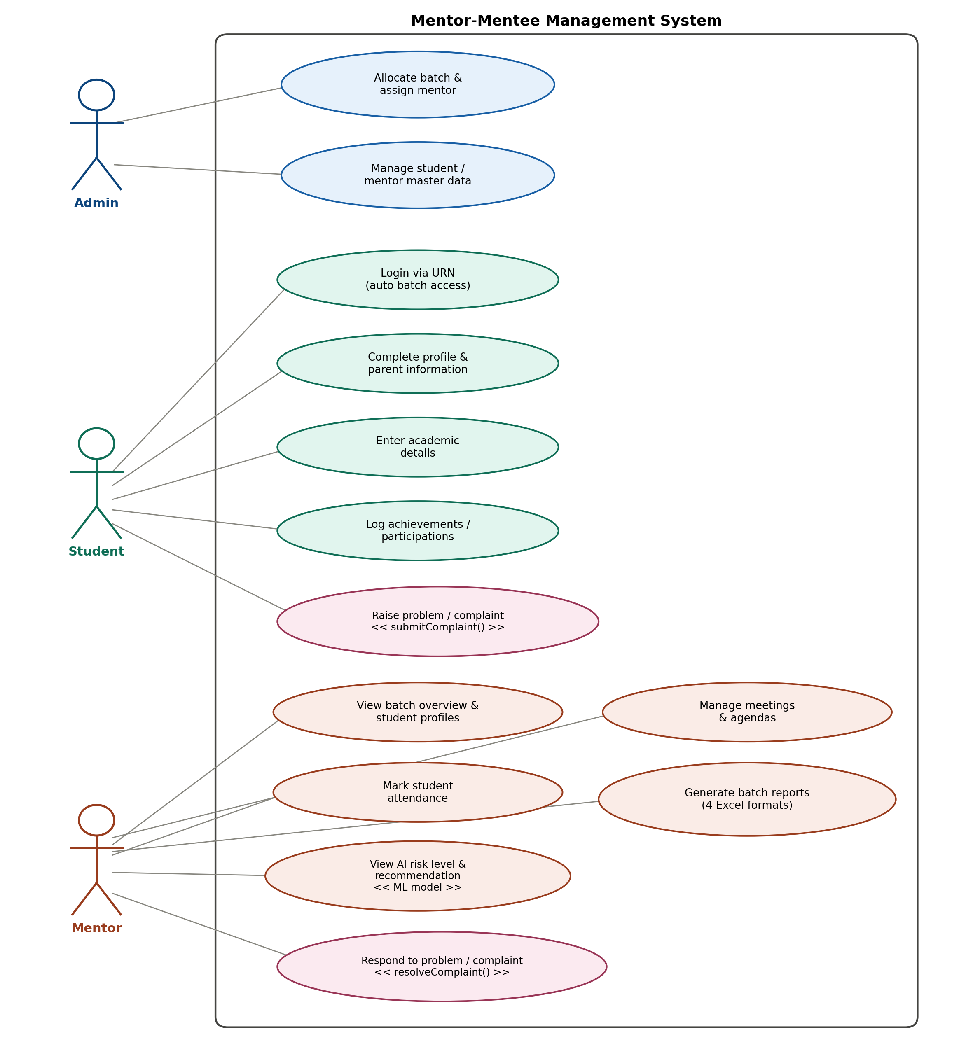
Figure 6.1: Use case diagram of the mentor-mentee management system

7. Entity-Relationship Diagram
The ER diagram uses classical Chen notation: rectangles represent entities, diamonds represent relationships, and ovals represent attributes, with primary keys shown as underlined ovals.
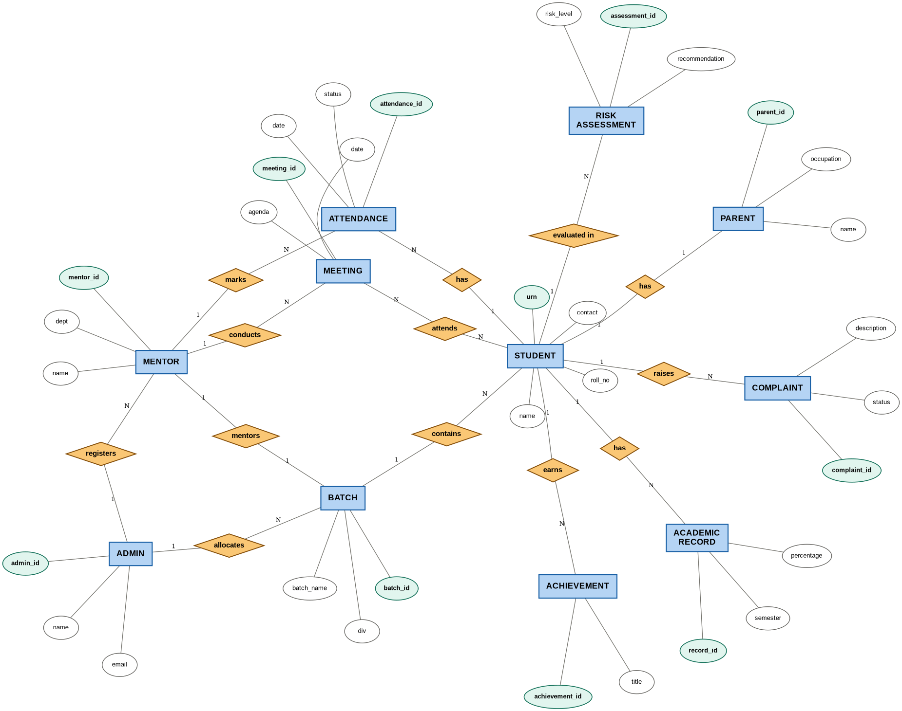
Figure 7.1: Entity-relationship diagram (Chen notation)

8. UML Class Diagram
The class diagram translates the ER model into an object-oriented structure with attributes and methods per class. The submitComplaint() method on Student and resolveComplaint() method on Mentor are highlighted, both operating on the shared Complaint class.
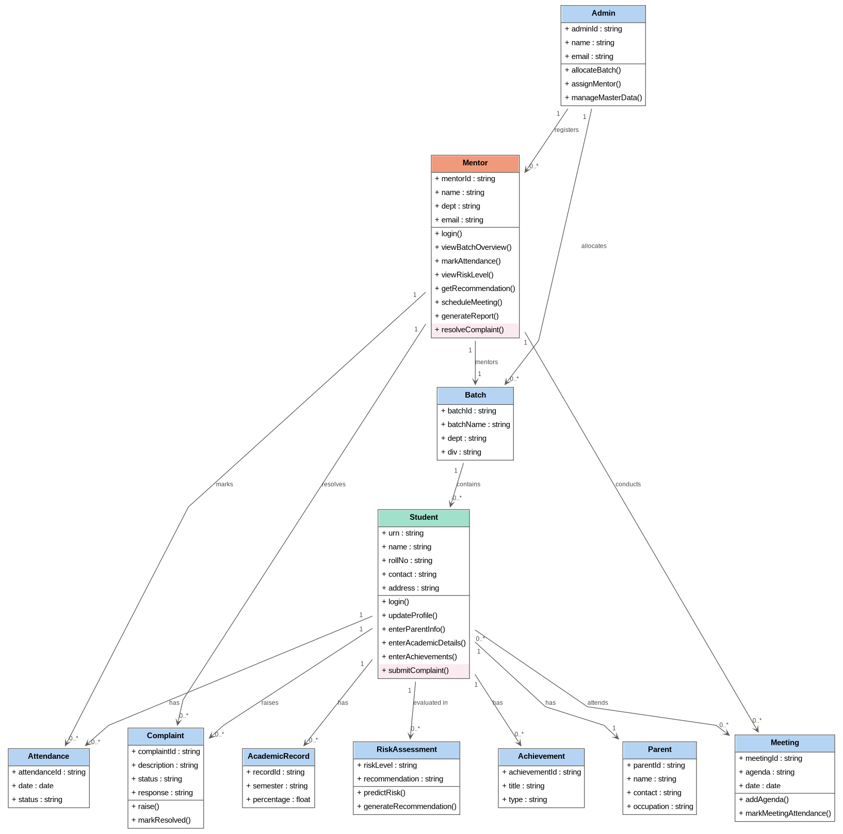
Figure 8.1: UML class diagram

9. Technology Stack
Layer | Technology
Frontend | HTML5, CSS3 (glassmorphism UI), JavaScript / React
Backend | Node.js with Express.js (REST API)
Authentication | JSON Web Tokens (JWT), role-based access control
Database | MySQL (via XAMPP for development)
ML libraries | Python, pandas, scikit-learn, XGBoost, imbalanced-learn (SMOTE)
ML model | Random Forest Classifier (primary), Gradient Boosting and Logistic Regression as benchmarks
ML integration | Flask/FastAPI microservice, called from the Node.js backend, serving a joblib-serialised model
Reporting | openpyxl / ExcelJS for auto-filled Excel report generation
Version control | Git and GitHub

10. References

10.1 Idea and domain background
- Development of Monitoring System for Mentor-Mentee Programme, IEEE Conference Publication, IEEE Xplore. https://ieeexplore.ieee.org/document/10246074/
- Online Student Mentoring System (Mentor Management System), International Journal for Research in Applied Science & Engineering Technology (IJRASET), 2024. https://www.ijraset.com/research-paper/mentor-management-system
- E-Mentoring System Application, IEEE Conference Publication, IEEE Xplore. https://ieeexplore.ieee.org/abstract/document/8653663
- Predictors and Early Warning Systems in Higher Education: A Systematic Literature Review. https://www.academia.edu/81362791/
- Analysis and Prediction of At-Risk Students Using Machine Learning Algorithms, arXiv preprint. https://arxiv.org/pdf/2606.20617
- Using Machine Learning to Predict Student Outcomes for Early Intervention and Formative Assessment, Scientific Reports (Nature), 2025. https://www.nature.com/articles/s41598-025-23409-w
- Towards a Fair and Transparent Early Warning System for Identifying Students at Risk of Academic Failure, Frontiers in Education, 2026. https://www.frontiersin.org/journals/education/articles/10.3389/feduc.2026.1878686/full

10.2 Technical and methodological references
- Elmasri, R. and Navathe, S. B., Fundamentals of Database Systems, 7th Edition, Pearson Education.
- Booch, G., Rumbaugh, J. and Jacobson, I., The Unified Modeling Language User Guide, 2nd Edition, Addison-Wesley.
- Pressman, R. S., Software Engineering: A Practitioner's Approach, 8th Edition, McGraw-Hill.
- Breiman, L., Random Forests, Machine Learning, vol. 45, pp. 5-32, 2001.
- Chen, T. and Guestrin, C., XGBoost: A Scalable Tree Boosting System, Proceedings of the 22nd ACM SIGKDD Conference, 2016.
- Chawla, N. V. et al., SMOTE: Synthetic Minority Over-sampling Technique, Journal of Artificial Intelligence Research, vol. 16, pp. 321-357, 2002.
- Express.js official documentation, https://expressjs.com/
- scikit-learn official documentation, https://scikit-learn.org/
- JSON Web Token (JWT) specification, RFC 7519, https://datatracker.ietf.org/doc/html/rfc7519

11. Conclusion
The proposed Mentor-Mentee Management System replaces a manual, register-driven mentoring process with a connected digital platform that keeps student data, attendance, achievements, complaints, and meeting records in one place. By layering a machine learning risk-classification model on top of this data, mentors move from reactively discovering defaulters at the end of a semester to proactively identifying at-risk students early, with a concrete, explainable recommendation for intervention. Auto-generating the four official mentoring reports directly from the database also removes a significant amount of manual, error-prone paperwork for mentors at the end of each semester. Future work includes extending the risk model with historical multi-semester trends, adding push notifications for defaulter alerts, and building an analytics view for the department to see risk distribution across all batches.

