Portfolio-External CSS

Code:

Html file

<!DOCTYPE html>

<html lang="en">

<head>

    <meta charset="UTF-8">

    <meta name="viewport" content="width=device-width, initial-scale=1.0">

    <title>My Portfolio</title>

    <link rel="stylesheet" href="styles-portfolio.css"> <!-- Link to external CSS -->

</head>

<body>

    <header>

        <h1>My Portfolio</h1>

    </header>

    <section id="introduction">

        <h2>Self Introduction</h2>

        <p>Hello! I am Sm, a passionate B.Tech student with a keen interest in technology and software development. Welcome to my portfolio!</p>

    </section>

    <section id="skills">

        <h2>Skills</h2>

        <ul>

            <li>Web Development</li>

            <li>Programming (C, C++, Python)</li>

            <li>Database Management</li>

        </ul>

    </section>

    <section id="projects">

        <h2>Projects & Work Experience</h2>

        <ul>

            <li><a href="https://github.com/sm/project1" target="_blank">Project 1</a></li>

            <li><a href="https://github.com/sm/project2" target="_blank">Project 2</a></li>

        </ul>

    </section>

    <section id="feedback">

        <h2>Feedback & Achievements</h2>

        <p>Received positive feedback for my contributions to open-source projects and college-level coding competitions.</p>

    </section>

    <section id="education">

        <h2>Education Profile</h2>

        <p>Bachelor of Technology (B.Tech) - [Your University Name] - [Year]</p>

    </section>

    <section id="contact">

        <h2>Contact Information</h2>

        <p>Email: <a href="mailto:sm@example.com">sm@example.com</a></p>

        <p>Phone: +1234567890</p>

        <p>Social Media: <a href="https://linkedin.com/in/sm" target="_blank">LinkedIn</a></p>

    </section>

</body>

</html>

Css file

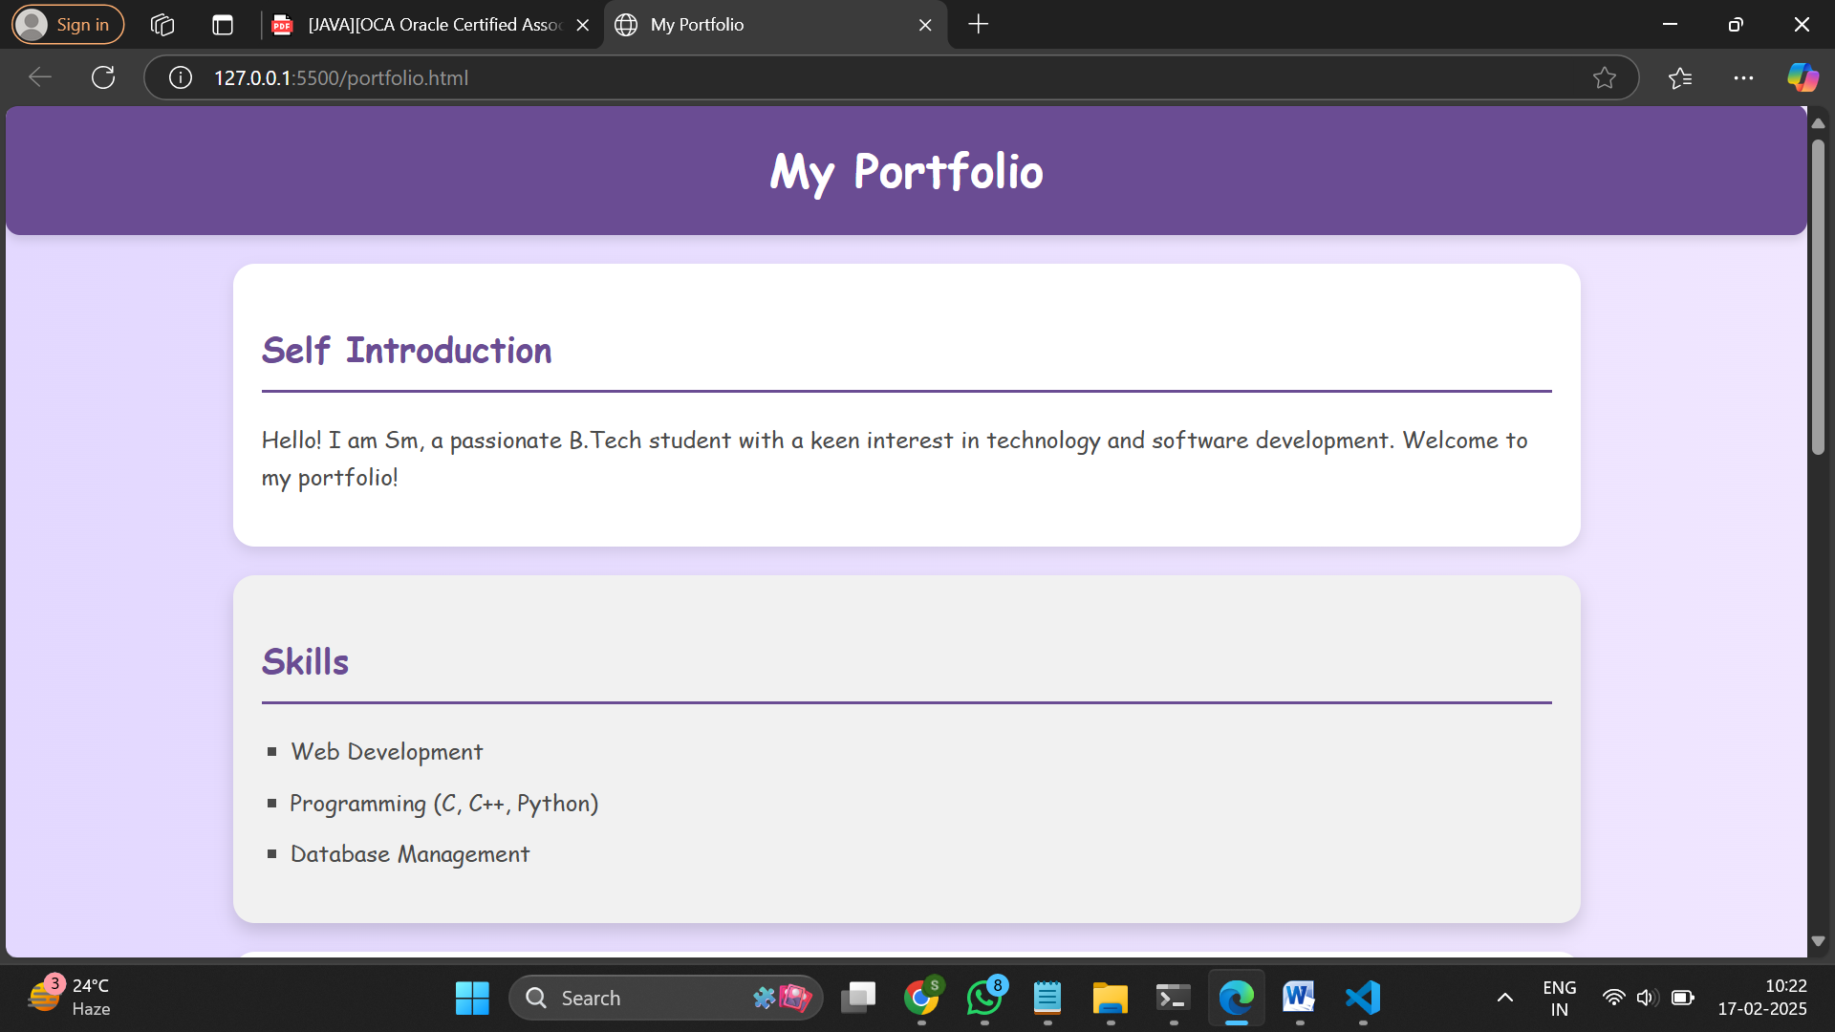

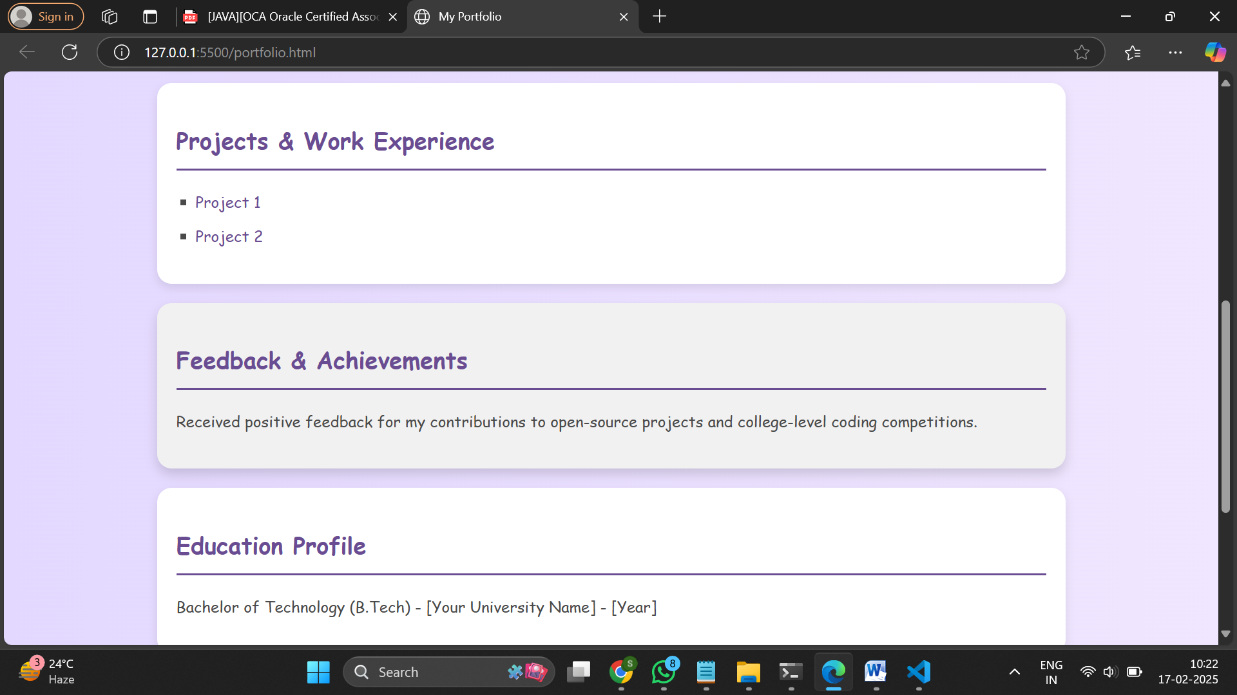

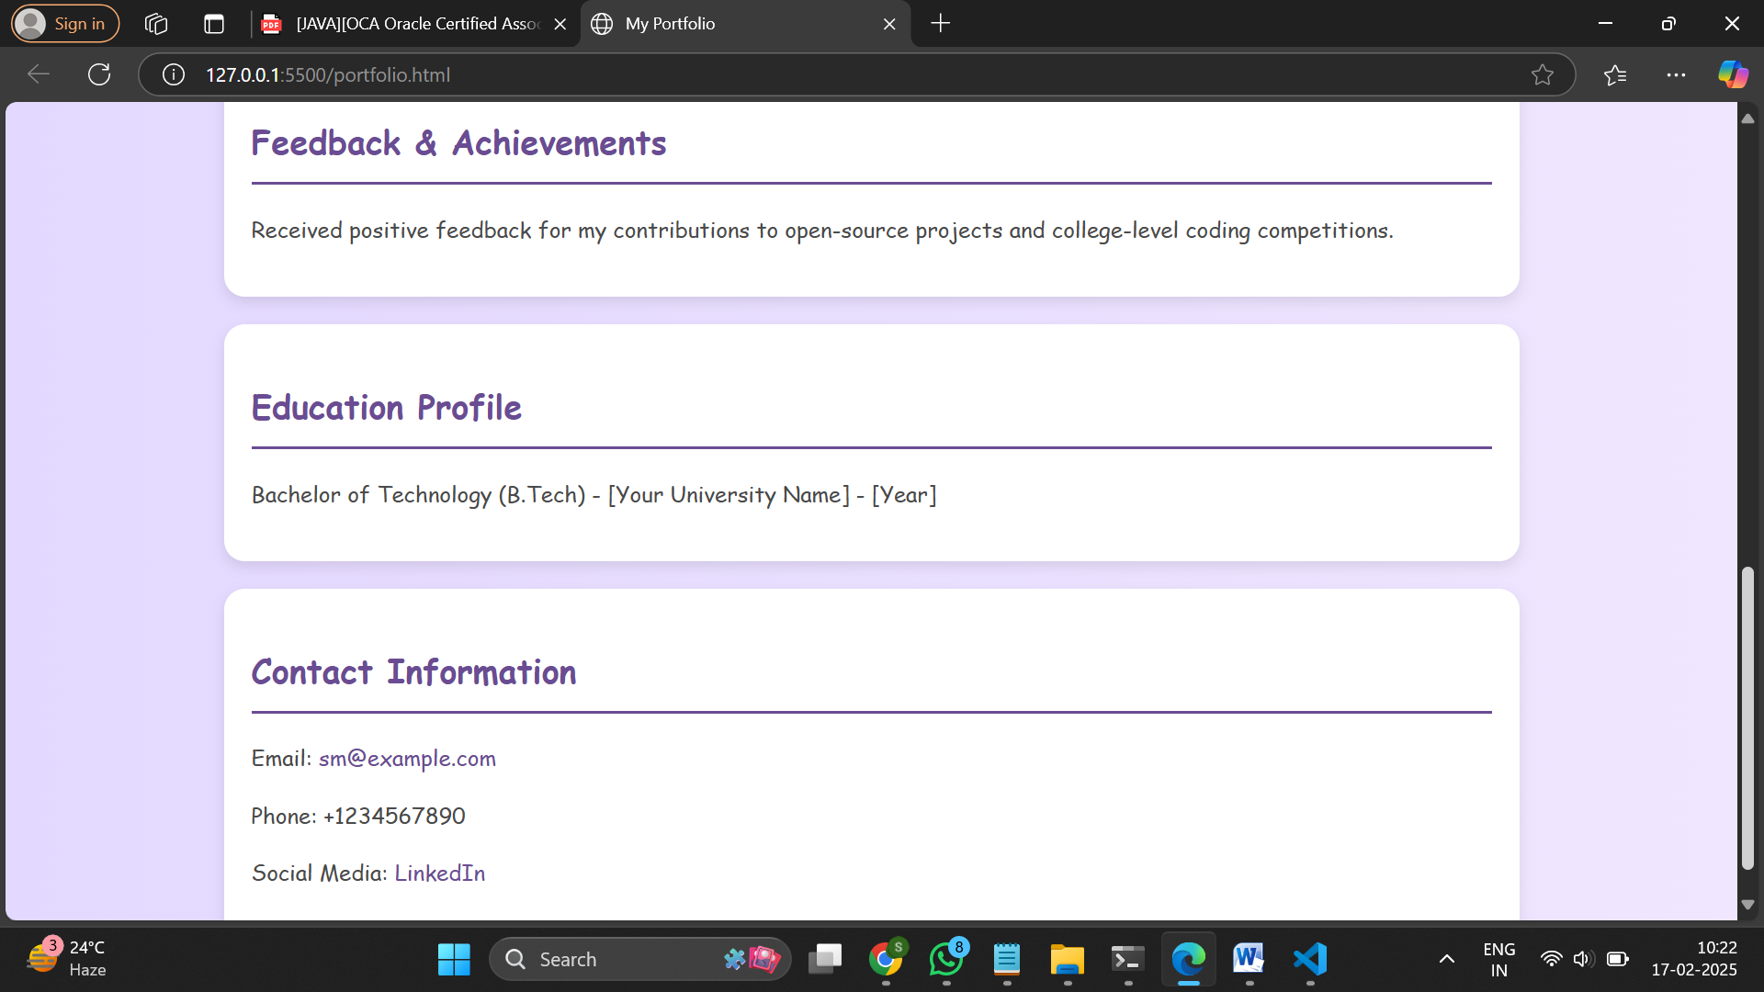

FeedbackForm

Html file  
<!DOCTYPE html>

<html lang="en">

<head>

    <meta charset="UTF-8">

    <meta name="viewport" content="width=device-width, initial-scale=1.0">

    <title>Feedback Form</title>

    <link rel="stylesheet" href="styles-feedback.css"> <!-- Link to external CSS -->

</head>

<body>

    <div class="container">

        <h2>Feedback Form</h2>

        <form action="#" method="post">

            <label for="name">Name (Optional):</label>

            <input type="text" id="name" name="name" placeholder="Enter your name">

            <label for="email">Email (Optional):</label>

            <input type="email" id="email" name="email" placeholder="Enter your email">

            <label for="phone">Phone (Optional):</label>

            <input type="tel" id="phone" name="phone" placeholder="Enter your phone number">

            <label for="rating">Rating:</label>

            <select id="rating" name="rating" required>

                <option value="">Select Rating</option>

                <option value="1">1 - Poor</option>

                <option value="2">2 - Fair</option>

                <option value="3">3 - Good</option>

                <option value="4">4 - Very Good</option>

                <option value="5">5 - Excellent</option>

            </select>

            <label for="questions">Any Questions regarding product or service:</label>

            <textarea id="questions" name="questions" rows="4" required placeholder="Enter your questions here..."></textarea>

            <label for="comments">Additional Comments (Optional):</label>

            <textarea id="comments" name="comments" rows="3" placeholder="Enter any additional comments..."></textarea>

            <button type="submit" class="submit-btn">Submit</button>

        </form>

    </div>

</body>

</html>

Css file

body {

    font-family: Arial, sans-serif;

    background: linear-gradient(to right, #007bff, #00c6ff);

    display: flex;

    justify-content: center;

    align-items: center;

    height: 100vh;

    margin: 0;

}

.container {

    background: #fff;

    padding: 20px;

    border-radius: 20px;

    box-shadow: 0 0 10px rgba(0, 0, 0, 0.1);

    width: 320px;

    text-align: center;

    border-radius: 20px;

    border-top-left-radius: 50px;

    border-top-right-radius: 50px;

}

label {

    font-weight: bold;

    display: block;

    margin-top: 10px;

    text-align: left;

}

input, select, textarea {

    width: 90%;

    padding: 8px;

    margin-top: 5px;

    border: 1px solid #ccc;

    border-radius: 10px;

    display: block;

    margin-left: auto;

    margin-right: auto;

    border-radius: 15px;

}

.submit-btn {

    background: #28a745;

    color: white;

    border: none;

    padding: 10px;

    margin-top: 10px;

    cursor: pointer;

    width: 100%;

    border-radius: 15px;

}

.submit-btn:hover {

    background: #218838;

}

Output:

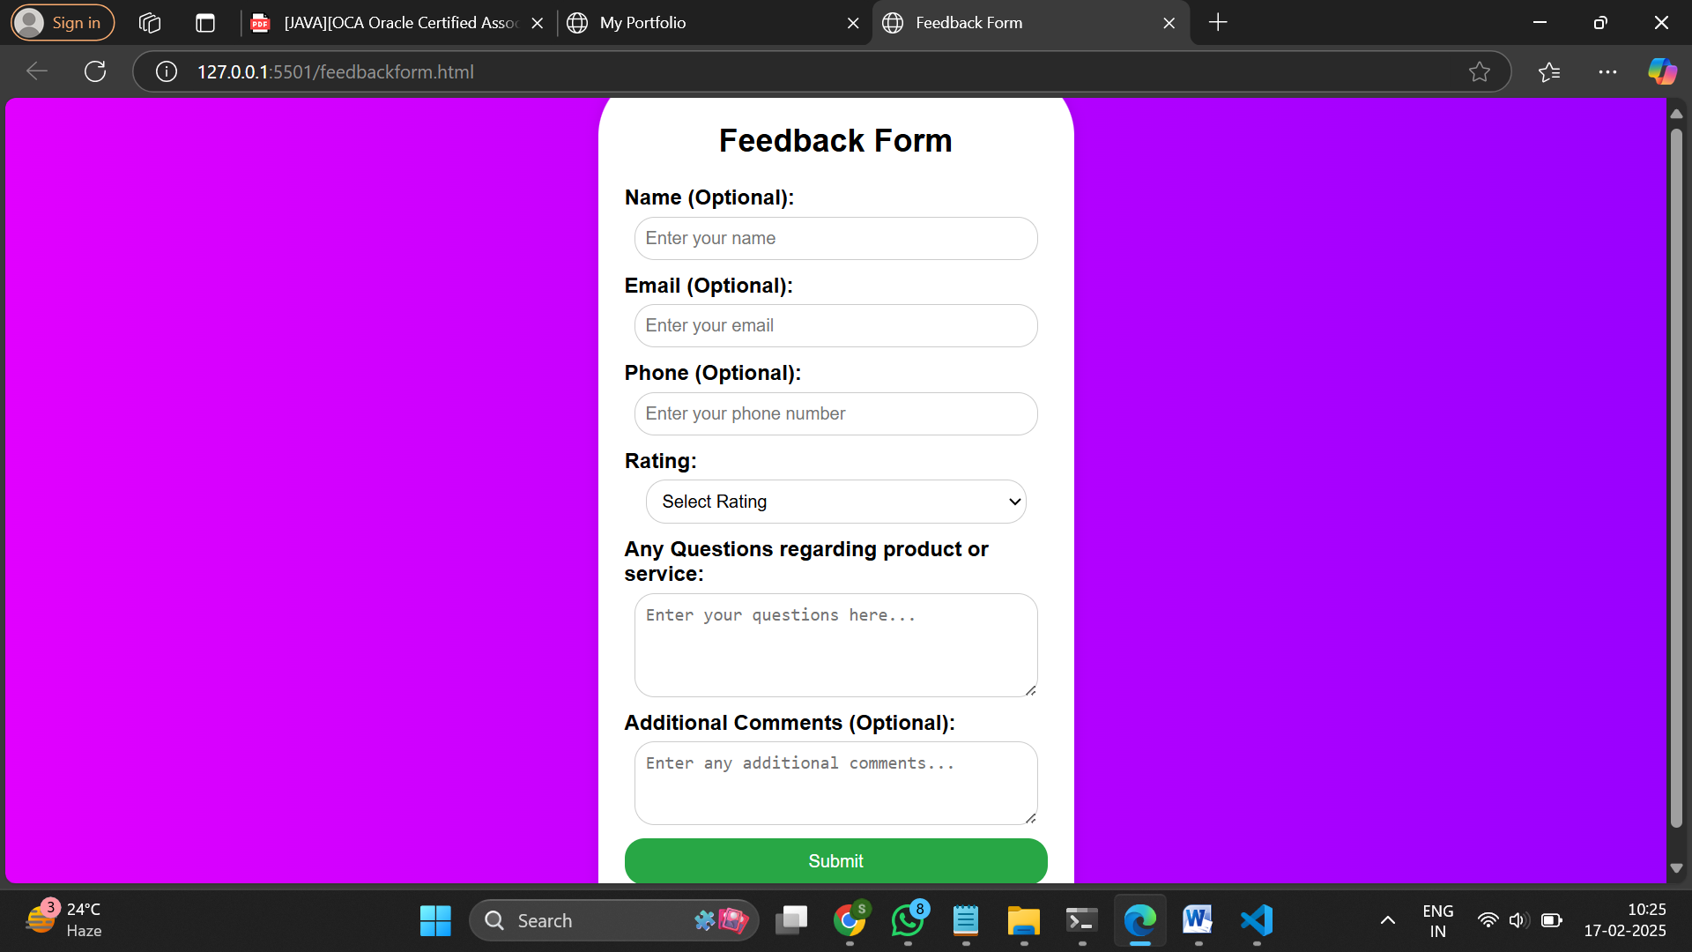

Githublink: https://github.com/AjeersMyna/FEWD_LAB.git

SandboxLINK: https://456qlx.csb.app/