STM32-Based Knee Exoskeleton Controller
Embedded Systems Internship Project Report (Proteus-Simulated Prototype)
Ajeesh VM | Dept. of Electronics and Communication Engineering, TKM College of Engineering, Kollam

1. Abstract
This report presents a Proteus-simulated, closed-loop position controller for a knee-exoskeleton joint, built around the STM32F103C6Tx microcontroller. A potentiometer (RV2) supplies the desired knee angle over an ADC channel, and firmware computes a position error, generates a proportional PWM signal, and drives an L293D motor driver connected to a DC motor. Since the simulated motor is not mechanically coupled to a physical rotary sensor in Proteus, the actual knee angle is produced by a software plant model rather than a real feedback sensor. The system was verified in simulation for forward motion, reverse motion, automatic stopping near the target angle, and UART-based status monitoring.

2. Introduction and Problem Statement
Powered knee exoskeletons require a controller that can track a reference joint angle and drive an actuator toward it while remaining within safe mechanical limits. As an internship exercise in embedded control, this project implements such a controller on an STM32F103C6Tx and validates it entirely within the Proteus simulation environment before any physical hardware is involved. The core problem addressed is: given a desired knee angle set by a potentiometer, how can the microcontroller compute an appropriate motor drive signal (speed and direction) to move the joint toward that angle, and how can this behaviour be observed and verified in simulation.

3. Objectives
- Acquire a desired knee-angle reference from a potentiometer (RV2) via the STM32 ADC.
- Compute the position error between the desired angle and the (simulated) actual angle.
- Generate a proportional PWM signal and drive an L293D H-bridge in the correct direction.
- Represent the resulting joint motion using a software plant model in Proteus.
- Monitor desired angle, actual angle, error, PWM duty and motor speed over UART.
- Verify forward motion, reverse motion and automatic stop behaviour in simulation.

4. System Architecture / Block Diagram
Figure 1 shows the signal flow of the system. RV2 provides the desired angle to the STM32 ADC. The controller computes the error against the software-simulated actual angle, generates a PWM + direction command, and drives the L293D / DC-motor stage. The resulting motion updates the software plant model, whose output angle is fed back into the error calculation, closing the loop. PA0/ADC1_IN0 is initialised in firmware as a provision for a future physical actual-angle sensor but is not read in the current control loop.
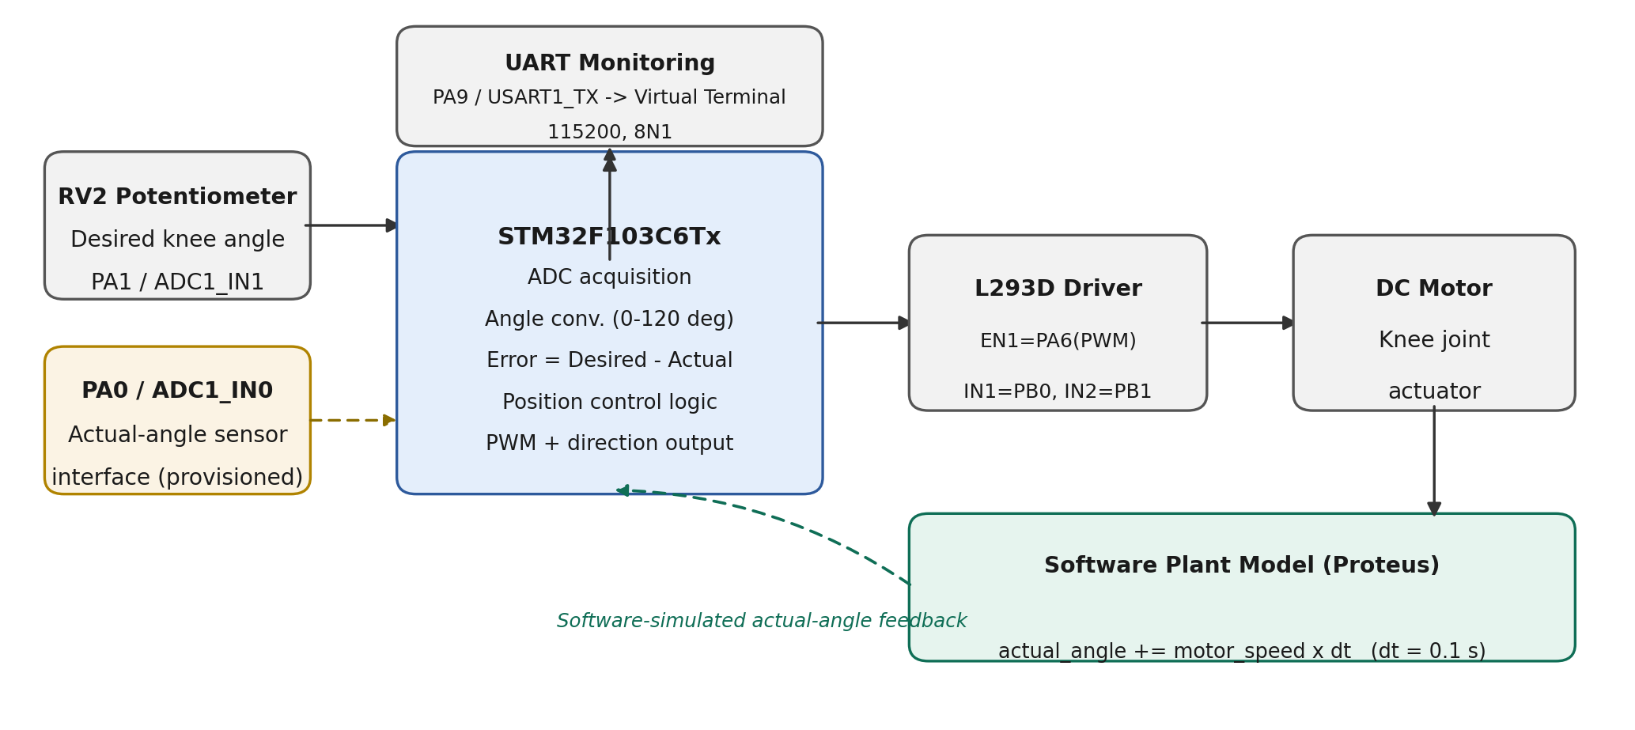
Figure 1: System block diagram of the STM32 knee-exoskeleton position controller.

5. Hardware and Software Used
Item | Role in the system
STM32F103C6Tx | Main controller: ADC read, error/PWM computation, direction control, UART logging
RV2 potentiometer | Desired knee-angle input (PA1 / ADC1_IN1)
L293D | H-bridge motor driver (EN1 = PA6 PWM, IN1 = PB0, IN2 = PB1)
DC motor | Represents the knee-joint actuator
Virtual Terminal | UART monitoring at 115200 baud, 8N1 (PA9 / USART1_TX)
Oscilloscope | PWM waveform observation on the TIM3_CH1 output

Software / tool | Purpose
STM32CubeIDE + HAL drivers | Firmware development (ADC1, TIM3 PWM, USART1, GPIO)
Proteus VSM | Schematic capture and mixed-signal simulation of the full circuit

6. Control Algorithm and Working Principle
The control loop runs once per iteration (100 ms firmware delay, DT = 0.1 s used in the plant update) and follows the sequence below, taken directly from the implemented firmware:
- Read RV2 via ADC1_IN1 (PA1) and convert: desired_angle = (adc_value × 120) / 4095.
- Compute error = desired_angle − actual_angle.
- Compute PWM duty = |error| × PWM_GAIN (PWM_GAIN = 2.0), clamped to 100%.
- If error > 0.5°: PB0 = HIGH, PB1 = LOW (forward).
- If error < −0.5°: PB0 = LOW, PB1 = HIGH (reverse).
- If |error| ≤ 0.5°: PB0 = PB1 = LOW and PWM duty forced to 0% (stop).
- Apply PWM via TIM3_CH1 compare value = (duty × 999)/100.
- Plant model: motor_speed = ±duty × 0.5 (signed by direction, else 0); actual_angle += motor_speed × DT, clamped to 0–120°.
- Transmit desired angle, actual angle, error, PWM duty and speed over USART1 (PA9) every cycle.

7. Proteus Implementation
The full circuit was built and simulated in Proteus VSM: RV1 and RV2 potentiometers biased between 3.3 V and GND with their wipers on PA0 and PA1, the STM32F103C6 device (VDDA = VDD, VSS/VSSA = GND), the L293D driver powered from a separate 5 V supply (B2) and driving the DC motor, a Virtual Terminal on USART1 for logging, and an oscilloscope probing the PWM/direction lines.
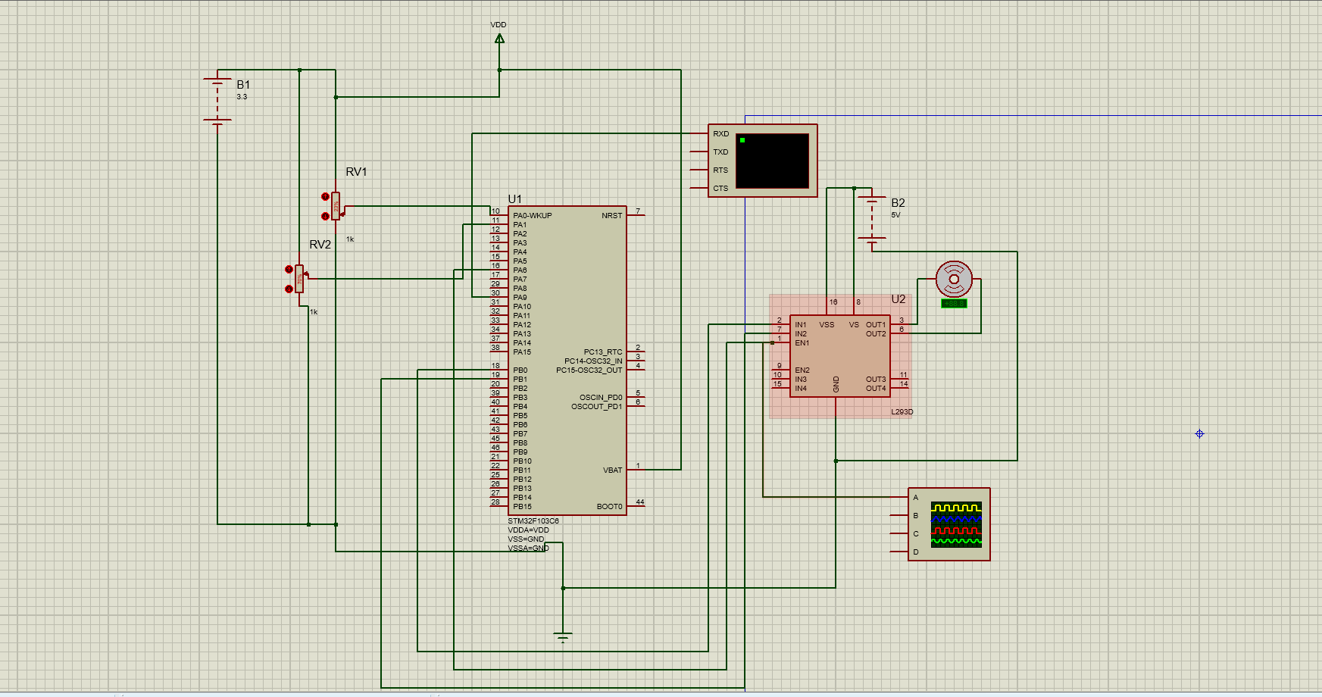
Figure 2: Complete Proteus circuit implementation.

8. Results and Discussion
The simulation was exercised for a step change in the desired angle and observed over UART. Representative logged samples are reproduced below directly from the Virtual Terminal output.
Case | Desired (°) | Actual (°) | Error (°) | PWM (%)
Forward (early) | 83.99 | 44.31 | 44.09 | 88.2
Forward (settling) | 83.99 | 78.63 | 5.96 | 11.9
Reverse (early) | 24.00 | 27.19 | -3.54 | 7.1
Reverse (near stop) | 24.00 | 24.48 | -0.48 | 0.0

In the forward case the actual angle rises toward the desired 83.99° while PWM duty falls proportionally to the shrinking error, consistent with pwm_duty = |error| × 2.0. In the reverse case the actual angle (initialised above the new desired value) decreases toward 24.00°, and PWM duty reaches 0.0% once |error| ≤ 0.5°, confirming the automatic-stop condition. Both cases also confirm correct direction selection (PB0/PB1) for positive and negative error.
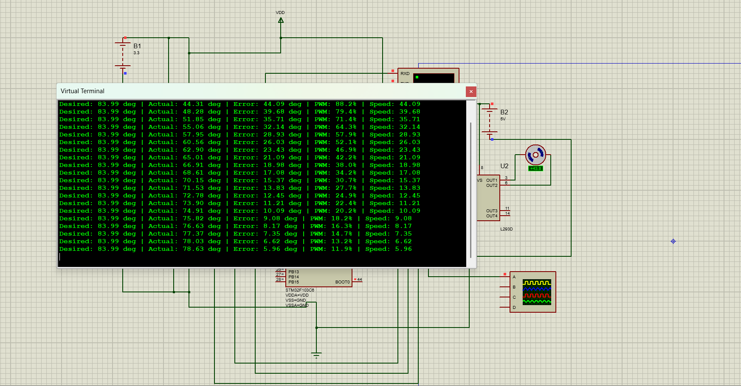
Figure 3: Forward-motion result — actual angle rising toward the desired angle, with UART log.
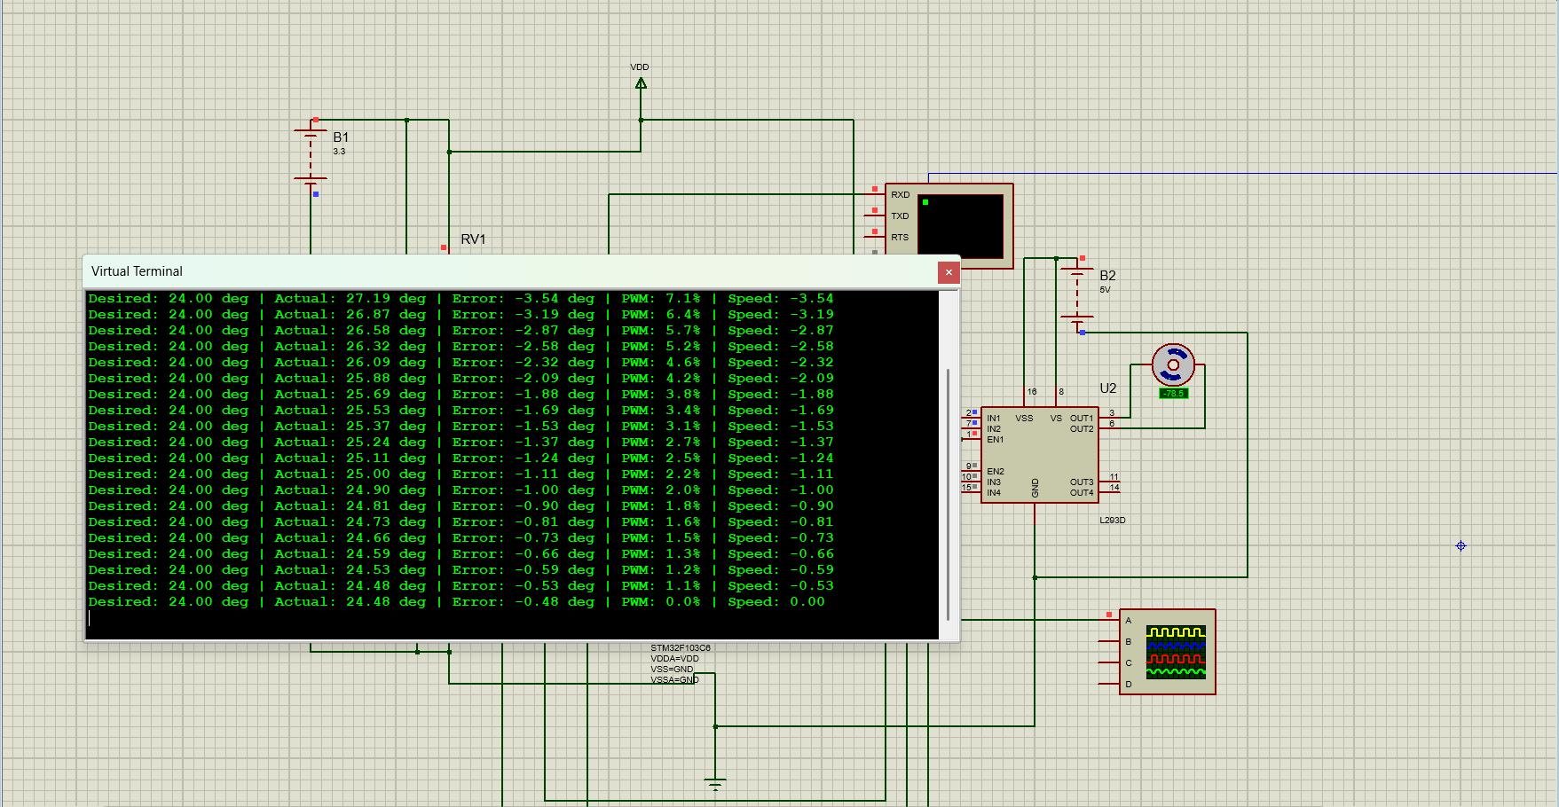
Figure 4: Reverse-motion result — actual angle falling toward the desired angle, with UART log.
[Insert dedicated oscilloscope screenshot of the TIM3_CH1 PWM waveform here]
Figure 5 (placeholder): PWM waveform on the oscilloscope.

9. Limitations
- The actual knee angle is produced by a software plant model in Proteus, not by a physical rotary position sensor; PA0/ADC1_IN0 is provisioned in firmware but not read in the control loop.
- The controller is proportional-only (duty ∝ |error|); no integral/derivative action or explicit PID tuning is implemented.
- No mechanical exoskeleton hardware, human-intention sensing (e.g. EMG/force), or physical joint sensor is part of the current prototype.
- Validation is limited to Proteus simulation; real motor dynamics, load and friction are not modelled.

10. Future Improvements
- Replace the software plant model with a real position sensor (e.g. rotary potentiometer or encoder) on PA0/ADC1_IN0 for genuine closed-loop feedback.
- Extend the control law to full PID for smoother tracking and reduced steady-state error.
- Add safety interlocks (soft angle limits, PWM ramping) ahead of any physical actuator deployment.
- Migrate from simulation to a physical STM32 + motor/driver bench setup for hardware-in-the-loop testing.

11. Conclusion
This project implemented and verified, in Proteus simulation, a proportional position controller for a knee-exoskeleton joint using an STM32F103C6Tx. The controller correctly reads a desired-angle reference, computes position error against a software-simulated actual angle, drives an L293D/DC-motor stage with an appropriate PWM duty and direction, stops automatically within ±0.5° of the target, and reports status over UART. The results confirm the intended control logic; the primary next step is to replace the software plant model with real position feedback as the project moves toward physical hardware.

