Version Manager Architecture Diagram Pack
LangGraph + MCP Multi-Agent System | Enterprise Architecture Views

Architecture Overview
This document provides industrial-style architecture diagrams for the Version Manager platform. The diagrams are embedded as high-resolution images so they can be reviewed directly in Word, shared with stakeholders, and reused in enterprise design reviews without Mermaid rendering.
View | Purpose | Primary Audience
System Context | Shows users, platform boundary, and external integrations. | Executives, architects, security
Logical Architecture | Shows layered components and module responsibilities. | Architects, developers
Pipeline Sequence | Shows execution order for the full assessment flow. | Developers, operators
Data Flow Diagram | Shows data movement across processes and stores. | Security, audit, architecture
Deployment Architecture | Shows recommended enterprise deployment zones. | Infrastructure, DevOps, security

System Context Architecture
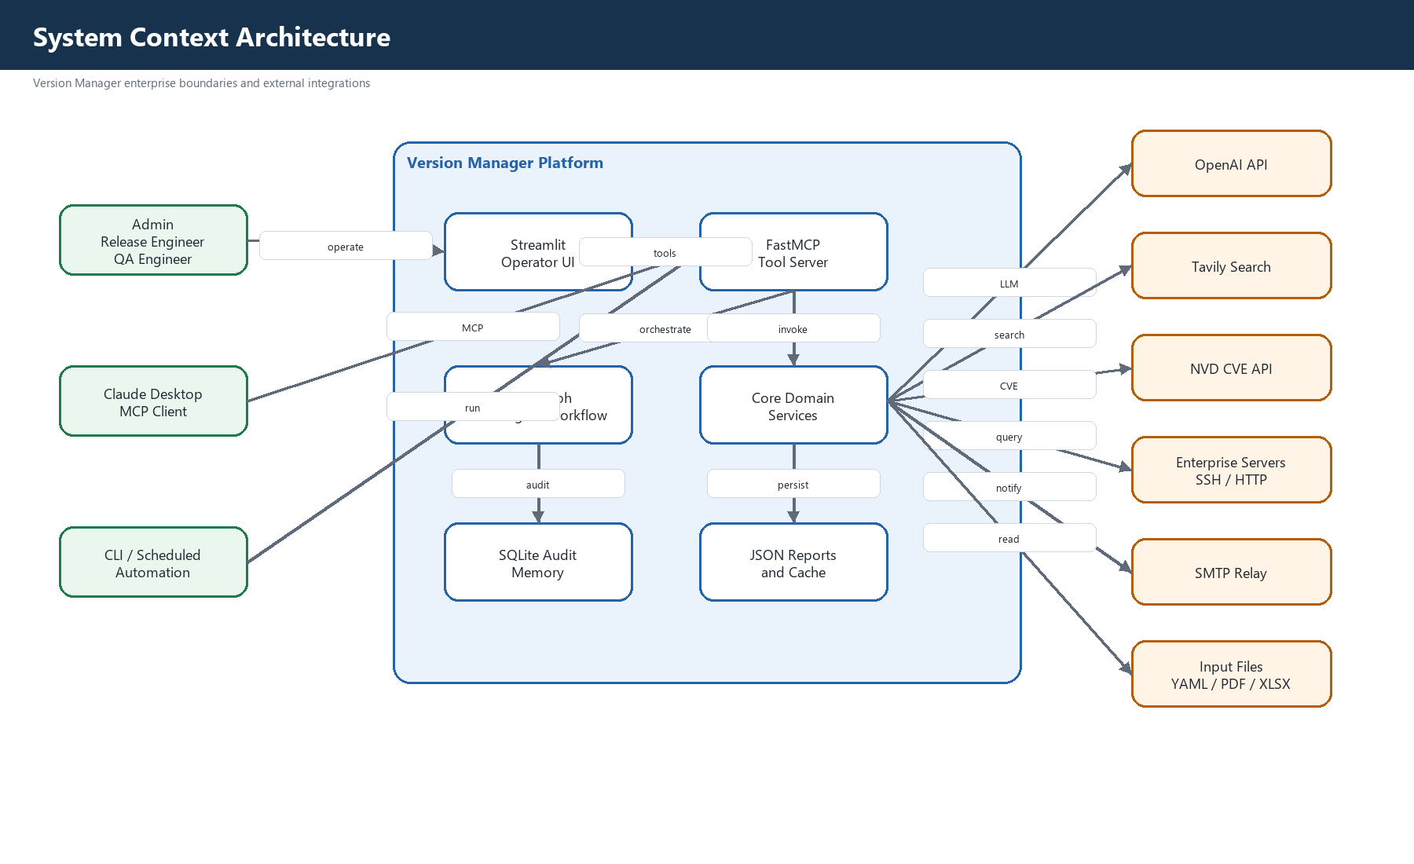
Figure 1. System Context Architecture

Logical Component Architecture
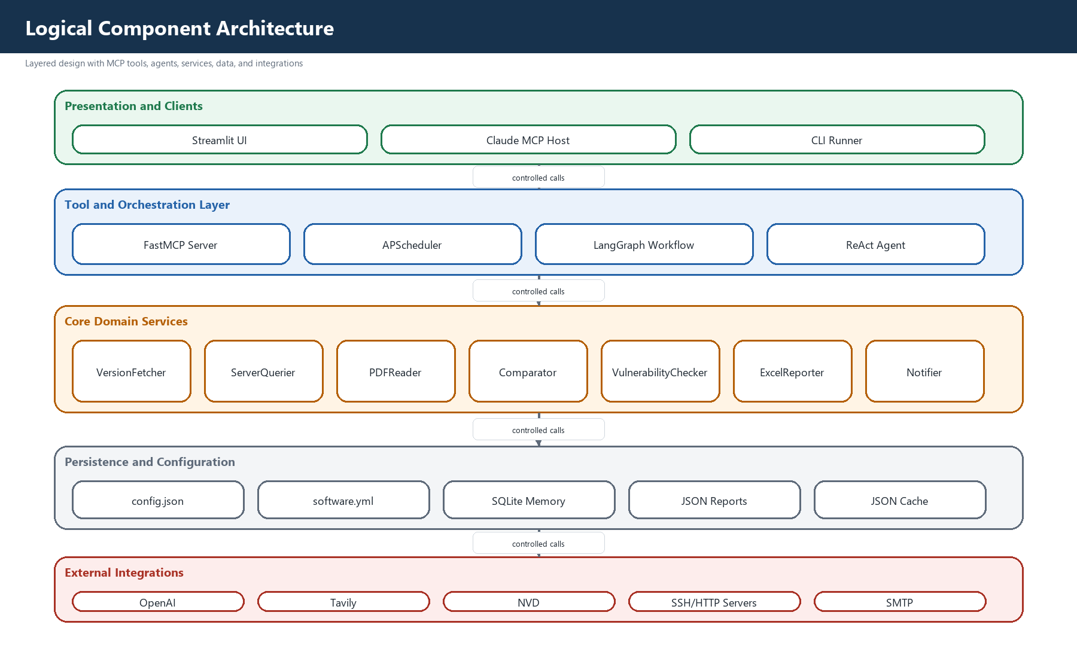
Figure 2. Logical Component Architecture

End-to-End Pipeline Sequence
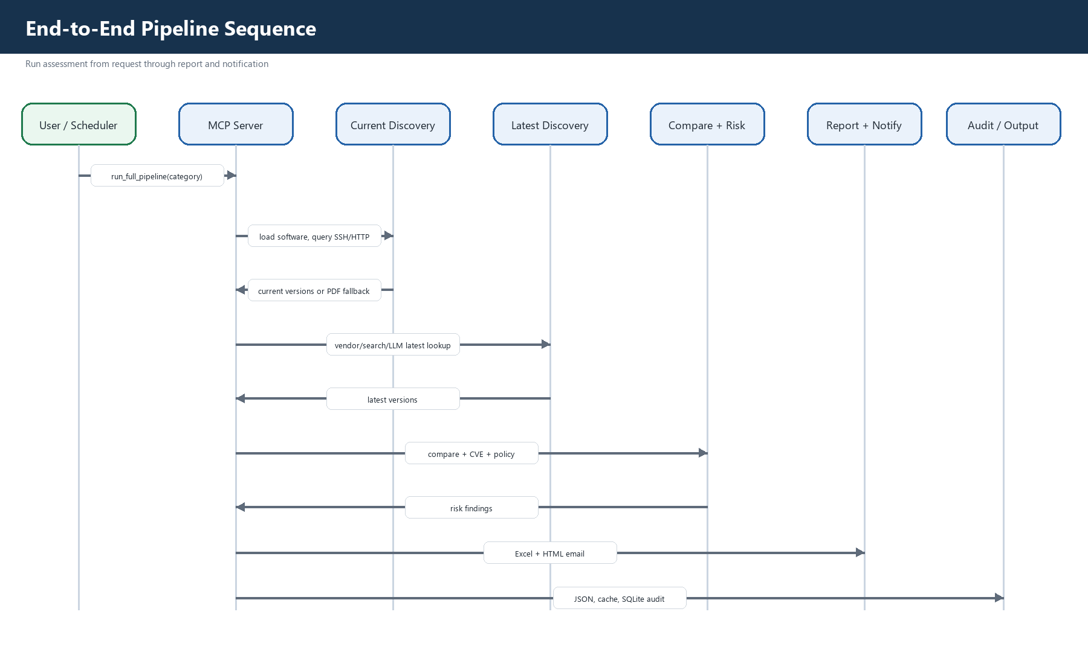
Figure 3. End-to-End Pipeline Sequence

Data Flow Diagram
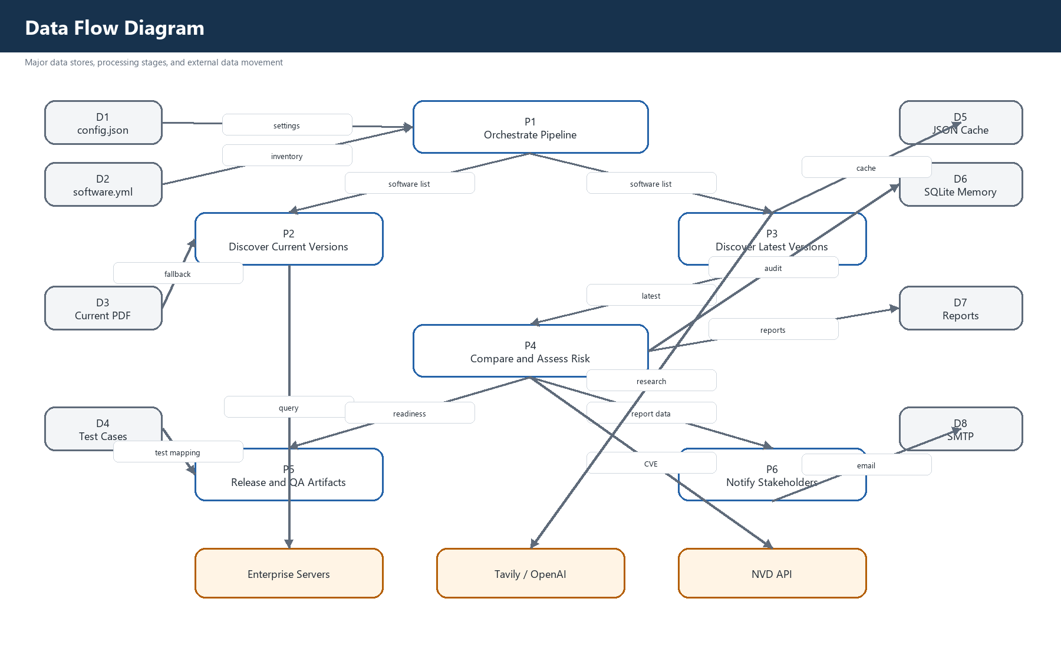
Figure 4. Data Flow Diagram

Enterprise Deployment Architecture
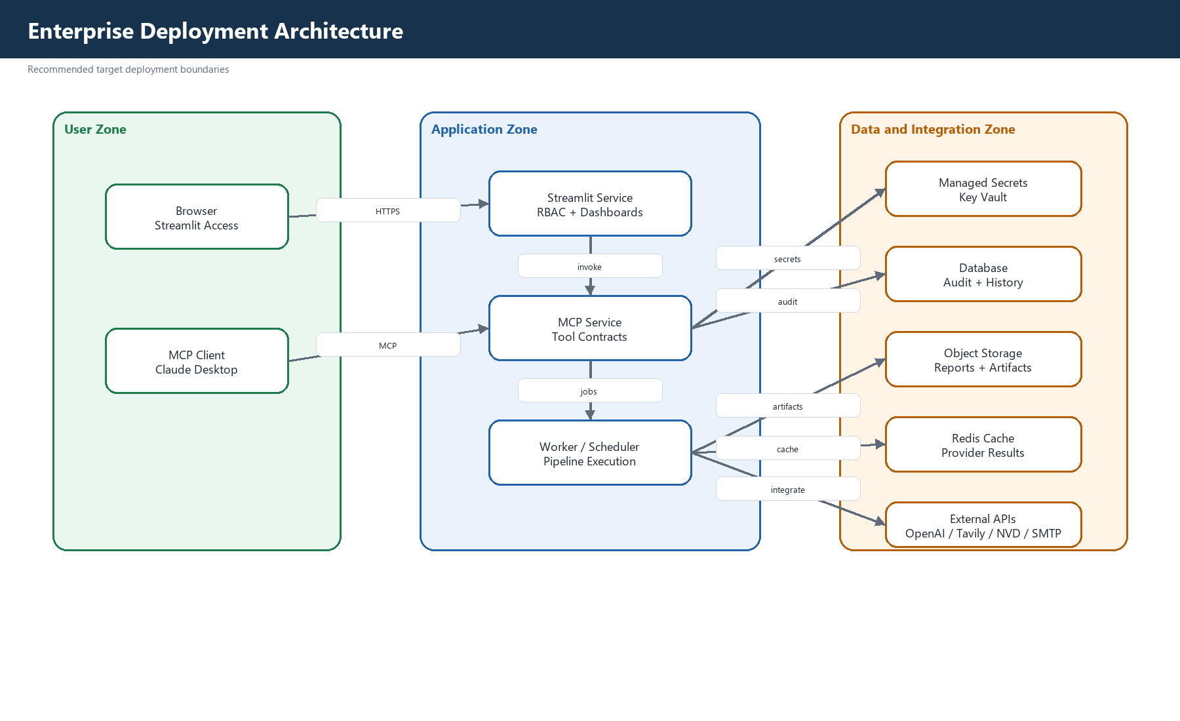
Figure 5. Enterprise Deployment Architecture

Component Responsibility Summary
Component | Enterprise Responsibility
Streamlit UI | Operator dashboard, report visualization, role-aware workflows.
FastMCP Server | Stable tool interface, deterministic pipeline coordination, scheduler lifecycle.
LangGraph Workflow | Least-privilege multi-agent orchestration with explicit state transitions.
Core Services | Version discovery, comparison, security assessment, reporting, notification.
SQLite / Reports / Cache | Audit memory, generated artifacts, provider result reuse.
External Integrations | OpenAI, Tavily, NVD, enterprise servers, and SMTP relay.

