Version Manager Agent Architecture and Code Flow
Industrial Multi-Agent Design | Generated 2026-07-06 22:40

1. Executive Summary
Version Manager uses a LangGraph supervisor/specialist multi-agent workflow, a FastMCP tool layer, role-aware Streamlit UI, and an assistant flow that prefers deterministic app/MCP tools before AI fallback. The latest implementation adds deterministic Workflow Planner and Workflow Verifier nodes to make the agent workflow more industrial-grade while preventing routing loops.

2. Target Agent Architecture
The workflow architecture is now:
START -> Planner Agent -> Specialist Agent -> Verifier Agent -> Planner Agent -> ... -> Reporting Agent -> END
- Planner Agent determines the next required step from current workflow state.
- Specialist agents perform domain-specific work using least-privilege tool allow-lists.
- Verifier Agent checks required outputs after each specialist step.
- Verifier retries a missing specialist output only once, then fails closed with a clear reason.
- Reporting Agent finalizes Excel, notification, audit, and report package outputs.

3. Agent Inventory
Agent | File/Class | Purpose | Primary Outputs
Planner | agent/multi_agent.py::PlannerAgent | Routes to the next required step using WorkflowPlanner. | next_agent, workflow_plan
Discovery | DiscoveryAgent | Loads software list and resolves installed/current versions. | software_inventory
Research | ResearchAgent | Collects latest vendor version metadata. | latest_versions
Analysis | AnalysisAgent | Compares current/latest versions and records run history. | comparison_results
Security | SecurityAgent | Assesses vulnerability and security posture. | vulnerability_results
Package Readiness | PackageReadinessAgent | Builds release/package readiness output. | package_readiness_results
Compatibility | CompatibilityAgent | Assesses compatibility requirements. | compatibility_results
QA Validation | QAValidationAgent | Builds QA validation and test case impact outputs. | qa_validation_results, testcase_impact_results
Verifier | agent/multi_agent.py::VerifierAgent | Checks specialist output completeness and prevents loops. | verification_result, verification_retries
Reporting | ReportingAgent | Generates report package, Excel, notification, audit. | report, report_package

4. Key Design Files
File | Responsibility
agent/multi_agent.py | LangGraph node classes, graph wiring, workflow state, specialist execution.
agent/workflow_planner.py | Deterministic workflow planning, workflow sequence, required/produced state mapping.
agent/workflow_verifier.py | Output verification and bounded retry policy.
agent/registry.py | Agent metadata, allowed tool definitions, role visibility.
agent/context.py | ReleaseContext: team, release, role, user, run_id, category, output path.
agent/contracts.py | Tool result envelope and typed contracts.
App/agent_tools.py | Streamlit-backed tool map for LangGraph, kept outside streamlit_app.py.
App/assistant_chat.py | Role-based assistant UI and chat flow.
agent/planner.py | Assistant planner for deterministic chat answers.
agent/verifier.py | Assistant response verification.
mcp_server.py | FastMCP tools and normalized MCP JSON response envelope.

5. Workflow Planner Design
WorkflowPlanner is deterministic and does not use an LLM. It checks workflow state fields in sequence and returns the first agent whose expected output is missing. If an agent is missing prerequisite inputs, it routes back to the upstream agent that produces that input.
Agent | Required Inputs | Produced Outputs
Discovery | None | software_inventory
Research | software_inventory | latest_versions
Analysis | software_inventory, latest_versions | comparison_results
Security | comparison_results | vulnerability_results
Package Readiness | comparison_results, vulnerability_results | package_readiness_results
Compatibility | comparison_results, package_readiness_results | compatibility_results
QA Validation | comparison_results, package_readiness_results | qa_validation_results, testcase_impact_results
Reporting | comparison_results, vulnerability_results, qa_validation_results | report, report_package

6. Workflow Verifier Design and Loop Protection
WorkflowVerifier validates the output of the last specialist agent. It uses the same produced-output contract as the planner. If expected output is missing, it routes back to the same agent once. If the output is still missing after the retry limit, it sets workflow_status to failed and ends the graph.
- MAX_VERIFICATION_RETRIES_PER_AGENT = 1.
- Each verifier result includes passed, next_agent, missing_outputs, reason, and retry_counts.
- Missing outputs are explicit, so operators can see which artifact or state field failed.
- The graph fails closed instead of looping indefinitely.

7. Tool Contract Design
Internal Streamlit-backed tools and MCP tools now follow a normalized result contract while preserving legacy top-level fields used by existing dashboards.
Field | Purpose
success | Boolean execution status.
source | Human-readable source label, for example Used app tool: QA Validation.
message | Short result summary.
data | Structured primary result payload.
paths | Artifact paths such as qa_validation.json or testcase_impact.json.
errors | Recoverable error list.
source_type | app_tool, mcp_tool, ai_fallback, file, or unknown.
legacy fields | Existing top-level fields preserved for compatibility.

8. Assistant Flow
The role-based assistant follows this flow:
ReleaseContext -> AssistantPlanner -> Tool/artifact answer -> AssistantVerifier -> AI fallback
- Admin sees AI Assistant.
- Release Engineer sees Release Assistant.
- QA Engineer sees QA Assistant.
- Assistant uses app artifacts first for release, QA dashboard, tester, signoff, and test case questions.
- AI fallback is used only when deterministic data cannot answer the question.

9. Code Flow for Full Workflow
Step | Code Path | Description
1 | streamlit_app.py | User triggers full/package/QA workflow from UI.
2 | runtime_state() | Builds scoped config and ReleaseContext for selected team/release.
3 | App/agent_tools.py | Creates Streamlit-backed tool map using normalized tool result envelopes.
4 | LangGraphVersionManager | Initializes graph state and invokes compiled LangGraph workflow.
5 | PlannerAgent | Chooses next specialist from state.
6 | Specialist Agent | Calls only allowed tools and updates shared state.
7 | VerifierAgent | Checks required outputs and retries once if missing.
8 | ReportingAgent | Builds report package, Excel, notification, and audit record.
9 | record_workflow_run() | Persists workflow status and summary.

10. Testing and Verification
The implementation was verified with:
- python -m unittest tests.test_workflow_runs tests.test_workflow_locks tests.test_agent_architecture tests.test_agent_memory
- python -m compileall agent App\agent_tools.py App\assistant_chat.py streamlit_app.py mcp_server.py
Important test coverage includes:
- ReleaseContext output path resolution.
- Tool result envelope compatibility.
- LangGraph workflow carries release context.
- Planner routes to the first missing output.
- Verifier retries once and fails closed instead of looping.
- Workflow completion path produces report and QA/testcase state.

11. Operational Notes
- streamlit_app.py should remain a thin integration/UI file; agent tool code belongs in App/agent_tools.py.
- HITL approval gates were intentionally not implemented per current project decision.
- Notes.txt is untracked and should not be committed because it may contain sensitive connection details.
- For local verification, run Streamlit at http://127.0.0.1:8501 and ask QA Assistant about current release or recommended test cases.

System Context Architecture
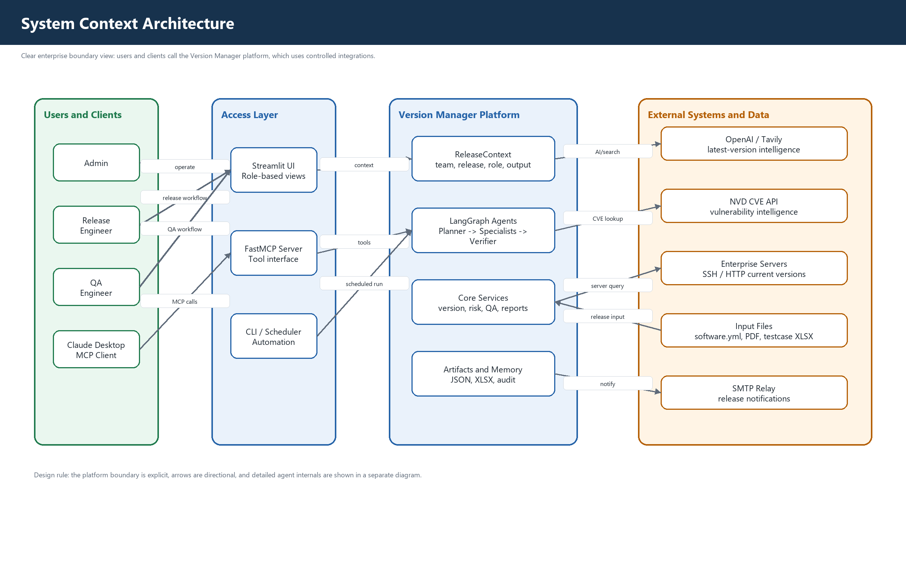
Enterprise boundary view with clear users, access layer, platform services, and external systems.

Agent Flow Architecture
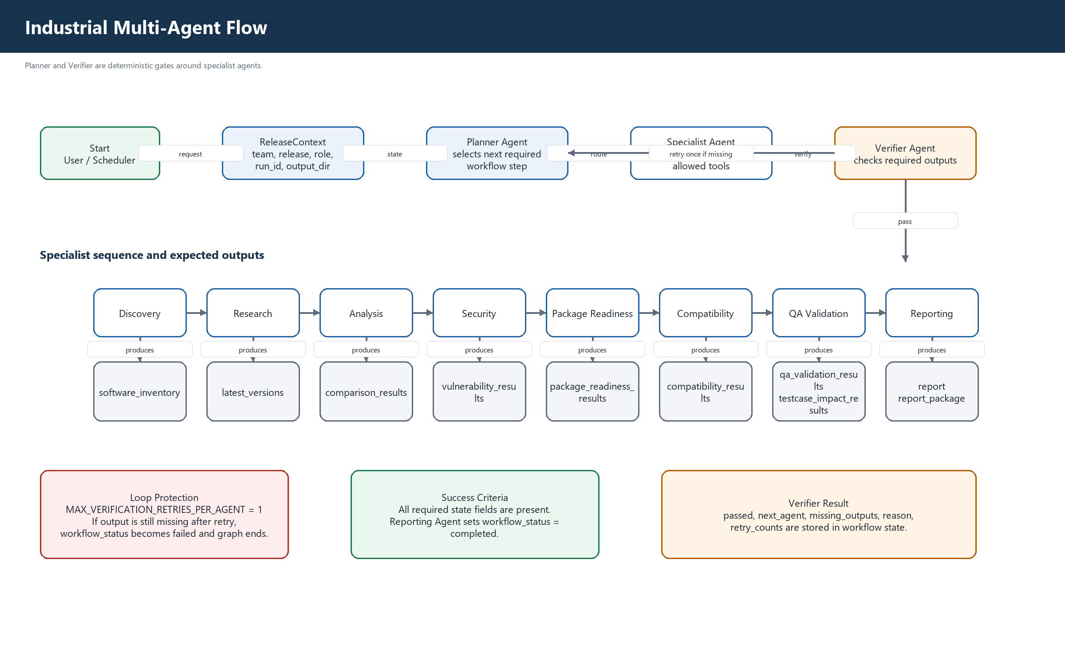
Planner and Verifier wrapped around specialist agents with bounded retry protection.

Code Flow and Module Boundaries
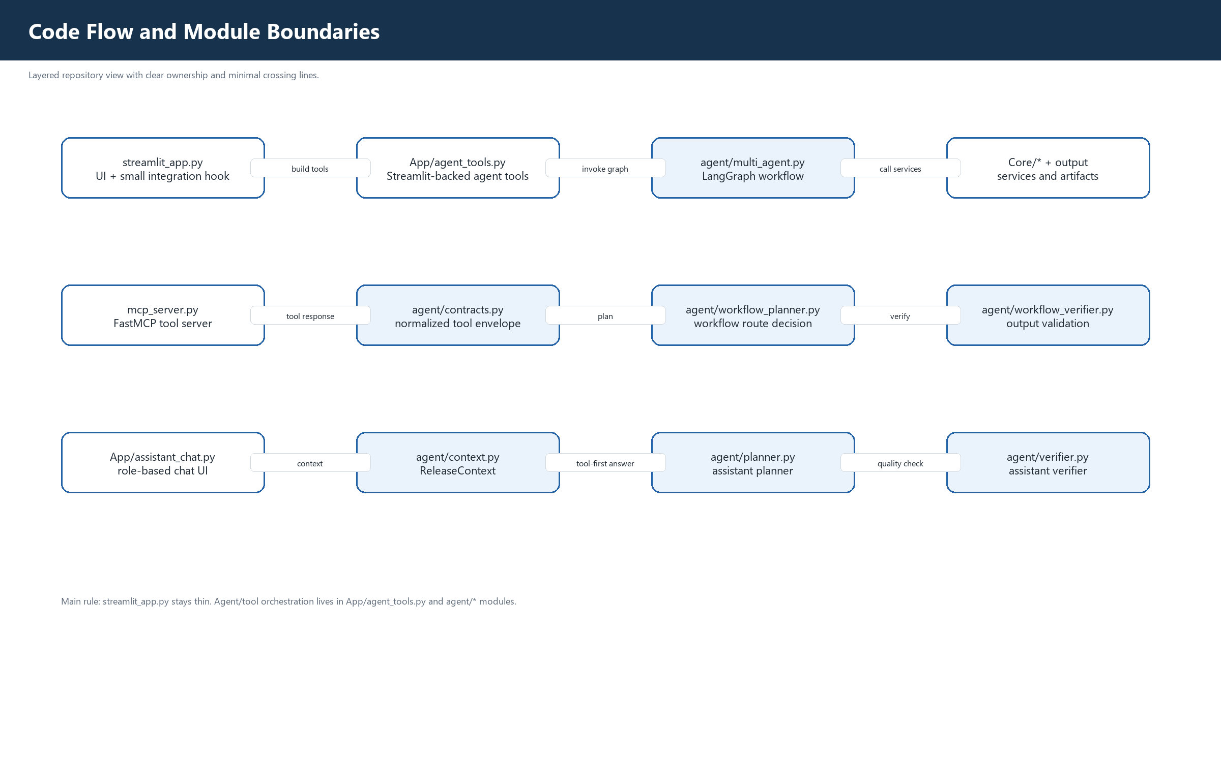
Repository-level code flow after moving agent tool code out of streamlit_app.py.

Tool Contract Flow
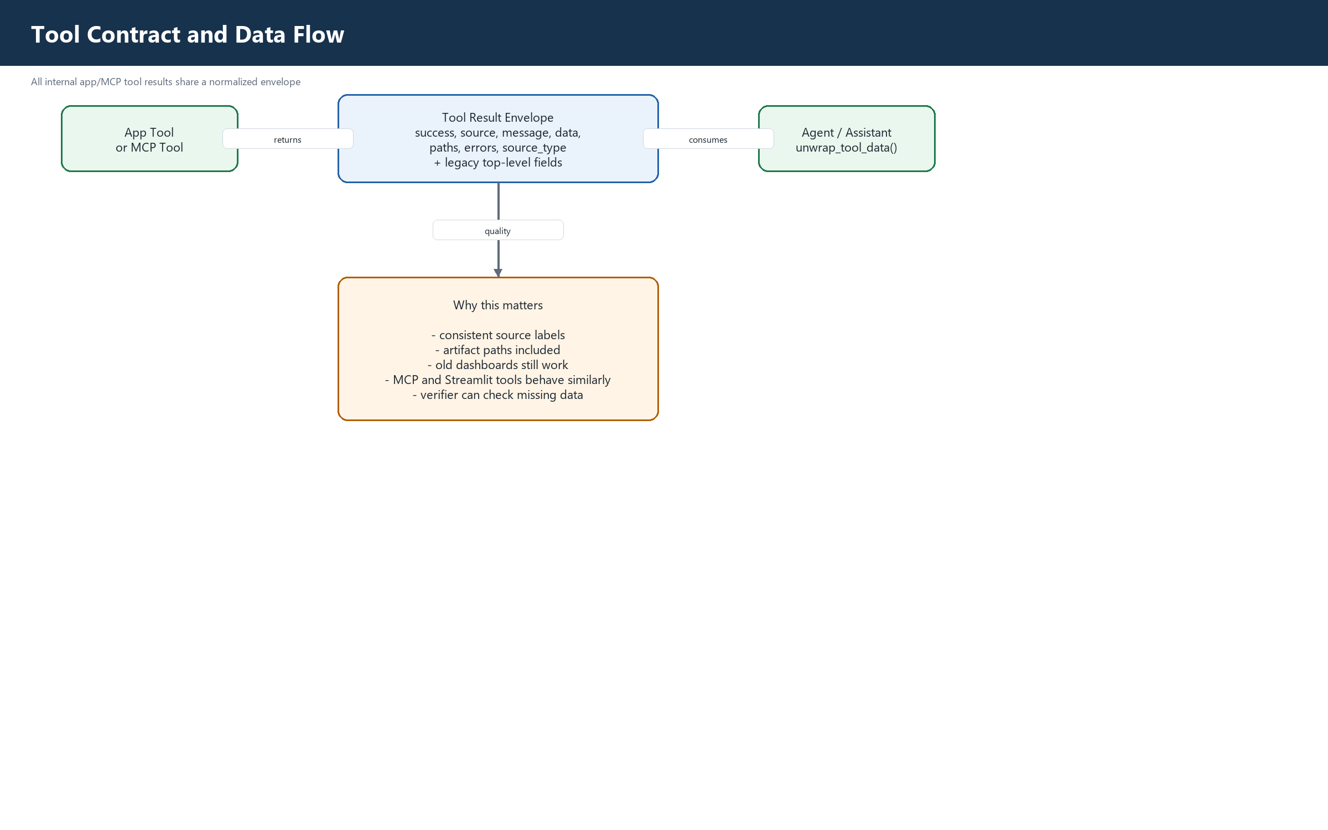
Normalized app/MCP tool result envelope consumed by agents and assistant.

