EPRA Platform Industrial-Grade Design Document
Enterprise Product Release AI Advisory Platform | Governed AI, MCP Tools, Multi-Agent Release Automation

1. Executive Summary
The Enterprise Product Release AI Advisory Platform (EPRA Platform) is an enterprise-grade release advisory system that automates third-party software version monitoring, current-version discovery, version comparison, vulnerability assessment, package readiness, QA validation, test impact analysis, reporting, and governed AI assistance.
The platform combines a Streamlit operational UI, MCP-style tool exposure, a LangGraph multi-agent workflow, OpenAI/Codex-assisted reasoning, Tavily-backed research, role-based access control, audit history, observability, and release evidence generation. It is designed to help release, QA, security, packaging, support, and compliance teams make faster and safer release readiness decisions.

2. Business Problem
- Enterprise products depend on multiple third-party software components, each with its own vendor release cycle.
- Release teams must track security patches, bug fixes, cumulative updates, service packs, compatibility changes, and download details.
- Manual tracking across vendors, QA files, vulnerability reports, package readiness, and compliance evidence is slow and error-prone.
- Teams need fast answers to questions such as release readiness, blocked packages, QA coverage, vulnerability posture, and pending checklist items.
- Standard scripts can generate outputs, but they cannot reliably correlate evidence, apply role-specific guardrails, and explain next actions in natural language.

3. Design Goals
- Provide a governed AI assistant for natural-language release, QA, package, security, and report questions.
- Expose release capabilities as MCP-style tools that can be reused by UI, agents, Claude/Codex workflows, and automation.
- Use deterministic multi-agent orchestration for production workflows while keeping optional ReAct tool-calling for experimentation.
- Generate traceable release evidence: JSON outputs, Excel reports, HTML reports, QA signoff history, and audit records.
- Implement role-aware access for Admin, Release Engineer, and QA Engineer personas.
- Support enterprise deployment with persistent storage, SMTP, audit history, and future integration points.

4. System Context
EPRA sits between enterprise users, MCP clients, local release inputs, infrastructure endpoints, external intelligence services, and reporting channels. Users interact through Streamlit or an MCP-compatible assistant; backend services collect evidence and persist generated release artifacts.

Figure 1. System Context Architecture
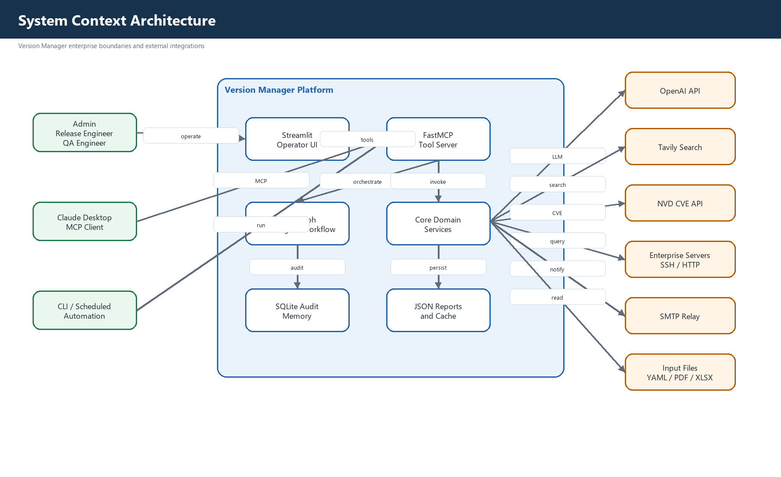

5. Logical Architecture
The architecture is layered to separate user experience, access control, assistant routing, orchestration, core domain services, persistence, and external integrations. This keeps AI capability governed and testable while allowing each service to evolve independently.

Figure 2. Logical Component Architecture
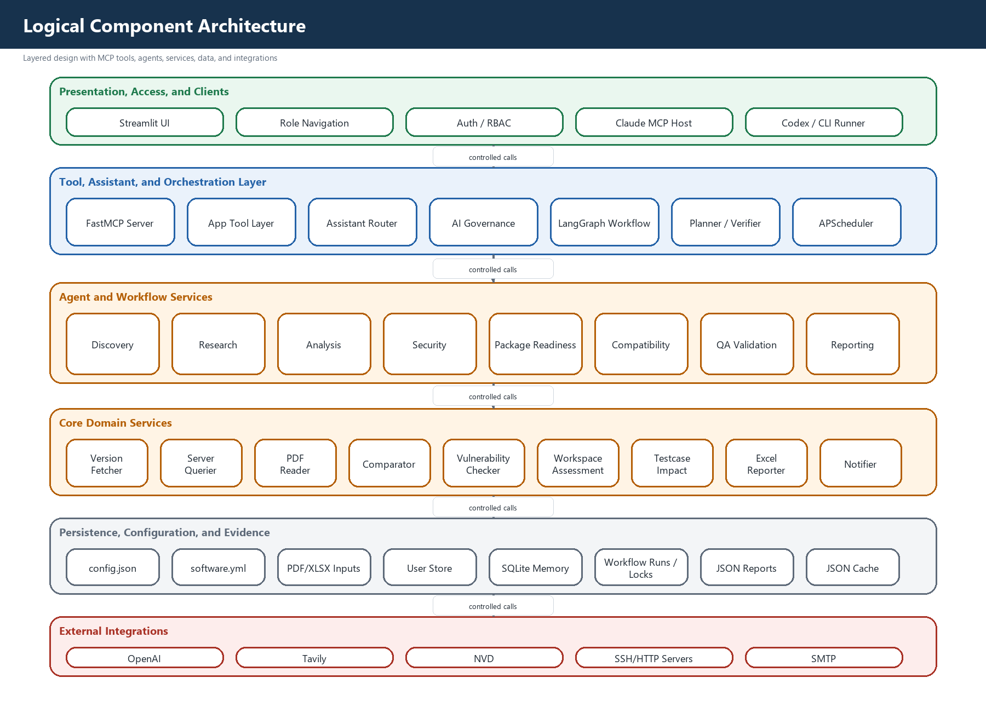
Layer | Main Components | Purpose
Presentation and Access | Streamlit UI, Role Navigation, Auth/RBAC | Dashboards, operations, reports, assistant, user access
Assistant and Tool Routing | Assistant Chat, Tool Router, AI Governance | Natural-language intent handling and governed response validation
Orchestration | FastMCP, LangGraph, Planner, Verifier, APScheduler | Tool exposure, multi-agent workflows, scheduled execution
Core Services | VersionFetcher, ServerQuerier, PDFReader, Comparator, VulnerabilityChecker, WorkspaceAssessment | Release intelligence and evidence generation
Persistence | JSON outputs, cache, SQLite/PostgreSQL, input files | Release artifacts, run history, audit, configuration, cache
External Integrations | OpenAI/Codex, Tavily, NVD, SSH/HTTP servers, SMTP | AI extraction, web research, security intelligence, notifications

6. Core Runtime Flow
- User selects product/team and release in the Streamlit UI or invokes an MCP tool/client.
- Authentication and role checks determine available pages, tools, reports, and assistant context.
- Latest version workflow researches vendor versions through direct logic, Tavily, OpenAI extraction, and cache.
- Current version workflow queries configured servers and falls back to PDF inventory extraction.
- Comparison workflow identifies version drift, update needs, and release compliance posture.
- Security workflow checks vulnerability posture and applies enterprise security policy enrichment.
- Package readiness workflow produces owners, blockers, readiness state, and pending checklist evidence.
- QA workflow produces QA validation, test coverage, tester details, evidence upload, and signoff history.
- Reporting workflow generates JSON, Excel, HTML, and email-ready outputs.
- Workflow runs, metrics, audit data, trace IDs, and output evidence are persisted for traceability.
Figure 3. Pipeline Sequence
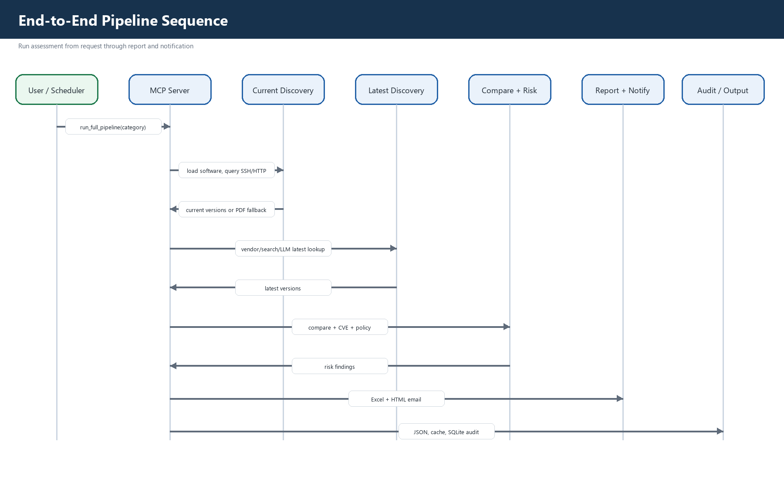

7. AI and Agentic Design

7.1 Governed Release Assistant
The assistant is implemented as a governed, evidence-first release advisor. It answers natural-language questions by first routing to trusted outputs or internal tools, then using approved web search where allowed, and AI fallback only when safe.
Capability | Implementation Files | Design Detail
Natural-language assistant | App/assistant_chat.py | Builds assistant context, handles prompt, renders source-labeled answers
Semantic tool routing | Core/assistant_tool_router.py | Maps prompt intent to approved tools with role and classification metadata
Final governance | Core/ai_governance.py | Classifies web prompts, blocks internal-data misuse, verifies final answer source
Role context | App/auth.py, App/user_store.py | Injects current role, permissions, user, and team scope
Figure 4. AI Assistant Request Flow
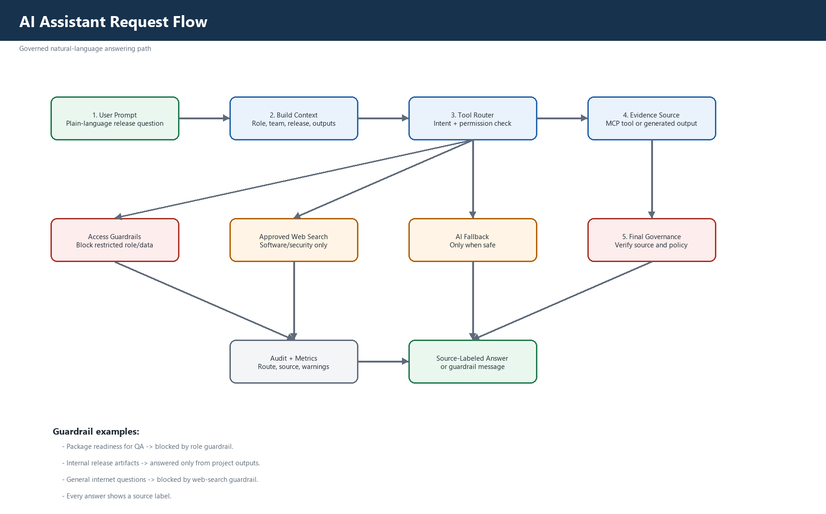

7.2 MCP-Style Toolset
Tool / Function | Purpose
get_software_list | Load scoped software inventory
query_server | Resolve current installed version from server
extract_from_pdf | Resolve current version from release PDF fallback
search_latest_version / fetch_latest_versions | Research latest vendor/software versions
fetch_current_versions | Build current-version catalog
compare_versions | Create version comparison report
check_vulnerabilities / save_vulnerability_report | Assess and persist security findings
assess_package_readiness / save_package_readiness | Generate package readiness and blocker evidence
generate_qa_validation / save_qa_validation | Generate QA validation plan
generate_testcase_impact | Map software updates to recommended tests
generate_excel_assessment | Create technical Excel report
log_audit_event | Persist audit/explainability event

7.3 Multi-Agent Workflow
The production workflow uses LangGraph-style deterministic routing. Specialized agents update shared workflow state and a verifier checks output completeness. This is more governable than an unconstrained chat loop and is suitable for audit-ready enterprise execution.
Agent / Step | Responsibility | Main Files
Planner | Decides next required workflow step based on missing outputs | agent/workflow_planner.py
Discovery | Loads software inventory and current versions | agent/multi_agent.py, mcp_server.py
Research | Finds latest vendor versions | Core/version_fetcher.py
Analysis | Compares current vs latest | Core/comparator.py
Security | Checks vulnerabilities and policy risk | Core/vulnerability_checker.py, Core/security_policy.py
Package Readiness | Creates package readiness status and blockers | Core/workspace_assessment.py
QA Validation | Creates QA validation and testcase impact outputs | Core/testcase_impact.py, App/pages/qa_validation.py
Reporting | Generates reports, emails, and artifacts | Core/excel_reporter.py, Core/notifier.py
Verifier | Checks completion and fails closed when outputs are missing | agent/workflow_verifier.py
Figure 5. Planner and Verifier Agent Flow
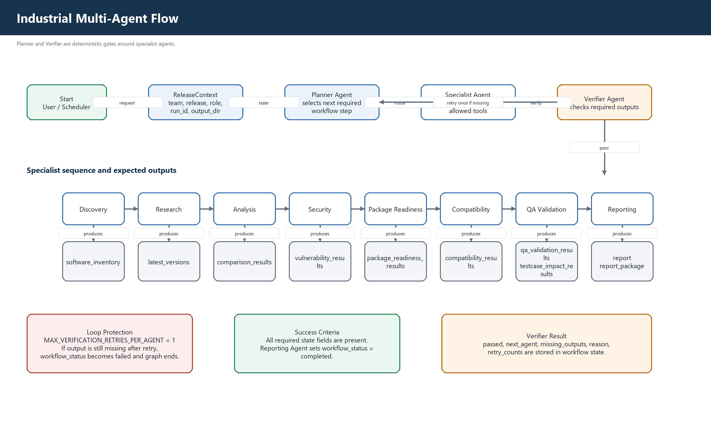

8. Data and Evidence Design
Artifact | Type | Purpose
software.yml | YAML input | Product/release software inventory
sample_version.pdf | PDF input | Current version fallback inventory
testcaseRepository.xlsx | Excel input | Maps software updates to QA test cases
current_versions.json | JSON output | Resolved installed/current versions
latest_versions.json | JSON output | Resolved latest vendor versions
comparison_report.json | JSON output | Version drift and update decision data
vulnerability_report.json | JSON output | Security findings and policy-adjusted risk
package_readiness.json | JSON output | Package readiness, owners, blockers, checklist
qa_validation.json | JSON output | QA status, tester details, coverage, evidence
testcase_impact.json / XLSX | JSON/Excel output | Recommended test cases and coverage gaps
Software_Version_Assessment.xlsx | Excel output | Technical report package
email_preview.html | HTML output | Management email preview
workflow_runs | SQLite/PostgreSQL | Run history and traceability
user_audit | SQLite/PostgreSQL | User/admin audit trail
Figure 6. Clean Data Flow
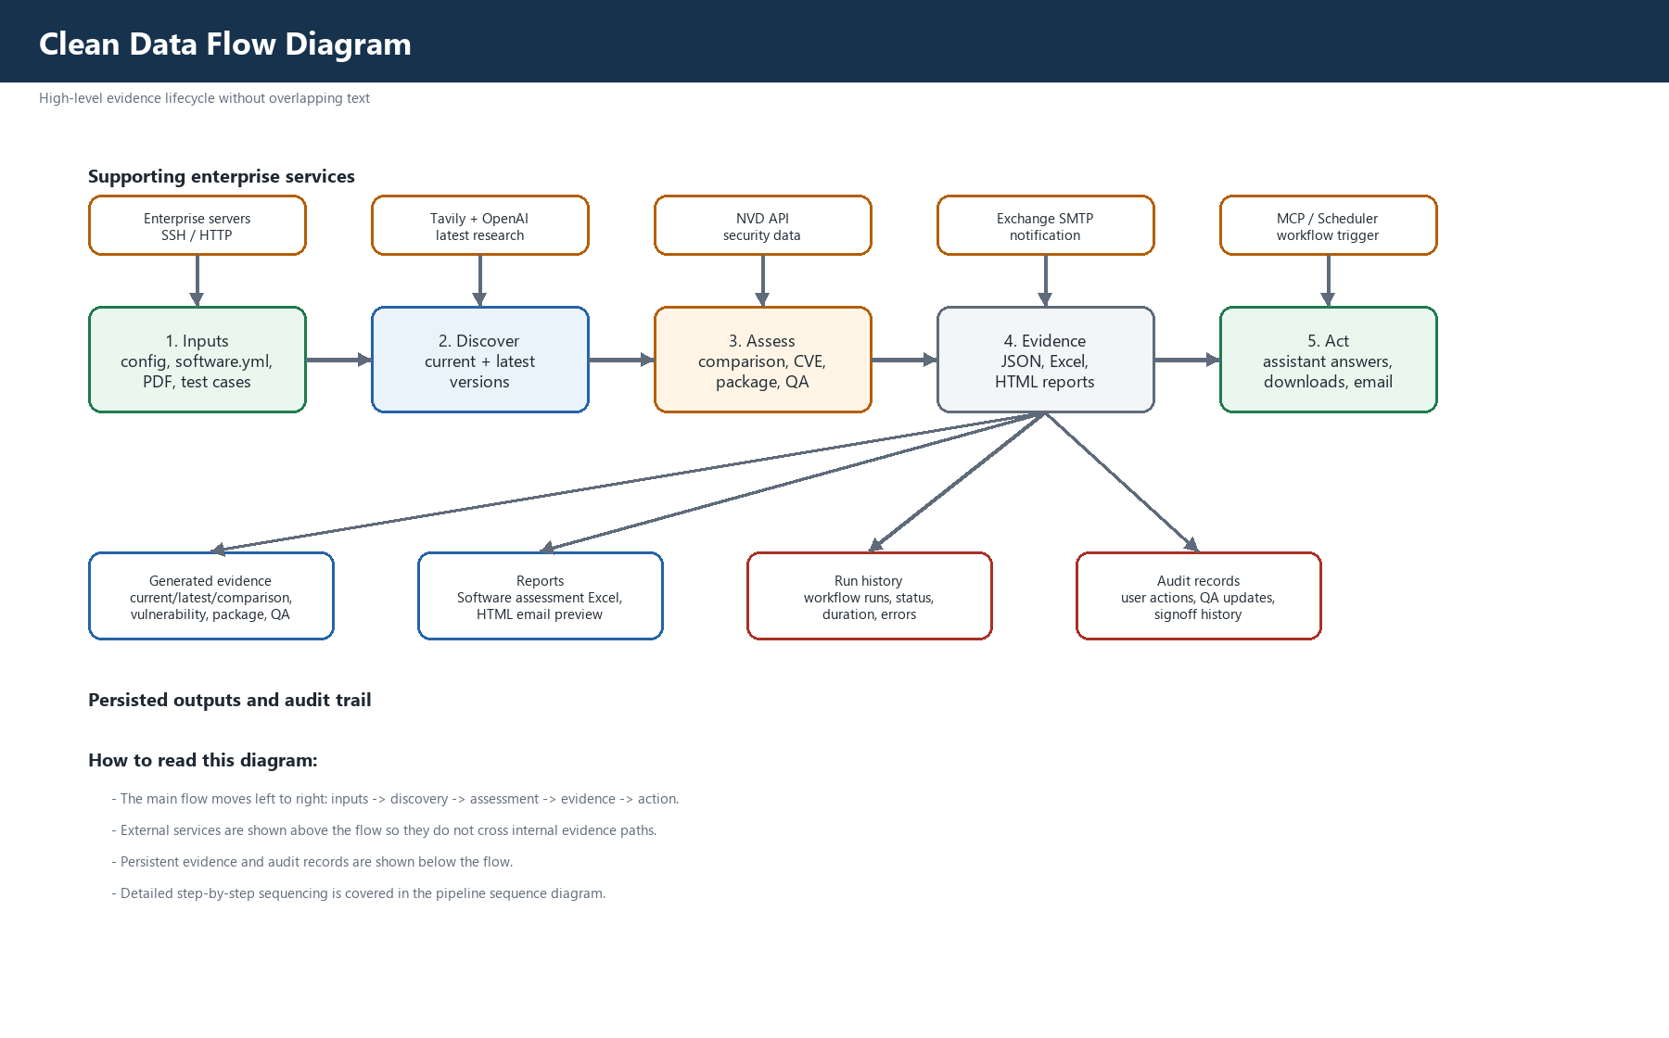

9. Security, Governance, and Compliance

9.1 Security Controls
- Login-protected application with Admin, Release Engineer, and QA Engineer roles.
- Password hashing through PBKDF2-HMAC-SHA256 with salt.
- Signed HMAC session tokens with expiry.
- Team/product scope limits user visibility.
- Inactive users cannot authenticate.
- User changes are recorded in user_audit.
- Security policy overlays raise risk for unsupported baselines and critical package exposure.

9.2 AI Governance and Guardrails
- Assistant follows evidence-first order: generated outputs, MCP/app tools, approved web search, safe AI fallback.
- Web search is limited to software versions, release notes, CVE advisories, compatibility matrices, and documentation.
- Internal release/package/report data must come from generated project outputs, not internet search.
- QA Engineer access to package readiness is blocked by role guardrail.
- Every answer includes a source label such as Used MCP tool or Access guardrail.
- Missing evidence results in fail-closed messaging rather than invented answers.

9.3 Compliance Evidence
- Version compliance score and security posture are calculated from comparison and vulnerability evidence.
- QA signoff captures signed by, signed date, coverage, executed test cases, comments, and status.
- Release artifacts are generated for audit and stakeholder review.
- Reports and downloads are role-filtered.
- Workflow run history preserves who triggered what for which team/release and when.

10. Observability and Traceability
Concern | Implementation | Files
Trace IDs | new_trace_id creates per-run trace identifiers | Core/observability.py
Step events | started/completed/failed structured events | Core/observability.py
Metrics | duration metrics written to output/metrics.jsonl | Core/observability.py
Workflow history | run ID, scope, status, actor, role, duration, summary JSON | App/workflow_runs.py
Concurrency control | team/release/scope workflow lock | App/workflow_locks.py
Agent audit | tool call/result/failure/final answer audit memory | agent/memory.py, agent/agent.py
Admin monitor | workflow history and planner/verifier state | App/workflow_ui.py

11. Deployment Architecture
The current demo can run in Streamlit Cloud or local desktop mode. The industrial deployment target is an enterprise-hosted environment with persistent storage, controlled secrets, approved SMTP, and access to internal inventory/server sources.
Figure 7. Deployment Architecture
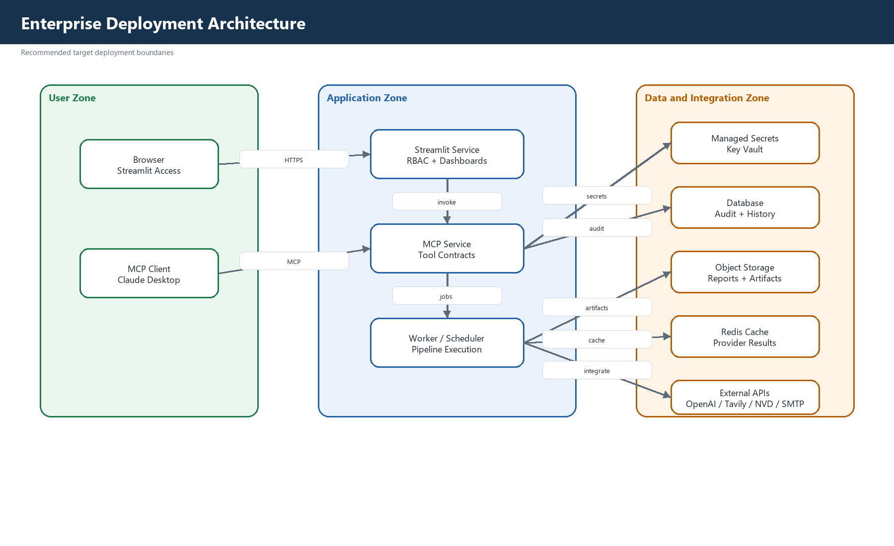
Environment | Usage | Design Note
Local/Enterprise Host | Primary intended implementation | Persistent inputs, outputs, audit DB, SMTP, secure configuration
Streamlit Cloud | Demo/checking only | Temporary storage; uploaded inventory/input files may be lost after restart
Future Container Platform | Scalable enterprise deployment | Separate UI/API/MCP services, centralized DB/cache/object storage

12. Reliability and Resilience
- Cache layer reduces repeated Tavily/OpenAI/NVD calls and improves repeatability.
- Current-version discovery has server lookup and PDF fallback.
- Workflow verifier prevents silent partial completion.
- Workflow locks avoid concurrent conflicting runs for the same team/release/scope.
- Missing output handling returns clear user guidance instead of false success.
- SMTP email flow reports delivery failure and recommends configuration review.

13. Test Strategy
Test Area | Representative Tests
Assistant routing | tests/test_assistant_tool_router.py
Assistant web guardrails | tests/test_assistant_web_search.py
AI governance | tests/test_ai_governance.py
Agent architecture | tests/test_agent_architecture.py
Workflow runs | tests/test_workflow_runs.py
Workflow locks | tests/test_workflow_locks.py
Comparator/cache/policy/vulnerability | tests/test_comparator.py, tests/test_cache.py, tests/test_policy.py, tests/test_vulnerability_checker.py
QA updates | tests/test_qa_updates.py

14. Scalability and Future Enhancements
- Integrate enterprise SSO and centralized identity provider.
- Move persistent storage to PostgreSQL and release artifacts to enterprise object storage or SharePoint.
- Add OpenTelemetry traces across UI, MCP tools, agents, and external calls.
- Integrate Jira, ServiceNow, Nexus, CMDB, CI/CD, SIEM/SOAR, and SharePoint.
- Add human approval workflow for release recommendations and email notifications.
- Add proactive alerts when vulnerabilities, package blockers, or QA gaps appear.
- Containerize Streamlit UI, MCP service, and worker processes for scale-out deployment.

15. Design Decisions
Decision | Rationale | Tradeoff
Use MCP-style tools | Reusable by UI, agents, Claude/Codex, and automation | Tool contracts must remain stable
Use LangGraph for production workflow | Deterministic, auditable, fail-closed orchestration | Less free-form than pure chat agent
Keep ReAct optional | Useful for experimentation and conversational tool use | Needs governance before broader production use
Evidence-first assistant | Reduces hallucination and ties answers to release data | Requires outputs to be generated first
Role-based report visibility | Protects package/QA/admin data | Requires clear user-role setup
Streamlit Cloud for demo only | Fast sharing for hackathon/demo | Temporary storage is not enterprise persistent

16. Conclusion
The EPRA Platform is designed as an industrial-grade governed AI release advisory system. It combines deterministic workflow automation, MCP tool interoperability, natural-language assistant access, security and compliance guardrails, traceable release evidence, and operational dashboards. The architecture is practical for current local/enterprise execution and has a clear path toward scalable enterprise deployment.

